The University of Azad Jammu and Kashmir, Muzaffarabad



Software Construction & Development (SC&D)
(Lab – 02)

Name | Ubaidullah Awan
Roll no | 2024-SE-17
Semester | ^{5th}
Batch | 2024-2028
Lab | 02
Submitted to | Engr. Asma Javaid
Submission date | Oct 27, 2026

Department of Software Engineering

Q 1: Draw an activity diagram by visualizing the process of the foodPanda application (online food order app) using swimlane.
Solution
The activity diagram below follows one food order from the moment the customer opens the app until the order is delivered and rated. Each swimlane shows who is responsible for an activity.

Swimlanes
Swimlane | Responsibility
Customer | Logs in, browses restaurants, builds the cart, checks out, receives the food and rates the order.
foodPanda App (System) | Shows menus, validates the order and payment, confirms and notifies, cancels/refunds if needed, assigns a rider and shares live tracking.
Restaurant | Receives the order, accepts or rejects it, prepares the food and marks it ready.
Rider | Accepts the delivery request, picks up the food and delivers it to the customer.

Decision points

- Payment successful? If not, the customer changes the payment method and checks out again. If yes, the order is confirmed.

- Accept order? If the restaurant rejects it, the app cancels the order, refunds the customer and notifies them, and the flow ends. If accepted, food preparation starts.

Activity Diagram with Swimlanes: foodPanda
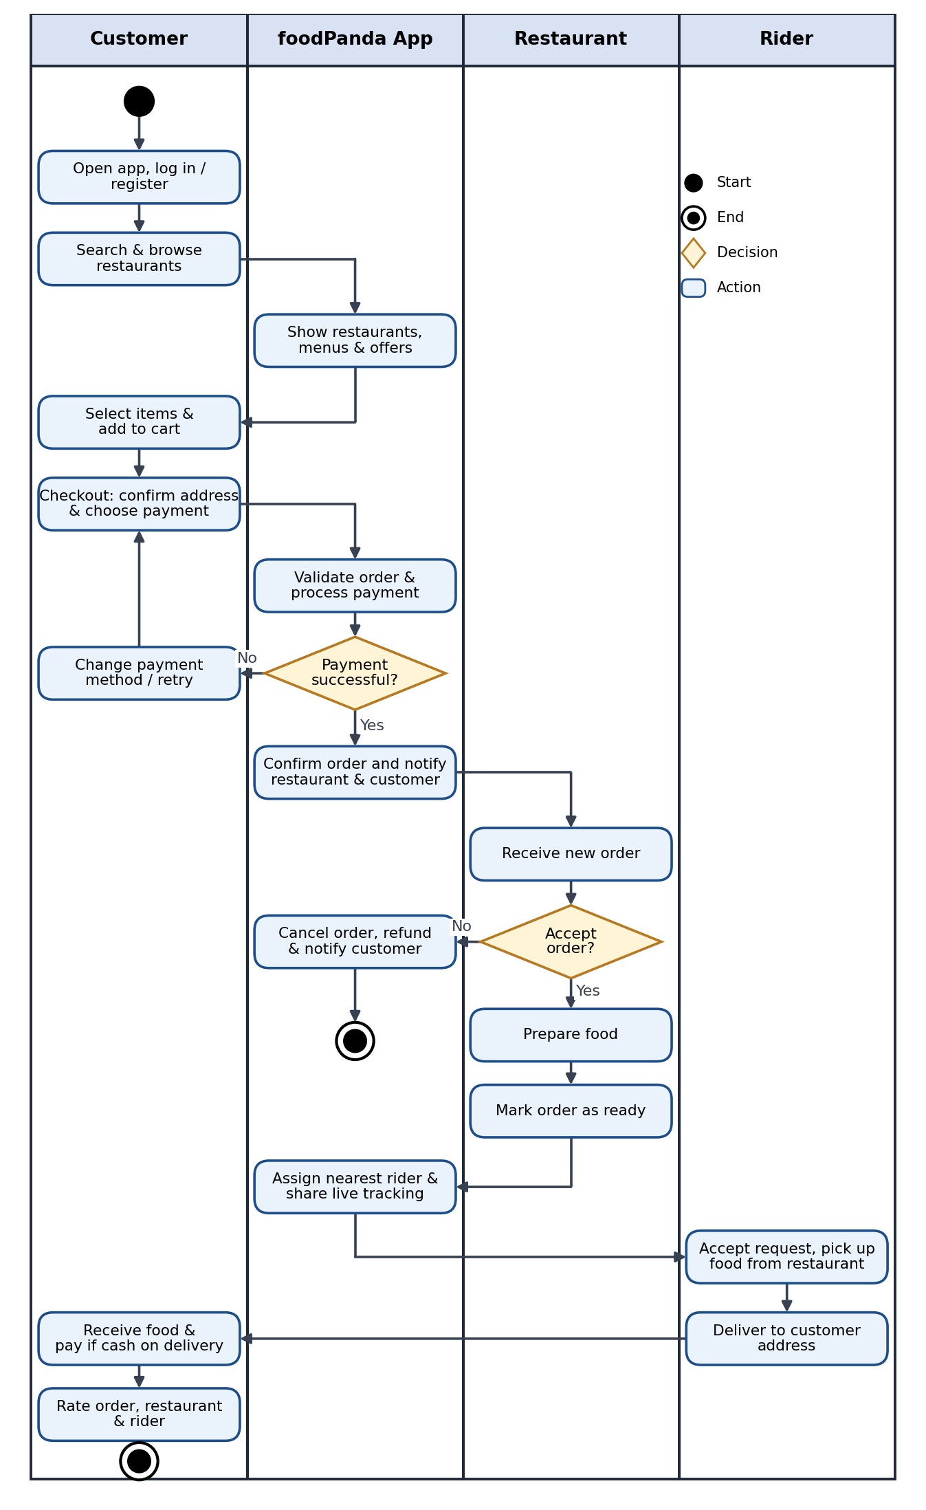

Figure 1: Swimlane activity diagram of the foodPanda ordering process

Q 2: Draw a State diagram for a Toaster. List activities within each state. Identify triggered and triggerless events/actions.
Solution
The toaster is modelled with four states: Idle, Toasting, Ejecting and Overheated (Fault). Orange dashed arrows are triggerless transitions; blue solid arrows are triggered by an event.

Figure 2: State diagram of a Toaster
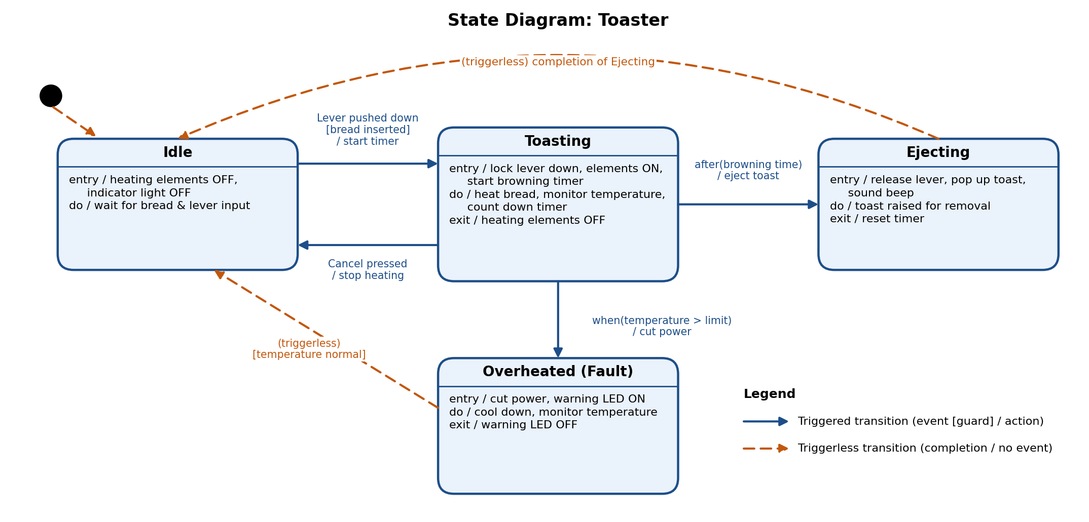
Activities within each state
State | Entry activity | Do activity | Exit activity
Idle | Heating elements OFF, indicator light OFF | Wait for bread and lever input | None
Toasting | Lock lever down, heating elements ON, start browning timer | Heat bread, monitor temperature, count down timer | Heating elements OFF
Ejecting | Release lever, pop up toast, sound beep | Toast stays raised for removal | Reset timer
Overheated (Fault) | Cut power, warning LED ON | Cool down, monitor temperature | Warning LED OFF

Triggered and triggerless events / actions
No. | Transition | Event (trigger) | Guard | Action | Type
1 | Start → Idle | None (initial transition) | - | - | Triggerless
2 | Idle → Toasting | Lever pushed down | [bread inserted] | Start timer, elements ON | Triggered
3 | Toasting → Idle | Cancel pressed | - | Stop heating | Triggered
4 | Toasting → Ejecting | after(browning time), a time event | - | Eject toast | Triggered
5 | Toasting → Overheated | when(temperature > limit), a change event | - | Cut power | Triggered
6 | Ejecting → Idle | None (completes when ejecting finishes) | - | - | Triggerless
7 | Overheated → Idle | None (completes after cool-down) | [temperature normal] | Warning LED OFF | Triggerless

Q 3: Draw State Machine diagram of Elevator/Lift.
Solution
The elevator works inside an Operational composite state made up of Idle, Moving Up, Moving Down, Doors Opening, Doors Open and Doors Closing. The emergency button or a fault can occur in any of them and takes the elevator to Emergency Stop.

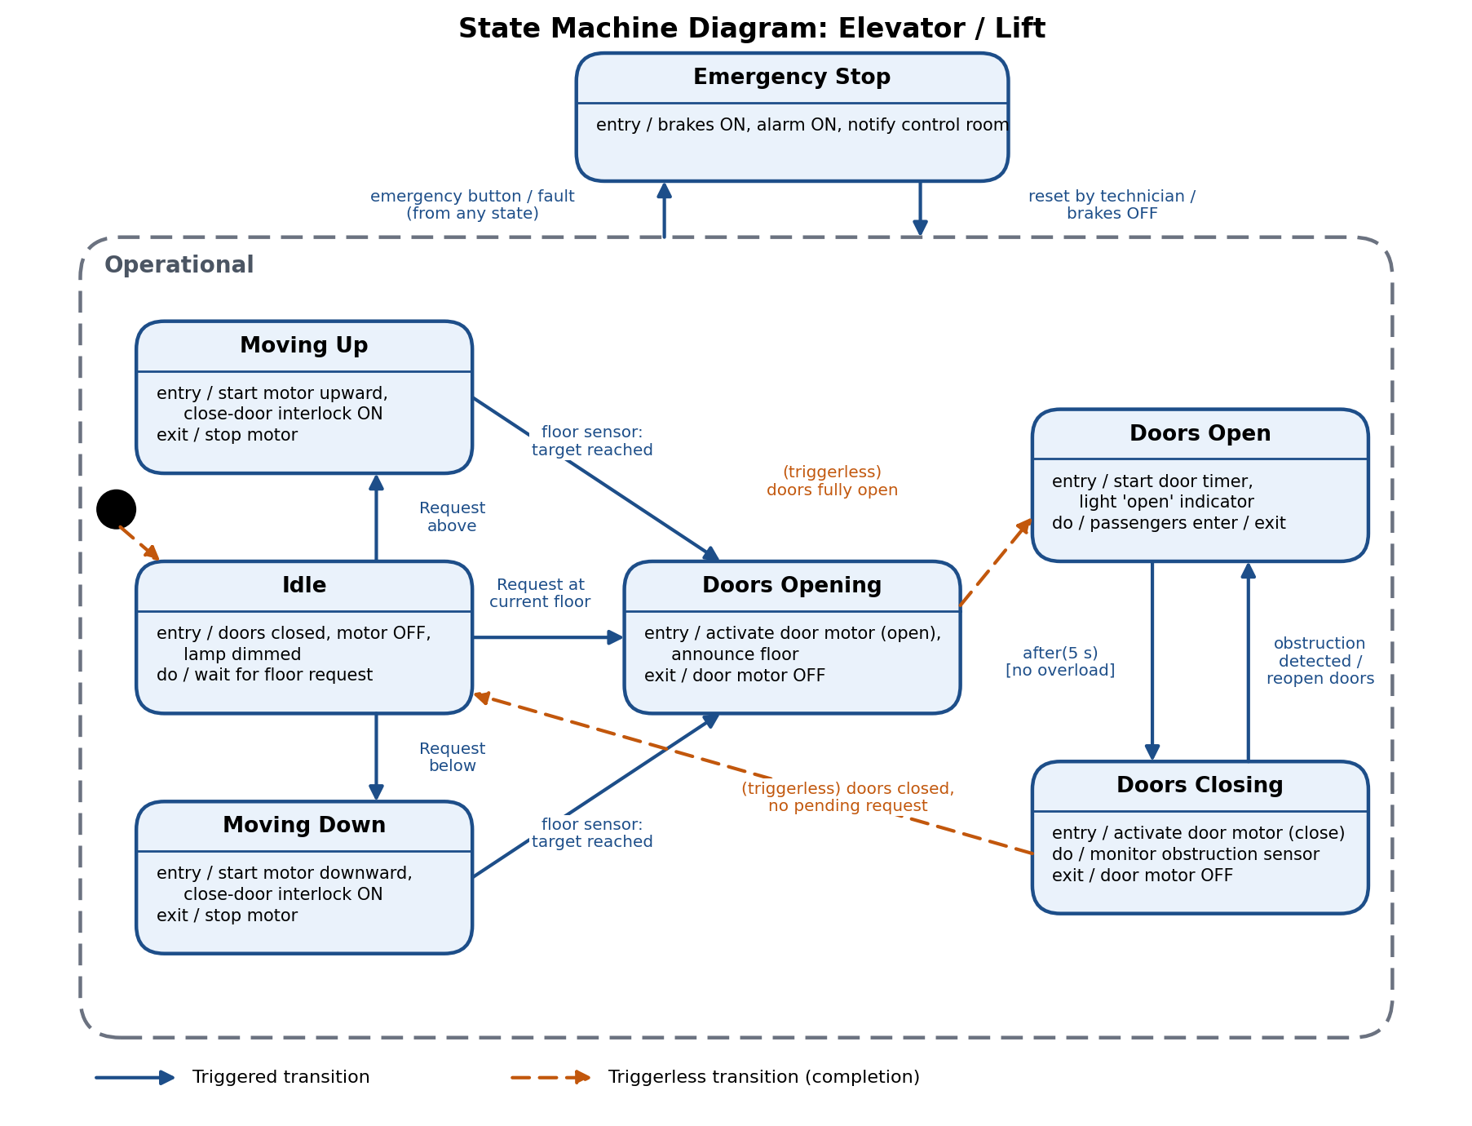

Figure 3: State machine diagram of an Elevator / Lift

States and their activities
State | Entry / do / exit activities | Meaning
Idle | entry: doors closed, motor OFF, lamp dimmed; do: wait for floor request | Waiting at a floor with doors closed.
Moving Up | entry: start motor upward, close-door interlock ON; exit: stop motor | Travelling to a higher floor.
Moving Down | entry: start motor downward, close-door interlock ON; exit: stop motor | Travelling to a lower floor.
Doors Opening | entry: activate door motor (open), announce floor; exit: door motor OFF | Doors are sliding open at the target floor.
Doors Open | entry: start door timer, show 'open' indicator; do: passengers enter / exit | Doors stay open for boarding.
Doors Closing | entry: activate door motor (close); do: monitor obstruction sensor; exit: door motor OFF | Doors are closing.
Emergency Stop | entry: brakes ON, alarm ON, notify control room | Elevator is halted after an emergency or fault.

Transitions
No. | Transition | Event / guard | Action | Type
1 | Start → Idle | None (initial transition) | - | Triggerless
2 | Idle → Moving Up | Floor request above the current floor | Start motor up | Triggered
3 | Idle → Moving Down | Floor request below the current floor | Start motor down | Triggered
4 | Idle → Doors Opening | Request at current floor / open button | Open doors | Triggered
5 | Moving Up → Doors Opening | Floor sensor: target floor reached | Stop motor | Triggered
6 | Moving Down → Doors Opening | Floor sensor: target floor reached | Stop motor | Triggered
7 | Doors Opening → Doors Open | None (completes when doors are fully open) | Start door timer | Triggerless
8 | Doors Open → Doors Closing | after(5 s) [no overload] | Close doors | Triggered
9 | Doors Closing → Doors Open | Obstruction detected | Reopen doors | Triggered
10 | Doors Closing → Idle | None (completes when doors are closed) [no pending request] | - | Triggerless
11 | Operational → Emergency Stop | Emergency button pressed / fault (from any state) | Brakes ON, alarm | Triggered
12 | Emergency Stop → Operational (Idle) | Reset by technician | Brakes OFF | Triggered

