1. Find all the ongoing/unfinished steps. Display the title of these steps and full names of the users who are taking these steps.

select s.title, concat(u.first_name, ' ', u.last_name) as full_name

from step_taken

inner join step s on step_taken.step_id = s.stepID

inner join user u on step_taken.user_id = u.userID;

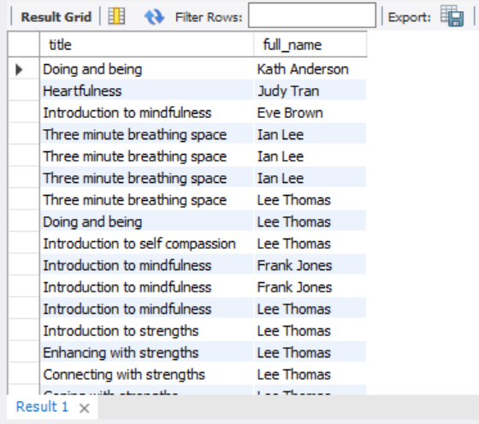

111 rows returned

2. List the themes and the number of the steps associated with these themes. Display the theme name and number of associated steps sorted in descending order

select t.name, count(st.step_id) as associated_steps

from step_theme st inner join theme t on st.theme_id = t.themeID

inner join step s on st.step_id = s.stepID

group by st.theme_id

order by associated_steps desc;

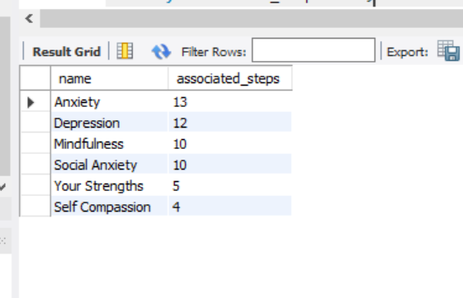

3. Which step is the least popular based on the average rating given by users? Display the title and ID of the step and its average rating (formatted to 2 decimal places). Only include those steps which are rated by at least one user.

#q3

select s.stepID, s.title, format(sum(st.rating)/count(st.step_id), 2) as average_rating

from step_taken st inner join step s on st.step_id = s.stepID

group by st.step_id;

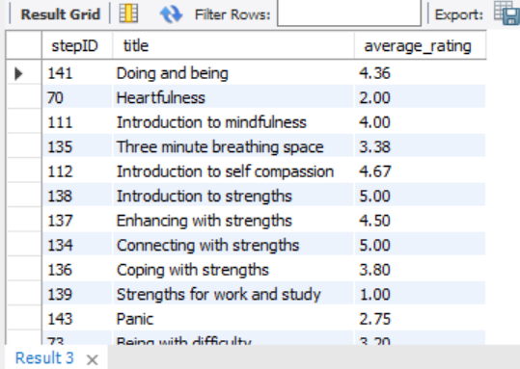

111 rows returned

4. Find the steps that are taken the greatest number of times. Display the ID, title and count of the times the step has been taken. In case of ties, display all the steps with the same number of times taken.

select s.stepID, s.title, count(st.step_id) as count from step_taken st

inner join step s on st.step_id = s.stepID

group by st.step_id

having count =

(select count(*) as count1 from step_taken st2

group by st2.step_id

order by count1 desc limit 1

);

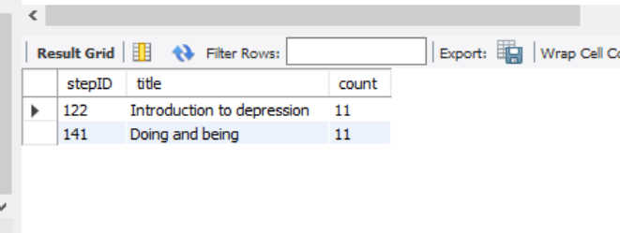

5. Who is the most followed user between age of 15 and 18? Display the age (as an integer), first name, and last name of such user along with the number of followers. (2 marks) Hint: The function TIMESTAMPDIFF can be used to subtract two timestamps. The function CURDATE returns current date.

#q5

select u.first_name, u.last_name, floor(DATEDIFF(curdate(), u.DOB) / 365.25) as age,

count(uf.followed_user_id) as number_of_followers from user_follow uf

inner join user u on uf.followed_user_id = u.userID

group by uf.followed_user_id

having age between 15 and 18

order by number_of_followers desc limit 1;

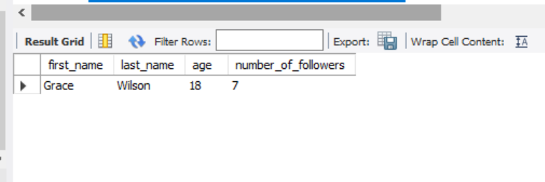

6. Find all steps that are never taken or are taken exactly once? Display the id and title of these steps along with the indication how many times the step has been taken (0 or 1).

#q6

select s.stepID, title, count(st.step_id) as step_taken

from step_taken st right outer join step s on st.step_id = s.stepID

group by s.stepID having step_taken in (0, 1);

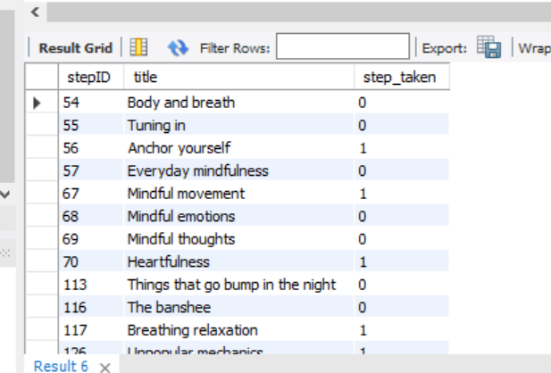

20 rows returned

7. Find users who started taking step ‘Doing and being’ after they had started the step ‘Panic’ but have never completed ‘Panic’. Display the user ID, first name and last name.

#q7

select u.userID, u.first_name, u.last_name

from step_taken st

inner join step s on st.step_id = s.stepID

inner join user u on st.user_id = u.userID

where s.title like 'Doing and being' and st.user_id in

(select st1.user_id from step_taken st1

inner join step s1 on st1.step_id = s1.stepID

where s1.title like 'Panic' and st1.when_finished is null);

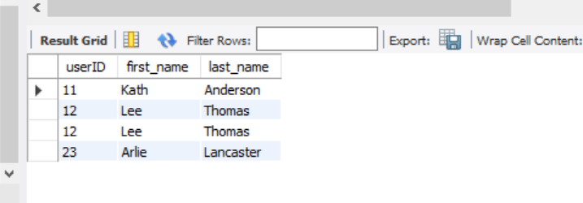

8. What finished steps were completed both by a user with first name "Alice" and a user with first name "Bob"? Display the ID and title of such steps along with the number of times each user has completed these steps.

#q8

select s.stepID, s.title, count(*) as number

from step_taken st

inner join user u on st.user_id = u.userID

inner join step s on st.step_id = s.stepID

where st.when_finished is not null and u.first_name = 'Bob' and step_id in

(select st2.step_id

from step_taken st2

inner join user u1 on st2.user_id = u1.userID

where st2.when_finished is not null and u1.first_name = 'Alice')

group by step_id;

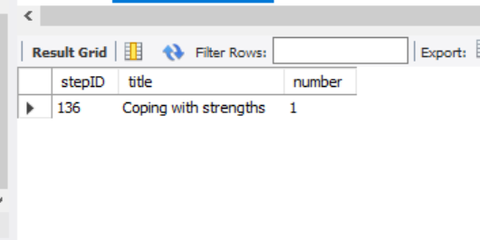

9. Find the top two users with the highest number of interests. For those two users, find out the common steps taken by both of them. Display the titles of the common steps they have taken and the number of times those steps are taken by each user.

#q9

select s.title, count(user_1_step.user_id) as total_steps

from step_taken user_1_step

join step_taken user_2_step on user_1_step.step_id = user_2_step.step_id and user_1_step.user_id != user_2_step.user_id

inner join (select user_id us1 from user_interest ui inner join user u on ui.user_id = u.userID group by

ui.user_id order by count(ui.user_id) desc limit 2) as top_two_users

on user_1_step.user_id = top_two_users.us1 inner join step s on user_1_step.step_id = s.stepID group by user_1_step.step_id;

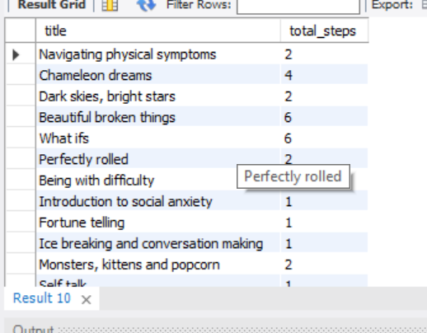

12 rows returned

10. For each user taking a step, calculate how many other users have taken the same step. We are only interested in the cases where the step is performed by at least 5 other users. Display the user ID, number of other users (at least 5 other users) who are taking the same step and the title of the taken step.

#q10

select user_step.user_id, count(others_users.user_id) as number_of_others_users, s.title

from step_taken user_step join step_taken others_users

on user_step.step_id = others_users.step_id and user_step.user_id != others_users.user_id

left outer join step s on user_step.step_id = s.stepID group by user_step.user_id having number_of_others_users >= 5;

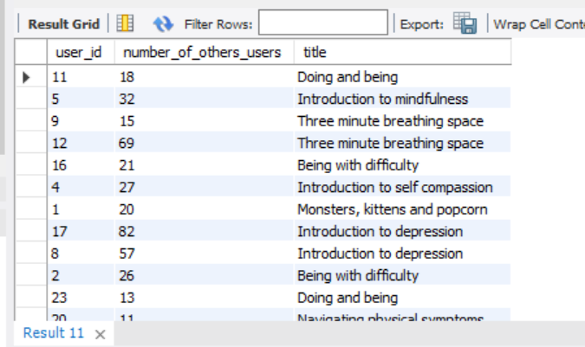

12 rows returned