1. Entered no. of days > 7 **~invalid**

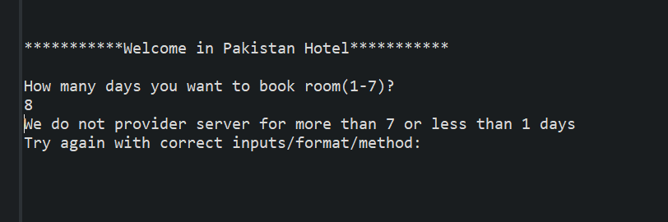

1. Entered no. of days < 1 **~invalid**

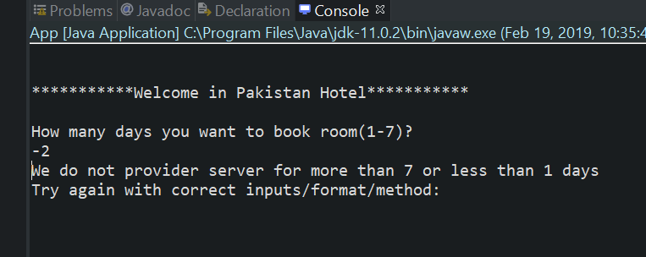

1. Entered no. of days is between 1 and 7 **~valid**

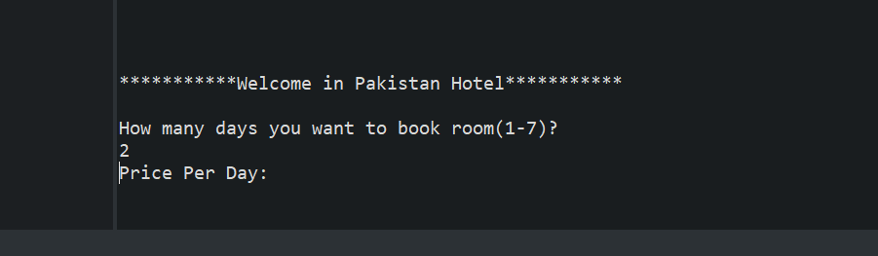

1. Amount proposed is less than 10,000 **~valid**

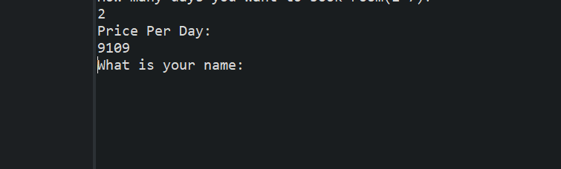

1. Amount proposed is greater than 10,000 and less than 25,000 **~valid**

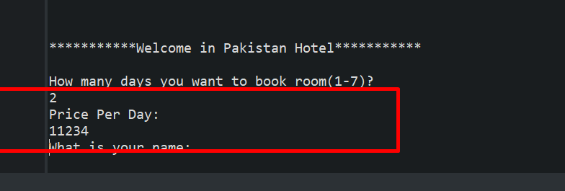

1. Amount proposed is greater 50,000 **~valid**

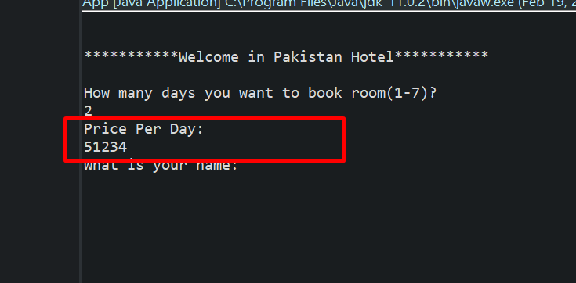

1. Amount proposed is between 25,001 and 49,999 **~invalid**

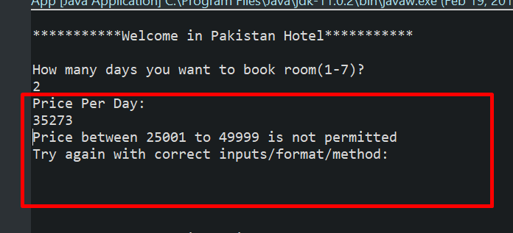

1. Amount proposed is less than or equal to 0 **~invalid**

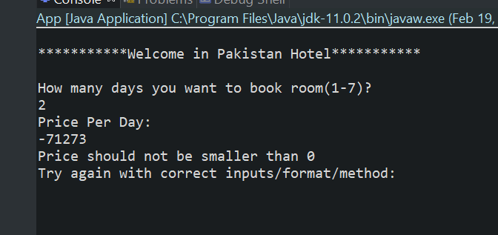

1. Name contains only alphabets **~valid**

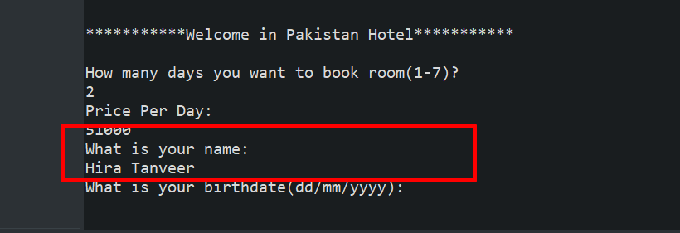

1. Name is alphanumeric **~invalid**

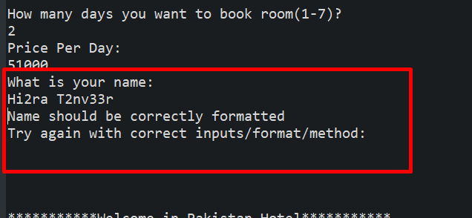

1. Name contains special characters **~invalid**

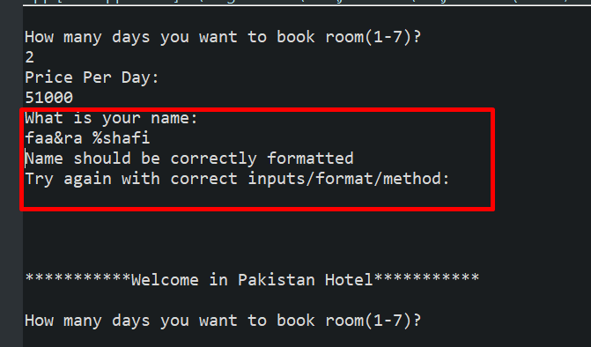

1. Name is in title case **~valid**



1. Name is in lower case **~invalid**

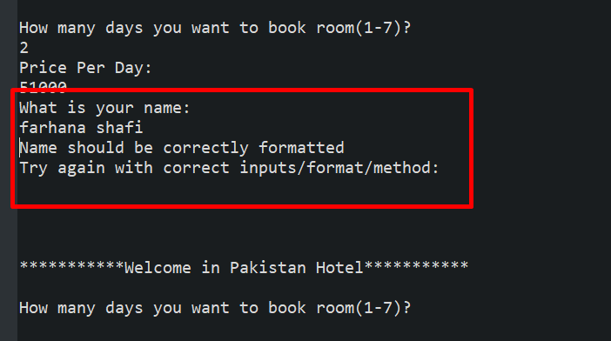

1. Name is in upper case **~invalid**

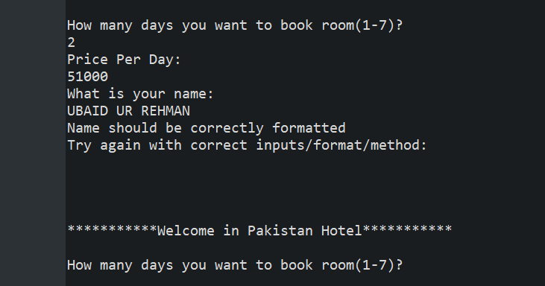

1. Format of date is *dd-mm-yyyy* **~valid**

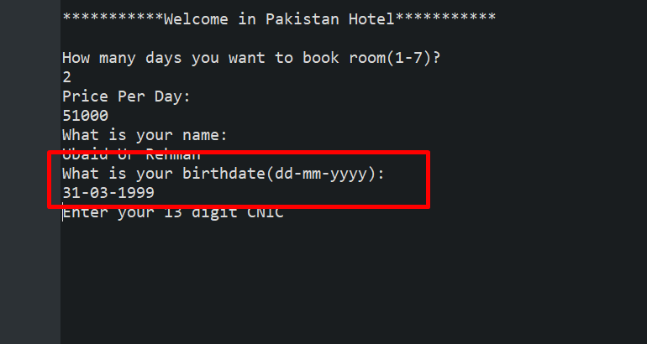

1. Format of date is *mm-dd-yyyy* **~invalid**

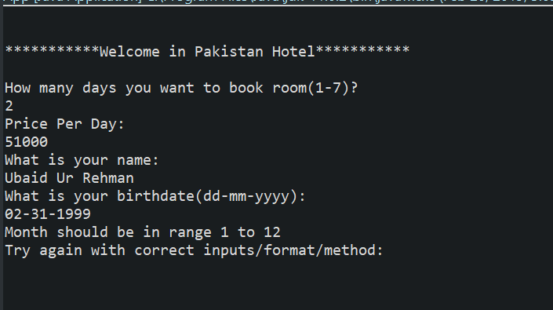

1. Month specified is >12 **~invalid**

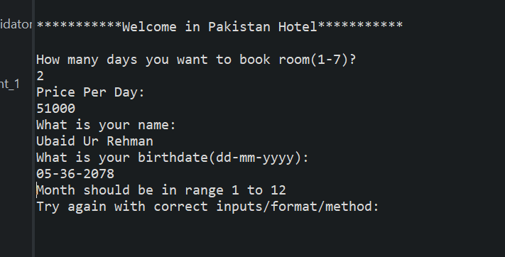

1. Month specified is <1 **~invalid**

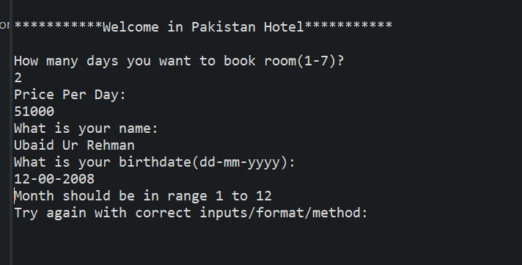

1. Month specified is between 1 and 12 **~valid**



1. Year specified is less than 2000 **~valid**



1. Year specified is greater than 2000 **~invalid**

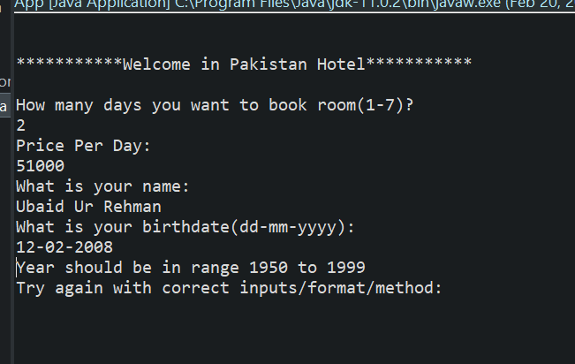

1. CNIC number entered is in integers only **~valid**

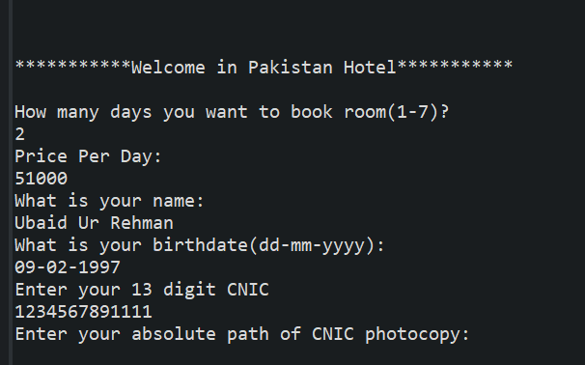

1. CNIC number entered is alphanumeric **~invalid**

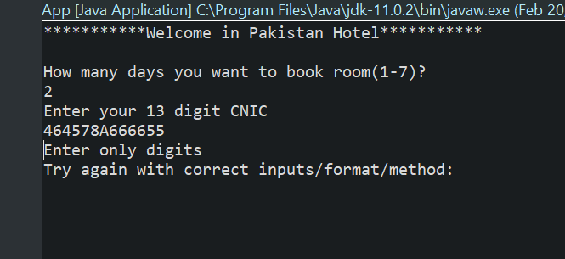

1. CNIC number entered has special characters **~invalid**

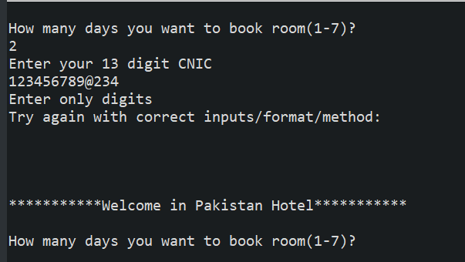

1. Length of CNIC number is greater than 13 **~invalid**

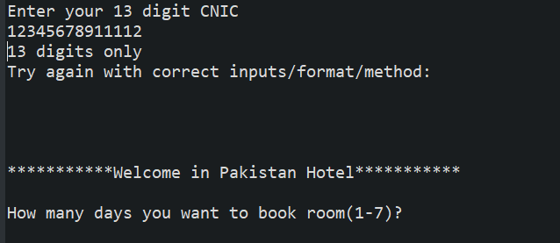

1. Length of CNIC number is less than 13 **~invalid**

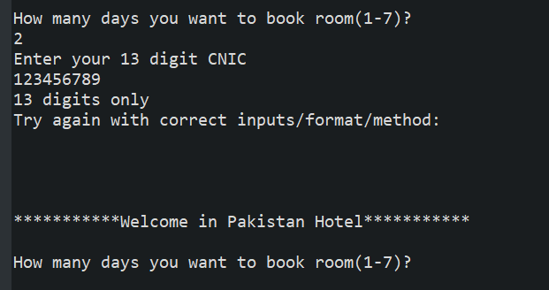

1. Length of CNIC number is exactly 13 **~valid**

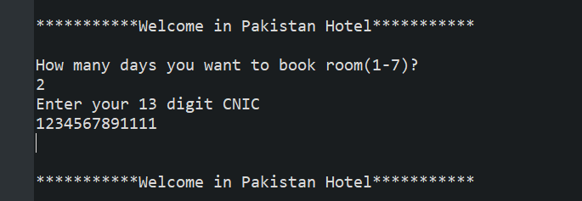

1. File uploaded as CNIC copy is in .jpeg format **~valid**

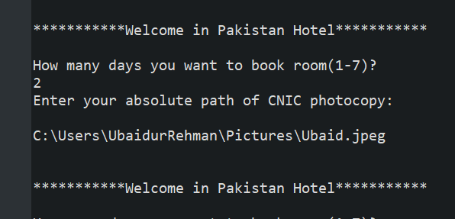

1. File uploaded as CNIC copy is in .png format **~valid**

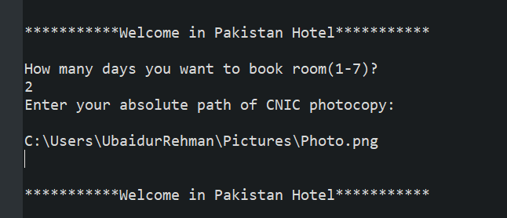

1. File uploaded as CNIC copy is in .pdf or any other format **~invalid**

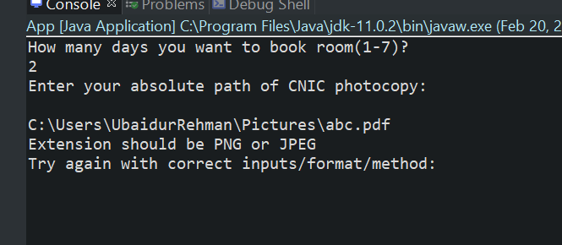

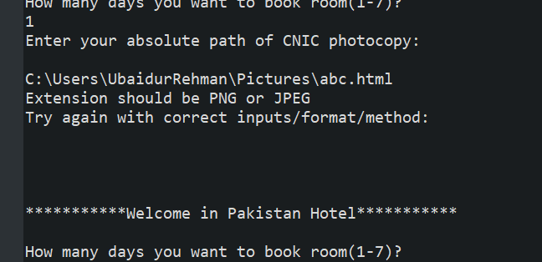

1. Rating entered by user is between 1 and 5 **~valid**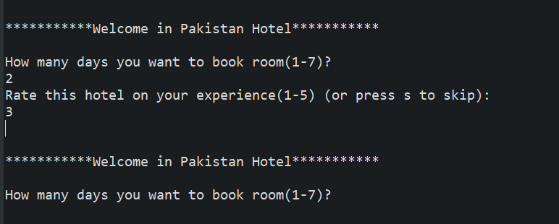
2. Rating entered by user is less than 1 **~invalid**

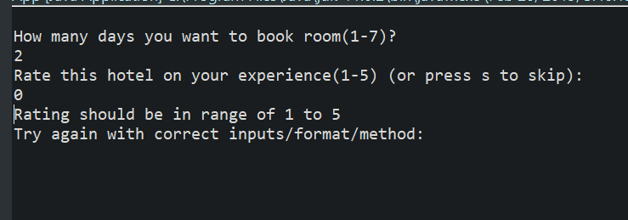

1. Rating entered by user is greater than 5 **~invalid**

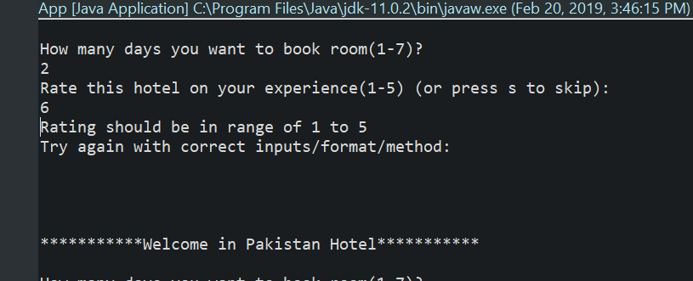

1. Date is 29 for month 02 when it’s a leap year **~valid**

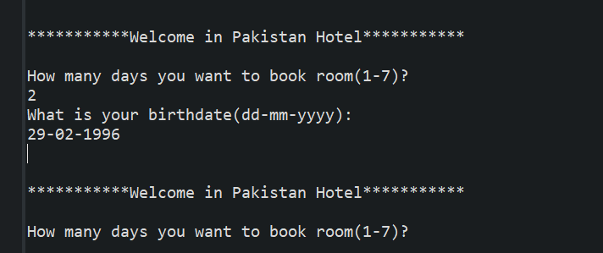

1. Date is greater than 28 for month 02 when it’s not a leap year **~invalid**

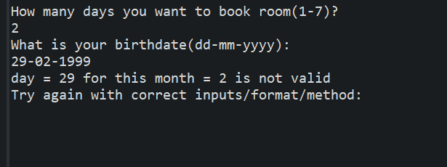

1. Date is greater than 1 and less than 30 for month 02 when it’s a leap year **~valid**

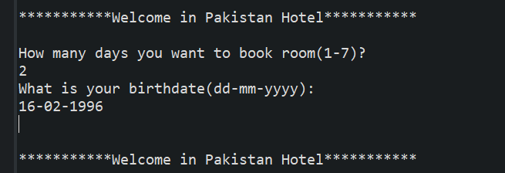

1. Date is greater than 1 and less than 29 for month 02 when it’s not a leap year **~valid**

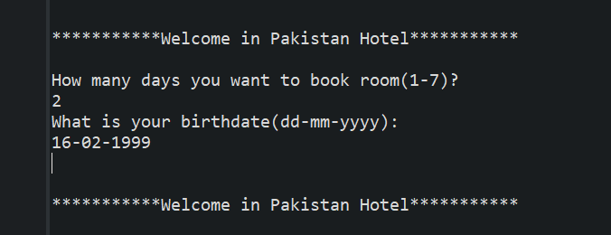

1. Date is greater than 31 for months 01, 03, 05, 07, 08, 10, 12 **~invalid**

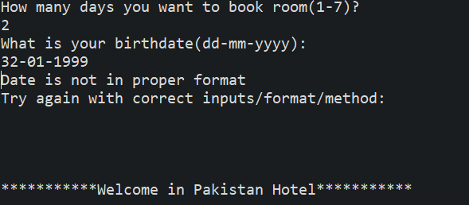

1. Date is greater than 1 and less than 31 for months 01, 03, 05, 07, 08, 10, 12 **~valid**

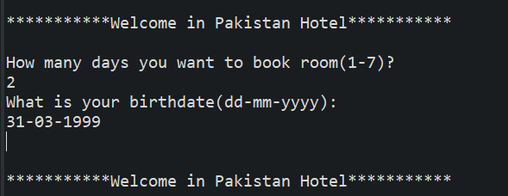

1. Date is greater than 30 for months 04, 06, 09, 11 **~invalid**

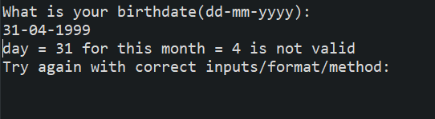

1. Date is greater than 1 and less than 30 for months 04, 06, 09, 11 **~valid**

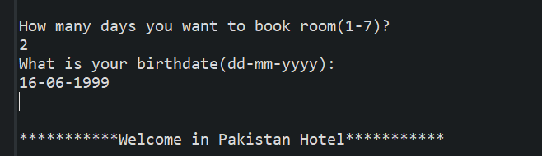

1. Date is less than 1 for any month between 1 and 12 **~invalid**

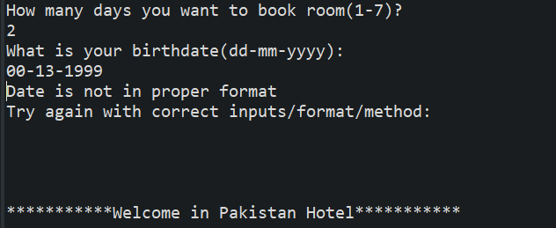

When all output is correct:

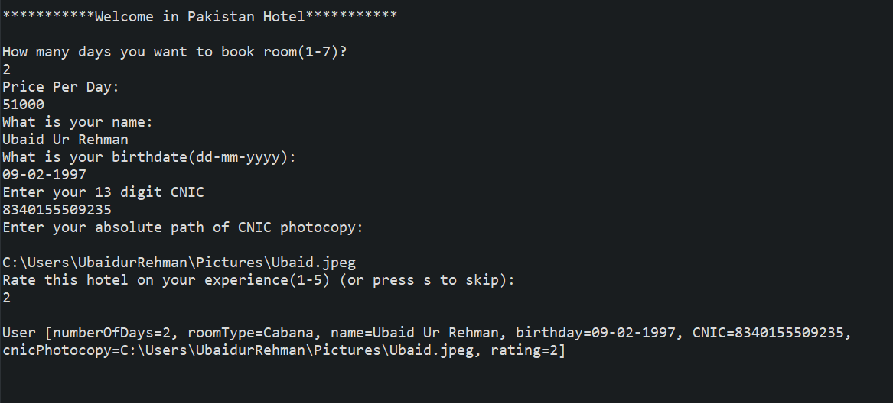

|  |  |  |  |
| --- | --- | --- | --- |
| # | Test Data | Expected Outcome | Classes Covered |
| 1 | 8 | F | 1 |
| 2 | -2 | F | 2 |
| 3 | 2 | T | 3 |
| 4 | 9,109 | T | 4 |
| 5 | 11,234 | T | 5 |
| 6 | 51,234 | T | 6 |
| 7 | 35,273 | F | 7 |
| 8 | -71,273 | F | 8 |
| 9 | Hira Tanveer | T | 9,12 |
| 10 | Hi2ra T2nv33r | F | 10 |
| 11 | faa&ra %shafi | F | 11 |
| 11a | “farhana shafi” | F | 13 |
| 12 | UBAID UR REHMAN | F | 14 |
| 13 | U&BAID UR REHM122AN | F | 10,11,14 |
| 14 | 31-03-1999 | T | 15,19,20,39 |
| 15 | 02-31-1999 | F | 16 |
| 16 | 12-00-2008 | F | 18,21 |
| 16 | 12-02-2008 | F | 21 |
| 17 | 05-36-2078 | F | 17,21 |
| 18 | 1234567891111 | T | 22,27 |
| 19 | 464578A666655 | F | 23 |
| 20 | 123456789@234 | F | 24 |
| 21 | 12345678911112 | F | 25 |
| 21a | 5567864@F67890 | F | 23,24,25 |
| 22 | 563fsh#%gs2 | F | 23,24,26 |
| 22a | 123456789 | F | 26 |
| 23 | Ubaid.jpeg | T | 28 |
| 24 | Photo.png | T | 29 |
| 25 | abc.pdf | F | 30 |
| 26 | abc.html | F | 30 |
| 27 | 3 | T | 31 |
| 28 | 5 | T | 31 |
| 29 | 0 | F | 32 |
| 30 | 6 | F | 33 |
| 31 | 29-02-1996 | T | 16,19,20,34 |
| 32 | 29-02-1999 | F | 35 |
| 33 | 16-02-1999 | T | 16,19,20,37 |
| 34 | 16-02-1996 | T | 16,19,20,36 |
| 35 | 31-04-1889 | F | 40 |
| 36 | 32-01-1999 | F | 38 |
| 37 | 16-06-1999 | T | 16,19,20,41 |
| 38 | 00-12-1999 | F | 42 |
| 39 | 00-13-1999 | F | 17,42 |
| 40 | 31-04-1999 | F | 40 |