HC-05

**-Bluetooth to Serial Port Module**

# Overview

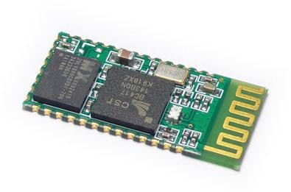

HC-05 module is an easy to use Bluetooth SPP (Serial Port Protocol) module, designed for transparent wireless serial connection setup.

Serial port Bluetooth module is fully qualified Bluetooth V2.0+EDR (Enhanced Data Rate) 3Mbps Modulation with complete 2.4GHz radio transceiver and baseband. It uses CSR Bluecore 04-External single chip Bluetooth system with CMOS technology and with AFH(Adaptive Frequency Hopping Feature). It has the footprint as small as 12.7mmx27mm. Hope it will simplify your overall design/development cycle.

# Specifications

## Hardware features

* Typical -80dBm sensitivity
* Up to +4dBm RF transmit power
* Low Power 1.8V Operation ,1.8 to 3.6V I/O
* PIO control
* UART interface with programmable baud rate
* With integrated antenna
* With edge connector

## Software features

* Default Baud rate: 38400, Data bits:8, Stop bit:1,Parity:No parity, Data control: has. Supported baud rate: 9600,19200,38400,57600,115200,230400,460800.
* Given a rising pulse in PIO0, device will be disconnected.
* Status instruction port PIO1: low-disconnected, high-connected;
* PIO10 and PIO11 can be connected to red and blue led separately. When master and slave are paired, red and blue led blinks 1time/2s in interval, while disconnected only blue led blinks 2times/s.
* Auto-connect to the last device on power as default.
* Permit pairing device to connect as default.
* Auto-pairing PINCODE:”0000” as default
* Auto-reconnect in 30 min when disconnected as a result of beyond the range of connection.

# Hardware

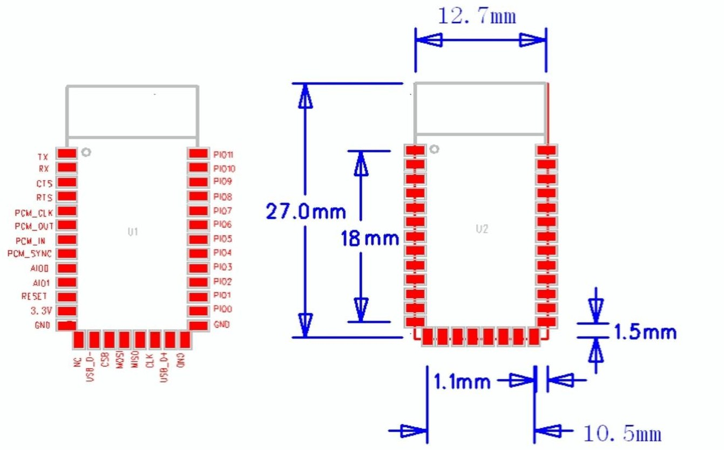

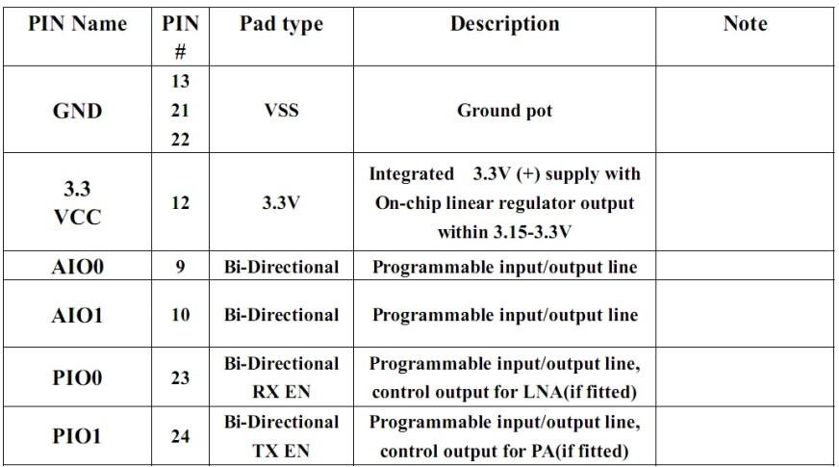

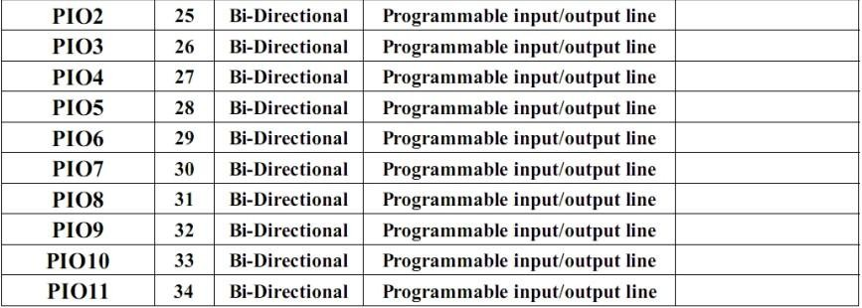

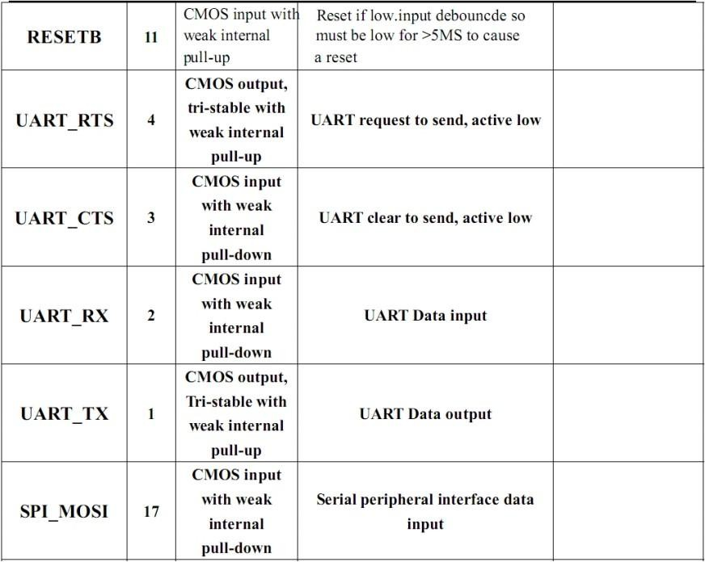

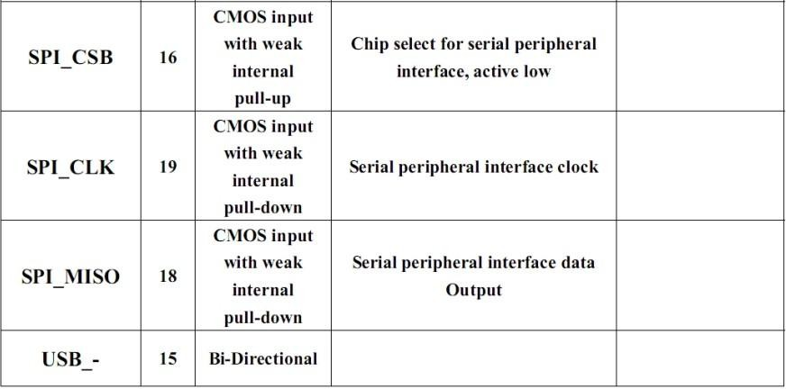

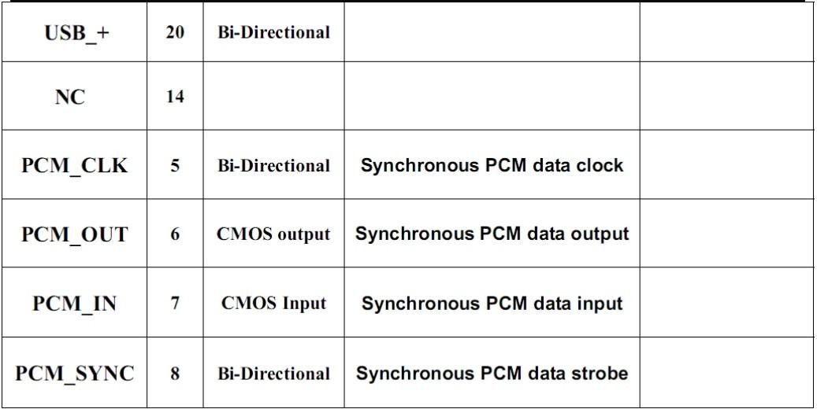

**AT command Default:**

How to set the mode to server (master):

1. Connect PIO11 to high level.
2. Power on, module into command state.
3. Using baud rate 38400, sent the “AT+ROLE=1\r\n” to module, with “OK\r\n” means setting successes.
4. Connect the PIO11 to low level, repower the module, the module work as server (master).

AT commands: (all end with \r\n)

1. Test command:

|  |  |  |
| --- | --- | --- |
| Command | Respond | Parameter |
| AT | OK | - |

1. Reset

|  |  |  |
| --- | --- | --- |
| Command | Respond | Parameter |
| AT+RESET | OK | - |

1. Get firmware version

|  |  |  |
| --- | --- | --- |
| Command | Respond | Parameter |
| AT+VERSION? | +VERSION:<Param>  OK | Param : firmware version |

Example:

AT+VERSION?\r\n

+VERSION:2.0-20100601 OK

1. Restore default

|  |  |  |
| --- | --- | --- |
| Command | Respond | Parameter |
| AT+ORGL | OK | - |

Default state:

Slave mode, pin code :1234, device name: H-C-2010-06-01 ,Baud 38400bits/s.

1. Get module address

|  |  |  |
| --- | --- | --- |
| Command | Respond | Parameter |
| AT+ADDR? | +ADDR:<Param>  OK | Param: address of Bluetooth  module |

Bluetooth address: NAP: UAP : LAP Example:

AT+ADDR?\r\n

+ADDR:1234:56:abcdef OK

1. Set/Check module name:

|  |  |  |
| --- | --- | --- |
| Command | Respond | Parameter |
| AT+NAME=<Param> | OK | Param: Bluetooth module name  (Default :HC-05) |
| AT+NAME? | +NAME:<Param>  OK (/FAIL) |

Example:

AT+NAME=HC-05\r\n set the module name to “HC-05” OK

AT+NAME=ITeadStudio\r\n OK

AT+NAME?\r\n

+NAME: ITeadStudio OK

1. Get the Bluetooth device name:

|  |  |  |
| --- | --- | --- |
| Command | Respond | Parameter |
| AT+RNAME?<Param1> | 1. +NAME:<Param2> OK  2. FAIL | Param1,Param 2 : the address of Bluetooth device |

Example: (Device address 00:02:72:od:22:24，name：ITead) AT+RNAME? 0002，72，od2224\r\n

+RNAME:ITead OK

1. Set/Check module mode:

|  |  |  |
| --- | --- | --- |
| Command | Respond | Parameter |
| AT+ROLE=<Param> | OK | Param:  0- Slave |
| AT+ ROLE? | +ROLE:<Param> |

|  |  |  |
| --- | --- | --- |
|  | OK | 1. Master 2. Slave-Loop |

1. Set/Check device class

|  |  |  |
| --- | --- | --- |
| Command | Respond | Parameter |
| AT+CLASS=<Param> | OK | Param: Device Class |
| AT+ CLASS? | 1. +CLASS:<Param> OK  2. FAIL |

1. Set/Check GIAC (General Inquire Access Code)

|  |  |  |
| --- | --- | --- |
| Command | Respond | Parameter |
| AT+IAC=<Param> | 1. OK 2. FAIL | Param: GIAC (Default : 9e8b33) |
| AT+IAC | +IAC:<Param>  OK |

Example: AT+IAC=9e8b3f\r\n OK

AT+IAC?\r\n

+IAC: 9e8b3f OK

1. Set/Check -- Query access patterns

|  |  |  |
| --- | --- | --- |
| Command | Respond | Parameter |
| AT+INQM=<Param>,<Param2>, | 1.OK | Param: |
| <Param3> | 2. FAIL | 0——inquiry_mode_standard |
| AT+ INQM? | +INQM ： <Param>,<Param2>, | 1——inquiry_mode_rssi |
|  | <Param3> | Param2: Maximum number of |
|  | OK | Bluetooth devices to respond |
|  |  | to |
|  |  | Param3: |
|  |  | Timeout (1-48 : 1.28s to |
|  |  | 61.44s) |

Example: AT+INQM=1,9,48\r\n OK

AT+INQM\r\n

+INQM:1, 9, 48 OK

1. Set/Check PIN code:

|  |  |  |
| --- | --- | --- |
| Command | Respond | Parameter |
| AT+PSWD=<Param> | OK | Param: PIN code (Default 1234) |
| AT+ PSWD? | + PSWD ：<Param>  OK |

1. Set/Check serial parameter:

|  |  |  |
| --- | --- | --- |
| Command | Respond | Parameter |
| AT+UART=<Param>,<Param2>,<  Param3> | OK | Param1: Baud Param2: Stop bit Param3: Parity |
| AT+ UART? | +UART=<Param>,<Param2>,  <Param3> OK |

Example: AT+UART=115200，1,2,\r\n OK

AT+UART?

+UART:115200,1,2 OK

1. Set/Check connect mode:

|  |  |  |
| --- | --- | --- |
| Command | Respond | Parameter |
| AT+CMODE=<Param> | OK | Param: |
| AT+ CMODE? | + CMODE:<Param> | 0 - connect fixed address |
|  | OK | 1 - connect any address |
|  |  | 2 - slave-Loop |

1. Set/Check fixed address:

|  |  |  |
| --- | --- | --- |
| Command | Respond | Parameter |
| AT+BIND=<Param> | OK | Param: Fixed address (Default  00:00:00:00:00:00) |
| AT+ BIND? | + BIND:<Param>  OK |

Example: AT+BIND=1234，56，abcdef\r\n OK

AT+BIND?\r\n

+BIND:1234:56:abcdef OK

1. Set/Check LED I/O

|  |  |  |
| --- | --- | --- |
| Command | Respond | Parameter |
| AT+POLAR=<Param1,<Param2> | OK | Param1:   1. PIO8 low drive LED 2. PIO8 high drive LED |
| AT+ POLAR? | + POLAR=<Param1>,<Param2>  OK |

|  |  |  |
| --- | --- | --- |
|  |  | Param2:   1. PIO9 low drive LED 2. PIO9 high drive LED |

1. Set PIO output

|  |  |  |
| --- | --- | --- |
| Command | Respond | Parameter |
| AT+PIO=<Param1>,<Param2> | OK | Param1: PIO number Param2: PIO level   1. low 2. high |

Example:

1. PIO10 output high level AT+PI0=10，1\r\n

OK

1. Set/Check – scan parameter

|  |  |  |
| --- | --- | --- |
| Command | Respond | Parameter |
| AT+IPSCAN=<Param1>,<Param2  >,<Param3>,<Param4> | OK | Param1: Query time interval  Param2：Query duration  Param3：Paging interval  Param4：Call duration |
| AT+IPSCAN? | +IPSCAN:<Param1>,<Param2>,<P  aram3>,<Param4> OK |

Example:

AT+IPSCAN =1234,500,1200,250\r\n OK

AT+IPSCAN?

+IPSCAN:1234,500,1200,250

1. Set/Check – SHIFF parameter

|  |  |  |
| --- | --- | --- |
| Command | Respond | Parameter |
| AT+SNIFF=<Param1>,<Param2>, | OK | Param1: Max time |
| <Param3>,<Param4> |  | Param2: Min time |
| AT+ SNIFF? | +SNIFF:<Param1>,<Param2>,<Par | Param3: Retry time |
|  | am3>,<Param4> | Param4: Time out |
|  | OK |  |

1. Set/Check security mode

|  |  |  |
| --- | --- | --- |
| Command | Respond | Parameter |
| AT+SENM=<Param1>,<Param2> | 1. OK 2. FAIL | Param1: 0——sec_mode0+off  1——sec_mode1+non_se |
| AT+ SENM? | + SENM:<Param1>,<Param2> |

|  |  |  |
| --- | --- | --- |
|  | OK | cure 2——sec_mode2_service 3——sec_mode3_link 4——sec_mode_unknow n  Param2: 0——hci_enc_mode_off 1——hci_enc_mode_pt_t o_pt 2——hci_enc_mode_pt_t  o_pt_and_bcast |

1. Delete Authenticated Device

|  |  |  |
| --- | --- | --- |
| Command | Respond | Parameter |
| AT+PMSAD=<Param> | OK | Param:  Authenticated Device Address |

Example:

AT+PMSAD =1234,56,abcdef\r\n OK

1. Delete All Authenticated Device

|  |  |  |
| --- | --- | --- |
| Command | Respond | Parameter |
| AT+ RMAAD | OK | - |

1. Search Authenticated Device

|  |  |  |
| --- | --- | --- |
| Command | Respond | Parameter |
| AT+FSAD=<Param> | 1. OK 2. FAIL | Param: Device address |

1. Get Authenticated Device Count

|  |  |  |
| --- | --- | --- |
| Command | Respond | Parameter |
| AT+ADCN? | +ADCN：<Param>  OK | Param: Device Count |

1. Most Recently Used Authenticated Device

|  |  |  |
| --- | --- | --- |
| Command | Respond | Parameter |
| AT+MRAD? | + MRAD：<Param>  OK | Param: Recently  Authenticated Device Address |

1. Get the module working state

|  |  |  |
| --- | --- | --- |
| Command | Respond | Parameter |

|  |  |  |
| --- | --- | --- |
| AT+ STATE? | + STATE：<Param>  OK | Param: “INITIALIZED” “READY” “PAIRABLE” “PAIRED” “INQUIRING” “CONNECTING” “CONNECTED” “DISCONNECTED”  “NUKNOW” |

1. Initialize the SPP profile lib

|  |  |  |
| --- | --- | --- |
| Command | Respond | Parameter |
| AT+INIT | 1. OK 2. FAIL | - |

1. Inquiry Bluetooth Device

|  |  |  |
| --- | --- | --- |
| Command | Respond | Parameter |
| AT+INQ | +INQ: <Param1> ， <Param2> ，  <Param3>  …. OK | Param1：Address Param2：Device Class Param3 ： RSSI Signal  strength |

Example:

AT+INIT\r\n OK

AT+IAC=9e8b33\r\n OK

AT+CLASS=0\r\n AT+INQM=1,9,48\r\n

At+INQ\r\n

+INQ:2:72:D2224,3E0104,FFBC

+INQ:1234:56:0,1F1F,FFC1

+INQ:1234:56:0,1F1F,FFC0

+INQ:1234:56:0,1F1F,FFC1

+INQ:2:72:D2224,3F0104,FFAD

+INQ:1234:56:0,1F1F,FFBE

+INQ:1234:56:0,1F1F,FFC2

+INQ:1234:56:0,1F1F,FFBE

+INQ:2:72:D2224,3F0104,FFBC OK

1. Cancel Inquiring Bluetooth Device

|  |  |  |
| --- | --- | --- |
| Command | Respond | Parameter |
| AT+ INQC | OK | - |

1. Equipment Matching

|  |  |  |
| --- | --- | --- |
| Command | Respond | Parameter |
| AT+PAIR=<Param1>,<Param2> | 1. OK 2. FAIL | Param1：Device Address  Param2：Time out |

1. Connect Device

|  |  |  |
| --- | --- | --- |
| Command | Respond | Parameter |
| AT+LINK=<Param> | 1. OK 2. FAIL | Param：Device Address |

Example: AT+FSAD=1234,56,abcdef\r\n OK

AT+LINK=1234,56,abcdef\r\n OK

1. Disconnect

|  |  |  |
| --- | --- | --- |
| Command | Respond | Parameter |
| AT+DISC | 1. +DISC:SUCCESS OK 2. +DISC:LINK_LOSS OK 3. +DISC:NO_SLC OK 4. +DISC:TIMEOUT OK 5. +DISC:ERROR   OK | Param：Device Address |

1. Energy-saving mode

|  |  |  |
| --- | --- | --- |
| Command | Respond | Parameter |
| AT+ENSNIFF=<Param> | OK | Param：Device Address |

1. Exerts Energy-saving mode

|  |  |  |
| --- | --- | --- |
| Command | Respond | Parameter |
| AT+ EXSNIFF =<Param> | OK | Param：Device Address |

**Revision History**

|  |  |  |
| --- | --- | --- |
| Rev. | Description | Release date |
| v1.0 | Initial version | 7/18/2010 |
|  |  |  |
|  |  |  |