* gphoto2

<https://mlagerberg.gitbooks.io/raspberry-pi/content/4.6-gphoto2.html>

(debug)

20

It turned out that that in fact there was gvfs-gphoto2-volume-monitor process in the background.

Run ps aux | grep gphoto, which might have output like:

peter 25802 2.1 0.1 302504 8736 ? Ssl 13:10 0:00 /usr/lib/gvfs/gvfs-gphoto2-volume-monitor  
peter 25814 2.2 0.1 441508 11176 ? Sl 13:10 0:00 /usr/lib/gvfs/gvfsd-gphoto2 --spawner :1.3 /org/gtk/gvfs/exec_spaw/21  
peter 25835 0.0 0.0 22676 1096 pts/0 S+ 13:10 0:00 grep --color=auto gphoto

First colums is PID (process id), kill them:

kill -9 25802 – volume-monitor  
kill -9 25814 – spaw/6

**Will have to find a way to avoid these processes to start altogether and**

**Will have to find way for camera to stay ON (turns off at low power)**

<https://stackoverflow.com/questions/53347759/importerror-libcblas-so-3-cannot-open-shared-object-file-no-such-file-or-dire>

Now gphoto2 can now connect to camera.

<https://pypi.org/project/gphoto2/0.8.0/>

<https://github.com/jim-easterbrook/python-gphoto2>

<https://github.com/jim-easterbrook/python-gphoto2/blob/master/examples/capture-image.py>

[Linux-DSLR-TimeLapse/DSLR_TimeLapse.py at master · IronSenior/Linux-DSLR-TimeLapse · GitHub](https://github.com/IronSenior/Linux-DSLR-TimeLapse/blob/master/DSLR_TimeLapse.py)

* Lets get OpenCv taking pictures

<https://www.linuxtut.com/en/eda129635816ad871e9d/>

<https://stackoverflow.com/questions/48049886/how-to-correctly-check-if-a-camera-is-available>

<https://sparkle-mdm.medium.com/use-a-digital-camera-in-opencv-instead-of-webcam-d8445898e6c8>

Camera – GPS

<https://mavlink.io/en/messages/common.html#RTK_BASELINE_COORDINATE_SYSTEM>

Kill processs code and connect cam trigger to rPi

[Raspberry Pi Tutorial 41: Control a DSLR with your Pi!](https://www.youtube.com/watch?v=1eAYxnSU2aw)

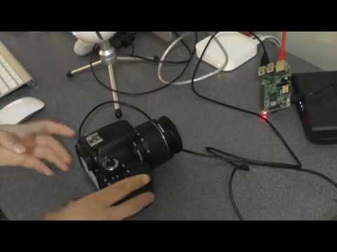

perspective – size- distance calculation. <https://pyimagesearch.com/2017/09/18/real-time-object-detection-with-deep-learning-and-opencv/>

<https://www.e-education.psu.edu/natureofgeoinfo/c2_p5.html> calculate scale of “air” photo

28gig / 24 meg = 1166

61gig/ 24 meg = 2541

120gig/ 24 meg = 5000

5 heures 11-4am

60 minutes

Pic aux 3 secondes = 6000 par nuit = 2.5m

Pic aux 4 secondes = 4500 par nuit =

3.3m

Pic aux 5 secondes = 3600 par nuit

5m

+- 3 km hr

3000 m / 60 min : 50 m / min

Dépendent du ratio distance /cover : combien m couvre une photo a 2m, 5m,etc