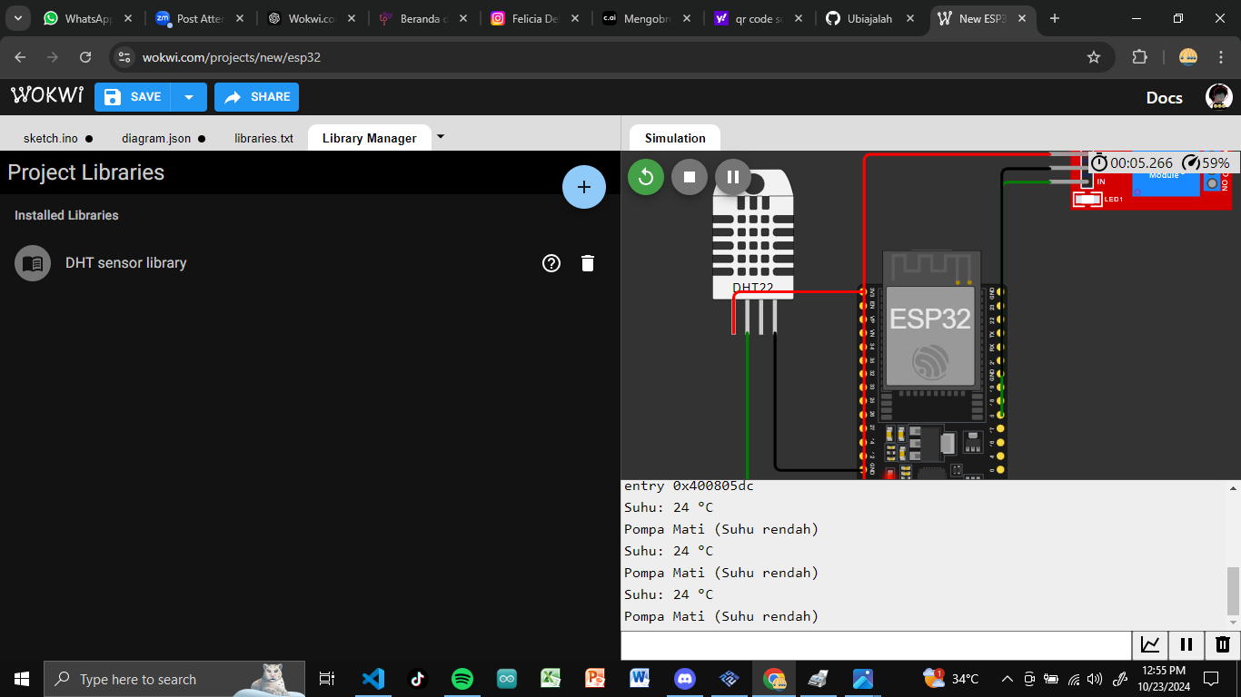

EXPLAIN : FOR DHT22 : VCC DHT22 TO 3.3V ESP

GND DHT22 TO GND (1,2,3) ESP32

SDA DHT22 TO GIOPIN 15 ESP32

FOR RELAY MODULE: VCC RELAY TO 5V ESP32

GND RELAY MODULE TO GND ESP32

IN RELAY MODUL TO GIOPIN 5 ESP32