Dreaming of Rosie
(When will we get a ‘personal ‘household robot?)

(Alan N. Federman)

As a baby boomer growing up in the sixties, one of my favorite Saturday morning cartoons was the “Jetsons.” Often, Mr. George Jetson would be served by his robot ‘Rosie,’ as he headed off to work in his flying car. Right now it looks like I’ll ride in flying car a lot sooner than I’ll be able to own a commercially developed personal home robot. I was thinking about this, and wondering when can we expect a ‘Rosie’ to serve us our morning coffee?

Stanford University HAI recently released a list of 100 sophisticated tasks desired in a ‘domestic’ robot. Some of these require a degree of sophistication and capability (emptying a dishwasher, sorting silverware and placing it in a drawer). Some of these tasks won’t be accomplished for years if not decades. A more gradual approach is to start at easier tasks and then work up to more complex behaviors. This is what the DARPA challenge did for autonomous vehicles and now for rescue robots. Similar challenges are done by other groups like NASA, Willow Garage, and Microsoft have led to advances in robotics. Even the hobbyist group I’ve been a member of, the Homebrew Robotics Club, has challenged members to improve their skills and capabilities by incremental tasks.

AI - Northstar Article

Activity list:

Let’s consider what it would take for a robot to do a typical household maintenance task: Picking up clothes tossed around the house and putting them in the washer. This is something we easily could delegate to a 5 year old child. ‘Rosie’ would certainly be able to do this, but is perhaps overqualified.



(Figure for Rosie – not sure if digital image rights apply)

From the picture, we see Rosie is fairly complicated. Mobility is like a unicycle, so stairs are out. “She” has two arms, but the grippers look unable to manipulate small items or push buttons. There is an accessory port for tools like the vacuum cleaner attachment. There is vision, speech and ‘radio’ communication. It looks like Rosie has social awareness and can communicate both verbally and with visual queues. All in all a very impressive list of features.

So, what would be needed for a more simple household robot, capable of being trained to pick up clothes off the floor and putting them in the washer? My nickname for such a platform is a GPHR – General Purpose Household Robot (pronounced ‘gopher’)

Mobility - the ability to move around the house (Single floor – no stairs)
Navigation - know the location of the rooms in the house to search for out-of-place items
Vision - identify clothes, distinguish between clothes and items that stay put like rugs and shoes,
also deal with obstacles like coffee tables, any movable items like people, pets (You’d want to
avoid putting the kitten, shoes or throw pillows in the washer.)
Manipulation – picking up and placing items
General AI - path planning, sequencing, etc.
Reasonable Cost - affordable so could be widely adapted and popular

While it currently is just possible to build a robot that could accomplish this now – an example would be the Willow Garage PR2 or Toyota Research Institute HSR, these platforms are research only and cost upwards of $200K – so we would need 2 orders of magnitude cost reductions to be profitable. Let’s consider the current state of the art, and evaluate some of the reasons Rosie won’t arrive for several years. We need to consider how we would develop an MVP – minimally viable product that actuall serves a useful purpose or purposes. Once ‘our foot is in the door,’ development of more complicated behaviors can commence.

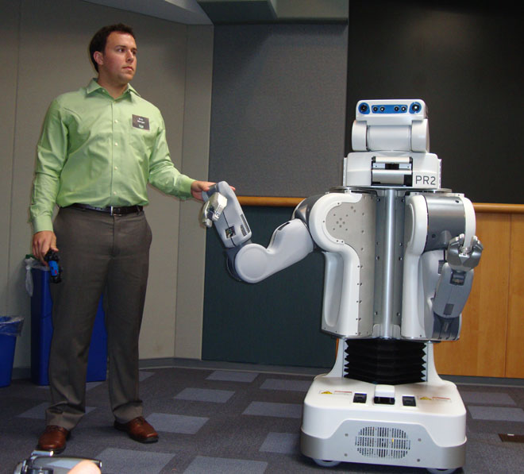

(Willow Garage PR2 - general purpose ‘humanoid” >$200,000 research platform)

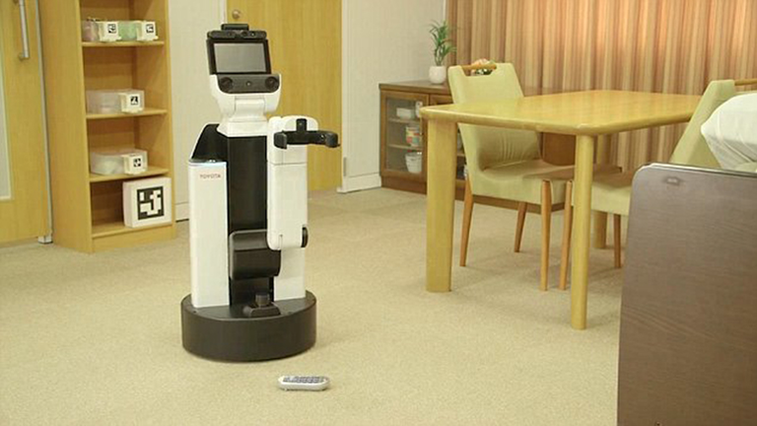
(Toyota Research Institute HSR – research platform)

Mobility - There have been major advances in motor, battery and sensor control that have advanced robot mobility. Brush Less Hub Motors(BLM) weigh less are more compact and because of the way they are controlled, allow odometry (wheel position) determination. Likewise, Lithium Ion Batteries are lighter and perform better than heavier Lead-Acid or NiCad. Most household robot tasks would require a relatively inexpensive differential drive mobility platform, consisting of two BLM motors (similar to hover boards). Currently it costs about $500 to build such a platform. Here is one area where the current state of the art is adequate and will continue to improve.

Vision - Likewise, there have been major advances in robot vision. Depth Cameras like the Asus Xtion and Intel Realsense, and open source software like OpenCV and Yolo combined with faster processing based on GPU acceleration allow the identification of people and objects. However in some ways, the technology is not fully mature. As an example a robot will ‘see’ a portrait of a person or an image of a person on TV and ‘assume’ it is a live person who is stationary. Another example is to see a stuffed toy dog and not ‘know’ if it is more like a toy teddy bear or real dog.

Manipulation - Designing a robot manipulator and gripper that is both capable of picking up a sock tossed on the floor and the ability to open a closed door is pretty challenging. While there are industrial robot arms capable of both course and fine manipulation, these aren’t affordable at present. While it might be possible to have a door opener or a pick-up from the floor manipulator, both capabilities simultaneously would be problematical. A potential work around would be something like the ‘Snap on’ tools concept, where the robot could attach a different accessory from its charging station. Just the capability to open the various doors and cabinets in a typical kitchen is remarkable – I once counted over 20 kinds of different knobs and dials to manipulate in just my kitchen alone. This is the one area in which I am uncertain how long the development will take. Currently, robot arms and grippers alone cost more than $2000.

Navigation and General AI - Lot of progress is being made here in both the cost of sensors and CPUs. These include laser ranging, sonars, and IMUs. ARM based processors, including ARM64 based offerings like the Raspberry Pi 4 and Nvidia Jetson Nano offer low cost, low power consumption and in some cases GPU acceleration. This makes many tasks, previously only available on desk sized computers, work on a consumer sized robot. I recently favorably reviewed a LD06 time of flight Lidar that retailed under $150 US. Speed and connectivity of computing continue to increase. Onboard and cloud based services for speech recognition and generation, visual perception and general AI will continue to improve. These platforms and the software that runs on them is an area that will continue to see the most progress, and since a lot of development is open source, relatively inexpensive to implement.

Currently developing a robot that could find and locate out of place items on the floor and perhaps place or sort them into bins is feasible, but probably not affordable. To my mind these are the stages or milestones needed to get to Rosie. I often think in terms of mnemonics, here is a version of an old nursery rhyme:

One, two, pickup the shoes;
Three, four, open drawers and doors;
Five, six, Pick up sticks;
Seven, eight, go out the gate;
Nine, ten, often and again.

Challenge level one - a robot with the ability to move around the home, picking up items and bringing them to a desired location.

Challenge level two – add a manipulator that can open closed doors and have enough mobility and reach to be able to place items on a counter.

Challenge level three – add enough dexterity to be able to manipulate items as small as silverware, fetch something from refrigerator.

Challenge level four – the ability to go outside, get the mail, take out the trash, foil porch pirates.

Challenge level five – social interaction and voice programming – the ability to request novel behaviors simply by vocal commands. So “Get me a cold beer from the bottom shelf and bring it to me in the shed” is understood and accomplished,

About the author:

Alan Federman is a retired scientist and engineer who has worked both at NASA and Stanford University’s AI Lab in robotics education and development.

