Moving the Robot with the Robot Commander App

You can control your robot with an App called Robot Commander. This app for Android devices can be obtained from the Play Store or the following URL: (*******).

Your robot needs to have the following installed and running on your robot:

if you don’t have it installed, install tf2-web-republisher and rosbridge.

Depending on what you want the robot to do as a minimum:

roslaunch magni-bringup base.launch >/dev/null 2>&1 &
rosrun move-basic move-basic &

roslaunch rosbridge_server rosbridge_websocket.launch >/dev/null 2>&1 &
rosrun tf2_web_republisher tf2_web_republisher

(if you are running fiducials they need to be launched as well.

With this running on the robot, launch the app

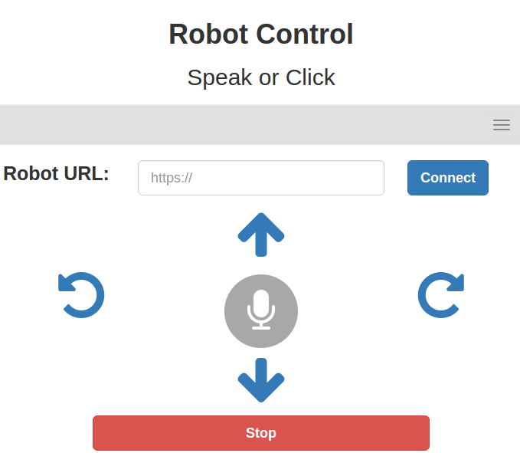

One the app starts, you need to give the robots IP address, for example:

wss://10.52.5.23:9090 and then press the connect button. If things work the button should cange to connected and the phone should say “connected” younthan can use the arrow keys, or tap the microphone for speech commands. Try saying ‘help’ to get the list of voice commands.

