**PRD TEMPLATE**

**Project/App Title:**

Pigeonhole

**Project/App Summary:**Manager application for storing data about their team members.

**Definition:**   
Pigeonhole - A small compartment, open at the front and forming part of a set, where letters or messages may be left for individuals.

In most business settings, you have a manager that manages a group of employees. A lot of these businesses use many different tools but wish upon one application that can do it all for them. While I probably won’t be able to cover it all in this class, I can sure start simple.   
  
This application will be based on how Target sets up their employees and a request for this application is coming first hand from a manager of Target department stores.  
  
The application should be able to send notifications to the manager’s team members; they should be able to edit their member’s information, just an overall place where managers can manage.

**Twist:**

As someone who knows a lot of people who run businesses (big and small), they all seem to face similar problems. The biggest problem would be that they have a hard time managing all of their tools and it just becomes stressful. So as a developer, I often hear from these people that I should make someone where they can manage all of their services in one place.

**Week 1 features:**

PRD Template & Site Design  
  
**Week 2 Features:**  
Login for Managers to change details for their team member’s  
jQuery Plugins and form validations  
  
**Week 3 Features:**

Settings screen for team members  
Attendance Scoring

**Week 4 Features:**

Survey Scores  
jQuery Animations



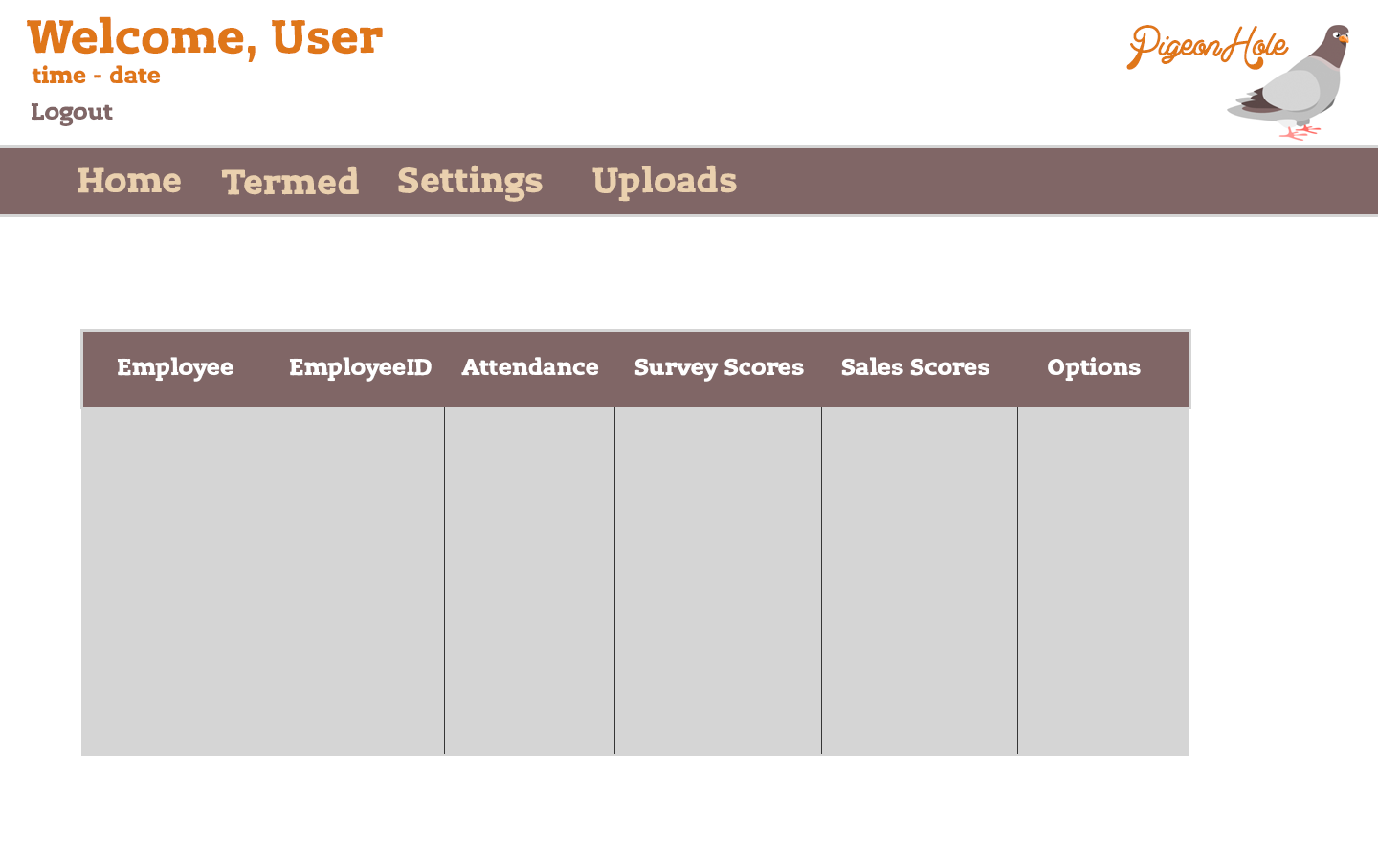

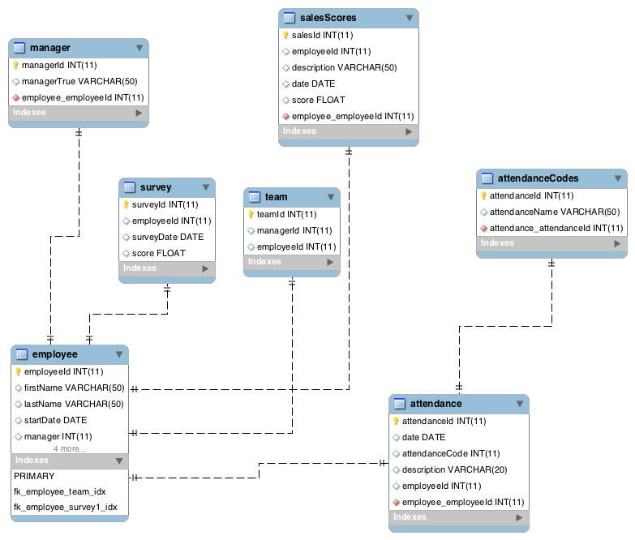

**Language and framework:**

I’m going to be using CodeIgniter and using both its internal code helpers, but additional code using PHP’s prepared statements.

**Version one:**

At the end of the 4 weeks, managers should be able to login and set profile data information for their team members. Possibly even an extra feature like attendance record. jQuery animations and plugins will be used to do different things like sorting and display settings.

**Version two:**

I would continue with what is required by implementing a scores system for each sales member. I would probably also add a few for these members to login and check their data, but for now no login for members will be given (only managers).