Instructions

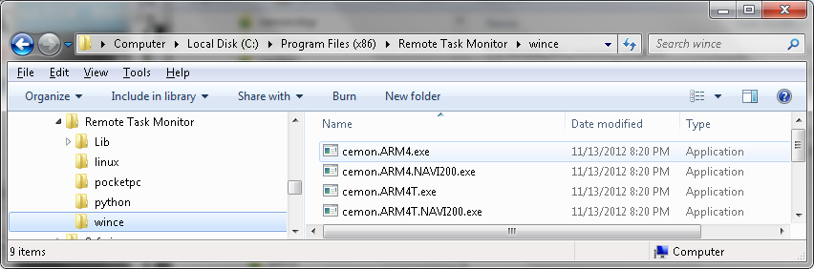
- Copy the appropriate cemon.*.exe file to your device.
Your cemon.*.exe files are located in the wince directory of your installation.
- Run the cemon program on the device.
- Make sure you have Ethernet or WiFi connection between your device and a Windows PC. Both should be on the same network.
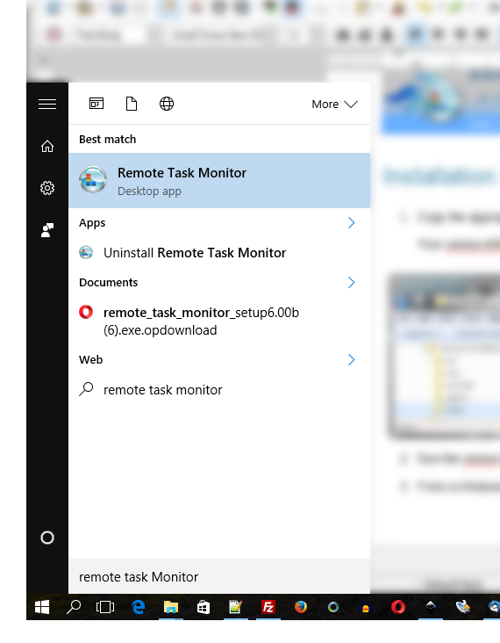
- From the Windows PC, run Remote Task Monitor:
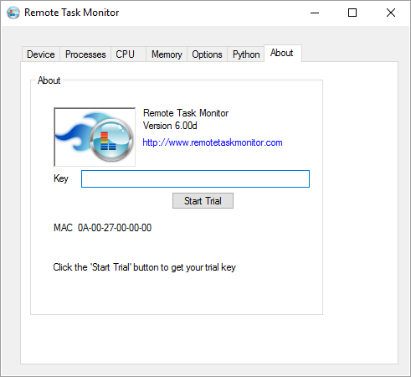
- Copy-Paste your license key or trial key in the “Key” box:
- Click on the “Device” tab and wait a couple of seconds for a connection to establish with the device.
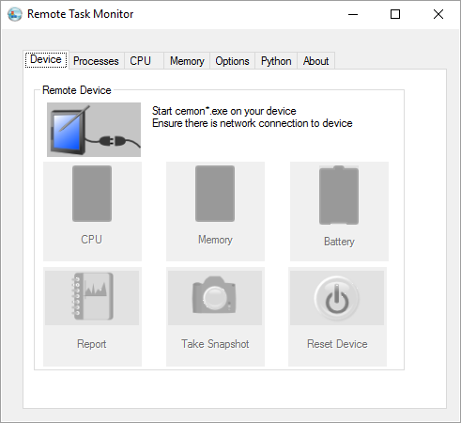
- After connection is successful:
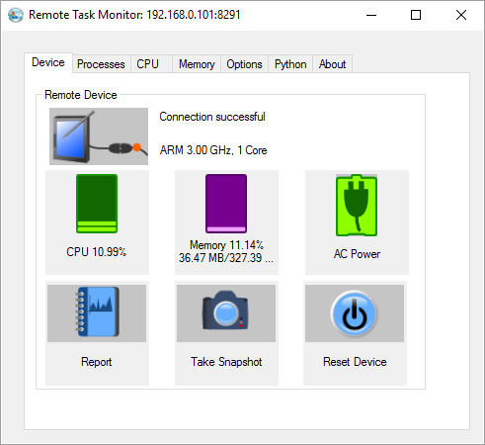
- If connection does not establish, make sure your device and the Windows PC are on the same network. Can you:
Ping the IP of the device from the PC?
Ping the IP of the PC from the device?
If you still need help, contact us at support@osletek.com.

