**MANUAL:**

**R Shiny App for Iteratively Adjusted Surrogate Variable Analysis (IA-SVA)**

**Author: Nathan Lawlor**

**Contact:** [**Nathan.lawlor03@gmail.com**](mailto:Nathan.lawlor03@gmail.com)

**Other Resources:**

**Manuscript on bioRxiv:** [**https://www.biorxiv.org/content/early/2017/06/18/151217**](https://www.biorxiv.org/content/early/2017/06/18/151217)

**Bioconductor package (iasva):** [**https://www.bioconductor.org/packages/devel/bioc/html/iasva.html**](https://www.bioconductor.org/packages/devel/bioc/html/iasva.html)

**Interactive Tutorial**

**Quick Start Guide:**

1. **Load Data**
2. **Data Preprocessing**
3. **Specify Known Factors to Adjust For**
4. **IA-SVA Analysis**
5. **Data/QC**
6. **Surrogate Variables**
7. **Pairwise Surrogate Variable**
8. **Identify Marker Genes**
9. **Marker Genes Table**
10. **Gene Enrichment Analysis**
11. **Gene Enrichment Analysis Table**
12. **Dimension Reduction and Visualization**

**Interactive Tutorial**

In addition to this manual, you can choose to have an interactive tutorial of this app by launching the app and clicking this button near the top left of your webpage:



Upon clicking this button, the tutorial should begin and you should see this:

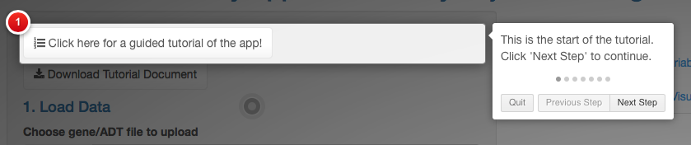

Navigate through this tutorial using the “Next Step” and “Previous Step” buttons. To exit out of this tutorial, click the “Quit” button or anywhere outside of the white boxes.

1. **Load Data**

In the first section of the app, the user must provide 2 input files:

1. A file containing gene expression/ADT level data, typically in matrix format. The matrix should be formatted so that rows represent the genes/markers and the columns represent the samples. For information about the exact file format of the expression data, please see the example data provided (information about downloading below).
2. A file containing sample metadata, typically in matrix format. The matrix should be formatted so that each row represents a sample and the columns represent different metadata variables (e.g., age, gender, disease state, etc.). For information about the exact file format of the sample metadata, please see the example data provided (information about downloading below).

For convenience, an example gene expression and sample metadata set (human peripheral blood mononuclear cells (PBMCs) from Kang et al. 2017: <https://www.nature.com/articles/nbt.4042>) are provided and are available for download by clicking the two buttons near the top left corner of the app:

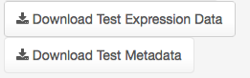

These two example files are .csv files and may be uploaded in the next steps to test out the app.

Users may upload their own expression and metadata files (or the downloaded test files) by clicking the “Browse” buttons pictured below:

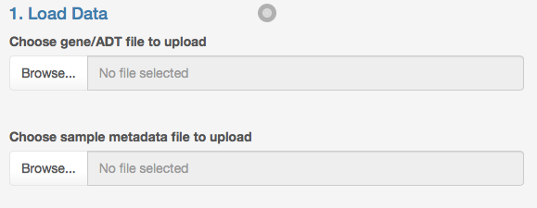

Input files must be in the format of either: .Rds, tab-delimited text, or .csv. Currently, the maximum size for input files is 2GB.

Upon successful loading of your input files, the user interface should look like this:

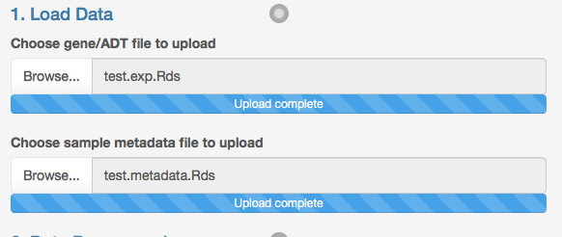

1. **Data Preprocessing**

After providing input files, the users have the choice of further pre-processing their data. Specifically, there is a step to remove lowly expressed/detected genes from the input matrix. By default, the app is set to keep genes with 5 or more read counts in 5 or more different cells/samples.

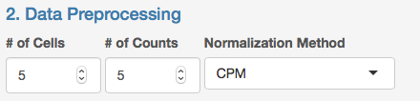

Users are able to adjust these values. Another example is as follows:

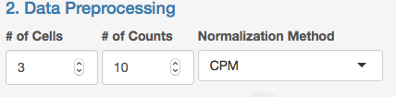

This example would keep genes with 10 or more read counts in 3 or more different cells/samples.

**Note: If users do not want to filter any genes, both values can be set to zero.**

In addition, the user may choose one of 4 normalization options:

1. CPM = counts per million. This method from the “edgeR” R package normalizes gene counts by the sample’s total counts and a scaling factor of one million.
2. Quantile = quantile normalization as implemented in the “preprocessCore” R package via the normalize.quantiles() function.
3. scran = single cell RNA-seq normalization method by deconvolving size factors from cell pools. This method from the “scran” R package normalizes gene counts using the computeSumFactors() function.
4. None = no normalization applied to the data.
5. **Specify Known Factors to Adjust For**

After loading the metadata input file, users will then be able to decide which known metadata variables should be adjusted for in the downstream analyses.

**Note if no metadata input file was uploaded, you will be unable to proceed past Step 3 and the “Known Factors” box will be empty as follows:**



However, once a metadata file is successfully uploaded, clicking on the “Known Factors” box should display all of the metadata variables specified in that file. In the example test.metadata.Rds file, the following Known Factors are as follows:

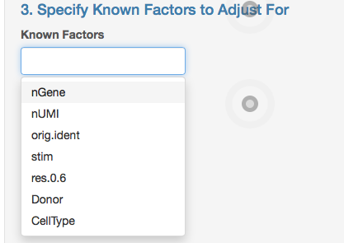

Note that the names of these known factors will be displayed as they are exactly provided in the metadata file.

Select a known factor to adjust for that variable in the downstream analysis. Users may choose multiple known factors (in this example, I chose the “Donor” and “nGene” variables:

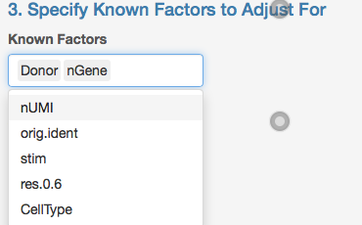

**Note: Users may remove variables from the “Known Factors” box using the “Backspace” or “Delete” key on your keyboard.**

**IV.** **IA-SVA Analysis**

The fourth step involves adjusting a final parameter prior to running the IA-SVA algorithm. This parameter “% Threshold for SV retention” is the numeric percentage threshold for SV retention. IA-SVA computes the percentage of unmodeled variance explained by the putative hidden factor and compares it with the user-defined threshold. If the percentage is greater than the threshold, the SV is retained.

Here, the user can specify a percent as a positive integer. Following this, click the blue “Run Analysis” button.

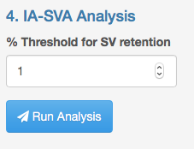

Upon clicking this button, the user should see a message prompt in the bottom right of the screen:



**V.** **Data/QC**

Once the IA-SVA algorithm finishes running, navigate over to the tabbed set of panels near the top right of the page. The “Data/QC” panel should now display information about your input gene/ADT dataset. For example:

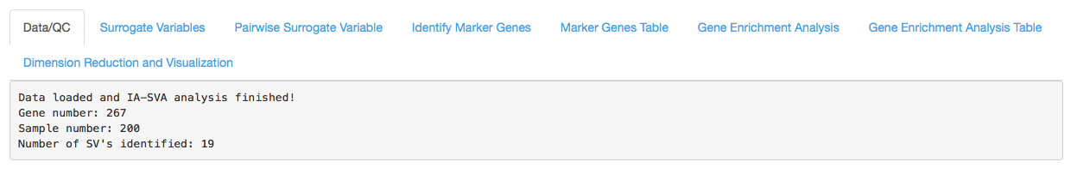

The output message will tell the user how many genes and samples were considered in the IA-SVA analysis. In this test case, 267 genes and 200 samples were provided as input. Additionally, this output message indicates the number of surrogate variables (in this case, 19) that were identified in your analysis.

Now, navigate to the next tabbed panel, “Surrogate Variables”.

**VI.** **Surrogate Variables**

Upon clicking on this tab, by default, the user should see two plots:

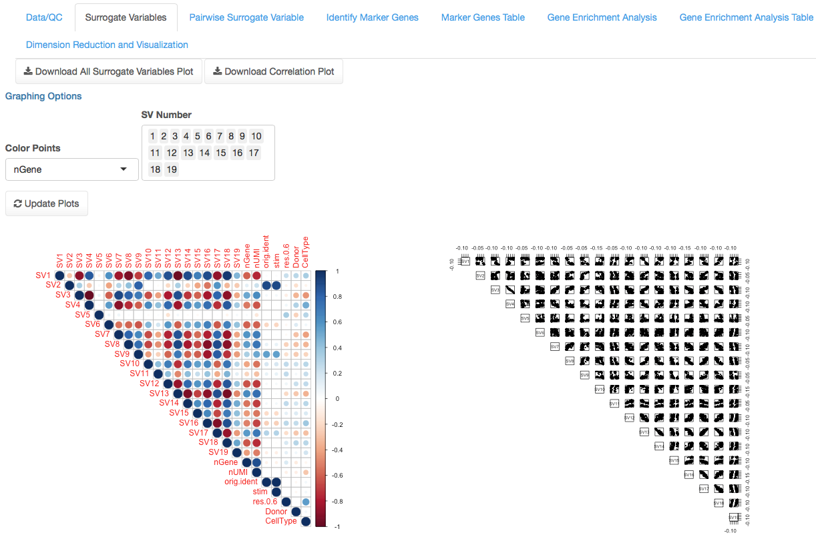

The plot on the bottom left, contains a circular plot depicting the correlation between each SV and all Known Factors provided in the analysis. The plot on the bottom right shows pairwise scatter plots of each surrogate variable identified (19 in this case).

In this example, it is difficult to visualize all 19 surrogate variables effectively. So let’s just focus on the first five SVs. To do this, the user needs to go to the “SV Number” box shown below:

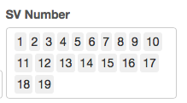

And merely remove all numbers except 1 through 5:

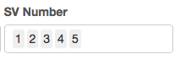

And then click the “Update Plots” button:



Which will re-display the two plots, this time only visualizing SVs 1 through 5. The updated plots in this example will look like this:

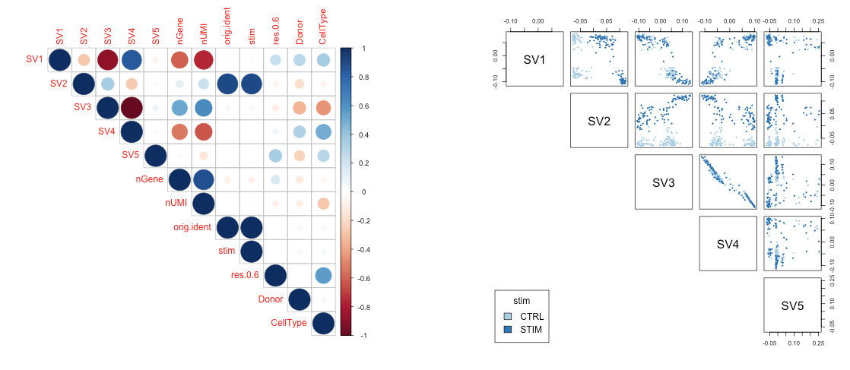

Focusing on the bottom right pairwise scatterplots, the user also has the choice to color cells/samples in this figure by different known factors. Users should specify a choice from the “Color Points” drop-down menu, and then click the update plots button.

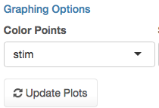

In the example below, the cells/samples are colored by the “stim” variable provided in the metadata file:

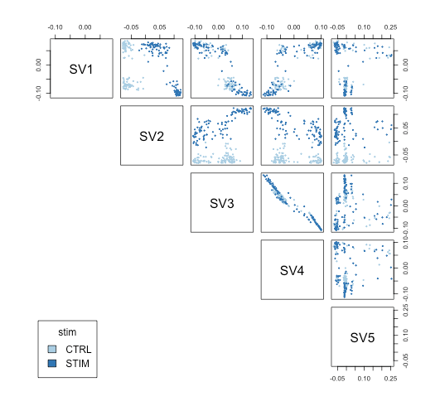

After plotting this data, users may also download PDF file versions by clicking the buttons:



Where the “Download Correlation Plot” corresponds to the circular plot in the bottom left of the page and the “All Surrogate Variables Plot” corresponds to the pairwise scatter plot in the bottom right of the page.

Next, navigate to the “Pairwise Surrogate Variable” tabbed panel.

**VII.** **Pairwise Surrogate Variable**

Upon clicking this tab, the user should see the following interactive plot:

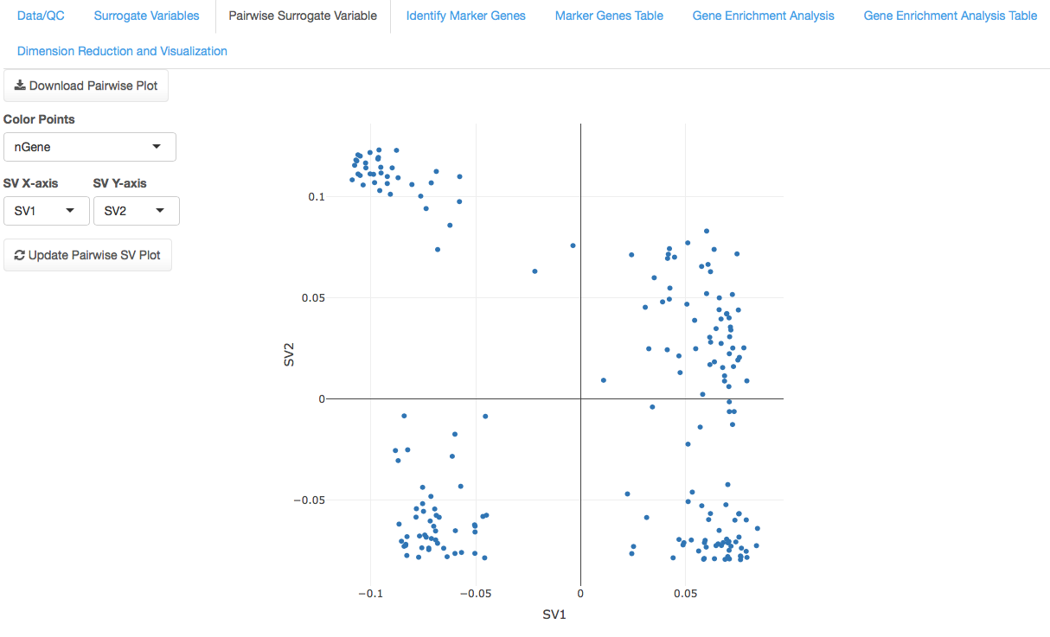

Within this tab, users may visualize two surrogate variables in a 2-D scatterplot. Which SVs that are chosen may be chosen by using the drop down menus:

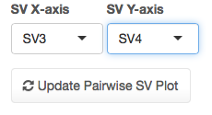

Users may also determine how to color the points (samples/cells) in the graph based on the known factors provided. Choose a selection in the “Color Points” drop down menu:

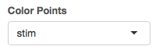

And then click the “Update Pairwise SV Plot” button will produce an updated plot:

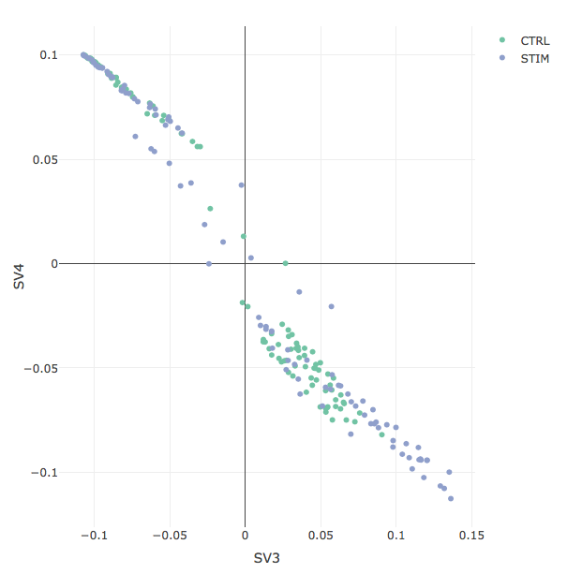

For each interactive plot produced, users may hover the “mouse” over each point on the graph to see the Surrogate Variable coordinates as well as the cell/sample name information.

An HTML version of the plot may be downloaded by clicking the following button:



Next, navigate to the “Identify Marker Genes” tabbed panel.

**VIII.** **Identify Marker Genes**

The next panel is where users can identify marker genes highly correlated with a Surrogate Variable. There are several parameters that the user must specify:

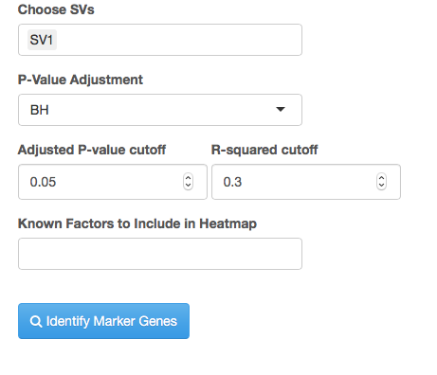

First, the user must indicate which surrogate variables in “Choose SVs” they wish to find marker genes for. Here, users may choose multiple or single surrogate variables. Second, the user must specify which multiple hypothesis testing correction method should be applied. By default, BH (Benjamini – Hochberg procedure) is chosen, but users may also choose “bonferroni” or “none”. Third, the users must provide an adjusted p-value cutoff (default is 0.05) between 0 and 1. Fourth, the user must provide an R-squared cutoff (default 0.3) between 0 and 1 which is used to identify genes correlated with each SV of interest. Lastly, the user must specify which known factor information should be included in the final visualization of marker genes.

In the previous example, I notice that the SV2 surrogate variable is highly correlated with the “stim” known factor:

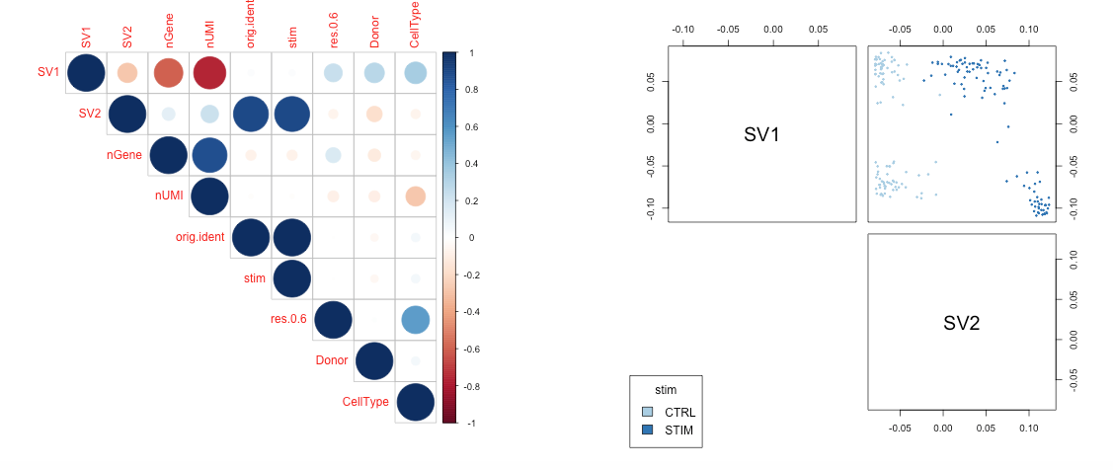

As a result, I decide to find marker genes associated with SV2 using the following options and clicking the “Identify Marker Genes” button:

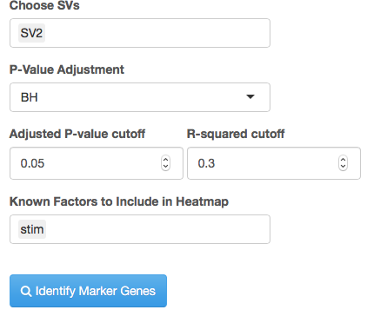

The resulting heatmap image is produced displaying the expression levels of each marker gene for each sample:

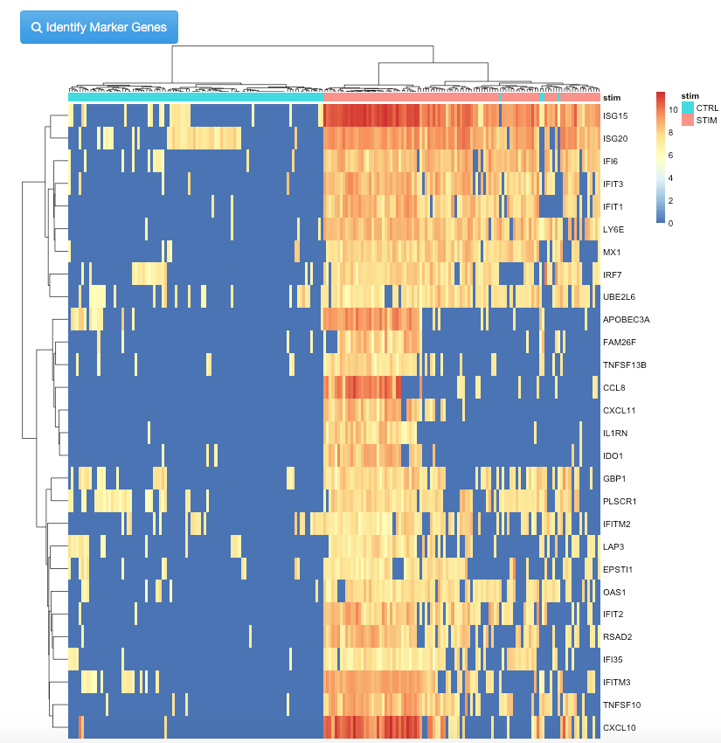

The resulting heatmap image may be downloaded in PDF format by clicking the button:



Next, navigate to the “Marker Genes Table” panel.

**IX.** **Marker Genes Table**

This tabbed panel will display an interactive table of the marker genes identified in the previous tabbed panel “Identify Marker Genes”. The table will look like this:

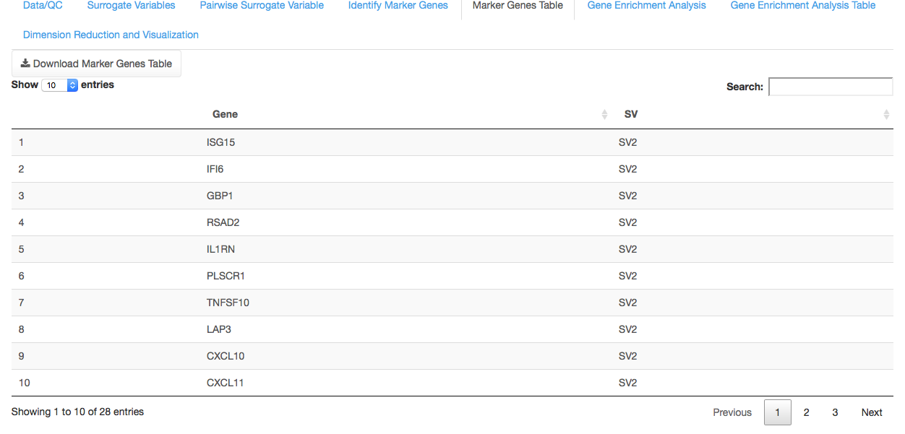

Where each entry of the table will contain a gene name and the SV they are associated with. If multiple SVs are provided, a gene may be associated with one or multiple SVs.

At the top of the table, users may specify how many entries to view (default: 10) or search for a particular gene of interest to filter the table results:



Lastly, the table may be downloaded in comma-separated value (CSV) format by clicking the following button:



Next, navigate to the “Gene Enrichment Analysis” tabbed panel.

**X.** **Gene Enrichment Analysis**

In this tabbed panel, users can identify the Gene Ontology (GO) terms and pathways (KEGG, etc) that are associated with the marker genes identified in the previous tabs “Identify Marker Genes” and “Marker Genes Table”.

From the drop-down menu, users may specify the pathway/database (by default, Gene Ontology Biological Process is selected):

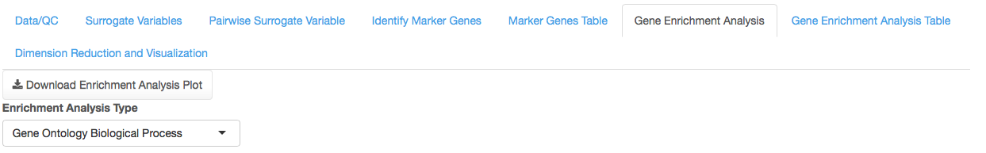

Other pathway/database options include:

1. Gene Ontology Cellular Component
2. Gene Ontology Molecular Function
3. Kyoto Encyclopedia of Genes and Genomes (KEGG)
4. Homo sapiens PBMC Cell Specific Modules
   1. This contains a set of human peripheral blood mononuclear cell (PBMC) specific gene lists as determined from public 10X Genomics single cell RNA-seq data.
5. Homo sapiens Immune Modules
   1. This contains blood transcriptional modules described by Chaussabel et al. (2008) and by Li et al. (2014) as well as metabolic profiling clusters from Weiner et al. (2012), obtained from the “tmod” R package: <https://cran.r-project.org/web/packages/tmod/vignettes/tmod.pdf>.

Next, the user should designate the “Species” type of their input data (by default: Homo sapiens is selected):



Currently, three species are supported:

1. Homo sapiens
2. Mus musculus
3. Rattus norvegicus

Lastly, before running the gene enrichment analysis, users should specify the multiple hypothesis testing correction method to use (either BH = benjamini and Hochberg procedure, bonferroni, or none) as well as the adjusted p-value cutoff (default set to 0.2).

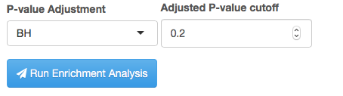

Upon clicking the blue “Run Enrichment Analysis” button, users should see the message prompt in the bottom right of their screen:

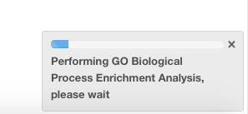

After the analysis finishes, the users should see the following plot displaying the top 10 enriched pathways:

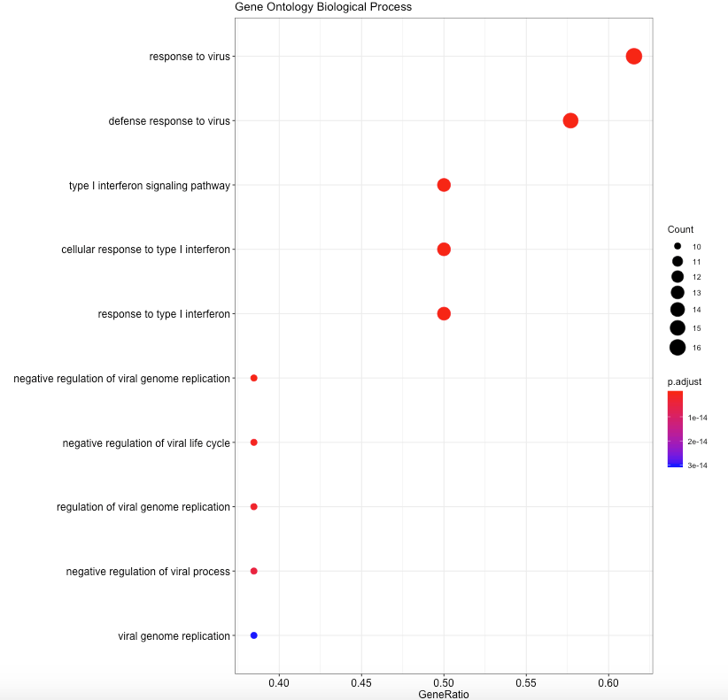

In the resultant plot, the y-axis displays the pathway/term name and the x-axis displays the “gene ratio” or the number of marker genes that fall within each pathway/term divided by the total number of genes in that pathway/term. The sizes of the points also reflect the “Count” or number of marker genes that fall within each pathway/term. Points are colored by their adjusted p-value.

The resultant plot may be downloaded by clicking the button:



Next, navigate to the “Gene Enrichment Analysis Table”.

**XI.** **Gene Enrichment Analysis Table**

This tabbed panel will display an interactive table of the pathways/terms identified in the previous tabbed panel “Gene Enrichment Analysis”. The table will look like this:

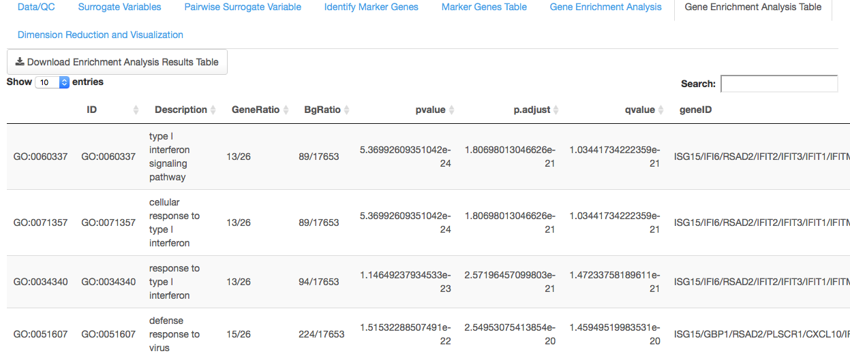

Where each entry of the table will contain a pathway term (ID), description, GeneRatio (number of marker genes in the pathway divided by the total genes in the pathway), p-value, adjusted p-value, q-value, and geneID (the marker genes that fell within the pathway).

The table may be downloaded in comma-separated value (CSV) format by clicking the following button:



Next, navigate to the “Dimension Reduction and Visualization” tabbed panel.

**XII.** **Dimension Reduction and Visualization**

In this last tabbed panel, users can perform dimension reduction analyses (PCA = principal component analysis, or t-SNE = t-distributed stochastic neighbor embedding) on their datasets to better visualize the complex structure/biology within their datasets:

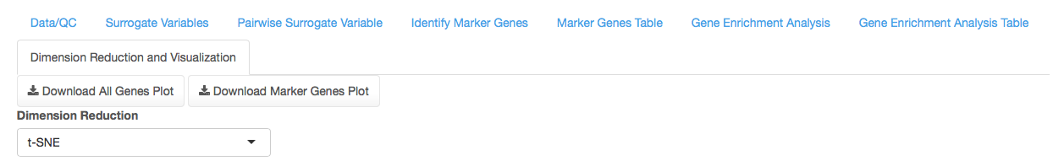

After selecting either “PCA” or “t-SNE”, users should then specify how the plots should be colored in the “Color Points” menu. Here, the known factors provided in the metadata file in the beginning stages should be displayed. In this example, we will color points/samples by their “stim” metadata variable:



Next, we run the dimension reduction analysis (this case, we chose t-SNE) and two 3-dimensional interactive plots are produced:

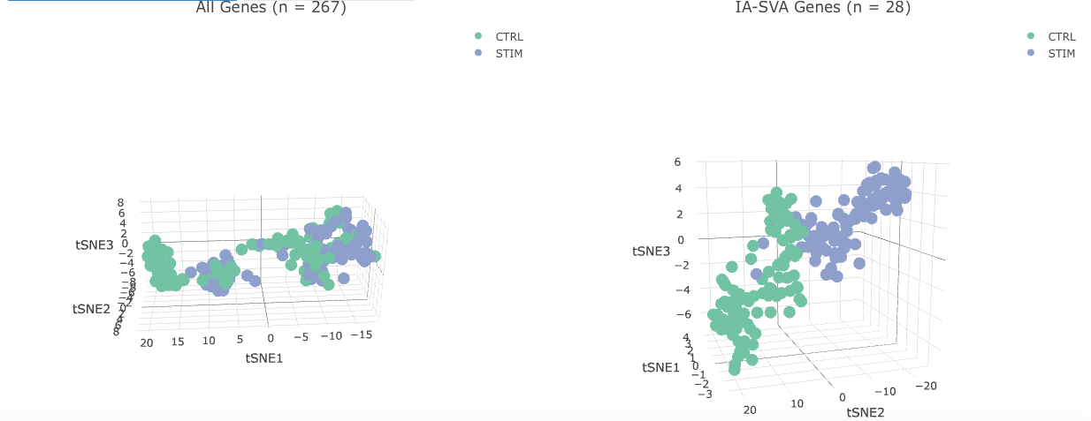

Where the bottom left plot represents the final t-SNE dimensions determined based on the original preprocessed data (all genes after filtering and normalization) and the bottom right plot represents the final t-SNE dimensions determined based on the marker genes identified via IA-SVA.

In both plots, users may hover their mouse over graph points to obtain information about the t-SNE dimensions and cell/sample name. Additionally, users may click and drag on the graph space to rotate the plot. Lastly, users may use their mouse wheel to zoom in and out of the plot.

HTML versions of each plot may be downloaded using the following buttons:

