The Beginning of the Stories

Summer holidays! Ajji smiled to herself as she waited for two more of her
grandchildren to arrive. Raghu and Meenu would be here soon. Anand and
Krishna had already arrived with their mother the previous evening. They had
been waiting restlessly for their cousins to arrive ever since. Even though Ajji
told them Raghu and Meenu would be here the next morning, these two kids
just would not listen. They went to the railway station with their grandfather,
Ajja, to receive them. The train must have pulled into the tiny railway station
of Shiggaon by now, and their grandfather would have hired a taxi to bring
them home along with their mother and the stacks of luggage.
Ajji hurried through her bath. She had finished cooking their favourite
dishes, and was now wearing a nice, soft cotton sari before going to the
veranda to wait for them.
There! There they came! What a noise the children were making! They all
nearly tumbled out of the car and came leaping and shouting to her, each
wanting to be the first to be hugged by her. Each one wanted to be closest to
Ajji.
Soon the children settled down. A visit to Ajji and Ajja’s house meant first
inspecting the garden to see how much the plants had grown since they last
came. Then they went to check on the cows, calves, dog, pups, cats and
kittens. Then they all ate huge quantities of Ajji’s delicious food. Finally,
while their mothers went off to chat and rest, the children gathered around
their grandmother for the best part of the holidays—listening to her wonderful
stories, particularly in the late afternoon.
Let us, too, gather under the fast revolving fan, on a mat on the floor,
fighting to be nearest to her, and listen in.
‘Doctor, Doctor’

The first day, the children asked, ‘Ajji, how do you know so many stories?’
Ajji smiled and answered, ‘My grandmother told me many stories. Some I
read in books. A few I learnt from youngsters like you, and the rest from your
Ajja.’ Then Ajji paused and said, ‘I see all of you have grown a lot since the
last time I saw you. So before I start telling any stories, I want to know what
each of you want to be when you grow up.’
Raghu, who was eleven years old, and the oldest of all, said immediately, ‘I
want to be an environment scientist.’ Meenu, who was nine, said, ‘I have not
decided, maybe a computer person like my dad.’ Anand, who was ten, said, ‘I
want to be an astronaut,’ and his twin sister Krishna firmly said, ‘I want to
become a fashion designer.’ Ajji smiled. ‘I am glad all of you have thought
about this. We should always have some aim in life which we must try to
achieve while being of help to others. Now let me tell you a story of a person
who learnt just such a lesson.’
Shall we, too, join Ajji and her gang of young friends and hear the story?

On a blazing hot summer afternoon, an old man came walking down a narrow
village path. He was tired and thirsty. Right by the road, he spotted a tiny
grocery store. It had a tin roof and mud walls. The shopkeeper sat inside
fanning himself and shooing away the flies that were buzzing around in the
stifling heat. There was a little bench in front of the store where the villagers
met when evening came and the land had cooled down. The old man flopped
down on the bench. He was so tired that for a while he could not speak.
Finally, he opened his mouth and uttered one word, ‘Water!’

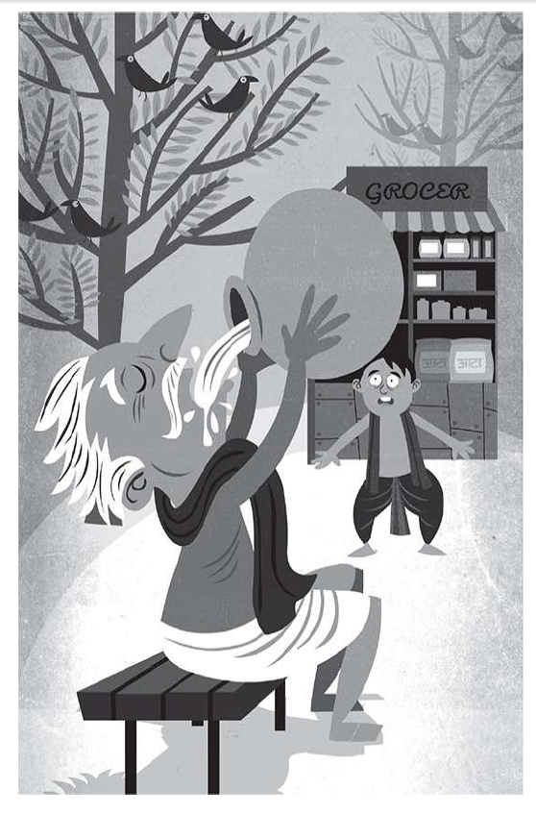
Now, this village had been facing a horrible problem for a long time. It was
near a great desert and the rains came only once a year to fill its ponds and
wells. But the rains had disappeared for the last two years, and the villagers
had been making do with water from a faraway stream. Every morning groups
of men and women walked a long distance, filled their pots from the little
stream and used that the whole day. Naturally, no one wanted to waste even a
drop of this precious water.
Yet how do you say no to a thirsty, tired old man when he asks for water?
Without a second thought, the shopkeeper, Ravi, who was very kindhearted,
poured out a tumbler of water from his pot and gave it to the old man. The
man drank it up greedily. Then he said one more word: ‘More!’ And without
waiting for Ravi to give it to him, he lunged for the pot, picked it up and
lifting it to his lips drank up Ravi’s entire day’s supply of water!
Poor Ravi, what could he do? He just stared in dismay. Then he told
himself, ‘Never mind. After all, I did help someone in need.’
The stranger, meanwhile, now seemed to feel better. He handed the pot back to Ravi, gave a smile that filled Ravi’s heart with warmth and said, ‘My
son, always be kind like this. Help everyone who comes to you like you
helped me, and you will be blessed.’ Then he picked up his stick and slowly
hobbled down the road. Ravi watched the strange old man disappear into the
distance, then returned to his shop.
The afternoon heat grew worse. After a while Ravi felt his head was about
to burst with a headache. His lips were parched and his throat hurt, it was so
dry. He really needed a drink of water. But the visitor had finished it all up!
Hoping to coax a drop or two out of the pot, Ravi lifted it to his lips and tilted it. Imagine his surprise when a gush of water ran down his face! It was sweet,
refreshing water which not only quenched his thirst, but wiped out his
headache too.
Ravi was staring at the water pot, trying to figure out what had just
happened, when Karim limped into his shop. Karim was a young man who
had hurt his leg in an accident many years ago which had left him with a limp.
When he was unwell or tired, his limp became worse. Karim, too, flopped
down on the bench in front of the store and caught his breath, like the old man. Then he fished out a shopping list from his pocket and handed it to Ravi.
As Ravi started packing up the items listed on the paper, Karim opened a little
bundle of food and ate his lunch sitting on the bench. Finally he wiped his

