The Beginning of the Stories

Summer holidays! Ajji smiled to herself as she waited for two more of her grandchildren to arrive. Raghu and Meenu would be here soon. Anand and Krishna had already arrived with their mother the previous evening. They hadbeen waiting restlessly for their cousins to arrive ever since. Even though Ajji told them Raghu and Meenu would be here the next morning, these two kids just would not listen. They went to the railway station with their grandfather, Ajja, to receive them. The train must have pulled into the tiny railway station of Shiggaon by now, and their grandfather would have hired a taxi to bring them home along with their mother and the stacks of luggage.
Ajji hurried through her bath. She had finished cooking their favourite dishes, and was now wearing a nice, soft cotton sari before going to the veranda to wait for them.
There! There they came! What a noise the children were making! They all nearly tumbled out of the car and came leaping and shouting to her, each wanting to be the first to be hugged by her. Each one wanted to be closest to Ajji.
Soon the children settled down. A visit to Ajji and Ajja’s house meant first inspecting the garden to see how much the plants had grown since they last came. Then they went to check on the cows, calves, dog, pups, cats and kittens. Then they all ate huge quantities of Ajji’s delicious food. Finally, while their mothers went off to chat and rest, the children gathered around their grandmother for the best part of the holidays—listening to her wonderful stories, particularly in the late afternoon. Let us, too, gather under the fast revolving fan, on a mat on the floor, fighting to be nearest to her, and listen in.

‘Doctor, Doctor’

The first day, the children asked, ‘Ajji, how do you know so many stories?’ Ajji smiled and answered, ‘My grandmother told me many stories. Some I read in books. A few I learnt from youngsters like you, and the rest from your Ajja.’ Then Ajji paused and said, ‘I see all of you have grown a lot since the last time I saw you. So before I start telling any stories, I want to know what each of you want to be when you grow up.’
Raghu, who was eleven years old, and the oldest of all, said immediately, ‘I want to be an environment scientist.’ Meenu, who was nine, said, ‘I have not decided, maybe a computer person like my dad.’ Anand, who was ten, said, ‘I want to be an astronaut,’ and his twin sister Krishna firmly said, ‘I want to become a fashion designer.’ Ajji smiled. ‘I am glad all of you have thought about this. We should always have some aim in life which we must try to achieve while being of help to others. Now let me tell you a story of a person who learnt just such a lesson.’Shall we, too, join Ajji and her gang of young friends and hear the story?
On a blazing hot summer afternoon, an old man came walking down a narrow village path. He was tired and thirsty. Right by the road, he spotted a tiny grocery store. It had a tin roof and mud walls. The shopkeeper sat inside fanning himself and shooing away the flies that were buzzing around in the stifling heat. There was a little bench in front of the store where the villagers met when evening came and the land had cooled down. The old man flopped down on the bench. He was so tired that for a while he could not speak. Finally, he opened his mouth and uttered one word, ‘Water!’

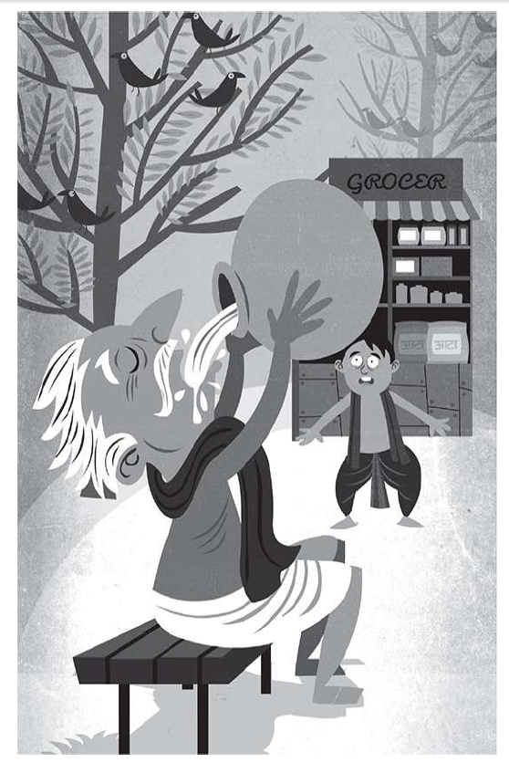

Now, this village had been facing a horrible problem for a long time. It was near a great desert and the rains came only once a year to fill its ponds and wells. But the rains had disappeared for the last two years, and the villagers had been making do with water from a faraway stream. Every morning groups of men and women walked a long distance, filled their pots from the little stream and used that the whole day. Naturally, no one wanted to waste even a drop of this precious water.
Yet how do you say no to a thirsty, tired old man when he asks for water? Without a second thought, the shopkeeper, Ravi, who was very kindhearted, poured out a tumbler of water from his pot and gave it to the old man. The man drank it up greedily. Then he said one more word: ‘More!’ And without waiting for Ravi to give it to him, he lunged for the pot, picked it up and lifting it to his lips drank up Ravi’s entire day’s supply of water!

