**This link** [**https://cordc.ucsd.edu/projects/hfrnet/**](https://cordc.ucsd.edu/projects/hfrnet/) **takes you to the High Frequency Radar Network.**

**Click on Data and select NCEI RTV (TOTAL) Archive.**

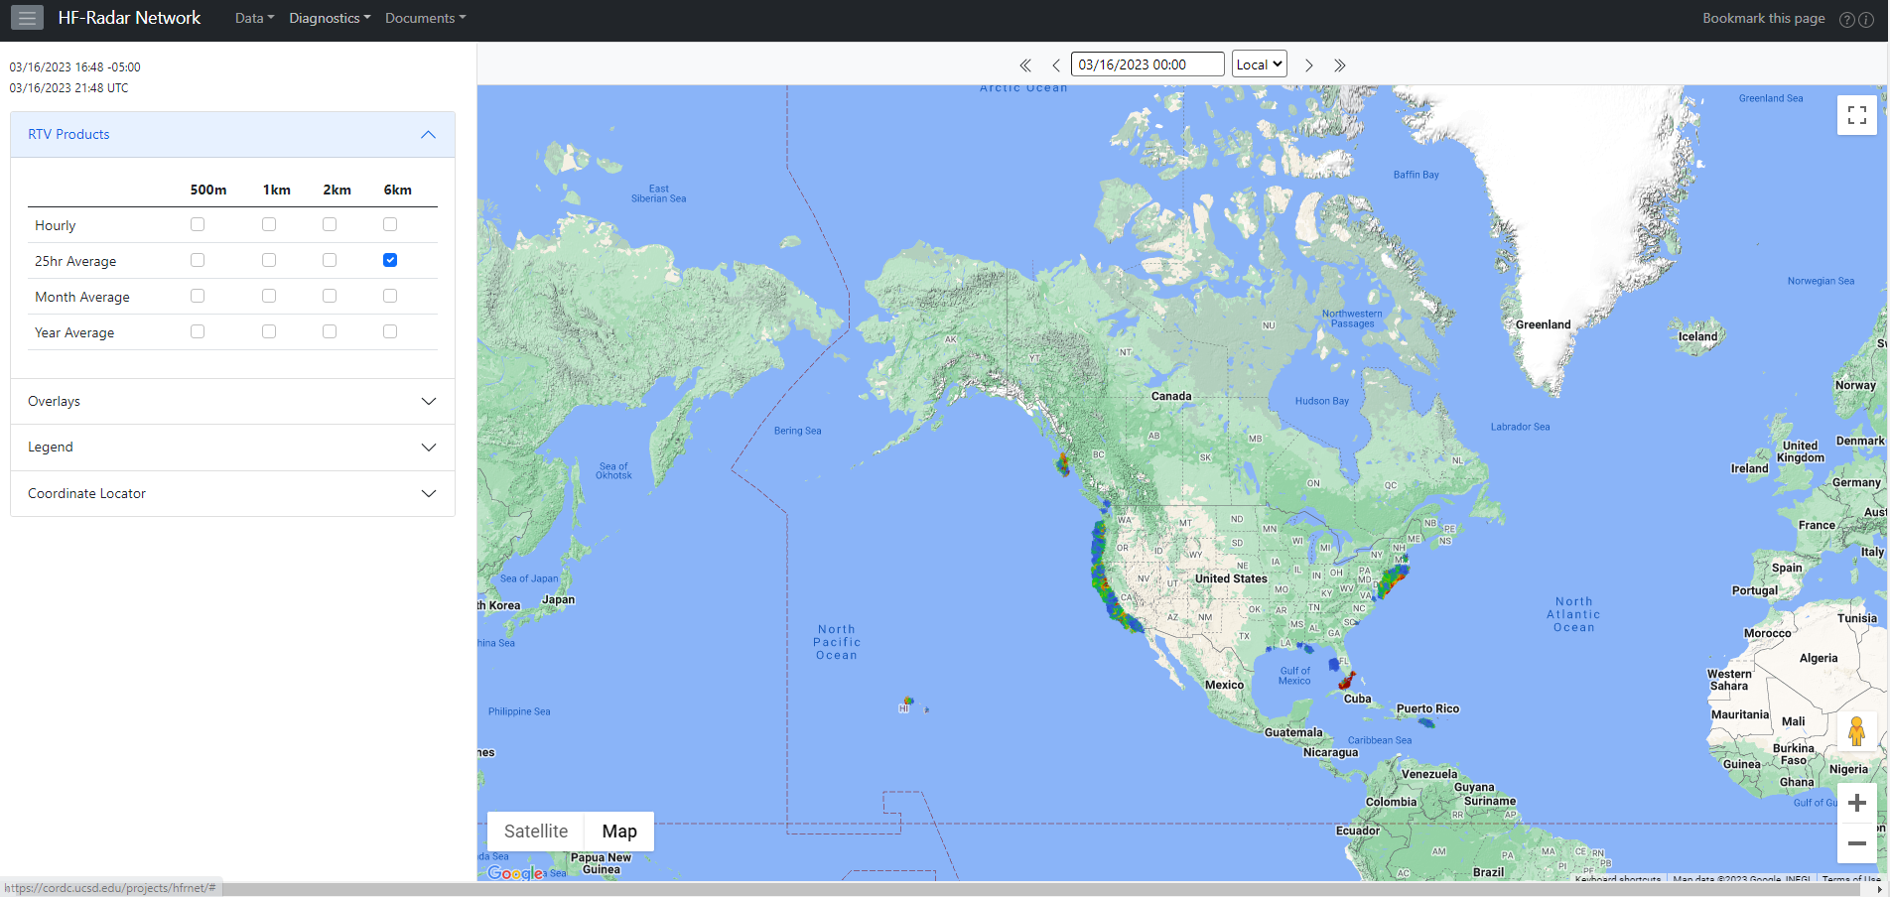

**A new window opens with the Access tab active. The information on the Access tab are tabulated. Download data is in the second row and there are three download options: THREDDS, HTTPS and FTP.**

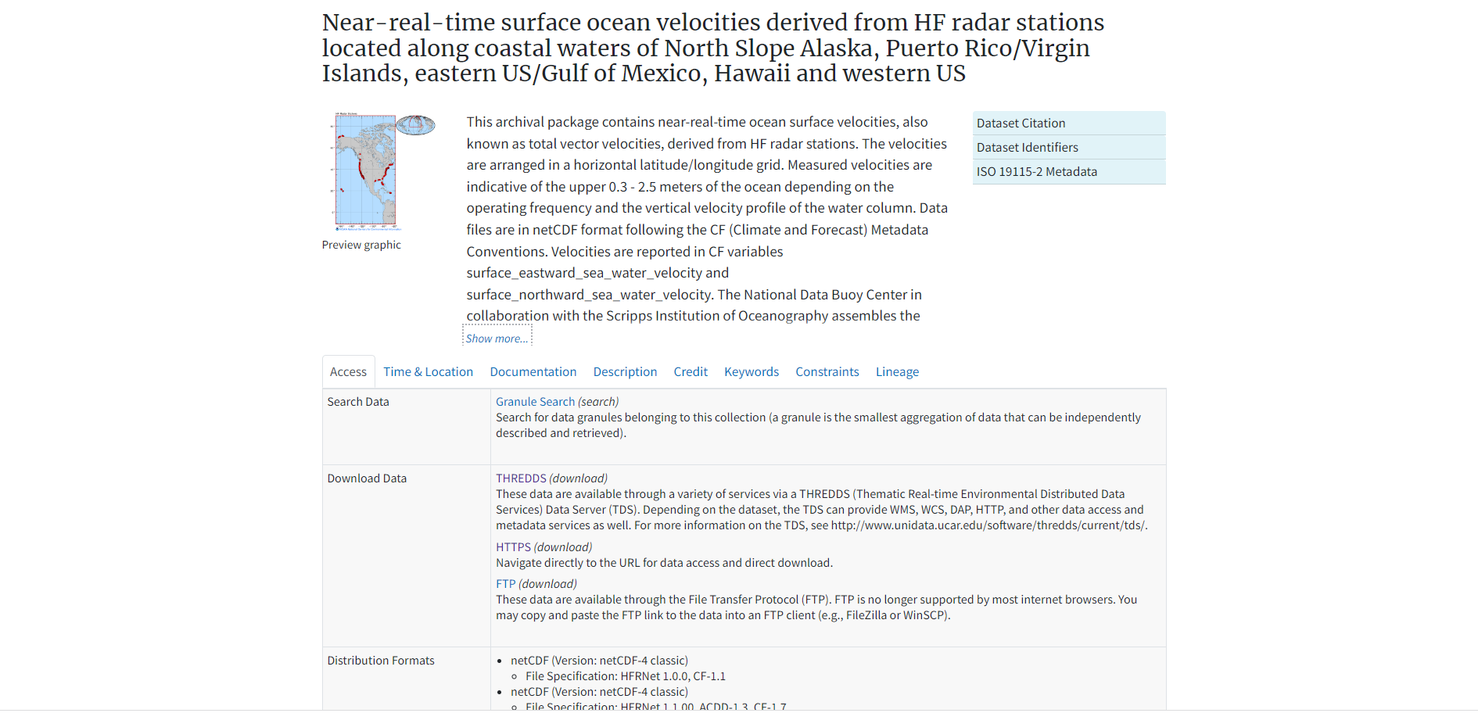

**The HFR data are in netCDF (.nc) and at hourly intervals. In the download process, the year, month and region of interest are selected. The regions are PRVI: Puerto Rico and Virgin Islands, USEGC: United States East and Gulf Coast, USHI: United States Hawaii, and USWC: United States West Coast). Note that the spatial resolutions of the data from the regions are different. The resolutions are as follows:**

**2 km and 6 km for PRVI**

**1 km, 2 km and 6 km for USEGC**

**1 km, 2 km and 6 km for USHI**

**500 m, 1 km, 2 km and 6 km for USWC**

**The naming convention of the files downloaded using any of the options is the same: .**

**THREDDS download**

**For more information about THREDDS:** [**https://www.unidata.ucar.edu/edu/software/tds/**](https://www.unidata.ucar.edu/edu/software/tds/)

**HTTPS download**

**Use https for downloading single files.**

**FTP download**

**ftp is the best option for downloading multiple files. This is the server for the ftp download: ftp-oceans.ncei.noaa.gov and by including the following /pub/data.nodc/ndbc/hfradar/rtv/ you access the HFR totals dataset. The suggested ftp clients are FileZilla or WinSCP. This could also be done using MATLAB, Python, LINUX command prompt.**

**Download and run the matlab file so as to download the HFR .nc files over a given time period and convert to .mat files for a spatial region of interest. This script enhances a faster download of the hourly datasets and it runs on matlab version 2018b and newer.**

**Disclaimer**

**The attached scripts are provided as they are and GCOOS is unable to provide technical support.**