**GCOOS DATA USE GUIDES**

**Last updated: June 5, 2023**

**HIGH FREQUENCY RADAR (HFR)**

**What data HFR collect?**

**High Frequency Radar (HFR) stations are installed close to the shoreline and/or on offshore platforms to measure ocean surface currents over a spatial coverage. Numerous HFR stations are installed along U.S. coast. In the US, the vast majority of these stations are managed by Regional Associations of the Integrated Ocean Observing System, such as GCOOS. Surface current vectors representing current direction and intensity from these stations can be accessed at the HFRnet Data Assembly Center:** [**https://cordc.ucsd.edu/projects/hfrnet/**](https://cordc.ucsd.edu/projects/hfrnet/) **(High Frequency Radar Network), and the GCOOS HFR Data page:** [**https://data.gcoos.org/hfradar/**](https://data.gcoos.org/hfradar/)**. The aim of this document is to serve as a guide on how to access HFR data.**

**How to access HFR data?**

**Access to HFR surface current total vectors data is provided on the two mentioned websites. Total vectors are the resultant surface currents estimated from current radials (component of the currents towards or away from a given station).**

1. **HFR Network**

**This link** [**https://cordc.ucsd.edu/projects/hfrnet/**](https://cordc.ucsd.edu/projects/hfrnet/) **takes you to the High Frequency Radar Network (Fig. 1).**

**Click on Data and select NCEI real time vector (RTV) (TOTAL) Archive.**

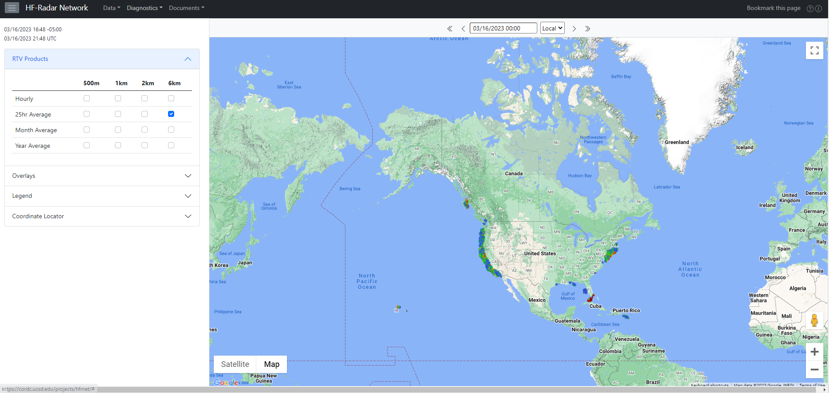

**Figure 1: HFR network online portal**

**A new window opens with the Access tab active. The information on the Access tab is tabulated. In the second row, three data download options were provided: THREDDS, HTTPS and FTP (Fig. 2).**

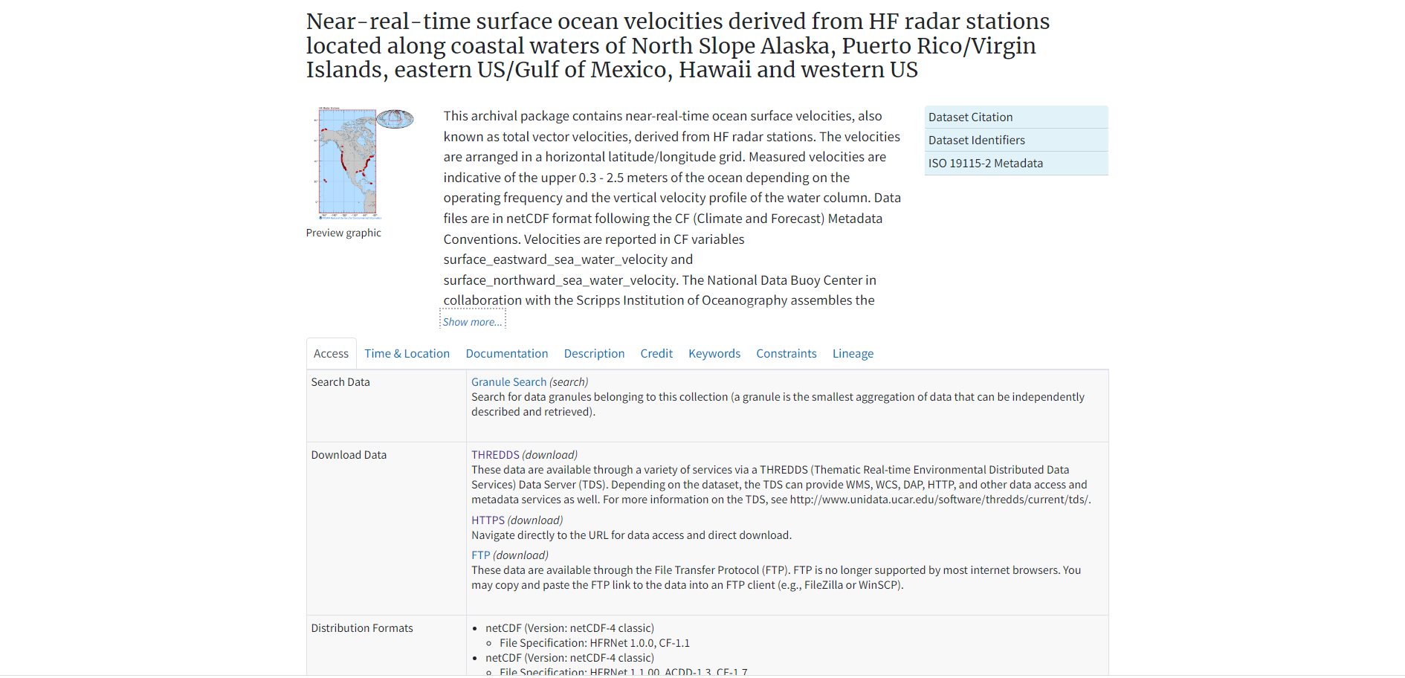

**Fig. 2: NCEI total vectors data download portal**

**The HFR data are stored in netCDF (.nc) and at hourly intervals. In the download process, the year, month and region of interest are selected. The region of interest is selected from the following: [PRVI: Puerto Rico and Virgin Islands], [USEGC: United States East and Gulf Coast], [USHI: United States Hawaii], and [USWC: United States West Coast]. Note that the spatial resolutions of the data from the regions are different. The spatial resolutions options are as follows:**

**2km and 6km for PRVI**

**1km, 2km and 6km for USEGC**

**1km, 2km and 6km for USHI**

**500m, 1km, 2km and 6km for USWC**

**The naming convention of the files downloaded using any of the options is the same.**

**THREDDS download**

**The directory structure is as follows: yyyy/mm/region/yyyymmddhh00_hfr_region_res_rtv_uwls_NDBC.nc. For more information about THREDDS:** [**https://www.unidata.ucar.edu/edu/software/tds/**](https://www.unidata.ucar.edu/edu/software/tds/)

**HTTPS download**

**Use https for downloading single files.**

**FTP download**

**This is the server for the ftp download: ftp-oceans.ncei.noaa.gov and by including the following /pub/data.nodc/ndbc/hfradar/rtv/ you access the HFR totals dataset. The suggested ftp clients are FileZilla or WinSCP. This could also be done using MATLAB, Python, LINUX command prompt.**

**Three scripts are provided in this** [**link**](https://github.com/Uchemos/HFR-Download.git) **for downloading the .nc files. Download and run the MATLAB and python files so as to download the HFR .nc files over any given time period. Multiple hourly .nc files can be downloaded using either of the two scripts. In addition to the .nc file download, the MATLAB script further extracts data for each time moment over a specified spatial area, deletes each .nc file after the data extraction and converts the entire extracted dataset to a .mat file. The MATLAB script runs on MATLAB version 2018b and newer. The commands provided on the .txt are run on the terminal.**

1. **GCOOS Data Portal**

**The HFR data page** [**https://data.gcoos.org/hfradar/**](https://data.gcoos.org/hfradar/) **(Fig. 3) will take you to a similar environment as the previous site. The page provides a list of download options for both current radials and total vectors. The total vectors can be obtained through the Coastal Observing Research and Development Center (CORDC) and National Data Buoy Center (NDBC) THREDDS data server as well as the NCEI RTV archiver (the same as Fig. 2). On the CORDC THREDDS server, the datasets are partitioned into different regions. Data for each region are further partitioned based on spatiotemporal resolutions. The datasets on the NDBC THREDDS are arranged with respect to regions and spatiotemporal resolutions of the data. As previously stated, the NCEI RTV Archiver link leads to the NCEI RTV data download portal shown on Fig. 2.**

**Figure 3: HFR network GCOOS data portal**

**Disclaimer**

**The attached scripts are provided as they are and GCOOS is unable to provide technical support.**

**Contact:**

**Dr. Uchenna Nwankwo, Oceanographer, GCOOS,** [**uchenna.nwankwo@gcoos.org**](mailto:uchenna.nwankwo@gcoos.org)