**Programming Assignment – Screen Designs**

C:\Users\Yuri\Desktop\Assignments\Programming\ViewQuiz.png

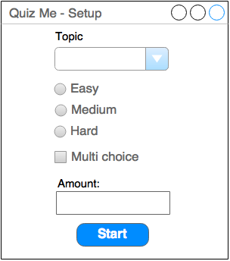

**Class Diagrams**

C:\Users\Yuri\Downloads\MiscClassUML.png

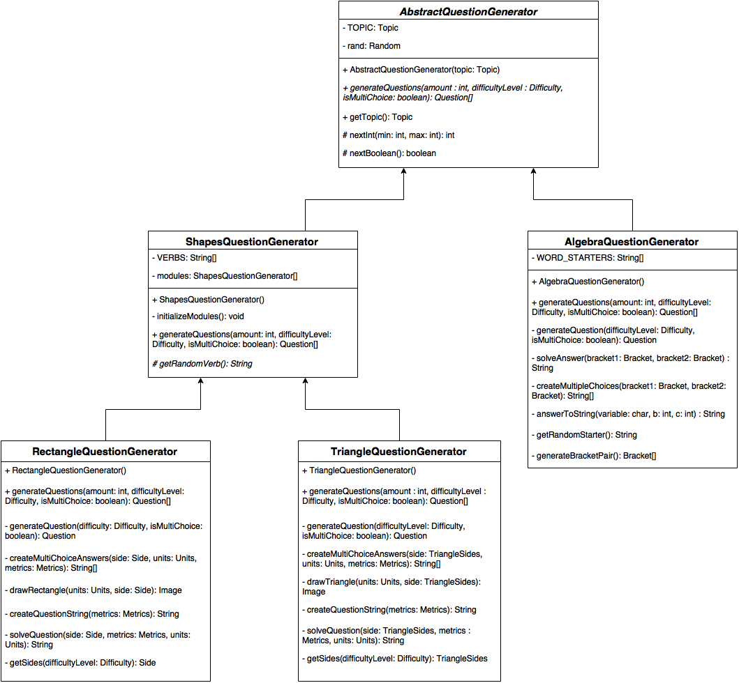

C:\Users\Yuri\Downloads\QuestionUML.png

**Test plan**

Due to the nature of my program, I’ve decided it’s most sensible to do JUnit testing and a test plan. The JUnit is for testing the GUI aspects of the program. Essentially the JUnit testing is the white box tests and the test plan is the black box test.

|  |  |  |  |  |  |
| --- | --- | --- | --- | --- | --- |
| **No.** | **Description** | **Data Type** | **Test data** | **Expected Result** | **Comment** |
| 1 | Not selecting a topic in the setup window then clicking the start button | Erroneous |  | An error message to show up telling the user to select a topic | Pass |
| 2 | Not selecting a difficulty level in the setup window then clicking the start button | Erroneous |  | An error message to show up telling the user to select a difficulty level | Pass |
| 3 | Not entering an amount of questions to generate then clicking the start button | Erroneous |  | An error message to show up telling the user to enter a valid number between 1 – 99 | Pass |
| 4 | Entering a non-integer string for the amount of questions to generate then clicking the start button | Erroneous | dfrtvnu  three | An error message will show up telling the user to enter a valid number between 1 – 99 | Pass |
| 5 | Enter the number 1 and 99 when choosing the amount of questions to generate then clicking the start button | Boundary | 1  99 | The program will generate and start the quiz with the number of requested question | Pass |
| 6 | Enter a number less than 1 and number greater than 99 when choosing the amount of questions to generate then clicking the start button | Erroneous | -5  102 | An error message will show up telling the user to enter a valid number between 1 – 99 | Pass |
| 7 | For multiple choice question, leave the fields empty then click next | Erroneous |  | A alert dialog will pop up to tell the user that they cannot leave the answer blank | Pass |
| 8 | For non-multiple choice question, leave the answer box empty then click next | Erroneous |  | A alert dialog will pop up to tell the user that they cannot leave the answer blank | Pass |
| 9 | Answer a question wrongly then click next | Typical |  | A message box telling the user they got the question wrong. Also, the correct answer will be displayed on an alert dialog | Pass |
| 10 | Answer a question correctly then click next | Typical |  | The program will display a spinning tick followed by a short sound clip being played to indicate they got the answer correct | Pass |
| 11 | Complete a quiz | Typical |  | The program will calculate the user’s score and percentage and display it on an alert dialog | Pass |