Name (s): Uchenna Osemeka
Course Name: Principles of Software Design
Group: L02-28
Course Code: ENSF 460
Assignment Number: Driver Project 2-Light Control
Submission Date: 5thDecember, 2025

Design
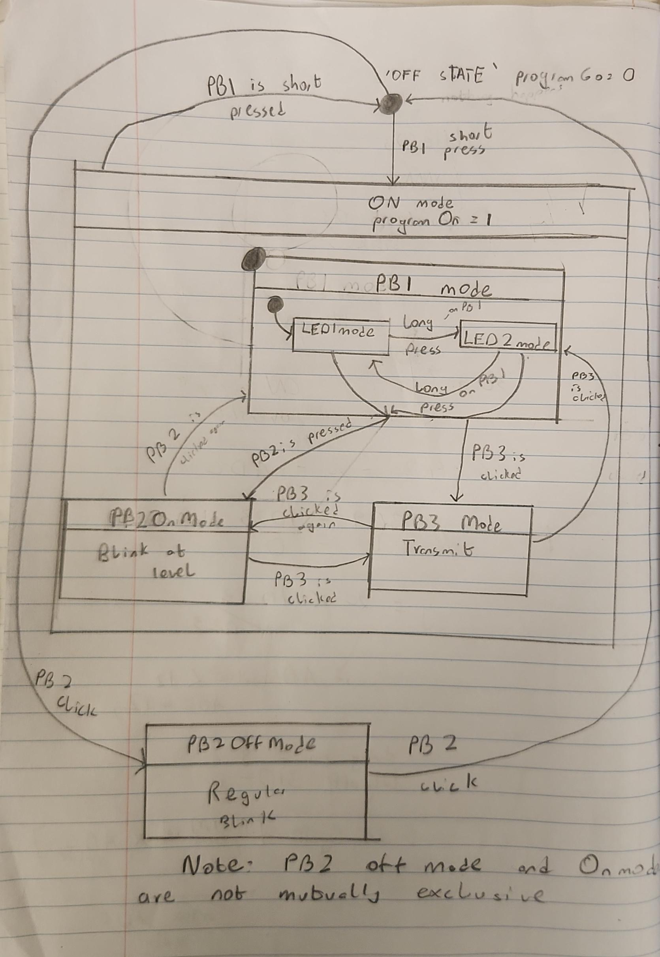
High Level State Diagram
Our high-level state diagram above shows the general design idea for what flags would trigger our device to change state. Omitted button functionality and specific functions for brevity. Refer to comments in code.
Implementation
Summary of Implementation
We organize files with a control class main which checks using an IOcheck function defined in our ios.h header. Ios.c class reads global variables updated by timer2 isr on overflow which debounces earlier cn interrupt. Depending on what global variable(flag) is enabled IOcheck calls the appropriate function defined in itself ios.c anf in the ADC.h. ADC.h implements the On Mode. General logic is divided where possible into two primary states programOn=0, and programOn= 1. This division keeps our encapsulation high and proper.
Details of Implementation
Our implementation for a countdown timer truly begins with a main function project3main.
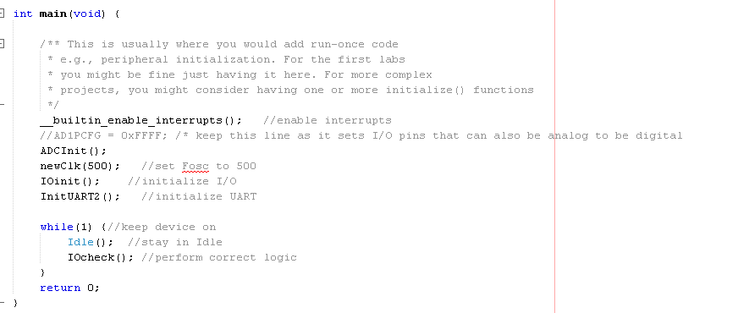
Here we initialize I/O, and UART transmissions wit IOinit(), and InitUART() respectively, then we initialize the ADC module with ADC_init(). Once initialized we have an always on while(1) loop comprising of Idle() and IOcheck(). Idle keeps the system reliably conserving power until an interrupt-a button press or timer overflow- causes the next instruction after Idle, IOcheck to be executed.
Before IOcheck is executed, the CN ISR is called on any button press. The CN ISR checks for a filter initiation with if(prsLfilter== 1), if so it sets the flag for the filter result. After possible filtering, it uses TMR2 to debounce button input on overflow to get a stable read.

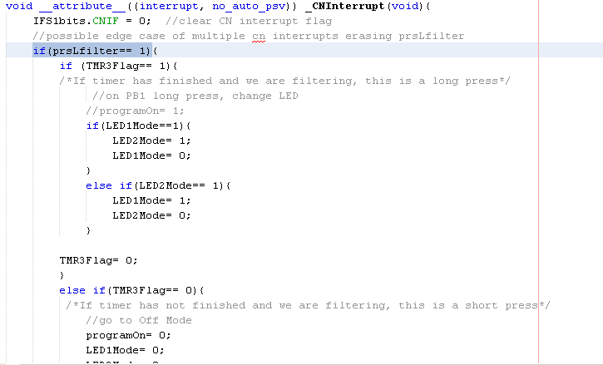
On Timer2 overflow, the input is ready and accurate. Depending on what input is read different flags are raised, using if else if logic, as well as contingency to start filter if needed.
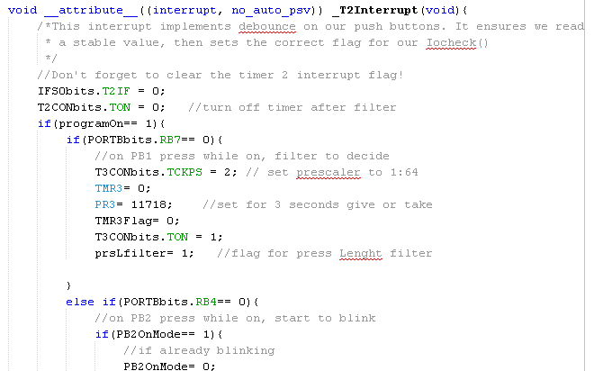
On return to main, IOcheck() is called. This function uses if else if logic to call the appropriate function depending on which flag has been raised.
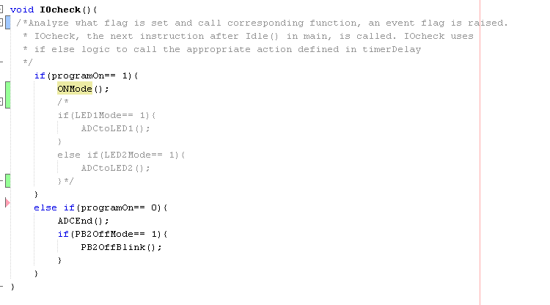
PB2Off blink governs pb2 blinking in the off mode.
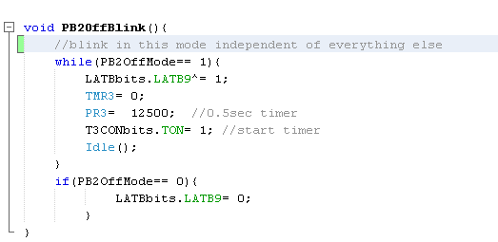
Moving on to where our program spends most of its time ADC.c
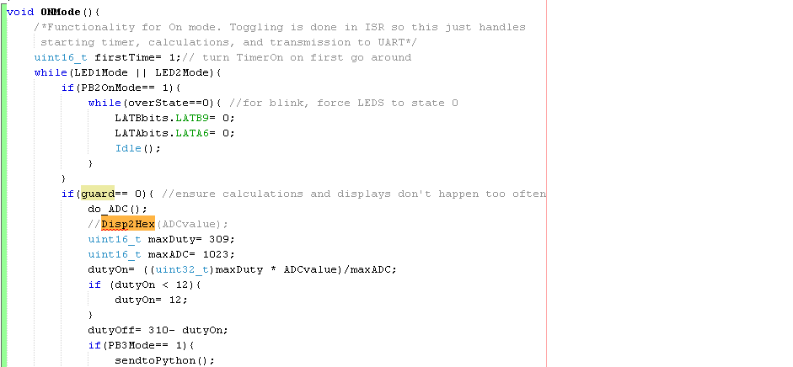
OnMode handles what happens in the On Mode, here we can transmit for PB3, blink for PB2, and start the PWM. We complete PWM by toggling LED in ISR, more on that later. We use a local variable first time to ensure Timer is only started once. overstate variable is used to force LED state off to simulate blink from PB2. Guard variable is used to make sure we recalculations of ADC and corresponding duty cycle doesn’t happen too often preventing visible flicker in our LED1mode
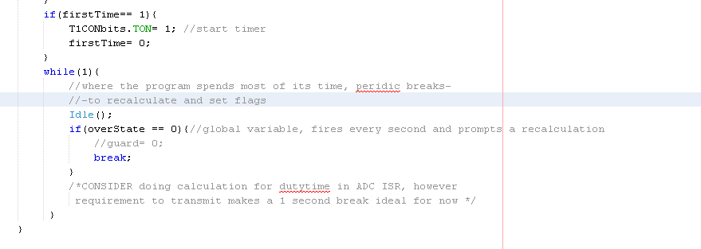
Our code spends most of its time switching LED state in our while(1) loop but breaks periodically to recalculate and possibly turn off if blinking
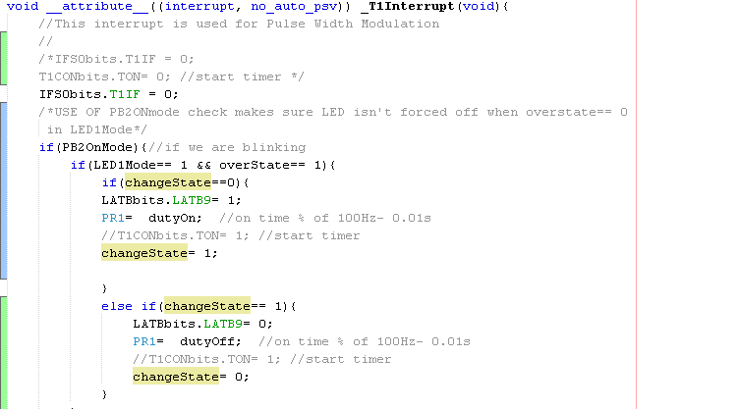
Actual toggling to do PWM is done in our T1 ISR above. We first check if PB2On mode to prevent blinking when PB2 blink is enabled. Then we use changeState to toggle between the LED states. Duty cycles are calculated as seen earlier.
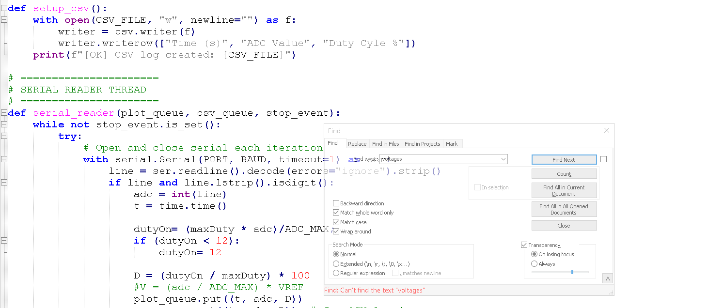
Python code uses threads to log and display ADC values and calculated duty cycle in real time. We use queues for logging and transmissions. And

