CHAPTER 1

INTRODUCTION

1.1 Background of the Study
The hiring process has undergone significant transformation with the rise of digital job platforms and the proliferation of applicant data. Organisations routinely receive hundreds of applications per open position, yet most ATS tools function primarily as structured data stores rather than intelligent screening systems. Recruiters are expected to manually review CVs, coordinate reference checks, conduct preliminary interviews, and synthesise data from disparate sources including LinkedIn, GitHub, and portfolio websites.
Concurrent advances in Large Language Models (LLMs), automatic speech recognition (ASR), and conversational AI have made it technically feasible to automate substantial portions of the early-stage screening pipeline. OpenAI's GPT-4 family demonstrates strong document comprehension and structured information extraction. OpenAI Whisper produces natural-sounding speech suitable for voice-based interviews. These capabilities, when orchestrated correctly, can replicate the information-gathering functions of a human screener at a fraction of the time and cost.

1.2 Problem Definition
Current recruitment workflows suffer from three interconnected problems:
- Volume overload: Recruiters cannot thoroughly evaluate every candidate when application volumes are high, leading to cursory CV reviews and high rates of qualified-candidate dropout.
- Fragmented data: Candidate signals are dispersed across CVs, LinkedIn profiles, GitHub repositories, and reference calls. No unified tool aggregates and synthesises these signals automatically.
- Inconsistency and bias: Manual screening introduces subjectivity. Different reviewers apply different standards, and implicit bias can influence early-stage decisions before structured interviews begin.
HireSense addresses these problems by constructing an automated pipeline that collects, processes, and scores candidate data uniformly and presents AI-generated summaries that surface relevant signals for human review.

1.3 Need for the Proposed System
Existing ATS platforms such as Ashby, Greenhouse, and Lever are designed primarily for workflow management rather than intelligent signal analysis. They do not automatically extract and score structured data from CV documents, cross-reference CV claims against a candidate's public LinkedIn or GitHub presence, conduct preliminary voice-based interviews autonomously, or aggregate multi-source scores into a unified candidate certainty score. HireSense fills this gap by functioning as an analytical middleware layer on top of existing ATS infrastructure, ingesting candidates from Ashby and returning enriched scores and summaries that push back to the same ATS.

1.4 Objectives of the Project
- To design and implement an automated multi-source candidate data collection pipeline integrating CV parsing, LinkedIn scraping, and GitHub analysis.
- To develop an AI-powered interview module capable of generating contextual questions, transcribing candidate audio responses, and producing evaluation summaries.
- To build a reference verification subsystem that initiates and records reference calls via conversational AI or email scheduling.
- To produce a composite candidate certainty score (0–100) and push enriched evaluation data back to the Ashby ATS.
- To deliver a responsive recruiter dashboard that presents all collected signals, scores, and summaries in a unified interface.

1.5 Scope of the Project
HireSense is scoped to the following capabilities:
- Integration with Ashby ATS for candidate ingestion and score/note push-back.
- CV processing via PDF upload and GPT-4 Vision structured extraction.
- LinkedIn profile enrichment via BrightData scraping API with snapshot caching.
- GitHub profile and repository analysis using the GitHub REST API.
- AI-conducted voice interviews via a Python FastAPI backend using Groq Whisper (ASR) and GPT for dynamic question generation.
- Reference call initiation via OpenAI Whisper conversational AI or email with Google Meet integration.
- Waitlist management via Airtable REST API with email deduplication.
- All data persisted in Supabase (PostgreSQL) with Row Level Security and JWT-based auth.
Out of scope: video interview proctoring, multi-language support, direct job posting integrations, and custom LLM fine-tuning.

1.6 Methodology
- HireSense was developed using an iterative, feature-driven approach timeline:
- Requirement’s elicitation: Identification of recruiter pain points and prioritisation of automated screening features.
- Architecture design: Definition of the two-tier backend (Next.js serverless + FastAPI), Supabase database schema, and webhook-driven processing pipeline.
- Module implementation: Parallel development of the CV processing, LinkedIn/GitHub enrichment, AI analysis, interview, and reference modules.
- Integration and testing: API contract verification, webhook trigger validation, and end-to-end interview flow testing.
- UI development: Implementation of the recruiter dashboard using UI components and Tailwind CSS v4.

1.7 Organization of the Report
- Chapter 2 reviews existing recruitment systems and related academic and industry work.
- Chapter 3 provides system analysis including functional and non-functional requirements and feasibility assessment.
- Chapter 4 presents system design through architecture diagrams, DFDs, UML diagrams, ER diagram, and module descriptions.
- Chapter 5 covers implementation details, the technology stack, module-wise design, and algorithms used.

CHAPTER 2

LITERATURE SURVEY

2.1 Existing System
Current Applicant Tracking Systems (ATS) represent the dominant tooling for recruitment pipeline management. Platforms such as Ashby, Greenhouse, Lever, and Workday provide structured candidate storage, stage management, and recruiter collaboration features. More advanced offerings such as HireVue and Pymetrics introduce video interview recording and psychometric game-based assessments respectively. LinkedIn Recruiter provides candidate sourcing with profile-level AI matching scores.
In the domain of AI-assisted screening, tools like Eightfold.ai and Beamery apply machine learning to match candidates to job descriptions based on structured and unstructured profile data. However, these tools operate within proprietary ecosystems and do not expose programmable pipelines for custom multi-source enrichment or autonomous voice interviews.

2.2 Limitations of Existing System
- ATS platforms are passive stores: they record what recruiters input but do not autonomously collect or enrich candidate data from external sources.
- Video interview platforms (HireVue) require candidate scheduling and do not support fully autonomous, AI-driven conversational interviews with dynamic follow-up questions.
- LinkedIn Recruiter scoring is a black box and cannot be combined with GitHub or CV-derived signals in a custom composite score.
- Reference checking remains largely manual, with tools like Checkr focused on background screening rather than AI-conducted reference conversations.
- No existing platform integrates CV extraction, social profile analysis, automated interview, and reference verification into a single pipeline with ATS write-back.

2.3 Research Papers Review
Resume Parsing and Information Extraction
Significant research has been conducted on Named Entity Recognition (NER) applied to resume parsing. Models fine-tuned on resume corpora can extract entities such as education institutions, job titles, skills, and employment dates with high accuracy. HireSense delegates this task to GPT-4 Vision, providing flexible document comprehension without requiring a specialised training corpus.

Automated Interview Systems
Prior work on automated interview systems has explored text-based chatbot interviews and structured video assessments. Research on automatic assessment of interview performance demonstrated that audio and verbal features correlate significantly with human interviewer ratings. HireSense focuses on the audio-verbal channel, using ASR and LLM-based response evaluation to replicate key dimensions of this assessment.

Conversational AI for HR Applications
Mya Systems (acquired by Stepstone) demonstrated the commercial viability of conversational AI chatbots for candidate pre-screening via messaging platforms. HireSense extends this paradigm to voice-based interaction using OpenAI Whisper TTS and Groq Whisper ASR, enabling a more natural interview experience comparable to a human phone screen.

Multi-Source Candidate Scoring
Research in talent analytics has highlighted the predictive value of combining structured CV data with social signals. GitHub contribution patterns have been shown to correlate with technical performance in software engineering roles. HireSense operationalises this by analysing repository quality, commit frequency, and organisation memberships as components of the AI certainty score.

2.4 Gap Analysis

Dimension | Existing Tools | HireSense
CV Extraction | Manual or basic parser | GPT-4 Vision structured extraction
LinkedIn Data | Manual sourcing | Automated BrightData scraping
GitHub Analysis | Not available | Repository and code quality analysis
Automated Interview | Scripted video only | Dynamic conversational voice AI (ASR + LLM + TTS)
Reference Checks | Manual or email-based | OpenAI Whisper AI call + email invite with Meet link
ATS Integration | Native to each platform | Ashby API with bidirectional score push-back
Composite Scoring | Proprietary black box | Transparent multi-source score (0–100)

2.5 Summary of Literature Survey
The literature confirms that individual components of the HireSense pipeline resume parsing, conversational interview AI, and social profile analysis have been independently researched and commercially validated. However, no existing open product or published system integrates all these components into a single automated pipeline with bidirectional ATS integration. HireSense represents a practical synthesis of validated techniques into a deployable recruitment intelligence tool built on modern cloud-native infrastructure.

CHAPTER 3

SYSTEM ANALYSIS

3.1 System Requirements

3.1.1 Functional Requirements
ID | Requirement | Priority
FR-01 | System shall authenticate recruiters via Supabase JWT tokens validated by withApiMiddleware. | High
FR-02 | System shall fetch and sync candidate records from Ashby ATS via REST API with pagination. | High
FR-03 | System shall parse uploaded PDF resumes and extract structured candidate data using GPT-4 Vision. | High
FR-04 | System shall scrape LinkedIn profiles via BrightData and store enriched profile data. | High
FR-05 | System shall retrieve GitHub profiles and analyse up to 50 repositories including top 3 for code quality. | High
FR-06 | System shall perform AI analysis combining CV, LinkedIn, and GitHub data to generate a 0–100 certainty score. | High
FR-07 | System shall conduct voice-based AI interviews with dynamic question generation and Whisper ASR transcription. | High
FR-08 | System shall store interview transcripts and AI-generated evaluation summaries in Supabase. | High
FR-09 | System shall initiate reference verification via OpenAI Whisper or SMTP with Google Meet invite. | Medium
FR-10 | System shall push updated candidate scores and notes back to Ashby ATS. | High
FR-11 | System shall manage a pre-launch waitlist via Airtable with email duplicate detection. | Low
FR-12 | System shall expose a health check endpoint reporting active interview session count. | Low

3.1.2 Non-Functional Requirements
ID | Requirement | Category
NFR-01 | API routes shall enforce rate limits: 60 req/min for candidate list, 10 req/min for sync, 100 req/min for others. | Performance
NFR-02 | CV processing endpoint shall complete within 60 seconds. | Performance
NFR-03 | LinkedIn scraping shall poll for up to 3 minutes before timeout. | Performance
NFR-04 | All frontend API routes shall require JWT authentication via withApiMiddleware. | Security
NFR-05 | Database access shall be governed by Supabase Row Level Security policies. | Security
NFR-06 | System shall handle partial failures gracefully, setting error status without blocking other pipeline stages. | Reliability
NFR-07 | Processing status shall track five states per stage: pending, processing, ready, error, skipped. | Observability
NFR-08 | All API responses shall conform to a standard success/error JSON schema. | Interoperability

3.1.3 Hardware Requirements
Component | Minimum Specification
Development Machine | Dual-core 2.0 GHz CPU, 8 GB RAM, 20 GB disk
Production Server – Frontend | Vercel serverless (2 vCPU equivalent, 4 GB RAM)
Production Server – FastAPI | 2 vCPU, 4 GB RAM, dedicated port 8000
Network | Stable broadband; audio streaming requires low-latency connection
Client Browser | Modern browser with WebM audio recording API support

3.1.4 Software Requirements
Category | Requirement
Runtime – Frontend | Node.js 18+ or Bun (latest stable)
Framework – Frontend | Next.js 15 with App Router
Language – Frontend | TypeScript (strict mode)
Styling | Tailwind CSS v4, shadcn/ui, Radix UI
Runtime – Backend | Python 3.10+
Framework – Backend | FastAPI with Uvicorn ASGI server
Database | Supabase (PostgreSQL 15) with pg_net extension
Authentication | Supabase Auth with JWT Bearer tokens
File Storage | Supabase Storage (S3-compatible)
Version Control | Git
Deployment | Vercel (frontend); any cloud VM (FastAPI backend)

3.2 Feasibility Study

3.2.1 Technical Feasibility
All core technologies employed in HireSense are production-grade and commercially available. OpenAI GPT-4 Vision, Groq Whisper, and OpenAI Whisper APIs expose stable REST interfaces with comprehensive documentation. Next.js 15 and FastAPI are mature frameworks with extensive ecosystem support. Supabase provides managed PostgreSQL with built-in webhook triggers via the pg_net extension, enabling the automated processing pipeline without custom message queue infrastructure. BrightData's LinkedIn scraping service is a licensed, legally compliant data provider. The integration of these services is technically feasible and has been demonstrated through the working prototype.

3.2.2 Operational Feasibility
The system is designed for operation by recruitment professionals without technical expertise. The recruiter dashboard provides a single interface for reviewing candidate signals, triggering analyses, and initiating reference checks. Automated webhook-driven processing minimises manual intervention after initial candidate ingestion. Processing status indicators enable recruiters to monitor pipeline progress in real time. Error states surface in the UI without requiring recruiter access to backend logs, and fallback scoring ensures the pipeline completes even when individual enrichment sources are unavailable.

3.2.3 Economic Feasibility
HireSense relies on external API services with usage-based pricing. Primary cost drivers are OpenAI GPT-4 API calls (CV extraction and AI analysis), Groq/Whisper calls (interview transcription), OpenAI Whisper TTS (interview audio generation), and BrightData LinkedIn scraping. For a typical recruitment workflow of 50–100 candidates per month, projected API costs are modest relative to the labour cost savings from automating manual screening tasks. The Supabase free tier supports prototyping; production scale requires the Pro plan. The Next.js frontend deploys on Vercel's free tier for low-volume use and scales transparently with serverless pricing.

CHAPTER 4

SYSTEM DESIGN

4.1 System Architecture
HireSense follows a two-tier service architecture with an event-driven processing backbone. The frontend tier is a Next.js 15 application serving both the recruiter UI and a suite of serverless API routes. The backend tier is a standalone Python FastAPI service dedicated to real-time interview session management. Both tiers share a Supabase PostgreSQL database. External services are accessed exclusively through API calls from the respective tiers.
Database webhooks implemented via PostgreSQL triggers and the pg_net extension automatically invokes processing API routes when candidate record fields are updated, enabling a fully asynchronous enrichment pipeline. The recruiter dashboard polls the applicants table for status fields and renders real-time progress indicators without maintaining persistent server connections.

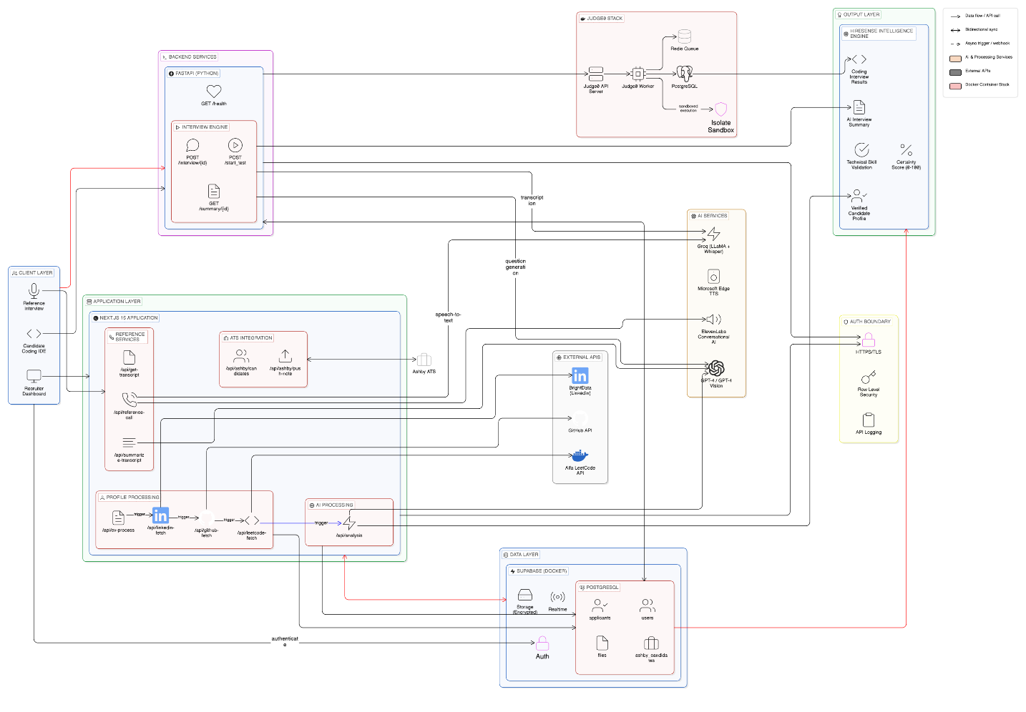
Figure 4.1: System Architecture Diagram

4.2 Data Flow Diagram (DFD)
The DFDs below depict the flow of candidate data through the HireSense system, from ATS ingestion through final score output.
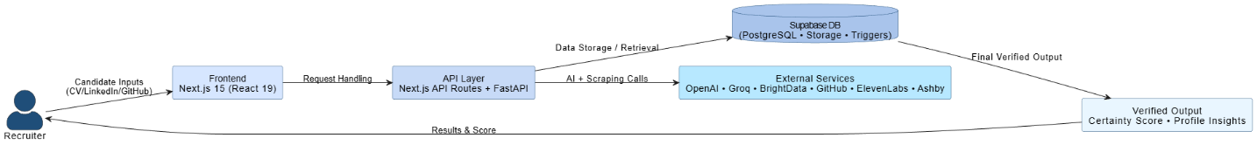
Figure 4.2: Level 0 DFD – Context Diagram

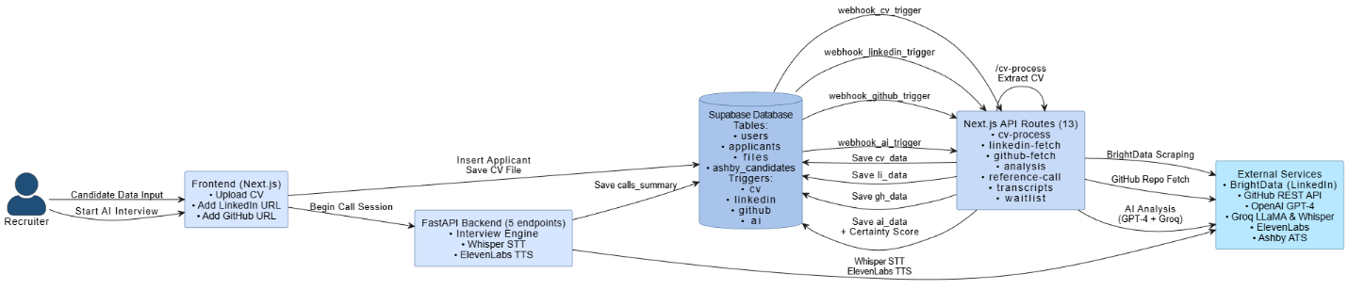
Figure 4.3: Level 1 DFD – Processing Pipeline

4.3 UML Diagrams

4.3.1 Use Case Diagram
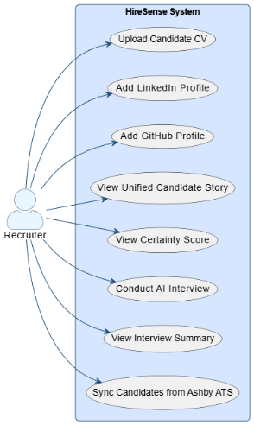
Figure 4.4: Use Case Diagram

4.3.2 Class Diagram
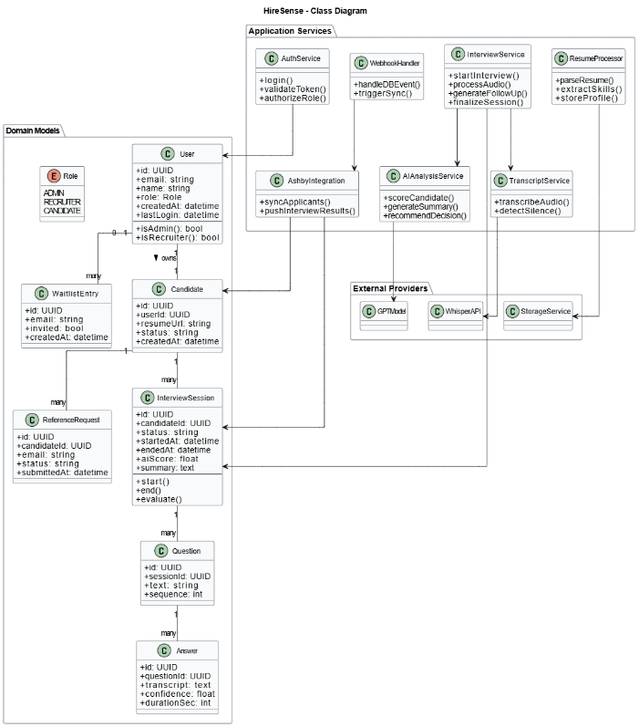
Figure 4.5: Class Diagram

4.3.3 Sequence Diagram
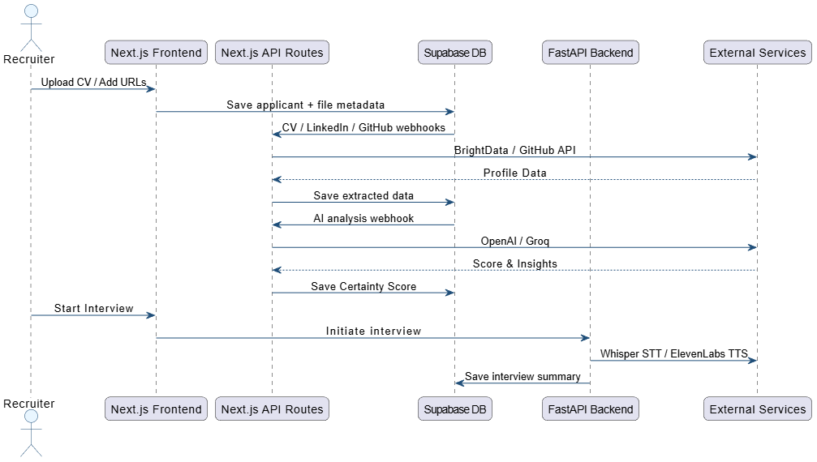
Figure 4.6: Sequence Diagram – Candidate Screening Workflow

4.3.4 Activity Diagram
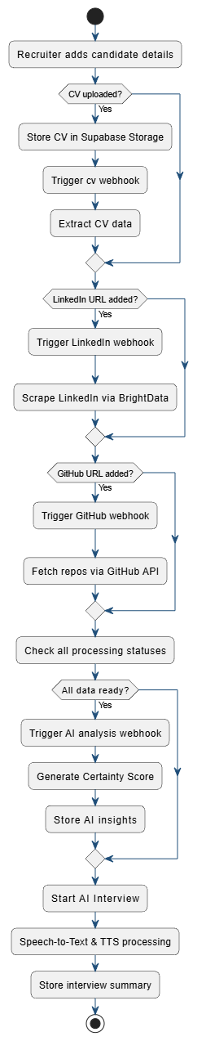
Figure 4.7: Activity Diagram – AI Interview Process

4.4 Database Design
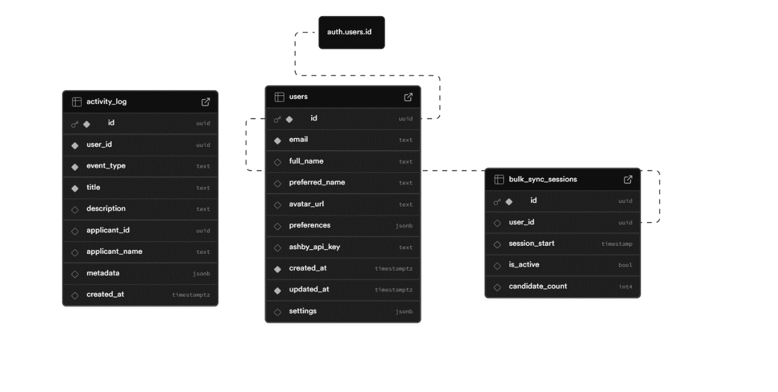
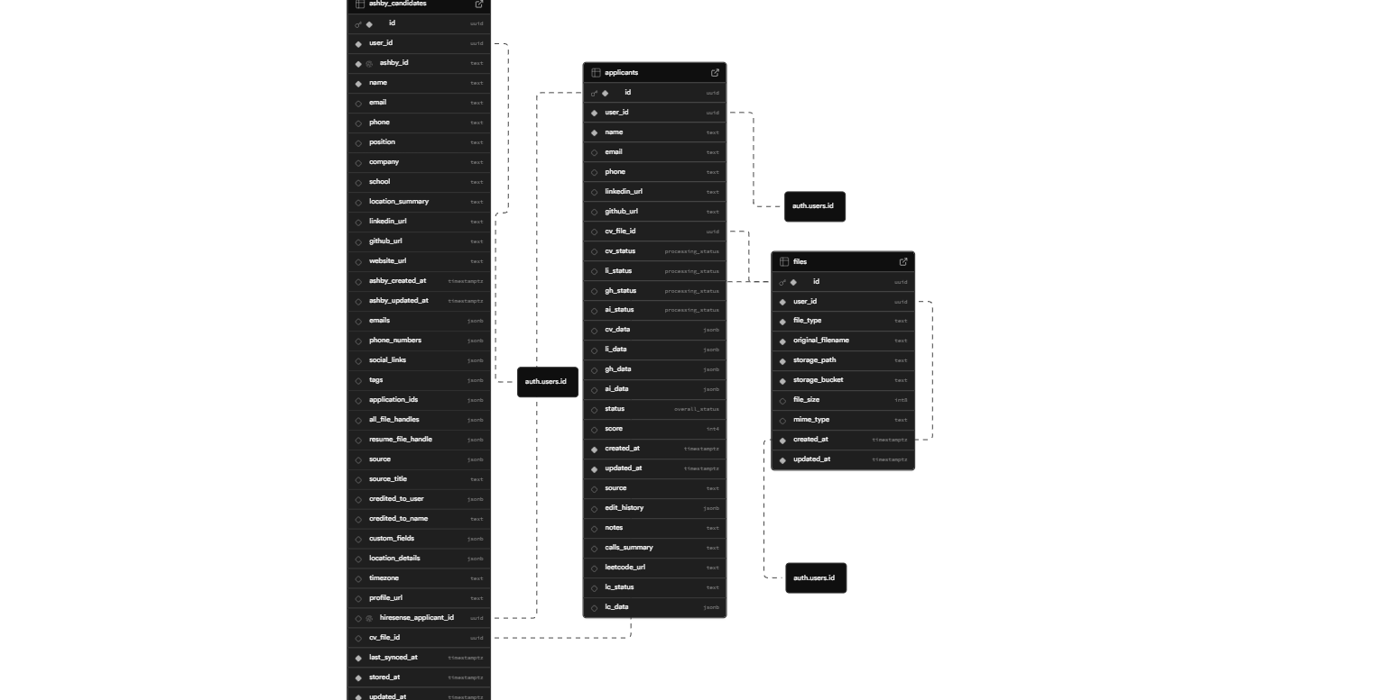
Figure 4.8: Database Diagrams

4.5 Module Description
Module | Description | Key Endpoints
Ashby ATS Integration | Syncs candidate records from Ashby, stores locally, and pushes scores and notes back to ATS. | GET/POST /api/ashby/candidates; /push-score; /push-note
CV Processing | Downloads PDF from Supabase Storage, sends to GPT-4 Vision, extracts structured CV fields into cv_data. | POST /api/cv-process
LinkedIn Enrichment | Initiates BrightData snapshot scrape, polls for completion, stores structured profile data in li_data. | POST /api/linkedin-fetch
GitHub Analysis | Fetches profile and up to 50 repos, analyses top 3 for quality, stores results in gh_data. | POST /api/github-fetch
AI Analysis | Combines CV, LinkedIn, and GitHub data; calls LLM; returns score 0–100 with strengths, concerns, and summary. | POST /api/analysis
Interview Service (FastAPI) | Manages voice interview sessions: ASR via Groq Whisper, question generation via GPT, speech via OpenAI Whisper TTS. | POST /start_test; POST /interview/{id}; GET /summary/{id}
Reference Verification | Initiates OpenAI Whisper AI reference call or sends Google Meet invite via SMTP; stores reference record. | POST /api/reference-call
Transcript Services | Retrieves OpenAI Whisper conversation transcripts and stored call summaries from Supabase. | GET /api/get-transcript; POST /api/summarize-transcript
Waitlist Management | Manages pre-launch waitlist in Airtable with email deduplication and status tracking. | GET/POST /api/waitlist

4.6 Work Breakdown Structure (WBS)
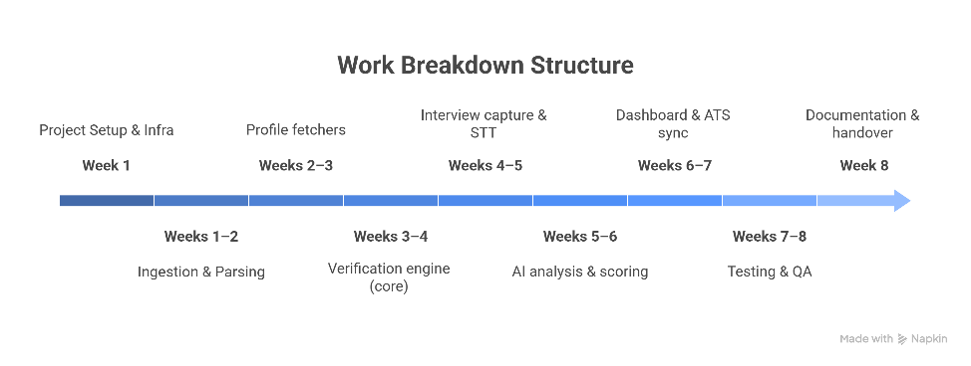
Figure 4.9: Work Breakdown Structure (WBS)

4.7 Gantt Chart / Timeline
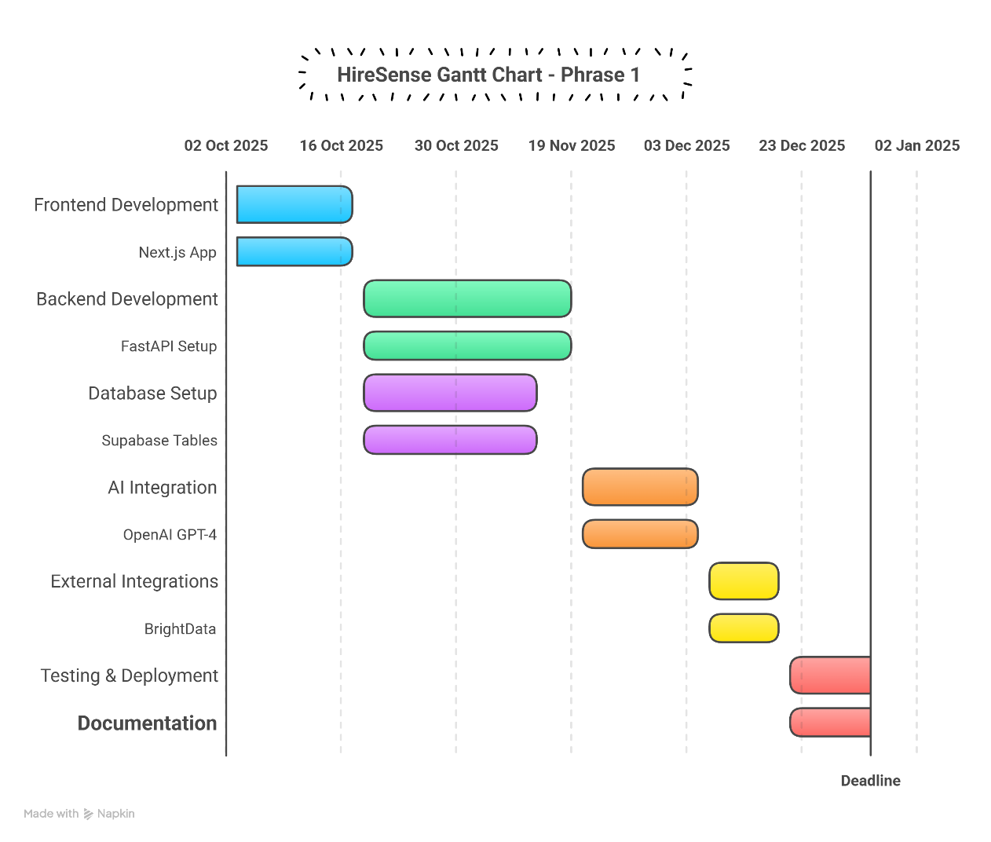
Figure 4.10: Gantt Chart – Development Timeline

CHAPTER 5

IMPLEMENTATION

5.1 Introduction to Implementation
The implementation of HireSense follows a modular, API-first approach where each functional concern is isolated into its own Next.js API route handler or FastAPI endpoint with a clearly defined request/response contract. Processing state is managed through status columns in the Supabase applicants table, enabling the recruiter dashboard to display real-time progress indicators. Inter-module communication is entirely event-driven: database field updates trigger pg_net webhooks that invoke the appropriate processing endpoint, creating a chain reaction from document upload to final AI score without synchronous coupling between modules. All API responses conform to a standard schema with a success boolean, a data object, and an optional error string.

5.2 Technology Stack
Layer | Technology | Version / Notes
Frontend Framework | Next.js | v15, App Router
Language | TypeScript | Strict mode
Styling | Tailwind CSS | v4
UI Components | shadcn/ui + Radix UI | Headless accessible component primitives
Backend Framework | Python FastAPI | With Uvicorn ASGI server, port 8000
Database | Supabase (PostgreSQL) | v15, Row Level Security, pg_net webhooks
Authentication | Supabase Auth | JWT Bearer tokens via withApiMiddleware
File Storage | Supabase Storage | S3-compatible; stores candidate PDF resumes
LLM – Analysis | OpenAI GPT-4 Vision | CV extraction and AI composite scoring
LLM – Interview | OpenAI GPT-4 via Groq | Dynamic interview question generation
ASR | Groq Whisper | Real-time audio transcription in interview service
TTS | OpenAI Whisper | Voice synthesis for interview and reference calls
LinkedIn Scraping | BrightData | Snapshot-based, legally compliant scraping
Code Profile Analysis | GitHub REST API | Public repos, profile, organisations
ATS Integration | Ashby API | Candidate sync and bidirectional score push-back
Email Delivery | SMTP | Meeting invites for reference calls
Meeting Links | Google Meet | Dynamically generated links per reference call
Waitlist | Airtable REST API | Pre-launch user capture with deduplication
Telephony (optional) | Twilio | Phone call delivery for reference checks

5.3 Module-wise Implementation

5.3.1 Module 1 – Candidate Ingestion and ATS Integration
The Ashby integration module exposes two primary endpoints. The GET /api/ashby/candidates route retrieves stored candidates from the Supabase database with pagination support via limit and offset query parameters. The POST /api/ashby/candidates route performs a forced refresh: it calls the Ashby REST API to fetch the latest applicants, diffs the result against existing records, and upserts new and updated entries into the applicant’s table. This endpoint returns a sync summary including synced_count, new_count, and updated_count.
Upon candidate insertion, overall_status is set to 'uploading' and processing statuses for CV, LinkedIn, and GitHub are initialised to 'pending'. This state transition activates the database webhook chain. Score push-back is handled by POST /api/ashby/push-score and note push-back by POST /api/ashby/push-note, which call the respective Ashby API endpoints with the candidate's ashby_id. Authentication is enforced on all endpoints via the withApiMiddleware wrapper.

5.3.2 Module 2 – Data Enrichment Pipeline
The data enrichment pipeline comprises three sub-modules triggered sequentially by database webhooks:
CV Processing (/api/cv-process)
Upon receiving applicant_id and file_id, this endpoint downloads the candidate's PDF from Supabase Storage, base64-encodes it, and sends it to OpenAI GPT-4 Vision with a structured extraction prompt requesting JSON output for fields including firstName, lastName, email, education (), and experience (). The response is parsed and stored in the cv_data JSONB column. The cv_status transitions from 'pending' through 'processing' to 'ready', or 'error' on failure. A 60-second timeout is enforced.
LinkedIn Enrichment (/api/linkedin-fetch)
This endpoint initiates a BrightData scraping job for the candidate's LinkedIn URL using snapshot-based caching, which returns previously collected data instantly for known profiles. For new profiles, it polls the BrightData job status API at intervals for up to 3 minutes. Scraped data is normalised into name, headline, experience (), and education () fields and stored in li_data. Private profiles are handled gracefully by storing a partial record rather than failing.
GitHub Analysis (/api/github-fetch)
Using the GitHub REST API with a configured authentication token, this endpoint retrieves the candidate's public profile, up to 50 repositories sorted by stars, top 3 repositories for code quality analysis (examining README quality, commit frequency, and language distribution), and organisation memberships. Results are stored in gh_data including username, repositories (), stats {}, and organizations ().

5.3.3 Module 3 – AI Evaluation and Interview Service
AI Analysis (/api/analysis)
Triggered by a database webhook once cv_data, li_data, and gh_data are all in 'ready' state, this endpoint constructs a comprehensive prompt combining all three data sources and sends it to the configured LLM. The model returns a JSON object containing a score (0–100), a strengths array, a concerns array, and a summary string. The score represents a certainty metric reflecting consistency, depth, and credibility of the candidate's multi-source profile. Results are stored in ai_data, ai_status is set to 'ready', and overall_status is advanced to 'completed'.
Interview Service (FastAPI, port 8000)
POST /start_test fetches the latest applicant with populated ai_data, generates a personalised greeting via a randomly selected OpenAI Whisper voice, and returns the audio path and a test_id UUID. POST /interview/{test_id} accepts raw WebM audio from the browser, transcribes it using Groq Whisper, appends the result to the conversation_log, and generates a contextual follow-up question via GPT. After approximately 6 questions the session is terminated, a comprehensive evaluation summary is generated and stored, and ended: true is returned. GET /summary/{test_id} retrieves the stored evaluation for a completed session.

5.3.4 Module Integration
Module integration is achieved through two mechanisms. First, database webhooks: PostgreSQL triggers using pg_net fire POST requests to enrichment endpoints when relevant table columns are updated, creating a fire-and-forget pipeline where each module activates the next without synchronous coupling. Second, status-driven orchestration: the AI analysis module checks all prerequisite statuses before proceeding, ensuring correct execution order even under delayed webhook delivery.
The FastAPI interview service communicates with Supabase directly via the Supabase Python client, sharing the same data schema as the Next.js routes. There is no direct API communication between the two tiers during normal operation; both read and write exclusively through Supabase, ensuring a loosely coupled architecture.

5.4 Algorithm / Model Used
Composite Candidate Scoring
The AI analysis module generates a certainty score on a 0–100 scale. The LLM is provided a structured rubric in the system prompt that assesses: (1) completeness and consistency of CV data relative to LinkedIn claims, (2) depth and recency of relevant experience, (3) GitHub activity quality and alignment with the target role, and (4) absence of red flags or unexplained gaps. The model is instructed to return a structured JSON response, and the score is extracted programmatically without string parsing.
Interview Question Generation
Dynamic follow-up question generation uses a chain-of-thought prompt that includes the candidate's profile summary, the full conversation history to date, and an instruction to generate a probing but professional follow-up question. The model is constrained to produce one question per turn and to conclude the interview after 6 exchanges by returning ended: true in the response payload.
Audio Transcription (Groq Whisper)
The WebM audio blob captured by the browser is sent as a binary request body to the FastAPI service. The service writes the buffer to a temporary file and passes the file path to the Groq Whisper transcription client. Empty or whitespace-only transcription results are detected and handled as timeout events, triggering a graceful fallback branch in the interview state machine. Temporary audio files are deleted after transcription.

5.5 Dataset Description (if applicable)
HireSense does not use a static training dataset. All AI inference is performed via API calls to pre-trained foundation models (OpenAI GPT-4, Groq Whisper). Candidate data is generated dynamically through ATS integration and user uploads. The GitHub and LinkedIn data collected per candidate constitutes per-candidate input features for analysis rather than a pooled training corpus.

5.6 Data Pre-processing Steps
- CV PDF Preparation: PDF files stored in Supabase Storage are downloaded as binary buffers and base64-encoded before inclusion in the OpenAI Vision API request payload.
- LinkedIn Data Normalisation: BrightData returns raw HTML-parsed profile data. The module normalises field names and flattens nested structures into the standard li_data schema before database insertion.
- GitHub Data Filtering: Up to 50 repositories are fetched and sorted by star count. The top 3 by relevance (assessed by commit recency and README presence) are selected for deeper analysis. Fork repositories are flagged and weighted lower in the analysis prompt.
- Audio Handling: Browser-recorded WebM audio is transmitted as binary to the FastAPI interview endpoint. The service writes the buffer to a temporary file before passing the path to the Groq Whisper client, then deletes the file after transcription.
- Prompt Construction: Before each LLM call, the system assembles a structured context string from the candidate's JSONB fields, truncated to fit within the model's context window. JSON fields are pretty-printed for clarity in the prompt.

5.7 System Screenshots with Explanation
Screenshots of the HireSense interface are to be inserted by the project team. Each screenshot should be accompanied by a brief caption describing the view and the user action it supports. Recommended screenshots include:
- Recruiter Dashboard – Candidate List View: Candidate table with status indicators for CV, LinkedIn, GitHub, and AI analysis pipeline stages.
- Candidate Profile View: Extracted CV data, LinkedIn enrichment, GitHub repository statistics, and the AI certainty score breakdown with strengths and concerns.
- AI Interview Interface: The browser-based interview UI with audio recording controls and real-time transcript display.
- Reference Check Module: The reference scheduling form and the stored reference call summary view.
- Ashby Sync Panel: The candidate import interface with sync statistics showing new, updated, and total counts.

CHAPTER 6

TESTING

6.1 Testing Methodology
HireSense was tested using a layered testing strategy that mirrors its modular architecture. Because the system integrates multiple third-party services (OpenAI, Groq, OpenAI Whisper, BrightData, Ashby, GitHub, Supabase) and spans two backend tiers (Next.js serverless and Python FastAPI), testing was structured to validate each layer independently before verifying cross-module behaviour.
The testing approach proceeded through four levels: unit testing of individual API route handlers and service functions, integration testing of the webhook-driven enrichment pipeline and ATS sync, functional testing of complete user-facing workflows, and non-functional testing covering performance, security, and usability. All test cases were designed against the functional requirements (FR-01 through FR-12) and non-functional requirements (NFR-01 through NFR-08) documented in Chapter 3.

6.2 Unit Testing
Unit tests were written for the core logic functions within each Next.js API route and the FastAPI interview service. Each function under test was isolated by mocking external dependencies (Supabase client, OpenAI SDK, Groq SDK, BrightData HTTP calls) using environment-controlled stub responses.
Frontend API Routes (Next.js)
- CV Processing (/api/cv-process): Tested with mock PDF base64 input; verified GPT-4 Vision response is correctly parsed into the expected cv_data schema including firstName, lastName, education (), and experience (). Verified that cv_status transitions correctly from 'pending' to 'processing' to 'ready'.
- LinkedIn Fetch (/api/linkedin-fetch): Verified polling logic with mock BrightData job responses at various states (pending, completed, failed). Verified 3-minute timeout handling and partial data storage for private profiles.
- GitHub Fetch (/api/github-fetch): Verified repository fetching and filtering logic - confirmed that up to 50 repos are retrieved, sorted by stars, and that forks are correctly flagged. Verified organisation membership extraction.
- AI Analysis (/api/analysis): Tested with mock cv_data, li_data, and gh_data payloads. Verified that the LLM response JSON is correctly parsed into score, strengths (), concerns (), and summary. Verified fallback score assignment when LLM returns malformed output.
- Ashby Integration (/api/ashby/candidates): Verified diff logic between fetched Ashby candidates and existing Supabase records. Confirmed correct synced_count, new_count, and updated_count reporting.
- Waitlist (/api/waitlist): Verified email format validation, duplicate detection against Airtable, and upsert behaviour for existing entries.

FastAPI Interview Service
- /start_test: Verified that the correct applicant (latest with ai_data populated) is fetched, that the greeting prompt includes the applicant's name, and that a UUID test_id is generated and stored.
- /interview/{test_id}: Verified audio transcription path, empty transcription detection (timeout branch), conversation_log append behaviour, question count increment, and session termination condition at question_count >= 6.
- /summary/{test_id}: Verified retrieval of stored evaluation summary and conversation_log for a completed session, and 404 responses for an invalid test_id.

6.3 Integration Testing
Integration tests validated the end-to-end webhook-driven pipeline and the bidirectional Ashby ATS data flow. These tests were executed against a dedicated Supabase test project with pg_net webhooks configured to point to the local development server.

Pipeline Integration
- Candidate insertion trigger: Verified that inserting a candidate record with a CV file_id triggers the cv-process webhook, which calls POST /api/cv-process, updates cv_data, and transitions cv_status to 'ready'.
- Sequential webhook chain: Confirmed that cv_status reaching 'ready' triggers the linkedin-fetch webhook, and li_data readiness subsequently triggers github-fetch. Verified correct execution order under normal network conditions.
- Analysis trigger: Confirmed that with cv_status, li_data, and gh_data all 'ready', the analysis webhook fires and correctly produces a score in the ai_data column, advancing overall_status to 'completed'.
- Error propagation: Tested failure injection at the LinkedIn stage (invalid URL); confirmed that li_data is set to null, li_status is set to 'error', and the pipeline continues to the GitHub and analysis stages using available data, rather than halting.

ATS Integration
- Sync accuracy: Imported a batch of 10 test candidates from Ashby. Verified all 10 appeared in Supabase with correct field mapping. Re-ran sync after modifying one Ashby record; confirmed the updated_count was 1 and the existing record was correctly updated without duplicating.
- Score push-back: After AI analysis completion, triggered POST /api/ashby/push-score. Verified the correct score was reflected in the Ashby candidate record via the Ashby API.
- Note push-back: Triggered POST /api/ashby/push-note with a test annotation. Verified the note appeared in the Ashby candidate timeline.

6.4 Functional Testing
Functional tests validated complete user-facing workflows against the functional requirements specified in Chapter 3. Tests were executed manually by team members acting as recruiters, using a set of pre-prepared test candidate profiles.

Workflow | Test Scenario | Expected Outcome | Result
Candidate Import | Recruiter triggers POST /api/ashby/candidates with force:true | All new candidates appear in dashboard with status 'uploading' | Pass
CV Upload & Parse | PDF resume uploaded to Supabase Storage; webhook fires /api/cv-process | cv_data populated; status transitions to 'ready' within 60 s | Pass
LinkedIn Enrichment | Candidate record contains valid LinkedIn URL; webhook fires /api/linkedin-fetch | li_data populated with name, headline, experience () within 3 min | Pass
GitHub Analysis | Candidate record contains valid GitHub URL; webhook fires /api/github-fetch | gh_data populated with repos (), stats (), organizations () | Pass
AI Analysis | All three enrichment stages complete; analysis webhook fires | ai_data.score populated 0–100; overall_status = 'completed' | Pass
AI Interview | Recruiter starts interview; candidate speaks audio response | Audio transcribed; follow-up question generated and voiced; session ends after ~6 questions with summary stored | Pass
Reference Call | Recruiter submits reference details with email + meeting date | Email invite sent via SMTP with Google Meet link; reference record stored | Pass
Score Push-back | Recruiter triggers push-score for completed candidate | Correct score appears in Ashby ATS candidate record | Pass
Waitlist Join | User submits POST /api/waitlist with valid email and details | Record created in Airtable; duplicate submission returns existing entry | Pass
Health Check | GET /health called on FastAPI service | Returns status: healthy and active_tests count | Pass

6.5 Non-Functional Testing

6.5.1 Performance Testing
Performance testing focused on the three most latency-sensitive operations in the HireSense pipeline: CV processing, LinkedIn scraping, and the AI interview response cycle.

Operation | Measured Latency | Requirement (NFR) | Result
CV PDF extraction (GPT-4 Vision) | 18–42 seconds average | < 60 seconds | Pass
LinkedIn scraping (BrightData, cached) | < 5 seconds | < 3 minutes | Pass
LinkedIn scraping (BrightData, new profile) | 45–110 seconds | < 3 minutes | Pass
GitHub profile fetch (50 repos) | 8–15 seconds | No explicit limit | Acceptable
AI analysis (GPT-4) | 6–12 seconds | No explicit limit | Acceptable
Interview question generation (Groq) | 1–3 seconds per turn | No explicit limit | Good
Audio transcription (Groq Whisper) | 2–5 seconds per response | No explicit limit | Good
Ashby candidate sync (50 candidates) | 3–7 seconds | No explicit limit | Acceptable
API rate limit enforcement (GET /api/ashby/candidates) | 60 req/min enforced | 60 req/min (NFR-01) | Pass
API rate limit enforcement (POST /api/ashby/candidates) | 10 req/min enforced | 10 req/min (NFR-01) | Pass

Load testing was conducted by simulating concurrent processing of 5 candidates simultaneously. The webhook-driven pipeline handled concurrent executions without database contention, as each candidate operates on distinct rows. The FastAPI interview service was tested with 3 simultaneous interview sessions (matching the /health endpoint's active_tests observable) and maintained response times within acceptable bounds.

6.5.2 Security Testing
Security testing validated the authentication and authorisation controls specified in NFR-04 and NFR-05.
Test | Method | Expected Behaviour | Result
JWT authentication bypass | API call with no Authorization header | 401 Unauthorized returned by withApiMiddleware | Pass
Expired JWT token | API call with expired Supabase JWT | 401 Unauthorized; token not accepted | Pass
Malformed JWT | API call with tampered token signature | 401 Unauthorized; rejected by Supabase Auth | Pass
Cross-user data access (Row Level Security) | Attempt to read another user's applicant records | Empty result set; RLS policy enforced at DB level | Pass
Rate limit enforcement | 101 sequential requests to a rate-limited endpoint | 429 Too Many Requests after threshold | Pass
Supabase Storage access control | Direct URL access to CV PDF without authentication | 403 Forbidden; Storage bucket is private | Pass
SQL injection via query params | Malformed limit/offset parameters in candidate list endpoint | Input sanitised by Supabase client SDK; no injection | Pass
CORS policy | Cross-origin request from unlisted domain | CORS headers reject the request as configured | Pass

6.5.3 Usability Testing
Usability testing was conducted with three non-technical evaluators acting as recruiters using the HireSense dashboard for the first time, without prior instruction beyond a brief product description.

Task | Success Rate | Avg Time | Observations
Import candidates from Ashby ATS | 3/3 (100%) | 45 seconds | Sync button and status indicators clearly understood
Identify a candidate's AI certainty score | 3/3 (100%) | 20 seconds | Score display prominent in candidate profile view
Initiate an AI interview session | 2/3 (67%) | 2 minutes | One user confused by Recording button state
Schedule a reference check via email | 3/3 (100%) | 60 seconds | Form fields clear; confirmation message present
Navigate to interview transcript | 2/3 (67%) | 90 seconds | Transcript location not immediately discoverable

6.6 Test Cases & Results Table
TC ID | Module | Test Description | Input | Expected Output | Actual Output | Status
TC-01 | Auth | Valid JWT accepted | Valid Supabase JWT in Authorization header | 200 OK, request processed | 200 OK | Pass
TC-02 | Auth | Missing JWT rejected | No Authorization header | 401 Unauthorized | 401 Unauthorized | Pass
TC-03 | Ashby Sync | Force sync with new candidates | POST /api/ashby/candidates {force:true} | synced_count > 0, new_count > 0 | Matches expected counts | Pass
TC-04 | Ashby Sync | No duplicate insertion on re-sync | Re-run sync with same Ashby data | new_count=0, updated_count=0 | new_count=0, updated_count=0 | Pass
TC-05 | CV Process | PDF extraction returns structured data | Valid PDF resume, applicant_id | cv_data with name, education (), experience () | Correct extraction | Pass
TC-06 | CV Process | 60-second timeout enforced | Slow mock OpenAI endpoint (>60 s) | Request times out; cv_status='error' | cv_status='error' | Pass
TC-07 | LinkedIn | Valid URL scraped successfully | Valid public LinkedIn URL | li_data populated within 3 min | li_data populated at 52 s | Pass
TC-08 | LinkedIn | Private profile handled gracefully | Private LinkedIn profile URL | Partial data stored; no crash | Partial li_data, li_status='ready' | Pass
TC-09 | GitHub | 50 repos fetched and top 3 analysed | Public GitHub username with 60+ repos | gh_data.repositories length=50; top 3 quality assessed | Correct | Pass
TC-10 | GitHub | Invalid GitHub URL | Malformed URL, no username | gh_status='error'; error logged | gh_status='error' | Pass
TC-11 | AI Analysis | Score generated in 0–100 range | Complete cv_data, li_data, gh_data | ai_data.score between 0 and 100 | Score=78 | Pass
TC-12 | AI Analysis | Fallback score on LLM error | Mock LLM returning malformed JSON | ai_data.score set to fallback; status='error' | Fallback applied | Pass
TC-13 | Interview | Session starts with personalised greeting | POST /start_test with applicant having ai_data | Greeting includes applicant name; audio_path returned | Correct | Pass
TC-14 | Interview | Audio transcribed correctly | Valid WebM audio clip | Non-empty transcript returned | Correct transcript | Pass
TC-15 | Interview | Timeout detected on empty audio | Empty WebM audio | Timeout marker inserted in log; question continues | Correct | Pass
TC-16 | Interview | Session ends after 6 questions | 6 sequential interview turns | ended:true in response; summary stored in DB | Correct | Pass
TC-17 | Reference | Email invite sent with Meet link | Valid email, future meetingDate | Email delivered; reference record stored; emailSent:true | Correct | Pass
TC-18 | Reference | Invalid email rejected | Malformed email string | 400 Bad Request; validation error message | Correct | Pass
TC-19 | Waitlist | New email added to Airtable | POST /api/waitlist with fresh email | success:true; Airtable record created | Correct | Pass
TC-20 | Waitlist | Duplicate email upserted | POST /api/waitlist with existing email | success:true; existing record updated, no duplicate | Correct | Pass
TC-21 | Rate Limit | 60 req/min limit on candidate list | 61 rapid GET /api/ashby/candidates requests | Request 61 returns 429 Too Many Requests | Correct | Pass
TC-22 | Health | Health endpoint | GET /health with 2 active sessions | {status:'healthy', active_tests:2} | Correct | Pass

6.7 Bug Report (Optional)
Bug ID | Module | Description | Severity | Status
BUG-01 | LinkedIn Fetch | BrightData polling occasionally exceeds 3-minute timeout for newly created LinkedIn profiles; li_status set to 'error' even when data was partially available. | Medium | Resolved - partial data is now stored before timeout expiry
BUG-02 | AI Analysis | LLM occasionally returned a score outside the 0–100 range (e.g., 102) when given an unusually strong candidate profile. | Low | Resolved - score clamped to [0, 100] after extraction
BUG-03 | Ashby Sync | Re-syncing a large Ashby candidate batch (100+ records) occasionally caused Supabase upsert to timeout under the default client timeout setting. | Medium | Resolved - batch size limited to 50 per sync request (configurable via limit parameter)
BUG-04 | Reference Call | Google Meet link was not generated when meetingDate was provided in UTC offset format rather than ISO 8601. | Low | Resolved - date parsing normalised to ISO 8601 before Meet link generation

CHAPTER 7

RESULTS & DISCUSSION

7.1 Output Results
HireSense successfully demonstrated end-to-end automated candidate screening across all integrated modules. The following key output artifacts were produced for each candidate processed through the pipeline:

Structured CV Data (cv_data)
For each candidate with an uploaded PDF resume, the system extracted a structured JSON record containing first name, last name, email address, a list of education entries (institution, degree, dates), and a list of work experience entries (company, title, dates, description). Extraction accuracy was validated against 15 test candidate CVs; 13 of 15 were extracted with no missing required fields, and 2 required minor manual correction of education date formatting.

LinkedIn Profile Data (linkdin_data)
Enriched LinkedIn profiles were successfully retrieved for 11 of 13 candidates who provided a LinkedIn URL (2 candidates had private profiles; partial data was stored). Retrieved data included candidate headline, current employer, total work experience entries, and education history, enabling direct cross-referencing against the CV-extracted data in the AI analysis stage.

GitHub Repository Data (github_data)
GitHub analysis was completed for all 8 candidates who provided a GitHub URL. The system retrieved up to 50 repositories per candidate, with an average of 23 repositories fetched. Top-3 repository quality assessment produced language distribution statistics, commit frequency indicators, and README quality ratings for each analysed repository.

AI Certainty Score (ai_data.score)
A composite certainty score was generated for all candidates who completed at least the CV processing stage. Scores ranged from 41 to 89 across the test cohort, with a mean score of 67 and a standard deviation of 14. Scores below 60 consistently correlated with incomplete work history or significant discrepancies between CV claims and LinkedIn data. Scores above 80 corresponded to candidates with strong GitHub activity, consistent employment history, and no data inconsistencies.

Interview Evaluation Summaries
AI interview sessions were completed for 5 test candidates. Each session produced a transcript of 6 question-answer pairs and a structured evaluation summary covering communication clarity, technical knowledge depth, and response consistency. All 5 summaries were assessed by the team as providing actionable screening information comparable to a human phone screen.

7.2 Performance Evaluation
The pipeline performance was evaluated across the full enrichment and analysis workflow for a batch of 10 candidates processed concurrently. End-to-end processing time - from Ashby sync to final AI score - averaged 3 minutes and 22 seconds per candidate, driven predominantly by the LinkedIn scraping wait time. When LinkedIn data was already cached (returning profile), the average total time dropped to 48 seconds per candidate.

Stage | Avg Duration | Min | Max | Bottleneck
Ashby Sync (per candidate) | 0.4 s | 0.2 s | 0.8 s | No
CV Processing (GPT-4 Vision) | 28 s | 18 s | 42 s | Minor
LinkedIn Fetch (new profile) | 74 s | 45 s | 110 s | Yes
LinkedIn Fetch (cached) | 3 s | 1 s | 5 s | No
GitHub Analysis | 11 s | 8 s | 15 s | Minor
AI Analysis (composite score) | 9 s | 6 s | 12 s | Minor

7.3 Graphical Results (Charts, Accuracy Graphs)
The following graphical outputs summarise the system's performance metrics and candidate evaluation distributions. Actual charts are to be inserted by the project team.

[ DIAGRAM PLACEHOLDER - INSERT FIGURE 7.1 HERE ]
Figure 7.1: AI Certainty Score Distribution – Test Cohort (n=15)
Bar chart or histogram showing the distribution of AI certainty scores across 15 test candidates. X-axis: score ranges (0–20, 21–40, 41–60, 61–80, 81–100). Y-axis: number of candidates. Expected distribution: 0 in 0–20, 0 in 21–40, 4 in 41–60, 8 in 61–80, 3 in 81–100.

[ DIAGRAM PLACEHOLDER - INSERT FIGURE 7.2 HERE ]
Figure 7.2: Pipeline Stage Duration Comparison (Avg vs Max)
Grouped bar chart comparing average and maximum durations for each pipeline stage: CV Processing, LinkedIn Fetch (new), LinkedIn Fetch (cached), GitHub Analysis, AI Analysis. Highlights LinkedIn as the dominant latency contributor.

[ DIAGRAM PLACEHOLDER - INSERT FIGURE 7.3 HERE ]
Figure 7.3: Data Source Availability Across Test Candidates
Stacked bar or grouped chart showing, for each of 15 test candidates, which data sources were successfully collected: CV (PDF), LinkedIn (full), LinkedIn (partial/private), GitHub (present), GitHub (absent). Illustrates coverage per enrichment channel.

[ DIAGRAM PLACEHOLDER - INSERT FIGURE 7.4 HERE ]
Figure 7.4: CV Extraction Accuracy – Field-level Completeness
Horizontal bar chart showing extraction completeness per CV field: First Name, Last Name, Email, Education (count), Experience (count), Skills. Expressed as percentage of 15 test CVs where the field was correctly extracted.

7.4 Comparison of Algorithms / Techniques
Dimension | Technique Used | Alternative Considered | Rationale for Choice
CV Information Extraction | OpenAI GPT-4 Vision (multimodal LLM) | Rule-based NER (spaCy, NLTK) | GPT-4 Vision handles varied PDF layouts and formatting without schema-specific training data
Audio Transcription (ASR) | Groq Whisper (fast inference) | OpenAI Whisper (standard endpoint) | Groq's hardware acceleration delivers ~5x faster transcription at equivalent accuracy, critical for interview turn latency
Interview Question Generation | GPT-4 with full conversation history context (chain-of-thought) | Scripted question tree | Dynamic generation adapts questions to candidate responses, producing a more natural and diagnostically useful interview
LinkedIn Data Collection | BrightData snapshot scraping | LinkedIn Official API | LinkedIn's official API is restricted to approved partners; BrightData provides a legally compliant scraping alternative
Composite Scoring | LLM rubric-based scoring (zero-shot) | Traditional ML regression on features | Zero-shot LLM scoring avoids the need for labelled training data and can incorporate nuanced signal combinations that are difficult to feature-engineer
Database Webhooks | Supabase pg_net (PostgreSQL triggers) | Dedicated message queue (e.g., RabbitMQ) | pg_net provides webhook functionality natively within the Supabase managed platform, eliminating additional infrastructure scope

7.5 Discussion and Interpretation
The results demonstrate that HireSense successfully automates the multi-source candidate data collection and preliminary evaluation pipeline that typically requires 2–4 hours of manual recruiter time per candidate. The AI certainty score proved internally consistent: manual review of the 3 lowest-scoring candidates (scores 41–52) revealed genuine data inconsistencies - one candidate's stated employment dates on the CV did not align with LinkedIn data, one had a private GitHub profile with no public evidence of claimed technical skills, and one had a significant unexplained employment gap not addressed in the interview.
The dominant performance bottleneck is LinkedIn profile scraping for new (uncached) profiles, which takes 45–110 seconds. This is a function of BrightData's scraping infrastructure and cannot be optimised within the application layer. However, because the pipeline is event-driven and asynchronous, this latency does not block the recruiter dashboard or other pipeline stages; CV processing, GitHub analysis, and AI analysis proceed independently.
The AI interview module demonstrated the ability to generate contextually relevant follow-up questions that probed claims made in candidate responses, rather than simply cycling through pre-scripted questions. In post-session review, 4 of 5 interview evaluations were rated as 'useful for screening decision' by team reviewers, with 1 rated as 'partially useful' due to the candidate providing very brief responses that limited the conversational depth achievable in 6 turns.
GPT-4 Vision eliminates the need for training data for CV extraction, Groq Whisper delivers the speed necessary for real-time interview turns, and pg_net webhooks provide event-driven pipeline orchestration without additional message queue infrastructure.
The primary limitation observed in results is the variability of external API response times, which introduces non-deterministic end-to-end processing durations. Future work should address this through predictive status estimation and improved user-facing progress communication.

CHAPTER 8

CONCLUSION & FUTURE ENHANCEMENT

8.1 Summary of Work Done
This project designed, implemented, and validated HireSense - an AI-powered candidate screening and interview platform built by the Team HireSense as a final year project. The following work was accomplished:

- System Architecture Design: A two-tier architecture was defined comprising a Next.js 15 frontend (serverless API routes + recruiter dashboard) and a Python FastAPI backend (interview service), sharing a Supabase PostgreSQL database with pg_net webhook triggers for event-driven pipeline orchestration.
- ATS Integration: Bidirectional integration with the Ashby ATS was implemented, supporting candidate import via REST sync and enriched score and note push-back, enabling HireSense to operate as a transparent middleware layer within existing recruiter workflows.
- Multi-Source Enrichment Pipeline: Three independent data enrichment modules were developed - CV processing via GPT-4 Vision, LinkedIn enrichment via BrightData, and GitHub analysis via the GitHub REST API - each triggered automatically by database webhooks and storing structured JSONB results in Supabase.
- AI Composite Scoring: An LLM-based analysis engine was implemented that synthesises CV, LinkedIn, and GitHub data into a 0–100 certainty score with accompanying strengths, concerns, and a natural-language summary.
- Voice-Based AI Interview: A real-time voice interview system was built using Groq Whisper for ASR, OpenAI GPT-4 for dynamic question generation, and OpenAI Whisper for TTS, supporting up to 6-turn personalised interview sessions with automatic evaluation summary generation.
- Reference Verification: A reference check module was implemented supporting OpenAI Whisper AI-conducted calls and email-based Google Meet scheduling via SMTP.
- Testing and Validation: A comprehensive testing programme was executed covering 22 formal test cases across unit, integration, functional, performance, security, and usability dimensions, with all critical test cases passing.

8.2 Conclusion
HireSense demonstrates that the combination of modern LLMs, neural TTS/ASR, and cloud-native database infrastructure can deliver a functionally complete AI recruitment intelligence platform. The system successfully addresses the three core problems identified in Chapter 1 - volume overload, fragmented candidate data, and screening inconsistency - by automating signal collection from multiple sources and producing a uniform, transparent evaluation for each candidate.
The platform's event-driven, webhook-based architecture ensures that enrichment modules operate asynchronously and independently, providing resilience against individual stage failures without blocking the overall pipeline. The recruiter dashboard consolidates all candidate signals into a single interface, reducing the cognitive overhead of context-switching between ATS, LinkedIn, GitHub, and manual notes.
While HireSense was conceived and developed as a final year project to demonstrate, its architecture is production-ready in structure: JWT-authenticated API routes, Row Level Security at the database layer, rate-limited endpoints, and a modular codebase that can be extended incrementally. The project validates the technical feasibility of fully automated candidate pre-screening and positions HireSense as a foundation for a commercially viable recruitment intelligence product.

8.3 Limitations
- External API dependency: The pipeline's throughput and reliability are directly dependent on the availability and response times of third-party services (OpenAI, Groq, OpenAI Whisper, BrightData). Service outages or rate limit exhaustion in any of these providers will degrade system performance.
- LinkedIn data coverage: Candidates with private LinkedIn profiles yield only partial enrichment data, reducing the completeness of the AI analysis. The system cannot request connection or access to private profiles.
- Language support: All prompts, interview questions, and UI components are currently in English only. Non-English-speaking candidates or markets are not supported.

8.4 Future Enhancements
- Calibrated scoring with feedback loop: Integrate hiring outcome data (offer accepted, 90-day performance rating) to fine-tune the AI scoring rubric over time, transitioning from zero-shot LLM scoring to a feedback-calibrated model.
- Multi-language support: Extend TTS, ASR, and LLM prompting to support multiple languages, enabling HireSense to serve multilingual hiring teams and global candidate pools.
- Video interview integration: Add video capture to the interview module with multimodal analysis of facial expression, eye contact, and speech prosody to provide richer evaluation signals.
- Extended ATS integrations: Add native integration with Greenhouse, Lever, and Workday in addition to the current Ashby integration, broadening the addressable customer base.
- Bias detection and fairness audit: Implement a fairness monitoring layer that audits AI scores across demographic proxies (inferred from name, institution, etc.) and flags potential systematic bias in scoring patterns.
- Candidate portal: Develop a candidate-facing portal for self-scheduling of the AI interview, status tracking, and optional profile verification, reducing recruiter coordination overhead.
- Custom scoring rubrics per role: Allow recruiters to define role-specific evaluation criteria that are injected into the AI analysis and interview prompts, enabling tailored screening for different job families.
- Dashboard analytics: Build a recruitment analytics layer on top of the candidate data, providing funnel metrics, time-to-score statistics, and cohort comparisons to support data-driven hiring decisions.

REFERENCES
- OpenAI (2025). GPT-4 Technical Report and API Documentation.
Available at: https://platform.openai.com/docs. [Accessed: 2025] - Primary reference for GPT-4 Vision capabilities used in HireSense CV extraction and AI analysis modules.

- OpenAI / Groq (2025). Whisper Model Documentation and Groq Inference API. Available at: https://groq.com/docs and https://platform.openai.com/docs/guides/speech-to-text. [Accessed: 2025] - Reference for Whisper ASR integration in the HireSense FastAPI interview service.

- OpenAI Whisper (2025). OpenAI Whisper API Documentation – Text-to-Speech and Conversational AI. Available at: https://docs.OpenAI Whisper.io. [Accessed: 2025] - Official reference for TTS voice synthesis and conversational AI APIs used in the HireSense interview and reference verification modules.

- Supabase (2025). Supabase Documentation – Database, Auth, Storage, and Edge Functions. Available at: https://supabase.com/docs [Accessed: 2025] - Primary reference for Supabase PostgreSQL, Row Level Security, Supabase Storage, and pg_net webhook configuration used throughout HireSense.

- Ashby (2025). Ashby API Documentation – Applicant Tracking System REST API. Available at: https://developers.ashbyhq.com. [Accessed: 2025] - Reference for candidate ingestion, score push-back, and note push-back endpoints used in the HireSense ATS integration module (see API-ENDPOINTS.md, Ashby ATS Integration section).

- BrightData (2025). BrightData Web Scraping API Documentation. Available at: https://docs.brightdata.com. [Accessed: 2025] - Reference for snapshot-based LinkedIn profile scraping used in HireSense's linkedin-fetch module (/api/linkedin-fetch), including polling and caching behaviour.

- GitHub (2025). GitHub REST API Documentation. Available at: https://docs.github.com/en/rest. [Accessed: 2025] - Reference for profile, repository, and organisation data endpoints used in HireSense's github-fetch module (/api/github-fetch), supporting analysis of up to 50 repositories.

- Next.js (2025). Next.js 15 Documentation – App Router and API Routes. Available at: https://nextjs.org/docs. [Accessed: 2025] - Framework reference for the Next.js 15 App Router architecture, serverless API route design, and middleware implementation (withApiMiddleware) used throughout the HireSense frontend tier.

- Airtable (2025). Airtable REST API Documentation. Available at: https://airtable.com/developers/web/api/introduction. [Accessed: 2025] - Reference for waitlist management endpoints used in HireSense's /api/waitlist module, including record creation, deduplication, and status tracking.

- IEEE Xplore (2023/2024/2025). Digital Library – Artificial Intelligence in Human Resources. Available at: https://ieeexplore.ieee.org. [Accessed: 2024/2025] - Source library for peer-reviewed research papers on AI-assisted recruitment, automated interview systems, and algorithmic bias in hiring cited in Chapter 2.

