**Name:** Ankit Sharma

**Email:** [kumarankitx022@gmail.com](mailto:kumarankitx022@gmail.com)

**Mob no.:** +91-7677241423

**ASSIGNMENT – 01**

**MEAN:** Mean is the most commonly used measure of central tendency. There are different types of mean, viz. arithmetic mean, weighted mean, geometric mean (GM) and harmonic mean (HM).

**1. Arithmetic mean** (or, simply, “mean”) is nothing but the average. It is computed by adding all the values in the data set divided by the number of observations in it.

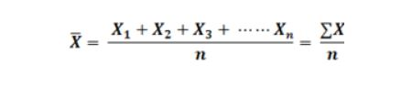

**2. Weighted mean:** When the values are not of equal importance, we assign them certain numerical values to express their relative importance. These numerical values are called weights. **If X1, X2, ……, Xkhave weights W1, W2,……., W3,** then **the** **weighted arithmetic mean** or **the weighted mean**, which is denoted as [clip_image034](https://econtutorials.com/wp-content/uploads/2015/07/clip_image034.png), is calculated by the following formula;

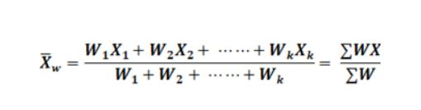

**3. Geometric mean:** The geometric mean, G, of a set of *n*positive values X1, X2, ……, Xnis the nth root of the product of the values. Mathematically the formula for geometric mean will be as follows;

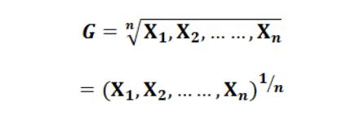

In practice, it is difficult to extract higher roots. The geometric mean is, therefore, computed using logarithms. Mathematically, it will be represented as follows;

[clip_image058](https://econtutorials.com/wp-content/uploads/2015/07/clip_image058.png)

**4. Harmonic mean:** The harmonic mean, **H, of a set of n values X1, X2, ……, Xn**is the reciprocal of the arithmetic mean of the reciprocals of the values. Mathematically, the formula for harmonic mean will be as follows;

