O’ZBEKISTON RESPUBLIKASI OLIY VA O’RTA MAXSUS

TA’LIM VAZIRLIGI

QARSHI DAVLAT UNIVERSITETI

MATEMATIKA VA KOMPYUTER ILMLARI FAKULTETI

AMALIY MATEMATIKA YO’NALISHI

“ALGORITMIK TILLAR VA DASTURLASH ASOSLARI” FANIDAN YOZGAN

KURS ISHI

**Mavzu: O’quv markazi web sayti(**boshqaruv tizimi bilan**)**

Bajardi: Shonazarov Uchqun

Qabul qildi: Matanov Muhammad

Qarshi - 2022

**MUNDARIJA**

**I-BOB. KIRISH. NAZARIY QISM.**

1.1.Yaratishda tanlangan dasturlash tili haqida.

1.2.Yaratishda tanlangan asosiy texnologiyalar va frameworklar.

**II-BOB.AMALIY QISM**

2.1.Saytning asosiy tuzilmasi va vazifasi

2.2.Kerakli kutubxonalar haqida

2.3.Sayt oynalaridan lavhalar

**XULOSA.**

**FOYDALANILGAN ADABIYOTLAR VA TA’LIM SAYTLARI RO’YXATI.**

**KIRISH**

Bu sayt backend va front end qismlar dan tashkil topgan. Saytni yaratishda asosan Java dasturlash tili ishlatilgan. Bunda Spring Boot texnologiyasidan foydalanilgan.

Java dasturlash tili – keng tarqalgan, foydalanishga qulay dasturlash tillaridan biri bo‘lib, unda mukammal darajadagi dasturiy mahsulotlarni yaratish mumkin. Bu dasturlash tili *Oak* dasturlash tili asosida paydo bo‘lgan. *Oak* (ma’nosi: eman daraxti) dasturlash tili

90-yillarning boshida Sun Microsystems (hozirda Oracle nomidan ish yuritadi) kompaniyasi tomonidan platformaga (operatsion tizimga) bog‘liq bo‘lmagan holda ishlovchi yangi avlod ”aqlli” qurilmalarini yaratishni maqsad qilib harakat boshlangan edi. Bunga

erishish uchun kompaniya xodimlari C++ tilini ishlatishni rejalashtirishgan, lekin ayrim sabablarga ko‘ra bu fikridan voz kechishdi. Oak dasturlash tili muvofaqiyatsiz chiqdi va 1995-yilda Sun uning nomini Javaga almashtirdi hamda bu tilga WWW rivojlanishiga xizmat qilishi uchun ma’lum o‘zgartirishlar kiritishdi. Java 1990 yillarda ishlab chiqarila boshlangan bo‘lsa ham, uning birinchi versiyasi(Java 1.0 ) 1996 yil ommaga taqdim etilgan.

Java obyektga yo‘naltirilgan dasturlash (OOP-object oriented programming) tili bo‘lib, u C++ ga ancha o‘xshash. C++ tilidagi eng ko‘p yo‘l qo‘yildigan xatolarga sabab bo‘luvchi qismlar olib tashlandi va u asosida bu dasturlash tilining texnologiyasi yaratildi. Java texnologiyasi o‘ta sodda, xavfsizlikni yuqori darajada ta'minlab bera oladigan, kuchli, to‘la obyektga yo‘naltirilgan dasturlash tili bo‘lib, operatsion muhit (platforma)ga bog‘liq bo‘lmagan holda ishlaydi. Bu til yordamida eng kichik qurilmalarga ham dasturlar yozish mumkin. Java texnologiyasi to‘laligicha JVM - Java Virtual Machine ga asoslangan. JVM ning vazifasi tarjimonlik hisoblanadi, ya’ni dastlab biz yozgan *\*.java* fayl, kompilyator yordamida bayt kodga o‘giriladi, so‘ngra esa JVM yordamida mashina tiliga o‘tkaziladi. Javaning sintaksisi C++ ga asoslangan. Shuning uchun C++ tilini biladiganlar Javani oson o‘rganishadi. Lekin undagi ko‘pchilik noqulaylik tug‘diradigan xususiyatlar olib tashlangan.

Javada asosan 4 tipdagi dasturlar yoziladi:

1) ***Standard* applications** – Linux, Mac yoki Windowsga o‘rnatib, kundalik ishlatiladigan dasturlar: mp3 player, ofis, antivirus kabilar. Ular AWT, Swing yoki JavaFX texnologiyalari orqali tuziladi.

2) **Web Applications** – tarmoq orqali ishlovchi ixtiyoriy dasturlar. Web dasturlar ikki qismdan, server tomon hamda klient tomon (brauzer) dan iborat. Javada faqat server tomon uchun dasturlar yoziladi. Bunda servlet, jsp, jsf kabi fundamental

texnologiyalardan boshlab *Swing*, *Play* kabi freymworklardan foydalaniladi. Umuman olganda brauzer uchun dasturlar HTML, CSS hamda Java Script kabi tillarda yoziladi.

3) **Enterprise Applications** – bu dasturlar yirik salmoqqa ega bo‘lib, odatda katta jabhalarda ishlatiladi. Banklar, tashkilotlar yoki astronomiya kabi sohalarda keng qo‘llaniladi. Ular yuqori xavfsizlik, yuklamani serverlarga teng taqsimlash (load balancing) yoki klasterlash (clustering – katta tizimdan xuddi yagona obyekt sifatida foydalanish) kabi sifatlarni talab qiladi.

4) **Mobile Applications** – Javada mobil qurilmalarga mos dasturlarni yozish imkoniyatini beradi. U Androiddan boshlab JME gacha qo‘llaniladi.

Java dasturlash tilini o’zida dinamik saytlar yaratish uchun maxsus paketlar mavjud bo’lib, Servlet nomli class barcha HTTP so’rovlari bilan ishlaydi. Ammo Javaning o’zida butun bir Web saytni yaratish ko’p vaqtni oladi. Shuning uchun hamma java dasturchilar uchun umumiy bo’lgan, kodlarni qayta - qayta yozmaslik uchun frameworklardan foydalaniladi.

Java Webda eng mashhur framework bu springdir. Spring framework bir nechta modullardan iborat bo’lib, turli sohalarga qarab qo’llaniladi. Web sayt yaratish uchun asosiylari: Web, Security, JPA.

Springda sayt yaratish uchun start.spring.io saytidan boshlang’ich kodlar generatsiya qilinadi.

Keyin bu saytda qo’llangan asosiy kutubxonalardan biri bu thymeleafdir. Thymeleaf – bu Spring Boot da html hujjatni generatsiya qiluvchi engine(mator) bo’lib, foydalanishga juda qulaydir. Uni dasturga qo’shish uchun loyiha ichidagi pom.xml fayliga quyidagi kutubxonalar qo’shiladi:

<dependency>  
 <groupId>org.springframework.boot</groupId>  
 <artifactId>spring-boot-starter-thymeleaf</artifactId>  
</dependency>

<dependency>  
 <groupId>org.thymeleaf.extras</groupId>  
 <artifactId>thymeleaf-extras-java8time</artifactId>  
  
</dependency>

Mening saytimda qo’llanilgan kutubxonalar va sozlamalar:

<?xml version="1.0" encoding="UTF-8"?>  
<project xmlns="http://maven.apache.org/POM/4.0.0" xmlns:xsi="http://www.w3.org/2001/XMLSchema-instance"  
 xsi:schemaLocation="http://maven.apache.org/POM/4.0.0 https://maven.apache.org/xsd/maven-4.0.0.xsd">  
 <modelVersion>4.0.0</modelVersion>  
 <parent>  
 <groupId>org.springframework.boot</groupId>  
 <artifactId>spring-boot-starter-parent</artifactId>  
 <version>2.5.3</version>  
 <relativePath/> <!-- lookup parent from repository -->  
 </parent>  
 <groupId>uz.jjp</groupId>  
 <artifactId>O-quv-markazi</artifactId>  
 <version>0.0.1-SNAPSHOT</version>  
 <name>O-quv-markazi</name>  
 <description>Demo project for Spring Boot</description>  
 <properties>  
 <java.version>11</java.version>  
  
 </properties>  
 <dependencies>  
 <dependency>  
 <groupId>org.springframework.boot</groupId>  
 <artifactId>spring-boot-starter-thymeleaf</artifactId>  
 </dependency>  
 <dependency>  
 <groupId>org.springframework.boot</groupId>  
 <artifactId>spring-boot-starter-web</artifactId>  
 </dependency>  
 <dependency>  
 <groupId>org.springframework.boot</groupId>  
 <artifactId>spring-boot-starter-data-jpa</artifactId>  
 </dependency>  
  
 <dependency>  
 <groupId>org.springframework.boot</groupId>  
 <artifactId>spring-boot-starter-security</artifactId>  
 </dependency>  
  
 <dependency>  
 <groupId>org.postgresql</groupId>  
 <artifactId>postgresql</artifactId>  
  
 </dependency>  
 <dependency>  
 <groupId>org.springframework.boot</groupId>  
 <artifactId>spring-boot-starter-test</artifactId>  
 </dependency>  
 <dependency>  
 <groupId>org.hibernate</groupId>  
 <artifactId>hibernate-core</artifactId>  
 <version>5.4.32.Final</version>  
 </dependency>  
 <dependency>  
 <groupId>org.thymeleaf.extras</groupId>  
 <artifactId>thymeleaf-extras-java8time</artifactId>  
  
 </dependency>  
 <dependency>  
 <groupId>io.jsonwebtoken</groupId>  
 <artifactId>jjwt</artifactId>  
 <version>0.9.1</version>  
 </dependency>  
 </dependencies>  
  
 <build>  
 <plugins>  
 <plugin>  
 <groupId>org.springframework.boot</groupId>  
 <artifactId>spring-boot-maven-plugin</artifactId>  
 </plugin>  
 </plugins>  
 </build>  
  
</project>

Bu saytda MOBT(ma’lumotlar omborini boshqarish tizimi) sifatida PostgreSql ni tanlaganman. Hozirgi kunda ko’plab MOBTlar mavjud, bu tizimlar 2 turga ajratiladi: 1.Sql; 2.NoSql.

SQL MOBT ancha avvaldan yaratilgan bo’lib, ma’lumotlarni bog’langan jadvallar ko’rinishida saqlaydi. Bunday MOBT larga quyidagilar kiradi:

- MS Access

- My SQL

- Postgre SQL

- MS Server

- SQLite

- Oracle

Spring Boot da bazadan ma’lumotlarni olib kelish uchun Repository interfeysidan foydalaniladi. Kompilatsiya jarayonida repositoryga yozilgan metodlar uchun maxsus SQL kodlar generatsiya qilinadi.

Pom.xml fayliga kiritiladigan kutubxona:

<dependency>  
 <groupId>org.postgresql</groupId>  
 <artifactId>postgresql</artifactId>  
  
</dependency>

SELECT so’rovini yozish uchun repositoryda find bilan boshlangan metodlar yoziladi. Sayt kodidan quyidagini misol qilib ko’rsatishim mumkin. Quyidagi model bo’yicha so’rovlar yozamiz:

Fan classi:

package uz.jjp.O.quv.markazi.entity;  
  
import javax.persistence.*;  
  
@Entity  
public class Fan {  
 @Id  
 @GeneratedValue(strategy = GenerationType.*IDENTITY*)  
 private Long id;  
 @Column(unique = true)  
 private String nom;  
 private String info;  
  
 public Long getId() {  
 return id;  
 }  
  
 public void setId(Long id) {  
 this.id = id;  
 }  
  
 public String getNom() {  
 return nom;  
 }  
  
 public void setNom(String nom) {  
 this.nom = nom;  
 }  
  
 public String getInfo() {  
 return info;  
 }  
  
 public void setInfo(String info) {  
 this.info = info;  
 }  
}

FanRepository classi:

package uz.jjp.O.quv.markazi.repository;  
  
import org.springframework.data.domain.Page;  
import org.springframework.data.domain.Pageable;  
import org.springframework.data.jpa.repository.JpaRepository;  
import org.springframework.data.jpa.repository.Query;  
import org.springframework.stereotype.Repository;  
import uz.jjp.O.quv.markazi.entity.Fan;  
  
import java.util.List;  
  
@Repository  
public interface FanRepository extends JpaRepository<Fan,Long> {  
  
 Page<Fan> findAllByNomContainsIgnoreCaseOrInfoContainsIgnoreCaseOrId(String nom, String info, Long id, Pageable pageable);  
  
 List<Fan> findAllByOrderByIdDesc();  
  
 Page<Fan> findAllByOrderByIdDesc(Pageable pageable);  
}

Saytda ma’lumotlarni xavfsizligini ta’minlash maqsadida Spring Securitydan foydalanganman. Uning maxsus kutubxonasini yuklab olgan holda uni loyihaga sozlab olsangiz u butun loyihani himoyasiga to’liq javob beroladi. Agar tegishli shaxs tasdiqlanmasa bazadagi ma’lumotlar tashqariga chiqarilmaydi. Mening saytimda hozircha yagona admin tizimga kirishi mumkin, lekin yana boshqa admin tayinlashni ilojisi mavjud.

O’zim faqat bitta boshqaruvchi bo’lishinio xohladim.

Pom.xml fayliga kiritiladigan kutubxona:

<dependency>  
 <groupId>org.springframework.boot</groupId>  
 <artifactId>spring-boot-starter-security</artifactId>  
</dependency>

Loyihada ma’lumotlar quyidagi shaklda almashinadi:

Baza(Model bo’yicha) -> Repository -> Service -> Controller -> FrontEnd

FrontEnd -> Controller -> Service -> Repository -> Baza(Model bo’yicha)

FrontEnd qismda esa hammamizga ma’lum html, css, javascript kodlari ishlatiladi:

<!doctype html>  
<html lang="en">  
  
<head>  
 <title>Fanlar</title>  
 <link href='https://unpkg.com/boxicons@2.0.9/css/boxicons.min.css' rel='stylesheet'>  
 <link rel="stylesheet" href="/css/header.css">  
 <link rel="stylesheet" href="/css/royxat.css">  
 <!-- Required meta tags -->  
 <meta charset="utf-8">  
 <meta name="viewport" content="width=device-width, initial-scale=1, shrink-to-fit=no">  
 <link rel="stylesheet" href="https://maxcdn.bootstrapcdn.com/font-awesome/4.7.0/css/font-awesome.min.css">  
 <!-- Bootstrap CSS -->  
 <link rel="stylesheet" href="https://stackpath.bootstrapcdn.com/bootstrap/4.3.1/css/bootstrap.min.css"  
 integrity="sha384-ggOyR0iXCbMQv3Xipma34MD+dH/1fQ784/j6cY/iJTQUOhcWr7x9JvoRxT2MZw1T" crossorigin="anonymous">  
  
 <meta http-equiv="Cache-Control" content="no-cache, no-store, must-revalidate">  
 <meta http-equiv="Pragma" content="no-cache">  
 <meta http-equiv="Expires" content="0">  
  
  
 <link href="/css/style.css" rel="stylesheet">  
   
</head>  
<style>  
 body {  
 background-image: url('/Снимок7.PNG');  
 background-size: cover;  
 }   
   
   
</style>  
  
<body>  
  
  
  
 <div class="modal fade" id="exampleModal" tabindex="-1" aria-labelledby="exampleModalLabel" aria-hidden="true">  
 <div class="modal-dialog">  
 <div class="modal-content">  
 <div class="modal-header">  
 <h5 class="modal-title" id="exampleModalLabel">Siz rostdan ham ushbu fanni o'chirmoqchimisiz?</h5>  
 <button type="button" class="close" data-dismiss="modal" aria-label="Close">  
 <span aria-hidden="true">&times;</span>  
 </button>  
 </div>  
  
 <div class="modal-footer">  
 <button type="button" class="btn btn-secondary" data-dismiss="modal">Bekor qilish</button>  
 <a href="/fanlar/ochirish/" class="btn btn-danger">O'chirish</a>  
 </div>  
 </div>  
 </div>  
 </div>  
  
  
  
  
 <div th:insert="header :: boshqism1"></div>  
 <div class="container bg-light mt-3 mb-3 pb-3 pt-2"  
 style="box-shadow: 1px 1px 15px 1px rgba(0, 0, 0, 0.788);">  
  
 <h2 style="padding-left: 10px;color: rgb(2, 26, 98);">Fanlar bo'limi</h2>  
 <hr>  
 <div class="row">  
 <div class="col-12 col-lg-4">  
 <div th:if="${fan} == null" style="background-color: rgb(200, 217, 250); padding: 13px;">  
  
  
 <h4>Fan qo'shish</h4>  
  
  
  
 <form th:action="@{/fanlar}" method="POST">  
 <div class="form-group">  
 <label for="mon">Nom:</label>  
 <input type="text" name="nom" id="mon" class="form-control" placeholder="Fan nomini kiriting..."  
 aria-describedby="nom" required>  
  
 </div>  
  
 <div class="form-group">  
 <label for="info">Izoh</label>  
 <textarea class="form-control" name="info" id="info" rows="5" placeholder="Izoh..."></textarea>  
 </div>  
 <input type="submit" class="btn btn-primary" value="Qo'shish"></input>  
 <input type="reset" class="btn btn-danger" value="Tozalash"></input>  
 </form>  
 </div>  
 <div th:if="${fan} !=null" style="background-color: rgb(192, 214, 255); padding: 13px;">  
 <h4>Fanni tahrirlash</h4>  
 <form th:action="@{/fanlar/edit}" method="POST">  
 <div class="form-group">  
 <label for="id">Id:</label>  
 <input th:value="${fan.id}" type="text" name="id" id="id" class="form-control" aria-describedby="id"  
 readonly>  
 </div>  
 <div class="form-group">  
 <label for="mon">Nom:</label>  
 <input th:value="${fan.nom}" type="text" name="nom" id="mon" class="form-control"  
 placeholder="Nomini kiriting..." aria-describedby="nom" required>  
  
 </div>  
 <div class="form-group">  
 <label for="info">Izoh</label>  
 <textarea th:field="${fan.info}" class="form-control" name="info" id="info" rows="5"  
 placeholder="Izoh..."></textarea>  
 </div>  
 <button type="submit" class="btn btn-primary">Tahrirlash</button>  
 <a href="/fanlar" class="btn btn-danger" style="font-weight: normal **!important**;">Bekor qilish</a>  
 </form>  
 </div>  
 </div>  
 <div class="col-12 col-lg-8" style="background-color: rgb(245, 243, 243); padding: 13px;">  
  
  
 <h4>Fanlar ro'yxati</h4>  
  
  
  
 <div style="display: flex; flex-wrap: wrap;justify-content: flex-end;">  
 <div style="font-size: 20px;padding-top: 4px;color: rgb(54, 54, 54);min-width: 115px;padding-left: 0;">  
 Natija:  
 <span id="jami" th:text="${totalItems}">99</span>  
 ta  
 </div>  
 <div style="padding-top: 6px;padding-left: 8px;">  
 <form id="izlash" th:action="@{/fanlar/izla}" method="get">  
 <input type="text" id="qidir" name="satr" placeholder="ma'lumot kiriting...">  
 <input type="submit" id="tugma" value="Izlash"></input>  
 </form>  
 </div>  
  
 </div>  
  
  
  
  
  
 <div th:if="${totalItems} == 0" id="royxatBush">  
 Ro'yxat bo'sh!  
  
 </div>  
 <table th:if="${totalItems} != 0" class="table table-striped datatable table-responsive">  
 <thead>  
 <tr>  
 <th>Id</th>  
 <th>Nom</th>  
 <th>Izoh</th>  
 <th>Amallar</th>  
 </tr>  
 </thead>  
 <tbody>  
 <tr th:each="o : ${fanlar}">  
 <td th:text="${o.id}">59</td>  
 <td th:text="${o.nom}">mob</td>  
 <td th:text="${o.info}">matika</td>  
 <td>  
 <a class="btn btn-info" th:href="@{/fanlar/edit/{id}(id=${o.id})}" style="border-radius: 50%;">  
 <i class="fa fa-pencil " aria-hidden="true"></i>  
 </a>  
  
  
  
 <button type="button" class="btn btn-danger" data-toggle="modal" data-target="#exampleModal"  
 th:attr="data-id=${o.id}" style="border-radius: 50%;">  
 <i class="fa fa-trash" aria-hidden="true"></i>  
 </button>  
  
  
 </td>  
 </tr>  
   
 </tbody>  
 </table>  
   
   
 <nav aria-label="Page navigation example" th:if="${pages} > 1">  
 <ul class="pagination d-flex flex-wrap justify-content-center">  
 <li class="page-item disabled" th:if="${pageNumber} == 0">  
 <a class="page-link" th:href="@{'/fanlar'+${surov}+'?page=' +${pageNumber-1}}" tabindex="-1">Avvalgi</a>  
 </li>  
 <li class="page-item" th:if="${pageNumber} > 0">  
 <a class="page-link" th:href="@{'/fanlar'+${surov}+'?page=' +${pageNumber-1}}" tabindex="-1">Avvalgi</a>  
 </li>  
   
  
 <li class="page-item ml-0 mr-0" th:each="i : ${#numbers.sequence(1,pages)}">  
 <a class="page-link" th:href="@{'/fanlar'+${surov}+'?page='+${i-1}}" th:text="${i}">1</a>  
 </li>  
   
  
 <li class="page-item disabled" th:if="${pageNumber} == ${pages-1}">  
 <a class="page-link" th:href="@{'/fanlar'+${surov}+'?page=' +${pageNumber+1}}">Keyingi</a>  
 </li>  
 <li class="page-item " th:if="${pageNumber} < ${pages-1}">  
 <a class="page-link" th:href="@{'/fanlar'+${surov}+'?page=' +${pageNumber+1}}">Keyingi</a>  
 </li>  
 </ul>  
 </nav>  
  
  
 <!-- <div th:if="${totalPages > 1}">  
 <div class="row col-sm-10">  
 <div class="col-sm-2" >  
 Total Rows: [[${totalItems}]]  
 </div>  
 <div class="col-sm-1">  
 <span th:each="i : ${#numbers.sequence(1,totalPages)}">  
 <a th:if="${currentPage != 1}" th:href="@{'/fanlar/page/' +${i}}">[[${i}]]</a>  
 <span th:unless="${currentPage != i}">[[${i}]]</span> &nbsp; &nbsp;  
 </span>  
 </div>  
 <div class="col-sm-1">  
 <a th:if="${currentPage < totalPages}" th:href="@{'/fanlar/page/' +${currentPage+1}}">Next</a>  
 <span th:unless="${currentPage < totalPages}">Next</span>  
 </div>  
 <div class="col-sm-1">  
 <a th:if="${currentPage < totalPages}" th:href="@{'/fanlar/page/' +${totalPages}}">Last</a>  
 <span th:unless="${currentPage < totalPages}">last</span>  
 </div>  
 </div>  
 </div> -->  
  
 </div>  
 </div>  
 </div>  
  
  
  
  
  
 <!-- Optional JavaScript -->  
 <!-- jQuery first, then Popper.js, then Bootstrap JS -->  
 <script src="https://code.jquery.com/jquery-3.3.1.slim.min.js"  
 integrity="sha384-q8i/X+965DzO0rT7abK41JStQIAqVgRVzpbzo5smXKp4YfRvH+8abtTE1Pi6jizo"  
 crossorigin="anonymous"></script>  
 <script src="https://cdnjs.cloudflare.com/ajax/libs/popper.js/1.14.7/umd/popper.min.js"  
 integrity="sha384-UO2eT0CpHqdSJQ6hJty5KVphtPhzWj9WO1clHTMGa3JDZwrnQq4sF86dIHNDz0W1"  
 crossorigin="anonymous"></script>  
 <script src="https://stackpath.bootstrapcdn.com/bootstrap/4.3.1/js/bootstrap.min.js"  
 integrity="sha384-JjSmVgyd0p3pXB1rRibZUAYoIIy6OrQ6VrjIEaFf/nJGzIxFDsf4x0xIM+B07jRM"  
 crossorigin="anonymous"></script>  
  
  
  
 <script>  
 $('#exampleModal').on('show.bs.modal', function (event) {  
 var button = $(event.relatedTarget)  
 var id = button.data('id');  
 var modal = $(this)  
 modal.find('.modal-footer a').attr('href', '/fanlar/ochirish/' + id)  
 })  
 </script>  
<script src="/js/tinymce.min.js"></script>  
<script src="/js/simple-datatables.js"></script>  
<!-- Template Main JS File -->  
<script src="/js/main.js"></script>  
  
</body>  
  
</html>

-bu fanlar bo’limidagi oyna. Qolgan oynalari shunga o’xshash va bundan murakkabroq kodlardan iborat.

Saytni domenini ***sayt.uz*** saytidan *uchqunilm.uz* holatida sotib olingan, hostingni esa ***webname.uz*** saytidan sotib olingan va shu serverda yurgizilgan. Endi saytni *uchqunilm.uz* manzilidan topishingiz mumkin.

Saytga kirishingizda o’quv markazi haqida reklamalar chiqadi:

* undagi ochilishi kutilayotgan yangi guruhlar,
* undagi mavjud guruhlar,
* o’quv markazi haqida qisqacha ma’lumot,
* markazdagi o’qituvchilar haqida qisqacha ma’lumot,
* sayt ma’muriyatiga murojaat,
* manzillar va hokazo.

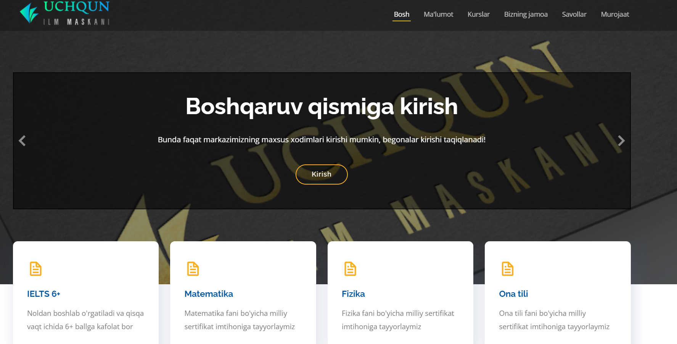



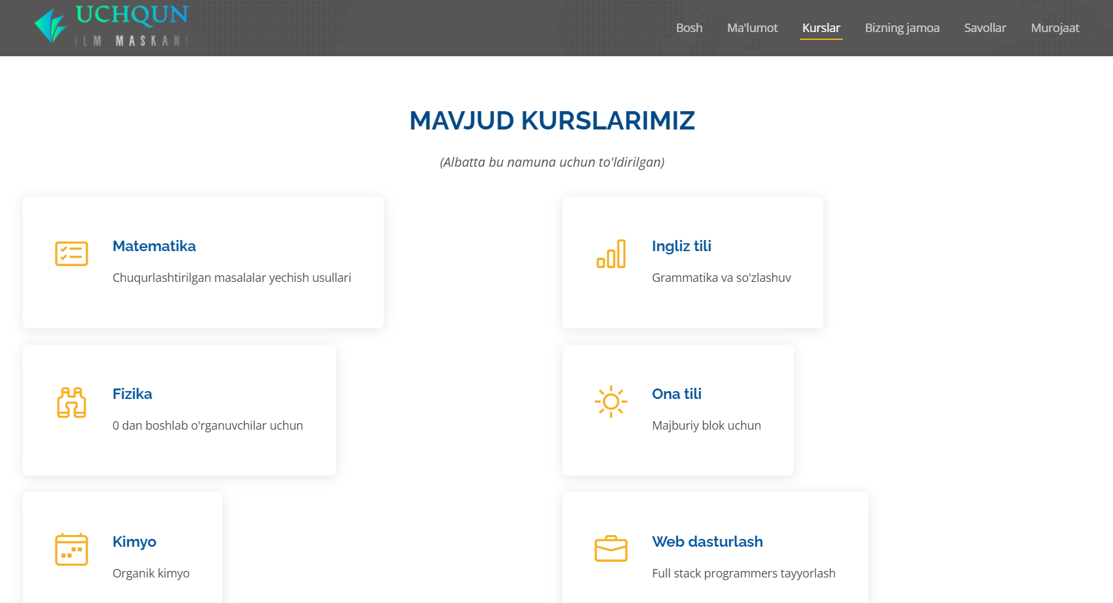



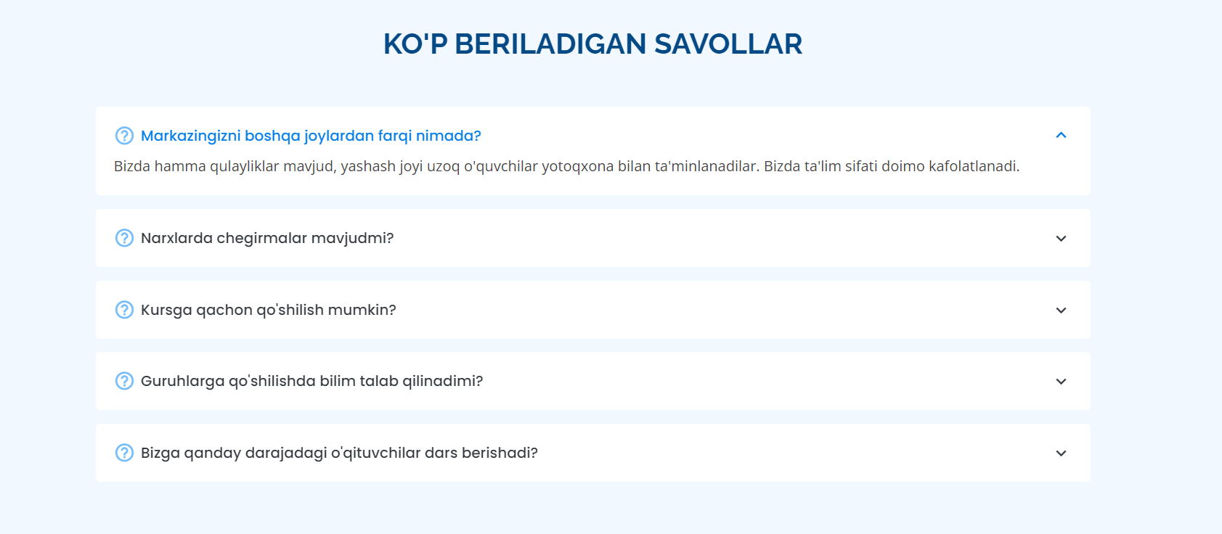

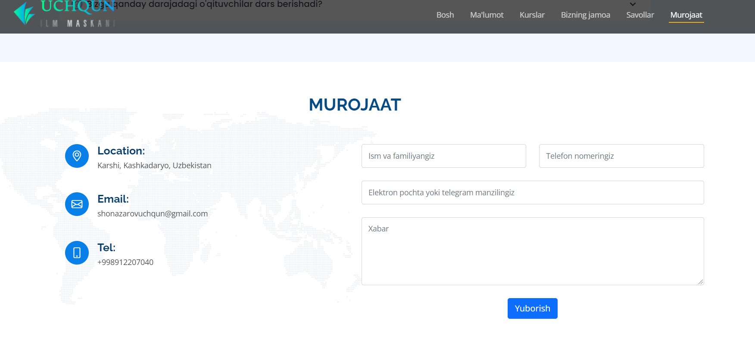

-bu qismda murojaat qilish joylashgan bo’lib, o’ng tomondagi formani to’gri to’ldirgan holda yuborish tugmasi bosilsa xabar telegram bot orqali, ya’ni maxsus yaratilgan telegram botning nomidan o’quv markazi adminstratoriga yuboriladi. Bunday qilib yaratishimga sabab hamma foydalanuvchi ham telegram messenjeridan ro’yxatdan o’tgan bo’lavermasligi ham mumkin, shuning uchun bot orqali xabar yuboriladi.

Boshqaruvchi AdminPanelga kirish uchun, quyidagi oynadagi kirish tugmasini bosish orqali kirishi mumkin:

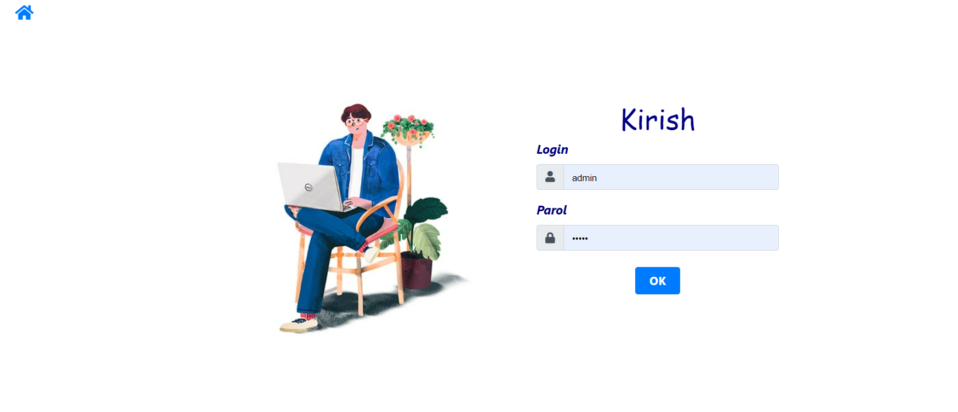

Tegishli login parollar kiritilgan holda boshqaruv qismiga o’tish mumkin.

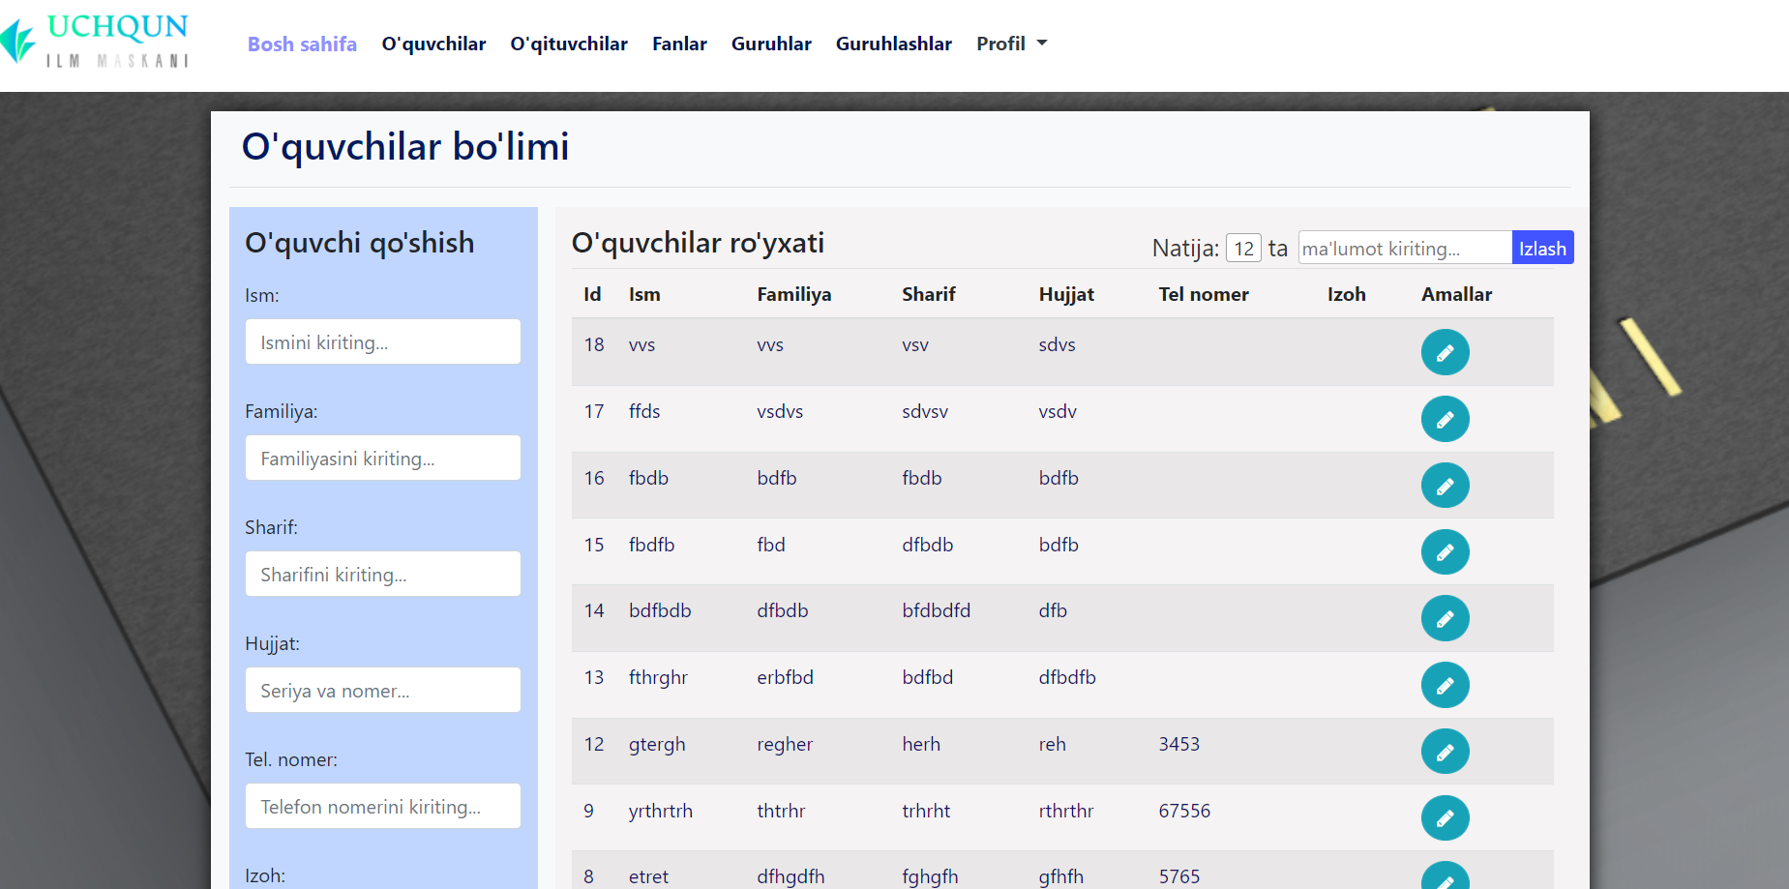

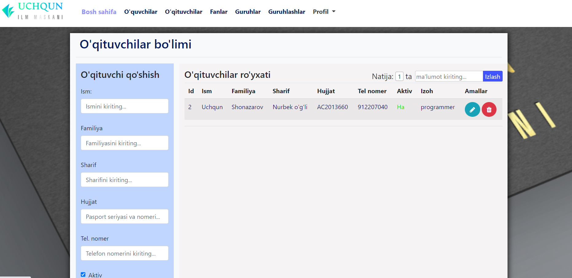

Va boshqa oynalar mavjud, yan bunda admin ma’lumotlar ham mavjud:

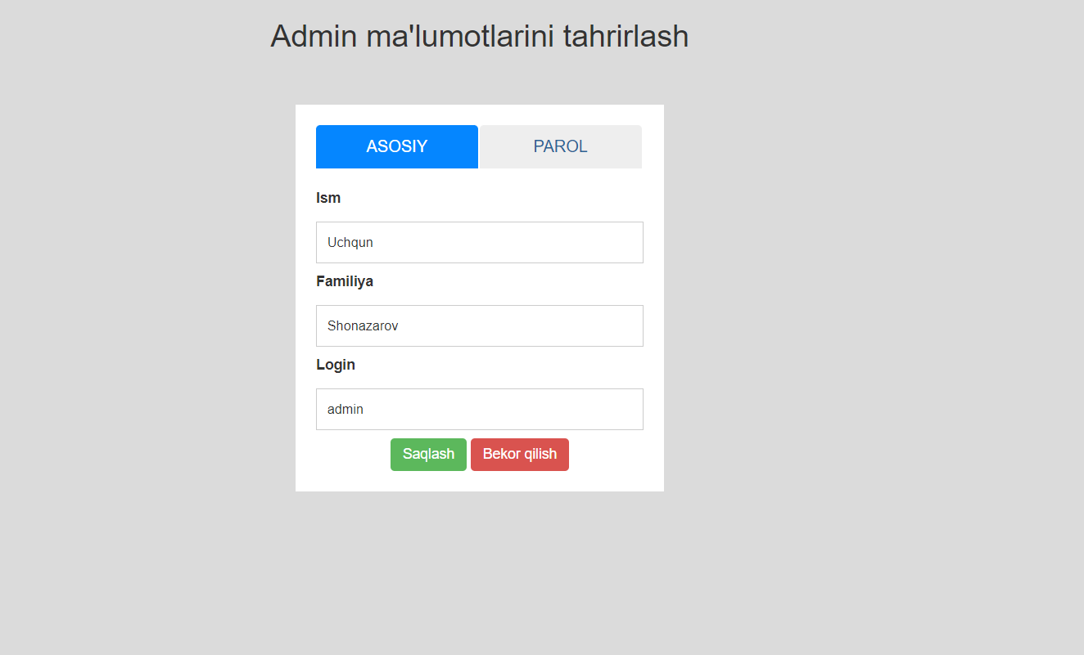

**Xulosa**

Bu sayt o’quv markazlari uchun yaratildi. Ushbu saytda o’quv markazining reklama qismi va boshqaruv qismi mavjud. Bunda boshqaruvni markaz adminstratori yuritib borishi mumkin. Yuqorida saytning hamma imkoniyatlarini ochib berolmagan bo’lishim mumkin. Lekin htttp://uchqunilm.uz linki orqali tanishib chiqishingiz mumkin. Bu sayt orqali ko’plab abituriyentlarni o’quv markaziga jalb qilish mumkin deb o’ylayman.

**Foydalanilgan adabiyotlar va ta’lim saytlari ro’yxati**

<https://start.spring.io/>;

<http://uchqunilm.uz>;

<https://getbootstrap.com/>;

<https://github.com/>;

<https://github.com/Uchqun7040/O-quv-markazi>;