**University of Waterloo**

**Department of Systems Design Engineering**

DESIGN SHOWCASE REPORT

**Design Team 20**

BME 161 – Introduction to Biomedical Design

Date Submitted: 22nd November 2020

Members:

* Hoang Bao Khanh Le #20878587
* Rayeeda Afrida Prerona #20913543
* Isha Sharma #20883793
* Utku Cicek #20910452
* Saad Hossain #20871248

# **Summary of Problem Space**

# The Situation of Concern and Situation Impact Statement

# Individuals living with a disability, in particular, spinal cord injury (SCI), are more likely to suffer from obesity compared to the general population [1]. This is concerning since SCI-specific obesity risk factors including cardiovascular disease, restricted physical activity, etc. [1], [2], [3]. It also promotes Type 2 diabetes, and worse, speeds up ageing. [4-6]

# Therefore, it is important for people with SCI to reduce and manage their weight in the long-term. However, for them, weight management is a major challenge. Methods for weight measurements are often expensive, not available in most clinics, and can place a high burden on clinic personnel and patients [7]. In addition to the ability to obtain an accurate weight in a clinic environment, there is a need for accurate weight measurement in the home environment. Studies from weight management strategies in the able-bodied population show that 75% of those achieving and maintaining weight loss weighed themselves weekly [8], proving self-weighing is an important self-regulatory part of the weight loss process. [9].

# There are several existing products that are used to weigh individuals with an SCI. However, most of these are not feasible for at-home use. One product is a digital wheelchair scale, from around $1,000 to $4,000 USD [10], [11], which is considered expensive compared to a bathroom scale (from around $10 to $50 USD [12]). Moreover, it is typically not possible for an individual with SCI to independently weigh themselves and their wheelchair separately. Medical beds equipped with weighing functions can also weigh patients with SCI [13], [14]. However, these beds are intended for medical use in healthcare facilities and are rarely found in home settings. Finally, the weight of people with SCI can be obtained using an adult sling mounted to a digital scale [15]. However, this product is not designed for independent use and is meant to be used under supervision by trained individuals. All these products are accurate but many times more expensive compared to a bathroom scale and not appropriate for at-home use.

# Therefore, there is a need to design an affordable device to be used by wheelchair-bound individuals affected by all degrees of Spinal Cord Injury (SCI) to accurately weigh themselves independently or with minimal assistance at the convenience of their own home to allow for better weight management in order to combat obesity and other weight-related health complications.

# This situation of concern is a modified version of [16].

# Constraints

# Must keep the user safe while using the solution

# Must not exceed electrical safety standards [18]

# Must not have weight capacity below 150kg

# Requirements

# Should make the user feel convenient using the solution:

# Should support independent use

# Should minimize installation time

# Should be inexpensive

# Should support weights that are at least 200kg [17]

# Basic Functions

# Considering user needs from personas, certain functions were decided upon presenting in the design solution. To start with, one of the most important functions is determining the user weight. This function solely relates to how the device can measure the weight by the aid of computation while coming in contact with the product. To combine the results and have them being used in our products, a crucial function in our device is to be able to display both weight and BMI on a screen was added. Additionally, the function of being connected to phones through an application can allow alternatives through which the responses can be displayed. The storing bodyweight function in the device enhances the amount of convenience a user can feel. While the memory function just requires an individual to weigh their wheelchairs once, it significantly reduces the hassle of measuring the wheelchair separately.

# **Solution Approach**

# The proposed solution approach (a 'cushion-scale') is a seat-cushion that is composed of two parts: a back-seat/rest and a base-seat. There are load cells and pressure sensors integrated into both the back-seat and the base-seat (connected using wires and circuitry to a microprocessor), which connects to an interface (which comprises an on/off switch and display). An individual with SCI would only need to be seated on this cushion-scale to obtain their weight. The cushion-scale could be placed on any chair (even a wheelchair) by the patient or someone else depending on the patient's upper-body functionality. The microprocessor would process the inputs from the load cells and pressure sensors by feeding them into a machine-learning trained on a dataset collected from user-testing to predict an accurate value of the patient's weight, which would then be presented on the interface's display for the patient to see.

Storyboard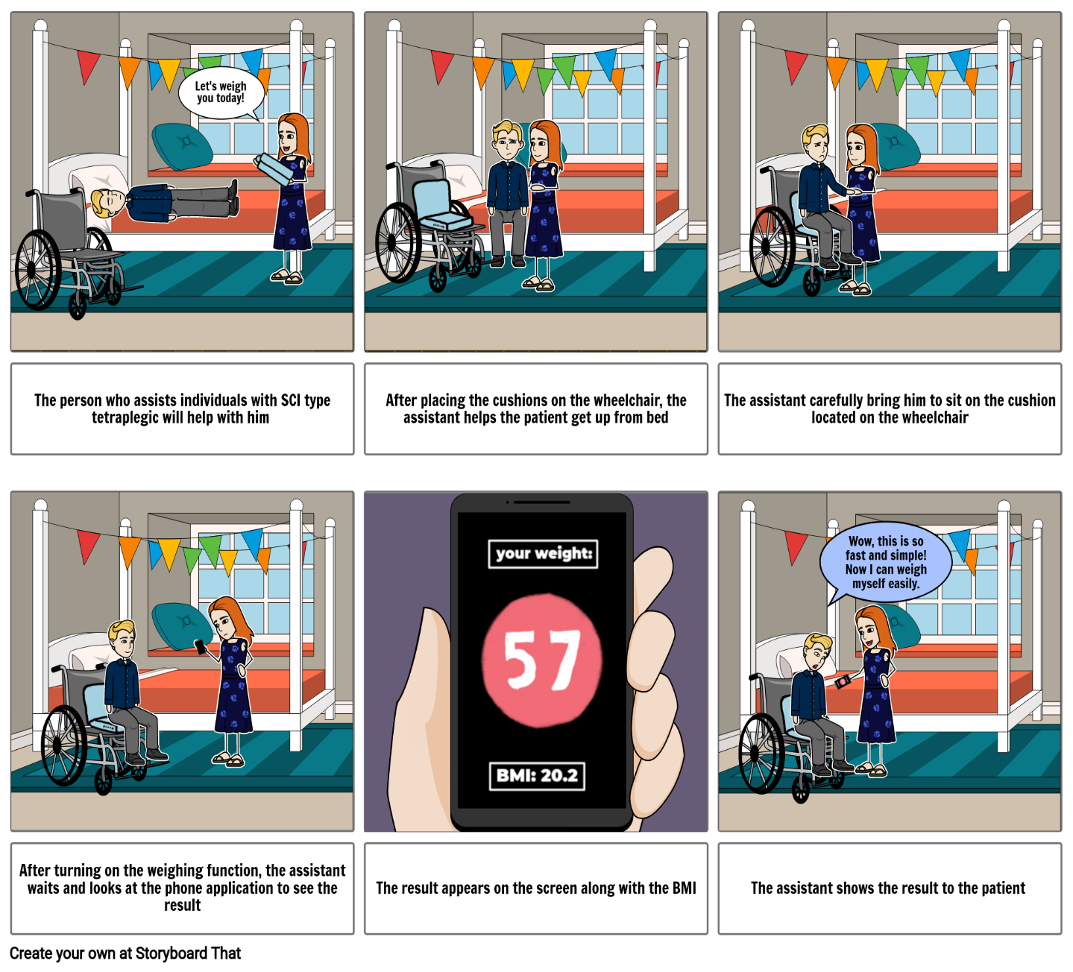

Fig.1: Storyboard depicting interaction of a tetraplegic individual with the device

# Sketch of Chosen Solution [19 – 21]

Load Cells

Upper Cushion

Lower Cushion

Covered by cushion material

Hinge

Fig.2: Sketch of Cushion Scale modelled using SolidWorks

Supports

Takes in variable input

Detect Mass



Pressure Sensor

Display Interface

Load Cells

Arduino/Processor

# **Engineering Analysis**

# The constraint of being able to support a weight of up to 150 kilograms was the focus of the engineering analysis. This is in relation to the load cells that are to be used as various load cells have a range of weight capacity. This constraint is important as an overall centerpiece of the product. The ability to meet the critical value would allow the product to measure weight for even weights up to 150 kilograms with the load cells in usage. The weight measuring function as well as the requirement of weight capacity go hand in hand with this constraint too, proving to be a crucial part of the analysis. Overall, the analysis helped in developing a further step to the design as it narrowed the choices of load cells to the ones that would be appropriate for the weight capacity in each of the cushions.

# The product consisted of a back cushion and a lower cushion. For a statics-based overview, the two parts were separated in order to have two distinct free body diagrams. This allowed more clarity in the equations for each of the parts, giving a more reliable data for the results. As a part of inputs, weight of the person was considered from the data given [22]. An individual with body mass of 120 kilograms and height 2 meters was considered for the calculations. The dimensions as well as mass of the wheelchair cushion were also determined from existing data and were given an average value [23]. For the lower cushion, there are a few known and unknown variables. The weight of the individual’s thighs, arms and any other leg components excluding the shank and foot acts on this cushion from the center point of the cushion, while the weight of the lower cushion was acting from another point within a certain distance from the previous force[24]. The presence of load cells in two places creates two normal forces from the lower cushion, namely L1 and L2. The remaining forces are mainly from the pin joint that attaches the two cushion parts together.

# For the upper cushion which rests on the back, a very similar scenario can be seen, with the weight of the individual acting on the center and the weight of the cushion acting beside it again. The difference that comes here is mainly the placement of the normal force and the inclination. Since wheelchairs are usually inclined, an assumption of a 75-degree angle working with the top cushion and the x axis was considered [25]. As a result, the cushion makes contact with the back seat at the top portion. The load cells are also located there, causing the normal force A to be acting there.

# Besides, since the approach is related to statics, the calculations did not take friction into consideration. A total of six equations were made, with six unknowns to find. Each cushion has three equations related to equilibrium. The first equation made sure the sum of the forces in the x axis equaled zero, while the second equation for the sum of forces in the y direction had to also total to zero. The last equation had to ensure the sum of moments about the pin joint for both upper and lower cushions added up to give zero. In this way, values of all the unknowns were obtained. The main goal was to find the total normal force acting, meaning the normal forces A, L1 and L2 were to be added up to determine the force. It is extremely crucial to keep in mind that the weight obtained from this calculator gave only 87.22 percent of the individual’s total weight as the calculations excluded the lower legs. This percentage was made of 23.86 percent of the lower body, and 63.36 percent of the upper body [26].

# From the calculations, we obtained the values of the unknowns present. Starting with the lower cushion, we can see that Ax = 0 N, Ay = 484.043 N, Bx= 0 N, By= - 98.265 N, L1 = 182.806 N, and L2 = 468.854 N. Since we need to obtain the total normal force, we add the three values, Ay, L1 and L2 together. This gives us the Total normal force as 1135.703 N.

# According to the constraint of weight tolerance, the critical value was about 150 kilograms. This analysis worked with an upper bound weight, 120 kilograms, making the calculations a good comparison in order to meet the critical value. Further analysis would lead to using load cells with the weight capacity according to the requirement of the upper and lower cushion. In other words, the design concept was successful to meet the engineering requirement, making it a huge positive feedback for the product as the entire concept surrounds the weight measuring system.

# Additionally, the equilibrium indicates the system being stable from the supports included in the designs. Also, there is no force acting in the x direction, showing more stability and how it is solely focused on vertical forces. As a result, the design needs no further revision for any forces or inputs.

# **Testing Plan**

# The medium-fidelity prototype of our cushion-scale would comprise of (1) compressed polyester as the cushion foam, (2) six 50 kg (capacity)-load sensors (strain gauges), (3) two self-made pressure distribution sensors, (4) an Arduino Uno, (5) Amplifiers and sets of wires to connect the circuitry (Arduino-compatible). Both the back-seat and base-seat would comprise three layers: two layers of foam, and one layer that will contain all the circuitry on a circuit board); the back and base would connect using a (6) hinge (stainless steel) and (7) threads(stitched). Furthermore, (8) a blue-tooth adapter would connect to the Arduino (using wires), to transmit information to one's phone. It would be able to output a weight value to the user's phone, not to mention that it would be foldable (due to the hinge). The load cells would be at the positions at which the cushion makes contact with the seat surface. In this prototype, the circuitry would be powered by (9) lithium batteries.

# The machine learning model would be trained on weight readings from ten able-bodied individuals; the then trained model would be in the Arduino to process inputs. This prototype can be placed and firmly settled on most seating platforms, obtain and output readings for an individual's weight (to a limited degree of accuracy), folded, and transported. Thus, its ability to obtain and output readings will allow us to test its weight-tolerance. It is possible to carry out trials on varying loads and determine the maximum value at which readings are reliable. Furthermore, owing to the prototype's ability to be folded, carried around, and be put to reasonable use, it is possible to assess how convenient the solution is. A user's interaction with this prototype will be similar to that of a final product (the functionality, however, is very prone to changing).

# Requirement 1: Weight Tolerance

# In order to test the weight tolerance, we will need to determine the value at which our device no longer outputs a value representative of the user’s weight. To obtain this value, we plan to compare readings obtained using our MFP (which will appear on the smartphone connected to the prototype using Bluetooth) to readings obtained on an Ozeri Precision Scale [27] (which has a capacity of 200kg). We then find the difference in the two readings and divide the difference by the Ozeri Scale value to obtain a value for the percentage error. The value of the ‘breaking point’ will be a percentage error of 2.5% (to allow for random errors). Readings will be obtained from a population of twelve able-bodied individuals (with masses ranging from 80 kg - 200kg); this allows us to use the Ozeri Scale (which is much cheaper than a wheelchair scale) and since the objective is to find the maximum weight at which the device is functional (it will have a negligible difference compared to a population of patients). We will obtain three percentage error values and calculate the mean. The mass of the first individual to have a mean percentage error greater than 2.5% will be the ‘breaking mass’. The mass of the individual which is least deviant from the breaking mass (but with a percentage error less than 2.5) will be the metric value for ‘Weight Tolerance’. If there is no breaking mass, then we have a score of 10 (maximum score) for weight tolerance. If the least value is the breaking mass, we have a score of 0. (A score of 5 would be 100kg). This value will most likely depend heavily on the number (6) and tolerance of the load cells(50kg) as this determines the capacity of the overall device. In addition, the size of the dataset used to train the Machine Learning Model (Linear Regressor) will affect the results. If the dataset is only trained on individuals with a mass less than 150kg (it is uncertain whether the weight tolerance would exceed that).

# Limitations:

# Unfortunately, for the Medium Fidelity Prototype, the materials have not been finalized (thus the dataset used to train the Linear Regressor will not be as large as the one for the final product), hence leading to possible inaccuracies. Furthermore, the ML model has not been trained on individuals with SCI, so it cannot account for any difference that would stem from behavioral differences in the seating orientation of an individual with SCI. A larger dataset made using individuals with SCI is very likely to amplify the accuracy of the solution, thus lowering the chances of a mean percentage value greater than 2.5%. Moreover, a different material might result in different readings from the load cell (might lessen or increase the force on it) which is more than likely to influence the value of weight tolerance.

# Requirement 2: Convenience

# This requirement is further split into four sub-requirements including – portability, degree of assistance, installation, and storage.

# The sub-requirement of portability can be tested by measuring the number of calories burned while carrying the cushion and moving it from one place to another (1m). This sub-requirement can be tested by individuals with SCI themselves, if they are able to do so or by the people who will be assisting them with this device/their primary caregivers. The number of calories burned can be measured using a wearable fitness tracker or possibly an application on their phones. For higher accuracy, a heart rate monitor can be used instead to measure the calories burned. On the other hand, the sub-requirement of storage, degree of assistance and storage can be evaluated using a survey given to potential users and their caregivers during user testing. The survey questions will be based on a Likert scale model and will help obtain the opinion of the users.

# The main survey question is:

# Statement: Measuring my weight using this cushion is a convenient process.

# Strongly Agree

# Agree

# Neutral

# Disagree

# Strongly Disagree

Additional survey questions are in the Appendix, section 1.6.

# Limitations:

# Measuring calories burned using wearable fitness trackers might not provide high accuracy and thus can be slightly misleading [28]. Using a heart-rate monitor to measure the calories burned would be a much more accurate alternative. However, access to such a monitor might not be available during this stage of the testing process. It is possible that the desired population (paraplegic and tetraplegic individuals) might not be available for participating in user trials and taking the survey. This might be more pronounced with tetraplegic patients since they might not be very comfortable while performing these trials and this would reduce our sample size and the survey results would not be representative of the entire user population. Since the medium fidelity prototype has limited functionality and is not exactly like the final product, the time and technical expertise needed to install it might be different from the actual cushion and thus the responses from the users might not be very credible. It is also possible that the medium fidelity prototype is not very compact in its design and thus might pose problems when it comes to evaluating its storage and portability.

# **Iteration Plan**

# Certain perspectives of the design came into question while going over the process of engineering analysis. The initial idea of having handles to the side as a support would hamper the way calculations would work in the system. In other words, there is a high possibility that the handles would tamper with the materials used in the cushion and bring irregularity in measurement of weight. As such, this entire portion was not considered afterwards, making it one of the iterations of the design.

# Apart from previous design sprints, majority of the iterations look at the future testing possibilities, starting from materials to load cells. According to the available prototype, the materials considered for the design add up to a high cost, making it counter the requirement of being cost effective. As a result, planning ahead would certainly include the concept of looking at more materials and testing them in aspects of durability, safety and cost. Moreover, the amount of testing done for the Medium Fidelity Prototype stands as an insufficient indicator, making it more than necessary to look for better options.

# On the other hand, to make results more accurate, further tests on load cells would help the product gain better results. This iteration would combine the idea of finding the optimal load tolerance for load cells and how different types of load cells work in the design. There could also be prototypes involving sensors in the middle of the cushions for future testing, in order to improve the collection of data.

# Speaking of data collection, this covers a huge part of the iteration plan. Considering how the engineering analysis looks, the weight of the leg [shank and foot] that gets excluded must be included using data collected during user testing. As mentioned earlier, this needs to be carried out with the help of machine learning, where the results would give an average value of the excluded weight from available information. For this to occur, an immense amount of data must be collected, meaning the number of tests has to increase in order to obtain information corresponding to individuals with a wider range of weights and heights. The outline and pattern can then be determined and used to develop a machine learning model to allow the user to have a more accurate overall weight of their body from sitting on the cushion.

# **Conclusion**

# To conclude, the objective of the solution was to design a convenient, affordable, and accessible device that can be used by all SCI patients to accurately weigh themselves with minimal assistance. Therefore, the attempt to do the aforementioned resulted in what can be called a ‘Cushion-Scale’; a data-driven solution (using a Linear Regression Machine Learning Model) that only requires that the solution (cushion) be placed on a steady seating platform ( e.g. : chair, wheelchair), and that the user sits on the cushion. The Engineering Analysis revealed that the force acting on the three critical positions for load cells (6 load cells are present, but are simplified to 3 in the planar analysis) for an individual of height 2m and mass 120kg would be well within the loadcell’s capacity. A medium fidelity prototype was designed to test the Weight Tolerance requirement (which involves comparing readings from the MFP to a reliable scale until a breaking point) and the Convenience Requirement (where a potential user would use the prototype and complete a survey). Highly recommended iterations include further exploration of the impact of handles/accessories to better stabilize the cushion, optimization of materials to ensure functional efficacy and costs, varying the amount and position of sensors, and most importantly the collection of more data.

# The design at its current stage in the process has yet to perform well and meet the requirements, to completely address the problem. While the prospect of using a Linear Regression Machine Learning model is rather innovative, it is also experimental. Sufficient data has yet to be collected and testing has yet to be finished. Moreover, the price of the MFP components alone is rather high. Nevertheless, there has been no indication that any of the current flaws cannot be fixed. If the idea is further developed, data is collected, materials are optimized, and higher fidelity prototypes are synthesized and tested on, there is a reasonable chance that this solution will meet the aforementioned goals. The design idea as it currently stands shows no relatively large causes of inconvenience, and with the proper iterations can also be a more affordable and functional solution as well.

**Reference List**

[1] S. Rajan, M. J. McNeely, C. Warms, and B. Goldstein, “Clinical Assessment and Management of Obesity in Individuals With Spinal Cord Injury: A Review,” *J Spinal Cord Med*, vol. 31, no. 4, pp. 361–372, 2008.

[2] D. A. Crane, J. W. Little, and S. P. Burns, “Weight gain following spinal cord injury: a pilot study,” *J Spinal Cord Med*, vol. 34, no. 2, pp. 227–232, 2011, doi: 10.1179/2045772311Y.0000000001.

[3] Y. Chen, Y. Cao, V. Allen, and J. S. Richards, “Weight matters: physical and psychosocial well-being of persons with spinal cord injury in relation to body mass index,” *Arch Phys Med Rehabil*, vol. 92, no. 3, pp. 391–398, Mar. 2011, doi: 10.1016/j.apmr.2010.06.030.

[4] J. Howcroft. BME161. Class Lecture, Needs Assessment Part 2: “Stakeholder Interview- Dr. Jamie Milligan.” Biomedical Engineering, University of Waterloo, Waterloo, Canada, September 21, 2020

[5] J. Howcroft. BME161. Class Lecture, Needs Assessment Part 2: “Stakeholder Interview- Sheri Roberts.” Biomedical Engineering, University of Waterloo, Waterloo, Canada, September 21, 2020

[6] J. Howcroft. BME161. Class Lecture, Needs Assessment Part 2: “Stakeholder Interview- Jeremy Howcroft.” Biomedical Engineering, University of Waterloo, Waterloo, Canada, September 21, 2020

[7] I. Eriks-Hoogland, R. Hilfiker, M. Baumberger, S. Balk, G. Stucki, and C. Perret, “Clinical assessment of obesity in persons with spinal cord injury: validity of waist circumference, body mass index, and anthropometric index,” *J Spinal Cord Med*, vol. 34, no. 4, pp. 416–422, Jul. 2011, doi: 10.1179/2045772311Y.0000000014.

[8] S. M. Fruh, “Obesity: Risk factors, complications, and strategies for sustainable long-term weight management,” *J Am Assoc Nurse Pract*, vol. 29, no. S1, pp. S3–S14, Oct. 2017, doi: 10.1002/2327-6924.12510.

[9] F. Nothwehr and N. A. Peterson, “Healthy eating and exercise: strategies for weight management in the rural idwest,” *Health Educ Behav*, vol. 32, no. 2, pp. 253–263, Apr. 2005, doi: 10.1177/1090198104272328.

[10] “Scales | Scales-Medical & Physician | Digital Wheelchair Scales – GlobalIndustrial.com.” https://www.globalindustrial.com/g/packaging/scales/Medical-Physician/bariatric-scales?infoParam.campaignId=T9A&gclid=CjwKCAjw1ej5BRBhEiwAfHyh1L2J4XmGR5dZFPGbjdY35W3N6kCYvOYBLy9H4VpWVmzOvc86dhZkuxoCuBYQAvD_BwE (accessed Aug. 17, 2020).

[11] “Ramp & Wheelchair Scales | Vitality Medical.” https://www.vitalitymedical.com/wheelchair-scale.html (accessed Aug. 17, 2020).

[12] “bathroom scale,” *Walmart.com*. https://www.walmart.com/search/?query=bathroom%20scale (accessed Aug. 17, 2020).

[13] “Hill-Rom Beds with weighing scale – All the products on MedicalExpo.” https://www.medicalexpo.com/product-manufacturer/hill-rom-bed-weighing-scale-280-162.html (accessed Aug. 17, 2020).

[14] “Bed with weighing scale, Scale bed – All medical device manufacturers – Videos. https://www.medicalexpo.com/medical-manufacturer/bed-weighing-scale-280.html (accessed Aug. 17, 2020).

[15] “Digital scale for weighing patients placed in a sling suspended from a ceiling hoist or mobile lifter,” *Guldmann*. https://www.guldmann.com/ca/products/lifting-accessories/miscellaneous/digital-scale (accessed Aug. 17, 2020).

[16] J. Howcroft. SYDE161.: “Situation of Concern” Systems Design Engineering, University of Waterloo, Waterloo, Canada, November 21, 2020.

[17] “Defining Adult Overweight and Obesity | Overweight & Obesity | CDC”, *Cdc.gov.* [Online]. Available at: <https://www.cdc.gov/obesity/adult/defining.html> [Accessed 24 October 2020]

[18] National Standard of Canada CAN/CSA-Z10535.1:15. “Hoists for the transfer of disabled persons — Requirements and test methods” (ISO 10535:2006)

[19] GrabCad. 2020. *Cella Di Carico 50Kg*. [online] Available at: <https://grabcad.com/library/cella-di-carico-50kg-1> [Accessed 22 November 2020].

[20] Lorcendy Terrence NANEMA, B., 2020. *Chair*. [online] GrabCAD. Available at: <https://grabcad.com/library/chair-766> [Accessed 22 November 2020].

[21] R, S., 2020. *Aircraft Passenger Seat*. [online] GrabCAD. Available at: <https://grabcad.com/library/aircraft-passenger-seat-3> [Accessed 22 November 2020].

[22] J. Howcroft. BME161. Class Lecture, “Design Sprint Instructions: Engineering Analysis”, System Design Engineering, University of Waterloo, Waterloo, Canada, September 21, 2020.

[23] Karman Wheelchairs,” Determining the Seat Width for a Wheelchair” https://www.karmanhealthcare.com/determining-the-seat-width-for-a-wheelchair/

# [24] A. Winter, R. Hotchkiss, “Mechanical principles of Wheelchair Design”, [Manual]

# [25] P.l Gilsdorf, R. Patterson, S Fisher, N Appel, “Sitting Forces and Wheelchair Mechanics”, *Journal of Rehabilitation Research and Development,* vol 27, issue 3, pp.239-246, 1990

# [26] R. Drillis, R. Contini, M. Bluestein, “Body Segment Parameters: A Survey of Measurement Techniques”, *Digital Resource Foundation for the Orthotics & Prosthetics Community*. [Online], Available: http://www.oandplibrary.org/al/1964_01_044.asp [Accessed November 21, 2020].

# [27] *Amazon.com*, 2020. [Online]. Available: https://www.amazon.com/Ozeri-Precision-Sensor-Technology-Detection/dp/B075RQ2MFX. [Accessed: 21- Nov- 2020].

# [28] News Center, “Fitness trackers accurately measure heart rate but not calories burned,” *News Center*. [Online]. Available: https://med.stanford.edu/news/all-news/2017/05/fitness-trackers-accurately-measure-heart-rate-but-not-calories-burned.html. [Accessed: 21-Nov-2020].

# **Appendix**

* 1. Additional Sketches

Fig.3 Hand drawn sketch of cushion scale (chosen solution)

1.2 Additional Storyboard

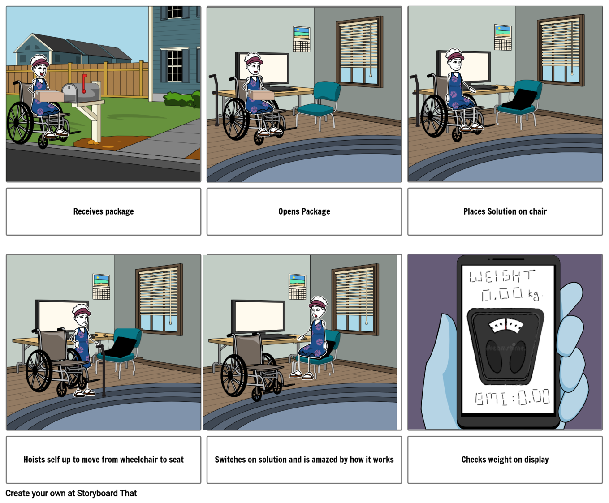

Fig.4 Storyboard depicting interaction of a paraplegic individual with the device

# 1.3 Engineering analysis:

# Constraint: Determining the maximum weight that can be exerted on the cushion, through which we can decide which category of load cells should be used in the device. This focuses on the constraint of being able to withstand a weight of up to 150kg.

# Goals:

# To find the relation between the forces exerted on the cushion and the normal force on it.

# To find out the normal forces acting on each cushion to compare it with our metrics/critical value.

# Givens:

# The weight distribution in the average human body [lower body weight- 746 N, upper body weight - 281 N]

# Dimensions of the cushion [upper cushion - 0.57m, lower cushion length - 0.4m, cushion width- 0.05m]

# Mass of the upper cushion [0.133kg]

# Mass of the lower cushion [0.4kg]

# Assumptions:

# We assume to have a user of mass [120 kilograms] and height [2 meters].

# Rationale: Since we are looking at a wide weight range, we are taking an upper bound of both our mass and height to see what an upper bound result would give us.

# Friction is negligible.

# Rationale: Having this as negligible is simply due to the analysis being based on statics, so we don’t require the value of friction.

# The foot is dangling.

# Rationale: As the cushion will be used mostly in wheelchairs or other forms of chair, we know that the legs are outside the seating area, that is, they dangle.

# The arms are placed on top of the lap.

# Rationale: The cushion must take the weight of the arms too, making this possible only if the arms lay on top of the patient’s lap and not the arm rests on the side.

# Determined the dimensions of the cushion as an average of available values.

# The inclination of the upper cushion is assumed to be 75 degrees from the x axis.

# Rationale: Wheelchairs are usually at an angle from the ground. Here, to make our calculation for the back cushion more rational, we have fixed a certain angle of inclination in order to make the forces act at an angle.

# The lower cushion and the wheelchair are parallel to the ground.

# Rationale: With the back cushion inclined, we made our wheelchair’s bottom portion of the seat parallel to the ground for simpler calculations of force and normal reaction force.

# Forces on the both the cushion acts in two distinct places.

# Rationale: We have made sure our force distribution is separated into two; the weight of the person acting around the center of mass and the cushion weight acting from a little distance away from it. This allows us to have a more in-depth conclusion rather than just having the normal force be equal to the force applied to the lower cushion.

# The normal force from the back cushion is acting on the upper end due to contact with the wheelchair (A), which is broken down to components.

# Rationale: The upper portion of the cushion makes contact with the wheelchair at a certain point, which is at the edge of the seat. For this reason, we have held our normal force being generated from that point.

# The normal force of the lower cushion is generated from two points (L1, L2) in which the load cells are placed.

# Rationale: The load cells are responsible for receiving the weight and giving an output, hence allowing us to consider two locations for equilibrium and stability.

# The force that will act on the lower cushion is assumed to be around 23.86 percent of the body weight, contributing to the weight of the thighs and other leg components. On the other hand, the force acting on the back cushion will be around 63.36 percent of the body weight, which is accounting for the upper body mass. Overall, we will get 87.22 percent of the person’s weight acting on the cushion.

# Rationale: By the distribution of mass in an average human body, we calculated how much weight will be acting from two different portions of the body: the upper body that consists of our torso and head, and the lower portion being the thighs and arms. In this way, we managed to see the total proportion that our cushion will be receiving, and later will give an output based on that.

# 1.4 Free Body Diagram

# 



# 1.5 Statics based analysis:

# For our design concept, our cushion had to be seen in two different parts for the free body diagram. The two cushions were joined by a pin joint.

# For the upper cushion, the force acts on point in the center. This force is generated from the upper body portion consisting of the torso and head. The upper cushion is also at an angle of 15 degrees from the y-axis. This causes the cushion to be at contact with the wheelchair at the top portion, generating the normal force there. From this scenario, we decided to generate three equations. Our known parameters are the force of the upper body and the dimensions of the upper cushion. From here, we can learn about the forces working in the support, that is the pin joint as well as the normal force which is broken down into x and y components. The three equations talk about the sum of forces in x axis and y axis respectively should equal to zero and the sum of moments about the pin joint.

# Our next portion of the calculation is from the free body diagram of the lower cushion. In this part, there are two points from which the forces act on the lower cushion and one point from which the cushion sends back a normal force. The pin joint also creates reactions in it from both the x and y axis. The given parameters are the two points of forces that we obtain from the weight distribution diagram. After that, we had to obtain the values such as the normal force exerted by the cushion and determine the support reactions. Again, we use the same three equations: sum of forces in the x direction, sum of forces in the y direction, and the sum of moments about the pin joint. These all sum up to zero.

# Overall, we would be getting 87.22% of the body weight working on the cushion. From there, the load cells inside each cushion will be giving back a normal reaction force. These two normal forces will add up to be our basis of the analysis, showing how much force can it exert back from the given parameters of a person with height 2metres and weight 120 kilograms.

# Results of the statics-based analysis:

# From the calculations, we obtained the values of the unknowns present. Starting with the lower cushion, we can see that Ax = 0 N Ay = 484.043 N Bx= 0 N By= - 98.265 N L1 = 182.806 N L2 = 468.854 N

# Since we need to obtain the total normal force, we add the three values, Ay, L1 and L2 together. This gives us the results: Total normal force = 1135.703 N

# From our above results, it can be seen that the values obtained do meet the necessary requirement of being able to withstand a weight of 120 kilograms, meaning that the load cells that need to be installed can meet the critical value of 150 kg. Overall, this is a positive indication about the design concept since it is in equilibrium and our supports have enough stability for the cushion. No further revision is required.

# 1.6 Additional Survey Questions:

# 1. I need assistance to set up the device for first-time usage.

# Strongly Agree

# Agree

# Neutral

# Disagree

# Strongly Disagree

# 2. I need assistance to sit on the cushion for weight measurement.

# Strongly Agree

# Agree

# Neutral

# Disagree

# Strongly Disagree

# 3. I need assistance in reading/interpreting the results after measuring weight.

# Strongly Agree

# Agree

# Neutral

# Disagree

# Strongly Disagree

# 4. I need assistance to put the cushion away after measuring weight.

# Strongly Agree

# Agree

# Neutral

# Disagree

# Strongly Disagree

# 5. The cushion can be packed and stored easily without occupying a lot of space when not in use.

# Strongly Agree

# Agree

# Neutral

# Disagree

# Strongly Disagree

# 6. I am comfortable with the time taken to install the cushion for the first time.

# Strongly Agree

# Agree

# Neutral

# Disagree

# Strongly Disagree

# 7. The installation process requires a level of technical expertise I am not used to.

# Strongly Agree

# Agree

# Neutral

# Disagree

# Strongly Disagree