Adapted Changes to the Ucomp Plugin:

A) TASK: Domain Relevance: - look at job 625087 for reference
1) additional information as entered in the plugin should not be shown in each CF job, but rather in the overall job instruction.
(don't send it in data CSV but rather in the first call that generates the CF job)

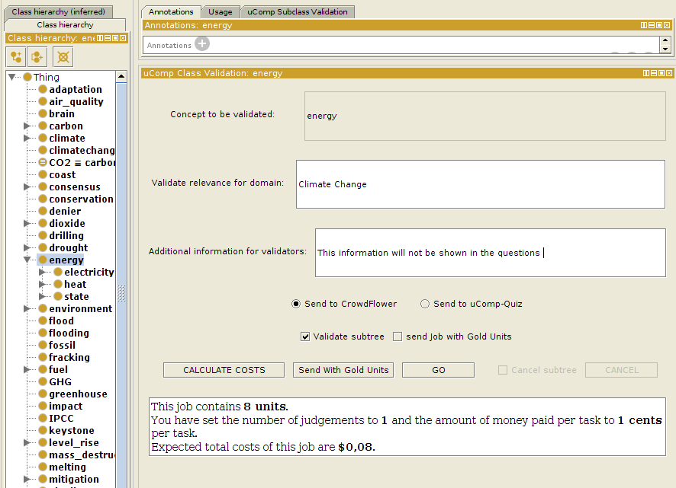
2) modify instructions as discussed on paper
3) change CF job name by adding the domain in ()at the end => e.g., Check word relevance for a domain (Human Anatomy)

4) individual job: "Is the concept 'Anatomic Structure System or Substance' relevant for the domain of Human Anatomy?"
=> put verified term between ''
=> add "of" before domain name
