Current Crowdflower Plugin Functionality:

1. Verification of Domain Relevance:

Located in the Ucomp Class Validation View.

Is a Concept relevant for a specific domain?

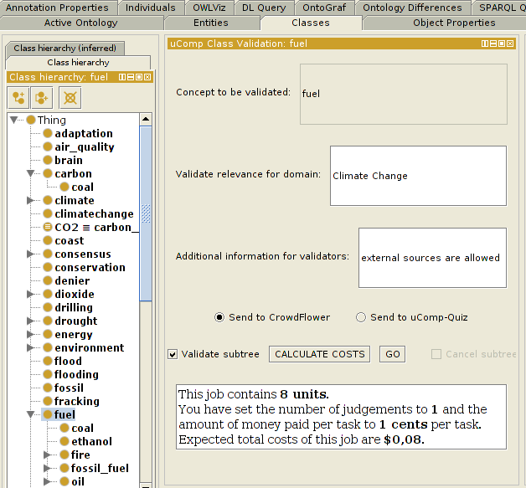

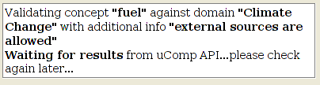

Generating The Task

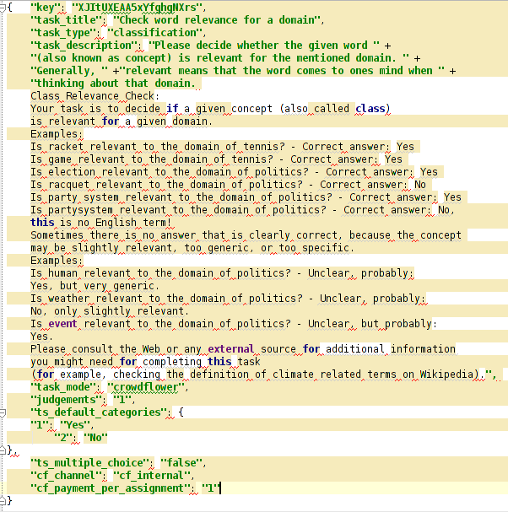
generated JSON from the plugin
this creates the job on crowdflower

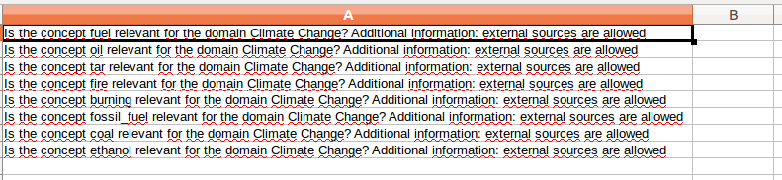
locally generated csv file. This file will be sent to crowdflower to add data to the job and contains the necessary items for the task.

generated crowdflower task

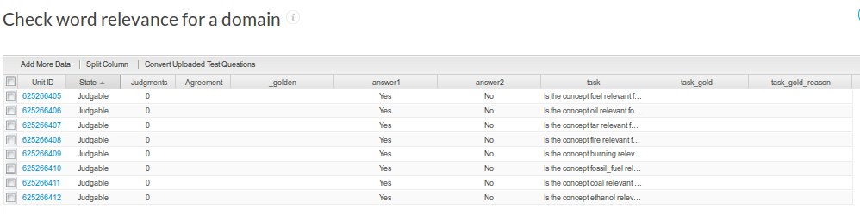
crowdflower job data (web view)

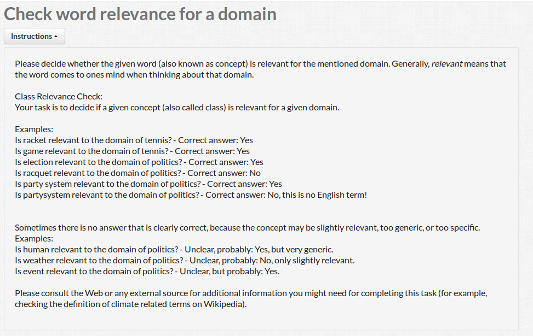
generated instructions
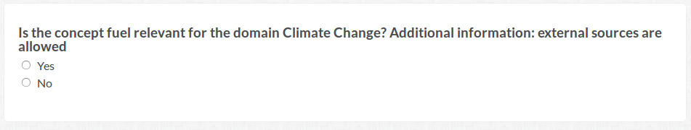
generated question for crowdworkers

2. Verification of Relation Correctness – Subsumption

Located in the Ucomp SubClass Validation.
Is a class a subclass of of another class?

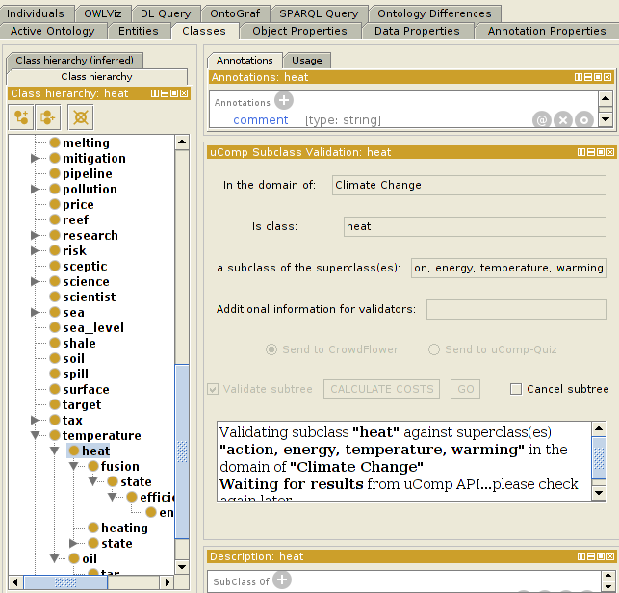
Created a crowdflower task which is now waiting for the results

task in the crowdflower interface

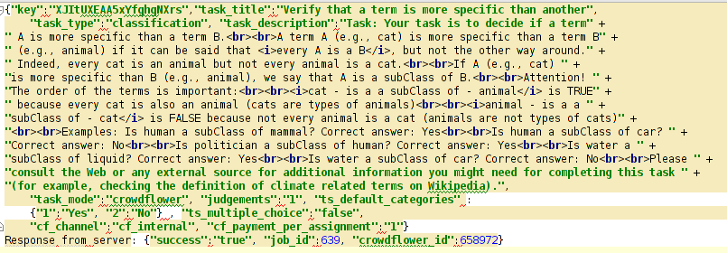
json call to the api to create the job

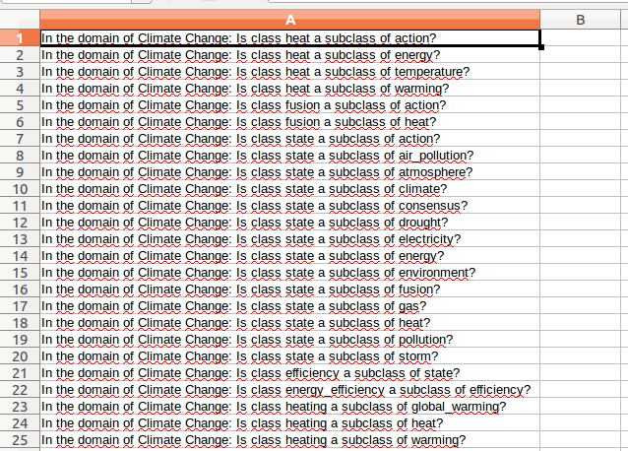
locally generated csv file which contains the data of the job and gets sent to the api

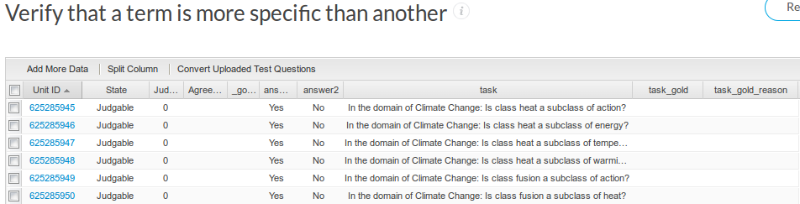
job data (web view)
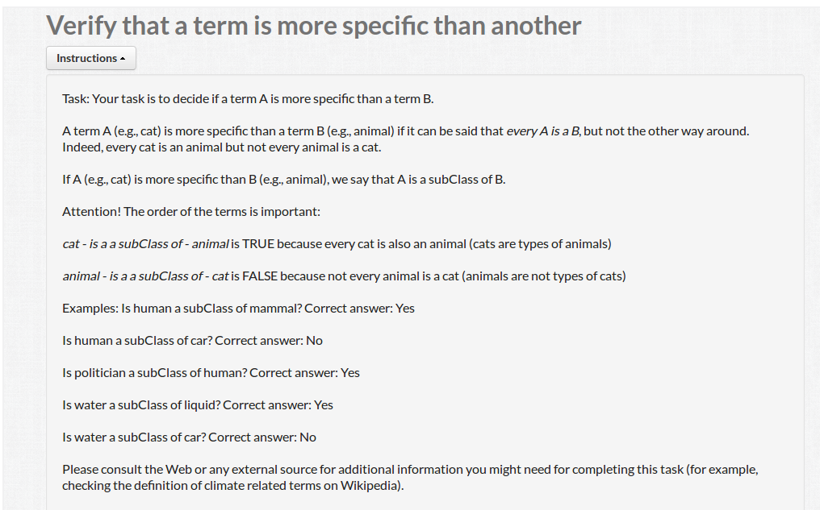
generated instructions


generated task

3. Verification of Relation Correctness – InstanceOf

Located in the Ucomp individual validation view
is an individual an instance of another class?

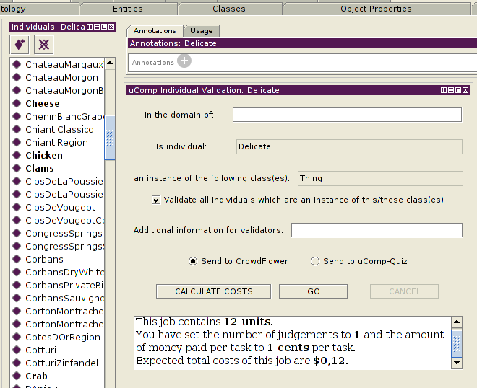
Generating a crowdflower job

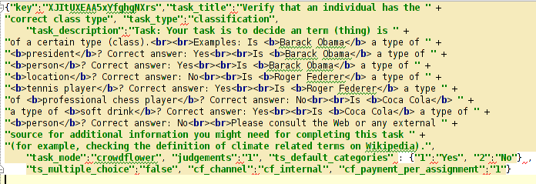
json call to create the job

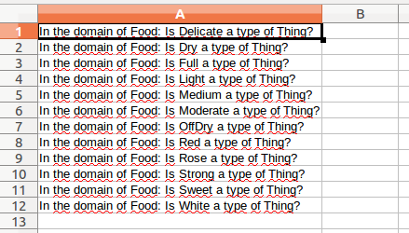

locally generated csv file with job data

created crowdflower job

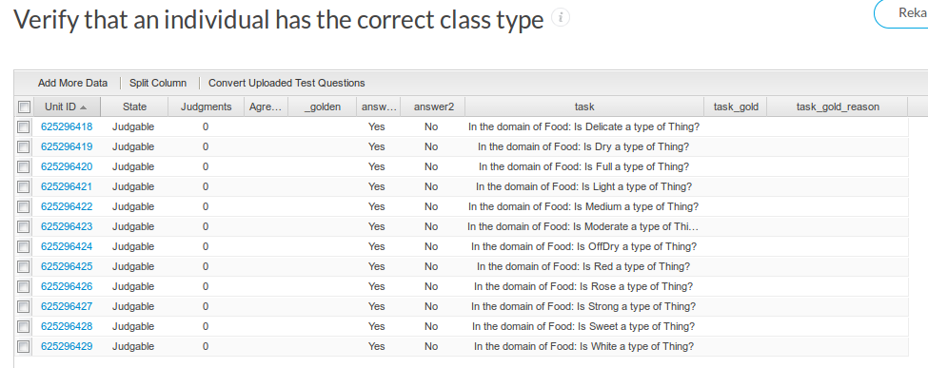
job data crowdflower (web view)

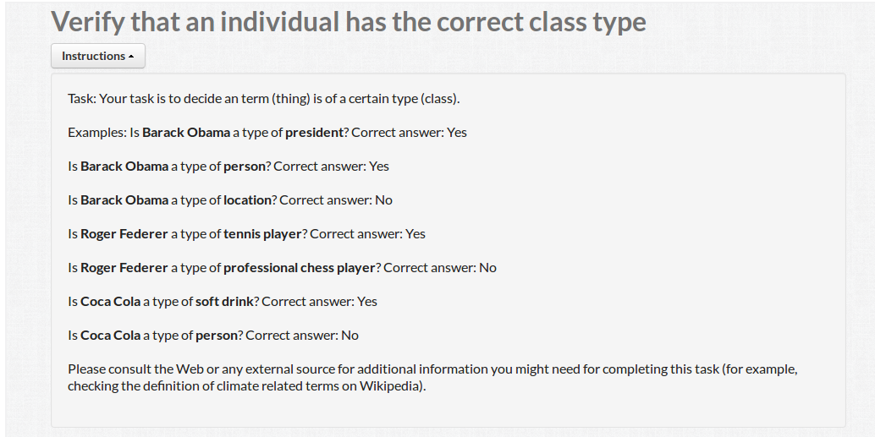
generated instructions


generated task for workers

4. Specification of Relation Type:

Located in the Object Property Views with the name uComp Relation Label Suggestion.
Assigns relation types to unlabeled object properties.

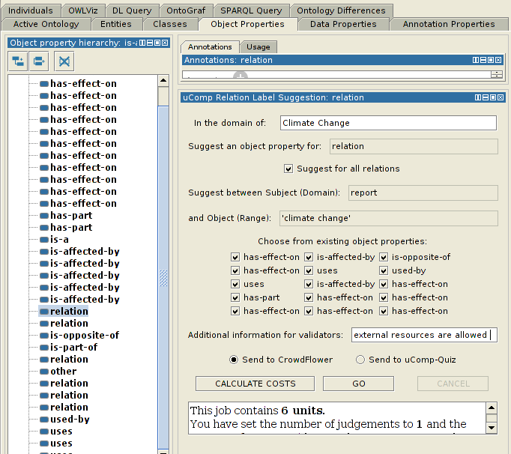
Generating the crowdflower job

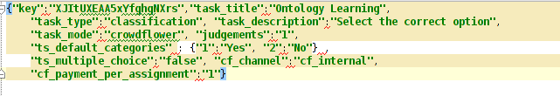
json call to create the crowdflower job

locally generated csv file
generated crowdflower job

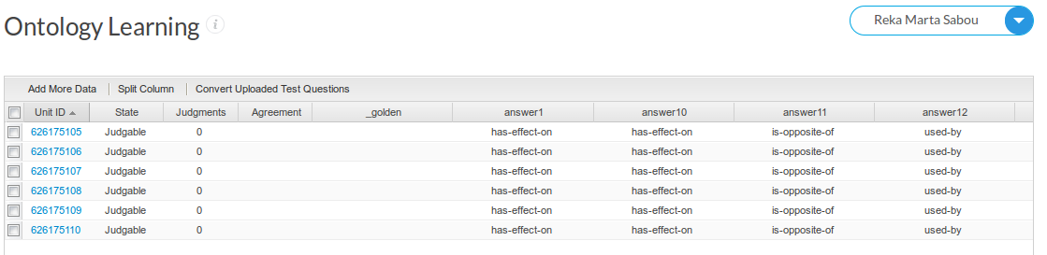
job data crowdflower (web view)


generated instructions

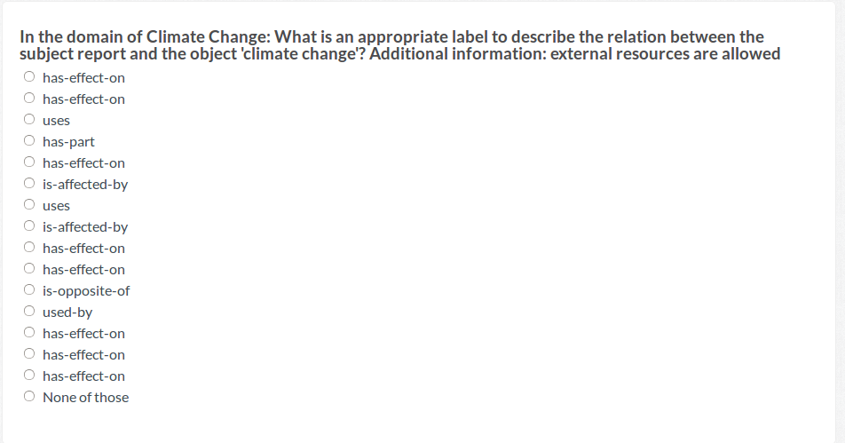
generated task for workers
5. Verification of Domain and Range:
Located in the Ucomp Object Property Validation view.
Verifies the correctness of domain and range restrictions. For each property two validation units are generated, one of the properteis domain, and one for the range axiom.

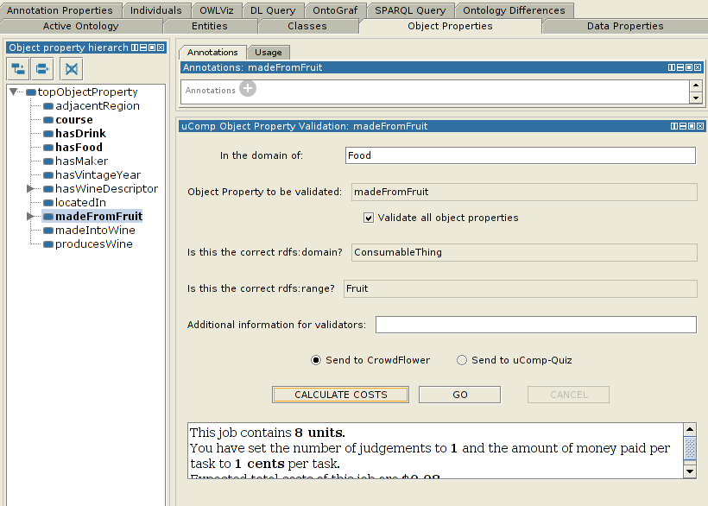
Generating the crowdflower job

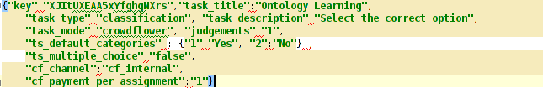
json call to create the crowdflower job
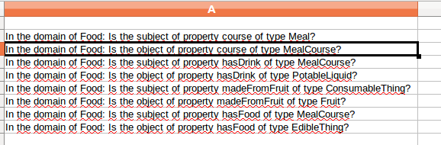
locally generated csv file
generated crowdflower job

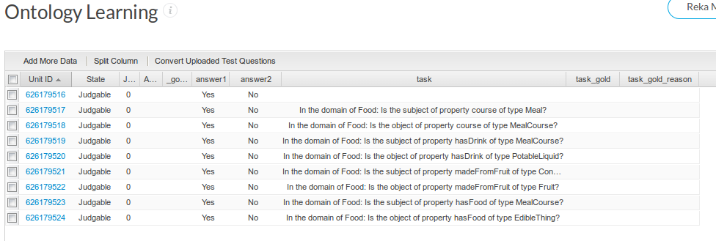
job data crowdflower (web view)


generated instructions


generated task for workers

