Current Status:

FileChooser

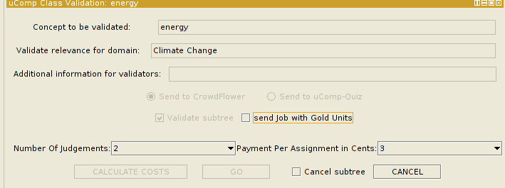
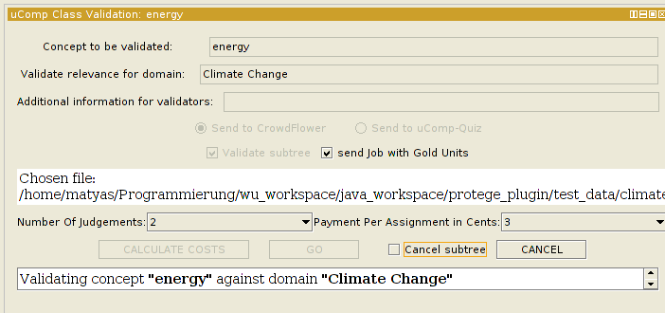
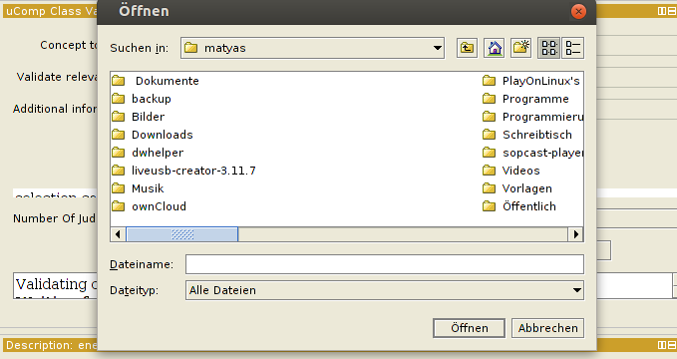

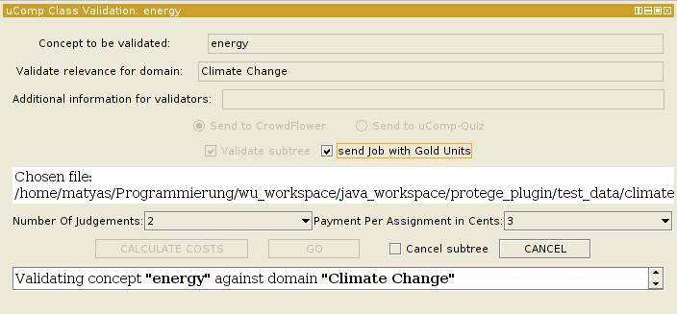
Number Of Judgemens And Payment Per Assignment

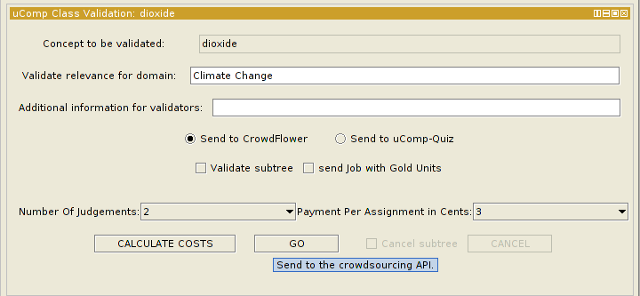

Through the existing Ucomp API it is unfortunately not possible to directly access the users preffered settings regarding the number of judgements and the desired cents that one wants to pay per assignment. The can be set on job creation though and this is what this dropdown boxes are for.

Per default the chosen setting is default for both values which means one cent per assignment and one number of judgements:

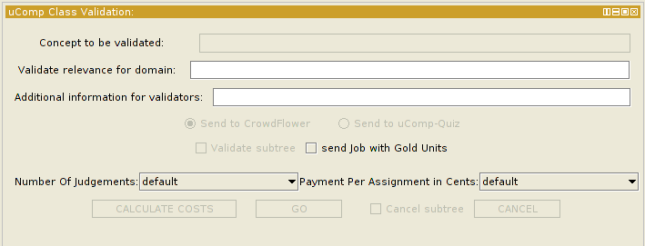

This functionalites are also available in the views:

ClassValidation:

SubclassValidation:

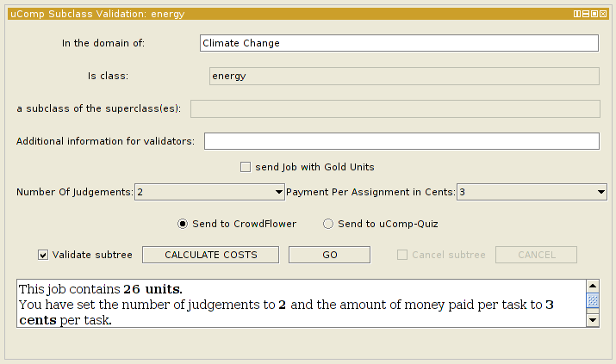

IndividualView:

