**Proposed Solution:**

In today's software development landscape, automated testing is crucial for guaranteeing code quality and confirming that applications function correctly. This document introduces a new method that uses large language models (LLMs) to automatically create test cases, improving the testing process overall. The suggested solution includes automating tasks from cloning repositories to creating pull requests. Through the use of LLMs, this approach seeks to make the creation of test cases more efficient, boost code coverage, and enhance the overall efficiency of development. The incorporation of advanced automation tools is anticipated to enhance the efficiency of the testing framework, leading to improved software quality and quicker development cycles**.**

**Pipeline Overview:**

The pipeline consists of several stages, each carefully designed to carry out particular tasks in creating and verifying test cases. This structured method guarantees that every step of the procedure is handled methodically, starting from the creation of the initial test case to thorough validation. The process seeks to increase the quality and reliability of software testing by dividing the pipeline into separate stages for generating and validating test cases, ensuring a high level of precision and efficiency.

**Methodology:**

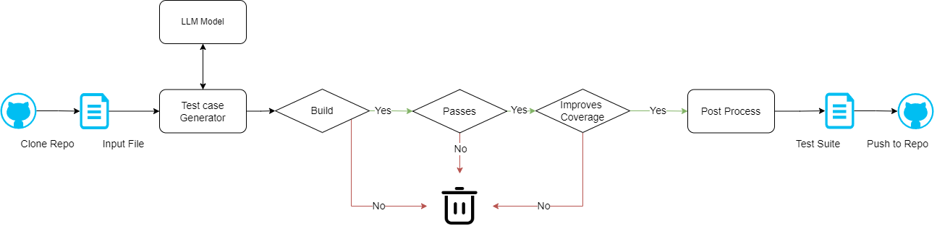

**1. Repository Cloning**

**Process:**

* The pipeline initiates by receiving a Git repository URL as input.
* It then clones the repository locally, producing a local copy of the codebase. This local copy becomes the environment where modifications and test case generation are conducted.

**Purpose:**

* Establishes a local workspace for detailed analysis and modification of the codebase.
* Guarantees that the pipeline functions with the most up-to-date version of the code, ensuring accuracy and relevance in subsequent stages.

**2. Model Processing**

This stage involves utilizing a large language model (LLM) to process and analyse the codebase, performing the following key functions:

**Header Analysis:**

* **Process:** The LLM reviews the headers at the beginning of each code file. It adds or updates necessary information, such as metadata or documentation comments, if headers are missing or outdated.
* **Purpose:** Ensures consistency and completeness in file headers, which is crucial for effective code documentation and long-term maintainability.

**Test Class Identification:**

* **Process:** The LLM identifies test classes within the codebase by searching for classes intended to test other components, typically indicated by specific naming conventions or annotations.
* **Purpose:** Determines where new test cases can be integrated. The model identifies suitable locations for adding new tests, ensuring that they complement rather than interfere with existing test cases.

**Test Case Generation:**

* **Process:** The LLM examines the primary code files to generate test cases based on the code’s logic and functionality. It constructs test scenarios that address various inputs, outputs, and edge cases.
* **Purpose:** Automatically produces comprehensive test cases to enhance code coverage and verify that the code functions correctly under diverse conditions.

**3. Filtering and Validation**

After new test cases are generated, they undergo a thorough validation process to ensure their effectiveness:

**Build and Test Validation:**

* **Process:** The code, inclusive of the newly generated test cases, is compiled and executed. This step verifies that the build process completes successfully and that all test cases pass without any errors.
* **Purpose:** Ensures that the introduction of new test cases does not cause any issues and that the overall codebase remains functional and free of errors.

**Coverage Assessment:**

* **Process:** Code coverage tools are employed to evaluate the extent to which the new test cases exercise the code. The results are examined to confirm that test coverage has improved relative to the previous state.
* **Purpose:** Validates that the new test cases enhance coverage, effectively targeting areas of the code that were previously untested.

**Iterative Improvement:**

* **Process:** The pipeline performs iterative rounds of test case generation and validation. This process continues until the desired level of code coverage is achieved or a predetermined maximum number of iterations is reached.
* **Purpose:** Refines and optimizes the test cases to maximize coverage and effectiveness, ensuring that the testing process continually evolves to meet quality objectives.

**4. Pull Request Creation**

**Process:**

* Once the new test cases have been validated and the desired level of coverage has been achieved, the changes, including these test cases, are committed to the local repository.
* Subsequently, a pull request is created in the original Git repository to propose the integration of these changes.

**Purpose:**

* Facilitates the review process by allowing other developers or stakeholders to examine and provide feedback on the new test cases before they are merged into the main codebase.
* Summarizes the changes and improvements made, ensuring that the modifications are communicated clearly and can be evaluated effectively by the team.

**Work Samples:**

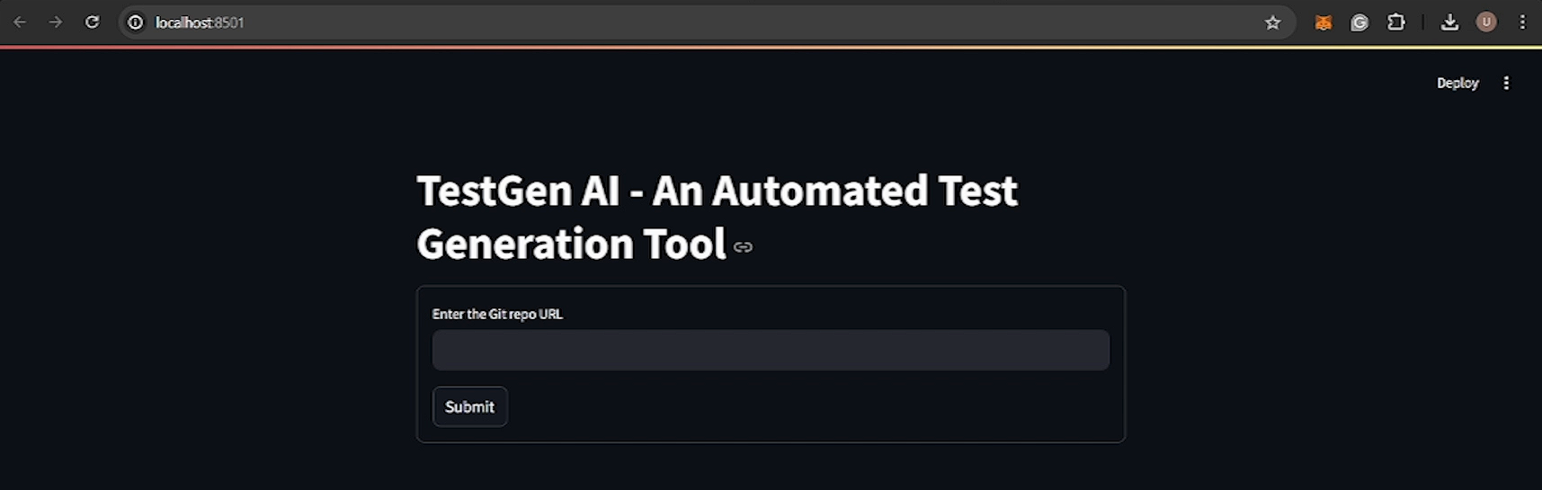

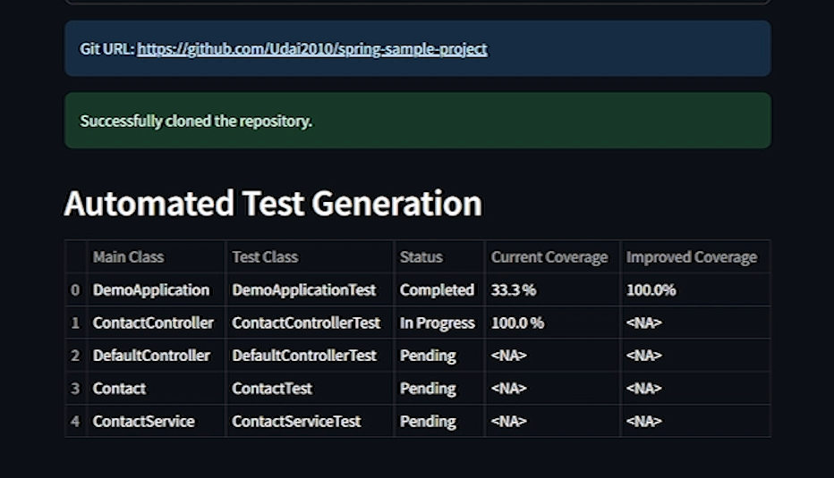

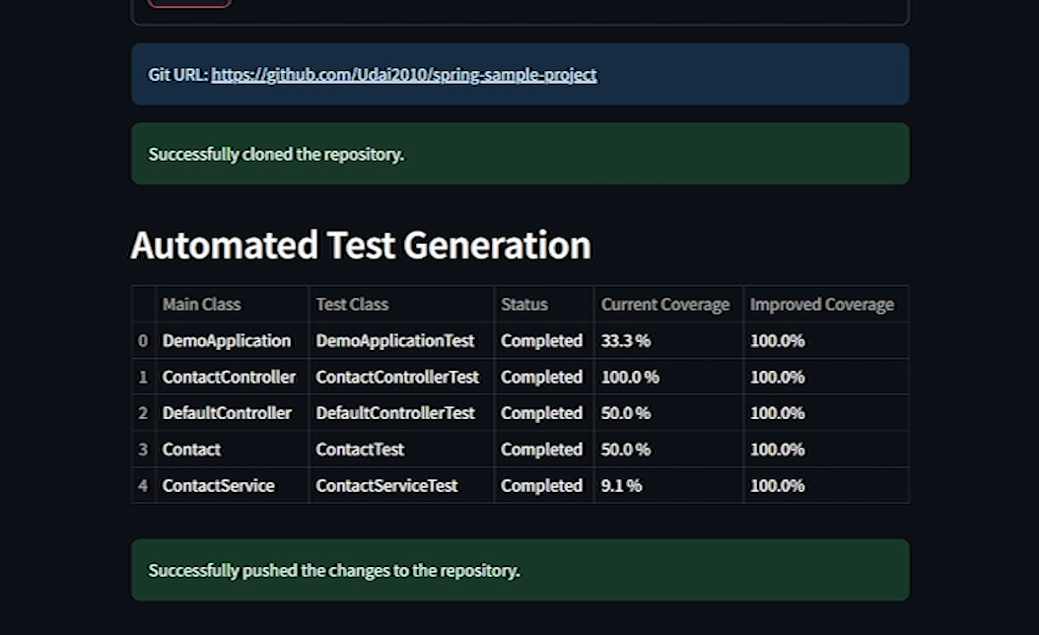

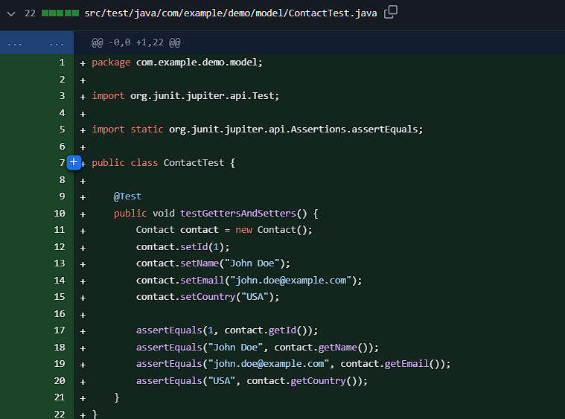

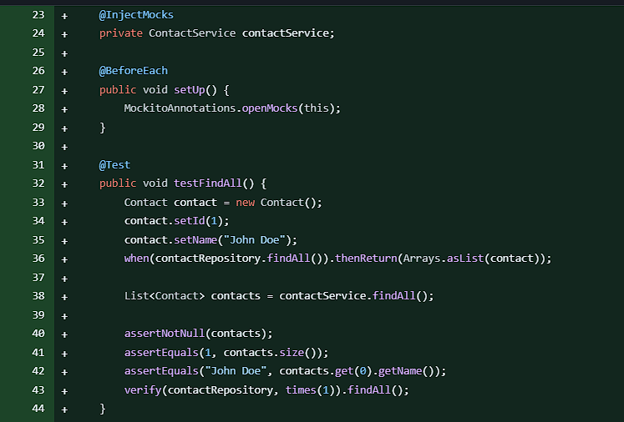

**Conclusion**

The proposed automated test case pipeline marks a substantial advancement in the field of software testing. By incorporating large language models (LLMs), this pipeline enhances test coverage, boosts efficiency, and refines the testing process, ultimately contributing to superior code quality and accelerated development cycles. This innovative approach addresses the complexities of automated software testing with a modern solution, establishing a new benchmark for industry best practices.