Hand Gesture Controlled Virtual Keyboard

# Project Overview

This project demonstrates a virtual keyboard controller using hand gesture recognition. By utilizing the webcam feed and the MediaPipe library, hand landmarks are identified in real time. These landmarks are then processed using OpenCV and specific gestures are mapped to keyboard inputs through the PyAutoGUI module.

# Technologies Used

- Python  
- OpenCV  
- MediaPipe  
- PyAutoGUI  
- Webcam

# Contribution

Contribution: Complete implementation of the system and testing.

# Results

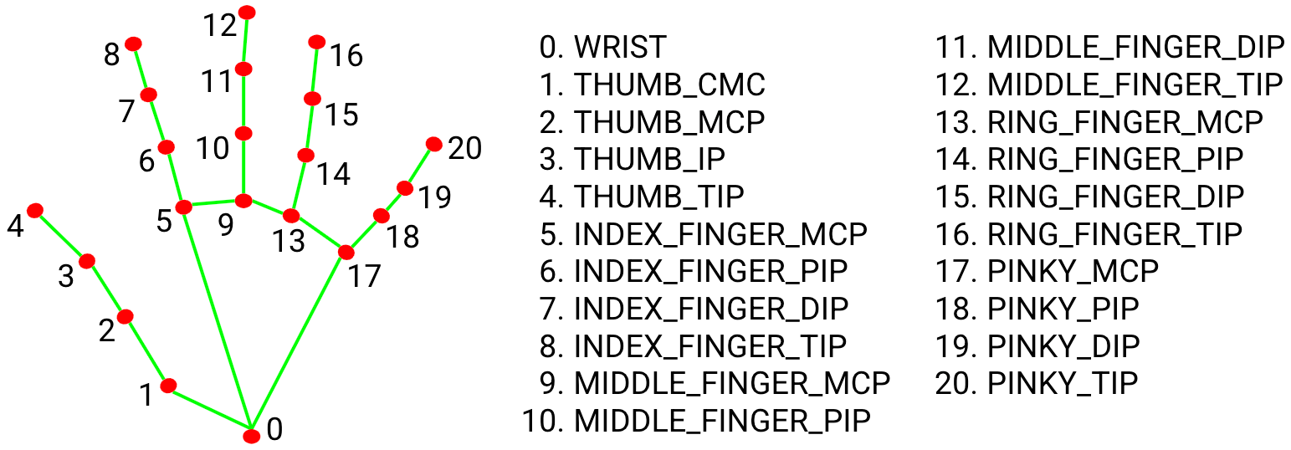

The above image shows node positions on the hand that are used for gesture recognition.

# Challenges & Learnings

The main challenge was achieving stable hand tracking and gesture interpretation in real time. Another challenge was ensuring that the virtual key presses happened only once per gesture to avoid repetition. This project helped improve our understanding of computer vision, real-time systems, and gesture mapping.

Name : Udai Batta

Group: 2C15

Roll No : 102483065