**IS1901 - Microcontroller based ICT Project**

**PROJECT PROPOSAL REPORT**

**Level 01**

**Arduino Controlled Smart Hydroponic Modular System**

Examiner

Mr. B. H. Sudantha

**Submitted by:**

Deshapriya B.G.A.U 225128K

Peligedara S.P.G.M.L 225079J

Rohana K.S 225125A

Jayasundara K.G.K.G.D 225127G

Magammana I.N 225126D

Bachelor of Information Technology

Faculty of Information Technology

University of Moratuwa

**Table of Contents**

**Submitted by:** 1

1. Introduction 2

1.1 Problem in Brief 2

1.2 Significance of Study 2

1.3 Aim and Objectives 3

2. Literature Study 4

3. Proposed Solution 5

3.1 Features of the Proposed Solution 5

3.2 Components required for the proposed solution 7

3.3 Nature of the Solution 9

3.4 Solution Design 9

3.5 Resources 10

3.6 Workload Matrix 12

4. References 13

# Introduction

## Hydroponics is a type of horticulture and a subset of hydro culture which involves growing plants, usually crops or medicinal plants, without soil, by using water-based mineral nutrient solutions.

In contrast to field cultivation, plants are commonly grown hydroponically in a greenhouse or contained environment on inert media, adapted to the controlled-environment agriculture (CEA) process. Plants commonly grown hydroponically include tomatoes, peppers, cucumbers, strawberries, lettuces, and cannabis

## 1.1 Problem in Brief

## Manual hydroponic systems pose challenges due to their labor-intensive nature and limited scalability. In these systems, the need for frequent monitoring and adjustment of environmental parameters such as pH, nutrient concentrations, and water levels requires significant human intervention. This manual management process is time-consuming, prone to error, and can result in inconsistencies in plant growth and yield. Moreover, manual systems lack the ability to respond promptly to changes in environmental conditions, leading to suboptimal growing conditions and decreased crop productivity. On the other hand, traditional farming methods face issues related to soil depletion, erosion, and contamination from pesticides and fertilizers. Conventional agriculture relies heavily on soil, which can lead to degradation of land and water resources. Additionally, traditional farming requires extensive land and water usage, contributing to environmental degradation and habitat loss. The reliance on pesticides and fertilizers further exacerbates environmental concerns and poses risks to human health. Overall, both manual hydroponic systems and traditional farming methods suffer from inefficiencies, environmental impacts, and limitations that hinder their ability to meet the growing demand for sustainable agriculture.

## 1.2 Significance of Study

The proposed Arduino Controlled Smart Hydroponic Modular System aims to automate and control hydroponic growing environments, addressing the challenges of manual management and providing advantages such as land preservation, water conservation, faster growth, minimal pesticide use, and reduced labor costs.

## 1.3 Aim and Objectives

**Aim:**

The proposed Arduino Controlled Smart Hydroponic Modular System aims to provide an efficient and effective solution for automated hydroponic cultivation, improving plant growth, resource utilization, and overall productivity.

**Objectives:**

* Monitoring and control:
* Develop a system capable of continuously monitoring critical parameters for plant growth in a hydroponic environment, including pH levels, electrical conductivity (EC), temperature, humidity, and water level.
* Actuator integration:
* Integrate actuators into the system to adjust environmental conditions as needed, such as controlling water pumps for nutrient delivery, activating plant lights for illumination, and operating nutrient dosing systems to adjust nutrient concentrations in the water.
* User interface design:
* Design a user-friendly interface that enables users to easily monitor the status of their hydroponic setup, interact with the system, and adjust parameters as necessary. This interface should provide real-time data(PH level and Temperature) visualization and intuitive controls.
* Automation implementation:
* Automate tasks within the hydroponic system to reduce the need for manual intervention and optimize plant growth. This includes automating nutrient delivery, lighting control, and environmental monitoring based on predefined thresholds and control algorithms.

# Literature Study

Hydroponics has gained significant attention in recent years as a sustainable alternative to traditional soil-based agriculture. Several studies have investigated the benefits of hydroponic systems, as well as the integration of automation technologies for improved efficiency and productivity.

Benefits of Hydroponic cultivation over conventional soil-based agriculture:

* Water Conservation:
* Hydroponic systems use significantly less water compared to traditional farming methods, making them ideal for regions facing water scarcity.
* Higher Yields:
* By providing plants with precise amounts of nutrients and water, hydroponic systems often produce higher yields and faster growth rates than soil-based cultivation.
* Land Preservation:
* Hydroponic systems can be implemented in urban areas and non-arable land, reducing the need for extensive farmland and preserving natural habitats.
* Reduced Environmental Impact:

- Hydroponic systems minimize the use of fertilizers and pesticides, leading to lower environmental pollution and soil degradation.

Benefits of automation in Hydroponics:

* Real-Time Monitoring:
* Automated systems enable real-time monitoring of crucial parameters such as pH, EC, temperature, and humidity, allowing for timely adjustments to optimize plant growth.
* Scalability:
* Automated hydroponic systems can be scaled up or down to meet the needs of a particular growing operation, making it possible to grow crops on a small or large scale.
* Precision Control:
* Automation allows for precise control of nutrient delivery, lighting, and environmental conditions, ensuring consistent and optimal growing conditions for plants.
* Labor Savings:
* By automating repetitive tasks such as nutrient dosing and irrigation, hydroponic systems require less manual labor, reducing operational costs and labor requirements.

# Proposed Solution

## The Arduino Controlled Smart Hydroponic Modular System is a comprehensive solution that integrates hardware and software components to create an automated and intelligent growing environment. By leveraging Arduino microcontrollers and various sensors and actuators, the system ensures precise monitoring and control of critical parameters for plant growth. The modular design allows for flexibility and scalability, making it suitable for different types and sizes of hydroponic setups.

## Features of the Proposed Solution

1. Temperature Control:

- Utilizes a temperature sensor to measure the temperature of the system.

- Microcontroller compares temperature readings to setpoint temperature.

- Activates cooling fans to reduce temperature if it exceeds the setpoint.

- Fan speed adjusts based on temperature difference, maintaining a defined temperature range.

- Ensures optimal system performance by dissipating heat effectively.

2. Nutrient Level Control with TDS Sensor:

- TDS sensor measures inorganic and organic substances in the solution, indicating nutrient level.

- Microcontroller compares TDS readings to set point nutrient level (600-1000 ions).

- Activates pump motors to add fertilizer if ions are below 600 or pump water if ions are above 1000.

- Maintains nutrient concentration within the desired range for plant health and growth.

3. PH Level Control with PH Sensor:

- PH sensor measures hydrogen ion concentration in the solution, indicating acidity or basicity.

- Microcontroller compares PH readings to set point PH level (5.5-6).

- Activates pump motors to add potassium hydroxide if pH is below 5.5 or phosphoric acid if PH is above 6.

- Ensures the PH of the solution remains within the optimal range for plant growth.

4. Humidity Control with Mist Maker Machine:

- Utilizes an ultrasonic mist maker module to generate mist and increase humidity levels.

- Automated with an Arduino microcontroller to control mist production based on predetermined conditions.

- Adjusts mist production according to humidity levels, time intervals, or plant requirements.

- Provides an ideal humidity environment for plant growth in the greenhouse.

5. Dehumidifier Machine:

- Utilizes a thermoelectric cooler (TEC) to condense moisture from the air and reduce humidity levels.

- Automated with an Arduino microcontroller to activate the dehumidifier when humidity exceeds a certain threshold.

- Deactivates the dehumidifier once humidity returns to the desired level.

- Ensures humidity levels are maintained within the optimal range for plant growth.

6. RTC Time Module for Light Control:

- Uses an RTC time module to control the growing light system, providing light at specific times for optimal plant growth.

- Displays the date for renewing the fertilizer solution on an LCD display.

- Ensures plants receive the necessary light and nutrients at the right times for healthy growth.

7. Real-time Display of Temperature and PH Levels:

- Displays current temperature and PH levels on a screen in real-time.

- Temperature and PH sensors provide readings to the microcontroller.

- Microcontroller processes the data and displays it on the screen using a numerical value.

- Allows continuous monitoring of conditions in the hydroponic system and adjustments as needed for optimal plant health.

## Components required for the proposed solution

1. Arduino Mega NodeMCU:

* An Arduino microcontroller serves as the central control unit. It interfaces with sensors and actuators to collect data and execute commands.

1. Arduino Clock:

* An RTC time module is used to control the required light in hydroponics and provide data about the days when the fertilizer solution should be changed. Here it becomes a growing light system that operates only at a certain time and provides the necessary light to the plant properly. The data about the date to renew the fertilizer solution is shown by the LCD display

1. LCD display:

* Shows real-time data such as pH, EC, temperature, humidity, etc.

1. PH sensor:

* Measures the acidity or alkalinity of the nutrient solution. This data helps ensure the pH remains within optimal ranges for plant growth.

1. Temperature & Humidity sensor:

* Monitors environmental conditions within the growing area, ensuring optimal growing conditions.

1. Water level sensor:

* Determines the water level of the tank.

1. TDS sensor:

* Measures the electrical conductivity of the solution, providing an indication of nutrient concentration. This helps maintain nutrient levels for plant health.

1. Light sensor:

* A light sensor can monitor ambient light levels, triggering artificial lighting if need.

1. Water Pump:

* Controlled by the Arduino to deliver water flow to the plants at scheduled intervals.

1. Plant lights:

* The Arduino can control artificial grow lights to supplement natural light or provide illumination in indoor growing environments.

1. Relays:

* For controlling high-power devices like water pumps and grow lights.

1. Cooling fans:

* control temperature in a system.
* Making it possible to maintain a stable temperature for optimal performance.

1. Aluminium Heat Sink Heat Sink Radiator:
2. Peltier Thermoelectric Cooler: Dehumidifier Machine
3. Brushless 7-Blade Cooling Fan:

## Nature of the Solution

**Figure 01: Block diagram of the input, process and output**

Dehumiditifire/Mistmaker

**Figure 01: Block diagram of the input, process and output**

**3.4 Solution Design**

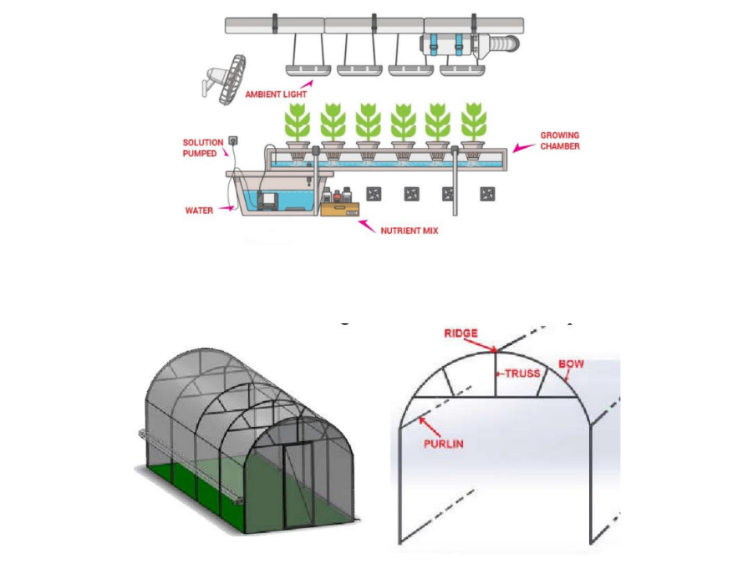

**Figure 02: A graphical view of the solution**

**3.5 Resources**

**Table 01: Components with budget allocation**

|  |  |  |  |
| --- | --- | --- | --- |
| **Component** | **Unit Price (LKR)** | **Unit** | **Total Price** |
| Arduino Mega NodeMCU | 5180.00 | 1 | 5180.00 |
| Arduino Clock DS1302 | 220.00 | 1 | 220.00 |
| Water pump | 700.00 | 1 | 700.00 |
| Ultrasonic mist maker | 1800.00 | 1 | 1800.00 |
| TDS sensor | 3350.00 | 1 | 3350.00 |
| PH sensor | 5250.00 | 1 | 5250.00 |
| Water level sensor | 120.00 | 1 | 120.00 |
| Light sensor | 140.00 | 2 | 280.00 |
| 12V power supply | 2000.00 | 1 | 2 000.00 |
| Pipes | N/A | N/A |  |
| Water tank | 400.00 | 1 | 400.00 |
| Water collection container | 200.00 | 1 | 200.00 |
| Plant light | 1150.00 | 2 | 2300.00 |
| DHT22 / AM2302 Digital Temperature and Humidity Sensor Module | 620.00 | 1 | 620.00 |
| TEC1-12706 DC12V 60W Peltier Thermoelectric Cooler | 720.00 | 1 | 720.00 |
| Aluminum Heat Sink Radiator | 420.00 | 1 | 420.00 |
| HM500 Grey Thermal Grease Thermal Conductive | 230.00 | 1 | 230.00 |
| Cooling fan | 600.00 | 2 | 1200.00 |
| External structure | N/A | N/A |  |
| Wires & other raw materials | N/A | N/A |  |
| Nutrients bottle | 100.00 | 3 | 300.00 |
| Keypad | 200.00 | 1 | 200.00 |
| LCD display | 1000.00 | 1 | 1000.00 |
| **Total** | | | 26,490.00 |

## Workload Matrix

**Table 02: Workload Matrix**

|  |  |
| --- | --- |
| Registration Number | Assigned Responsibilities |
| 225128K | PCB Designing  User Interface  Water level sensor & pump |
| 225079J | TDS sensor |
| 225125A | DHT22 temperature and humidity sensor |
| 225127G | PH sensor  Pump motor |
| 225126D | Lighting System |

# References

[1] <https://en.wikipedia.org/wiki/Hydroponics>

[2] <https://www.arduino.cc/>

[3] [How To Use An RTC (Real Time Clock) With Arduino Uno R3 | Make an Accurate Clock! (youtube.com)](https://www.youtube.com/watch?v=gv1h-3kK6SU)

[4][රු 250 වතුර මෝටරය Dc Submersible water pump - YouTube](https://www.youtube.com/watch?v=9ZBqUvOYJ4g)

[5] [Using Keypads with Arduino - Build an Electronic Lock (youtube.com)](https://www.youtube.com/watch?v=vl1-R6NsejM)

[6] <https://youtu.be/a4zfBkQ4LcE?si=gXHIwxRaqT0q5BjM>

[7] <https://www.freshwatersystems.com/blogs/blog/what-are-hydroponic-systems>