

**Feelix Solutions**

**Group Assignment**

**Core Creators**

IS 1110 – Business Foundation

Batch 22 - Semester 2

Part I – Story of the Company

**1.1 Executive summary**

Feelix Solution, led by founder Nisal Damsara Liyanage, stands as a beacon of innovation in the digital solutions realm. With a mission to inspire the digital world and bring brilliance to every creation, the company embarked on a journey marked by strategic evolution and steadfast commitment to excellence.

Beginning humbly, Feelix Solution leveraged personal connections to secure projects and establish a foothold in the market. A pivotal moment arrived with the acquisition of a significant project in Qatar, prompting the company's formal registration and expansion into the region under the banner of 'Brill Creations'. Strategic networking efforts facilitated the establishment of a robust customer base, particularly in Qatar, showcasing the company's adaptability and cultural acumen.

Responding to economic fluctuations, Feelix Solution strategically shifted focus towards product innovation and global expansion. Initiatives such as allocating profits for future investments, leveraging personal connections for talent recruitment, and prioritizing employee engagement propelled the company forward. Measuring success through financial performance, employee satisfaction, and customer feedback, Feelix Solution remains at the forefront of digital transformation, paving the way for enduring success and industry leadership.

**1.2/1.3 INTRODUCTION AND A BRIEF HISTORY OF FEELIX SOLUTIONS**

* Company Name: Feelix Solution
* Vision: Inspiring the Digital World with trusted and noteworthy solutions.
* Mission: Bringing Brilliance in Every Creation.
* Product & Service: Innovative Digital Solution

You can also get services from them for business-to-business model. Also provides services on how to generate income through a plugging for related businesses. Apart from that, plugging development also provides services for the fields like development, database, data analysis and cyber security. Services such as prompt engineering and 360 video graphics, which are new to the industry, are also available.

##### 

##### Logo: The name for this company is based on the phoenix bird. It was changed to Felix to suit the company.

##### 

##### Clients: There are twenty-five high class clients in Qatar. All the 12 companies under nabina holdings do software creation.With operations in **Qatar, Canada, Australia, and Sri Lanka,** Brill Creations is truly a global name in media and advertising. Currently, they are working to share their own production to the market. Most of the projects are taken up by new clients at a minimum level.

##### 

##### Projects: First projects are obtained through friends. While those projects were being carried out from Sri Lanka for some time, the Qatar project was received. Later, several projects were implemented in Qatar. They are doing this project by starting a company called Bill Creation in Qatar.

##### The first project is for a wholesale market of an organization with seven garments operating under the name Prabath Fashion. Later, the ERP system was implemented for the same 7 garments. Later, this method was implemented for their T-state as well.

##### 

##### Currently, two projects are being implemented in Nestlé.

##### Qatar Mobile Website-

We designed **Qatar Mobile**‘s website, [qatarmobile.qa](https://qatarmobile.qa/), to reflect their role as a leader in the mobile technology market. The site features a sleek, modern design that resonates with tech-savvy customers. We focused on a user-friendly interface, ensuring easy navigation and quick access to their extensive range of mobile devices and accessories. High-resolution product images and detailed descriptions enhance the shopping experience.

###### Client: Qatar Mobile

# Waypoint Studio Qatar

For[Waypoint Studio Qatar](https://waypoint-studio.com/), Brill Creations developed a website that mirrors their innovative spirit in digital design and branding. The site, waypoint-studio.com, is a showcase of creativity and functionality, offering a glimpse into the studio’s world of digital artistry. We emphasized a clean, modern aesthetic, aligning with Waypoint Studio’s cutting-edge approach to design.

###### Client: Waypoint Studios Qatar

* Affiliations : The CEO of this company has many contacts with friends in his field. The first project was also obtained through them.

##### Competitors: Because the project is implemented in Qatar, Canada and Australia, there is competition with the business that accepts other projects in those countries.

### Industry : Feelix solution is a newly established business venture typically characterized by innovation, scalability, and a high potential for growth. This company often operates in emerging or disruptive industries, aiming to introduce new products, services, or business models to the market. They are usually founded by entrepreneurs or small teams with a vision to address a specific problem or capitalize on an untapped opportunity.

* They stay in the industry in activities such as 360 design data analysis, database.

**1.4 Inspiration for a startup(business idea)**

**Background:**

The CEO and the founder of the business , who we'll refer to as Nisal Damsara Liyanage, comes from a line of successful business people. His family's businesses introduced him to the complexities of entrepreneurship at a young age, giving him a deep understanding for the business world. But unlike some people who might feel pressured to carry on their family's business, his enthusiasm for entrepreneurship came from a very personal place: his deep-seated desire to forge his own path and follow his passions.   
  
**Passion for Entrepreneurship:**

Nisal Damsara had a strong desire to launch his own firm, in contrast to the traditional professional path of looking for work. This devotion was more than just a passing interest; it was what kept him motivated and ambitious. He showed a strong interest in software development and information technology (IT) from a young age. His obsession with technology was a reflection of his forward-thinking attitude, which saw opportunity for innovation and disruption in the digital space, in addition to being in line with his own interests.   
  
**Foundation for Education:**

Nisal Damsara's pursuit of education strengthened his path towards entrepreneurship. He immersed himself deeply in the fields of software development and IT during his undergraduate degree program, developing his abilities and broadening his knowledge. His academic pursuits not only gave him the necessary technical know-how but also nourished his entrepreneurial spirit and promoted an atmosphere that encouraged originality and creative thought.

**Entrepreneurial Venture:**

He started his entrepreneurial path with the support of his family, his own entrepreneurial enthusiasm, and his IT-focused educational background. He started his own software development business by utilizing the knowledge and understanding he had acquired during years of immersion in the technology sector. This business endeavor was a representation of his steadfast dedication to his passion and vision, not just a way to make money.

**1.5 Details on the journey of building a customer base**

* Upon commencing his entrepreneurial journey, the individual initially secured projects through personal connections, handling general tasks without formal company registration. However, a significant turning point arose with the acquisition of a project in Qatar, marking a pivotal shift in the company's direction. Subsequently, prompted by this breakthrough, the entity underwent registration as a private company. Taking advantage of investment from Qatar, the company expanded its presence in the region by establishing branches under the name 'Brill Creations'.
* In the early stages of operations in Qatar, the company effectively built a strong customer base, largely through personal connections and referrals. Notably, the first project in Qatar came through a friend, highlighting the importance of leveraging personal networks. The company's success and recognition in Qatar further enhanced its reputation, attracting interest from numerous respected businesses. As a result, the company now collaborates with around 25 top-tier companies in Qatar, including well-known names like Nabina Group and Takeaway Restaurant, demonstrating its ability to expand and solidify its customer base in the region.
* Navigating the language and cultural differences in Arab countries like Qatar posed a unique challenge to the company. However, it successfully overcame these obstacles by forming partnerships through Arabic intermediaries, enabling effective communication with local stakeholders. This strategic approach emphasized the company's commitment to cultural sensitivity and inclusivity, ultimately boosting its efforts to expand its customer base across diverse markets.
* Currently, the company has shifted its focus from serving multiple clients to developing and marketing its own products. This strategic pivot reflects the company's proactive approach to establishing a stronger market presence. Through strategic methods, the company aims to cultivate the necessary customer base to support its transition to product-centric operations. This evolution underscores the company's adaptability and responsiveness to changing market dynamics and consumer preferences, driving its continued growth.

**1.6 Business performance and strategies**

The company has implemented several notable strategies to enhance its business performance.

* Amidst economic downturns, particularly observed in Qatar and Sri Lanka, the company strategically shifted its focus from acquiring new customers to releasing proprietary products into the global market. This decision reflects a deliberate emphasis on product innovation and global expansion, rather than solely relying on customer acquisition during challenging economic periods.
* Additionally, the company has demonstrated a commitment to long-term sustainability by allocating 25% of its annual profit towards future investments. This strategic financial allocation underscores the company's forward-thinking approach and dedication to fostering future growth and development.
* Furthermore, the founder's strategic decision to recruit friends as employees showcases a focus on talent utilization and cohesion within the workforce. Leveraging personal relationships and understanding the strengths of individuals within the employee community contribute to the company's overall success and performance.
* Recognizing the importance of employee motivation, the company has implemented various strategies, including offering competitive wages, organizing social gatherings, and providing flexible work arrangements such as remote work options. Moreover, the willingness of the founder to personally engage with employees, including traveling to Qatar for work-related purposes, demonstrates a proactive approach to fostering a positive work environment and maintaining high employee morale.
* Expansion into new markets, such as Australia, further underscores the company's strategic growth initiatives. By diversifying its geographical footprint and exploring new opportunities, the company aims to capitalize on untapped markets and drive continued business growth.
* Moreover, the strategic partnership with an Arab intermediary, colloquially referred to as "Arab Shrek," has facilitated business operations in Qatar. This relationship-building strategy has enabled the company to navigate cultural nuances and establish strong partnerships within the region, contributing to its sustained success and performance in the Qatar market.

**1.7 Measuring business success**

* Measuring business success means figuring out how well a company is doing. It involves looking at different things like how much money the company makes, how happy its customers are, and how efficiently it runs.
* Feelix solutions measure their success using **profit, revenue, return on investment**. Financially, success is about making a good profit, having enough money to keep things going smoothly, and getting a good return on any investments.
* Employee engagement and satisfaction contribute significantly to overall success. Therefore, Feelix solutions consider the employee satisfaction as a measurement of business success.
* Also, they use customer satisfaction as a measurement to measure the business success. Feelix solutions get direct feedback from customers through surveys, reviews, and testimonials. Accordingly, they decide what needs to be improved in the company.
* Feelix solutions measure the success of the business according to the innovation and adaptability. They analyze how they change facing unexpectable obstacles and make plans to achieve their goals.

**Part II – Understanding the Business Reality**

The entrepreneur offers valuable advice to aspiring businessmen, emphasizing the importance of acquiring a comprehensive understanding of the legal intricacies inherent in operating within the IT sector. Furthermore, he advocates for a diligent assessment of opportunities, threats, strengths, and weaknesses prior to embarking on a business venture.

A foundational step towards establishing oneself in the technology industry, according to the entrepreneur, involves a strategic focus on developing proprietary products. This strategic approach aligns with his vision of fostering innovation and differentiation within the market.

Drawing upon his prior experiences as a software engineer in two distinct organizations, the entrepreneur possesses a breadth of knowledge pertinent to the business he endeavors to initiate. Additionally, his familial background in entrepreneurship serves as a source of inspiration, further enriching his entrepreneurial journey.

The entrepreneur underscores the significance of understanding and navigating legal considerations in business operations, gleaned from his experiences in Qatar. This awareness underscores his commitment to conducting business ethically and in accordance with regulatory requirements.

Furthermore, the entrepreneur shares insights into his vision for the future trajectory of the industry. Contrary to prevailing sentiments regarding the potential displacement of jobs by AI technology, he contends that strategic product development holds the key to sustained relevance and success in the IT sector. He advocates for a shift towards offering proprietary products rather than conventional services, positioning innovation as a catalyst for continued growth and competitiveness.

**References :**

* https://feelixsolutions.com/
* <https://brillcreations.com/about-us/>

**Appendices :**

- Evidence of the meeting



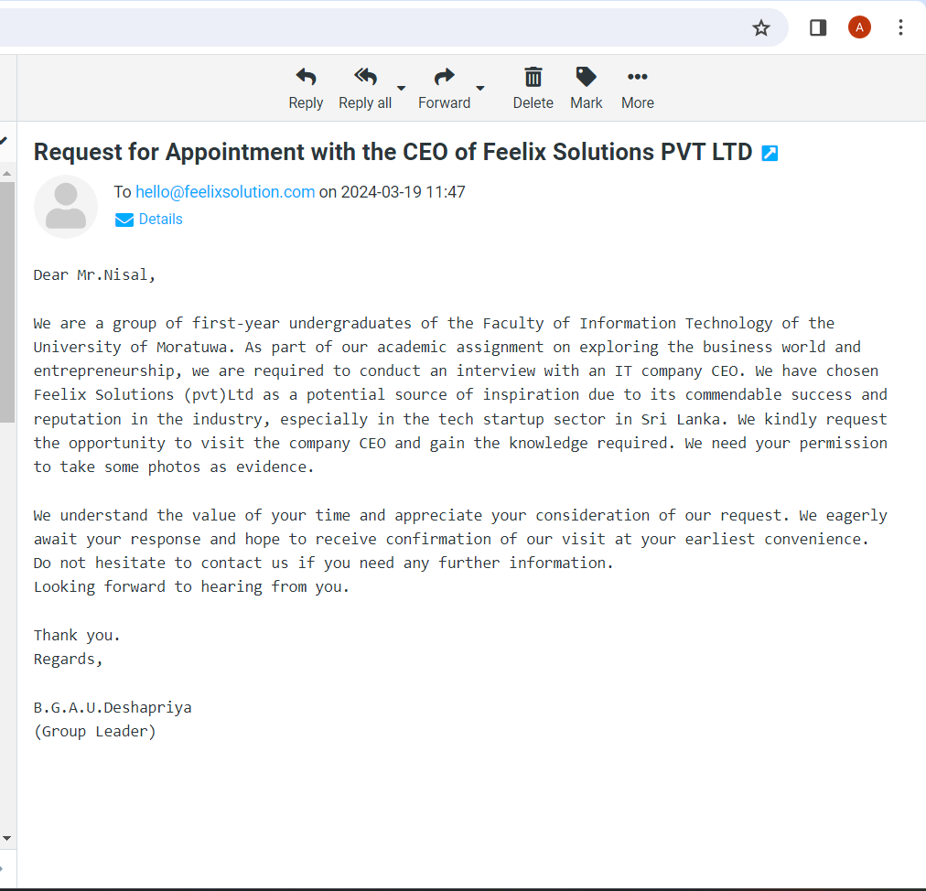

- Interview preparation documents



- Individual contributions

1. Executive summary and Business performance and strategies – Deshapriya B.G.A.U
2. Introduction – Isumi
3. Inspirations for a startup (business idea) – Nethma
4. Details on the journey of building a customer base – Nirodya P.G.S
5. Measuring business success – Nethmi
6. Part II - Understanding the Business Reality – Udayashan S.M.K