|  |  |
| --- | --- |
| **Assessment 1B – Software Requirements Specifications** | |
| **Project Name** | Driving License Management System |
| **Group #** | 1 |
| **Group Members Names** | Carlos Armando Escalona Montes de Oca  Jayawarne Arachchige Dewmi Nihara Sakunali  Srijana Aryal  Sudarshan Udash |
| **Version** | 1.0 |
| **Date Created** | October 10th 2022 |

Contents

1. Introduction 3

1.1 Purpose 3

1.2 Product scope 3

2. Overall Description 3

2.1 Product Perspective 3

2.2 Product Functions 3

2.3 Stakeholders 4

2.4 Operating Environment 4

2.4.1 Software Requirements 4

2.4.2 Hardware Requirements 4

2.5 Constraints 4

2.6 Assumptions 4

3. External Interface Requirements 4

3.1 User Interfaces 4

3.2 Hardware Interfaces 10

3.3 Software Interfaces 10

4. Functional Requirements 10

4.1 Use Case Diagram 10

4.2 Use Case Narratives 10

● Applicant Registration 11

● Applicant Login 11

● Applicant Booking a Trial 11

● Applicant Canceling a Trial 12

5. Non-Functional Requirements 12

5.1 Performance 12

5.2 Security 13

5.3 Maintainability 13

5.4 Reliability 13

5.5 Usability 13

6. References 13

7. Glossary 13

# Introduction

## Purpose

This software requirements specification document ensures that all members of the development team are on the same page regarding what needs to be built and are fully aware of the proposed software system's goal, scope, functional requirements, challenges, and budget.

## Product scope

The main purpose of the proposed Driving License Management System is to allow users to manage their license trial processes online through the system.

# Overall Description

## Product Perspective

Similar products have been developed before. This project aims to meet requirements from public institutions in charge of issuing driving licenses in a country or state. Applicants would have access to the system with a simple GUI supported on common web browsers, having the option to choose the date of preference available for the trial. Staff should be able to approve or reject the driving license application, verify the history, and edit applicant and appointment information.

Driving Licenses System

Applicants

Staff

DB

## Product Functions

The major functions of the Driving License Inventory System are listed below.

* Applicants can register into the system.
* Applicants can login securely into the system.
* Applicants can book a trial.
* Applicants can cancel a trial.
* Applicants can view the results.
* Applicants can logout from the system.
* Staff can login securely into the system.
* Staff can verify, approve, and reject the booking application.
* Staff can check all the applicant’s booking history.
* Staff can logout from the system.

## Stakeholders

The various user classes of this system include Applicants, staff, and payment institutions.

Stakeholder Table / Matrix:

|  |  |  |
| --- | --- | --- |
| **Name** | **Interest** | **Influence** |
| Applicants | High | Low |
| Staff | Medium | High |
| Payment Institution | Medium | Medium |

## Operating Environment

### Software Requirements

* Database: Server-less and self-contained SQLite database.
* Client/server System
* Operating Browsers: Google Chrome, Mozilla Firefox
* Platform: Python
* Operating System: Windows XP and above.

### Hardware Requirements

* N/A

## Constraints

* Time which was assigned to the project is limited.
* Since group members are residing in different time zones, communication among each other is a bit challenging.
* Lack of adequate developing skills.
* Varied knowledge on programming languages.

## Assumptions

1. Applicants can request for booking the trial examination from any part of the respective country.
2. Payment is not done through the system.

# External Interface Requirements

## User Interfaces

The system should include two main user interface views:

**Applicant Views:**

* *Landing page: In this page the user is going to create the applicant account or login using an existing account.*

* *Login page: In this page the user is going to login on the system using the credentials.*

* *Registration page: In this page the user is going to create a new account.*

* *Applicant home page: Once the applicant is logged in this should be the main page where the user can start the application and view results information.*

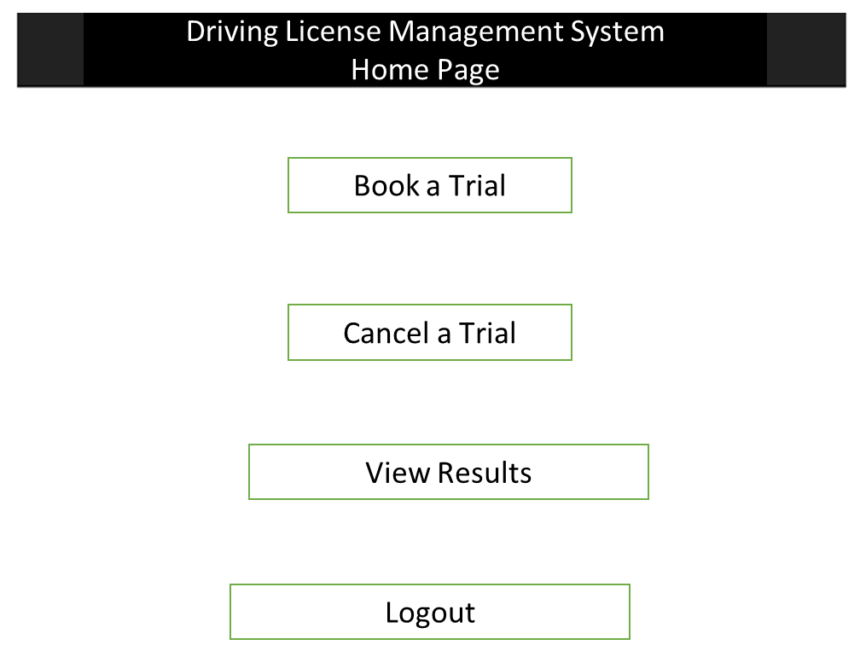

* *Applicant booking a trial page: Applicant should be able to select the location and date of the trial and confirm.*

* *Applicant canceling a trial page: Applicant should be able to canceled an already schedule location.*

* *Applicant results of a trial page: Applicant should be able to verify an already schedule trial.*

***Staff Views:***

* *Staff Login page: In this page the staff user is going to login using an admin existing account.*

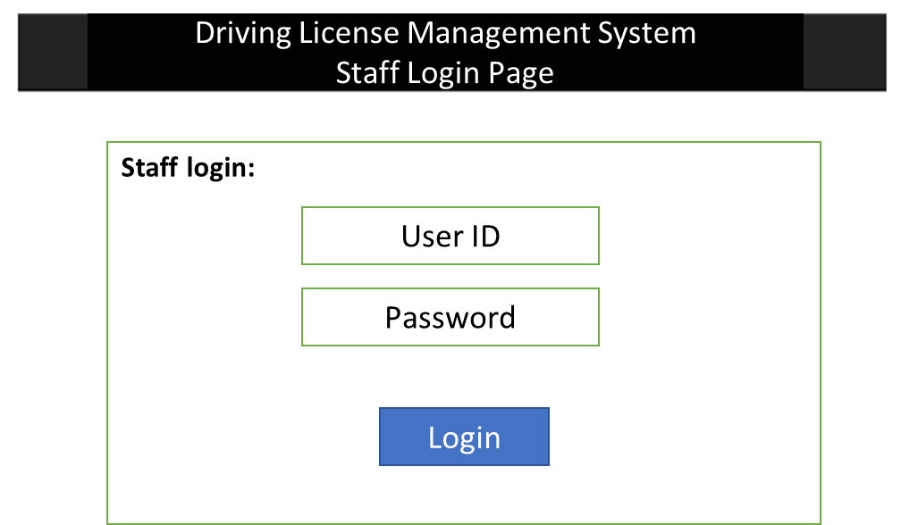

* *Approve / Reject Appointments Staff View: This view shows the appointments list of the different locations.*

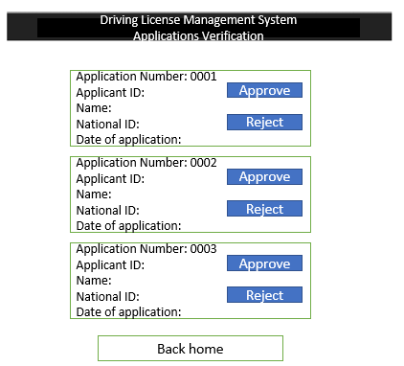

* *Appointments History View: Government staff can click a specific appointment, validate the history log and edit information.*

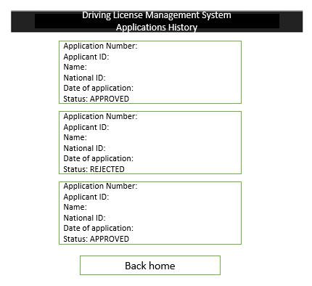

## Hardware Interfaces

No such hardware requirement is necessary.

## Software Interfaces

* *System and User/applicant GUI interface.*

# Functional Requirements

The following use cases allow the applicants to Register, Login, book a trial and cancel a trial.

## Use Case Diagram

The use case diagrams for Driving License Management System are presented below. The involved actors are Applicant (Users applying into the system) and Staff (The users operating the system).

## 4.2 Use Case Narratives

### Applicant Registration

|  |  |
| --- | --- |
| **Use Case Name** | *Registration* |
| **Use Case ID** | 001 |
| **Goal** | To successfully register in the system |
| **Priority** | High |
| **Actors** | Applicant |
| **Pre-conditions** | Applicants must enter the system URL using the provided |
| **Post-conditions** | Applicants can login to the system and get access to the home view. |
| **Trigger** | Click the “Registration” button. |
| **Main Flow** | 1. The applicant navigates through the system web page. 2. Applicants click the “Registration” button. 3. Applicants fills in the details asked in the placeholders. It includes First Name, Middle Name, Last Name, Date of Birth, Mobile Number, Password, Confirm Password, Security Question and Answer. 4. Applicants click the “Sign Up” Button. 5. The system will show the “Successful Register” message. 6. The system provides a user ID for the applicant. 7. Users now can access the system with the registered account. |
| **Exceptions** | Incorrect format on placeholder details. |
| **Supporting Information** |  |

### Applicant Login

|  |  |
| --- | --- |
| **Use Case Name** | *Login* |
| **Use Case ID** | 002 |
| **Goal** | This use case describes how an applicant user logs into the system |
| **Priority** | High |
| **Actors** | Applicant |
| **Pre-conditions** | Applicants must have a valid User ID / password. |
| **Post-conditions** | Applicants can navigate through the system. |
| **Trigger** | Click the “login” button. |
| **Main Flow** | 1. The applicant navigates through the system web page. 2. The applicant clicks on the Login bar that asks them the login details. 3. The applicant enters the validated User ID and password and clicks the login button. 4. The system redirects to a successful login home page. |
| **Exceptions** | Invalid User ID/Password |
| **Supporting Information** |  |

### Applicant Booking a Trial

|  |  |
| --- | --- |
| **Use Case Name** | *Book a Trial* |
| **Use Case ID** | 003 |
| **Goal** | This use case describes how an applicant already logged can book a trial for a driver’s license. |
| **Priority** | High |
| **Actors** | Applicant |
| **Pre-conditions** | Applicants must have a valid User ID/ password. |
| **Post-conditions** | Applicants should have successful appointment in the system |
| **Trigger** | Click the “Book a Trial” button. |
| **Main Flow** | 1. In the home page the applicant should click “Book a Trial” button 2. The system shows a fill form with: Complete name, national ID number, living address information. 3. Applicants select an available location, date, and time from the grill. 4. The applicant submits the information. 5. The system registers the appointment requirement in the database. 6. The system shows the applicant a “submitted information” message confirmation. |
| **Exceptions** | * Invalid information provided for the customer must show an error message. * The customer closes the browser before submitted represents a loss of data. |
| **Supporting Information** |  |

### Applicant Canceling a Trial

|  |  |
| --- | --- |
| **Use Case Name** | *Cancel a Trial* |
| **Use Case ID** | 004 |
| **Goal** | This use case describes how an applicant already logged can cancel a booked trial for a driver’s license. |
| **Priority** | High |
| **Actors** | Applicant |
| **Pre-conditions** | Applicants must have a valid user / password. |
| **Post-conditions** | Applicants should have successful booked trial to get the cancel appointment option |
| **Trigger** | Click the “Cancel Appointment” button. |
| **Main Flow** | 1. In the home page the applicant should click “Cancel a Trial” button 2. The system shows a filled form with: Complete name, national ID number, living address information. 3. The applicant clicks on the cancel trial button. 4. The system registers the appointment cancelation requirement in the database. 5. Applicants are redirected to the home page. |
| **Exceptions** | * The customer closes the browser before submitted represents a loss of data. |
| **Supporting Information** |  |

### Staff Registration

|  |  |
| --- | --- |
| **Use Case Name** | *Registration* |
| **Use Case ID** | 005 |
| **Goal** | To successfully register in the system |
| **Priority** | High |
| **Actors** | Staff |
| **Pre-conditions** | Staff must enter the system URL using the provided |
| **Post-conditions** | Staff can login to the system and get access to the home view. |
| **Trigger** | Click the “Registration” button. |
| **Main Flow** | 1. The staff navigates through the system web page. 2. Applicants click the “Registration” button. 3. Applicants fills in the details asked in the placeholders. It includes First Name, Middle Name, Last Name, Date of Birth, Mobile Number, Password, Confirm Password, Security Question and Answer. 4. Applicants click the “Sign Up” Button. 5. The system will show the “Successful Register” message. 6. The system provides a staff ID for the staff. 7. Staff now can access the system with the registered account. |
| **Exceptions** | Incorrect format on placeholder details. |
| **Supporting Information** |  |

### Staff Login

|  |  |
| --- | --- |
| **Use Case Name** | *Login* |
| **Use Case ID** | 006 |
| **Goal** | This use case describes how a staff logs into the system |
| **Priority** | High |
| **Actors** | Staff |
| **Pre-conditions** | Staff must have a valid Staff ID / password. |
| **Post-conditions** | Staff can navigate through the system. |
| **Trigger** | Click the “login” button. |
| **Main Flow** | 1. The staff navigates through the system web page. 2. The staff clicks on the Login bar that asks them the login details. 3. The staff enters the validated staff ID and password and clicks the login button. 4. The system redirects to a successful login home page. |
| **Exceptions** | Invalid Staff ID/Password |
| **Supporting Information** |  |

### Staff approving an applicant’s booking

|  |  |
| --- | --- |
| **Use Case Name** | *Approve Application* |
| **Use Case ID** | 007 |
| **Goal** | This use case describes how a staff who’s already logged in can approve an applicant’s booking request. |
| **Priority** | High |
| **Actors** | Staff |
| **Pre-conditions** | Staffs must have a valid Staff ID / password. |
| **Post-conditions** | Staff must have requested bookings for the license trial. |
| **Trigger** | Click the “Approve” button. |
| **Main Flow** | 1. In the home page the staff will view the list of applied bookings from applicant. 2. The staff clicks on the approve button. 3. The system registers the appointment approval in the database. 4. Staffs are redirected to the home page. 5. Notification is sent to applicant on successful approval. |
| **Exceptions** | * The staff closes the browser * The staff declines the applicants booking |
| **Supporting Information** |  |

### Staff rejecting an applicant’s booking

|  |  |
| --- | --- |
| **Use Case Name** | *Reject Application* |
| **Use Case ID** | 008 |
| **Goal** | This use case describes how a staff who’s already logged in can reject an applicant’s booking request. |
| **Priority** | High |
| **Actors** | Staff |
| **Pre-conditions** | Staffs must have a valid Staff ID / password. |
| **Post-conditions** | Staff must have requested bookings for the license trial. |
| **Trigger** | Click the “Reject” button. |
| **Main Flow** | 1. In the home page the staff will view the list of applied bookings from applicant. 2. The staff clicks on the reject button. 3. The system registers the appointment rejection in the database. 4. Staffs are redirected to the home page. 5. Notification is sent to the applicant on the booking rejection. |
| **Exceptions** | * The staff closes the browser * The staff approves the applicants booking |
| **Supporting Information** |  |

### Applicant View Result

|  |  |
| --- | --- |
| **Use Case Name** | View Results |
| **Use Case ID** | 009 |
| **Goal** | This use case describes how an applicant who has already booked for a trial can view the results whether their application is approved or rejected. |
| **Priority** | High |
| **Actors** | Applicant |
| **Pre-conditions** | Applicant must have booked for a trial. |
| **Post-conditions** | Applicant can learn whether their application is accepted or not. |
| **Trigger** | Click the “View Result” button. |
| **Main Flow** | 1. In the home page the applicant will click on the View Result button. 2. The applicant views the result of their application |
| **Exceptions** | * The view result page is empty because no booking was made. |
| **Supporting Information** |  |

# Non-Functional Requirements

## Performance

Although the amount of user traffic in this product will be comparatively lower than most systems i.e., E-commerce websites, it is necessary that the product perform in its best capacity for the number of users that interact with it. No matter the number of users at a particular time, the system must have a very fast response and execution time. Also, the workload that the system can carry at once should have to be manageable corresponding to the number of users who use the system at the same time.

## Security

Since the proposed system is going to contain some valuable data like personal information of the candidates, their credit card/bank details it is necessary to secure and protect them against malware attacks or unauthorized access. Only the staff is going to have the access to candidates’ data and their accesses are protected with passwords. Moreover, encryption technologies will be used for sensitive details to make sure that the product follows Data Privacy Acts.

## Maintainability

The time required for a system recovery should have to be comparatively less. For example, if a component, or a certain function is not functioning properly, it must be at least 95% of maintainability for 24 hours, which means 90% of the problem can be fixed within 24 hours. There will be continuous updates and maintenance to eliminate any possible bugs and errors. In addition to this, version controls like GitHub or Gitlab will be used to keep backups of all system versions so that any team can manage and maintain the product at any given time.

## Reliability

The proposed system isdeveloping to have a 90% reliability for two weeks, this means that there is a 90% likelihood that the system won't encounter a critical failure during this time frame, assuming normal usage conditions. It will be kept in mind that the system does not collapse in its functionalities with changes to its surrounding environments over time. The system should work the same after thousands of hours as it did on the first to provide its services.

## Usability

The system that we are going to develop will contain user friendly interfaces, so the users may interact with the system and may receive the service as per their requirements. To ensure that users interact with the system in the easiest manner, learning as well as navigating through the system will be made easier. Also, we are expecting to run usability testing with the product before we finalize it, so that we will be able to guarantee that the proposed system is going to satisfy the requirements of its users.

# References

1. Bandakkanavar, R. (2022) Software requirements specification document with example, Krazytech. Available at: <https://krazytech.com/projects/sample-software-requirements-specificationsrs-report-airline-database> (Accessed: October 23, 2022).
2. Non-functional Requirements: Examples, Types, How to Approach (<https://www.altexsoft.com/blog/non-functional-requirements/>)
3. Pitb (no date) *Verify your driving license*, *DLIMS*. Available at: (<https://www.projectreserve.com/2021/07/driving-license-application-management-system.html> (Accessed: October 23, 2022).
4. *What is the data protection act? Experian business* (no date) *Consumer*. Available at: <https://www.experian.co.uk/business/glossary/data-protection-act/> Accessed: October 23, 2022).

# Glossary

1. GUI - Graphical User Interface, is a form of user interface that allows users to interact with electronic devices through graphical icons and audio indicator such as primary notation, instead of text-based UIs, typed command labels or text navigation.
2. Stakeholder matrix - is a graphic version of a stakeholder analysis.