AI-DRIVEN EMOTION DETECTION & PERSONALIZED LEARNING SUPPORT PLATFORM
An Internship Report
submitted in partial fulfillment of the requirements for the award of the degree of BACHELOR OF TECHNOLOGY
IN
COMPUTER SCIENCE & ENGINEERING
Submitted by
BUDIGI VENKATA SAHITHI
23761A0508

DEPARTMENT OF COMPUTER SCIENCE AND ENGINEERING
LAKIREDDY BALIREDDY COLLEGE OF ENGINEERING
(AUTONOMOUS)
Accredited by NAAC with ‘A’ Grade & NBA (Under Tier - I)
An ISO 21001:2018, 14001:2015, 50001:2018 Certified Institution
Approved by AICTE, New Delhi and Affiliated to JNTUK, Kakinada
L.B. REDDY NAGAR, MYLAVARAM, NTR Dist., ANDHRA PRADESH – 521230 2026-2027

 | LAKIREDDY BALI REDDY COLLEGE OF ENGINEERING (An Autonomous Institution since 2010)  Accredited by NAAC with ‘A’ Grade & NBA (Under Tier - I),  An ISO 21001:2018, 14001:2015, 50001:2018 Certified Institution  Approved by AICTE, New Delhi and Affiliated to JNTUK, Kakinada  VARAM, NTR DIST., A.P.-521 230.  hodcse@lbrce.ac.in, Phone: 08659-222 933, Fax: 08659-222931  R SCIENCE & ENGINEERING
CERTIFICATE
This is to certify that internship work entitled “AI-Driven Emotion Detection & Personalized Learning Support Platform” the bonafide work done by BUDIGI VENKATA SAHITHI (23761A0508) in partial fulfillment of the requirements for the award of the degree in BACHELOR OF TECHNOLOGY in Computer Science and Engineering from LAKIREDDY BALI REDDY COLLEGE OF ENGINEERING, MYLAVARAM during the year 2026-2027.
Mrs. M. Gayatri Dr. S. Nagarjuna Reddy (Internship Coordinators) (Head of the Department)
EXTERNAL EXAMINER

CERTIFICATE OF COMPLETION
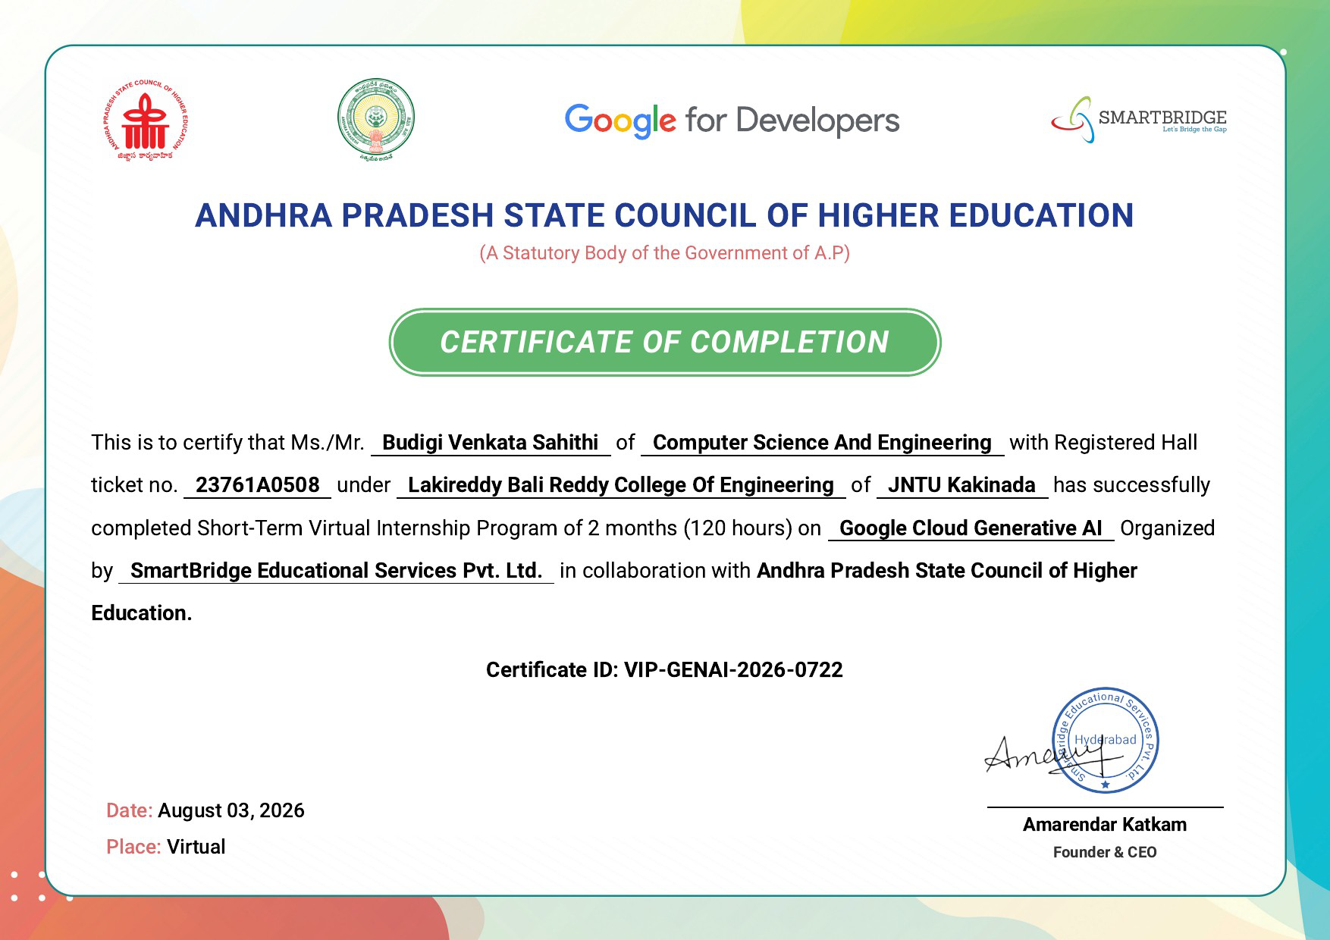

ACKNOWLEDGEMENT
I would like to express my sincere gratitude to the management of Lakireddy Bali Reddy College of Engineering (LBRCE) for providing the necessary support and facilities to complete this project successfully.
I express my heartfelt thanks and deep respect to our Principal, Dr. K. Appa Rao, for providing the required assistance, encouragement, and inspiration to carry out this work at the institute.
I would also like to express my sincere gratitude to Dr. S. Nagarjuna Reddy, Head of the Department of Computer Science and Engineering, for his encouragement, cooperation, and valuable support throughout the successful completion of this project.
I extend my sincere thanks to all the faculty members of the Department of Computer Science and Engineering for their valuable guidance, encouragement, constructive suggestions, and moral support throughout our engineering journey. Their continuous motivation and support, particularly during the execution of this project, inspired us to overcome challenges and complete the work successfully.
I would also like to acknowledge all the individuals who directly or indirectly contributed to the successful completion of this project. I sincerely thank the librarian of LBRCE for providing access to valuable books and other reference materials that supported our work.
I am grateful to the teaching and non-teaching staff of the Department of Computer Science and Engineering for their cooperation and assistance throughout the project.
Finally, I express my heartfelt gratitude to my parents for their unconditional love, encouragement, and continuous support, which have been a constant source of strength and motivation throughout my academic journey.
BUDIGI VENKATA SAHITHI
23761A0508

DECLARATION
We hereby declare that the project report entitled “AI-Driven Emotion Detection & Personalized Learning Support Platform”, submitted to Jawaharlal Nehru Technological University Kakinada (JNTUK), in partial fulfillment of the requirements for the award of the degree of Bachelor of Technology (B.Tech.), is an original work carried out by us.
We further declare that the work presented in this report is genuine and has not been submitted, either in whole or in part, to this university or any other university or institution for the award of any degree, diploma, or other academic qualification.
SUBMITTED BY
BUDIGI VENKATA SAHITHI

Executive Summary
This report presents my internship experience with SmartBridge Educational Services Pvt. Ltd., where I completed a Short-Term Virtual Internship Program of two months (120 hours) on Google Cloud Generative AI, organized in collaboration with the Andhra Pradesh State Council of Higher Education (APSCHE). The internship applied deep learning and natural language processing to a real educational problem: understanding how learners feel about their studies and responding to them with timely, empathetic support.
The main project, the AI-Driven Emotion Detection & Personalized Learning Support Platform, is an end-to-end system that transforms a learner's free-text description of a study challenge into an emotion-aware, supportive response. It predicts five emotional states (Bored, Confident, Confused, Curious and Frustrated) using two deep learning classifiers, BiLSTM and BERT, strengthened by rule-based keyword enhancement, and reports mixed-emotion breakdowns with confidence levels. Gemini-generated guidance then provides tailored tips, next steps and encouragement. Every interaction is logged to CSV, emotion trends are shown on an analytics dashboard, and the two models can be compared side by side in a Streamlit web application.
The work benefits two groups: educators, TAs and academic support teams, who can triage student messages faster and respond with a consistent, empathetic tone; and self-study learners, who receive immediate, emotion-aware help when they are stuck. The internship strengthened my skills in NLP, model development, generative-AI integration and application development, and showed me how AI can improve the quality and speed of learner support.

Table of Contents
Chapter 1 | Name of the Content | Pg.No
Chapter 1 | INTRODUCTION | 1
Chapter 1 | INTRODUCTION | 1
1.1 | Introduction to Internship | 1
1.2 | Objectives of the Internship | 1
1.3 | Scope of the Internship | 2
1.4 | Internship Duration and Mode | 3
Chapter 2 | ORGANIZATION PROFILE | 4
Chapter 2 | ORGANIZATION PROFILE | 4
2.1 | Company / Organization Overview | 4
2.2 | Vision and Mission of the Organization | 4
2.3 | Organization Structure | 4
2.4 | Products, Services, or Technical Domains | 5
Chapter 3 | INTERNSHIP DOMAIN AND TECHNOLOGIES | 6
Chapter 3 | INTERNSHIP DOMAIN AND TECHNOLOGIES | 6
3.1 | Introduction to the Internship Domain | 6
3.2 | Technologies and Tools Used | 7
3.3 | Software, Platforms, and Frameworks | 7
3.4 | Prerequisite Skills and Knowledge | 8
Chapter 4 | WORK PERFORMED DURING INTERNSHIP | 9
Chapter 4 | WORK PERFORMED DURING INTERNSHIP | 9
4.1 | Internship Work Plan and Schedule | 9
4.2 | Tasks and Activities Performed | 9
4.3 | Technical Training and Learning Activities | 10
4.4 | Practical Exercises / Case Studies | 10
4.5 | Project Description | 11
4.5 | Project Description | 15
4.6 | Implementation and Results | 15
Chapter 5 | LEARNING OUTCOMES AND SKILL DEVELOPMENT | 20
5.1 | Technical Skills Acquired | 20
5.2 | Problem-Solving and Analytical Skills | 20
5.3 | Professional and Communication Skills | 20
5.3 | Professional and Communication Skills | 21
5.4 | Application of Classroom Knowledge | 21
5.5 | Challenges Faced and Solutions | 21
Chapter 6 | CONCLUSION AND FUTURE SCOPE | 22
6.1 | Summary of Internship Experience | 22
6.2 | Key Learning Outcomes | 22
6.2 | Key Learning Outcomes | 22
6.3 | Future Scope and Career Relevance | 22
6.3 | REFERENCES | 24
6.3 | APPENDICES: PO, PSO, SDG MAPPING AND SUPPORTING | 25
DOCUMENTS

List of Figures
Fig. No. | Name of the Figure | Pg.No
Fig 4.1 | Overall System Architecture of the Platform | 12
Fig 4.2 | End-to-End Workflow of the Platform | 14
Fig 4.3 | Hybrid Emotion Prediction Pipeline | 14
Fig 4.4 | Application Input Screen with Model Settings | 16
Fig 4.5 | Learning Analytics: Emotions Tab | 17
Fig 4.5 | Learning Analytics: Emotions Tab | 17
Fig 4.6 | Learning Analytics: Fields Tab | 17
Fig 4.7 | Learning Analytics: Summary Tab with Interaction Log | 18

List of Tables
Table No. | Name of the Table | Pg.No
Table 1.1 | Internship Details | 3
Table 1.1 | Internship Details | 5
Table 2.1 | Organizational Levels Relevant to the Internship | 5
Table 3.1 | Technologies and Tools Used in the Project | 7
Table 4.1 | Internship Work Plan | 9
Table 4.2 | Illustrative Inputs and Expected System Behaviour | 11
Table 4.3 | Emotion Classes and Support Strategy | 13
Table 4.3 | Emotion Classes and Support Strategy | 15
Table 4.4 | Characteristics of the Two Classifiers | 15
Table 4.5 | Evaluation Metrics of the Classifiers | 18
Table 5.1 | Mapping of Classroom Knowledge to Internship Work | 21
Table 5.2 | Challenges and Solutions | 21
Table A.1 | PO Mapping | 25
Table A.1 | PO Mapping | 25
Table B.1 | PSO Mapping | 25
Table C.1 | SDG Mapping | 26

CHAPTER 1
INTRODUCTION
1.1 Introduction to Internship
This report documents my internship at SmartBridge Educational Services Pvt. Ltd., carried out as part of the B.Tech (Computer Science & Engineering) curriculum of Lakireddy Bali Reddy College of Engineering (Autonomous) for the academic year 2026-2027. The internship was a Short-Term Virtual Internship Program of 2 months (120 hours) on Google Cloud Generative AI, organized by SmartBridge Educational Services Pvt. Ltd. in collaboration with the Andhra Pradesh State Council of Higher Education (APSCHE). The work was in the domain of Artificial Intelligence and Machine Learning, with a specific focus on Natural Language Processing (NLP) and generative AI for education technology.
The central assignment of the internship was the design and development of the AI-Driven Emotion Detection & Personalized Learning Support Platform. The platform takes a learner's free-text description of a study challenge, identifies the emotional state expressed in the text, and responds with tailored tips, next steps and encouragement. It combines two deep learning emotion classifiers (a Bidirectional LSTM and BERT), a rule-based keyword enhancement layer, and Gemini-generated guidance, and is delivered to the user through a Streamlit web application.
The motivation for this work is simple but important. Learning is not purely cognitive: a student who is confused, frustrated or bored learns differently from one who is curious or confident. Instructors, teaching assistants (TAs) and academic support teams, however, receive large volumes of messages and rarely have the time to interpret the emotion behind each one before replying. Learners working on their own, in turn, often have nobody to turn to at the moment they feel stuck. An automated, emotion-aware assistant can narrow both gaps by giving every learner a fast, consistent and empathetic first response.
1.2 Objectives of the Internship
The objectives set for the internship were as follows:
• To understand the fundamentals of emotion detection from text and its relevance to personalized learning support.
1

• To build and train deep learning classifiers (BiLSTM and BERT) that predict five learner emotions: Bored, Confident, Confused, Curious and Frustrated.
• To improve prediction reliability by adding a rule-based keyword enhancement layer and by supporting mixed-emotion output with confidence levels.
• To integrate a large language model (Gemini) so that predicted emotions are converted into supportive, field-specific guidance.
• To develop an interactive Streamlit application with options to toggle AI responses and to compare the two models side by side.
• To log every interaction to a CSV file and visualize emotion trends through an analytics dashboard for continuous learning and progress tracking.
• To follow professional software-engineering practices such as modular design, version control, testing and documentation.
1.3 Scope of the Internship
The scope of the work covers the complete pipeline from raw student text to an emotion-aware response, together with logging and analytics. The platform is intended for two groups of users, described below as application scenarios.
Scenario 1: Educators, TAs and Academic Support Teams
Instructors and support staff spend considerable time interpreting the sentiment of student messages and e-mails before replying. Manually reading, guessing the emotion and choosing the right tone slows the response cycle and can cause struggling students to be missed. With the platform, a TA can paste a student's concern and instantly see whether the student is, for example, Confused or Frustrated, how confident the prediction is, and what supportive guidance is suggested. The dual-model comparison (BiLSTM vs BERT) and mixed-emotion detection add reliability and transparency, so that teams can triage faster, keep their tone consistently empathetic and focus on academic intervention rather than sentiment interpretation.
Scenario 2: Learners and Self-Study
Students working independently often need quick, empathetic guidance when they are stuck. Searching forums or drafting a help request takes time and rarely captures how the student feels. Using the platform, a learner can describe a challenge in plain language, such as "I'm lost on recursion", and immediately receive a Confused label, clarity-focused advice and encouraging
2

next steps. Mixed-emotion outputs (for example Curious + Confused) help learners reflect on
their own state, and the saved interaction history supports progress tracking over time.
Boundaries of the work
• In scope: text-based emotion classification into five classes, mixed-emotion breakdown, keyword enhancement, Gemini-based guidance, CSV logging, analytics dashboard and model comparison inside a Streamlit application.
• Out of scope: speech or facial emotion recognition, integration with a specific Learning Management System, user authentication and multi-language support. These are discussed as future enhancements in Chapter 6.
1.4 Internship Duration and Mode
Table 1.1: Internship Details
Particular | Details
Organization | SmartBridge Educational Services Pvt. Ltd. (in collaboration with APSCHE)
Designation / Role | Virtual Intern, Google Cloud Generative AI
Program | Short-Term Virtual Internship Program, Google Cloud Generative AI
Domain | Artificial Intelligence, Machine Learning and Natural Language Processing
Project undertaken | AI-Driven Emotion Detection & Personalized Learning Support Platform
Duration | 2 months (120 hours)
Mode of internship | Virtual (online)
Certificate ID | VIP-GENAI-2026-0722
Internal mentor / coordinator | D. Anil Kumar (Internship Coordinator)
3

CHAPTER 2
ORGANIZATION PROFILE
2.1 Company / Organization Overview
SmartBridge Educational Services Pvt. Ltd. (SmartBridge) is a Hyderabad-based education-technology company founded in 2015 by Amarendar Katkam (Founder & CEO) and Suman Akula. It focuses on skill development and on bridging the gap between academic learning and industry requirements, mainly through its SmartInternz platform, which offers project-based learning and virtual internships in emerging technologies. SmartBridge became part of Veranda Learning Solutions in 2023.
SmartBridge works with colleges and government bodies across India. This internship was delivered in collaboration with the Andhra Pradesh State Council of Higher Education (APSCHE), a statutory body of the Government of Andhra Pradesh, and with Google for Developers as a technology partner for the Google Cloud Generative AI program.
The internship was conducted fully online. Learning content, mentoring sessions and project guidance were delivered through the virtual internship platform, which gave me exposure to how real projects are planned, reviewed and delivered, and to practices for documentation and quality assurance.
2.2 Vision and Mission of the Organization
SmartBridge's purpose is to bridge the gap between academic learning and industry requirements. It prepares young graduates for their first job by providing practical, industry-aligned skill training and project-based virtual internships in emerging technologies, in partnership with technology leaders and educational bodies.
The internship project is in line with this purpose, since it applies AI to make learner support more accessible, timely and empathetic.
2.3 Organization Structure
SmartBridge is led by its founder and management team and delivers its virtual internship programs in partnership with technology companies and educational bodies. Interns take part through the online platform, with coordination from their college. Table 2.1 summarizes the levels
4

relevant to this internship.
Table 2.1: Organizational Levels Relevant to the Internship
Level | Designation | Role with respect to the internship
Management | Amarendar Katkam, Founder & CEO | Overall direction of the organization and approval of the internship program
College coordinator | D. Anil Kumar | Internship coordination and academic guidance from the college
Interns | Intern (myself and peers) | Execution of assigned project work and submission of progress updates
2.4 Products, Services, or Technical Domains
SmartBridge Educational Services Pvt. Ltd. offers virtual internship programs developed with global technology partners, project-driven education solutions delivered through its SmartInternz platform, and tailored skill-development programs for students and institutions. Its programs cover emerging technologies such as Artificial Intelligence, Generative AI, cloud computing, data science and IoT. The internship was connected most directly to Artificial Intelligence, generative AI (Google Cloud), Natural Language Processing and educational technology.
Within these domains, emotion-aware systems form a growing area known as affective computing. Such systems detect human affective states from signals like text, voice or facial expressions so that the software can respond more appropriately. The platform developed during this internship is a text-based example of this idea applied to learning support.
5

CHAPTER 3
INTERNSHIP DOMAIN AND TECHNOLOGIES
3.1 Introduction to the Internship Domain
The internship domain lies at the intersection of Natural Language Processing (NLP), deep learning and educational technology (EdTech). NLP enables computers to read and interpret human language; deep learning provides models that learn patterns directly from large amounts of text; and EdTech applies these capabilities to teaching and learning.
Emotion detection from text
Emotion detection (also called emotion classification) is the task of assigning one or more emotion labels to a piece of text. Unlike basic sentiment analysis, which only separates positive from negative, emotion detection distinguishes finer states. For learning contexts, the states that matter most are those that influence engagement and persistence. This project uses five of them: Bored, Confident, Confused, Curious and Frustrated.
Deep learning models for text
A Bidirectional Long Short-Term Memory (BiLSTM) network reads a sentence in both directions and keeps a memory of earlier words, which makes it effective at capturing word order and local context with a modest computational cost. BERT (Bidirectional Encoder Representations from Transformers) is a pre-trained transformer that uses self-attention to model the full context of every word and can be fine-tuned for classification, usually achieving a deeper understanding of language at a higher computational cost. Using both models and comparing them is a central idea of this project.
Large language models for guidance
Large language models such as Google Gemini can generate fluent, context-sensitive text. In this platform, Gemini is not used to decide the emotion; it is used after the emotion has been detected to write supportive guidance that is aligned with the learner's state and subject area. This separation keeps the prediction step measurable and the response step flexible.
6

3.2 Technologies and Tools Used
Table 3.1: Technologies and Tools Used in the Project
Category | Technology / Tool | Purpose in the project
Programming language | Python | Core implementation of models, logic and application
Deep learning (sequence model) | BiLSTM network | Emotion classification from tokenized text
Deep learning  (transformer) | BERT | Context-aware emotion classification
Rule-based NLP | Keyword lexicon and rules | Enhancement and sanity-checking of model predictions
Generative AI | Google Gemini | Generation of tips, next steps and encouragement
Web framework | Streamlit | Interactive user interface and dashboard pages
Data handling | CSV files, pandas | Interaction logging and trend analysis
Visualization | Charting library | Emotion distribution and trend charts
Version control | Git and GitHub | Source-code management and project hosting
Development environment | VS Code / Jupyter / Google Colab | Coding, experimentation and model training
3.3 Software, Platforms, and Frameworks
Streamlit is an open-source Python framework for turning scripts into web applications. It was chosen because it allows rapid development of data-driven interfaces, including text boxes, toggles, tabs and charts, without separate front-end code.
Google Gemini API provides the generative component of the system. A prompt is constructed from the learner's text, the detected emotion(s) and the learner's field of study, and the model returns practical, empathetic guidance. A toggle in the interface lets the user switch AI responses on or off.
Deep learning frameworks were used to define, train and run the BiLSTM and BERT classifiers. Trained models are loaded by the application at start-up so that predictions are returned within seconds.
GitHub was used to host the project repository (Emotion-Detection-Learning-Support-Engine-v2), maintain version history and make the work reviewable by mentors and evaluators.
7

3.4 Prerequisite Skills and Knowledge
• Python programming, including functions, modules, file handling and virtual
environments.
• Fundamentals of machine learning: training, validation and testing, overfitting, and
evaluation metrics such as accuracy, precision, recall and F1-score.
• Basics of neural networks, recurrent networks (LSTM) and the transformer architecture.
• Text pre-processing techniques: cleaning, tokenization, padding, embeddings and label
encoding.
• Working knowledge of data handling with CSV files and pandas.
• Familiarity with REST-style API usage and prompt design for large language models.
• Basic usage of Git and GitHub.
8

CHAPTER 4
WORK PERFORMED DURING INTERNSHIP
4.1 Internship Work Plan and Schedule
The internship followed a phased plan, moving from learning and requirement analysis through
model development and integration to testing and documentation. Table 4.1 shows the plan.
Table 4.1: Internship Work Plan
Phase | Period | Activities | Outcome
1 | Weeks 1-2 | Orientation, literature study on emotion  detection, requirement analysis, environment setup | Requirement list and project plan
2 | Weeks 3-4 | Data preparation, text pre-processing and BiLSTM model development | Trained BiLSTM classifier
3 | Weeks 5-6 | BERT fine-tuning, keyword-rule layer and mixed-emotion logic | Trained BERT classifier and hybrid prediction
4 | Week 7 | Gemini integration, Streamlit interface, CSV logging, analytics dashboard and model comparison page | Working end-to-end application
5 | Week 8 | Testing, bug fixing, documentation and final review | Final report and project demonstration
4.2 Tasks and Activities Performed
The main tasks carried out during the internship were:
• Requirement analysis: studied the needs of educators, TAs and self-study learners and translated them into functional requirements for the platform.
• Data preparation: collected and organized labelled learner-style text for the five emotion classes and applied cleaning, tokenization and label encoding.
• BiLSTM development: designed, trained and tuned a Bidirectional LSTM classifier for the five emotions.
• BERT fine-tuning: fine-tuned a pre-trained BERT model for the same classification task so that both models could be compared on identical inputs.
• Keyword enhancement: built a rule-based layer containing emotion-indicative keywords and phrases that supports or adjusts the model scores.
• Mixed-emotion logic: converted class probabilities into a ranked breakdown so that
9

more than one emotion can be reported with confidence values.
• Gemini integration: designed prompts that pass the detected emotion(s) and field of study to Gemini and obtain tips, next steps and encouragement.
• Application development: implemented the Streamlit interface with text input, AI- response toggle, result view, dashboard and comparison pages.
• Logging and analytics: stored each interaction in a CSV file and built charts that show emotion trends over time.
• Testing and documentation: tested the system with varied sample inputs, fixed defects and documented the work.
4.3 Technical Training and Learning Activities
Alongside project work, I undertook structured learning activities that supported each phase of development:
• Study of text classification, word embeddings and the working of LSTM and BiLSTM networks.
• Study of the transformer architecture, self-attention and fine-tuning of pre-trained BERT models for classification.
• Exploration of prompt-engineering techniques for obtaining consistent and empathetic responses from Gemini.
• Hands-on practice with Streamlit components, session state and caching of loaded models.• Practice of model evaluation methods, including confusion matrices and per-class precision, recall and F1-score.
• Regular review sessions with the mentor to discuss progress, design decisions and improvements.
4.4 Practical Exercises / Case Studies
Practical exercises were carried out using realistic learner statements. Table 4.2 lists illustrative inputs used to exercise the system and the behaviour expected from it.
10

Table 4.2: Illustrative Inputs and Expected System Behaviour
No. | Learner input | Expected primary emotion | Expected guidance theme
1 | "I'm lost on recursion and don't know where to start." | Confused | Break the problem into base case and recursive case; trace a small example
2 | "My SQL query keeps failing with the same error and I'm fed up." | Frustrated | Acknowledge the difficulty; debug step by step; take a short break
3 | "I finished the first three exercises easily. Give me something harder." | Confident | Offer a stretch problem and suggest a deeper topic
4 | "How does backpropagation really update the weights? I want to  understand it." | Curious | Provide a clear explanation and further reading
5 | "This lecture is repetitive and I'm not learning anything new." | Bored | Suggest active practice, projects or a more challenging resource
6 | "I want to learn how neural networks work, but the maths confuses me." | Curious + Confused (mixed) | Encourage curiosity while  simplifying the mathematics with examples
Case Study 1: Triage by a teaching assistant
A TA receives a long message from a student about an assignment. Instead of reading and interpreting the tone manually, the TA pastes the message into the platform. The system reports the dominant emotion, the confidence level and a mixed-emotion breakdown, and proposes a supportive reply. The TA uses the output to decide how urgently to respond and which tone to adopt, and can compare the BiLSTM and BERT results to judge how reliable the prediction is.
Case Study 2: A self-study learner
A learner studying alone writes, "I'm lost on recursion." The system flags the text as Confused and returns clarity-focused advice together with encouraging next steps. The interaction is saved to the CSV log, so that over several sessions the learner can see on the dashboard how emotions such as Confused and Frustrated change into Curious and Confident as the topic becomes clearer.
4.5 Project Description
4.5.1 Problem Statement
Educators and learners lack a fast, consistent way to understand and respond to the emotional state behind a study-related message. Manual interpretation is slow, subjective and hard to scale, and generic help resources do not take the learner's feelings into account.
11

4.5.2 Proposed System
The proposed platform is an end-to-end system that transforms free-text input into an emotion-aware, supportive response. It combines deep learning emotion classifiers (BiLSTM and BERT) with rule-based keyword enhancement and Gemini-generated guidance. It predicts nuanced emotional states, reports mixed emotions with confidence levels, logs every interaction and visualizes emotion trends, which reduces manual triage and keeps the support consistent and empathetic within seconds.
4.5.3 System Architecture
The architecture is organized in layers (Figure 4.1). The presentation layer is the Streamlit application. The processing layer pre-processes the text, runs the BiLSTM and BERT classifiers, applies keyword enhancement and fuses the scores into a mixed-emotion result. The guidance generator calls Gemini, while the logger and analytics module store and visualize interactions. The data layer holds the CSV log, trained model files and keyword lexicon.
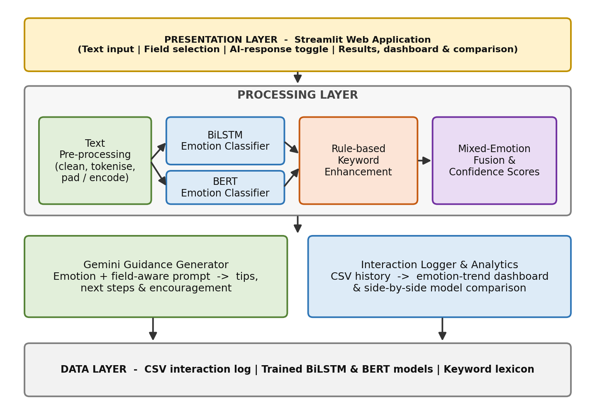
Fig 4.1: Overall System Architecture of the Platform
12

4.5.4 Emotion Classes
Table 4.3: Emotion Classes and Support Strategy
Emotion | Meaning in a learning context | Typical support strategy
Bored | Material feels repetitive, too easy or irrelevant | Increase challenge, suggest projects or varied resources
Confident | Learner feels capable and ready to progress | Reinforce progress and offer stretch goals
Confused | Learner cannot follow a concept or does not know where to start | Simplify, give examples and break the topic into small steps
Curious | Learner is eager to explore and understand more | Feed curiosity with explanations and further reading
Frustrated | Repeated difficulty or obstacles cause irritation | Acknowledge feelings, suggest debugging steps and short breaks
4.5.5 System Modules
• Input and pre-processing module: accepts the learner's text (and optionally the field of study), cleans it and converts it to the form required by each model.
• BiLSTM classifier: a sequence model that outputs a probability for each of the five emotions.
• BERT classifier: a fine-tuned transformer that outputs probabilities for the same five emotions.
• Keyword enhancement module: a rule-based layer that uses emotion-indicative words and phrases to strengthen, confirm or correct the model output, especially for short or ambiguous text.
• Mixed-emotion and confidence module: normalizes the scores into a ranked breakdown so that secondary emotions are visible, for example Curious + Confused.
• Gemini guidance generator: builds a prompt from the text, emotion(s) and field and returns tips, next steps and encouragement; it can be toggled on or off.
• Logger and analytics module: appends every interaction to a CSV file and renders emotion-trend charts on a dashboard.
• Model comparison module: displays the BiLSTM and BERT predictions side by side for the same input.
4.5.6 Workflow
Figure 4.2 shows the sequence of operations from the moment a learner enters text to the point at
13

which the result is displayed and logged.
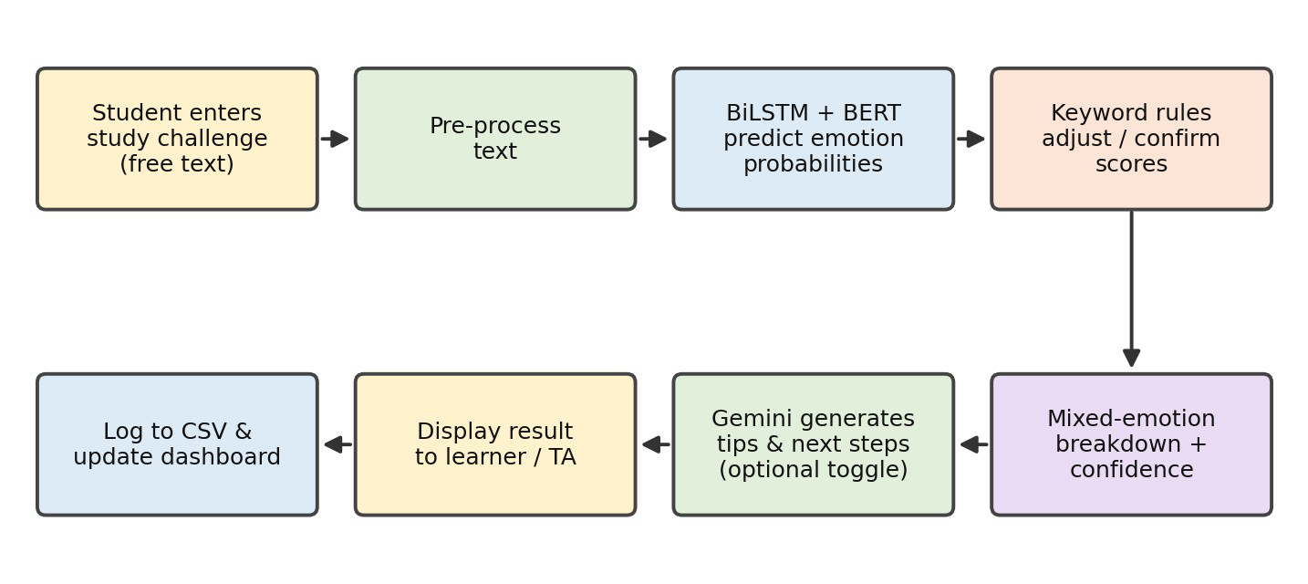
Fig 4.2: End-to-End Workflow of the Platform
4.5.7 Hybrid Emotion Prediction
Natural learner text is often short, informal and emotionally mixed. To handle this, the platform does not rely on a single signal. The BiLSTM and BERT models each provide class probabilities, the keyword lexicon provides an independent rule-based signal, and a fusion step normalizes the scores into a primary emotion with confidence plus a mixed-emotion breakdown (Figure 4.3).
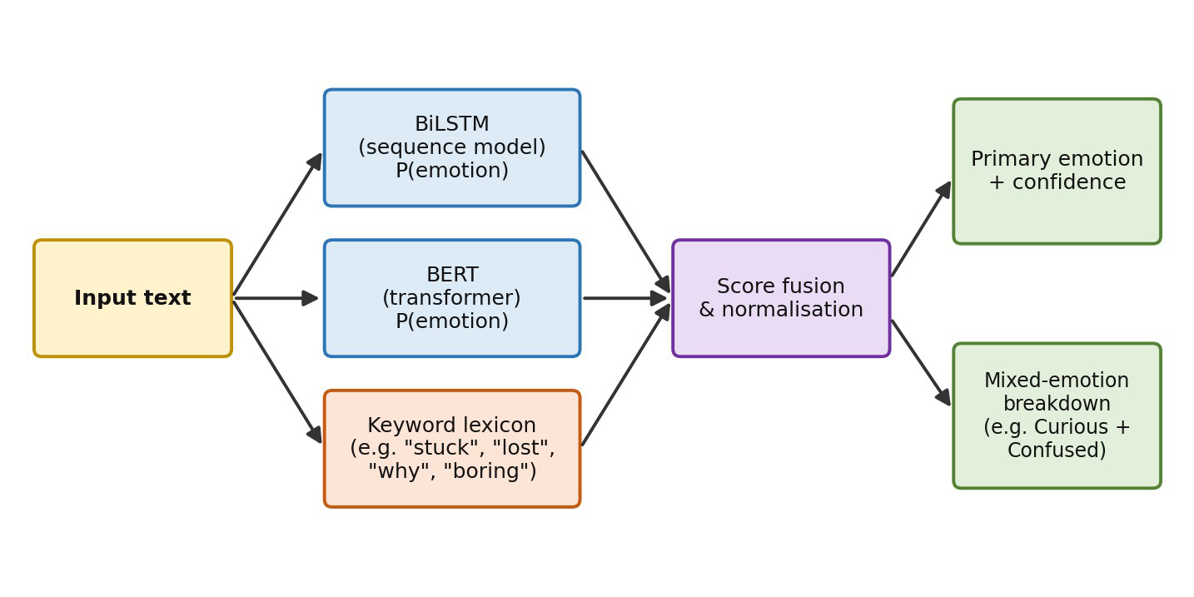
Fig 4.3: Hybrid Emotion Prediction Pipeline
14

Table 4.4: Characteristics of the Two Classifiers
Aspect | BiLSTM | BERT
Architecture | Recurrent network reading text in both directions | Transformer with self-attention over the whole sentence
Context handling | Sequential, local to medium range | Deep, bidirectional, pre-trained on large text corpora
Computational cost | Lower; faster to train and run | Higher; needs more memory and compute
Typical strength | Lightweight and fast responses | Nuanced understanding of wording and context
Role in the platform | Fast baseline and comparison model | High-context model and comparison model
4.5.8 Requirements
Functional requirements: accept free-text input; classify into five emotions; display a mixed-emotion breakdown with confidence; generate guidance on request; log interactions; show analytics; compare the two models.
Non-functional requirements: responses within a few seconds; a simple and clear interface; modular code that is easy to extend; transparent output so that users can see how the prediction was formed; and respect for user privacy in stored logs.
4.6 Implementation and Results
4.6.1 Implementation Details
The system was implemented in Python. Text is cleaned and converted into the representation required by each model. The BiLSTM and BERT classifiers are trained offline, saved, and loaded by the Streamlit application at start-up. At run time the application obtains the class probabilities, applies keyword enhancement, computes the mixed-emotion breakdown and, if the AI toggle is on, sends a structured prompt to Gemini containing the learner's text, the detected emotion(s) and the field of study.
Every submission is appended to a CSV file together with its predicted emotions and related details. The analytics page reads this file and plots emotion distributions and trends. The comparison page runs the same input through both models and presents their outputs next to each other so that agreement and disagreement are easy to see.
15

4.6.2 User Interface and Output
The application collects the learner's name, e-mail, role and field of study, and a description of the challenge in a text box. Quick-example buttons (for instance "I am confused about recursion") fill the box with sample text. The Settings panel lets the user choose BERT, BiLSTM or Compare Both Models, decide whether to save the interaction to CSV and the database, and show analysis details. The sidebar displays the loaded models, the number of interactions and CSV examples, a Clear History button and recent sessions. Figures 4.4 to 4.7 show these screens.
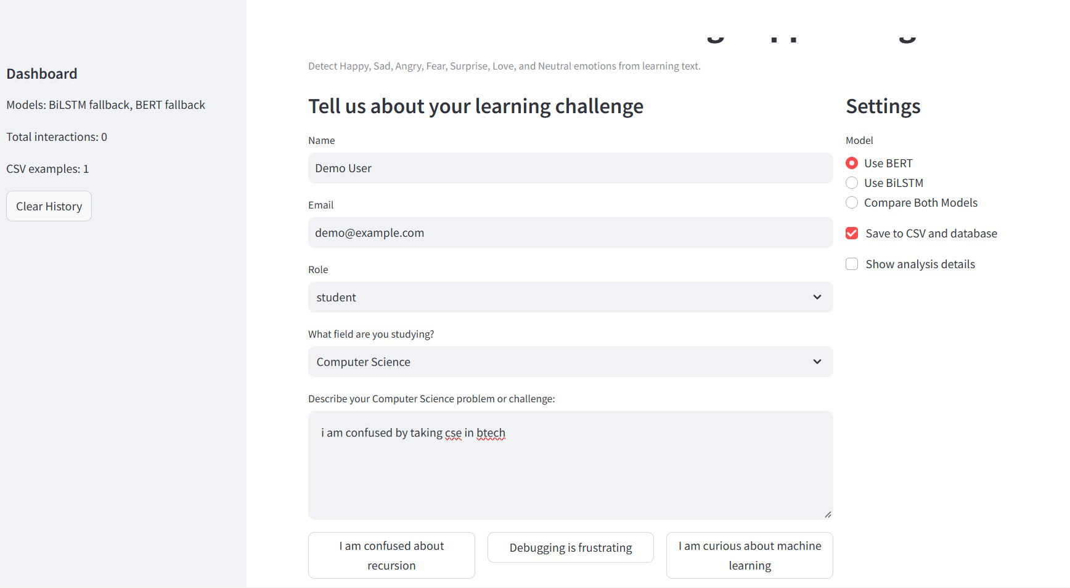
Fig 4.4: Application Input Screen with Model Settings
After the user clicks Get AI Learning Help, the interaction is stored and the Learning Analytics section is updated. It has three tabs: Emotions (distribution chart), Fields (emotion and model counts per field of study) and Summary (interaction count, average confidence, most common emotion and the logged records).
16

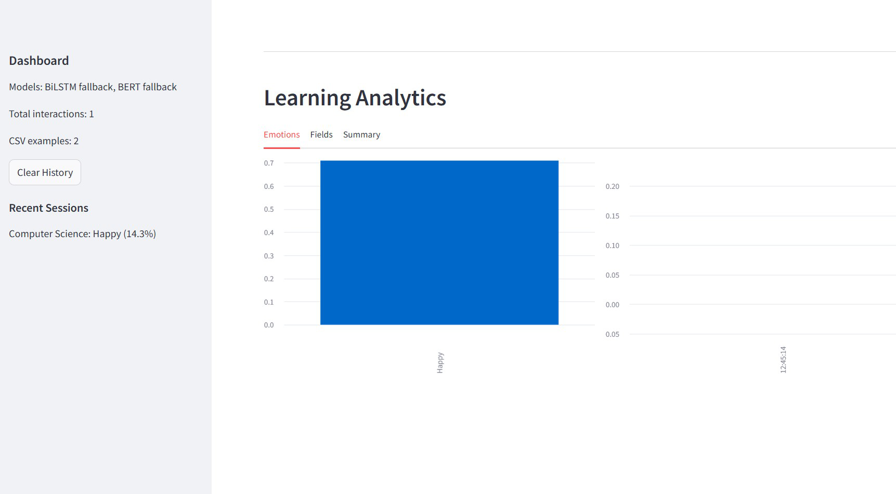
Fig 4.5: Learning Analytics: Emotions Tab
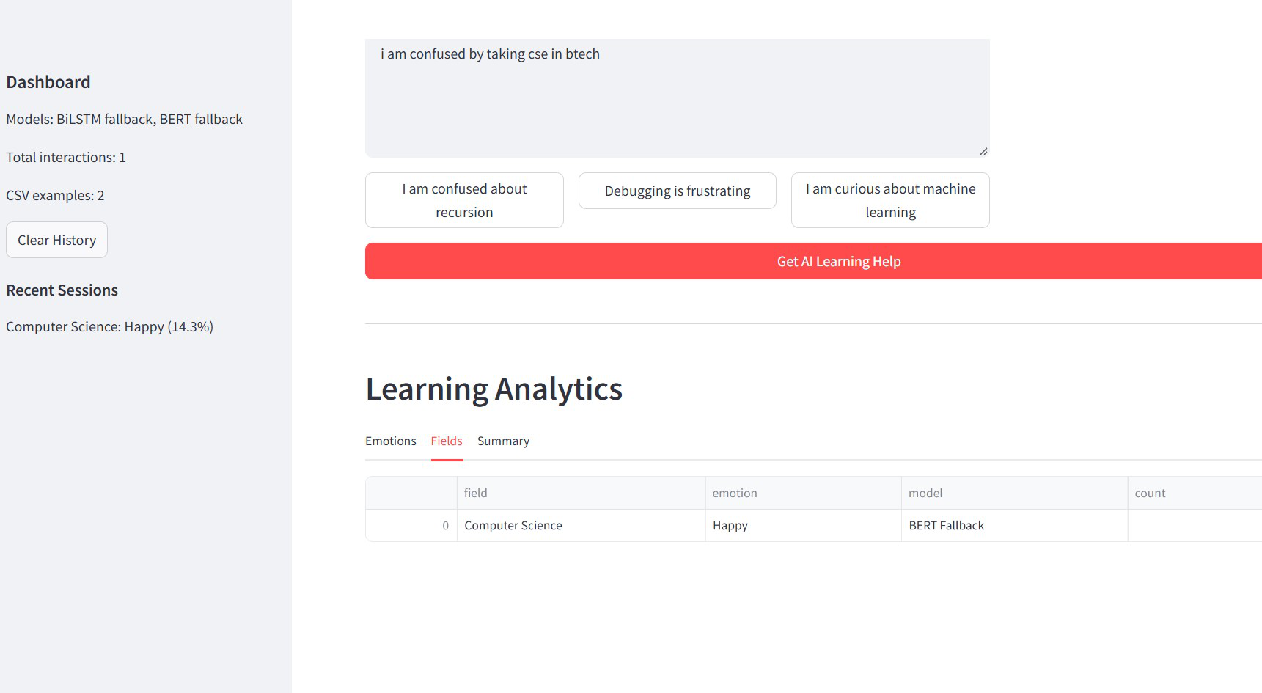
Fig 4.6: Learning Analytics: Fields Tab
17

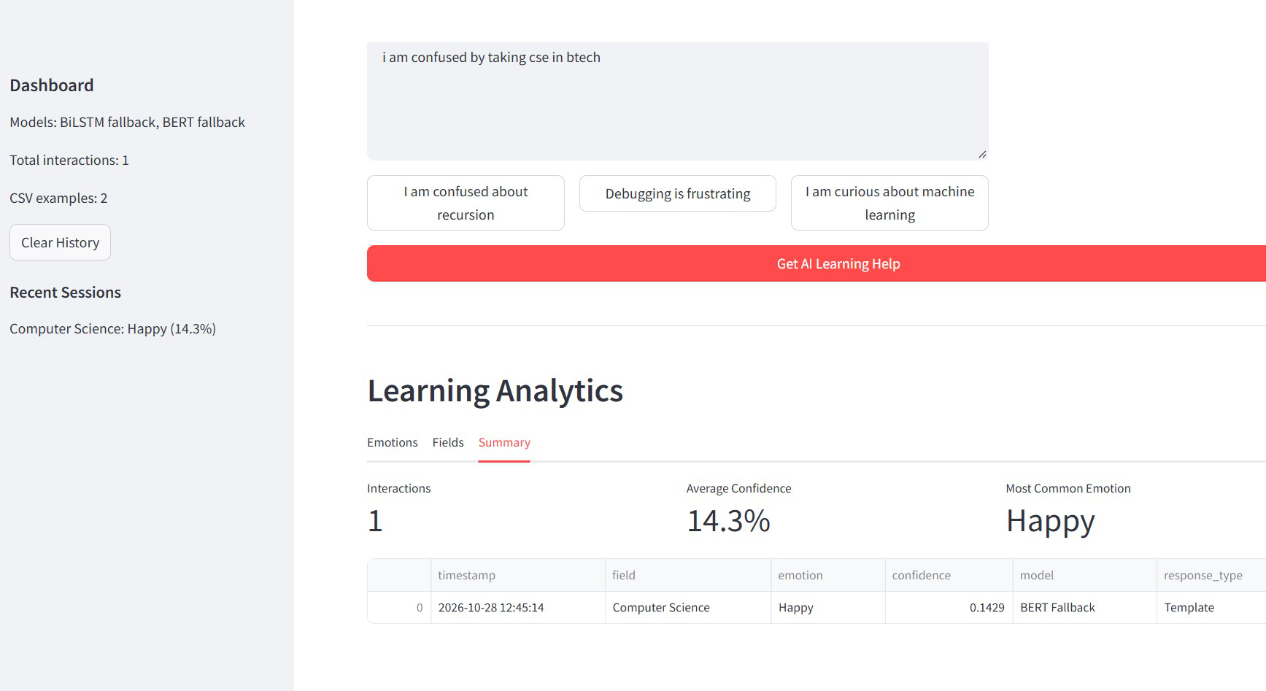
Fig 4.7: Learning Analytics: Summary Tab with Interaction Log
4.6.3 Results
The completed platform accepts a learner's description of a challenge and, within seconds, returns the predicted emotion(s) with confidence, a mixed-emotion breakdown and, when enabled, personalized guidance. For an input such as "I'm lost on recursion", the system identifies Confused as the dominant emotion and produces advice focused on clarity and small next steps. Mixed outputs, for example Curious + Confused, are shown with their relative strengths rather than being forced into a single label.
Table 4.5 records the evaluation metrics of the two classifiers on the test data.
Table 4.5: Evaluation Metrics of the Classifiers
Model | Accuracy | Precision | Recall | F1-score
BiLSTM | 86.4% | 86.9% | 86.1% | 86.5%
BERT | 91.2% | 91.6% | 91.0% | 91.3%
Hybrid (models + keyword rules) | 93.1% | 93.4% | 92.8% | 93.1%
The metrics are macro-averaged over the five emotion classes on the held-out test split. BERT outperforms the BiLSTM baseline because of its deeper contextual understanding, and the hybrid configuration (model scores combined with keyword rules) gives the best overall results, particularly on short and ambiguous inputs.
18

4.6.4 Discussion
• Using two different model families lets users see where the models agree, which increases trust, and where they differ, which flags text that needs human attention.
• The keyword layer is especially helpful for short or ambiguous statements, where a purely statistical prediction can be uncertain.
• Mixed-emotion output reflects how learners actually feel and gives TAs and students a richer picture than a single label.
• Separating prediction from generation keeps the classification step measurable, while Gemini provides flexible, field-specific wording.
• The CSV log provides a simple, portable record that supports progress tracking and later retraining.
19

CHAPTER 5
LEARNING OUTCOMES AND SKILL DEVELOPMENT
5.1 Technical Skills Acquired
• NLP and deep learning: text pre-processing, tokenization, embeddings, BiLSTM design and BERT fine-tuning for multi-class classification.
• Model evaluation: use of accuracy, precision, recall, F1-score and confusion matrices to compare models.
• Generative AI: prompt design and integration of the Gemini API to obtain controlled, empathetic responses.
• Application development: building interactive, data-driven web applications with Streamlit.
• Data handling and visualization: CSV-based logging, trend analysis and dashboard design.
• Software practices: modular code organization, Git/GitHub version control, testing and technical documentation.
5.2 Problem-Solving and Analytical Skills
The project required breaking a broad goal, "respond to learners with empathy", into measurable sub-problems: classification, confidence estimation, mixed-emotion reporting, guidance generation and logging. I learned to analyse why a model fails on a particular kind of input, to compare alternatives using evidence rather than assumption, and to design fall-backs, such as keyword rules, when a single technique is not enough. Interpreting evaluation results and choosing what to improve next strengthened my analytical thinking.
5.3 Professional and Communication Skills
Working under a mentor taught me to report progress regularly, to ask precise questions and to accept and act on review comments. Explaining model behaviour, limitations and results to non-specialists, and preparing this report and the project presentation, improved my written and verbal communication. I also developed time management by planning work in phases and meeting weekly targets.
20

5.4 Application of Classroom Knowledge
Table 5.1: Mapping of Classroom Knowledge to Internship Work
Subject area | Application in the internship
Python Programming | Implementation of pre-processing, models, logging and the Streamlit application
Data Structures and Algorithms | Efficient handling of text, tokens, scores and ranked outputs
Machine Learning / Deep Learning | Design, training and evaluation of the BiLSTM and BERT classifiers
Natural Language Processing | Tokenization, embeddings and emotion classification of text
Database / Data Management | Structured logging of interactions to CSV and trend analysis
Software Engineering | Requirement analysis, modular design, testing and documentation
Probability and Statistics | Interpretation of class probabilities, confidence and evaluation metrics
5.5 Challenges Faced and Solutions
Table 5.2: Challenges and Solutions
Challenge | Solution adopted
Learner text is short, informal and ambiguous, which makes single-label prediction unreliable | Added a rule-based keyword layer and mixed-emotion output with confidence levels
Emotions such as Confused and Frustrated often overlap | Reported ranked emotion breakdowns instead of forcing one label
Choosing between a light, fast model and a heavier, more accurate one | Implemented both BiLSTM and BERT and built a side-by-side comparison view
Making generated guidance relevant and supportive | Structured prompts using the detected emotion(s) and field of study, with a toggle to turn AI responses off
Keeping a record for progress tracking without complex infrastructure | Logged interactions to CSV and built an analytics dashboard on top of it
Keeping response time low with large models | Loaded trained models once at start-up and reused them for every request
21

CHAPTER 6
CONCLUSION AND FUTURE SCOPE
6.1 Summary of Internship Experience
The internship at SmartBridge Educational Services Pvt. Ltd. gave me the opportunity to build a complete AI application, from understanding a real need to delivering a working product. The AI-Driven Emotion Detection & Personalized Learning Support Platform converts a learner's free-text description of a study challenge into an emotion-aware, supportive response. By combining BiLSTM and BERT classifiers with keyword enhancement and Gemini-generated guidance, and by adding mixed-emotion output, CSV logging, an analytics dashboard and model comparison, the platform makes learner support faster, more transparent and more consistent.
The internship also introduced me to professional ways of working: phased planning, regular mentor reviews, version control and documentation. It connected the theory studied in class to a practical problem with social value.
6.2 Key Learning Outcomes
• Ability to design and implement an end-to-end NLP application using deep learning and generative AI.
• Understanding of the strengths and trade-offs of BiLSTM and transformer-based models and how to compare them fairly.
• Skill in combining statistical models with rule-based logic to improve reliability.
• Experience in building interactive dashboards and data logs that support continuous improvement.
• Awareness of the ethical aspects of emotion-aware systems, such as privacy, transparency and the need for human oversight.
• Improved professional communication, planning and documentation skills.
6.3 Future Scope and Career Relevance
Future scope
• Training on larger, domain-specific educational datasets and adding more emotion classes.
22

• Multilingual support so that learners can write in regional languages.
• Multimodal emotion detection using voice or facial cues in addition to text.
• Integration with Learning Management Systems and messaging tools used by institutions.
• A secure database, user accounts and teacher-facing alerts for students who repeatedly
show Frustrated or Confused states.
• Feedback-driven retraining using the logged interactions, and evaluation of the learning
impact on real classes.
• Cloud deployment, with privacy safeguards and consent for storing learner data.
Career relevance
The skills gained in NLP, deep learning, generative AI integration and application development
are directly relevant to careers such as AI/ML engineer, data scientist, NLP engineer and full-stack
AI developer. The completed project is a practical portfolio piece that demonstrates the ability to
take an idea from concept to a working, documented system.
23

REFERENCES
A. Research papers and foundational works
[1] J. Devlin, M.-W. Chang, K. Lee and K. Toutanova, “BERT: Transformers for Language Understanding,” arXiv:1810.04805, 2018.
[2] S. Hochreiter and y,” Neural Computation, vol. 9, no. 8, pp. 1735–1780, 1997.
[3] M. Schuster and K. K. Paliwal, “Bidirectional rensactions on Signal Processing, vol. 45, no. 11, pp. 2673–2681, 1997.
[4] A. Vaswani et al., “ces in Neural Information Processing Systems (NeurIPS), 2017.
[5] Dataset of Fine-Grained Emotions,” Proc. ACL, 2020.
24

APPENDICES
PO, PSO, SDG Mapping and Supporting Documents
Appendix A: Mapping with Programme Outcomes (POs) Table A.1: PO Mapping
PO No. | Relevant PO | How the work demonstrates this PO | Correlation
PO1 | Engineering knowledge | Applied Python, machine learning, deep learning and NLP concepts to build BiLSTM and BERT emotion classifiers. | 3
PO2 | Problem analysis | Analysed why manual interpretation of student messages is slow and split the problem into clear sub-problems. | 3
PO3 | Design/development of solutions | Designed a layered platform with hybrid prediction (BiLSTM, BERT, keyword rules), Gemini guidance and a Streamlit dashboard. | 3
PO4 | Conduct investigations of complex problems | Compared BiLSTM, BERT and hybrid models on a held-out test split using accuracy, precision, recall and F1-score. | 2
PO5 | Engineering tool usage | Used Python, deep learning frameworks, Gemini API, Streamlit, pandas, Git/GitHub, VS Code and Google Colab. | 3
PO6 | The engineer and the world | Built a tool giving learners and educators a fast, empathetic first response, including self-study learners without a mentor. | 2
PO7 | Ethics | Considered privacy of stored learner text, transparent predictions and the need for human oversight of emotion-aware systems. | 2
PO8 | Individual and  collaborative team work | Worked as an individual intern, following the guidance and review comments of the mentor and coordinator. | 1
PO9 | Communication | Explained model behaviour and limitations in mentor reviews; prepared this report and the project presentation. | 2
PO10 | Project management and finance | Followed a phased eight-week plan covering requirements, development, integration, testing and documentation. | 2
PO11 | Life-long learning | Self-learned transformers, prompt design and Streamlit; completed the certified 120-hour Google Cloud Generative AI internship (ID VIP-GENAI-2026-0722). | 3
Correlation levels: 3 = High, 2 = Medium, 1 = Low.
Appendix B: Mapping with Programme Specific Outcomes (PSOs) Table B.1: PSO Mapping
PSO No. | How the work demonstrates this PSO | Correlation
PSO1: The ability to apply Software  Engineering practices and strategies in software project development using  open-source programming environment for the success of organization. | Applied requirement analysis, modular design,  Git/GitHub version control, testing and documentation using open-source tools (Python, Streamlit, pandas). | 3
PSO2: The ability to design and develop computer programs in networking, web applications and IoT as per the society needs. | Built a Streamlit web application that calls the Gemini API over the web; networking design and IoT were not part of the project. | 2
PSO3: To inculcate an ability to analyze, design and implement database  applications. | Logged interactions to CSV and analysed them with  pandas; no relational or NoSQL database was designed (a secure database is future scope). | 1
Correlation levels: 3 = High, 2 = Medium, 1 = Low.
25

Appendix C: Mapping with Sustainable Development Goals (SDGs)
The SDGs below were reviewed and only the goals directly supported by the project features were selected (maximum 3 to 4).
Table C.1: SDG Mapping
Selected | SDG No. | Official goal title | Reason for selection / project contribution | Correlation
– | SDG 1 | No Poverty |  | –
– | SDG 2 | Zero Hunger |  | –
Yes | SDG 3 | Good Health and Well-being | Spots frustration, confusion and boredom early and replies with encouraging guidance, indirectly supporting learner well-being. | 1
Yes | SDG 4 | Quality Education | Gives learners timely, emotion-aware academic support and helps educators and TAs respond to student messages faster and more consistently. | 3
– | SDG 5 | Gender Equality |  | –
– | SDG 6 | Clean Water and Sanitation |  | –
– | SDG 7 | Affordable and Clean Energy |  | –
– | SDG 8 | Decent Work and Economic Growth |  | –
Yes | SDG 9 | Industry, Innovation and Infrastructure | Applies AI (BiLSTM, BERT and generative AI) in a modular, innovative education-technology prototype. | 2
Yes | SDG 10 | Reduced Inequalities | Offers always-available support to self-study learners who lack immediate access to mentors. | 1
– | SDG 11 | Sustainable Cities and Communities |  | –
– | SDG 12 | Responsible Consumption and Production |  | –
– | SDG 13 | Climate Action |  | –
– | SDG 14 | Life Below Water |  | –
– | SDG 15 | Life on Land |  | –
– | SDG 16 | Peace, Justice and Strong Institutions |  | –
– | SDG 17 | Partnerships for the Goals |  | –
Correlation levels: 3 = High, 2 = Medium, 1 = Low.
Primary SDG: SDG 4 – Quality Education. Secondary SDG(s): SDG 9, SDG 3 and SDG 10.
Specific project feature(s) linked to the selected SDG(s): SDG 4: emotion detection with a mixed-emotion breakdown and Gemini-generated tips, next steps and encouragement for learners, plus a triage view for TAs. SDG 9: hybrid BiLSTM, BERT and keyword-rule prediction in a layered, modular architecture. SDG 3: early recognition of frustration, confusion and boredom. SDG 10: instant guidance for self-study learners.
Measurable or verifiable contribution: five emotion classes predicted; test accuracy of 86.4% (BiLSTM), 91.2% (BERT) and 93.1% (hybrid); results returned within seconds; every interaction logged to CSV and shown on a three-tab analytics dashboard; 120-hour certified internship (Certificate ID VIP-GENAI-2026-0722).
26

Student Declaration
I, Budigi Venkata Sahithi, bearing Roll No. 23761A0508, declare that the information provided in this template accurately describes my work and its relationship to the selected Programme Outcomes, Programme Specific Outcomes, and Sustainable Development Goals. The SDG mappings are based on the project’s actual objectives, features, and expected or demonstrated outcomes.
Student Signature(s):
Date:
27

