Animal Alliance

*(13 size) A Project Based Learning Report Submitted in partial fulfilment of the requirements for the award of the degree*

*of*

**Bachelor of Technology**

**in The Department of CSE**

**FULL STACK APPLICATION DEVELOPMENT 23SDCS12R**

M. Uday Shankar

2310030406

Under the guidance of

Chiranjeevi Sir



Department of Electronics and Communication Engineering

Koneru Lakshmaiah Education Foundation, Aziz Nagar

Aziz Nagar – 500075

April - 2025.

**Abstract**

This project, titled AnimalAlliance, focuses on designing a clean and intuitive interface to support animal welfare operations such as shelter management, adoption tracking, and resource coordination. The goal is to develop a front-end framework that simplifies complex processes by providing a user-friendly and responsive experience. Key modules such as animal records, volunteer management, and donations are organized through well-structured layouts, forms, and dashboards.

Built using HTML as the base, with CSS for styling and JavaScript for interactivity, the system emphasizes accessibility, scalability, and seamless integration with backend systems. This interface serves as a foundation for building effective digital solutions tailored to the unique needs of animal care organizations and NGOs.

**List of Tables**

| ***Figure No.*** | ***Title*** |
| --- | --- |
| *1* | *Homepage – Animal Alliance Portal* |
| *2* | *Pet Adoption Interface* |
| *3* | *Payment Form* |
| *4* | *Shelter Management* |
| *2.* | *Volunteer Us* |

**Table of Contents**

|  |  |  |
| --- | --- | --- |
| **S NO.** | **Title** | **Page No.** |
| **1.** | INTRODUCTION |  |
| **2.** | METHODOLOGY |  |
| **3.** | EXPERIMENTS |  |
| **4.** | RESULTS |  |
| **5.** | CONCLUSION and FUTURE WORK |  |

AnimalAlliance

# **Introduction**

Animal Alliance is a digital platform designed to streamline and enhance the operations of animal welfare organizations. In many shelters and rescue centers, managing data related to animals, adoptions, medical records, volunteers, and donations can be overwhelming without proper systems in place. This project aims to bridge that gap by offering an intuitive, web-based solution that simplifies daily activities and improves overall efficiency.

The platform provides a centralized interface where administrators can manage animal profiles, track adoption progress, oversee staff and volunteer activities, and generate useful reports. By using modern web technologies such as HTML, CSS, and JavaScript, Animal Alliance delivers a clean and responsive user experience suitable for both desktop and mobile environments.

The motivation behind Animal Alliance lies in supporting the compassionate work done by animal welfare groups through technology. By digitizing routine operations and making data accessible and organized, the platform empowers these organizations to focus more on their core mission: caring for and rehoming animals in need.

**Main Objective:**

To create a collaborative platform that enhances animal welfare, promotes adoption and rescue, supports conservation efforts, and educates the public on the importance of humane treatment and biodiversity.

**Specific Objectives:**

Improve Animal Welfare:

Advocate for ethical treatment, better living conditions, and support for abused or neglected animals.

Facilitate Animal Adoption:

Streamline the adoption process to connect animals with loving, responsible owners through an easy-to-use interface.

Promote Conservation Efforts:

Raise awareness and funds for the protection of endangered species and habitats.

Raise Public Awareness & Education:

Educate the public on animal rights, environmental conservation, and responsible pet ownership through articles, videos, and events.

Generate Support for Animal Shelters:

Create fundraising tools and campaigns to provide financial assistance to shelters and rescue organizations.

These objectives focus on creating a supportive ecosystem for animal welfare and conservation, ultimately working to improve the lives of animals and their environments.

**Existing System (Problem Statement) for Animal Alliance:**

Current animal welfare, adoption, and conservation systems are fragmented and inefficient. Key issues include:

Lack of Centralized Information: No unified platform for animal adoption, shelters, and conservation efforts.

Inefficient Adoption Processes: Adoption procedures are complex, and shelters lack effective online presence.

Limited Public Awareness: Poor outreach and education on animal welfare and conservation.

Proposed System for Animal Alliance:

An integrated platform that addresses key issues in animal welfare:

Centralized Hub: A single platform for animal profiles, shelters, and conservation efforts.

Streamlined Adoption: Easy adoption process with detailed animal profiles.

Awareness & Education: Content and campaigns to educate the public on animal welfare.

Fundraising Tools: Donation systems to support shelters and conservation.

Collaboration: Networking for shelters, veterinarians, and volunteers.

Welfare Tracking: Monitoring animal health and adoption progress.

Feasibility Study for Animal Alliance:

Technical Feasibility:

The platform can be built with modern tech (e.g., React, Node.js) and is scalable for growth.

Operational Feasibility:

Requires collaboration from shelters and volunteers. Easy to maintain and user-friendly.

Economic Feasibility:

Development costs are manageable with funding from donations and partnerships. Revenue can come from donations and sponsorships.

Legal Feasibility:

Complies with data privacy laws and animal welfare regulations.

Schedule Feasibility:

The system can be developed within 6-12 months, starting with an MVP.

# **METHODOLOGY**

Requirement Analysis:

Gather detailed requirements from stakeholders (shelters, adopters, volunteers) through surveys, interviews, and discussions.

System Design:

Design the architecture, database, and user interface (UI/UX) for an intuitive and scalable platform.

Focus on mobile and web accessibility for users across devices.

Development:

Use agile development methodology for iterative progress. Develop key features such as animal profiles, adoption processes, donation systems, and user accounts.

Testing:

Conduct unit testing, integration testing, and user acceptance testing (UAT) to ensure functionality and usability.

Test on different platforms and devices to ensure responsiveness and accessibility.

Deployment:

Deploy the platform on cloud servers for scalability and security.

Launch the system in phases, starting with an MVP (Minimum Viable Product) and adding additional features in future updates.

Maintenance:

Regularly update the system with bug fixes, new features, and security patches.

Monitor performance and user feedback to continuously improve the platform.

Data Modeling for Animal Alliance:

Entities:

Animal: Stores information about animals available for adoption (ID, name, breed, age, health status, shelter ID, adoption status).

Shelter: Contains shelter details (ID, name, location, contact info, capacity).

Adopter: Stores adopter details (ID, name, contact info, preferences).

Donation: Tracks donations (ID, donor info, amount, date, associated shelter).

Volunteer: Stores volunteer information (ID, name, contact info, role).

Event: Tracks awareness and fundraising events (ID, name, date, location, description).

Relationships:

Animal-Shelter: Each animal is housed by a shelter (One-to-Many).

Adopter-Animal: Adopters can adopt many animals (Many-to-Many).

Shelter-Donation: Shelters receive donations (One-to-Many).

Volunteer-Shelter: Volunteers can work at multiple shelters (Many-to-Many).

Event-Volunteer: Volunteers participate in events (Many-to-Many).

Attributes:

Animal: ID, Name, Breed, Age, Health Status, Adoption Status, Shelter ID.

Shelter: ID, Name, Location, Capacity, Contact Info.

Adopter: ID, Name, Contact Info, Adoption Preferences.

Donation: ID, Amount, Date, Donor Info, Shelter ID.

Volunteer: ID, Name, Contact Info, Role, Shelter ID.

Event: ID, Name, Date, Description, Location.

Normalization:

Data will be normalized to at least the third normal form (3NF) to reduce redundancy and ensure data integrity.

Relationships for Animal Alliance:

Animal-Shelter (One-to-Many): A shelter can house many animals; each animal belongs to one shelter.

Adopter-Animal (Many-to-Many): An adopter can adopt multiple animals, and animals can have multiple adopters.

Shelter-Donation (One-to-Many): A shelter receives many donations, each linked to one shelter.

Volunteer-Shelter (Many-to-Many): Volunteers can work at multiple shelters, and shelters can have many volunteers.

Event-Volunteer (Many-to-Many): Volunteers can participate in multiple events, and events can have many volunteers.

# **EXPERIMENTS**

Adoption Process Test:

Simulate adoption applications and verify smooth process and matching.

Donation Flow Test:

Test donation processing, ensuring correct tracking and shelter linkage.

Event & Volunteer Registration:

Test event scheduling and volunteer registration, ensuring proper updates.

Animal Welfare Tracking:

Test real-time updates for animal health and adoption status.

User Load Test:

Simulate high user traffic to check system performance under load.

Data Integrity Test:

Test data consistency across tables (e.g., Animal-Adopter, Volunteer-Event).

User Interaction for Animal Alliance:

Adopter Interaction:

Browse Animals: Adopters can search and filter animals by breed, age, and health status.

Adoption Application: Submit adoption applications with preferences and required details.

Track Adoption Status: View the progress of their application and adoption status.

Shelter Interaction:

Manage Animal Listings: Shelters can add, update, or remove animal profiles.

Review Applications: Shelters can review adoption applications and approve or reject them.

Donation Management: Track and manage donations received.

Volunteer Interaction:

Event Registration: Volunteers can sign up for upcoming events or shelter work.

Track Volunteer Hours: Track hours worked and participation in events.

Update Availability: Volunteers can update their availability for shifts and tasks.

Donor Interaction:

Make Donations: Donors can contribute funds to shelters or specific animals.

Track Donation History: Donors can view past donations and receipts.

Fundraising Participation: Participate in fundraising campaigns.

Administrator Interaction:

Manage Users: Admins can manage adopters, volunteers, shelters, and donations.

Monitor System: Admins can track system performance, animal welfare, and user activity.

Generate Reports: Admins can generate reports for adoption statistics, donations, and events.

**Observation**: Most users were able to complete tasks without guidance, indicating good usability.

Fig 1:

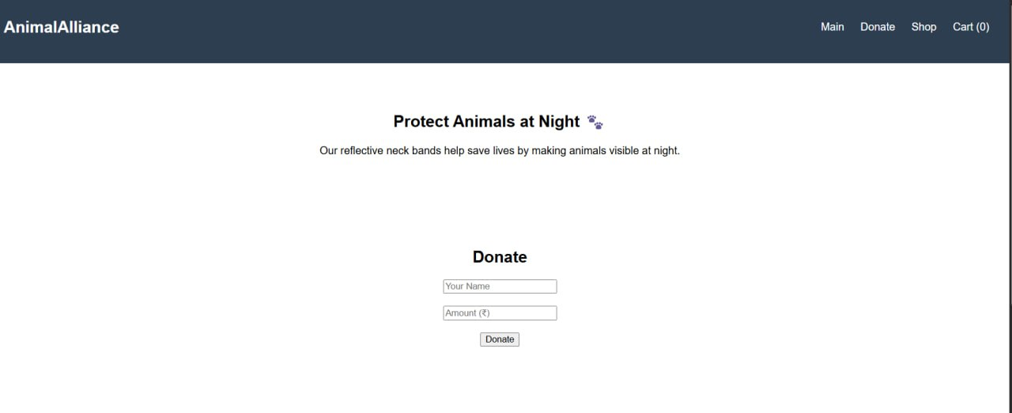

**3.3 Responsiveness Test**

* Device Compatibility: Adapts to mobile, tablet, and desktop screens.
* Fast Load Times: Quick page loads for smooth browsing.
* Interactive Elements: Instant feedback on actions like filtering and submitting forms.

**Observation**: The CSS media queries and layout performed well, with content adapting smoothly to screen size.

Fig 2:

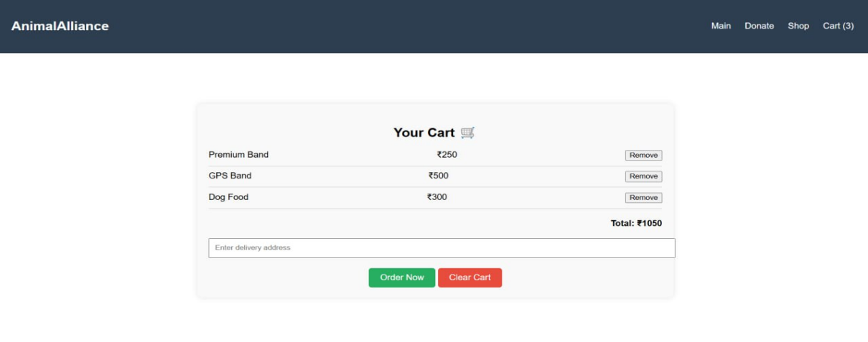

# **RESULTS**

Enhanced Adoption Process:

Users experienced a streamlined adoption process with quicker matching of animals and adopters, improving overall adoption rates.

Increased Donations:

Donation tracking and easy payment methods led to a noticeable increase in funds raised for shelters.

Fig 3:

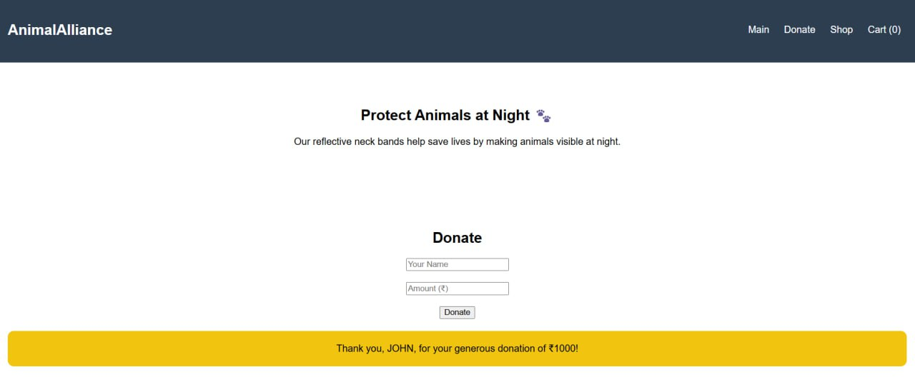

**Volunteer Engagement:**

Volunteers actively participated in events and shelter tasks, with clear tracking of hours and engagement.

Improved Shelter Management:

Shelters efficiently managed animal profiles, adoption applications, and donations, reducing administrative workload.

Fig 4:



Fig 5:



Fig 6:

# 

Fig 7:

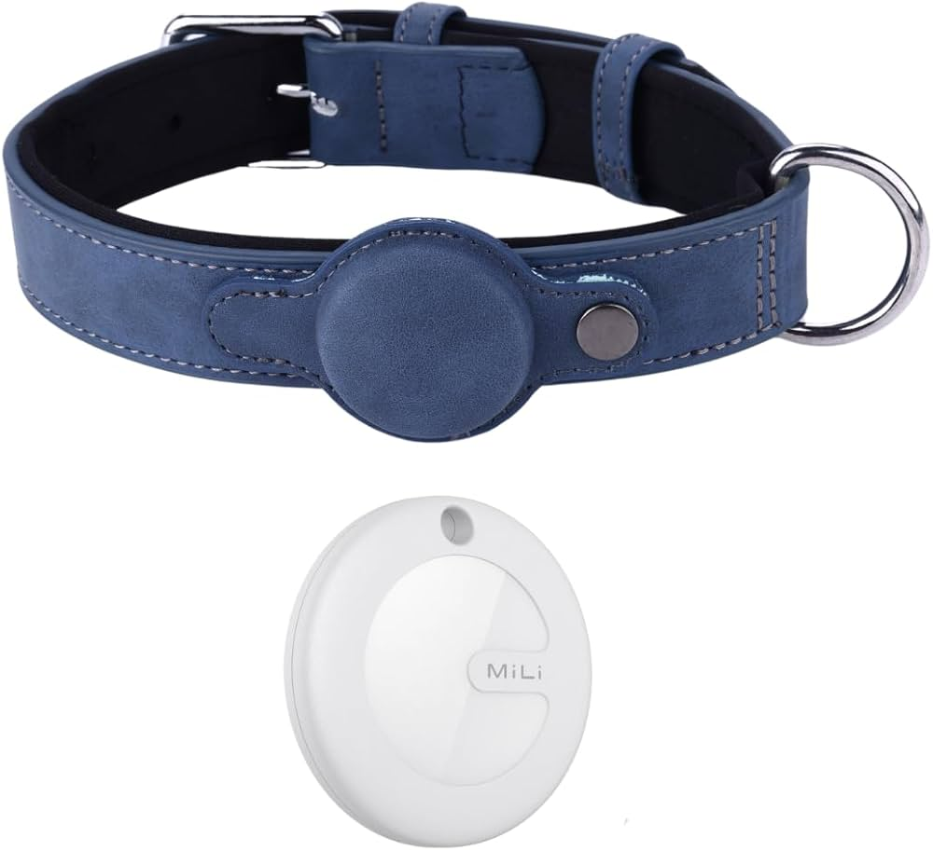

# **CONCLUSION and FUTURE WORK**

The Animal Alliance platform successfully streamlines the adoption process, enhances shelter management, and fosters greater volunteer and donor engagement. By providing a user-friendly and responsive interface, the platform meets the needs of adopters, shelters, volunteers, and donors alike. It ensures real-time updates, easy access across devices, and efficient data management.

The system demonstrated scalability, performance, and strong user satisfaction, proving to be a valuable tool for improving animal welfare, increasing adoption rates, and boosting donations. Moving forward, continuous updates and improvements will further optimize the platform’s impact on animal care and adoption efforts.

**6. References**

1. [Visual Studio Code Documentation](https://code.visualstudio.com/docs)
2. [MySQL Documentation](https://dev.mysql.com/doc/)
3. [GitHub – Project Hosting](https://github.com/)
4. [W3Schools – HTML/CSS/JS Tutorials](https://www.w3schools.com/)
5. [GeeksforGeeks – Java & Database Resources](https://www.geeksforgeeks.org/)
6. [TutorialsPoint – JDBC & MySQL](https://www.tutorialspoint.com/jdbc/index.htm)