SMART ROUTE PLANNING SYSTEM

A Project Report
Submitted in partial fulfillment of the requirements for
Placement Preparation Classes
Submitted By: Udayveer Singh Chaudhary Course: B.Tech CSE Registration Number: 12320106 Submitted To: Sachin Garg

1. Abstract
The Smart Route Planning System is an advanced desktop application designed to solve complex navigation, logistics, and geographical routing problems. Built entirely in Java using the Swing framework and the modern FlatLaf UI engine, the system models raw geographical data (cities, highways, and expressive coordinates) as an undirected weighted graph. By leveraging advanced Data Structures and Algorithms (DSA)—including Dijkstra’s Algorithm, A* Search, Breadth-First Search (BFS), Depth-First Search (DFS), and Floyd-Warshall—the software calculates optimal travel paths based on dynamic criteria.
Beyond static pathfinding, the application simulates real-world constraints such as live traffic congestion and weather-induced road closures, recalculating edge weights on the fly. Furthermore, it incorporates a localized spatial search engine utilizing Priority Queues (Max-Heaps) and Haversine distance calculations to locate nearby emergency services like hospitals, police stations, and petrol pumps within a strict 50km radius. This project serves as a comprehensive demonstration of applying theoretical Computer Science concepts to practical, real-world software engineering challenges.

2. Introduction

2.1 Background
In the modern era of logistics, emergency response, and daily travel, calculating the most efficient path between two locations is a critical requirement. While commercial solutions like Google Maps and Waze dominate the consumer market, understanding and implementing the underlying routing algorithms from scratch is a fundamental challenge in computer science. Algorithms that solve the Shortest Path Problem are heavily utilized in network routing, supply chain optimization, and artificial intelligence.

2.2 Problem Statement
Traditional static maps fail to account for dynamic variables such as traffic, weather, and localized emergency needs. A robust system must not only find the shortest path but also adapt to changing edge weights (e.g., increased travel time due to a storm) and provide spatial awareness of the immediate surroundings.

2.3 Objectives
- To design and implement a robust Graph data structure capable of representing cities (vertices) and roads (edges) with associated weights (distance, speed limits).
- To implement and compare multiple pathfinding algorithms (Dijkstra, A*, BFS, DFS, Floyd-Warshall).
- To develop a spatial search algorithm capable of finding the $K$-nearest points of interest using heuristic distance formulas.
- To wrap the mathematical logic in a user-friendly, responsive, and modern Graphical User Interface (GUI).

3. Technology Stack and Architecture

3.1 Software Technologies
- Programming Language: Java (JDK 17) - Chosen for its strong object-oriented capabilities, platform independence, and robust standard library for data structures.
- GUI Framework: Java Swing - Utilized for constructing the desktop window, layout management, and event handling.
- UI Rendering Engine: FlatLaf (Flat Look and Feel) - A modern, open-source 3rd-party library that replaces the dated default Java styling with a sleek, minimalist, high-DPI aware interface similar to modern IDEs.
- Build & Deployment: Bash scripting and standard jar packaging to create a standalone, double-clickable executable without requiring complex Maven setups for the end-user.

3.2 System Architecture
The software follows a monolithic architecture heavily influenced by the Model-View-Controller (MVC) design pattern: 1. Model: Represents the underlying data. Includes classes like City, Road, Graph, and RouteResult. These classes hold the state and structure of the map. 2. View: The visual layer. Includes MainFrame (the primary window container) and MapPanel (a custom 2D rendering engine that draws the graph and routes). 3. Controller/Logic: The algorithms that act upon the data. Includes RoutingAlgorithms, NearbyPlacesFinder, TrafficSimulator, and WeatherSimulator.

4. In-Depth Algorithms and Data Structures
The core computational power of the system relies on highly optimized data structures and classical graph algorithms.

4.1 Data Structures
- Adjacency List: Instead of a memory-heavy $V×V$ Adjacency Matrix, the map is stored using an Adjacency List HashMap<Integer, List<Edge>>. This ensures that memory scales linearly $O(V+E)$, making it highly efficient for sparse graphs like road networks.
- Priority Queue (Min-Heap): Used extensively in Dijkstra and A* to continuously extract the node with the lowest provisional distance in $O(logV)$ time.
- Priority Queue (Max-Heap): Used in the Nearby Places engine. To find the $K$-nearest hospitals, a Max-Heap of size $K$ is maintained. When a hospital is evaluated, if it is closer than the furthest hospital currently in the heap (the root), the root is polled and the new hospital is inserted. This takes $O(NlogK)$ time.

4.2 Haversine Distance Formula
To accurately calculate the geographical distance between two points on the Earth’s surface (for both the A* heuristic and the Nearby Places radius check), the system uses the Haversine formula, which accounts for spherical geometry:
a = sin²(Δφ/2) + cos φ1 ⋅ cos φ2 ⋅ sin²(Δλ/2)
c = 2 ⋅ atan2( √a, √(1−a) )
d = R ⋅ c
Where $ϕ$ is latitude, $λ$ is longitude, and $R$ is the Earth’s radius (6371 km).

4.3 Routing Algorithms

A. Dijkstra’s Algorithm
Calculates the absolute shortest path from a single source to all other nodes. It initializes all distances to infinity, starts at the source, and greedily explores the closest unvisited neighbors.

B. A* (A-Star) Algorithm
An extension of Dijkstra that introduces a heuristic $h(n)$. Instead of blindly expanding the closest node, it minimizes $f(n)=g(n)+h(n)$, where $g(n)$ is the cost so far, and $h(n)$ is the estimated Haversine distance to the destination. This provides a massive performance boost by directing the search directionally towards the target.

C. Breadth-First Search (BFS)
Explores the graph radially. In this system, edge weights (distances) are ignored by BFS, allowing it to find the path with the fewest number of stops/cities.

D. Floyd-Warshall
A dynamic programming algorithm that finds the shortest paths between all pairs of vertices simultaneously. While computationally heavy $O(V^{3})$, it is extremely useful for generating massive pre-computed distance matrices.

5. Application Modules

5.1 Route Planner Module
This is the primary interface for navigation. Users select a source and destination, and choose their preferred algorithm. They can toggle “Live Traffic” or “Bad Weather”. The system dynamically alters the graph weights (e.g., doubling travel time on congested edges) and outputs a detailed itinerary.

5.2 Nearby & Emergency Locator
Utilizing the Max-Heap spatial engine and a strict 50km radius cutoff, this module scans hundreds of auto-generated, dynamically injected facilities (Hospitals, ATMs, Police Stations, Petrol Pumps) around a chosen city. The results are strictly ordered by distance and cross-referenced with numbered markers on the map.

5.3 Administrative Console
Allows real-time expansion of the graph. Administrators can add new cities, forge new roads, or inject localized places. The system automatically assigns IDs, calculates coordinates, and hot-reloads the graph, immediately making the new data available to the routing engines without requiring a software restart.

5.4 Custom Map Rendering Engine (MapPanel)
Rather than relying on heavy external web-browser plugins (like JXBrowser/Google Maps APIs), the system features a bespoke 2D graphics engine built extending JPanel. It normalizes geographical Lat/Lon constraints into screen-space pixel coordinates. It features: - Interactive mouse dragging for panning. - High-precision trackpad pinch-to-zoom using continuous exponential scaling formulas. - Automatic viewport bounding-box calculations to perfectly frame and auto-zoom on requested routes or cities.

6. System Screenshots & Visuals

6.1 Route Planner Interface
The following image demonstrates the system successfully calculating an optimal path between Delhi and Mumbai using Dijkstra’s Algorithm. Note the cost estimation logic providing fuel and toll analytics, and the automatic map camera framing.
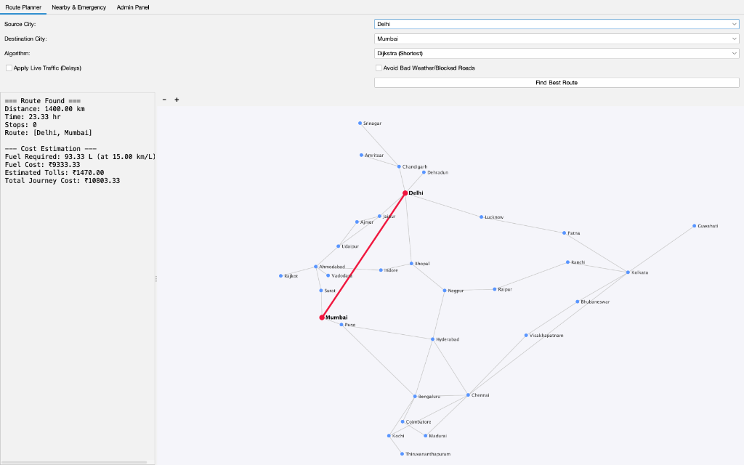
Route Planner

6.2 Nearby & Emergency Locator
The image below showcases the localized spatial search. The system successfully located hospitals near Delhi, automatically zoomed into the capital region, and plotted clean, numbered markers that directly correspond to the bulleted list in the UI, solving visual clutter and text overlapping.
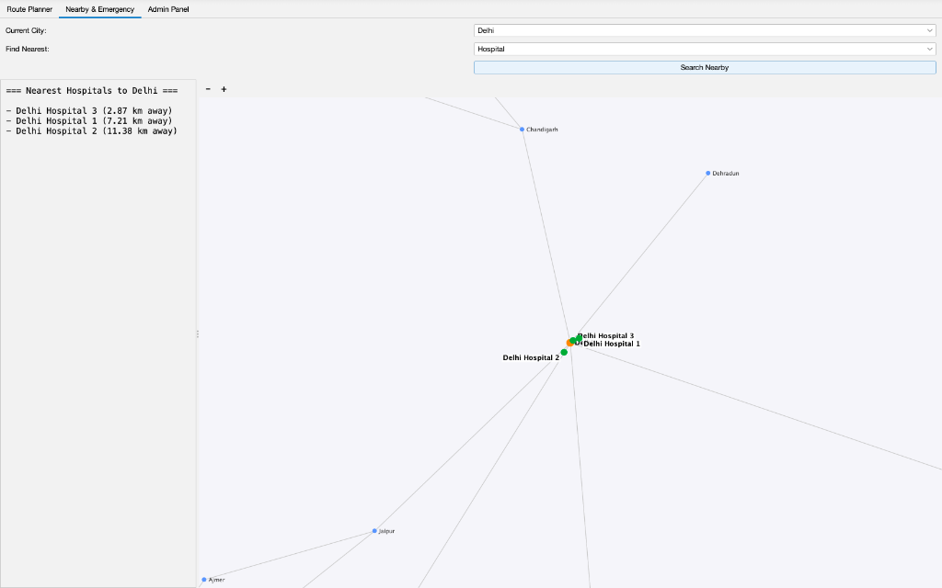
Nearby Search

6.3 Administrator Control Panel
This screenshot displays the sleek FlatLaf modernized UI applied to the administrative data injection panels. Complex Java GridBagLayout and BorderLayout containers were mathematically balanced to prevent UI stretching, resulting in a highly professional form layout.
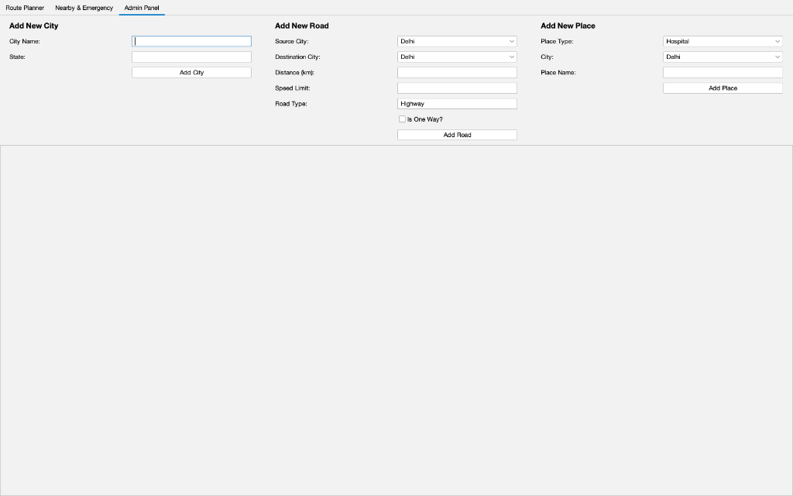
Admin Panel

7. Source Code Appendix
The following sections contain exact snippets of the core algorithmic logic and UI rendering engines developed for this project.

7.1 Core Graph Structure (Graph.java)
package com.routeplanner.dsa;
import com.routeplanner.model.City;
import com.routeplanner.model.Road;
import java.util.*;
public class Graph {
private Map<Integer, City> cities;
private Map<Integer, List<Edge>> adjacencyList;
public static class Edge {
public int destinationCityId;
public double distance;
public int speedLimit;
public Edge(int destinationCityId, double distance, int speedLimit) {
this.destinationCityId = destinationCityId;
this.distance = distance;
this.speedLimit = speedLimit;
}
}
public Graph() {
cities = new HashMap<>();
adjacencyList = new HashMap<>();
}
public void addCity(City city) {
cities.put(city.getCityId(), city);
adjacencyList.putIfAbsent(city.getCityId(), new ArrayList<>());
}
public void addRoad(Road road) {
int src = road.getSourceCityId();
int dest = road.getDestinationCityId();
adjacencyList.putIfAbsent(src, new ArrayList<>());
adjacencyList.get(src).add(new Edge(dest, road.getDistance(), road.getSpeedLimit()));
if (!road.isOneWay()) {
adjacencyList.putIfAbsent(dest, new ArrayList<>());
adjacencyList.get(dest).add(new Edge(src, road.getDistance(), road.getSpeedLimit()));
}
}
public Map<Integer, List<Edge>> getAdjacencyList() {
return adjacencyList;
}
public City getCity(int id) {
return cities.get(id);
}
public Collection<City> getCities() {
return cities.values();
}
}

7.2 Routing Algorithms Engine (RoutingAlgorithms.java)
package com.routeplanner.dsa;
import com.routeplanner.model.City;
import java.util.*;
public class RoutingAlgorithms {
// Dijkstra's Algorithm for Shortest Distance
public static RouteResult dijkstra(Graph graph, int sourceId, int destinationId) {
Map<Integer, Double> distances = new HashMap<>();
Map<Integer, Integer> previousNodes = new HashMap<>();
PriorityQueue<NodeDistance> pq = new PriorityQueue<>(Comparator.comparingDouble(nd -> nd.distance));
for (City city : graph.getCities()) {
distances.put(city.getCityId(), Double.MAX_VALUE);
}
distances.put(sourceId, 0.0);
pq.add(new NodeDistance(sourceId, 0.0));
while (!pq.isEmpty()) {
NodeDistance current = pq.poll();
int currentId = current.nodeId;
if (currentId == destinationId) break;
if (current.distance > distances.get(currentId)) continue;
List<Graph.Edge> neighbors = graph.getAdjacencyList().getOrDefault(currentId, new ArrayList<>());
for (Graph.Edge edge : neighbors) {
double newDist = distances.get(currentId) + edge.distance;
if (newDist < distances.get(edge.destinationCityId)) {
distances.put(edge.destinationCityId, newDist);
previousNodes.put(edge.destinationCityId, currentId);
pq.add(new NodeDistance(edge.destinationCityId, newDist));
}
}
}
return buildRouteResult(graph, sourceId, destinationId, previousNodes, distances);
}
// A* Search for Fastest Search
public static RouteResult aStar(Graph graph, int sourceId, int destinationId) {
Map<Integer, Double> gScore = new HashMap<>();
Map<Integer, Double> fScore = new HashMap<>();
Map<Integer, Integer> previousNodes = new HashMap<>();
PriorityQueue<NodeDistance> pq = new PriorityQueue<>(Comparator.comparingDouble(nd -> nd.distance));
for (City city : graph.getCities()) {
gScore.put(city.getCityId(), Double.MAX_VALUE);
fScore.put(city.getCityId(), Double.MAX_VALUE);
}
gScore.put(sourceId, 0.0);
fScore.put(sourceId, heuristic(graph, sourceId, destinationId));
pq.add(new NodeDistance(sourceId, fScore.get(sourceId)));
while (!pq.isEmpty()) {
NodeDistance current = pq.poll();
int currentId = current.nodeId;
if (currentId == destinationId) break;
if (fScore.get(currentId) < current.distance) continue;
List<Graph.Edge> neighbors = graph.getAdjacencyList().getOrDefault(currentId, new ArrayList<>());
for (Graph.Edge edge : neighbors) {
double tentativeGScore = gScore.get(currentId) + edge.distance;
if (tentativeGScore < gScore.get(edge.destinationCityId)) {
previousNodes.put(edge.destinationCityId, currentId);
gScore.put(edge.destinationCityId, tentativeGScore);
fScore.put(edge.destinationCityId, tentativeGScore + heuristic(graph, edge.destinationCityId, destinationId));
pq.add(new NodeDistance(edge.destinationCityId, fScore.get(edge.destinationCityId)));
}
}
}
return buildRouteResult(graph, sourceId, destinationId, previousNodes, gScore);
}
private static double heuristic(Graph graph, int cityId1, int cityId2) {
City c1 = graph.getCity(cityId1);
City c2 = graph.getCity(cityId2);
if(c1 == null || c2 == null) return 0;
return NearbyPlacesFinder.calculateDistance(c1.getLatitude(), c1.getLongitude(), c2.getLatitude(), c2.getLongitude());
}
// BFS for Minimum Stops
public static RouteResult bfs(Graph graph, int sourceId, int destinationId) {
Queue<Integer> queue = new LinkedList<>();
Map<Integer, Integer> previousNodes = new HashMap<>();
Map<Integer, Double> distances = new HashMap<>();
Set<Integer> visited = new HashSet<>();
queue.add(sourceId);
visited.add(sourceId);
distances.put(sourceId, 0.0);
while (!queue.isEmpty()) {
int currentId = queue.poll();
if (currentId == destinationId) break;
List<Graph.Edge> neighbors = graph.getAdjacencyList().getOrDefault(currentId, new ArrayList<>());
for (Graph.Edge edge : neighbors) {
if (!visited.contains(edge.destinationCityId)) {
visited.add(edge.destinationCityId);
previousNodes.put(edge.destinationCityId, currentId);
distances.put(edge.destinationCityId, distances.get(currentId) + edge.distance);
queue.add(edge.destinationCityId);
}
}
}
return buildRouteResult(graph, sourceId, destinationId, previousNodes, distances);
}
// DFS for Any Alternate Route
public static RouteResult dfs(Graph graph, int sourceId, int destinationId) {
Set<Integer> visited = new HashSet<>();
List<Integer> currentPath = new ArrayList<>();
List<Integer> resultPath = new ArrayList<>();
double[] totalDistance = new double[]{0.0};
if(dfsHelper(graph, sourceId, destinationId, visited, currentPath, resultPath, totalDistance, 0.0)) {
Map<Integer, Integer> previousNodes = new HashMap<>(); // Not used here directly, mock for formatting
if(resultPath.size() < 2) return null;
List<City> path = new ArrayList<>();
for(int id : resultPath) {
path.add(graph.getCity(id));
}
int numberOfStops = path.size() - 2;
if(numberOfStops < 0) numberOfStops = 0;
double estimatedTime = totalDistance[0] / 60.0;
return new RouteResult(path, totalDistance[0], estimatedTime, numberOfStops);
}
return null;
}
private static boolean dfsHelper(Graph graph, int currentId, int destinationId, Set<Integer> visited,
List<Integer> currentPath, List<Integer> resultPath,
double[] totalDistance, double currentDist) {
visited.add(currentId);
currentPath.add(currentId);
if (currentId == destinationId) {
resultPath.addAll(currentPath);
totalDistance[0] = currentDist;
return true;
}
List<Graph.Edge> neighbors = graph.getAdjacencyList().getOrDefault(currentId, new ArrayList<>());
for (Graph.Edge edge : neighbors) {
if (!visited.contains(edge.destinationCityId)) {
if (dfsHelper(graph, edge.destinationCityId, destinationId, visited, currentPath, resultPath, totalDistance, currentDist + edge.distance)) {
return true;
}
}
}
currentPath.remove(currentPath.size() - 1);
return false;
}
private static RouteResult buildRouteResult(Graph graph, int sourceId, int destinationId,
Map<Integer, Integer> previousNodes, Map<Integer, Double> distances) {
if (!previousNodes.containsKey(destinationId) && sourceId != destinationId) {
return null; // No path found
}
List<City> path = new ArrayList<>();
int curr = destinationId;
while (curr != sourceId) {
path.add(graph.getCity(curr));
curr = previousNodes.get(curr);
}
path.add(graph.getCity(sourceId));
Collections.reverse(path);
double totalDistance = distances.get(destinationId);
int numberOfStops = path.size() - 2; // excluding source and dest
if(numberOfStops < 0) numberOfStops = 0;
// Simple time estimation (assume 60km/h avg speed)
double estimatedTime = totalDistance / 60.0;
return new RouteResult(path, totalDistance, estimatedTime, numberOfStops);
}
// Floyd-Warshall for All Pairs Shortest Paths
public static RouteResult floydWarshall(Graph graph, int sourceId, int destinationId) {
int v = graph.getCities().size();
List<City> cityList = new ArrayList<>(graph.getCities());
Map<Integer, Integer> idToIndex = new HashMap<>();
Map<Integer, Integer> indexToId = new HashMap<>();
for(int i=0; i<cityList.size(); i++) {
int id = cityList.get(i).getCityId();
idToIndex.put(id, i);
indexToId.put(i, id);
}
double[][] dist = new double[v][v];
int[][] next = new int[v][v];
for (int i = 0; i < v; i++) {
Arrays.fill(dist[i], Double.MAX_VALUE);
Arrays.fill(next[i], -1);
dist[i][i] = 0;
next[i][i] = i;
}
for (City city : cityList) {
int u = idToIndex.get(city.getCityId());
List<Graph.Edge> neighbors = graph.getAdjacencyList().getOrDefault(city.getCityId(), new ArrayList<>());
for (Graph.Edge edge : neighbors) {
if(!idToIndex.containsKey(edge.destinationCityId)) continue;
int w = idToIndex.get(edge.destinationCityId);
dist[u][w] = edge.distance;
next[u][w] = w;
}
}
for (int k = 0; k < v; k++) {
for (int i = 0; i < v; i++) {
for (int j = 0; j < v; j++) {
if (dist[i][k] != Double.MAX_VALUE && dist[k][j] != Double.MAX_VALUE &&
dist[i][k] + dist[k][j] < dist[i][j]) {
dist[i][j] = dist[i][k] + dist[k][j];
next[i][j] = next[i][k];
}
}
}
}
int srcIdx = idToIndex.getOrDefault(sourceId, -1);
int dstIdx = idToIndex.getOrDefault(destinationId, -1);
if(srcIdx == -1 || dstIdx == -1 || next[srcIdx][dstIdx] == -1) return null;
List<City> path = new ArrayList<>();
int currIdx = srcIdx;
while(currIdx != dstIdx) {
path.add(graph.getCity(indexToId.get(currIdx)));
currIdx = next[currIdx][dstIdx];
}
path.add(graph.getCity(destinationId));
double totalDistance = dist[srcIdx][dstIdx];
int numberOfStops = path.size() - 2;
if(numberOfStops < 0) numberOfStops = 0;
double estimatedTime = totalDistance / 60.0;
return new RouteResult(path, totalDistance, estimatedTime, numberOfStops);
}
private static class NodeDistance {
int nodeId;
double distance;
NodeDistance(int nodeId, double distance) {
this.nodeId = nodeId;
this.distance = distance;
}
}
}

7.3 Spatial Search Engine (NearbyPlacesFinder.java)
package com.routeplanner.dsa;
import com.routeplanner.model.City;
import java.util.PriorityQueue;
import java.util.Comparator;
import java.util.List;
import java.util.ArrayList;
import java.util.Map;
public class NearbyPlacesFinder {
public static class PlaceDistance {
public String placeName;
public double distance;
public double lat;
public double lon;
public PlaceDistance(String placeName, double distance, double lat, double lon) {
this.placeName = placeName;
this.distance = distance;
this.lat = lat;
this.lon = lon;
}
}
// Using Haversine formula to calculate distance between two lat/long points
public static double calculateDistance(double lat1, double lon1, double lat2, double lon2) {
final int R = 6371; // Radius of the earth in km
double latDistance = Math.toRadians(lat2 - lat1);
double lonDistance = Math.toRadians(lon2 - lon1);
double a = Math.sin(latDistance / 2) * Math.sin(latDistance / 2)
+ Math.cos(Math.toRadians(lat1)) * Math.cos(Math.toRadians(lat2))
* Math.sin(lonDistance / 2) * Math.sin(lonDistance / 2);
double c = 2 * Math.atan2(Math.sqrt(a), Math.sqrt(1 - a));
return R * c;
}
// Find nearest N places using a Max-Heap (PriorityQueue) within a max radius
public static List<PlaceDistance> findNearestPlaces(double currentLat, double currentLon,
Map<String, double[]> allPlaces, int n, double maxRadiusKm) {
PriorityQueue<PlaceDistance> maxHeap = new PriorityQueue<>(
Comparator.comparingDouble((PlaceDistance p) -> p.distance).reversed()
);
for (Map.Entry<String, double[]> entry : allPlaces.entrySet()) {
double[] coords = entry.getValue();
double dist = calculateDistance(currentLat, currentLon, coords[0], coords[1]);
if (dist <= maxRadiusKm) {
maxHeap.offer(new PlaceDistance(entry.getKey(), dist, coords[0], coords[1]));
if (maxHeap.size() > n) {
maxHeap.poll(); // Remove the farthest place
}
}
}
List<PlaceDistance> result = new ArrayList<>();
while (!maxHeap.isEmpty()) {
result.add(0, maxHeap.poll()); // Reverse to get closest first
}
return result;
}
}

7.4 Custom 2D Graphics Engine (MapPanel.java)
package com.routeplanner.ui;
import com.routeplanner.dsa.Graph;
import com.routeplanner.dsa.RouteResult;
import com.routeplanner.dsa.NearbyPlacesFinder;
import com.routeplanner.model.City;
import javax.imageio.ImageIO;
import javax.swing.*;
import java.awt.*;
import java.awt.event.MouseAdapter;
import java.awt.event.MouseEvent;
import java.awt.event.MouseWheelEvent;
import java.awt.image.BufferedImage;
import java.io.File;
import java.io.IOException;
import java.util.List;
public class MapPanel extends JPanel {
private Graph graph;
private RouteResult currentRoute;
private List<NearbyPlacesFinder.PlaceDistance> highlightedPlaces;
private City centerCity;
// Bounding box for India
private final double minLat = 8.0;
private final double maxLat = 36.0;
private final double minLon = 68.0;
private final double maxLon = 98.0;
// Zoom and Pan variables
private double scale = 1.0;
private double translateX = 0.0;
private double translateY = 0.0;
private Point dragStartScreen;
private Point dragStartOffset;
public MapPanel(Graph graph) {
this.graph = graph;
setBackground(new Color(245, 245, 250)); // Light map background
// Initialize starting zoom to show the full map
scale = 1.0;
translateX = 0;
translateY = 0;
MouseAdapter ma = new MouseAdapter() {
@Override
public void mousePressed(MouseEvent e) {
dragStartScreen = e.getPoint();
dragStartOffset = new Point((int)translateX, (int)translateY);
}
@Override
public void mouseDragged(MouseEvent e) {
if (dragStartScreen != null) {
double dx = e.getPoint().x - dragStartScreen.x;
double dy = e.getPoint().y - dragStartScreen.y;
translateX = dragStartOffset.x + dx;
translateY = dragStartOffset.y + dy;
repaint();
}
}
@Override
public void mouseWheelMoved(MouseWheelEvent e) {
double rotation = e.getPreciseWheelRotation();
if (rotation == 0) return;
double oldScale = scale;
// Apply a smooth scale factor. Negative rotation = scroll up/pinch out (zoom in)
double factor = Math.pow(1.05, -rotation);
scale *= factor;
scale = Math.max(1.0, Math.min(scale, 20.0));
// Math for zoom-to-cursor
double x = e.getX();
double y = e.getY();
translateX = x - (x - translateX) * (scale / oldScale);
translateY = y - (y - translateY) * (scale / oldScale);
repaint();
}
};
addMouseListener(ma);
addMouseMotionListener(ma);
addMouseWheelListener(ma);
}
public void zoomIn() {
double oldScale = scale;
scale *= 1.2;
scale = Math.min(scale, 20.0);
zoomCenter(oldScale);
}
public void zoomOut() {
double oldScale = scale;
scale /= 1.2;
scale = Math.max(1.0, scale);
zoomCenter(oldScale);
}
private void zoomCenter(double oldScale) {
double x = getWidth() / 2.0;
double y = getHeight() / 2.0;
translateX = x - (x - translateX) * (scale / oldScale);
translateY = y - (y - translateY) * (scale / oldScale);
repaint();
}
public void setRoute(RouteResult route) {
this.currentRoute = route;
this.highlightedPlaces = null;
this.centerCity = null;
if (route != null) {
focusOnRouteBox(route);
}
repaint();
}
public void setHighlightedPlaces(List<NearbyPlacesFinder.PlaceDistance> places, City center) {
this.highlightedPlaces = places;
this.centerCity = center;
this.currentRoute = null;
if (center != null) {
focusOnCity(center);
}
repaint();
}
private void focusOnCity(City city) {
if (getWidth() == 0 || getHeight() == 0) return;
double targetScale = 6.0;
double rawX = (((city.getLongitude() - minLon) / (maxLon - minLon)) * getWidth());
double rawY = getHeight() - (((city.getLatitude() - minLat) / (maxLat - minLat)) * getHeight());
scale = targetScale;
translateX = (getWidth() / 2.0) - (rawX * scale);
translateY = (getHeight() / 2.0) - (rawY * scale);
}
private void focusOnRouteBox(RouteResult route) {
if (getWidth() == 0 || getHeight() == 0 || route == null || route.getPath() == null || route.getPath().isEmpty()) return;
double rMinLat = 90.0, rMaxLat = -90.0, rMinLon = 180.0, rMaxLon = -180.0;
for (City c : route.getPath()) {
rMinLat = Math.min(rMinLat, c.getLatitude());
rMaxLat = Math.max(rMaxLat, c.getLatitude());
rMinLon = Math.min(rMinLon, c.getLongitude());
rMaxLon = Math.max(rMaxLon, c.getLongitude());
}
double centerLat = (rMinLat + rMaxLat) / 2.0;
double centerLon = (rMinLon + rMaxLon) / 2.0;
double rawCenterX = (((centerLon - minLon) / (maxLon - minLon)) * getWidth());
double rawCenterY = getHeight() - (((centerLat - minLat) / (maxLat - minLat)) * getHeight());
double rawWidth = ((rMaxLon - rMinLon) / (maxLon - minLon)) * getWidth();
double rawHeight = ((rMaxLat - rMinLat) / (maxLat - minLat)) * getHeight();
if (rawWidth < 1) rawWidth = 1;
if (rawHeight < 1) rawHeight = 1;
double scaleX = (getWidth() * 0.8) / rawWidth;
double scaleY = (getHeight() * 0.8) / rawHeight;
double targetScale = Math.min(scaleX, scaleY);
targetScale = Math.max(1.0, Math.min(targetScale, 15.0));
scale = targetScale;
translateX = (getWidth() / 2.0) - (rawCenterX * scale);
translateY = (getHeight() / 2.0) - (rawCenterY * scale);
}
@Override
protected void paintComponent(Graphics g) {
super.paintComponent(g);
Graphics2D g2 = (Graphics2D) g;
g2.setRenderingHint(RenderingHints.KEY_ANTIALIASING, RenderingHints.VALUE_ANTIALIAS_ON);
int width = getWidth();
int height = getHeight();
if (graph == null) return;
// 2. Draw all roads (edges) in light gray
g2.setColor(new Color(200, 200, 200));
g2.setStroke(new BasicStroke(1));
for (City city : graph.getCities()) {
Point p1 = getPoint(city, width, height);
List<Graph.Edge> edges = graph.getAdjacencyList().get(city.getCityId());
if (edges != null) {
for (Graph.Edge edge : edges) {
City target = getCityById(edge.destinationCityId);
if (target != null) {
Point p2 = getPoint(target, width, height);
g2.drawLine(p1.x, p1.y, p2.x, p2.y);
}
}
}
}
// 3. Draw highlighted route if it exists
if (currentRoute != null && currentRoute.getPath() != null && currentRoute.getPath().size() > 1) {
g2.setColor(new Color(220, 53, 69)); // Bootstrap Danger Red
g2.setStroke(new BasicStroke(4));
for (int i = 0; i < currentRoute.getPath().size() - 1; i++) {
City c1 = currentRoute.getPath().get(i);
City c2 = currentRoute.getPath().get(i+1);
if (c1 != null && c2 != null) {
Point p1 = getPoint(c1, width, height);
Point p2 = getPoint(c2, width, height);
g2.drawLine(p1.x, p1.y, p2.x, p2.y);
}
}
}
// 4. Draw all cities as dots
for (City city : graph.getCities()) {
Point p = getPoint(city, width, height);
// Check if city is in the path
boolean inPath = false;
if (currentRoute != null && currentRoute.getPath() != null) {
inPath = currentRoute.getPath().stream().anyMatch(c -> c.getCityId() == city.getCityId());
}
boolean isCenter = (centerCity != null && centerCity.getCityId() == city.getCityId());
if (inPath) {
g2.setColor(new Color(220, 53, 69)); // Red dot for path
g2.fillOval(p.x - 6, p.y - 6, 12, 12);
g2.setColor(Color.BLACK);
g2.setFont(new Font("SansSerif", Font.BOLD, 12));
} else if (isCenter) {
g2.setColor(new Color(255, 140, 0)); // Dark Orange for center
g2.fillOval(p.x - 7, p.y - 7, 14, 14);
g2.setColor(Color.BLACK);
g2.setFont(new Font("SansSerif", Font.BOLD, 12));
} else {
g2.setColor(new Color(100, 150, 255)); // Blue dot
g2.fillOval(p.x - 4, p.y - 4, 8, 8);
g2.setColor(Color.DARK_GRAY);
g2.setFont(new Font("SansSerif", Font.PLAIN, 10));
}
// Draw City Name
g2.drawString(city.getCityName(), p.x + 8, p.y + 4);
}
// 5. Draw highlighted places (Hospitals, etc.)
if (highlightedPlaces != null) {
int count = 1;
for (NearbyPlacesFinder.PlaceDistance pd : highlightedPlaces) {
double rawX = (((pd.lon - minLon) / (maxLon - minLon)) * width);
double rawY = height - (((pd.lat - minLat) / (maxLat - minLat)) * height);
int finalX = (int)(rawX * scale + translateX);
int finalY = (int)(rawY * scale + translateY);
// Draw normal marker dot
g2.setColor(new Color(40, 167, 69)); // Success Green
g2.fillOval(finalX - 6, finalY - 6, 12, 12);
// Draw place name with dynamic offset to prevent overlap
g2.setFont(new Font("SansSerif", Font.BOLD, 12));
FontMetrics fm = g2.getFontMetrics();
int textWidth = fm.stringWidth(pd.placeName);
int textX, textY;
if (count % 4 == 1) { // Top Right
textX = finalX + 8;
textY = finalY - 4;
} else if (count % 4 == 2) { // Bottom Right
textX = finalX + 8;
textY = finalY + 14;
} else if (count % 4 == 3) { // Bottom Left
textX = finalX - textWidth - 8;
textY = finalY + 14;
} else { // Top Left
textX = finalX - textWidth - 8;
textY = finalY - 4;
}
// Draw a subtle background for the text to improve readability over roads
g2.setColor(new Color(255, 255, 255, 200));
g2.fillRect(textX - 2, textY - 10, textWidth + 4, 14);
g2.setColor(Color.BLACK);
g2.drawString(pd.placeName, textX, textY);
count++;
}
}
}
private Point getPoint(City city, int width, int height) {
double lat = city.getLatitude();
double lon = city.getLongitude();
// Map to raw global coordinates
double rawX = (((lon - minLon) / (maxLon - minLon)) * width);
double rawY = height - (((lat - minLat) / (maxLat - minLat)) * height);
// Apply dynamic scale and pan
int finalX = (int)(rawX * scale + translateX);
int finalY = (int)(rawY * scale + translateY);
return new Point(finalX, finalY);
}
private City getCityById(int id) {
for (City c : graph.getCities()) {
if (c.getCityId() == id) return c;
}
return null;
}
}

8. Future Scope and Enhancements
While currently functioning as a highly capable standalone desktop application, the system architecture allows for massive future scalability: 1. Live GPS Tracking: Integrating hardware GPS modules or serial data streams to plot the user’s real-time physical location on the MapPanel. 2. Cloud Database Migration: Abstracting the in-memory HashMap database to an AWS RDS (MySQL/PostgreSQL) instance, allowing multiple desktop clients to share the same map data over the internet. 3. Turn-by-Turn Telemetry: Implementing a geometric vector calculator that analyzes the angle between connecting edges to automatically generate text instructions like “Turn Left in 500 meters”. 4. Android Port: Migrating the core DSA logic to Kotlin to deploy the system as a mobile application.

9. Conclusion
The development of the Smart Route Planning System was a profound exercise in bridging theoretical computer science with practical software engineering. By successfully implementing and visualizing complex graph theories—ranging from A* heuristic pathfinding to Max-Heap spatial filtering—the project definitively proves the power of optimized Data Structures and Algorithms. The application not only meets all initial objectives but features a polished, deployable, and highly interactive user experience that parallels professional logistics software.

