**Week - 3**

**Spring Core and Maven**

**Exercise 1: Configuring a Basic Spring Application**

**Steps:**

1. **Set Up a Spring Project:**

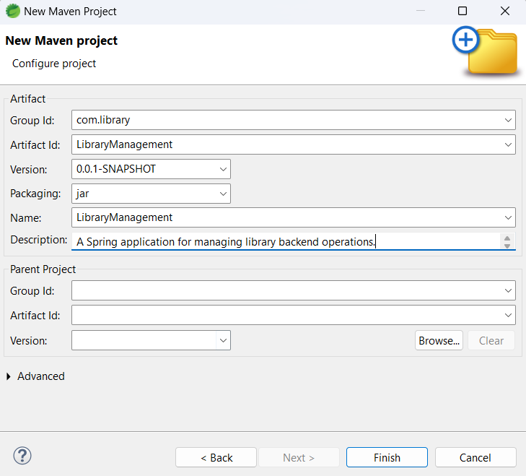

**Add spring core dependencies:**

<dependencies>

<dependency>

<groupId>org.springframework</groupId>

<artifactId>spring-context</artifactId>

<version>5.3.33</version>

</dependency>

</dependencies>

1. **Configure the Application Context:**

**applicationContext.xml**

<?xml version="1.0" encoding="UTF-8"?>

<beans xmlns="http://www.springframework.org/schema/beans"

xmlns:xsi="http://www.w3.org/2001/XMLSchema-instance"

xsi:schemaLocation="

http://www.springframework.org/schema/beans

https://www.springframework.org/schema/beans/spring-beans.xsd">

<bean id="bookService" class="com.library.service.BookService" />

</beans>

1. **Define Service and Repository Classes:**

**BookService class:**

**package** com.library.service;

**public** **class** BookService {

**public** **void** addBook(String title) {

System.***out***.println("BookService: Adding book " + title);

}

}

**BookRepository class:**

**package** com.library.repository;

**public** **class** BookRepository {

**public** **void** saveBook(String title) {

System.***out***.println("Saving book: " + title);

}

}

1. **Run the Application:**

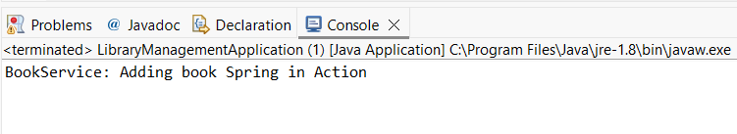

**Exercise 2: Implementing Dependency Injection**

**Steps:**

1. **Modify the XML Configuration:**

<?xml version="1.0" encoding="UTF-8"?>

<beans xmlns="http://www.springframework.org/schema/beans"

xmlns:xsi="http://www.w3.org/2001/XMLSchema-instance"

xsi:schemaLocation="

http://www.springframework.org/schema/beans

https://www.springframework.org/schema/beans/spring-beans.xsd">

<bean id="bookRepository" class="com.library.repository.BookRepository" />

<bean id="bookService" class="com.library.service.BookService">

<property name="bookRepository" ref="bookRepository" />

</bean>

</beans>

1. **Update the BookService Class:**

**BookService class:**

**package** com.library.service;

**import** com.library.repository.BookRepository;

**public** **class** BookService {

**private** BookRepository bookRepository;

**public** **void** setBookRepository(BookRepository bookRepository) {

**this**.bookRepository = bookRepository;

}

**public** **void** addBook(String title) {

System.***out***.println("BookService: Adding book...");

bookRepository.saveBook(title);

}

}

1. **Test the Configuration:**

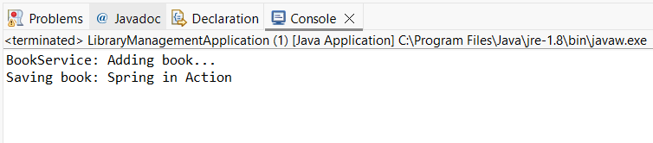

**Exercise 4: Creating and Configuring a Maven Project**

**Steps:**

1. **Create a New Maven Project:**

Same as in Exercise 1

1. **Add Spring Dependencies in pom.xml:**

<dependencies>

<!-- Spring Core Context -->

<dependency>

<groupId>org.springframework</groupId>

<artifactId>spring-context</artifactId>

<version>5.3.33</version>

</dependency>

<!-- Spring AOP -->

<dependency>

<groupId>org.springframework</groupId>

<artifactId>spring-aop</artifactId>

<version>5.3.33</version>

</dependency>

<!-- Spring Web MVC -->

<dependency>

<groupId>org.springframework</groupId>

<artifactId>spring-webmvc</artifactId>

<version>5.3.33</version>

</dependency>

</dependencies>

1. **Configure Maven Plugins:**

<build>

<plugins>

<plugin>

<groupId>org.apache.maven.plugins</groupId>

<artifactId>maven-compiler-plugin</artifactId>

<version>3.8.1</version>

<configuration>

<source>1.8</source>

<target>1.8</target>

</configuration>

</plugin>

</plugins>

</build>