**Week 4**

**2. Spring REST hands on**

**Hands on 1**

**Hello World RESTful Web Service**

**Code:**

**HelloController.java**

package com.cognizant.spring_learn.controller;

import org.slf4j.Logger;

import org.slf4j.LoggerFactory;

import org.springframework.web.bind.annotation.GetMapping;

import org.springframework.web.bind.annotation.RestController;

@RestController

public class HelloController {

private static final Logger *LOGGER* = LoggerFactory.*getLogger*(HelloController.class);

@GetMapping("/hello")

public String sayHello() {

*LOGGER*.info("Start");

String message = "Hello World!!";

*LOGGER*.info("End");

return message;

}

}

**SpringLearnApplication.java**

package com.cognizant.spring_learn;

import org.springframework.boot.SpringApplication;

import org.springframework.boot.autoconfigure.SpringBootApplication;

@SpringBootApplication

public class SpringLearnApplication {

public static void main(String[] args) {

SpringApplication.*run*(SpringLearnApplication.class, args);

}

}

**Output:**

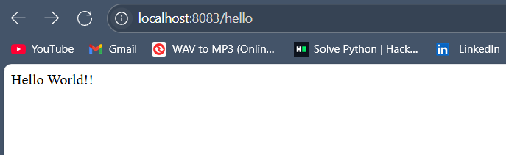

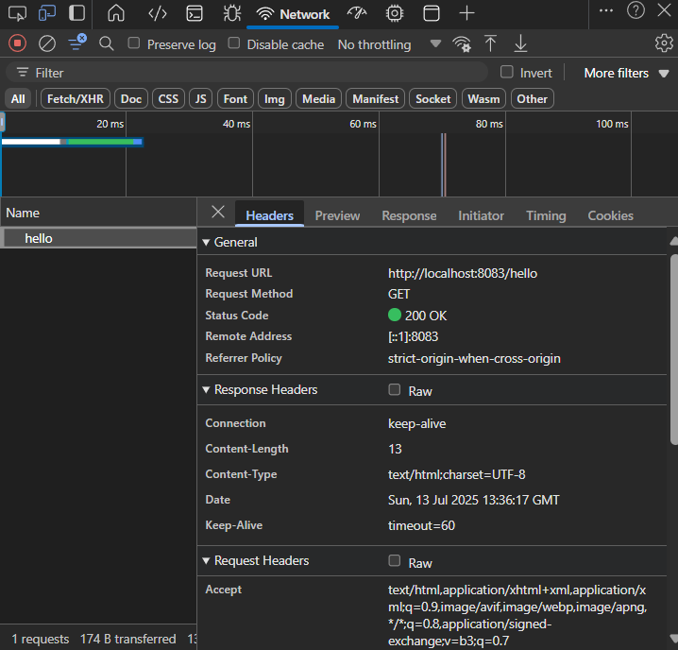

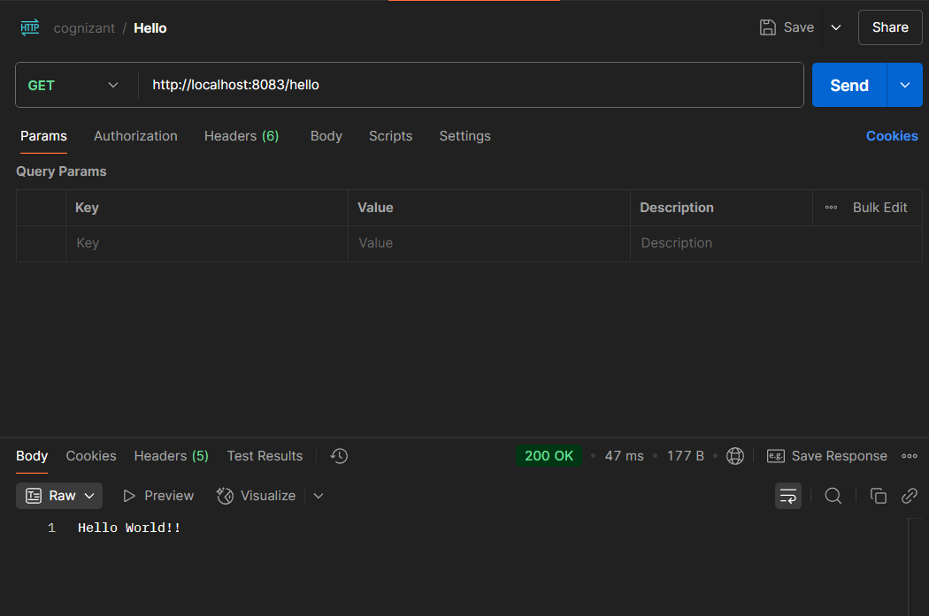

**Hands on 2**

**REST - Country Web Service** 

**Code:**

**CountryController.java**

package com.cognizant.spring_learn.controller;

import org.springframework.web.bind.annotation.RequestMapping;

import org.springframework.web.bind.annotation.RestController;

import org.springframework.context.ApplicationContext;

import org.springframework.context.support.ClassPathXmlApplicationContext;

import com.cognizant.spring_learn.Country;

import org.slf4j.Logger;

import org.slf4j.LoggerFactory;

@RestController

public class CountryController {

private static final Logger *LOGGER* = LoggerFactory.*getLogger*(CountryController.class);

@RequestMapping("/country")

public Country getCountryIndia() {

*LOGGER*.info("Start!");

ApplicationContext context = new ClassPathXmlApplicationContext("country.xml");

Country country = (Country) context.getBean("country", Country.class);

*LOGGER*.debug("Country: {}", country);

*LOGGER*.info("End");

return country;

}

}

**Output:**

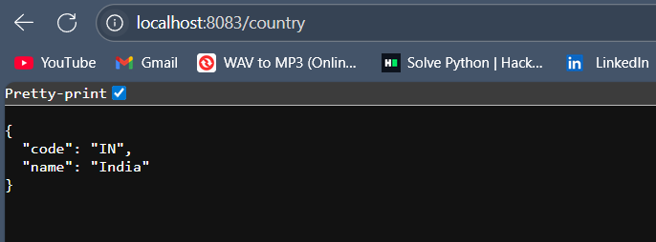

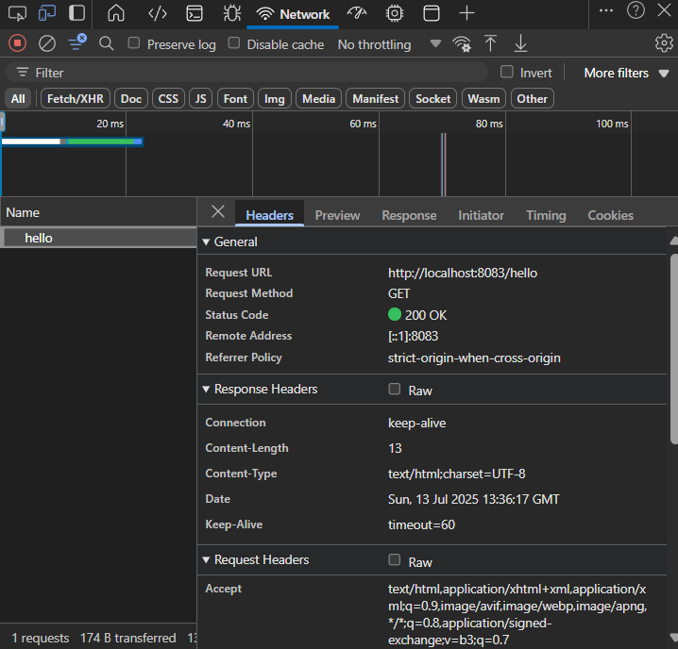

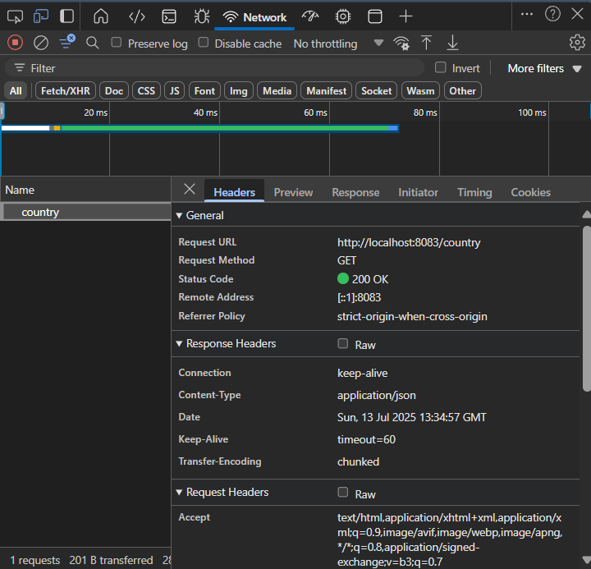

**Hands on 4**

**REST - Get country based on country code** 

**Code:**

Country.xml

<?xml version="1.0" encoding="UTF-8"?>

<beans xmlns="http://www.springframework.org/schema/beans"

xmlns:xsi="http://www.w3.org/2001/XMLSchema-instance"

xsi:schemaLocation="

http://www.springframework.org/schema/beans

https://www.springframework.org/schema/beans/spring-beans.xsd">

<bean id="countryList" class="java.util.ArrayList">

<constructor-arg>

<list>

<bean class="com.cognizant.spring_learn.Country">

<property name="code" value="IN" />

<property name="name" value="India" />

</bean>

<bean class="com.cognizant.spring_learn.Country">

<property name="code" value="US" />

<property name="name" value="United States" />

</bean>

<bean class="com.cognizant.spring_learn.Country">

<property name="code" value="JP" />

<property name="name" value="Japan" />

</bean>

<bean class="com.cognizant.spring_learn.Country">

<property name="code" value="DE" />

<property name="name" value="Germany" />

</bean>

</list>

</constructor-arg>

</bean>

</beans>

**CountryService.java**

package com.cognizant.spring_learn.service;

import java.util.List;

import org.springframework.context.ApplicationContext;

import org.springframework.context.support.ClassPathXmlApplicationContext;

import org.springframework.stereotype.Service;

import com.cognizant.spring_learn.Country;

@Service

public class CountryService {

public Country getCountry(String code) {

ApplicationContext context = new ClassPathXmlApplicationContext("country.xml");

List<Country> countries = (List<Country>) context.getBean("countryList");

return countries.stream()

.filter(c -> c.getCode().equalsIgnoreCase(code))

.findFirst()

.orElse(null);

}

}

**CountryController.java**

package com.cognizant.spring_learn.controller;

import org.springframework.beans.factory.annotation.Autowired;

import org.springframework.web.bind.annotation.*;

import com.cognizant.spring_learn.Country;

import com.cognizant.spring_learn.service.CountryService;

import org.slf4j.Logger;

import org.slf4j.LoggerFactory;

@RestController

public class CountryController {

private static final Logger *LOGGER* = LoggerFactory.*getLogger*(CountryController.class);

@Autowired

private CountryService countryService;

@GetMapping("/countries/{code}")

public Country getCountry(@PathVariable String code) {

*LOGGER*.info("Start getCountry with code: {}", code);

Country country = countryService.getCountry(code);

*LOGGER*.info("End getCountry");

return country;

}

}

**Output:**

