**Sales Performance Analysis Dashboard using Power BI**

**Name : Uday Kumar Reddy**

**Mail :** [**udaykumar200425@gmail.com**](mailto:udaykumar200425@gmail.com)

**Abstract**

This document outlines the initial phase of a Business Intelligence project, aimed at developing a solution to support data-driven decision-making. In Module 1, foundational work was completed, which included understanding project requirements, data collection, data transformation, and the creation of initial DAX measures to enhance data insights. This groundwork will serve as the basis for further analysis and dashboard development in subsequent project module

**Introduction**

Business Intelligence (BI) is a strategic solution that enables organizations to transform data into actionable insights, improving decision-making processes. This project aims to develop a BI solution that empowers a company to monitor business performance in real-time and respond effectively to market dynamics. Module 1 focused on establishing the project’s foundation by preparing the dataset, transforming it into an analysis-ready form, and building essential data measures. These steps were critical in creating a structure that supports future analysis and reporting.

**Objective**

The analysis focuses on the following key objectives:

1. **Customer Segmentation**: Categorize customers into spending tiers (Platinum, Gold, Silver) to enable personalized engagement strategies.
2. **Rating Analysis**: Integrate product ratings with sales volumes to highlight top-performing products.
3. **Sales Trend Analysis**: Analyze Year-over-Year (YoY) Sales Growth to uncover growth patterns and trends.
4. **Product Popularity Assessment**: Implement a Weighted Rating system to prioritize products that are in high demand and well-rated, supporting inventory and marketing decisions.

These objectives collectively offer insights into customer value, product satisfaction, and sales trends, providing a comprehensive understanding of business dynamics.

**Data Analysis Approach**

In Module 1, the data analysis was carried out through a series of structured tasks aimed at meeting project objectives and preparing the dataset for deeper insights and advanced reporting. The key tasks completed in this phase are outlined below:

**Task 1: Analyze the Problem Requirement**

* Examined the project requirements to identify specific goals, including customer segmentation, sales trend analysis, product popularity, and rating analysis. This helped in understanding the necessary data transformations and calculations for achieving these objectives.

**Task 2: Data Gathering and Transformation**

* Collected essential data across four tables: customer_table, product_table, salesperson_table, and sales_table.
* Applied various transformations in the Power Query Editor, including:
  + Merging tables based on shared attributes (e.g., customer ID, product ID) to form a consolidated dataset.
  + Adjusting data types of columns as required for accurate calculations and analysis, ensuring consistent data structure across the dataset.

**Task 3: DAX Formulae for New Measures and Calculated Columns**

* Utilized DAX formulas to create measures and calculated columns critical for assessing sales, profitability, product ratings, and discounts. Key DAX formulas and their purposes included:
* **Total Sales (Measure)**: Total Sales = SUM(Sales_Orders[Sales_Amount])
* **Previous Year Sales (Measure)**: Previous Year Sales = CALCULATE([Total Sales], SAMEPERIODLASTYEAR(Sales_Orders[OrderDate]))
* **YoY Sales Growth (Measure)**: YoY Sales Growth = DIVIDE([Total Sales] - [Previous Year Sales], [Previous Year Sales], 0)
* **Total Rating Points (Measure)**: Total Rating Points = SUMX(Sales_Orders, Sales_Orders[User_Rating] * Sales_Orders[Quantity])
* **Profit (Column)**: Profit = Sales_Orders[Sales_Amount] - Sales_Orders[Product_Details.Cost_Price] * Sales_Orders[Quantity]
* **Discount Amount (Column)**: Discount Amount = Sales_Orders[Sales_Amount] * (Sales_Orders[Discount] / 100)
* **Quantity (Column)**: Quantity = ROUND(DIVIDE(Sales_Orders[Sales_Amount], Sales_Orders[Product_Details.Cost_Price]), 0)

**Task 4: Customer Segmentation Using DAX**

Developed a segmentation model to classify customers into spending categories (Platinum, Gold, Silver) for targeted engagement. DAX formulas used for segmentation included:

* **Total Spend (Measure)**: Total Spend = SUM(Sales_Orders[Sales_Amount])
* **Customer Rank (Measure)**: Customer Rank = RANKX(ALL(Customer_Info), [Total Spend], , DESC, Skip)
* **Customer Expense (Column)**: Customer Expense = IF([Total Spend] > 500,"Platinum",IF([Total Spend] > 50, "Gold", "Silver"))

**Methodology**

The methodology for Module 1 consisted of several key steps:

1. **Data Collection**:  
   Data was collected from [mention the source, e.g., sales and transaction databases, customer analytics records], covering essential business aspects for BI insights.
2. **Data Preparation**:  
   Using the Power Query Editor, the data was transformed by:
   * Cleaning inconsistencies and filling missing values.
   * Merging multiple tables to create a unified, analysis-ready dataset.
3. **DAX Formulas**:  
   DAX measures and calculated columns were created to derive valuable metrics. Key measures included:
   * **Total Sales**: A measure to calculate overall sales, defined by Total Sales = SUM(SaleAmount).
   * **Average Customer Rating**: To measure customer satisfaction, defined by Average Rating = AVERAGE(CustomerRating). These measures were designed to enable future analysis of trends and KPIs.

**Results Interpretation**

The DAX calculations and visualizations provide several key insights:

1. **Customer Insights**: Ranking and expense classification reveal high-value customers, informing loyalty strategies.
2. **Product Performance**: Weighted Rating highlights popular and well-rated products, supporting promotional efforts.
3. **Sales Trends**: YoY Sales Growth reveals seasonal patterns, guiding strategic decisions in business planning.

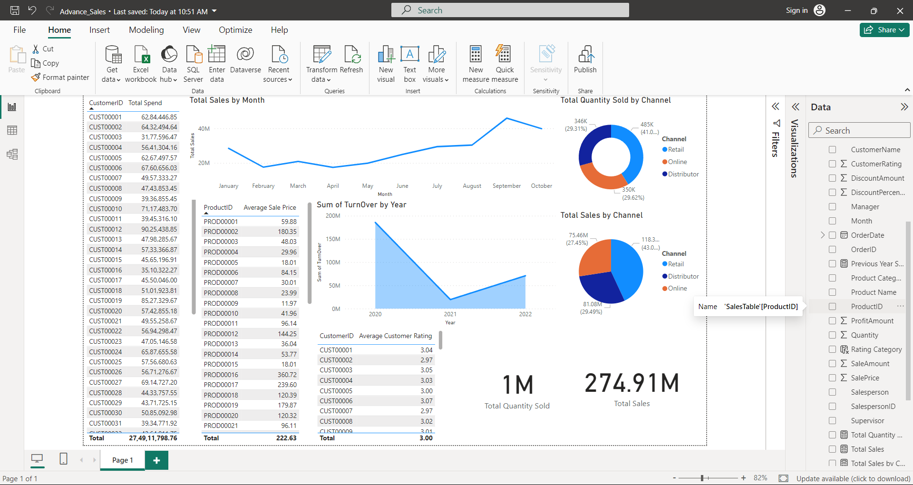

### Conclusion

Module 1 successfully laid the groundwork for this BI project. Through meticulous data collection, transformation, and the application of DAX formulas, the data has been structured to facilitate in-depth analysis and visualization. The measures created in this phase will be pivotal in the development of KPIs, enabling the organization to respond proactively to business insights.

### Future Work

In future modules, further analysis and visualization work will be undertaken. This will involve:

1. Developing interactive dashboards that display KPIs in real-time.
2. Implementing advanced DAX calculations for deeper insights.
3. Expanding data connections to incorporate additional datasets, refining the solution to support dynamic business intelligence reporting.