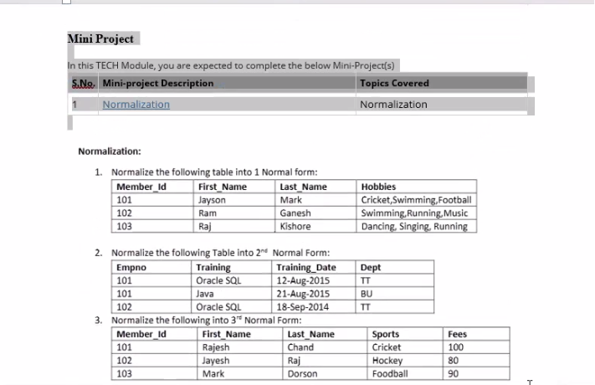
ASSIGENMNET 01
Member_ID |  | First_Name | Last_Name | Hobbies_1 | Hobbies_2 | Hobbies_3
101 |  | Jayson | Mark | Cricket | Swimming | Football
102 |  | Ram | Ganesh | Swimming | Running | Music
103 |  | Raj | Kishore | Dancing | Singing | Running
- Anwer

- Answer
Empno | Training | Training_date
101 | Oracle SQL | 12-Aug-2015
101 | Java | 21-Aug-2015
102 | Oracle SQL | 18-Sep-2014

Training | Dept
Oracle SQL | TT
Java | BU

- Answer
Member_Id | First_Name | Last_Name | Sports
101 | Rajesh | Chand | Cricket
102 | Jayesh | Raj | Hockey
103 | Mark | Dorson | Football

Sports | Fees
Cricket | 100
Hockey | 80
Football | 90

