**Student Course Enrollment System User Manual**

**Version 1.0**

**Project Manager: Uday Shankar Boddupalli (2868122)**

**Design and Technical Lead: Yogeshwar Suresh (2862061)**

1. **Table of Contents**

1. **Introduction**
   1. **Welcome to Student Course Enrollment System**
   2. **How to Use this User Manual**

1. **Navigating The Website**
   1. **Homepage layout**
   2. **Student Login to Study Center**
   3. **List of courses available for Enrollment**
   4. **Enrollment Status of a student**
   5. **Admin Dashboard**
   6. **Adding New Courses**
   7. **Pop up to fill in new course details**
   8. **Enrollment Status for newly added course**
   9. **Details of newly added course**
2. **Introduction**

**1. Welcome to Student Enrollment System**

Welcome to Student Enrollment System Website, this user manual will guide you exploring our website at your fingertips, whether you are returning user or First-timer, this website provides a convenient way for students and administrators to browse through their dashboards to enroll classes, add new classes.

This user manual will be your trusty companion while you navigate through website, we’ll show you how to find your way around the homepage layout, search through our students and admin dashboard how to enroll in classes, how to create a new course.

**2. How to use this user manual**

This manual is designed for easy navigation, and we’ve provided two ways for you to get the most out of it.

* **Jump to Specific Sections:** Utilize the table of contents at the beginning of this manual. It acts like a roadmap, listing all the major sections. Click on the section title that you are interested in, and you'll be whisked away to that specific part of the guide. This is perfect if you are a current student or admin who knows how to access this kind of website.
* **Follow the step-by-step guide:** Prefer a more structured approach? No problem! Follow this user manual sequentially, from the start to the end. We'll guide you through each section of the website, highlighting key functionalities. This option is ideal for first-time users who want a comprehensive understanding of everything that **Student Course Enrollment System** Website has to offer.

**2. Navigating the website**

The Student Course Enrollment System website is designed for smooth and intuitive user experience. Let’s delve into the key sections you’ll encounter while navigating the website.

1. **Homepage Layout**

This is our starting page; you will find captivating visuals showcasing the login page with real time updating date and time display. Here users, either student or administrator should enter their designated credentials and click sign into enter their specifically designed dashboard.

Figure 1: Application Home Screen

1. **Student Login to Study Center**

Once the student successfully logins into the study center, they will be taken to their dashboard, where they have their name displayed, with active courses that they previously enrolled, and list off classes available their course name , description of course, how many seats available, current seat status and start date and end date

Figure 2: Student Login

Figure 3: Student dashboard

1. **List of courses available for enrollment**

When the student decides which course that they want to enroll in, then they can click on the enroll button to add that course to their active course.

Note: Student can only enroll in three active courses.

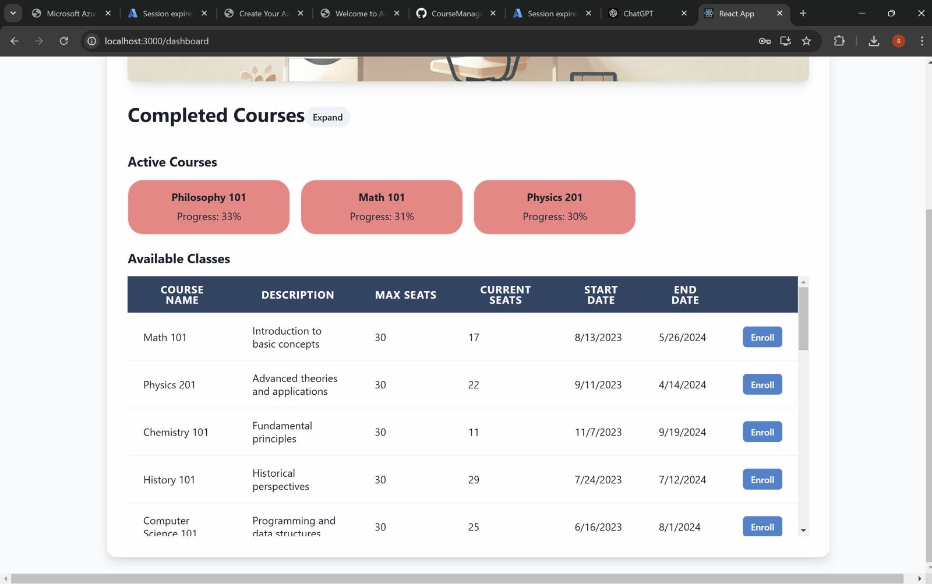

Figure 4: List of courses available and Active Courses

1. **Enrollment Status of Student**
   1. **Enrolling in a class**

If the student is enrolled in less than three active courses, the student can enroll in any of the available courses by clicking on the enroll button and the student will be successfully enrolled in the course. The student can only enroll in the courses they have not yet completed.

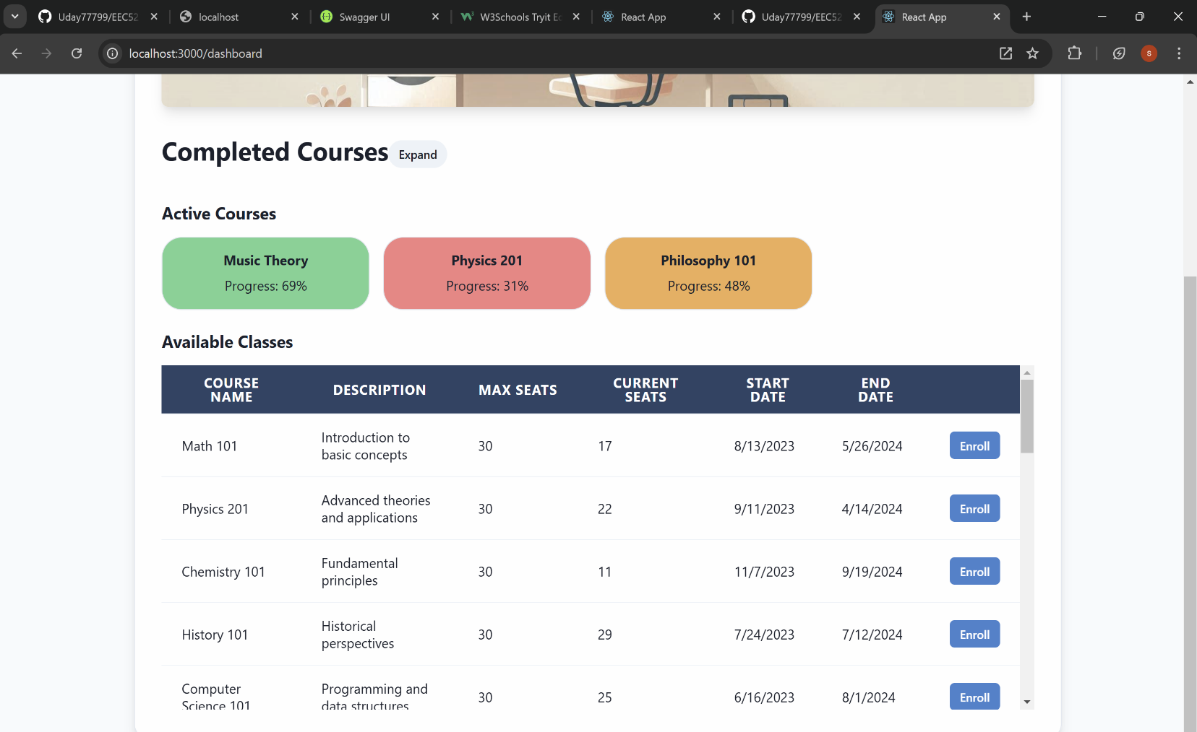

Figure 5: Enrollment Status

* 1. Enrolling in Completed Course or Already Enrolled Course

If the student tries to enroll in courses they have already enrolled or completed, the system will not let the user enroll with a pop up message stating that the student has already enrolled in the course and to contact the admin.

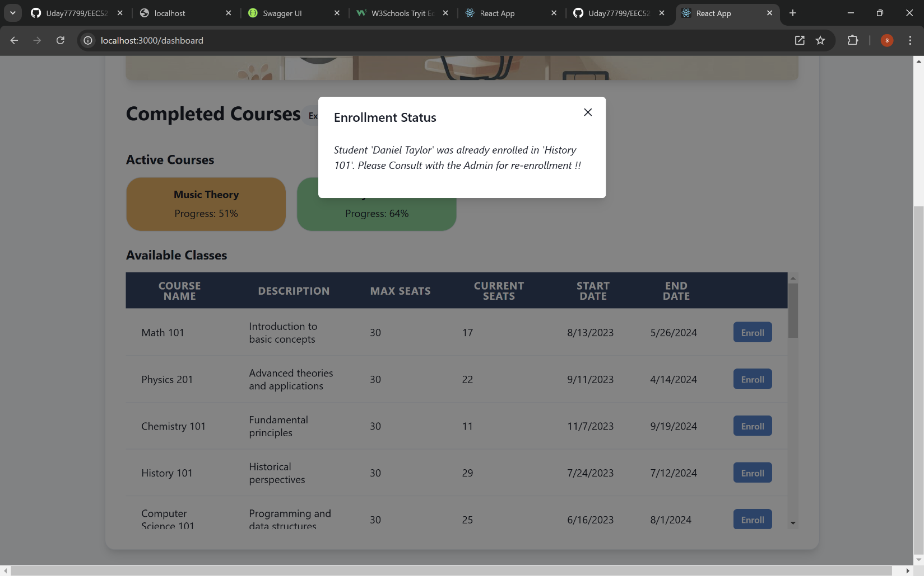 Figure 6: Enrollment Status in Completed course

* 1. Enrolling In More Than Three Active Courses

If the student meets the only three active courses criteria and still they wanted to add one or more courses, the enrollment status pop will appear on the dashboard stating that maximum active courses have been reached, in order to add more courses you have complete the existing active courses before enrolling in new one.

Figure 7: Enrollment Status in More Than Three classes

1. **Admin Dashboard**

When admin logs in using their credentials in study center they will enter into their own user dashboard, where the dashboard display their name, list of students enrolled, and list of courses. When they click to expand the list of student and courses, they can see the complete list of students with their student ID, full name and their email address. For list of courses contains course ID, course name and their description.

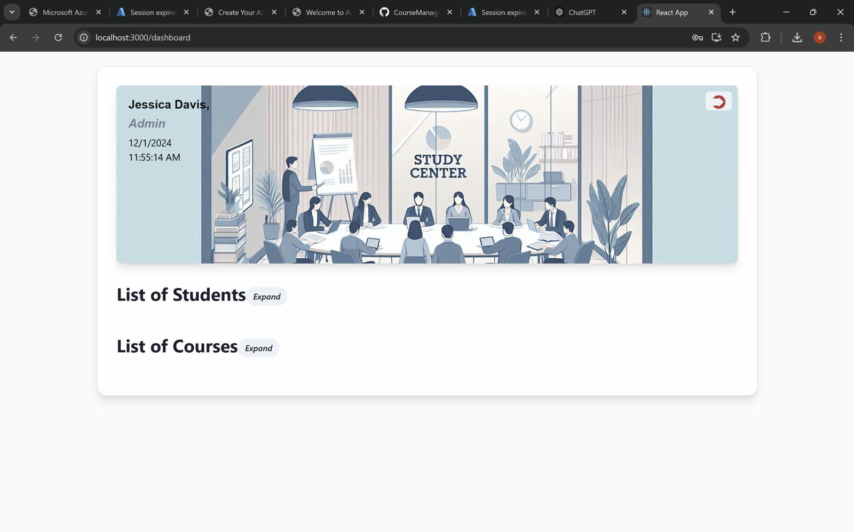

Figure 8: Admin Dashboard

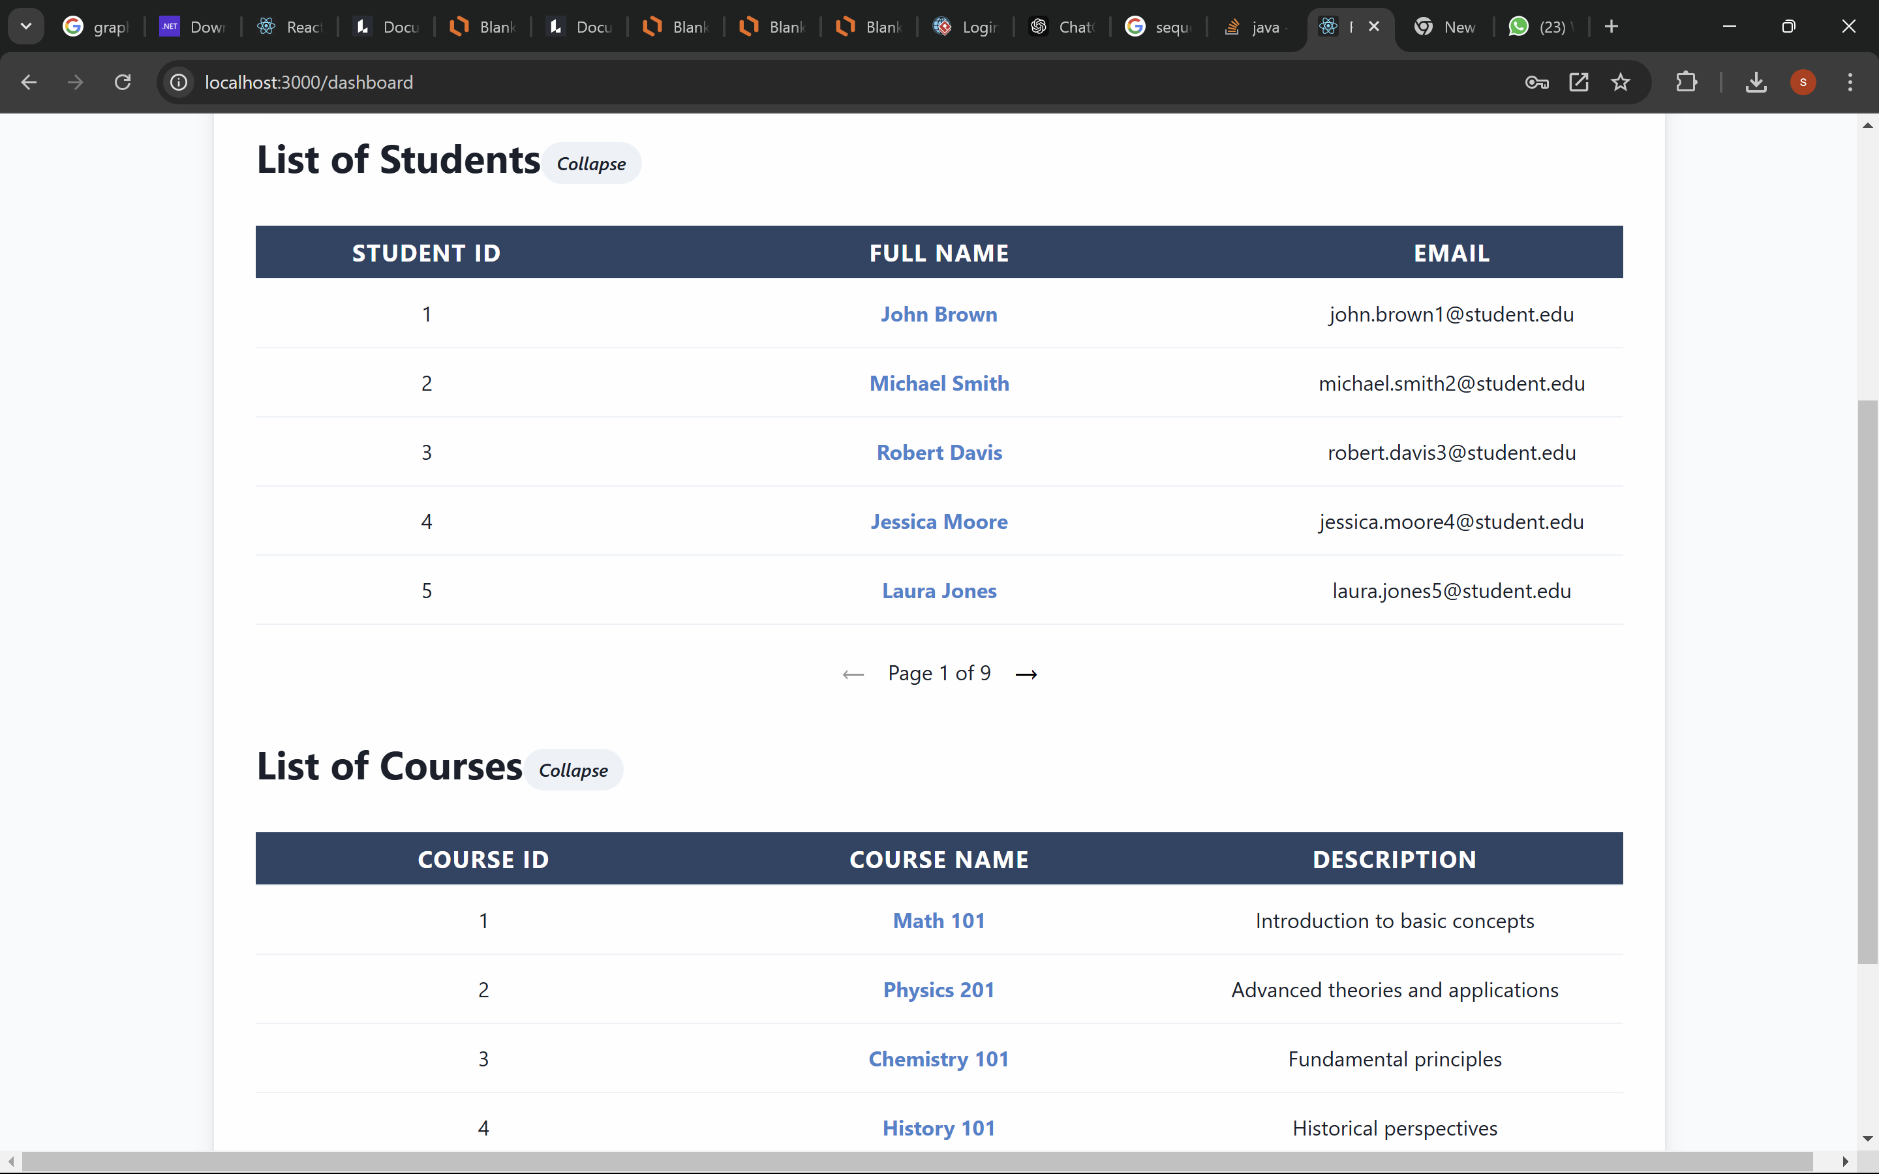Figure 9: List of Students and List of Courses

1. **Adding new courses**

When an administrator wants to add new courses to the list of courses below the list of courses on far right downside they can find the add new course button, when you click on it add new course menu will pop. Which contains text box to enter new course, description, max seats, current seats, start and end date.

Figure 10: Pop to add new course

1. **Pop up to fill new course details**

In this case the administration wants to add Psychology201 course to the list of courses, description for this Psychology201, max and current seat have been set, Start and end date also given, once all this done click the **ADD** button to add this course and make this course available to the students with the other courses in student dashboard.

Figure 11: New Courses have been added in list of text boxes

1. **Enrollment Status for newly added course**

After clicking on **the ADD** button, a pop up will appear and displays that the new course have been added successfully.

Figure 12: Enrollment Status of new course which have been added

1. **Details of newly added course**

After successfully added the new course, now the new course will be appear in the list of courses, where you can select that new course, it will display the details of that particular course.

Figure 13: Details of newly added courses