**(Q.1)What is React Js?**

* The React.js framework is an open-source JavaScript framework and library developed by Facebook. It is used for building interactive user interfaces and web applications quickly
* The main objective of ReactJS is to develop User Interfaces (UI) that improves the speed of the apps. It uses virtual DOM (JavaScript object), which improves the performance of the app. The JavaScript virtual DOM is faster than the regular DOM. We can use ReactJS on the client and server-side as well as with other frameworks. It uses component and data patterns that improve readability and helps to maintain larger apps.
* React is a [JavaScript](https://www.simplilearn.com/tutorials/javascript-tutorial/introduction-to-javascript)-based UI development library. Facebook and an open-source developer community run it. Although React is a library rather than a language, it is widely used in web development. The library first appeared in May 2013 and is now one of the most used frontend libraries for web development.

**(Q.2) What is NPM in React Js?**

* npm is the world's largest Software Registry. The registry contains over 800,000 code packages. Open-source developers use npm to share software. Many organizations also use npm to manage private development.
* npm is free to use002EYou can download all npm public software packages without any registration or logon.
* npm is installed with Node.js This means that you have to install Node.js to get npm installed on your computer. Download Node.js from the official Node.js web site: [https://nodejs.org](https://nodejs.org/)
* The name npm (Node Package Manager) stems from when npm first was created as a package manager for Node.js. All npm packages are defined in files called package.json. The content of package.json must be written in JSON. At least two fields must be present in the definition file: name and version.
* npm can manage dependencies.npm can (in one command line) install all the dependencies of a project.Dependencies are also defined in package.json.

**(Q.3) What is Role of Node Js in react Js?**

* [ReactJS](https://www.simplilearn.com/tutorials/reactjs-tutorial) and [NodeJS](https://www.simplilearn.com/tutorials/nodejs-tutorial/what-is-nodejs) are both [JavaScript](https://www.simplilearn.com/tutorials/javascript-tutorial/introduction-to-javascript) technologies. But the uses of NodeJS and ReactJS are entirely different. NodeJS is a framework of JavaScript which is mainly used for working with the [backend](https://www.simplilearn.com/tutorials/programming-tutorial/what-is-backend-development) of our application or building the backend using JavaScript, whereas ReactJS is a JavaScript front-end library. It is mainly used for building the user interface or the [frontend](https://www.simplilearn.com/tutorials/programming-tutorial/best-front-end-programming-languages) of our application. Though both are used for different purposes, both these technologies make our application faster and easy to handle.
* React and Node.js are both open-source JavaScript libraries that are used to build user interfaces and server-side applications, respectively. Both are the most popular technologies in the world of front-end web development today, but they are quite different.
* Features of Node.js:  There are other programming languages also that we can use to build back-end services so what makes Node.js different I am going to explain.
* It is easy to get started and can be used for prototyping and agile development
* It provides fast and highly scalable services
* It uses JavaScript everywhere so it is easy for a JavaScript programmer to build back-end services using Node.js
* The source code is cleaner and consistent.
* Large ecosystem for open source library.
* It has an Asynchronous or Non-blocking nature.

**(Q.4) What is CLI command In React Js?**

* A command-line interface is a way that you can interact with a computer through text. It works by you typing in special commands in a command prompt.
* A command-line interface (CLI) is a computer program that processes commands in the form of text inputs and in turn execute system functions. In the early days of computing, the only way to interact with a computer was through the terminal. But today, many users interact with the computer via a graphical user interface (GUI). As a software developer, you are likely to have used a CLI. If you are a Node.js or React developer, you use the npm CLI (almost) every day.
* You probably have used a CLI to install or configure software or automate repetitive tasks. There are many use cases for building a CLI and knowing how to do that with your JavaScript and React.js skills can be productive.

**(Q.5) What is Components in React Js?**

* Components are independent and reusable bits of code. They serve the same purpose as JavaScript functions, but work in isolation and return HTML.
* Components come in two types, Class components and Function components.

(1)Class Components:

* A class component must include the extends React.Component statement. This statement creates an inheritance to React.Component, and gives your component access to React.Component's functions.
* The component also requires a render() method, this method returns HTML.

Ex.

import React, { Component } from 'react';

class classcomponents extends Component {

    render() {

        return (

            <div>

                <h1>Class Components</h1>

            </div>

        );

    }

}

export default classcomponents;

(2)Function Components

* A Function component also returns HTML, and behaves much the same way as a Class component, but Function components can be written using much less code, are easier to understand.

Ex.

import React from 'react';

function functioncomponents(props) {

    return (

        <div>

            <h1>Function Components</h1>

        </div>

    );

}

export default functioncomponents;

**(Q.6) What is Header and Content Components in React Js?**

* Header:

import React from 'react';

import {

    BrowserRouter as Router,

    Routes,

    Route,

    Link,

  } from "react-router-dom";

import Classcomponents from './classcomponents';

import Functioncomponents from './functioncomponents';

function Header(props) {

    const Menu = {'./classcomponents':'Classcomponents','./functioncomponents':'Functioncomponents'}

        const ReturnData = Object.entries(Menu).map((res,i)=>{

            return <li className="nav-item" key={i}>

            <Link className='nav-link' to={res[0]}>{res[1]}</Link>

          </li>

        })

    return (

        <>

        <Router>

        <nav className="navbar navbar-expand-sm bg-dark navbar-dark">

  <div className="container-fluid">

    <a className="navbar-brand" href="#">Logo</a>

    <button className="navbar-toggler" type="button" data-bs-toggle="collapse" data-bs-target="#collapsibleNavbar">

      <span className="navbar-toggler-icon"></span>

    </button>

    <div className="collapse navbar-collapse" id="collapsibleNavbar">

      <ul className="navbar-nav">

        {ReturnData}

      </ul>

    </div>

  </div>

</nav>

        <Routes>

            <Route path='/classcomponents' element={<Classcomponents/>}/>

            <Route path='/functioncomponents' element={<Functioncomponents/>}/>

        </Routes>

        </Router>

        </>

    );

}

export default Header;

**(Q.7) How to install React Js on Windows, Linux Operating System? How to install NPM and How to check version of NPM?**

* Installation on Windows

Step 1: Install Node.js installer for windows. Once downloaded open NodeJS without disturbing other settings, click on the Next button until it is completely installed.

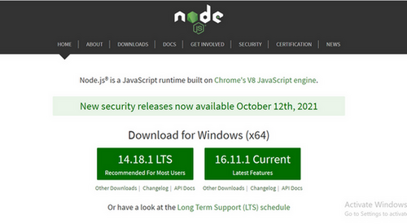

Step 2: Open command prompt  to check whether it is completely installed or not type the command –> node -v

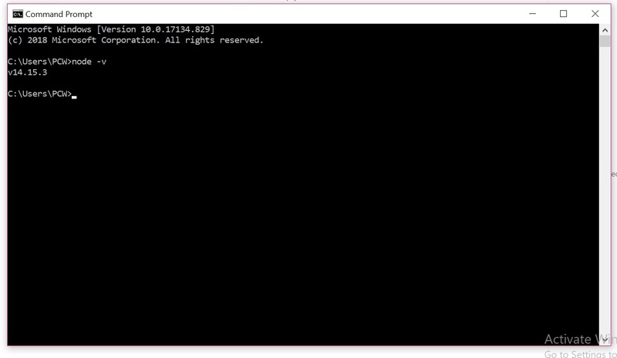

If the installation went well it will give you the version you have installed .

Step 3: Now in the terminal run the below command:

npm install -g create-react-app

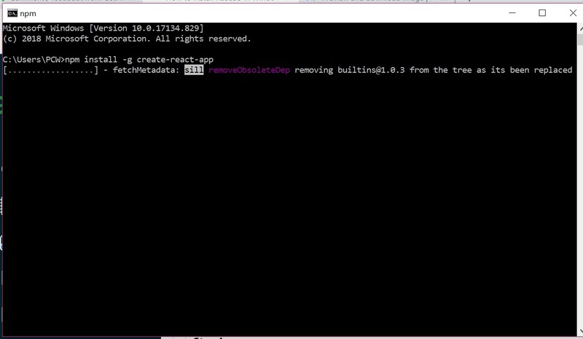

It will globally install react app for you. To check everything  went well run the command

create-react-app --version

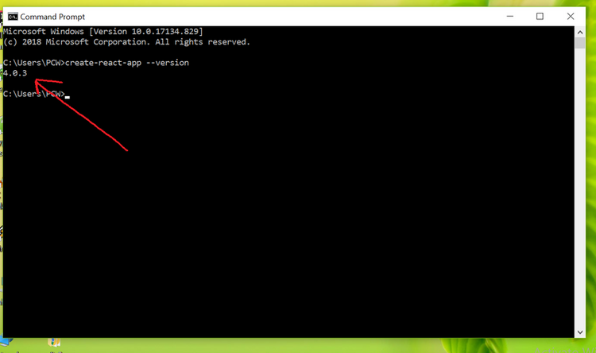

If everything went well it will give you the installed version of react app

Step 4:Now Create a new folder where you want to make your react app using the below command:

mkdir newfolder

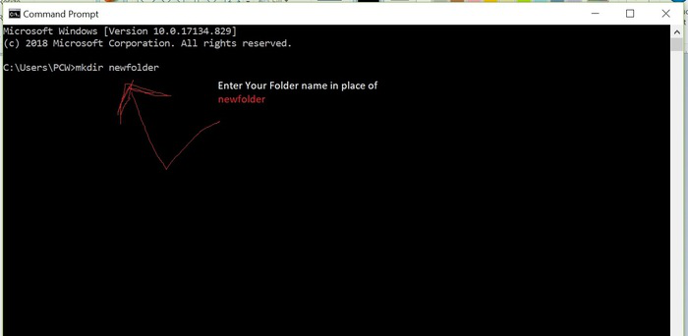

Move inside the same folder using the below command:

cd newfolder (your folder name)

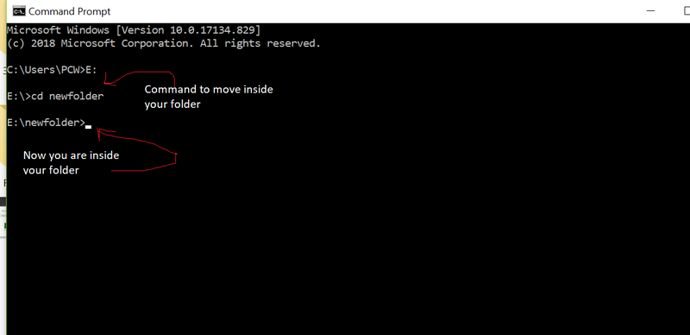

Step 5: Now inside this folder run the command –>

create-react-app reactfirst YOUR_APP_NAME

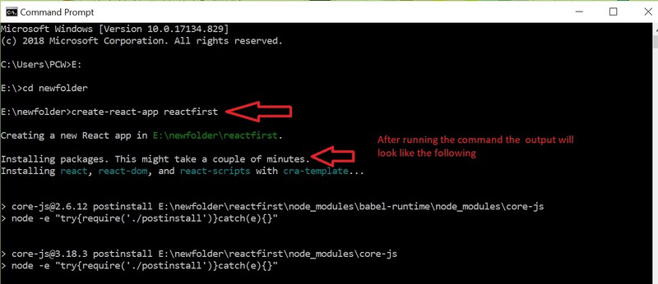

It will take some time to install the required dependencies.

Step 7: To start your app run the below command :

npm start

Once you run the above command a new tab will open in your browser showing React logo as shown below :

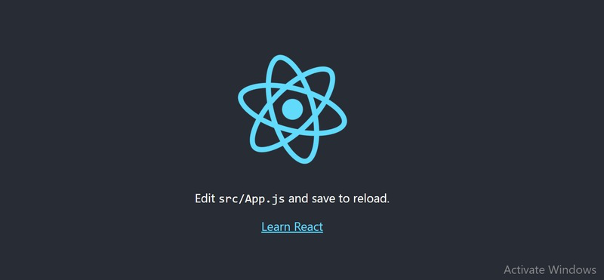

* Installation on Linux

Step-1:

To install npm on Ubuntu Linux, login into your server as a sudo user and invoke the command below:

$ sudo apt install npm

Once the installation is complete, you can verify the version of npm installed using the command:

$ npm –version

6.14.4 [Output]

The latest version at the time of writing this is v6.14.4 as captured in the output.

The installation of npm also installs node.js and you can confirm the version of node installed using the command:

$ node --version

v10.16.0 [Output]

Step-2:

create-react-app is a utility that enables you to set up all the tools required to create a React Application. It saves you a great deal of time and energy setting everything from scratch and gives you the head start needed.

To install the tool, run the following npm command:

$ sudo npm -g install create-react-app

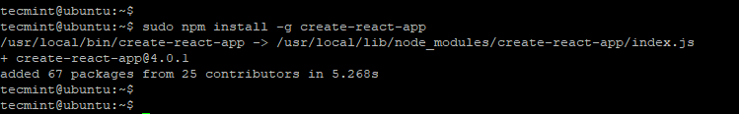

Once installed, you can confirm the version of installed by running:

$ create-react-app --version

4.0.1 [Output]

Step-3:

Creating a React application is quite simple & straightforward. We are going to create a react app called tecmint-app as follows.

$ create-react-app tecmint-app

This takes roughly 5 minutes to install all the packages, libraries, and tools needed by the application. Some patience will come in handy.

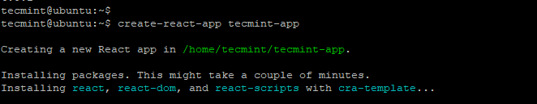

If the creation of the application was successful, you will get the notification below giving the basic commands that you can run to start managing the application.

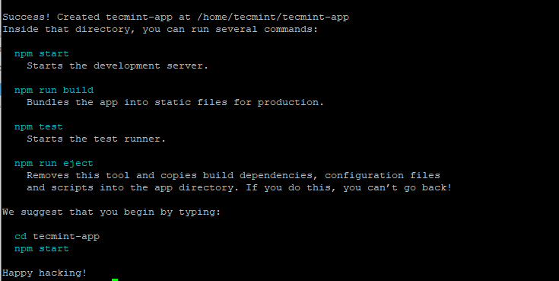

To run the application, navigate into the app directory

$ cd tecmint-app

Then run the command:

$ npm start

You will end up getting the output below showing you how to access the application on the browser.

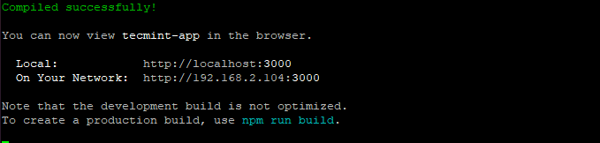

Fire up your browser and browse your server’s IP address

<http://server-ip:3000>

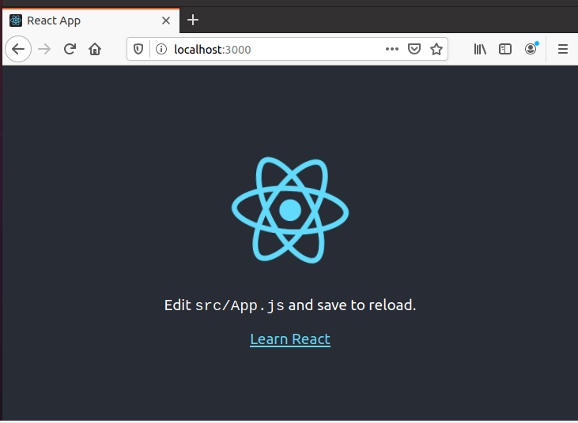

This shows that the default React app is up and running. In this guide, we have successfully installed React JS and created an application in React.

* Check Version of NPM

Step-1:

Open cmd on your computer.

Step-2:

Now to check the NPM version, type the command

NPM -- version or NPM -v

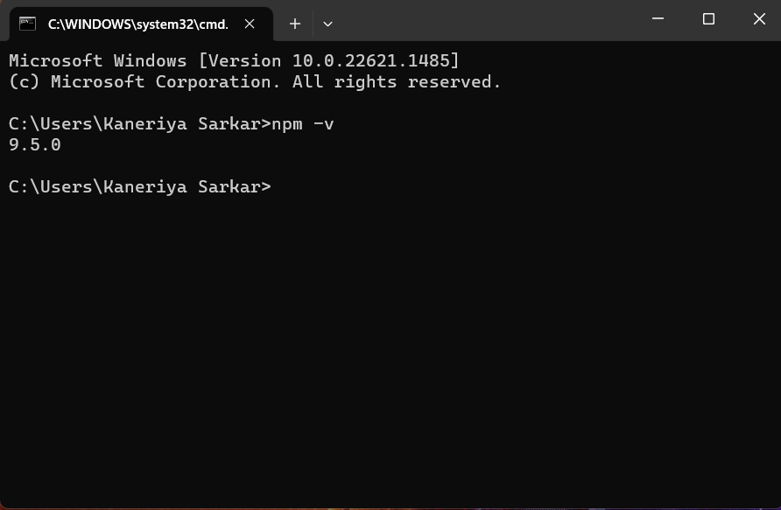

**(Q.8) How to check version of React Js?**

* Step-1:

Open cmd on your computer.

* Step-2:

We can easily check the React version by using the command mentioned below on our command line.

* npm view react version

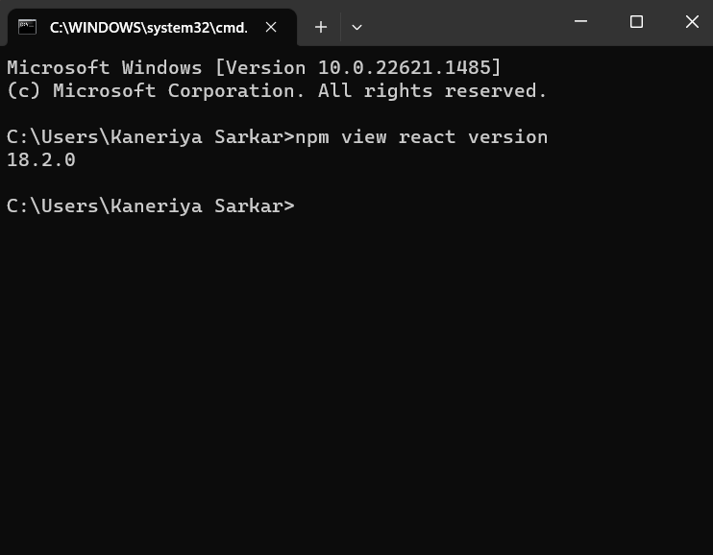

**(Q.9)How to change in components of React Js?**

* Using useState hooks

import React from 'react';

import { useState } from 'react';

function Usestate(props) {

    const [name, setname] = useState("Tony Stark")

    const BtnClck=()=>{

        setname("Iron Man")

    }

    return (

       <>

       <div className="container">

        <div className="row">

            <div className="col">

                <h2>{name}</h2>

                <button className="btn btn-danger" onClick={BtnClck}>Click Me</button>

            </div>

        </div>

       </div>

       </>

    );

}

export default Usestate;