PL/SQL
Part 01
1. begin
dbms_output.put_line('Hello ADBMS Section C');
end;
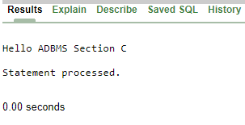

2. DECLARE
a NUMBER := 10;
b NUMBER := 20;
sum_result NUMBER;
BEGIN
DECLARE
temp NUMBER;
BEGIN
temp := a + b;
DBMS_OUTPUT.PUT_LINE('Sum = ' || temp);
END;
END;
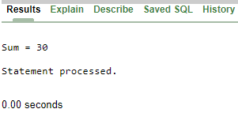

3. BEGIN
DBMS_OUTPUT.PUT_LINE('Result = ' || (5 * 10 * 2));
END;
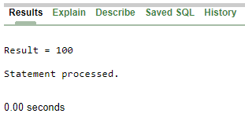

4. DECLARE
msg VARCHAR2(20) := 'Hello World';
BEGIN
DBMS_OUTPUT.PUT_LINE(UPPER(msg));
END;
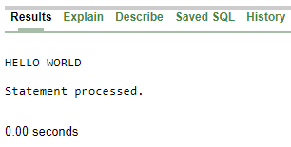

5. DECLARE
x NUMBER := 25;
y NUMBER := 10;
result NUMBER;
BEGIN
result := x - y;
DBMS_OUTPUT.PUT_LINE('Result = ' || result);
END;
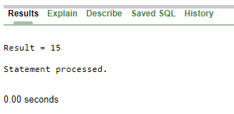

6. DECLARE
a NUMBER := 12;
b NUMBER := 14;
c NUMBER := 16;
d NUMBER := 18;
avg_result NUMBER;
BEGIN
avg_result := (a + b + c + d) / 4;
DBMS_OUTPUT.PUT_LINE('Average = ' || avg_result);
END;

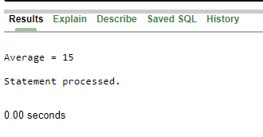

7. DECLARE
pi CONSTANT NUMBER := 3.14159;
BEGIN
DBMS_OUTPUT.PUT_LINE('Value of PI = ' || pi);
END;

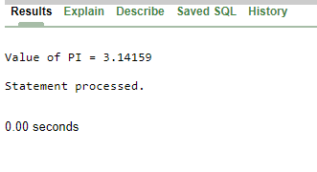

Part 02:
1. SELECT DEPTNO, DNAME
FROM DEPT
WHERE DEPTNO = 10;
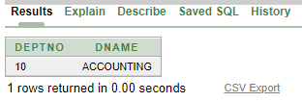

2. SELECT DEPTNO, LOWER(DNAME) AS DNAME
FROM DEPT
WHERE DEPTNO = 20;
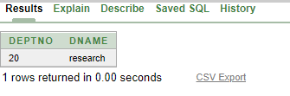

3. SELECT ENAME, SAL + 250 AS incremented_salary
FROM EMP
WHERE ENAME = 'SMITH';
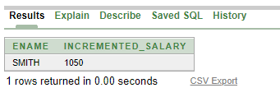

4. SELECT ENAME, HIREDATE
FROM EMP
WHERE ENAME = 'KING';
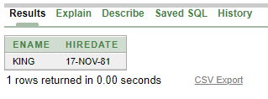

5. SELECT ENAME, SAL, SUM(SAL) OVER () AS total_salary
FROM EMP;
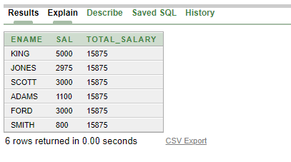

6. SELECT ENAME, SAL, COMM
FROM EMP
WHERE ENAME = 'ALLEN';

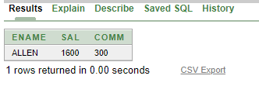

7. SELECT ENAME, SAL
FROM EMP
WHERE ENAME LIKE '%TT%';
