// Total Issues to be cleared -- > Implementation:

File : TA.cpp

1) signatureGeneration Function → function modification
- remove cpsrng Generator and put it as input to the function as it is already generated in the main function.
- Multiply Hash value with random number generated i.e. a as per equation said below.

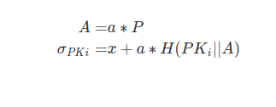
2) checkRegValid function → TODO
- Complete the function

3) Validaterequest function → function input changes
- changes to be done in signature function inputs.

File : `Vehicle.cpp`

1) signMessage function → to be reviewed
- Not same as blueprint given.

2) sendingMessage function → to be reviewed
- Not same as blueprint given.

File : `Key.cpp` and `Message.cpp`

→ No mistakes have been identified in these files so far.

