Where Is My Bus implementation guide
Milestone 1 source handover
This guide helps developers open, test and verify the first implementation of the Android bus application. It covers the separate server and client solutions, public bus search, database schema, test evidence and the remaining work before location tracking can be delivered.

Delivery status
The server and mobile core compile and pass their automated tests. The complete Android application still requires Android SDK and JDK verification. This delivery is a project foundation and is not ready for production release.
Delivered | Verification
ASP.NET Core API solution | Build and foundation tests passed
MAUI Android source and mobile core | Core tests passed; Android build blocked
15 MySQL tables and SQL scripts | Source checked; MySQL execution pending
Docker development configuration | Execution pending; Docker unavailable

Architecture
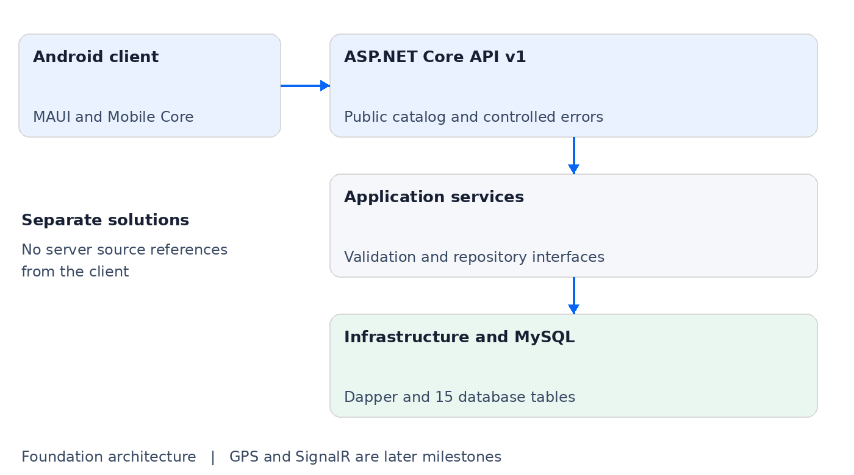

Open and run the project
Extract the source package to a short folder path. Open Server/WhereIsMyBus.Server.sln and Client/WhereIsMyBus.Client.sln in separate Visual Studio windows. The server does not require the Android workload.
- Install .NET 10 and a supported Visual Studio Android development toolchain.
- Copy Server/.env.example to .env and replace the two password placeholders.
- Run docker compose up --build -d from Server. MySQL uses port 3307 and the API uses port 5080.
- Open http://localhost:5080/swagger and check /health/ready.
- Start the Android emulator and build the client in Debug. The development endpoint is http://10.0.2.2:5080/.
- Search TS09AB1234 or choose Hyderabad to Warangal. Seeded buses should display Tracking unavailable.

Public API contract
Path | Purpose
/api/v1/buses/search | Exact registration search
/api/v1/buses/by-route | Search using ordered route stops
/api/v1/locations/search | Populate source and destination choices
/api/v1/routes | Read route catalog
/api/v1/app-info | Report enabled foundation capabilities
/health/live and /health/ready | Check process and database connectivity

Passenger experience
Passengers can choose English, Telugu or Hindi search labels, search by number, or choose different route locations. The page shows loading, validation, offline and empty-result messages. Large buttons, rounded cards and light/dark surfaces provide the initial visual theme. Android layout and accessibility still need device verification.

Database and security
The schema includes identities and roles, buses, drivers, assignments, routes, stops, sessions, GPS history, latest location, favorites, refresh token hashes and audit records. Only catalog seed data is inserted. There are no seeded accounts, passwords or live locations.
Generated active-session keys prevent simultaneous active sessions for the same bus or driver. Compound foreign keys associate a GPS update with its session bus. Update IDs support future idempotent writes. These database constraints do not replace the authentication and tracking logic still to be implemented.
Current endpoints are public catalog reads. SQL uses parameters, input and response sizes are bounded, and failures return controlled errors. Driver authentication, secure local token storage, GPS consent, foreground collection and protected administrative writes remain later work.

Automated test evidence
Suite | Passed | Failed
Server unit tests | 29 | 0
Server HTTP tests with mocked repository | 7 | 0
Server architecture tests | 3 | 0
Mobile core unit tests | 11 | 0
Total | 50 | 0
Tests ran on Linux using .NET SDK 10.0.401. HTTP tests exercise the real request pipeline with a mocked repository. They do not prove MySQL query execution. Unit tests require no device or real network service. The source package includes TRX results and coverage evidence.

Verification still required
The Android build failed because the SDK was absent and Java lacked required development tools. Automatic dependency installation failed certificate validation while downloading the SDK manifest. No APK or emulator test is claimed. Docker and MySQL were unavailable, so database initialization and Compose startup remain unverified.

Next implementation stages
After foundation verification, implement driver authentication and authorized master-data writes, then complete passenger navigation, foreground GPS sessions, transactional location ingestion, SignalR and Google Maps. Complete localization and accessibility, run the full database and Android test matrix, and provide owner-signed release packages with a production HTTPS deployment.

