Understanding YouTube Success
Analyzing Channel Growth, Engagement, and Global Trends

Group 7
Hinkalben Dobariya
Shubham Shivekar
Tanya Sharma
Uday Kumar Eepu
Montclair State University
Data Visualization
Dr. Eyyub Kibis
March 9, 2025

Table of Contents
1. Abstract 3
2. Introduction 3
3. Dataset Overview & Preparation 4
3.1. Overview 4
3.2. Data Exploration & Transformations 4
3.2.1. Handling Missing Values 5
3.2.2. Feature Engineering 5
4. Analysis & Methods 5
4.1. Correlation Analysis 6
4.2. Differentiating Top & Bottom Performing YouTube Channels 6
4.3. Engagement Trends Across Content Categories 8
4.4. Exploring Country-Level Factors That Influence YouTube Growth 9
5. Results & Insights 10
5.1. Understanding YouTube's Top Performers 10
5.2. Which YouTube Categories Drive the Most Views and Subscribers? 10
5.3. Which Countries Dominate YouTube Earnings & Content Creation? 11
5.4. Deep Dive into YouTube's 'Shows' Category 12
6. Limitations of Study & Future Considerations 13
7. Conclusion 13
8. Interactive Dashboard 14

Abstract
This study explores key factors contributing to YouTube channel success by analyzing top-ranking channels based on subscribers, video views, and earnings. Using Python for data cleaning and statistical analysis and Tableau for visualization, we identify trends in engagement across content categories, the impact of country-level factors on channel growth, and correlations between key metrics such as video uploads, earnings, and subscriber count. The findings suggest that while subscriber count is strongly linked to viewership, content upload frequency does not necessarily drive success. Additionally, external economic indicators such as education and unemployment show no measurable relationship with YouTube performance, as per the dataset analyzed in this study.
The dataset used for this analysis was sourced from Kaggle’s Global YouTube Statistics 2023 and is a static dataset, meaning it represents a snapshot of data rather than real-time or continuously updated information. The dataset was compiled from multiple reliable sources to ensure accuracy and comprehensiveness.
Disclaimer: This study is conducted solely for academic purposes and does not represent real-time trends, financial advice, or business consulting insights. The findings are based on available data and should not be generalized beyond the scope of this research.

Introduction
YouTube has become an essential platform for content creators, businesses, and marketers. However, the factors driving channel success remain unclear. This project aims to identify what differentiates high-performing YouTube channels from lower-ranked ones and how engagement varies across different content categories and global economic indicators.

Our SMART goals include:
- Identifying core success drivers of top YouTube channels.
- Analyzing engagement patterns across content categories.
- Exploring the influence of country-level economic factors on YouTube channel growth.
- Evaluating correlations between subscribers, views, and estimated earnings.

Dataset Overview & Preparation

Overview
The dataset used in this study was sourced from Kaggle’s Global YouTube Statistics 2023. The data was compiled from multiple reputable sources to ensure accuracy and completeness. However, since the dataset is static, it provides a snapshot of YouTube channel performance rather than real-time or continuously updated metrics.
The dataset originally contained 28 variables, covering a wide range of channel metrics, content details, and geographic information. However, for this study, we focused only on the most relevant variables that align with our research objectives while excluding those that did not contribute to meaningful insights.
From the original 28 variables, the following were selected as they directly supported our analysis:
Category | Metrics
Channel Performance Metrics | Subscribers – Total number of subscribers.
 | Video Views – Total views across all videos.
 | Uploads – Number of videos uploaded.
 | Highest Yearly Earnings – Estimated highest earnings in a year.
Content Category Information | Category – Type of content (e.g., Entertainment, Education, Music).
Geographic & Economic Data | Country – Country where the channel is registered.
 | Gross Tertiary Education Enrollment (%) – Percentage of individuals in higher education.
 | Population – Total population of the country.
 | Unemployment Rate (%) – National unemployment percentage.
 | Urban Population (%) – Percentage of population in urban areas.

Data Exploration & Transformations
Before proceeding with analysis, data cleaning and transformations were performed using Python (Link to the Google Collab File) to ensure data consistency and accuracy.
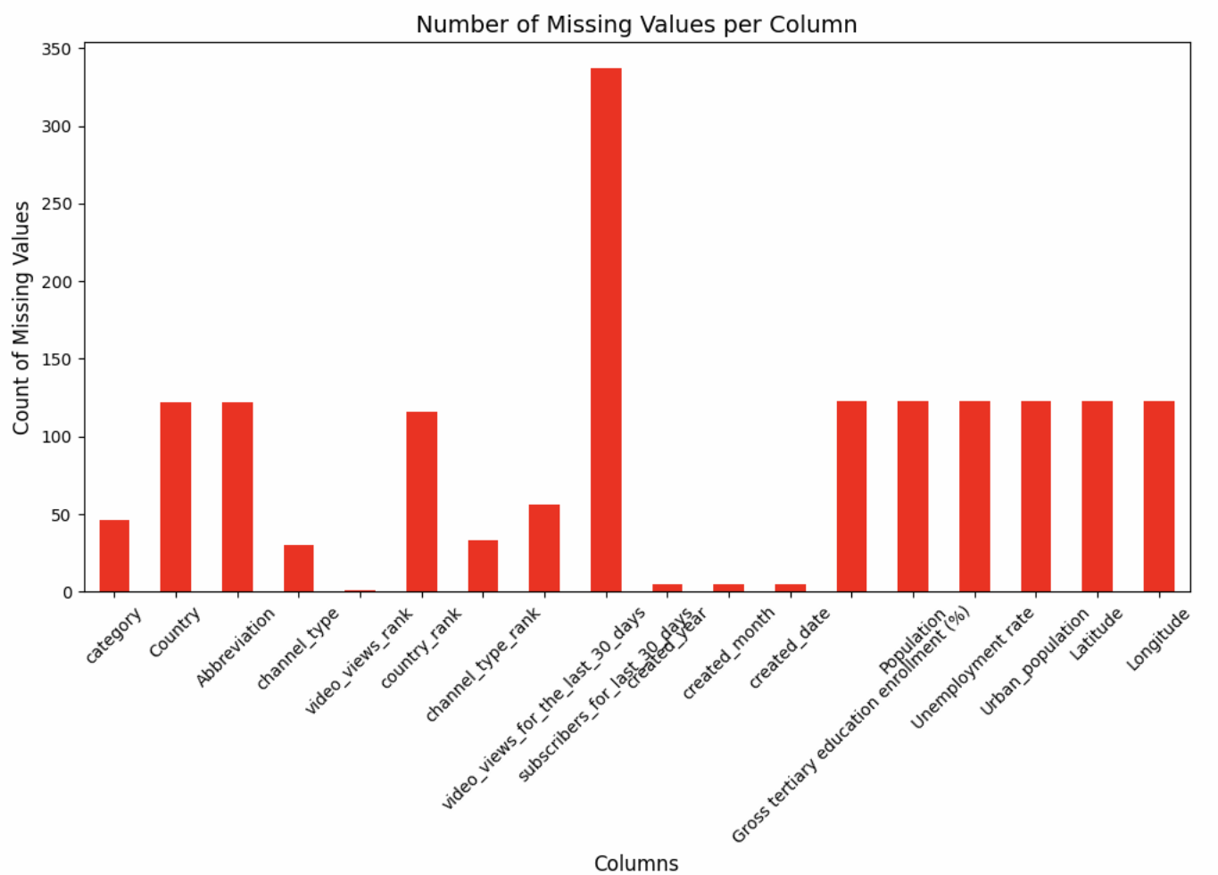

Handling Missing Values
To maintain data integrity, rows with missing values in critical variables such as Category, Country, Gross Tertiary Education Enrollment (%), Population, Unemployment Rate, Urban Population, Latitude, and Longitude were removed. For non-critical variables, missing values were replaced with “Data Not Available” to ensure transparency while retaining valuable data.

Feature Engineering
To enhance the analysis and derive better insights, new variables were created:
- Performance Score – A composite score based on subscriber count, video views, and earnings.
- Performance Category – Categorization of channels into Top Performers and Bottom Performers based on Performance score.
- Population_Scaled – Standardized version of population data for comparison across different countries.
- Urban_Population_Scaled – Adjusted urban population metric to facilitate geographic trend analysis.
Final Cleaned Dataset
After preprocessing, the dataset was refined to 830 rows and 28 columns, ensuring only complete and relevant data was included in the study.

Analysis & Methods
To understand what factors, contribute to YouTube channel success, we employed a combination of statistical analysis and data visualization techniques. This section outlines the step-by-step approach taken to explore trends, identify correlations, and validate hypotheses using Python for data analysis and Tableau for visualization.
The analysis was structured to answer the research objectives, ensuring that each step aligned with the project’s goals. Specifically, we conducted:
- Correlation Analysis: To determine relationships between key metrics such as subscribers, views, uploads, and earnings.
- Statistical Hypothesis Testing: Using t-tests and ANOVA to compare differences between groups (e.g., top vs. bottom performers, category engagement levels).
- Multiple Linear Regression Analysis: To examine how country-level factors impact YouTube performance, we built two regression models:
  - Model 1: Predicting Subscribers per Country based on Population, Urban Population Percentage, and Education Enrollment Rate.
  - Model 2: Predicting Video Views per Country using the same independent variables.
- Feature Engineering: Creating new variables such as Performance Score and Performance Category to refine comparative analysis.
- Visualization & Interpretation: Building interactive Tableau dashboards to present insights in a compelling, data-driven manner.
Each of these steps is detailed in the following subsections, aligned with the study’s four main objectives.

Correlation Analysis
Before performing advanced statistical analysis, we examined the correlation between key YouTube success factors to understand the relationships between various metrics. The correlation heatmap below highlights the strength of associations among subscribers, views, earnings, uploads, and country-level economic indicators.
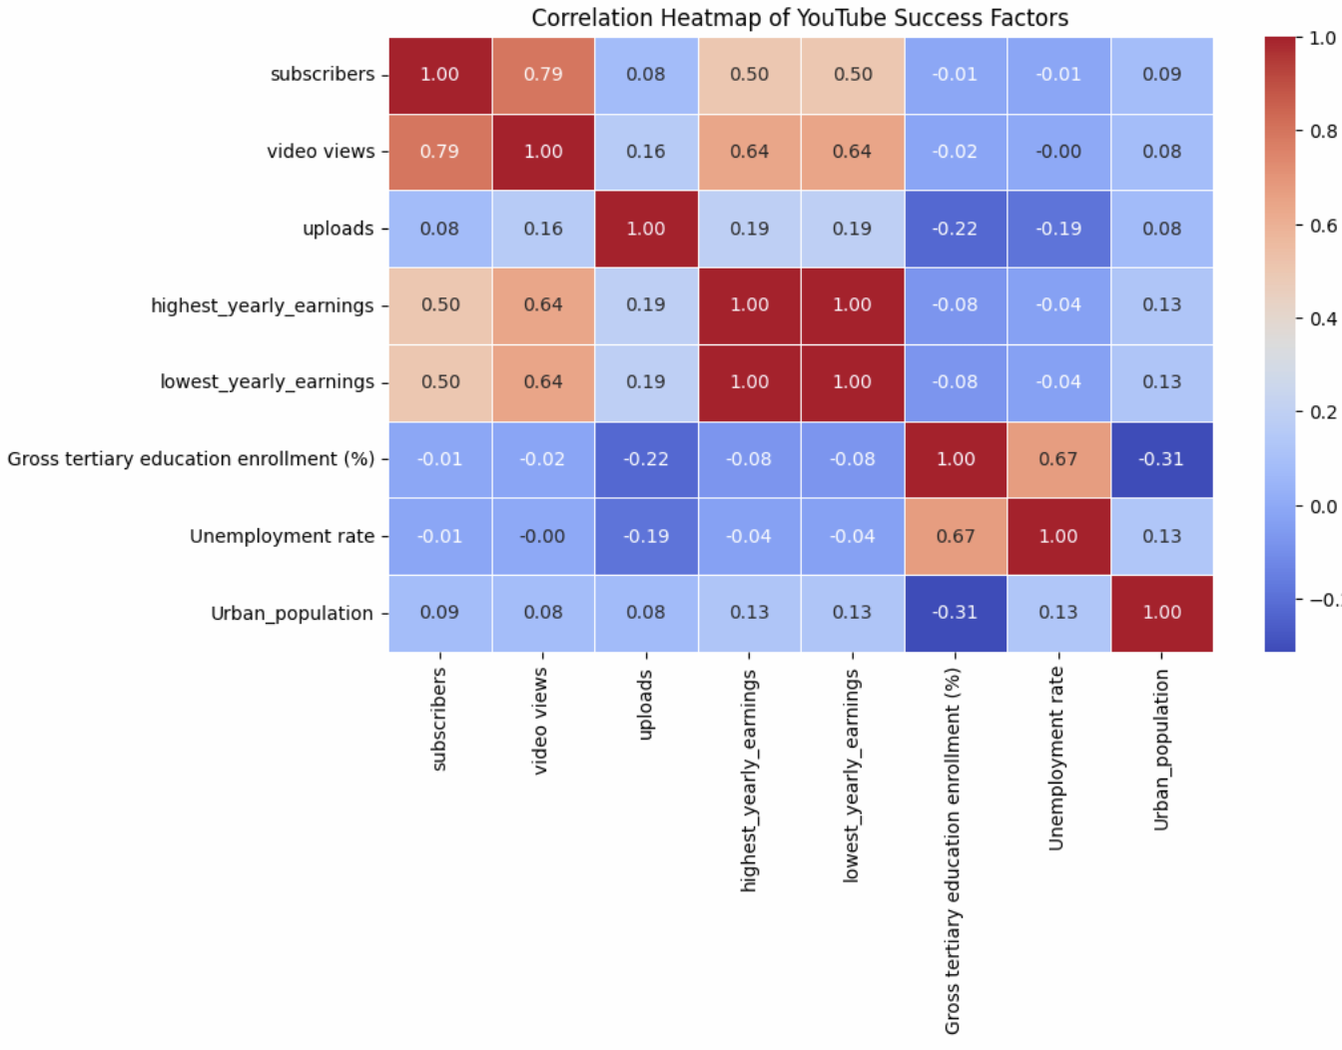
Key Observations from the Correlation Matrix:
- Subscribers & Video Views: Strong correlation (0.79) confirms that a higher subscriber count is directly linked to increased video views.
- Views & Earnings: Moderate-to-strong correlation (0.64) suggests that while higher views contribute to earnings, additional factors likely influence monetization.
- Uploads & Subscribers: Weak correlation (0.08) indicates that posting more videos does not necessarily lead to subscriber growth.
- Country-Level Factors: Education, unemployment, and urban population percentages show no meaningful correlation with YouTube performance, reinforcing the finding that economic conditions do not dictate success.
This correlation analysis helped determine which variables were worth further exploration in the study, guiding the choice of statistical tests and regression models in later sections.

Differentiating Top & Bottom Performing YouTube Channels
To distinguish between high-performing and low-performing YouTube channels, we employed statistical analysis and classification techniques to assess key performance metrics.
Methodology:
- Performance Scoring: A weighted Performance Score was calculated using subscribers (50%), video views (30%), and highest yearly earnings (20%) to create a comparative ranking.
- Categorization: Channels were segmented into Top Performers (Top 25%), Middle Performers, and Bottom Performers (Bottom 25%) based on their Performance Score.
- Comparative Analysis: Mean and median values for subscribers, video views, and earnings were computed for Top vs. Bottom Performers to identify key differentiators.
- T-Test for Statistical Validation: An independent t-test was conducted to determine whether the differences in subscribers, views, and earnings between the two groups were statistically significant.
To further analyze the distinctions between these groups, we compared subscribers, video views, and highest yearly earnings across categories.
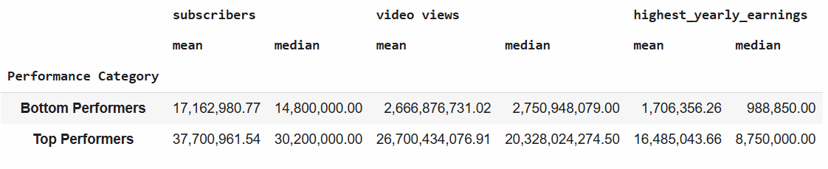
Key Observations:
- Subscribers:
  - Top Performers have an average of 37.7M subscribers, more than double that of Bottom Performers (17.1M).
  - The median subscriber count also reflects this gap, with 30.2M vs. 14.8M, indicating a consistent difference across the dataset.
- Video Views:
  - Top Performers generate an average of 26.7B views, nearly ten times higher than Bottom Performers (2.67B views). The median value (20.3B vs. 2.75B) suggests that even within these groups, top channels consistently outperform their lower-ranked counterparts.
- Yearly Earnings:
  - Top Performers earn an average of $16.49M per year, whereas Bottom Performers make only $1.70M on average.
  - The median earnings gap is even more pronounced ($8.75M vs. $988K), emphasizing that top channels not only attract more views but also significantly out-earn their counterparts.
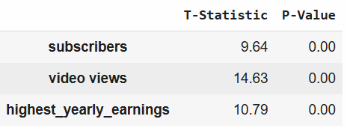
Findings & Statistical Significance
The results confirmed that Top Performers consistently have significantly higher engagement metrics compared to Bottom Performers.
- The T-Test showed p-values < 0.05, confirming that the observed differences in subscribers, video views, and earnings were statistically significant and not due to random chance.
- These findings align with our correlation analysis, reinforcing that engagement levels (views and subscribers) are key drivers of revenue potential.
This objective's findings are further visualized and detailed in the "Results & Insights" section, supported by Tableau dashboards.

Engagement Trends Across Content Categories
To analyze engagement trends across different YouTube content categories, we examined whether certain categories attract significantly more subscribers and video views than others. This helps identify which content types perform best on YouTube in terms of audience engagement.
Methodology:
- Summary Statistics (Mean & Median):
  - Calculated the average and median values for subscribers and video views across each category to identify the most engaging content types.
- ANOVA Test:
  - Performed a one-way ANOVA test to determine if the differences in engagement levels between content categories were statistically significant.
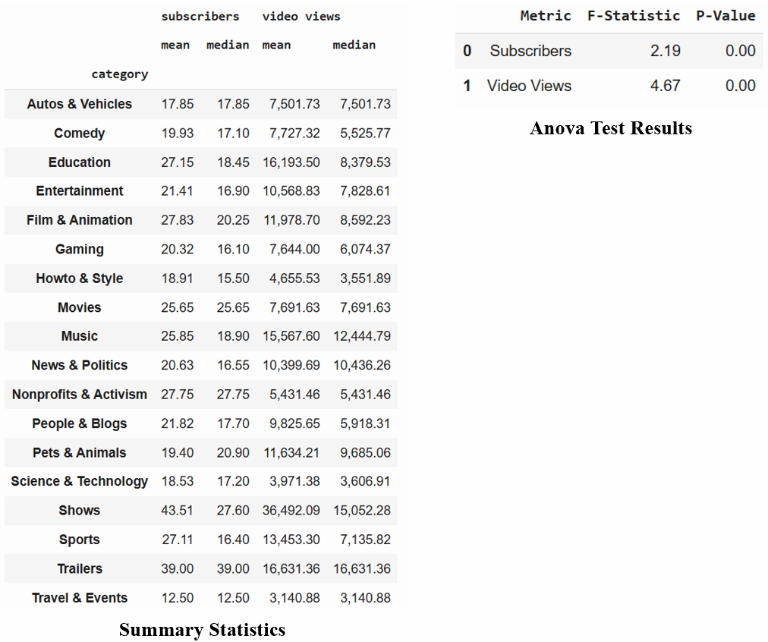
Findings:
- Top Performing Categories:
  - Entertainment ($1.67B), Music ($1.29B), and People & Blogs ($727M) had the highest engagement and revenue.
  - These categories attract higher subscriber growth and video views, making them the most dominant on YouTube.
- Underperforming Categories:
  - Travel & Events, Science & Technology, and Nonprofits & Activism had the lowest engagement levels and revenue.
  - These categories have niche audiences, limiting their monetization potential.
Statistical Significance:
- The ANOVA test yielded p-values < 0.05, confirming that differences in engagement levels across content categories are statistically significant.
- The F-statistic values (Subscribers: 2.19, Video Views: 4.67) indicate that engagement varies significantly across different content types.
Further visualization of these insights is presented in the "Results & Insights" section with category-wise engagement comparisons in Tableau dashboards.

Exploring Country-Level Factors That Influence YouTube Growth
To assess whether country-level socio-economic indicators impact YouTube engagement, we analyzed factors like education levels, unemployment rates, population size, and urbanization rates to see if they influence subscribers per country and video views per country.
Methodology:
- Data Scaling: Applied Z-score transformation to normalize large numerical values like Population and Urban Population to ensure uniformity in analysis.
- Multiple Linear Regression Models:
  - Model 1: Predicted Subscribers per Country using education enrollment, unemployment rate, population, and urbanization.
  - Model 2: Predicted Video Views per Country using the same independent variables.
- Regression Analysis:
  - Examined the R-squared (R²) values to measure how well country-level factors explain YouTube engagement.
  - P-values were analyzed to determine if the relationships between independent and dependent variables were statistically significant.
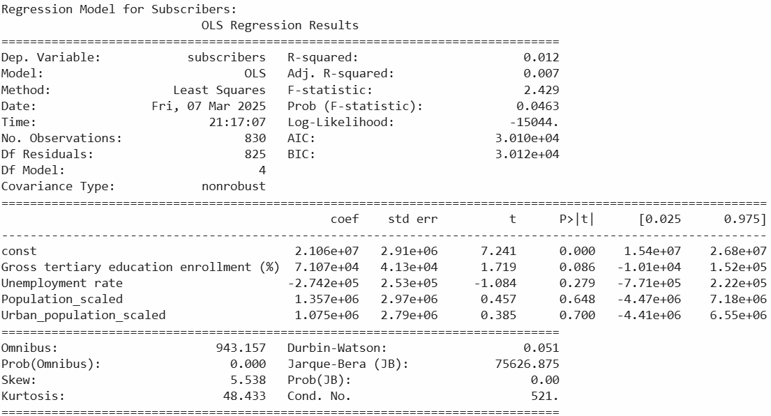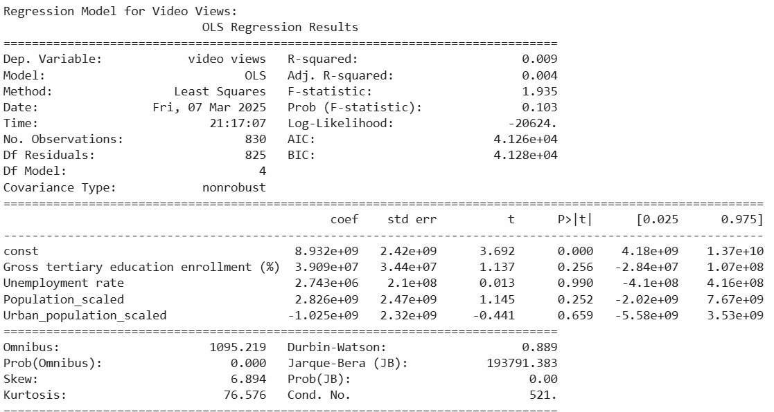
Findings:
- The R² values were extremely low (1.2% for subscribers and 0.9% for video views), indicating weak relationships between country-level indicators and YouTube success.
- None of the factors (Education, Unemployment, Population, Urbanization) showed statistical significance, meaning that YouTube growth is not driven by country-specific macroeconomic conditions.
- Key Takeaway: Content strategy, creator engagement, and platform algorithms play a much larger role than country-level factors in determining YouTube success.
Geographical Visualization: Since regression results showed weak relationships, we created a visual representation of YouTube earnings and count of youtubers/ channels distribution by country to provide context on which regions dominate YouTube revenue and content creation.

Results & Insights
This section presents key findings through visual charts, data-driven observations, and practical implications for content creators, marketers, and businesses leveraging YouTube for growth.

Understanding YouTube's Top Performers
The success of YouTube’s top-performing channels is driven by a combination of high subscriber count, massive video views, and strong revenue generation. Channels like T-Series, Cocomelon, and SET India dominate the platform, amassing over 100M subscribers and billions of views, leading to multi-million-dollar annual earnings.
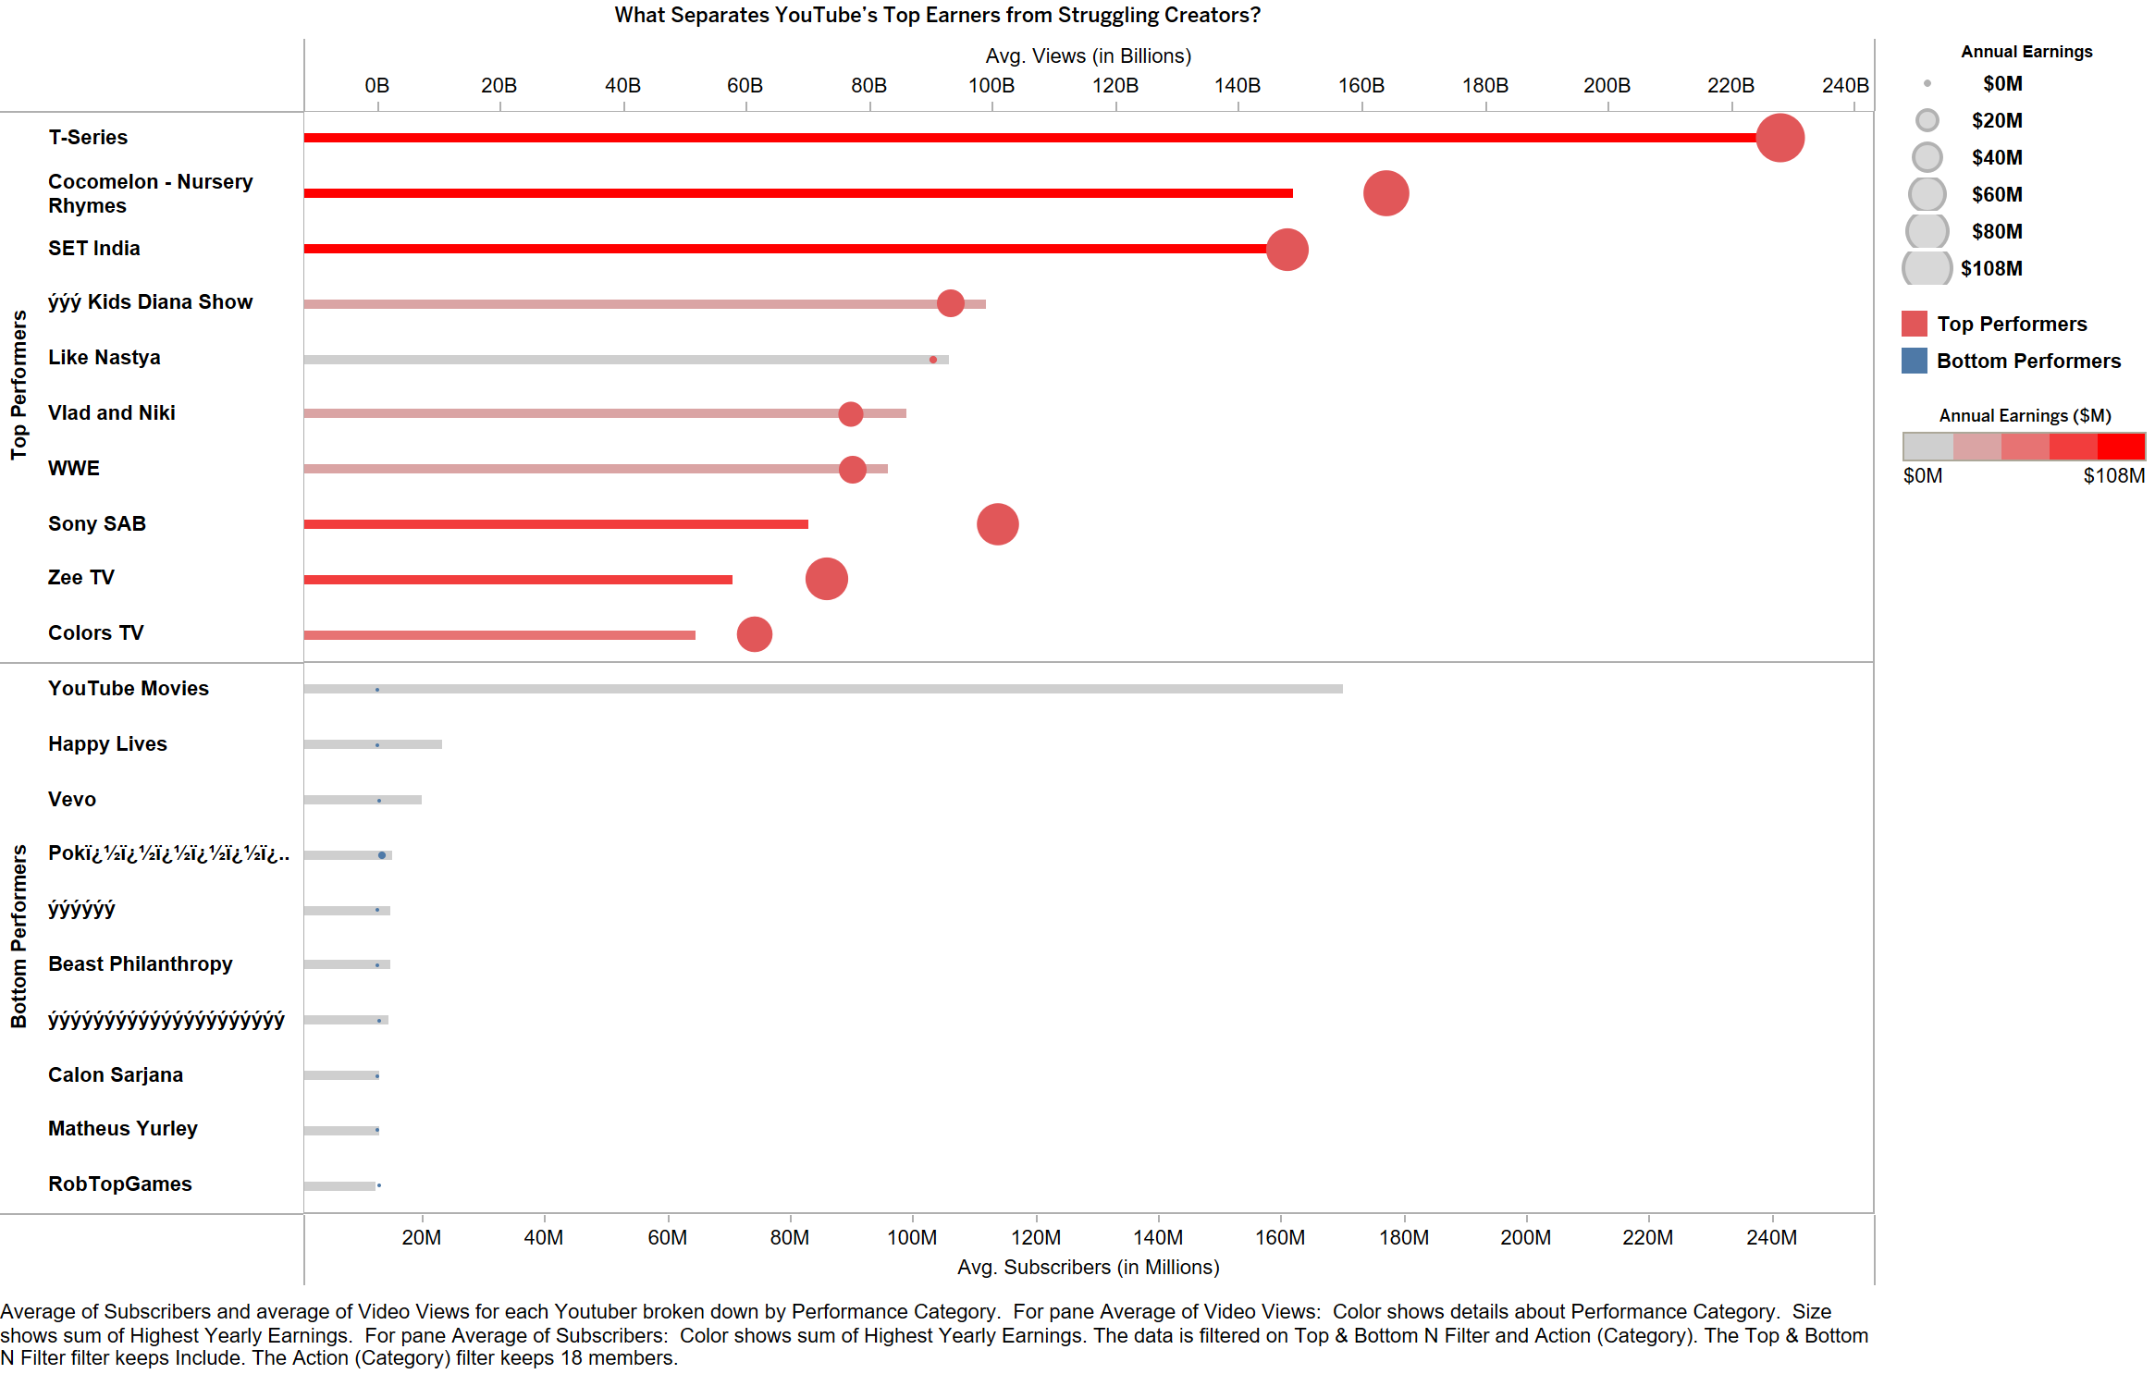
Key Takeaways:
- Not just subscribers but views are also the key driver of earnings. High engagement leads to higher monetization.
- Content type and audience reach matter. Channels targeting a global audience (music, entertainment, kids' content) tend to outperform others.
- Bottom-performing channels struggle to monetize. Even with decent subscriber bases, lack of engagement or niche content can limit revenue.

Which YouTube Categories Drive the Most Views and Subscribers?
Content type significantly influences engagement and revenue on YouTube. Our analysis highlights Entertainment, Music, and People & Blogs as the most lucrative categories, generating the highest earnings and engagement levels.
- Entertainment ($1.67B) and Music ($1.29B) dominate earnings despite having moderate subscriber counts.
- Shows and Education categories lead in subscriber growth and video views, suggesting strong audience retention.
- Underperforming categories like Science & Technology, Travel & Events, and Nonprofits struggle with engagement and earnings, signaling limited monetization opportunities.
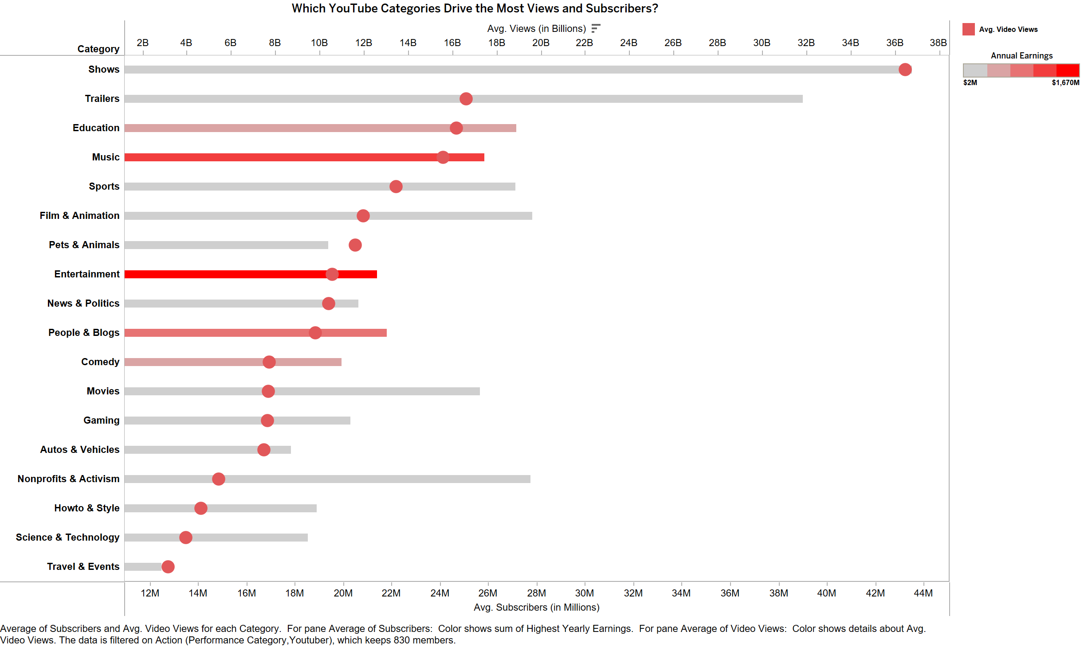
Actionable Insights:
- Creators should prioritize content in high-engagement categories like Entertainment and Music for better monetization opportunities.
- Emerging niches (Education, Shows) show potential for long-term growth, making them attractive for new creators.
- Low-performing categories need strategic pivots, such as leveraging collaborations or optimizing video formats for engagement.

Which Countries Dominate YouTube Earnings & Content Creation?
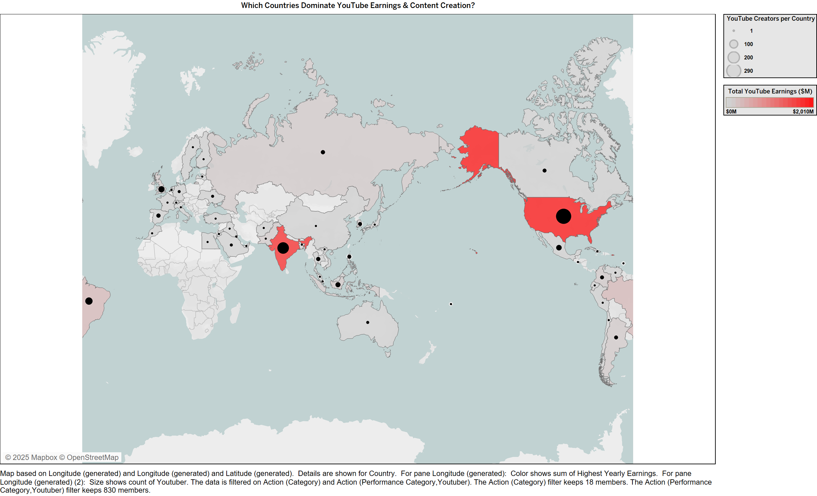
Key Findings:
- United States ($2.01B) and India ($1.77B) are the largest contributors to YouTube’s economy, both in terms of total earnings and number of creators. Brazil ($348M) and the United Kingdom ($176M) follow, but with significantly lower earnings than the top two nations.
- Emerging Markets: Countries like Pakistan, South Korea, and Argentina have relatively fewer creators but still generate millions in earnings.
- Minimal Presence: Some regions, such as Peru, Venezuela, and Bangladesh, show negligible or zero reported earnings, despite having active YouTube creators.
Insights & Implications:
- The dominance of the U.S. and India suggests that audience size and advertiser investment play critical roles in revenue generation. Whereas, Latin America and parts of Asia present growth opportunities, with potential for increased monetization as digital economies expand.
- Content creators targeting global audiences should consider platform trends in these high-earning regions to maximize visibility and revenue potential.

Deep Dive into YouTube's 'Shows' Category
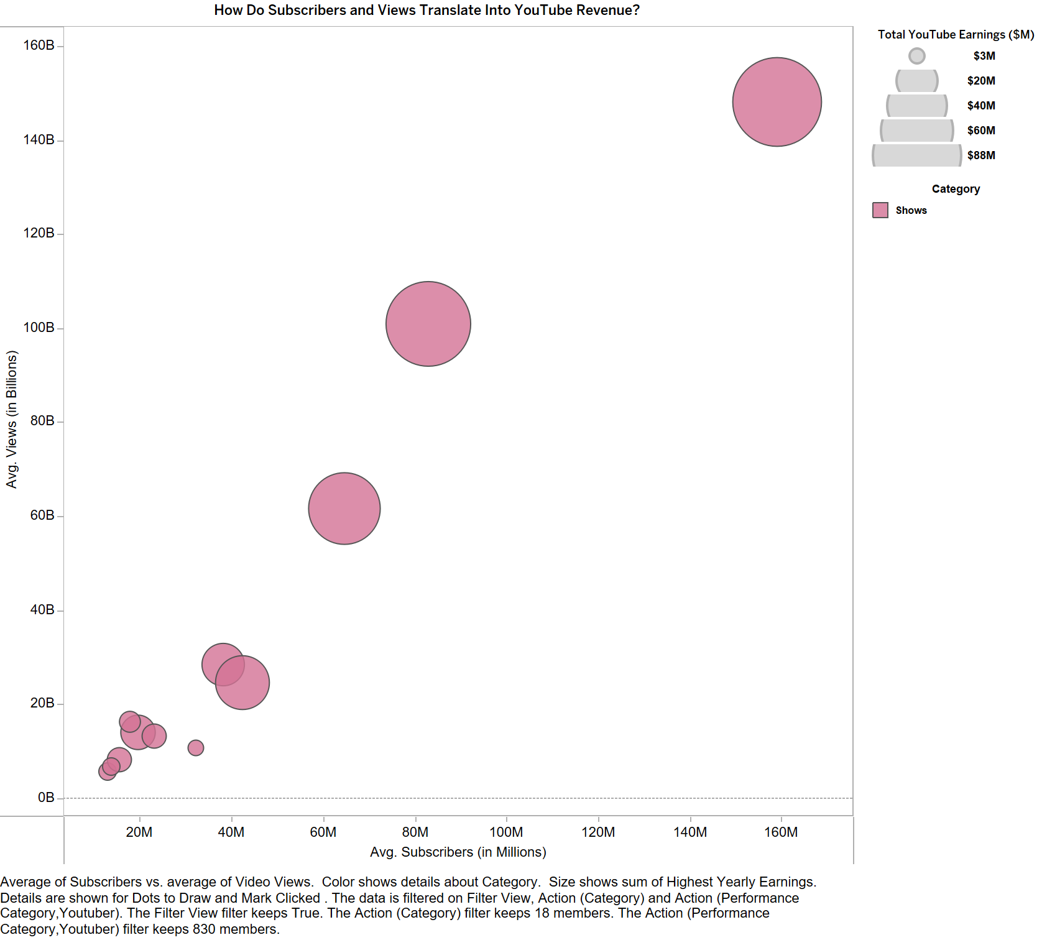
The Shows category exhibits a compelling balance between high subscriber counts, significant viewership, and strong revenue generation. Leading channels such as SET India (159M subscribers, 148B views, $88M earnings) and Sony SAB (83M subscribers, 101B views, $80M earnings) exemplify how television-based content has successfully transitioned into YouTube dominance.
- Strong Engagement & Revenue:
  - High Viewership: Shows have an average of 36B views, one of the highest among all categories.
  - Consistent Earnings: This category yields substantial revenue, with multiple channels exceeding $50M annually.
  - Global Audience Appeal: Channels like Masha and the Bear (25B views, $32M earnings) showcase the ability of kids’ and family content to reach billions worldwide.
- What Drives This Success?
  - Repurposing TV Content: Many of these channels leverage existing TV content, maximizing audience reach with minimal new production costs.
  - Evergreen, High-Retention Content: Family-friendly and episodic content ensures sustained engagement and long-term viewership.
Note: This analysis focuses on the Shows category. However, other categories can be explored using the interactive Tableau dashboard link provided in the following section.

Limitations of Study & Future Considerations
This study provides valuable insights into YouTube success factors, but certain limitations should be noted:
- Static Dataset – The dataset represents a single point in time (2023) and does not track long-term trends. Future research can use historical data to analyze growth patterns.
- Estimated Earnings – Revenue estimates may not account for sponsorships, memberships, or alternate income streams. More accurate financial data could enhance insights.
- Limited Engagement Metrics – Watch time, audience retention, and engagement rates were not included. Incorporating these factors can provide a fuller success model.
- Regional Monetization Differences – Ad revenue varies by country, impacting earnings. Future studies should explore CPM rates across regions.
- Influencer & Virality Factors – External factors like collaborations and social media influence were not considered. Adding these could improve predictive accuracy.

Conclusion
This analysis highlights key drivers of YouTube success:
- Top channels thrive on engagement, not just upload frequency.
- Entertainment & Music dominate earnings, while some categories underperform.
- The U.S. and India lead in YouTube content and revenue.
- Subscribers and views impact revenue, but deeper engagement metrics are needed for a complete picture.
These insights offer practical takeaways for creators and businesses, helping optimize content strategy for growth.

Interactive Dashboard
For a detailed exploration, visit the Tableau Public Dashboard to filter insights by category, geography, and earnings.
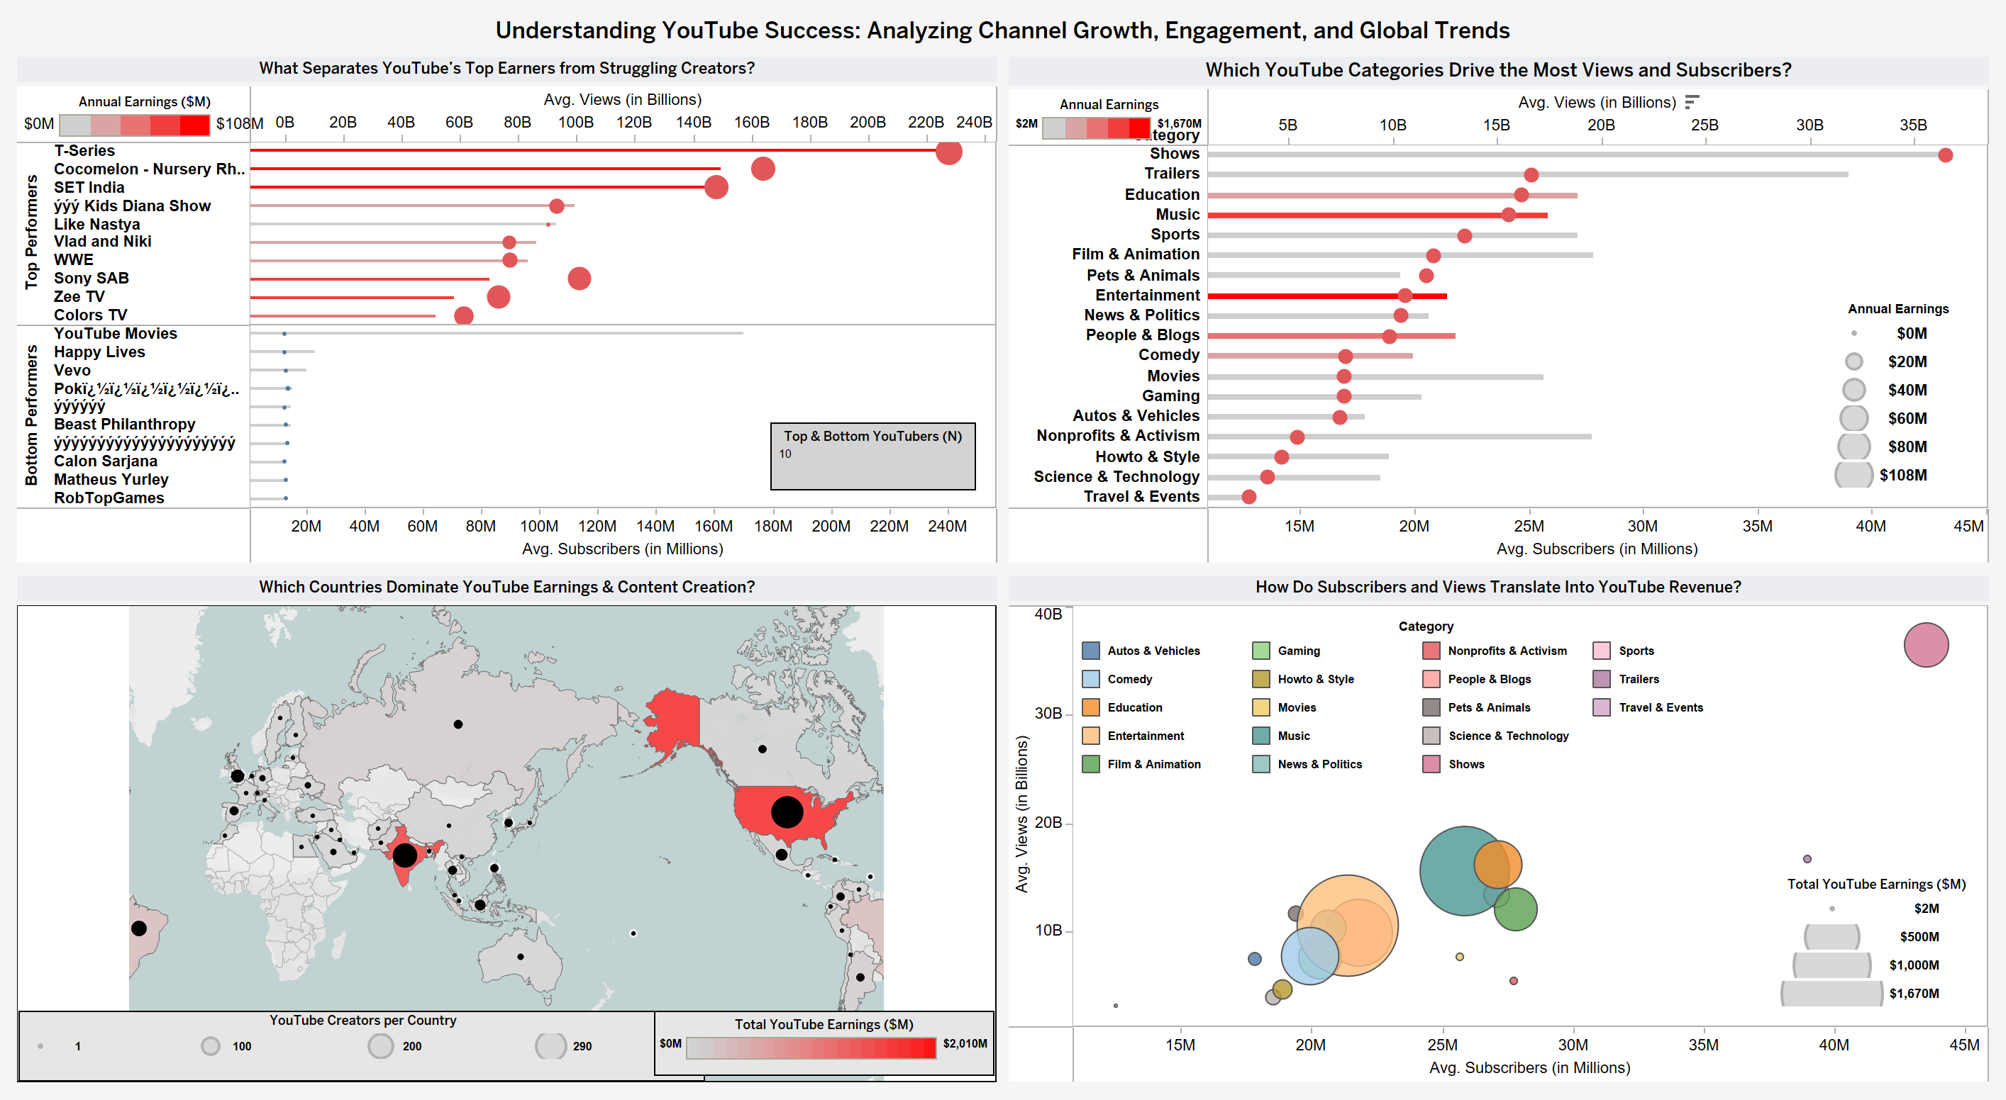
https://public.tableau.com/views/UnderstandingYouTubeSuccess_AnalyzingChannelGrowthEngagementandGlobalTrends/Dashboard?:language=en-US&:sid=&:redirect=auth&:display_count=n&:origin=viz_share_link

