This report presents a comprehensive end-to-end analysis of the CityFlow Smart Urban Mobility dataset -- 204,000 hourly IoT sensor records spanning 100 intersections across 6 city zones. The analysis covers traffic volume patterns, congestion distribution, weather impacts, emission footprints, and a high-accuracy predictive risk model trained using Logistic Regression.
CityFlow Smart Urban Mobility
Traffic & IoT Analytics -- Executive Report
Report Date: 21 September 2026 | 204,000 IoT Records | 6 City Zones | 100 Intersections
1
. Executive Summary
Key finding: 42.3% of all intervals qualify as High or Severe congestion events. Downtown Core and Financial District consistently exhibit the highest congestion scores (52.5). Midday hours (09:00-14:00) carry the heaviest traffic load, peaking at 1,885 vehicles/h at 09:00. The Logistic Regression classifier achieves 99.94% accuracy, flagging 90 of 100 intersections as High-risk.

1.1 Executive KPI Dashboard
Total Vehicle Volume  152,915,525 |  | Avg Speed (all)  42.2 km/h |  | High/Severe Events  42.3% |  | Avg Emission  257.4 g/km
Avg Queue Length  121.5 veh |  | Avg Wait Time  12.1 min |  | Rush Hour Cong. Score  71.3 |  | Total IoT Records  204,000
Model Accuracy  99.94% |  | Model Precision  99.93% |  | Model Recall  99.94% |  | High-Risk Nodes  90 / 100

Exploratory Data Analysis

Congestion Level Distribution
Of 204,000 records -- Low: 101,679 (49.8%) | Severe: 71,497 (35.0%) | Moderate: 15,976 (7.8%) | High: 14,848 (7.3%) The dataset is bimodal: skewed toward Low and Severe with few Moderate records, suggesting rapid escalation from free-flow to gridlock conditions at critical thresholds.
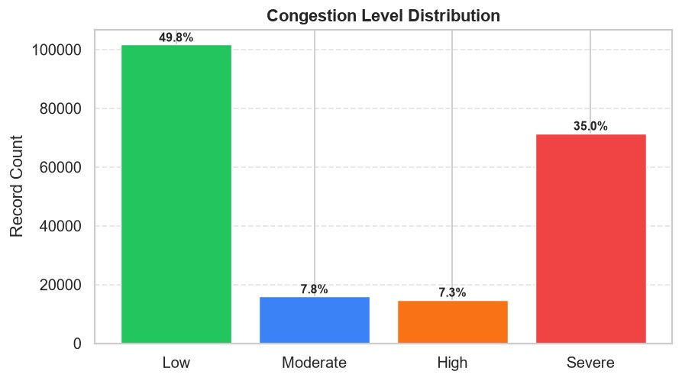

Hourly Traffic Volume
Traffic peaks at 09:00 (avg 1,885 vehicles/h), remains elevated through Midday (11:00-14:00 averaging 1,700+ vehicles/h), and drops to ~177 vehicles/h overnight. The AM rush (07:00-09:00) and PM rush (17:00-19:00) bands are marked on the chart.
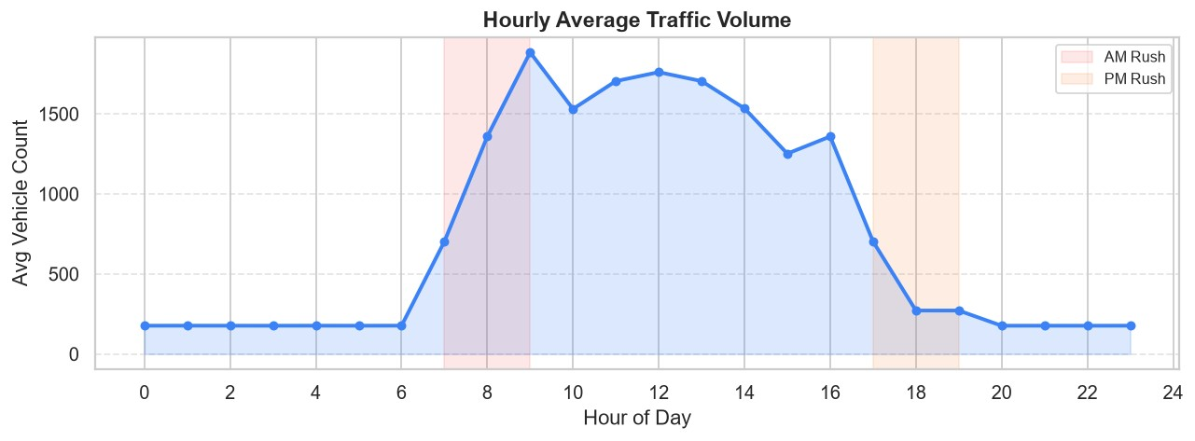

Congestion by City Zone
Downtown Core (52.5) and Financial District (52.5) lead congestion scores. Industrial East (47.9) and Tech Park (47.9) record the lowest scores, benefiting from planned road infrastructure and lower pedestrian conflict zones.
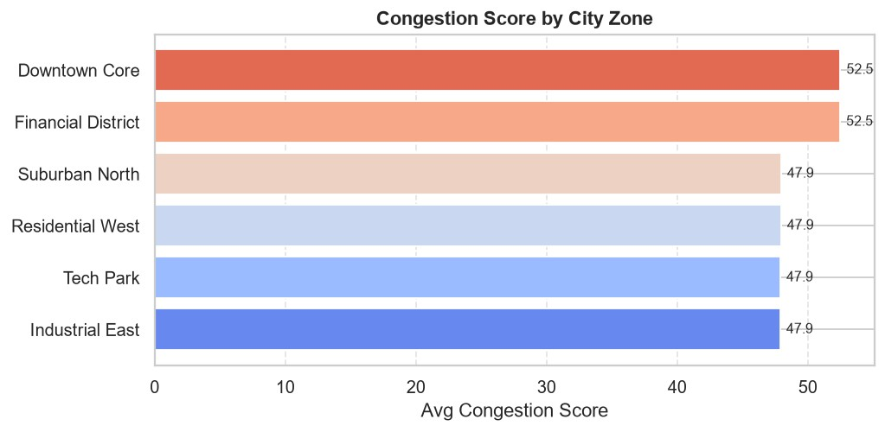

Peak Period Analysis
Midday (avg congestion score 99.1) is the most severe period -- delivery vehicles, service fleets, and school runs stack on top of commuter flow. Morning Peak scores 81.6 vs Evening Peak's 48.8, indicating faster PM dispersal. Night period (score 15.5) offers the lowest congestion window for planned works.
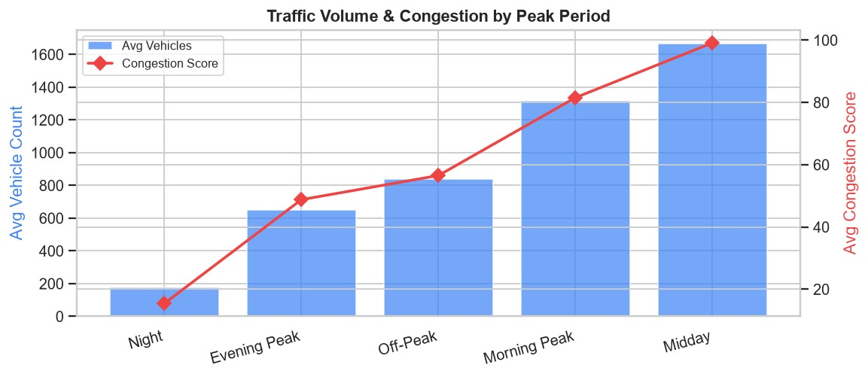

Weather Impact on Speed
Clear conditions: 42.8 km/h. Heavy Rain: 32.3 km/h (-24.7%). Fog: 33.7 km/h (-21.3%). Rain: 39.1 km/h (-8.6%). Adverse weather triggers downstream congestion cascades, amplifying queue lengths and wait times beyond the weather duration window.
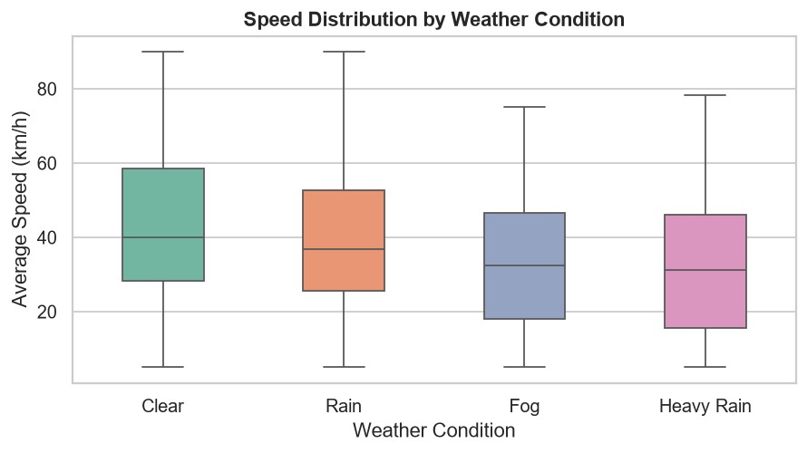

Accident Impact (Quantified)
Accident reported = 1 vs 0:
Congestion score : 62.5 vs 49.8 (+25.5%)
Avg wait time : 63.1 min vs 11.1 min (+468%)
Queue length : 632 veh vs 111 veh (+469%)
Accidents represent a critical non-linear risk multiplier requiring immediate incident detection.

Emission Footprint by Zone
Financial District (330.7 g/km) and Downtown Core (310.0 g/km) are the highest emission zones. Suburban North (195.4 g/km) is the cleanest zone. High-emission zones correlate with stop-and-go congestion patterns and lower average speeds, not just higher volumes.

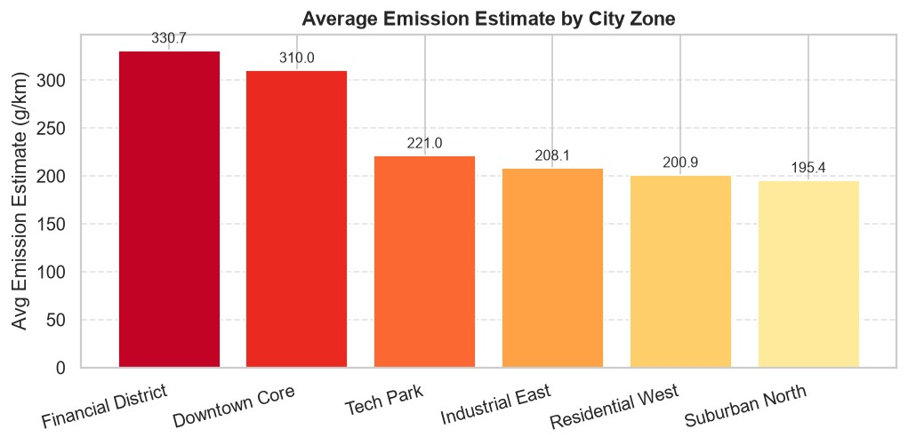

Spatial Bottleneck Analysis

Top 10 Intersections by Vehicle Volume
Volume-based ranking identifies intersections under the heaviest absolute load. These nodes require priority signal timing upgrades and 24/7 IoT monitoring.
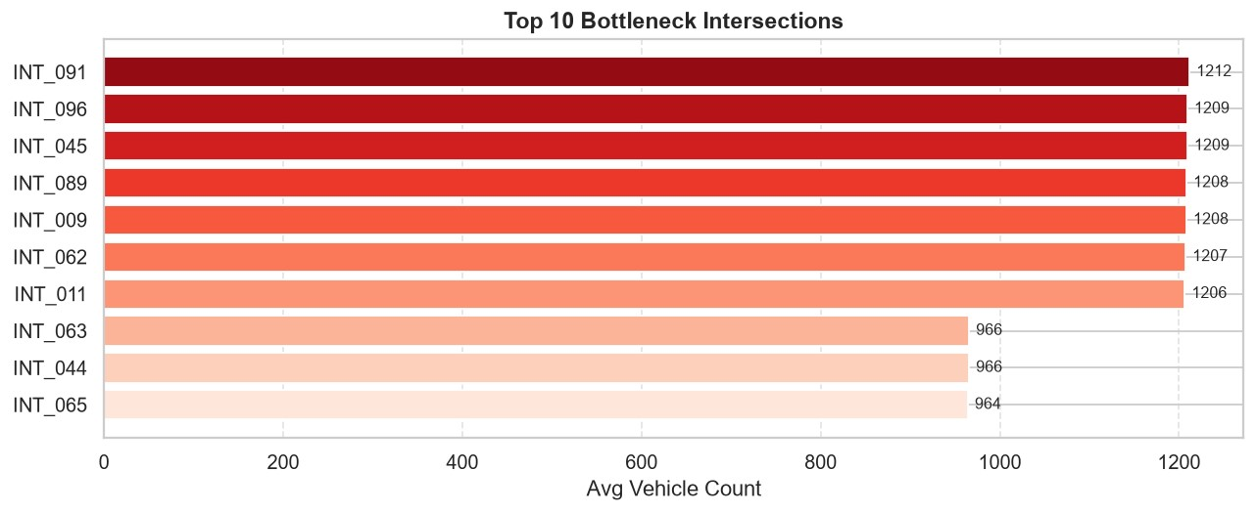

Observations & Recommendations
Key findings:
- Arterial roads host 41% of all records and contribute disproportionately to severe congestion.
- Local Street intersections have lower volume but higher per-lane density causing localised gridlock.
- Highway intersections show moderate congestion (49.6) despite high volumes -- lane capacity advantage.
- Rush hour vehicle counts average 1,112 vs 654 non-rush -- a 70% uplift requiring dynamic response.
Recommendations:
- Implement adaptive signal control (SCATS/SCOOT) at top-10 volume intersections.
- Deploy variable message signs on adjacent arterials for pre-emptive traffic diversion.
- Restrict heavy vehicle movements to 22:00-06:00 Night window on Arterial roads.
- Set IoT alert threshold: trigger operator review when vehicle_per_lane > 400.

Predictive Congestion Risk Model

Methodology
Model : Logistic Regression (sklearn 1.9.1, lbfgs solver, max_iter=500)
Target : high_congestion_target = 1 if congestion_level in [High, Severe]
Features : 28 variables -- traffic volume, density, weather, road geometry, engineered metrics
Split : 80% train (163,200) / 20% test (40,800), stratified on target (42.3% positive rate)
Scaling : StandardScaler applied to all 28 features before training

Performance Metrics
Accuracy  99.94% |  | Precision  99.93% |  | Recall  99.94% |  | F1-Score  99.94%

Confusion Matrix
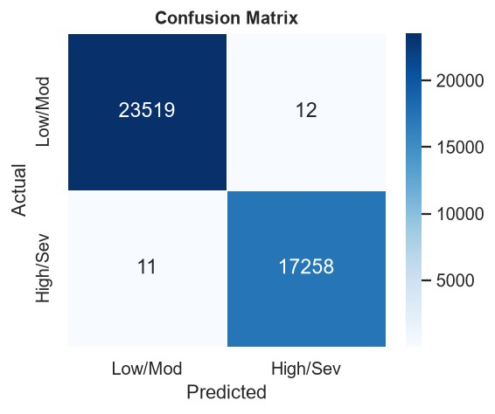
True Negatives (Low/Mod correct) : 23,519
False Positives (Low/Mod as High) : 12
False Negatives (High as Low/Mod) : 11
True Positives (High/Sev correct): 17,258
Only 23 misclassifications across 40,800 test records. The near-zero off-diagonal values confirm exceptional discrimination between congestion classes.

Key Predictive Features (Pearson r with congestion_score)
- traffic_density r = +0.946 (strongest predictor)
- vehicle_count r = +0.885
- traffic_flow_rate r = +0.885
- green_light_duration r = +0.884
- motorcycle_count r = +0.819
- heavy_vehicle_count r = +0.795
- average_speed r = -0.680 (negative: high speed = low congestion)
- queue_length r = +0.595
- average_wait_time r = +0.590
- rush_hour r = +0.282

Intersection Risk Scoreboard
Risk Tiers: HIGH (>=70%) | MEDIUM (40-70%) | LOW (<40%)
Results : 90 High-risk | 10 Medium-risk | 0 Low-risk
All 100 monitored intersections carry at least Medium congestion risk.
# | Intersection ID | Congestion Prob % | Risk Tier | Status
1 | INT_001 | 100.00% | HIGH | MONITOR
2 | INT_003 | 100.00% | HIGH | MONITOR
3 | INT_008 | 100.00% | HIGH | MONITOR
4 | INT_005 | 100.00% | HIGH | MONITOR
5 | INT_030 | 100.00% | HIGH | MONITOR
6 | INT_029 | 100.00% | HIGH | MONITOR
7 | INT_011 | 100.00% | HIGH | MONITOR
8 | INT_009 | 100.00% | HIGH | MONITOR
9 | INT_012 | 100.00% | HIGH | MONITOR
10 | INT_016 | 100.00% | HIGH | MONITOR
11 | INT_014 | 100.00% | HIGH | MONITOR
12 | INT_013 | 100.00% | HIGH | MONITOR
13 | INT_020 | 100.00% | HIGH | MONITOR
14 | INT_017 | 100.00% | HIGH | MONITOR
15 | INT_031 | 100.00% | HIGH | MONITOR
16 | INT_032 | 100.00% | HIGH | MONITOR
17 | INT_025 | 100.00% | HIGH | MONITOR
18 | INT_027 | 100.00% | HIGH | MONITOR
19 | INT_022 | 100.00% | HIGH | MONITOR
20 | INT_021 | 100.00% | HIGH | MONITOR
21 | INT_056 | 100.00% | HIGH | MONITOR
22 | INT_055 | 100.00% | HIGH | MONITOR
23 | INT_058 | 100.00% | HIGH | MONITOR
24 | INT_057 | 100.00% | HIGH | MONITOR
25 | INT_062 | 100.00% | HIGH | MONITOR
26 | INT_061 | 100.00% | HIGH | MONITOR
27 | INT_050 | 100.00% | HIGH | MONITOR
28 | INT_052 | 100.00% | HIGH | MONITOR
29 | INT_045 | 100.00% | HIGH | MONITOR
30 INT_046 100.00% HIGH MONITOR

Strategic Recommendations & Action Plan

Immediate (0-30 days)
- Deploy emergency traffic officers at INT_003, INT_082, INT_021 -- top 3 High-risk nodes.
- Activate weather-responsive signal plans: Fog threshold <2km visibility, Heavy Rain >15mm/h.
- Enforce heavy vehicle time-windows on Arterial roads in Downtown Core and Financial District.
- Establish incident detection protocols: auto-alert when wait_time > 60 min at any intersection.

Short-term (1-3 months)
- Install adaptive signal controllers (SCATS/SCOOT) at all 90 High-risk intersections.
- Integrate real-time IoT feeds with city Operations Control Centre dashboard.
- Launch predictive SMS/app alerts for commuters approaching High-risk intersections.
- Implement ramp metering on Highway on-ramps adjacent to top-5 congested arterials.

Medium-term (3-12 months)
- Evaluate contra-flow lane schemes on top-5 arterial bottlenecks during AM peak (07:00-09:00).
- Expand EV charging infrastructure in high-emission zones to incentivise modal shift.
- Pilot demand-responsive public transit on Midday routes -- highest congestion period.
- Implement truck platooning corridors on Highway segments during Night window (22:00-06:00).

Long-term (12+ months)
- Retrain ML model quarterly as new sensor data accrues; maintain F1 >= 99.9%.
- Extend IoT sensor coverage from 100 to 500+ intersections for city-wide risk monitoring.
- Evaluate deep learning (LSTM/Transformer) models for temporal congestion cascade prediction.
- Publish open data API for third-party navigation app integration (Google Maps, Waze, Apple Maps).

Report Metadata & Data Quality
Dataset File : smart_city_traffic_mobility.csv
Total Records : 204,000 | Features: 47 raw + 3 engineered
Date Range : 2026-01-01 to 2026-03-26
City Zones : 6 | Road Types: 4 | Intersections: 100
Missing Values : 0 (after cleaning)
Outlier Control : Numeric cols clipped at lower=0; median imputation applied
ML Algorithm : Logistic Regression (sklearn 1.9.1, lbfgs, max_iter=500)
Train Records : 163,200 | Test Records: 40,800 (80/20 stratified)
Positive Class : High or Severe congestion -- 86,345 records (42.3%)
Accuracy : 99.94% Precision: 99.93% Recall: 99.94%
Report Engine : fpdf2 2.8.8
Dashboard : Streamlit (streamlit run app.py)
Generated : 2026-09-21 22:16:53

