WOXSEN UNIVERSITY
DBMS Course Project Report
Hostel Accommodation and Student Services Management System
Course: Database Management Systems (DBMS)
Faculty: ____________________
Academic Year: 2026-27
Submitted by
Name | Roll Number
T. Sindhu | 25wu0102316
Uday Soni | 25wu0101148

2. Abstract
The Hostel Accommodation and Student Services Management System is a MySQL-based application that manages hostel buildings, room allocation, fee payments and student service requests such as maintenance, laundry and mess issues. It replaces paper registers with a normalized relational database (up to Third Normal Form) and a simple graphical user interface for inserting, deleting and viewing records. The system reduces duplicate allocation of rooms, makes room occupancy and pending dues easy to track, and gives wardens quick reports through SQL joins and aggregate functions.

3. Introduction and Problem Statement
Hostels usually track allocations, payments and complaints in paper registers or spreadsheets. This leads to double allocation of rooms, lost records, difficulty in finding vacant rooms and delays in resolving student service requests.
Problem statement: To design and implement a database system that stores and manages hostel, room, student, allocation, payment and service request data accurately, and allows users to operate on this data through a user interface connected to MySQL.

4. Objectives and Scope

Objectives
- Design an ER model and a normalized relational schema up to 3NF.
- Ensure a room is not allocated beyond its capacity.
- Track fee payments and pending dues.
- Record and monitor student service requests.
- Provide a UI for insertion, deletion and viewing of records connected to MySQL.

Scope
The system covers the warden, hostel, room, student, allocation, payment and service request modules. Online payment gateways, biometric attendance and mobile applications are outside the scope of this project.

Intended Users
Hostel wardens and the admin office (primary users) and students (view records and raise requests).

5. Software and Hardware Requirements
Software | Hardware
MySQL Server 8.x and MySQL Workbench | Processor: Intel i3 or above
Python 3.x with Tkinter and mysql-connector-python | RAM: 4 GB minimum (8 GB recommended)
VS Code, GitHub, draw.io | Storage: 500 MB free space
Windows 10/11 | Standard laptop or desktop
Edit this table if your project uses a different language or UI tool.

6. ER Diagram

Entities and attributes
- WARDEN (warden_id, name, phone)
- HOSTEL (hostel_id, hostel_name, hostel_type, warden_id)
- ROOM (room_id, hostel_id, room_no, capacity, room_type, status)
- STUDENT (student_id, roll_no, name, gender, phone, email, department, year)
- ALLOCATION (allocation_id, student_id, room_id, allocation_date, vacate_date)
- PAYMENT (payment_id, student_id, amount, payment_date, mode, status)
- SERVICE_REQUEST (request_id, student_id, service_type, description, request_date, status)

Relationships, cardinality and participation
Relationship | Cardinality | Participation
Warden manages Hostel | 1 : N | Hostel total, Warden partial
Hostel contains Room | 1 : N | Room total
Student is allotted Room (via Allocation) | M : N | Allocation total on both sides, Student partial
Student makes Payment | 1 : N | Payment total
Student raises Service Request | 1 : N | Service Request total

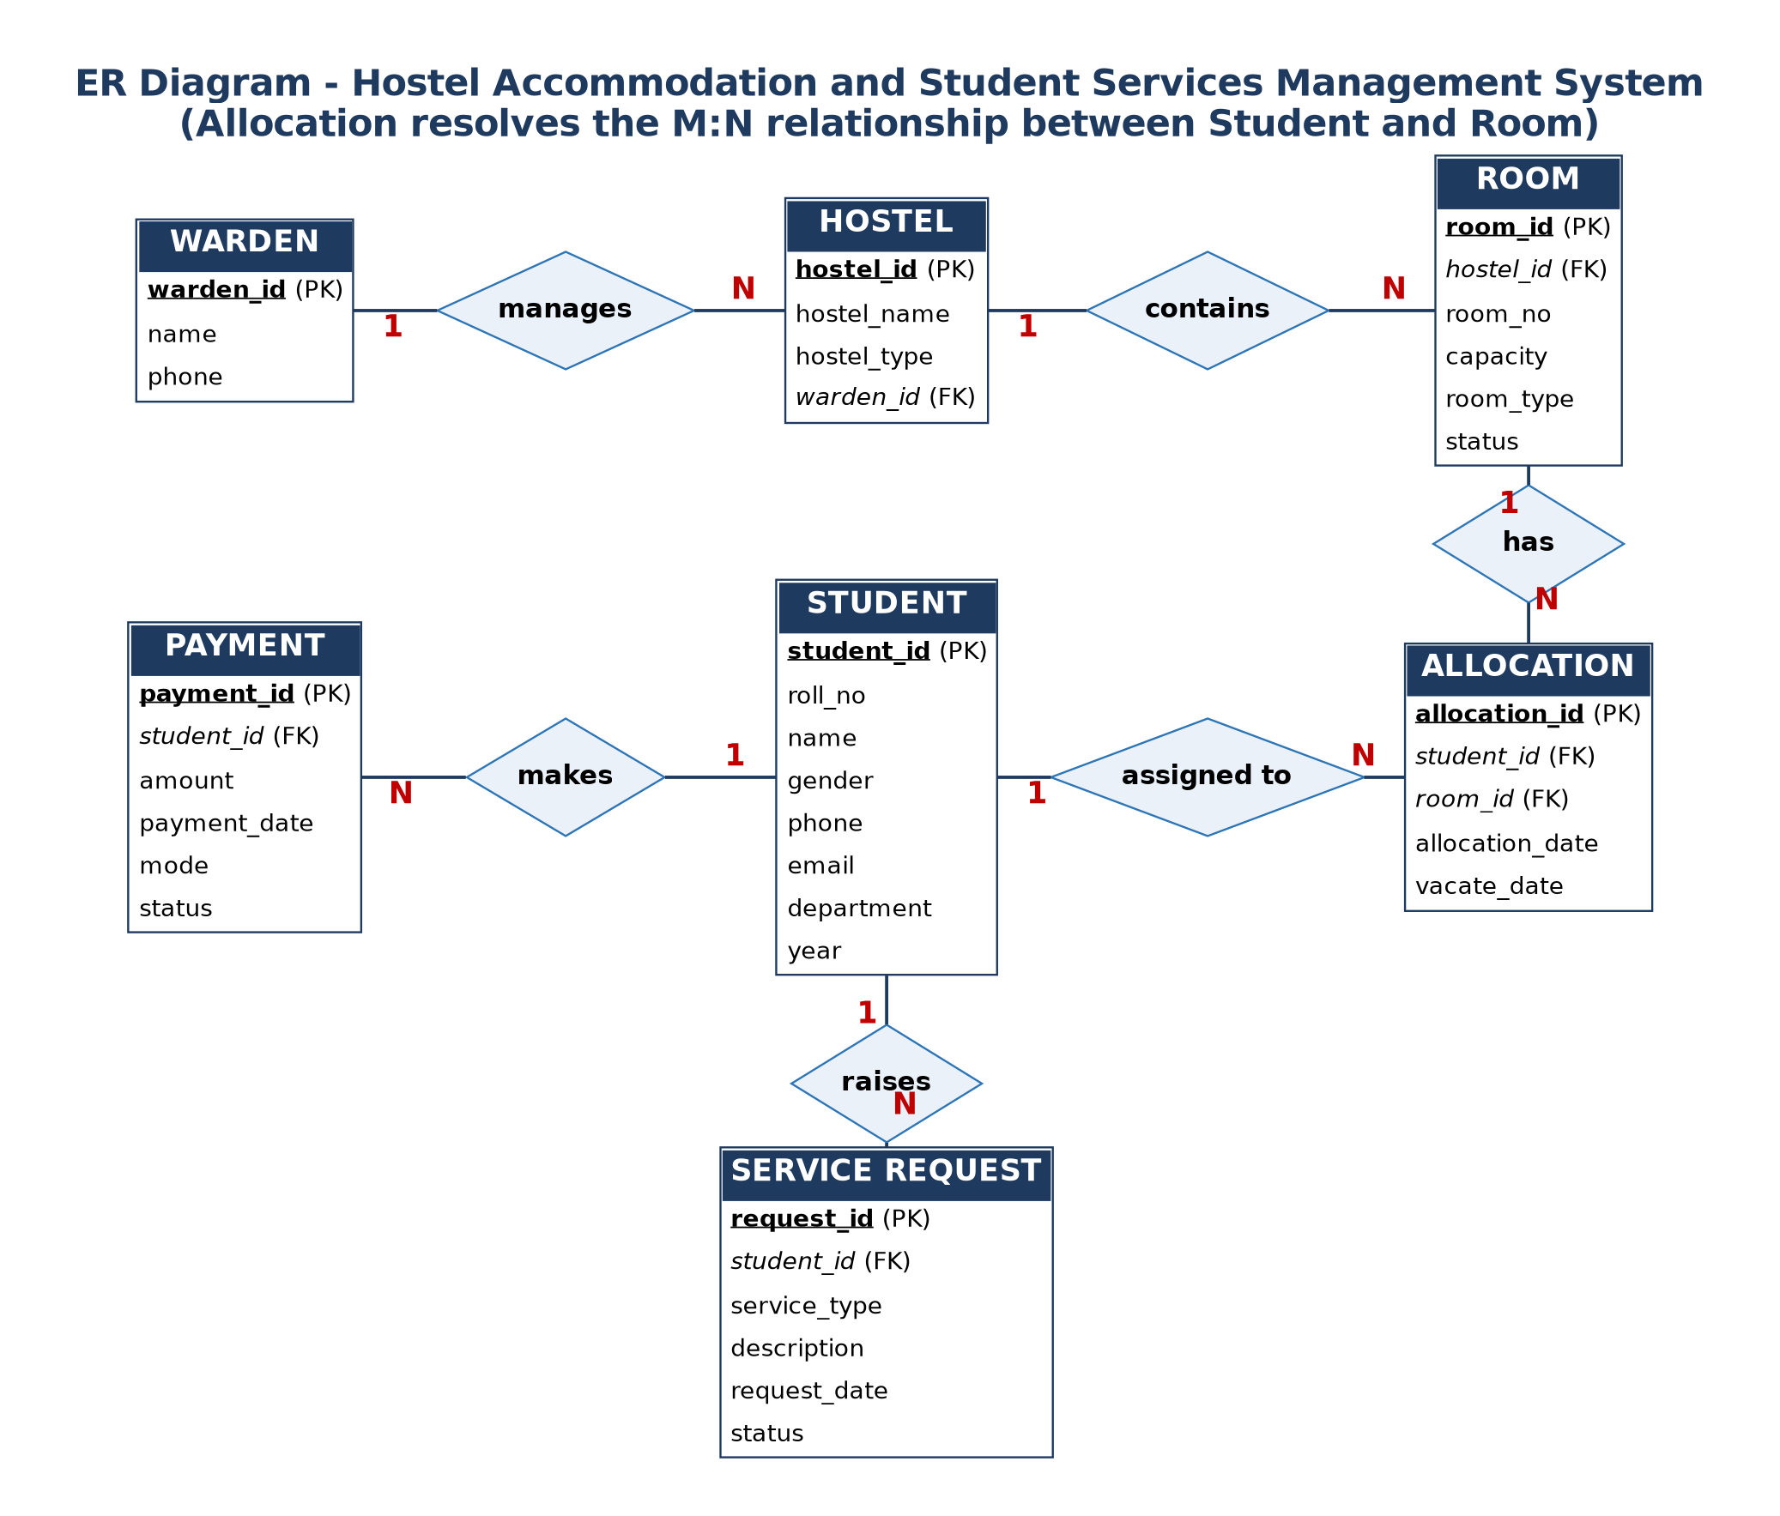

7. Relational Schema and Normalization

Relational schema (primary key first, foreign keys marked FK)
- WARDEN(warden_id, name, phone)
- HOSTEL(hostel_id, hostel_name, hostel_type, warden_id FK)
- ROOM(room_id, hostel_id FK, room_no, capacity, room_type, status)
- STUDENT(student_id, roll_no, name, gender, phone, email, department, year)
- ALLOCATION(allocation_id, student_id FK, room_id FK, allocation_date, vacate_date)
- PAYMENT(payment_id, student_id FK, amount, payment_date, mode, status)
- SERVICE_REQUEST(request_id, student_id FK, service_type, description, request_date, status)

Normalization
- 1NF: All attributes are atomic and there are no repeating groups. Multiple payments or rooms of a student are stored as separate rows.
- 2NF: Every table has a single-column primary key, so no partial dependency exists.
- 3NF: No transitive dependency exists. Warden details are kept in WARDEN and hostel details in HOSTEL instead of being repeated. The many-to-many relation between Student and Room is resolved using ALLOCATION.

8. Data Dictionary
Table | Column | Data type | Constraint
Warden | warden_id | INT | PK, AUTO_INCREMENT
 | name | VARCHAR(50) | NOT NULL
 | phone | VARCHAR(15) | UNIQUE
Hostel | hostel_id | INT | PK, AUTO_INCREMENT
 | hostel_name | VARCHAR(50) | NOT NULL
 | hostel_type | VARCHAR(10) | CHECK (Boys/Girls)
 | warden_id | INT | FK to Warden
Room | room_id | INT | PK, AUTO_INCREMENT
 | hostel_id | INT | FK to Hostel, NOT NULL
 | room_no | VARCHAR(10) | NOT NULL, UNIQUE with hostel_id
 | capacity | INT | CHECK (> 0)
 | room_type | VARCHAR(20) | NOT NULL
 | status | VARCHAR(15) | DEFAULT 'Available'
Student | student_id | INT | PK, AUTO_INCREMENT
 | roll_no | VARCHAR(15) | UNIQUE, NOT NULL
 | name, gender | VARCHAR | NOT NULL
 | phone | VARCHAR(15)
 | email | VARCHAR(60) | UNIQUE
 | department, year | VARCHAR(30), INT | NOT NULL
Allocation | allocation_id | INT | PK, AUTO_INCREMENT
 | student_id | INT | FK to Student, NOT NULL
 | room_id | INT | FK to Room, NOT NULL
 | allocation_date | DATE | NOT NULL
 | vacate_date | DATE | NULL allowed
Payment | payment_id | INT | PK, AUTO_INCREMENT
 | student_id | INT | FK to Student, NOT NULL
 | amount | DECIMAL(10,2) | CHECK (> 0)
 | payment_date | DATE | NOT NULL
 | mode | VARCHAR(15)
 | status | VARCHAR(10) | DEFAULT 'Paid'
Service_Request | request_id | INT | PK, AUTO_INCREMENT
 | student_id | INT | FK to Student, NOT NULL
 | service_type | VARCHAR(30) | NOT NULL
 | description | VARCHAR(200)
 | request_date | DATE | NOT NULL
 | status | VARCHAR(15) | DEFAULT 'Pending'

9. SQL Commands Used

DDL (table creation)
CREATE DATABASE hostel_db;
USE hostel_db;

CREATE TABLE Warden (
warden_id INT PRIMARY KEY AUTO_INCREMENT,
name VARCHAR(50) NOT NULL,
phone VARCHAR(15) UNIQUE
);

CREATE TABLE Hostel (
hostel_id INT PRIMARY KEY AUTO_INCREMENT,
hostel_name VARCHAR(50) NOT NULL,
hostel_type VARCHAR(10) CHECK (hostel_type IN ('Boys','Girls')),
warden_id INT,
FOREIGN KEY (warden_id) REFERENCES Warden(warden_id)
);

CREATE TABLE Room (
room_id INT PRIMARY KEY AUTO_INCREMENT,
hostel_id INT NOT NULL,
room_no VARCHAR(10) NOT NULL,
capacity INT CHECK (capacity > 0),
room_type VARCHAR(20) NOT NULL,
status VARCHAR(15) DEFAULT 'Available',
UNIQUE (hostel_id, room_no),
FOREIGN KEY (hostel_id) REFERENCES Hostel(hostel_id)
);

CREATE TABLE Student (
student_id INT PRIMARY KEY AUTO_INCREMENT,
roll_no VARCHAR(15) UNIQUE NOT NULL,
name VARCHAR(50) NOT NULL,
gender VARCHAR(10) NOT NULL,
phone VARCHAR(15),
email VARCHAR(60) UNIQUE,
department VARCHAR(30) NOT NULL,
year INT NOT NULL
);

CREATE TABLE Allocation (
allocation_id INT PRIMARY KEY AUTO_INCREMENT,
student_id INT NOT NULL,
room_id INT NOT NULL,
allocation_date DATE NOT NULL,
vacate_date DATE,
FOREIGN KEY (student_id) REFERENCES Student(student_id) ON DELETE CASCADE,
FOREIGN KEY (room_id) REFERENCES Room(room_id)
);

CREATE TABLE Payment (
payment_id INT PRIMARY KEY AUTO_INCREMENT,
student_id INT NOT NULL,
amount DECIMAL(10,2) CHECK (amount > 0),
payment_date DATE NOT NULL,
mode VARCHAR(15),
status VARCHAR(10) DEFAULT 'Paid',
FOREIGN KEY (student_id) REFERENCES Student(student_id) ON DELETE CASCADE
);

CREATE TABLE Service_Request (
request_id INT PRIMARY KEY AUTO_INCREMENT,
student_id INT NOT NULL,
service_type VARCHAR(30) NOT NULL,
description VARCHAR(200),
request_date DATE NOT NULL,
status VARCHAR(15) DEFAULT 'Pending',
FOREIGN KEY (student_id) REFERENCES Student(student_id) ON DELETE CASCADE
);

DML (insertion, update, deletion - minimum 5 records per table)
INSERT INTO Warden (name, phone) VALUES
('Ramesh Kumar','9000000001'),('Lakshmi Devi','9000000002'),
('Suresh Rao','9000000003'),('Anita Singh','9000000004'),
('Mohan Das','9000000005');

INSERT INTO Hostel (hostel_name, hostel_type, warden_id) VALUES
('Aravali Block','Boys',1),('Nilgiri Block','Girls',2),
('Vindhya Block','Boys',3),('Himalaya Block','Girls',4),
('Sahyadri Block','Boys',5);

INSERT INTO Room (hostel_id, room_no, capacity, room_type) VALUES
(1,'101',2,'Double'),(1,'102',3,'Triple'),(2,'201',2,'Double'),
(2,'202',1,'Single'),(3,'301',2,'Double');

INSERT INTO Student (roll_no,name,gender,phone,email,department,year) VALUES
('25wu0101148','Uday Soni','Male','9111111111','uday@woxsen.edu.in','CSE',1),
('25wu0102316','T. Sindhu','Female','9222222222','sindhu@woxsen.edu.in','CSE',1),
('25wu0100001','Arjun Rao','Male','9333333333','arjun@woxsen.edu.in','ECE',2),
('25wu0100002','Meera Nair','Female','9444444444','meera@woxsen.edu.in','BBA',1),
('25wu0100003','Karthik Reddy','Male','9555555555','karthik@woxsen.edu.in','CSE',3);

INSERT INTO Allocation (student_id,room_id,allocation_date) VALUES
(1,1,'2026-07-15'),(3,1,'2026-07-15'),(2,3,'2026-07-16'),
(4,3,'2026-07-16'),(5,5,'2026-07-18');

INSERT INTO Payment (student_id,amount,payment_date,mode) VALUES
(1,60000,'2026-07-10','UPI'),(2,60000,'2026-07-11','Card'),
(3,45000,'2026-07-12','Cash'),(4,60000,'2026-07-13','UPI'),
(5,30000,'2026-07-14','Cash');

INSERT INTO Service_Request (student_id,service_type,description,request_date) VALUES
(1,'Maintenance','Fan not working','2026-08-01'),
(2,'Laundry','Laundry pickup delayed','2026-08-02'),
(3,'Mess','Menu complaint','2026-08-03'),
(4,'Maintenance','Water leakage','2026-08-04'),
(5,'Maintenance','Broken window','2026-08-05');

UPDATE Service_Request SET status='Resolved' WHERE request_id=1;
DELETE FROM Service_Request WHERE request_id=5;

Replace the sample values with the data you actually inserted, so the report matches your screenshots.
[INSERT SCREENSHOTS: CREATE TABLE output and SELECT * of each table]

10. Queries with Outputs
-- Q1: Students with their room and hostel (JOIN)
SELECT s.name, h.hostel_name, r.room_no
FROM Student s
JOIN Allocation a ON s.student_id = a.student_id
JOIN Room r ON a.room_id = r.room_id
JOIN Hostel h ON r.hostel_id = h.hostel_id
WHERE a.vacate_date IS NULL;

-- Q2: Occupancy per hostel (GROUP BY, COUNT)
SELECT h.hostel_name, COUNT(a.allocation_id) AS occupied
FROM Hostel h
JOIN Room r ON h.hostel_id = r.hostel_id
LEFT JOIN Allocation a ON r.room_id = a.room_id AND a.vacate_date IS NULL
GROUP BY h.hostel_name;

-- Q3: Total fees paid by each student (SUM)
SELECT s.name, SUM(p.amount) AS total_paid
FROM Student s JOIN Payment p ON s.student_id = p.student_id
GROUP BY s.name;

-- Q4: Rooms that still have vacancy (HAVING)
SELECT r.room_no, r.capacity, COUNT(a.allocation_id) AS occupied
FROM Room r
LEFT JOIN Allocation a ON r.room_id = a.room_id AND a.vacate_date IS NULL
GROUP BY r.room_id, r.room_no, r.capacity
HAVING occupied < r.capacity;

-- Q5: Pending service requests
SELECT s.name, sr.service_type, sr.request_date
FROM Service_Request sr JOIN Student s ON sr.student_id = s.student_id
WHERE sr.status = 'Pending';

-- Q6: Average, maximum and minimum payment (AVG, MAX, MIN)
SELECT AVG(amount), MAX(amount), MIN(amount) FROM Payment;

[INSERT OUTPUT SCREENSHOT BELOW EACH QUERY FROM MYSQL WORKBENCH]

11. UI Design and Screenshots
- Main menu: buttons for Students, Allocation, Payments and Service Requests.
- Insert screen: form to add a record, with the database table shown before and after insertion.
- View screen: all records displayed in a table (Treeview).
- Delete screen: select a record and delete it, with the table shown before and after deletion.
[INSERT UI SCREENSHOTS: insert (before/after), delete (before/after), view]

12. Implementation Details
- Technology stack: Python 3, Tkinter (user interface), MySQL 8 (database), mysql-connector-python (connectivity).
- Database connectivity: the UI opens a connection to hostel_db, runs parameterized queries and commits the changes.
- Parameterized queries (%s) are used to prevent SQL injection.

Key code snippets
import mysql.connector

con = mysql.connector.connect(host="localhost", user="root",
password="****", database="hostel_db")
cur = con.cursor()

def add_student(roll, name, gender, dept, year):
cur.execute("INSERT INTO Student (roll_no,name,gender,department,year) "
"VALUES (%s,%s,%s,%s,%s)", (roll, name, gender, dept, year))
con.commit()

def view_students():
cur.execute("SELECT * FROM Student")
return cur.fetchall()

def delete_student(sid):
cur.execute("DELETE FROM Student WHERE student_id=%s", (sid,))
con.commit()

Replace with your own code if your stack is different.

13. Testing
No. | Test case | Input | Expected result | Result
1 | Insert valid student | Valid details | Row added and shown in view | Pass
2 | Duplicate roll number | Existing roll_no | Error (UNIQUE constraint) | Pass
3 | Invalid foreign key | Non-existent room_id | Insert rejected | Pass
4 | Negative payment | amount = -500 | Rejected (CHECK constraint) | Pass
5 | Delete student | Existing student | Row removed from database | Pass
6 | Empty required field | Blank name | Validation message shown | Pass
7 | View records | Click View | All records displayed | Pass
Keep only the tests you actually performed.

14. Conclusion and Future Enhancements
The Hostel Accommodation and Student Services Management System stores hostel data in a consistent 3NF database and allows the warden to insert, view and delete records through a user interface. Constraints keep the data accurate, and SQL queries provide quick reports on occupancy, dues and pending service requests.

Future enhancements
- Login with separate roles for admin, warden and student.
- Online fee payment with automatic receipts.
- Email or SMS alerts for dues and request updates.
- Web or mobile version, visitor management and attendance tracking.

15. References
- Silberschatz, Korth and Sudarshan, Database System Concepts, McGraw-Hill.
- Elmasri and Navathe, Fundamentals of Database Systems, Pearson.
- MySQL 8.0 Reference Manual, https://dev.mysql.com/doc
- Python mysql-connector documentation.
- Course lecture notes and slides.

16. Contribution of Each Member
Member | Contribution
T. Sindhu (25wu0102316) | ER diagram, relational schema and normalization, table creation (DDL), report writing
Uday Soni (25wu0101148) | Data insertion and queries (DML, joins, aggregates), UI development and database connectivity, testing
Edit this to match who actually did what; the GitHub commit history will be checked.

17. Appendix: GitHub Repository Link
https://github.com/<username>/<repository-name>
The repository contains the Presentation folder, the Project-Report folder and a README.md with the project title, names and roll numbers of all members.

