The Proposal:
Mitigating "Lag-to-Churn": An AI-Driven Edge Defence Framework Against DDoS Attacks in the Gaming Industry

-By Uday Vachasiddha
Roll no: 213065

1. Introduction:
The modern gaming industry relies heavily on "Games as a Service" (GaaS) models, where real-time performance and continuous availability are critical to revenue. Unlike traditional web applications, multiplayer games operate in highly sensitive network environments where even a two-second delay (lag) can ruin the user experience.
Although the industry has advanced in graphics and mechanics, it remains highly vulnerable to Distributed Denial of Service (DDoS) attacks. The democratization of cybercrime, specifically the rise of "DDoS-as-a-Service," allows malicious actors to launch volumetric and application-layer attacks with ease. These attacks cause severe server instability, leading directly to player frustration, churn, and massive financial losses for game studios.

2. Problem Statement:
Service downtime and high latency in gaming usually result from malicious traffic overwhelming core servers.
However, most existing traditional DDoS mitigation tools route traffic to centralized "scrubbing centers." While effective for standard websites, this rerouting adds significant latency (ping) that makes real-time gaming unplayable.
Currently, there is a critical need for a decentralized security system specifically optimized for gaming that can:
- Filter malicious packets in milliseconds without routing traffic away from the game server.
- Differentiate between legitimate player actions and sophisticated botnet traffic.
- Operate directly at the network edge to neutralize attacks before they consume core server CPU.
This gap motivates the development of an AI-enhanced, edge-based predictive mitigation system that protects both service availability and player retention.

3. Research Context:
Machine learning has been widely applied in network anomaly detection, and technologies like eBPF (Extended Berkeley Packet Filter) have revolutionized high-speed packet processing.
However, these approaches are often researched in isolated corporate or web-hosting environments rather than high-stakes, UDP-heavy gaming networks. There is limited research on integrating lightweight machine learning algorithms directly with kernel-level packet filtering at the network edge to maintain the strict <20ms latency required by competitive gaming.
This project aims to address this gap by developing a hybrid framework that uses AI to baseline player behaviour and eBPF to execute instantaneous packet drops at the edge.

4. Scope:
This project aims to design and implement a simulated edge-defence network that:
- Integrates Cloudflare's Anycast routing to simulate global traffic distribution.
- Predicts and identifies malicious DDoS packets using LightGBM and Random Forest algorithms.
- Drops malicious traffic at the kernel level using eBPF/XDP.
- Visualizes attack mitigation and latency preservation through a local dashboard.
Due to student resource constraints, the system will not be deployed on physical global hardware. Instead, it will operate using a hybrid simulation environment (GNS3/Mininet) to prove the architectural logic and filtering speeds.

5. Aim and Objectives:
Aim:
To design and develop a decentralized security framework that filters malicious network traffic without adding latency to real-time gaming environments.
Objectives:
- Design a simulated Anycast edge-computing network topology.
- Preprocess and analyze clean gaming traffic versus malicious botnet traffic.
- Develop lightweight machine learning models (LightGBM) for real-time traffic classification.
- Implement eBPF/XDP scripts to execute millisecond packet dropping based on AI rules.
- Create a monitoring dashboard to visualize "dropped" vs. "passed" packets and server latency.
- Complete system testing and document performance metrics.
Key Milestones:
- Simulation environment (GNS3/Mininet) configured.
- AI traffic classification model trained and tuned.
- eBPF kernel-level filtering integrated.
- Attack simulation (DDoS vs. Edge Node) successfully executed.
- Dashboard and real-time logging implemented.
- Final documentation and report completed.

6. Solution Method / Architecture:
Technology Stack:
The proposed system will be implemented using the following technologies:
- Python: For system orchestration and AI model development.
- LightGBM & Random Forest: For high-speed packet classification and feature extraction.
- eBPF / XDP: For kernel-level, zero-latency packet dropping.
- GNS3 & Mininet: For creating the software-defined network (SDN) and generating attack traffic.
- Cloudflare (Free Tier): To demonstrate Anycast routing principles.
- Grafana / Streamlit: For building the real-time latency and attack dashboard.
Development Process:
The system will follow a layered architecture consisting of the following components:
- Distribution Layer: Simulating Anycast to split traffic across edge nodes.
- Intelligence Layer: AI baselining "normal" player UDP traffic.
- Execution Layer: eBPF inspecting packets on the network interface card (NIC).
- Core Layer: The protected game server receiving only clean traffic.
The system will process network flow data to estimate threat levels and update eBPF drop rules dynamically.
Database and Platform:
The dataset (PCAP files of gaming traffic and botnets) will be processed locally. The system will run on a Linux-based environment (required for eBPF kernel features).

Methodology Diagram:
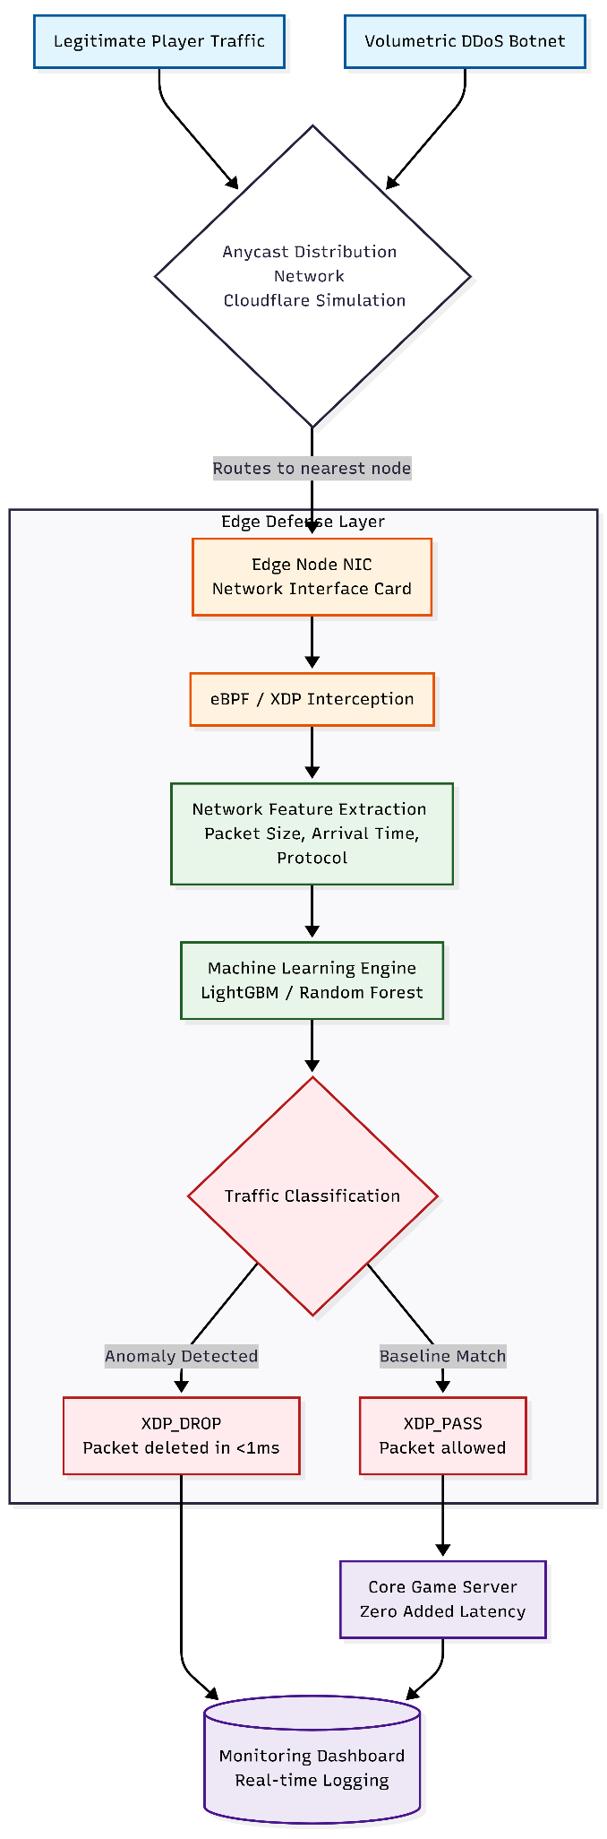
7. Work Breakdown Structure & Gantt Chart:
Phase | Tasks | Duration
Phase 1: Research & Setup | Literature review, Dataset acquisition (PCAP files), GNS3/Mininet installation | Week 1 – Week 2
Phase 2: Data Preparation | Parsing network traffic, Feature engineering (packet size, interval) | Week 3 – Week 4
Phase 3: Model Development | Training Random Forest/LightGBM, Model evaluation, Latency tuning | Week 4 – Week 5
Phase 4: Edge Integration | Writing eBPF/XDP scripts in C/Python, Linking AI rules to kernel filters | Week 6 – Week 7
Phase 5: Simulation & UI | Running Mininet DDoS attacks, Dashboard UI design for traffic monitoring | Week 7 – Week 8
Phase 6: Testing & Docs | System testing (measuring ping/lag), Report writing | Week 9 – Week 10

Gantt Chart:
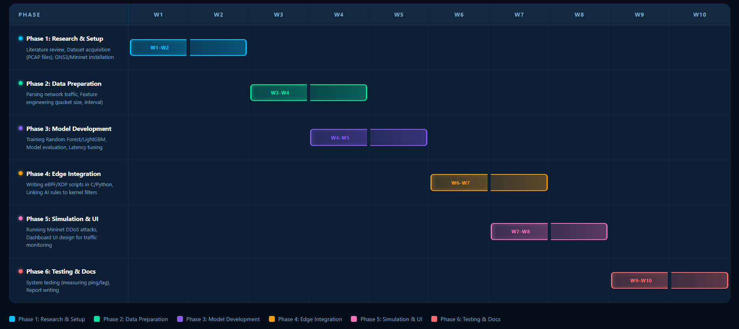

8. Risk Assessment:
Risk Analysis
Risk | Likelihood | Impact
eBPF / Linux Kernel compatibility issues | Medium | High
Lack of modern, game-specific DDoS datasets | High | Medium
Hardware constraints running heavy GNS3 simulations | Medium | High
LightGBM model misclassifying real players (False Positives) | Medium | High

Mitigation Plan
- Use standard Ubuntu environments with native eBPF support to avoid kernel panics.
- Generate synthetic UDP gaming traffic using Mininet if public PCAP datasets are insufficient.
- Optimize GNS3 topologies to run within the RAM limits of a standard student laptop.
- Prioritize "Precision" over "Recall" in the ML model to ensure legitimate players are never accidentally blocked.

9. Project Deliverables:
The final project will deliver:
- A configured network simulation topology file (GNS3/Mininet).
- Trained LightGBM prediction models optimized for network traffic.
- Functional eBPF/XDP scripts capable of dropping packets dynamically.
- A real-time dashboard visualizing attack mitigation and server latency.
- Final project report and technical documentation.
- Presentation slides demonstrating the "Smart Bouncer" system functionality.

10. Conclusion:
This project proposes the development of an AI-driven edge defence system to protect the gaming industry from crippling DDoS attacks. By integrating the intelligent classification of machine learning with the raw speed of kernel-level eBPF filtering, the system aims to shift network security away from latency-heavy central scrubbing. The resulting framework will demonstrate how gaming studios can maintain real-time server availability, preserve the player experience, and ultimately protect their revenue from "Lag-to-Churn" phenomena.

