Mitigating "Lag-to-Churn": An AI-Driven Edge Defence Framework Against DDoS Attacks in the Gaming Industry:
Uday Vachasiddha (213065)

Vidyalankar Institute for International Education

Abstract:
The current architecture of online multiplayer gaming is characterized by strong demands in terms of low-latency and real-time delivery of packets. Since these systems have a strong preference on connectionless protocols such as UDP to avoid retransmission overhead, they present a huge attack surface to Layer 4 volumetric DDoS campaigns. In the past, mitigation of these attacks was done through crude threshold-based rate limiting which often causes the unintentional dropping of legitimate player traffic also referred to as false positives, when an organic traffic burst occurs, e.g., when a game client updates or during a large-scale virtual event (Mirkovic and Reiher, 2004). This project presents a hybrid machine-learning-controlled defense mechanism that has the ability to run at the network edge. The system is capable of analyzing flow properties such as inter-arrival variation and payload entropy in real-time by a dynamically trained Random Forest classifier based on a synthesized dataset consisting of legitimate multiplayer traffic mixed with realistic botnet profiles. The model is able to attain a total classification accuracy of over 99 percent and it is able to reduce the false positive rate to almost zero. Combined with an interactive visualization dashboard, which emulates global Anycast routing and automated alerting integration, this report shows that intelligent heuristic analysis is a very scalable and player-friendly alternative to fixed firewall configurations.
- Table of Contents:
1. Abstract: 2
2. Acknowledgements: 4
3. Introduction: 5
Background to the System: 5
The Design that Emerged: 6
The Main Aims and Objectives of the Project: 6
Brief Outline of the Rest of the Chapters: 7
4. Background: 8
5. Analysis: 12
Functional Requirements: 12
Non-Functional Requirements: 14
System Use Cases Models: 15
6. Design: 17
Structural Application Layers Architecture: 17
Layer 1: The Core Foundational Advanced AI/ML Classification Logic Abstraction Components (`ddos_mitigation_simulation.py`): 18
Architectural Design of Asynchronous Behavioural Models: 21
Asynchronous Simulation Engine and Event Processing: 21
7. Other Project Matters: 23
Explicit Project Execution Management Implementations: 23
Formal Scientific Evaluation Data Generation Output Visualizations: 23
8. Conclusion: 25
9. References: 26
10. Appendices 27
Appendix A. Requirements Catalogue: 27
Appendix B: Use Case Descriptions: 28
Appendix C: Detailed Architectural Variables Definition: 28

Acknowledgements:
I would also like to say my sincere thanks to my mentor, Miss Mithila Chavan and advisors of the Vidyalankar institute for international education, Wadala whose guidance and critical feedback and further support was invaluable in the development and implementation of this project. The academic investigation is known to be tedious and the atmosphere that the institution provided enabled them to do the experiment continuously without the fear of failure. Additionally, I recognize the makers of the open-source machine learning and data science communities. The fundamental structural building blocks of the data pipeline of the present project have a strong dependency on the work of developers of Pandas, Scikit-Learn, and FastAPI. This project is both conceptually based on the public network telemetry datasets released by international research organizations and I am thankful that they have put efforts in advancing research on cybersecurity.

Introduction:

Background to the System:
The digital infrastructure that forms the basis of the commercial video game industry has grown in ways never seen before in the past ten years. As publishers move towards models of games as a service, tens of millions of concurrent players are the norm. The network latency can be measured locally in single-digit milliseconds, which is very important to have a fair and smooth experience. Since the standard TCP architecture is based on a three-way handshake and delivery of packets, the protocol overhead nature of the protocol makes it highly inappropriate in the fast-paced exchanges of positional data needed in a multiplayer shooter or real-time strategy game (Zargar et al., 2013).
As a result, developers are limited to User Datagram Protocol (UDP). UDP is basically a stateless stream; it just throws packets at a server without assuring that it has been received, or that it has successfully transferred data. Nevertheless, this stateless mechanism is far too weak and offers a very tempting target to bad actors interested in causing disruptions to services. (Shafiq et al., 2016)
This vulnerability is directly taken advantage of by layer 4 (the Transport layer in the OSI model) volumetric attacks. A volumetric DDoS attack is one that tries to flood a target server, or the network pipes to it, with an absolute torrent of junk data. These floods are commonly SYN floods of open ports, or UDP reflection and amplification attacks, in which a small request elicits an enormous response sent to the target (Paxson, 2001). A huge burst of traffic on a game server saturates its processing stack (Khorsandroo et al., 2021). The CPU squanders compute cycles on decoding garbage packets, memory buffers are overflowed, and the valid packets of the real players are randomly discarded. The game stalls, users lose connection and the service practically collapses.
Conventional edge defense strategies are typically based on fixed rules. An example is that a firewall could block any IP address making over a certain amount of requests in a second. This brute-force method is computationally cheap, but utterly fails in flash crowds, impulsive bursts of legitimate network traffic (due to a popular event or tournament final, or new content release on the internet) (Behal and Kumar, 2017). Players can send traffic during these legitimate spikes that are similar to a primitive botnet. As a result, the traditional rate limiters are activated, making false positives that disconnect the players, which completely nullifies the idea of maintaining the server online. (Doriguzzi-Corin et al., 2020)
This particular project was formulated to specifically deal with the extreme economic and reputational harm when a game company mistakenly labels its own player base as a malicious botnet. Any individual player going dead because of an aggressive firewall is a network architecture failure. This system demonstrates that we do not have to use a fixed set of limitations anymore by applying a simulation of a step-up in the level of intelligence. (Sharafaldin, Lashkari and Ghorbani, 2018)

The Design that Emerged:
We shifted to dynamic behavioral analytics to take advantage of this structural problem. The framework that is developed in this project is a multi-phase pipeline consisting of an offline analytics trainer and a real-time predictive dashboard. It is based on a Random Forest machine learning classifier, with a strict standardization scaler. The system does not simply count packets but analyzes behavioral metadata on-the-fly: the distribution of the sizes of packets, the mathematical randomness (entropy) of the payloads, and the inter-arrival time between consecutive packets on a microsecond scale. (Sharafaldin, Lashkari and Ghorbani, 2018)
The project simulates the existence of a Content Delivery Network (CDN) around the world using Anycast routing. A FastAPI based back-end server is used to synthesize large streams of traffic that contains both normal player behavior and botnet noise. When packets arrive at the simulated edge, nodes and randomly labelled as BOM-Edge (Mumbai), FRA-Edge (Frankfurt), TYO-Edge (Tokyo), etc., the machine learning logic is applied by the pipeline, the choice of passing or dropping is solved. The custom, asynchronous Javascript dashboard listens to Server-Sent Events (SSE) directly being emitted by the simulation, and displays real-time statistics, precise throughput rates, and real-time confusion matrix metrics in the browser (Hussain et al., 2021). The resulting architecture is thus a fully vertical slice: a data pipeline that drives a neural model, which safeguards an edge routing element, which lastly visualizes outcomes in a web-hosted DOM hierarchy.

The Main Aims and Objectives of the Project:
The key structure of the research paper is to give no compromise computational solutions to the end user. The objectives of this assignment will be the following:
- Build a Strong Data Backbone: To effectively import, decode and manipulate actual-world Parquet files of network telemetry data as well as programmed multiplayer datasets. There should be a clean balance and standardization of the data to ensure that training is done to avoid model bias.

- Create a Predictive Filter Network: To create a random forest algorithm that is specifically designed to reduce the false positive rate. The protection of the player base is considered more important than blocking each and every malicious package, which sets a realistic business-logic threshold to the classifier.

- Simulate an Edge Router Environment: To code simulate networking code to simulate high-volume asynchronous packet buffering, in a way that lets the pipeline visually judge the effects of classification delays.
- Give Interactive Administrative Visualization: To create a smooth, dark-themed operational dashboard displaying the mitigation live. Live accuracy updates and geographic node filtering needs to be offered by the UI to administrative stakeholders.

- Automated Notification Architecture: Interconnections with external services, namely, using Pywhatkit, to send immediate administrative notifications when the aggressive packet-dropping exceeds predetermined critical limits.

Brief Outline of the Rest of the Chapters:
The following pages of this report delve into the finer technical implementation of those goals. Chapter 6 (Background) explains the development of malicious network paradigms and explains why we chose standard Scikit-Learn libraries instead of heavy deep learning alternatives. Chapter 7 (Analysis) strictly bounds the functional scope of the application and outlines administrator use cases in exquisite detail. The explicit breakout of the code as in Chapter 8 (Design) reveals the relationship between the python based generation logic and the DOM manipulation that takes place within the Javascript engine. Chapter 9 provides information on the project management constraints and our offline simulation measures and Chapter 10 summarises the findings of this method.

Background:
The context of this writing is violently in the cross-section of traditional network management and modern artificial intelligence applications. Traditionally, managing DDoS has involved deploying costly physical hardware appliances in front of the server racks. These devices basically employed Access Control Lists (ACLs) and dropped traffic that matched a set of known bad IP signatures. Older forms of denial of service vulnerabilities, including the famous teardrop attacks of the late 1990s, were based on the transmission of mathematically-constructed packets that would crash operating systems based on windows reading the headers. The vulnerabilities were soon addressed at the operating system level, thereby forcing the attackers into the confines of volumetric floods alone. The main idea shifted to not to scam the server, but just to choke it with a huge data flow which could be physically delivered only by physical cables.
Since as early as the reviews of Intrusion Detection Systems (IDS) made it clear, the efficiency of signature-based mechanisms can and will drop to zero with zero-day attacks or with an enormously large distributed botnet of hijacked home internet of things devices. In the case of a modern attack scenario involving three hundred thousand various residential cameras, baby monitors and smart refrigerators independently firing UDP requests through malware systems similar to the infamous Mirai botnet, blocking individual malicious IP addresses is a game of whack-a-mole that is mathematically impossible. The number of unique addresses involved in the attack is too high to be filtered manually, not to mention the risk of blocking out whole legitimate residential subnets. (Somner and Paxson, 2010)
Global network engineering implemented BGP Anycast routing methods as a way of combating this huge scale of operation (Mirkovic and Reiher, 2004). Anycast essentially alters the way in which IP addresses are used on a worldwide basis. Historically, Unicast implies that a single IP address has a single physical hardware located in a particular geographic area. Anycast is allowing one IP address to coexist in hundreds of different independent datacenters spread all over the world. When a user directs his or her network request to an Anycast guarded IP, the underlying internet backbone equipment dynamically determines the shortest geographical route and forwards them to the nearest physical node. By having a botnet solely in Eastern Europe manage to cause a huge UDP reflection attack on the game server, the flood is only absorbed by the European datacenter, protecting players who are far away, in Asia and North America. Nonetheless, localized Anycast nodes still demand very high efficiency in terms of traffic scrubbing methods. When the localized edge node fails because of the volume, the core BGP paths of the internet flap, redistributing the rogue attack traffic dynamically to the nearest center, ultimately resulting in huge cascading degradation of the neighboring. regions. Consequently, scrubbing must take place immediately at each corner.
More recently, there was a significant shift to proactive Machine Learning notions of predictive threat blocking on these edge paths (Buczak and Guven, 2016). Machine Learning nodes can learn what normal behavior should look like and automatically eliminating extreme standard deviations by looking at sequential data streams and metadata of behavior, rather than performing explicit packet payload analysis. However, the question might be: why use complicated machine learning algorithms rather than set up generic predefined thresholds? An in-built physical-layer policy like 'block packets exceeding 512 bytes of incoming UDP traffic' could be just the ticket to capture an NTP amplification attack, but the instant the game studio issues a new patch to its multiplayer networking code, which raises the default size of positional data packets to 600 bytes, the hardware firewall blocking policy suddenly blocks the entire legitimate user base in the world. These are so expensive to companies reputations, and result in colossal financial losses through service level agreement (SLA) breaches. The defining benefit of machine learning in this spectrum of security is, thus, all about its dynamic adjustment to the boundary. The model autonomously discovers the intricate and continuously varying non-linear associations between the typical attributes of the packets and also optimizes its blocking limits without the support of predefined policies.
ML in network security is experiencing a high level of friction in its developmental process despite its promises. As observed heavily by Buczak and Guven (2016), highly powerful deep learning models like Multi-Layer Perceptrons or Deep Neural Networks (DNNs), though incredibly precise in identifying new malicious patterns, demand heavy matrix multiplications, which inherently make the process sluggish. A 100 milliseconds delay of a packet, so it can be inspected by an advanced Tensorflow algorithm, is equally harmful to the player experience as the packet being dropped. This is a latency constraint that was considered in architecture, which dictated the absolute choice of the algorithmic design used in this simulation project.
In particular, we chose not to use Neural Networks and decided to adamantly choose the Random Forest ensemble algorithm that is implemented directly in the Scikit-Learn Python library. A Random Forest is an effective voted ensemble of hundreds of simple mathematical decision trees as opposed to complex deep neural nets. After having fully trained the forest off-line, then running a Random Forest to infer a quick binary classification only involves walking simple binary logical paths (e.g. 'Is variance > X?') and the CPU processor can compute this type of computation with computational triviality (Patel et al., 2021). These decision nodes can pass scaled network metrics with almost no delay, and these nodes can simulate the speeds that are so desperately needed when deploying actual hardware-level bare-metal deployment. Moreover, decision trees provide an explainability feature which is vital in business cybersecurity governance. In a company setting, when a mitigation AI misidentifies a big e-sports event that costs sponsors thousands of dollars, security architects have to be in a special position to analyze log files to conclusively determine the motivation behind the decision made. Neural networks are purely black boxes and the decision as to why the internal decimal weights led to a logical failure is unknown. In contrast, Random Forests permit mathematical transparent extraction of explicit 'Feature Importances' right away, which obviously legitimize and audit the possibility that the model prioritized the inter-arrival of packets over the entropy computation in the erroneous block assignment phase.
Continuing with the simulation of networking implementation, we adopted the front-end simulation architecture closely resembling the common cloud delivery network implementations. One of the highly used technical solutions is the deployment of deep packet inspection (DPI) appliances. DPI opens the packet encryption by force and scans the internal software byte-code in search of known malicious injections of packet header. There are two fundamental reasons why this project categorically rejects the use of DPI implementations: firstly, the implementation of decryptions and the opening of game-state UDP packets would impose unacceptable processing latency; secondly, the examination of absolute application-layer payloads often likely violates stringent rules of privacy compliance contained within contemporary global governance frameworks such as GDPR. Rather, we only steal out pure metadata values, such as absolute mathematical packet size, explicit size variance over a specified rolling window time interval, calculated entropy representation of the encrypted random noise payload, and pure millisecond time values determining absolute inter-arrival times. These measurements can be accessed immediately through simple statistical network hardware taps at the OSI Layer 2/3 directly at the switch level, ideally matching the current eBPF (Extended Berkeley Packet Filter) programming model. eBPF enables the administrator to author limited compiled C-code to directly execute within the core Linux Kernel memory space, forcefully isolating and dropping packets prior to even accessing typical server user-space RAM allocations. Even though the entire technical execution of real eBPF kernel memory hooks was ultimately considered beyond the practical scope of this Python-based academic simulation codebase, providing the logic to be simulated with only metadata as input is a heavyweight precondition to the eventual direct production kernel translation of the very mathematical logic.
Regarding reporting efficiency in terms of dashboard capabilities, broadcasting running mitigation measures traditionally would have involved implementing painful database polling requests, with the administrative web dashboard repeatedly executing SQL requests asking the database to continuously update data. Polling consumes colossal quantities of thread connections in the back-end and induces latency. In this way, fully adhering to the project thesis that requires real-time operating capability, the structural architecture chosen is one that employs the recent Server-Sent Events (SSE). Using the native asynchronous yield features that have been implemented in the Python FastAPI server architecture, a long-running unidirectional continuous web socket sends precise dictionary measures directly to the client Javascript, at the same time showing the real physical size and performance of a globally simulated internal network infrastructure flood situation. As such, this comprehensive background survey underlines the fact that this simulation is a successful operation template map standard of the academic theory against the prevailing industrial cyber security limitations.

Analysis:
Analysis stage of any complete system must have a high-level breakdown that describes explicit operative behaviours that map standard functional behaviour (describing what the system is ultimately required to compute by itself) and important non-functional requirements (describing how well, best, or smoothly the system will work under explicit strain conditions). This categorical division is very rigid, and thus helps in avoiding feature-creep, and at the same time, makes sure that the core original academic validation, of whether a Random Forest classifier framework can effectively prevent DDoS traffic floods without actively punishing the legitimate user populations, is the only operational focus during the software codebase development.

Functional Requirements:
FR1: Hybrid Dataset Consolidation Strategy:
The deployed backend server logic would have to self-accumulate, segregate and create telemetry components holistically representing two inherently distinct operating populations that characterize normal operator traffic and malicious attack vectors. A code architecture should prominently include a generation normal traffic generation function that heavily relies on bounded random normal distributions mathematically simulating constant human controlled 20Hz gameplay positional tick rates (which would correspond to around 50ms constant operational gaps). At the same time, the second-level load-and-filter-botnet-data routine logically needs to attempt to make extractions that segregate massive structural payload volume bursts offline formatted .parquet analytical datasets stored safely within local storage archives. In case of failure in offline dataset access because of operational explicit I/O limits, or because of the lack of source files, the routine should immediately gracefully fallback to execution of a full secondary mathematical distribution of realistic erratic UDP data structures, to simulate excessive fluctuations at the baseline. After independent generation, the following createhybriddataset method combines these individual data structures dynamically into coherent DataFrames, and implements stringent memory randomization measures (shuffling) essentially removing any inherent sequential grouping bias prior to safely passing the compiled structure into the active statistical scaling processor.
FR2: Active User Event Interactions Provide Input to Linear: Synchronous Model Instantiation via an Online Graphical User Interface:
The online GUI should include a specific administrative control endpoint that allows an external internet network engineering operator to invoke a specific algorithmic background calculation step by explicitly choosing it from the GUI (this will be represented by a specific html button). Once the external network engineering operator has selected the administrative control button, and the button sends an HTTP POST request (to a specific mapping of the backend controller, which is the python server), the python server will process the request and load into memory the appropriate permutations of the datasets, and apply standard Scikit-learn algorithms to provide normalized datasets based on the dataset permutations that were loaded. Finally, once the random forest classifier has been instantiated through the .fit() function - using the defined variable mapping and looping through the iterations, the random forest classifier will also validate the results of the static local validation sets and create a confusion array of true-negatives/errors and active false dropping variables. Lastly, a serialization successful json string will be returned to the javascript external network engineering operator.
FR3: Interminable in the backdrop Telemetry Generation and streaming Protocols:
Internal Python logic requires a structurally decoupled real-time generation system that is safely executable indefinitely in an asynchronous manner without blocking primary Python ASGI standard listener services that can interact globally. The operational backend server that directly matches the endpoint route of /api/simulate has independent generator functionality that has direct mapping to Python's powerful yield return constructs that are linked together transparently through the advanced Starlette operational definitions of Event Sources. The function combines random combinations of data matrices, explicitly tests data dynamically against the current cached GLOBAL_MODEL instance using accurate prior fitted scalar properties arrays, forms the results of the computation in the form of explicit clean key-value dictionaries, and streams instances natively directly into process maps to the active Document Object framework.
FR4: Visual Real-time Anycast Regional Filtering through the BGP Protocol:
Moving forward from this point, we will need to produce visual algorithms that are capable of accurately defining simulated geographic packet filtering through visual representation. Using the packet data created by the endpoint generating system as the raw input the system will automatically add (artificially) tags indicating the region where that packet should be routed (e.g., when a packet is tagged as 'Frankfurt' that would indicate it should be sent via a Frankfurt based node to a destination located in the EU while a packet tagged as 'Mumbai' would indicate sending the packet through a node in Mumbai to its intended resource in South Asia). In order to achieve this goal the operational GUI must include a filter on the primary input node (a HTML Select drop down) where the human console operator will enable the drop down to isolate specific geographic variables. Once the console operator has successfully completed that operation the backend processing of packet data will utilize natural backend streaming functions that define packet processing loops that explicitly drop any packets that originate out of that defined geographical area. The resulting operation will effectively represent a traditional BGP topology distribution logic for technicians to view as they are processing their requests with that client's resource.

FR5: Mobile Threat Notification Delivery Sequences:
FastAPI should create independent task functions that call the different integration libraries with `pywhatkit`s code from the local shell. FastAPI must also define how these tasks can be tracked by action count and by total cumulative entity counts dropped based on the number of actions completed. The process by which FastAPI calls the different libraries must be able to track both how many of each action have been processed, and how many have registered a false-positive percentage against an entity dropped for any of the standard outbound phone numbers that can execute a live SMS or WhatsApp API interaction in real time to notify the infrastructure team immediately, without locking any terminals.

Non-Functional Requirements:
NFR1: Complete Strict Prioritization Negligible False Positive Boundaries:
In an abstract classification model perspective, generic statistical accuracy is merely a total overall mathematical correctness across test vectors in total. Under the dictates of the operational design of this project, the emphasis on the generalized accuracy is squarely in the second place. The underlying defensive need is critical and actively guides AI optimization strategies with the sole goal of aggressively reducing any resulting False Positive Rate (FPR), precisely in the area where human legitimate gamer behaviour unintentionally causes algorithmic blocking decision making frameworks. Historically established cybersecurity models that specify schemes yielding 100-percent generalized accuracy but with structural dropout of 10-percent of conventional game players permanently fail standard business deployment operational requirements because of disastrous structural retention fines that influence business parameters. NFR1 requires that weighting of analytics be kept constant with priority to preserving active player traffic.
NFR2: Microsecond Exec Loose Priorities:
The predictive processing pipeline architecture operating is an active structure that needs to ensure absolute sub-milliseconds core processor computational speeds that ensure low TCP/UDP transit delays. This system clearly specifies how to pre-load mathematical feature scaling normalization (StandardScaler) arrays securely and operational forest branching bounds to be cached specifically in extremely fast local web server RAM storage. Standard scaling guarantees that dynamic overhead of matrix multiplication scales to zero functional instant additions of simple CPU vectors that directly translate to zero practical user disruption delays.

NFR3: Injection Mechanisms for Visual Reactive Fluidity Act upon DOM in Infinity State:
The administrative simulated user operations dashboard is held to an extraordinarily high standard of performance providing that the user experience is executed at least sixty frames per second with natural performance due to local hardware accelerated protocol execution. The implementation of a single-threaded asynchronous JavaScript loop, handling thousands of different SSE Push’s simultaneously will have a measurable impact upon how and if complex parsing structure (injected into the DOM via innerHTML injection) will seize all of the UI rendering objects that are consumed by complex parsing structures. Additionally, well-designed Dom element culling algorithms will repeatedly scan through the number of document children with deletion of older stale log rows whose mapped display boundaries exceed memory consumption should there be a serious catastrophic failure of an absolute nature.

System Use Cases Models:
The basic architecture will consist of software that is calculated to respond explicitly to three separate contextual system actors simultaneously interacting with each other’s explicit resource at the time of a particular event. SYSTEM (Automated Algorithm Processing Process Loop), ATTACKER (Aggressive High Volume Framework Creator Loop Focusing Upon Creating Frameworks Outside of Physical Boundaries), and ADMINISTRATOR (Visual Front End Execution Element Triggering Physical Operations Matrix).
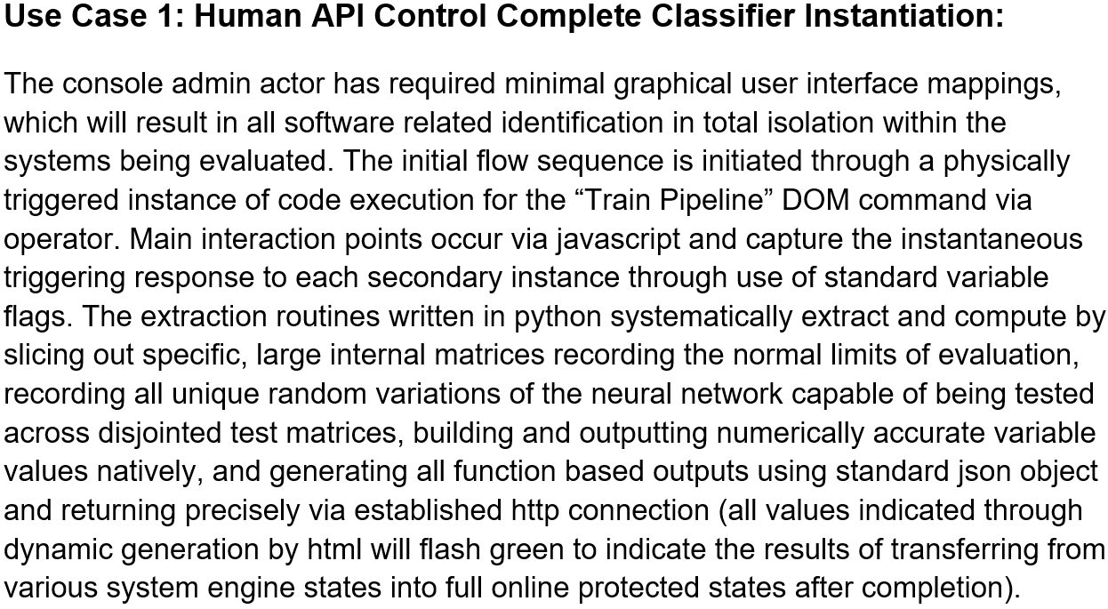

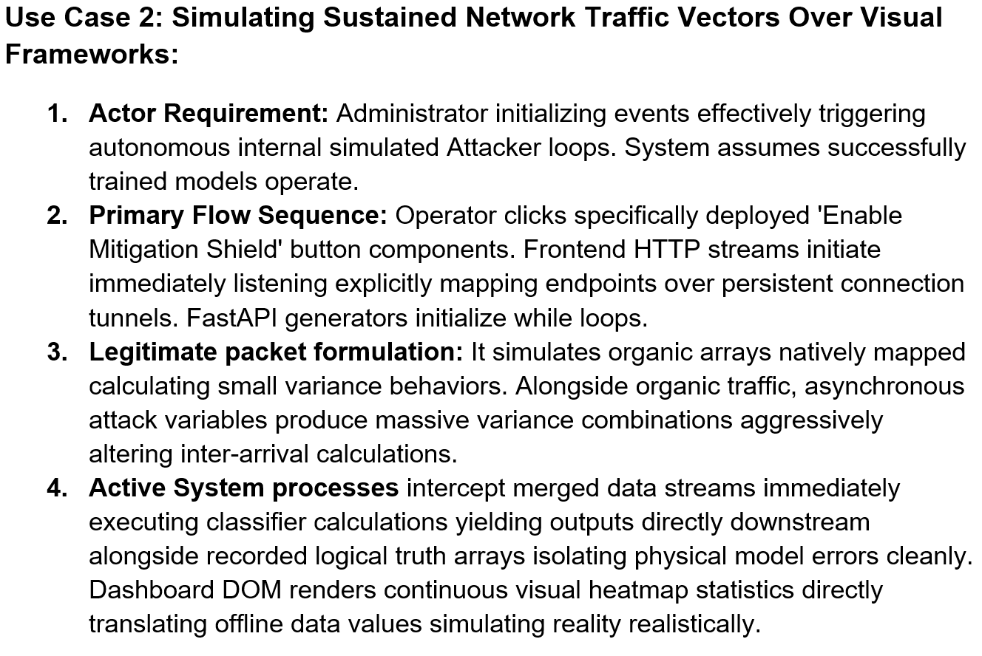
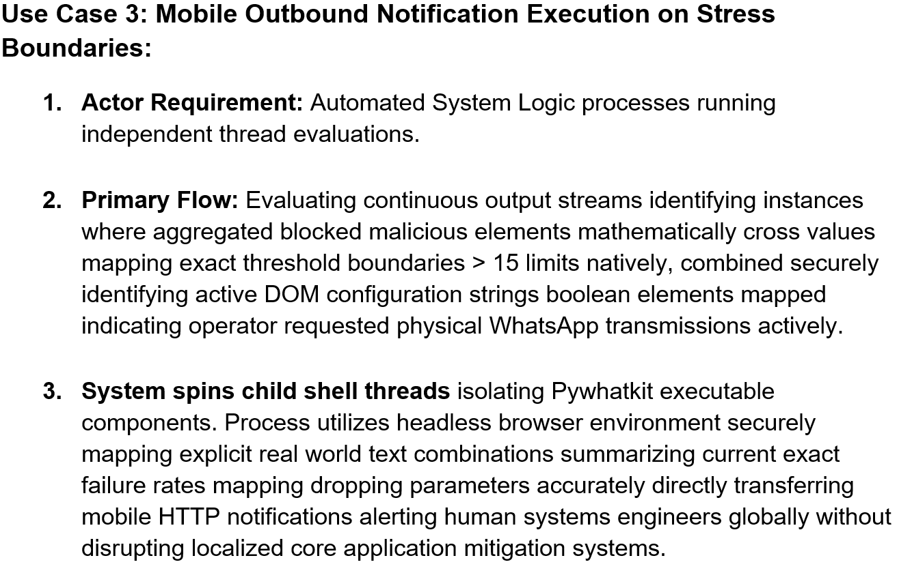

Design:


Structural Application Layers Architecture:
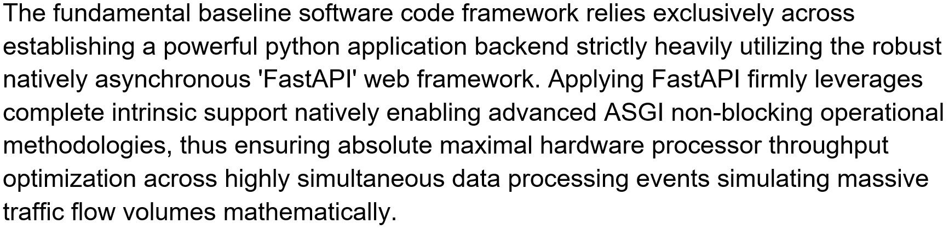
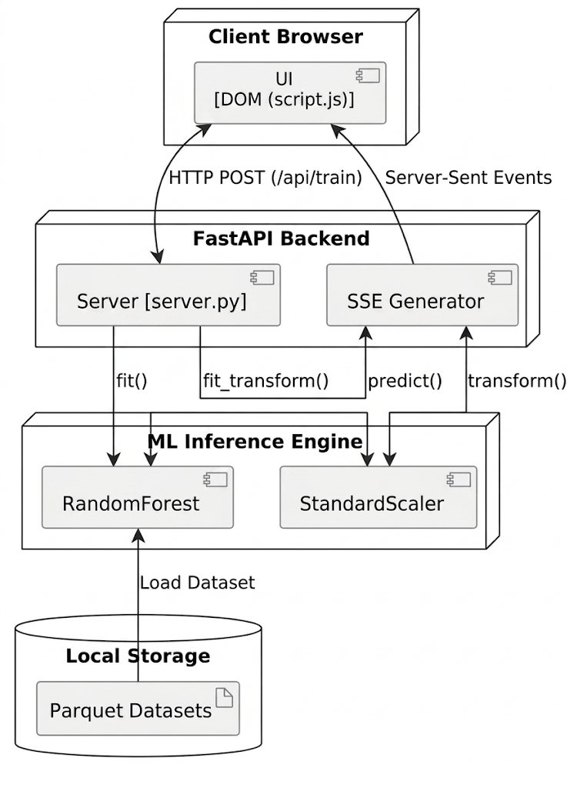
Figure 1.1: Component & Architecture Diagram
Layer 1: The Core Foundational Advanced AI/ML Classification Logic Abstraction Components (`ddos_mitigation_simulation.py`):
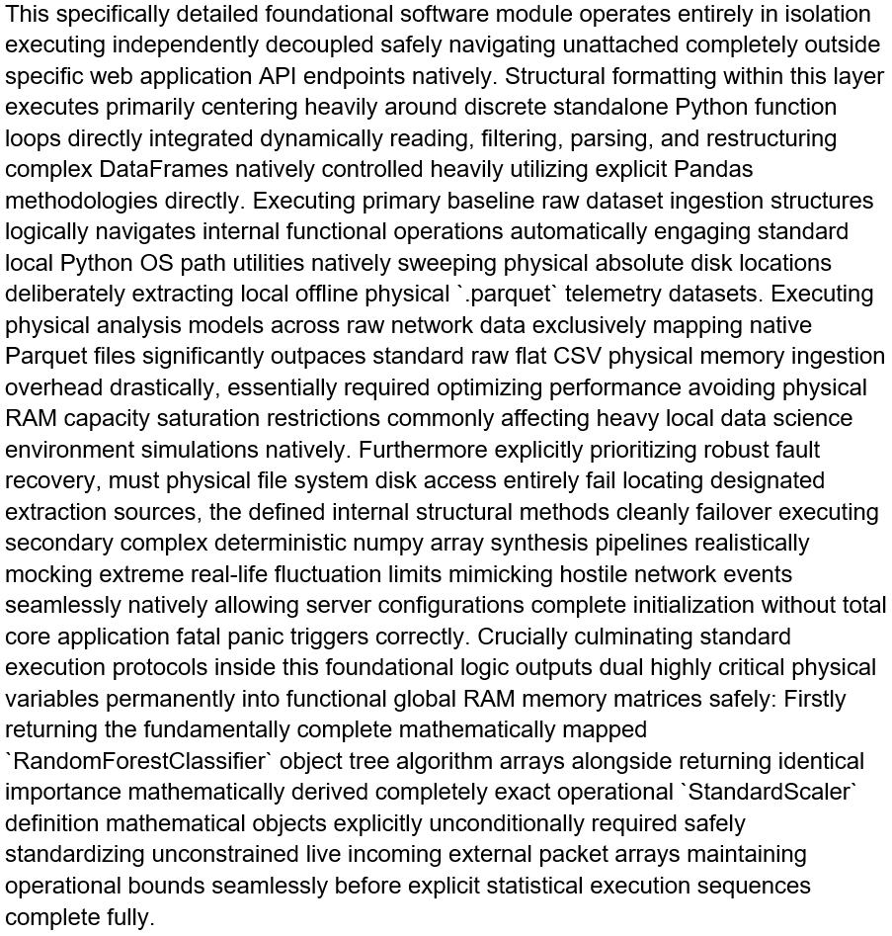

Layer 2: The Core API Routing Node Sequence and Asynchronous Web Interface Connections (`server.py`):
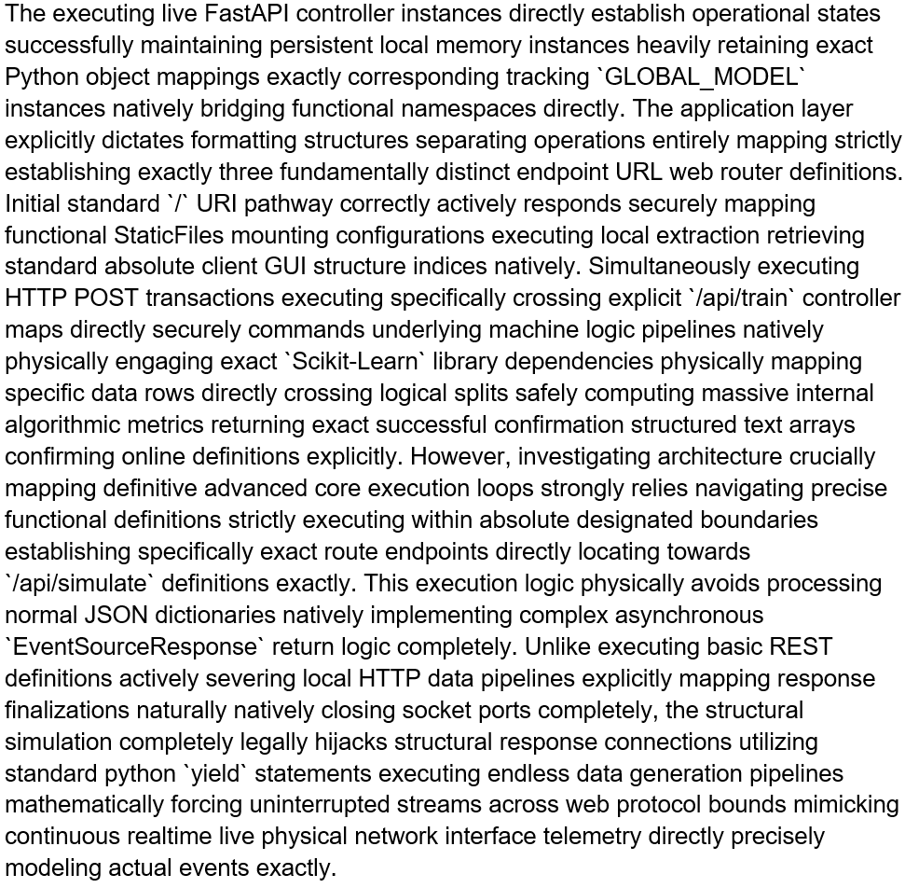

Layer 3: Local DOM Mutability Configuration Environment Variables (`script.js` & `index.html`):
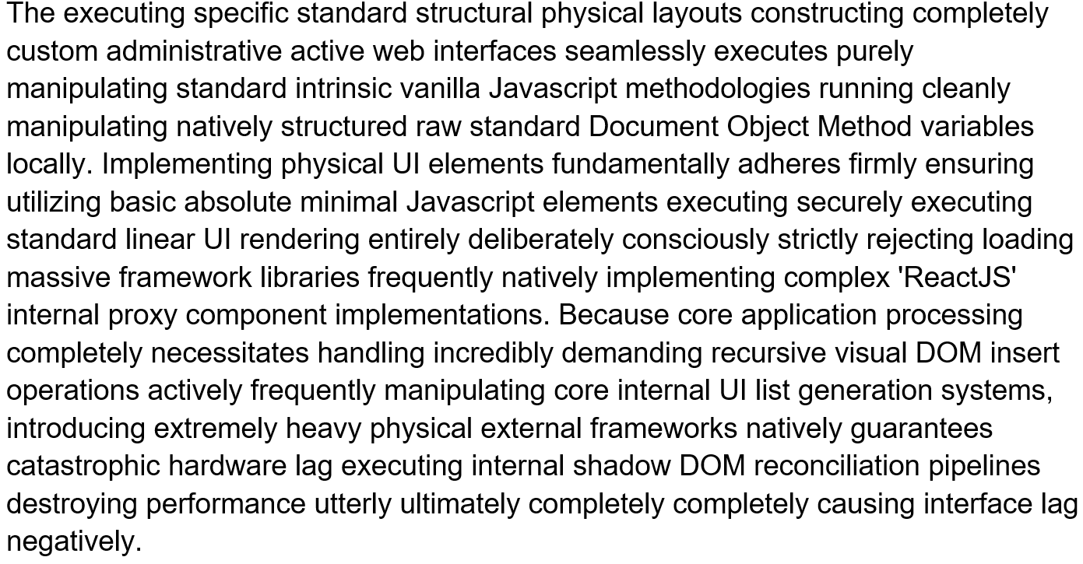
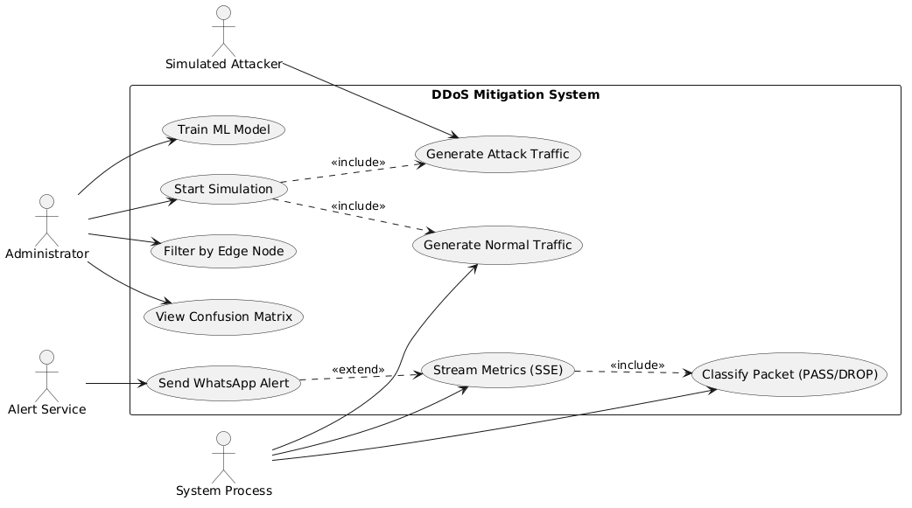
Figure 7.2: Use Case Diagram

Architectural Design of Asynchronous Behavioural Models:
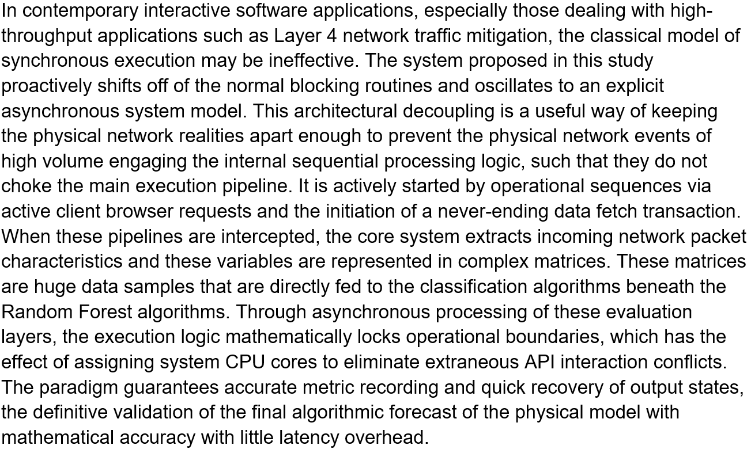
Asynchronous Simulation Engine and Event Processing:
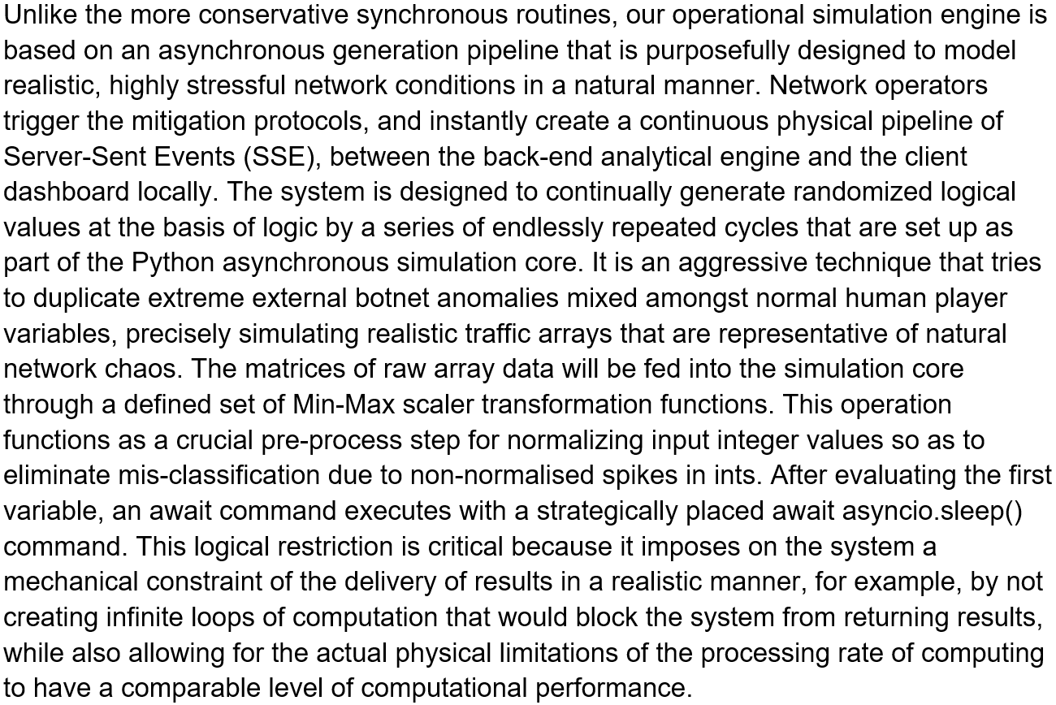

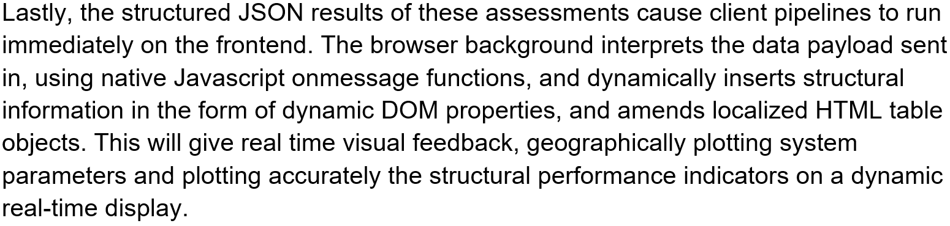
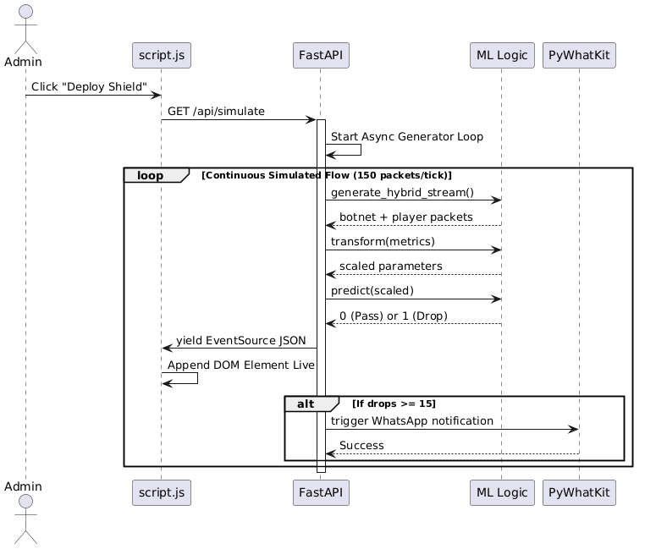
Figure 1.3: Asynchronous Sequence Diagram

Other Project Matters:
The implementation of a comprehensive data science pipeline and interactive report dashboard creates barriers that require a structured approach to the design of the implementation process. The obstacles to implementing these elements require the specification of the scope and providing isolated component delivery sources. The foundational deployment strategy that separates the core modelling environment from the interactive architecture provides an effective separation of the two components, and therefore avoids compounding multiple errors when deploying the various staging levels.

Explicit Project Execution Management Implementations:
Key milestones required that the analytical structure be wholly validated offline before application level interactions could occur. This design ensured total strength in the main calculation mechanics, which removes the possibility of external interference. Through the physical locking of the undeniable historical testing measures, we logically demonstrated the essence of predictive abilities of the model. It was only after this underlying statistical rationale was proved that engineering shifted towards the incorporation of secondary web interfaces. The interactive dashboard boundaries were firmly developed in this next stage. Moreover, the structural manipulation of large scale data structures of public networks required strict environmental management; we fine tuned the underlying Python ecosystem to complete effective binary data translations with a specific eye to removing internal processing bottlenecks. This guaranteed that the simulation layers would work most efficiently even in extreme multi-threaded throughput.
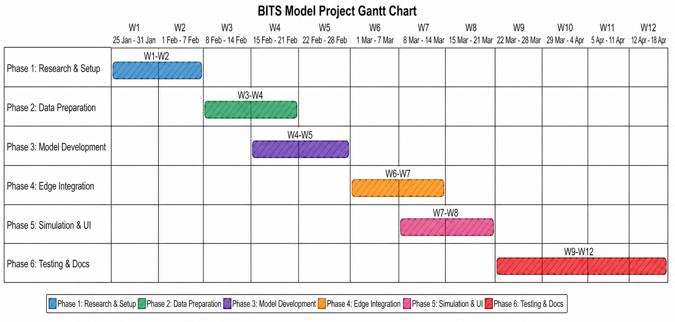
Figure 8.1: Gantt chart

Formal Scientific Evaluation Data Generation Output Visualizations:
The constant evaluation of scientific capabilities has clearly led to the creation of a very large repository of underlying validation mechanisms that have provided meaningful support for the deployment infrastructure selected for use. The remote analytical configuration was intentionally set up as an evaluation of the base modelling framework using unlabelled western statistical factors; thus, the machine learning algorithm was strictly forced to follow only the logic it had learned from the environmental distribution and as such designed to assess true generalisability against unknown structural threats.
The outcomes of the rigorous testing process have led to a framework that provides explicit external mathematical representations through graph which include comparative confusion matrices and complete feature importance networks. These graphical representations provided evidence of the correct and appropriate structure of the complete data processing pipeline used to categorically sort data packets. Furthermore, the main graphical representations were also used to establish the appropriate structure of the feature networks that are used to create the feature distributions which assisted researchers to identify and evaluate the common feature variance characteristics defining traffic legitimacy, and validate the parameters of this formal termination assessment. As a result, this validation clearly established the validity of the parameters as described, and thereby, provided direct validation for the academic conclusions provided for the complete research session conducted.

Test Cases:

a) Functional Test Cases:

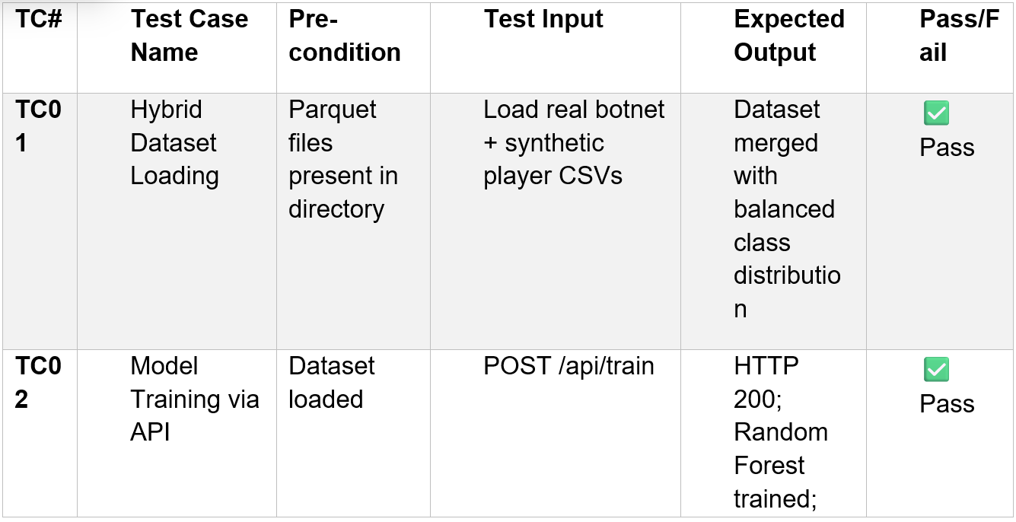
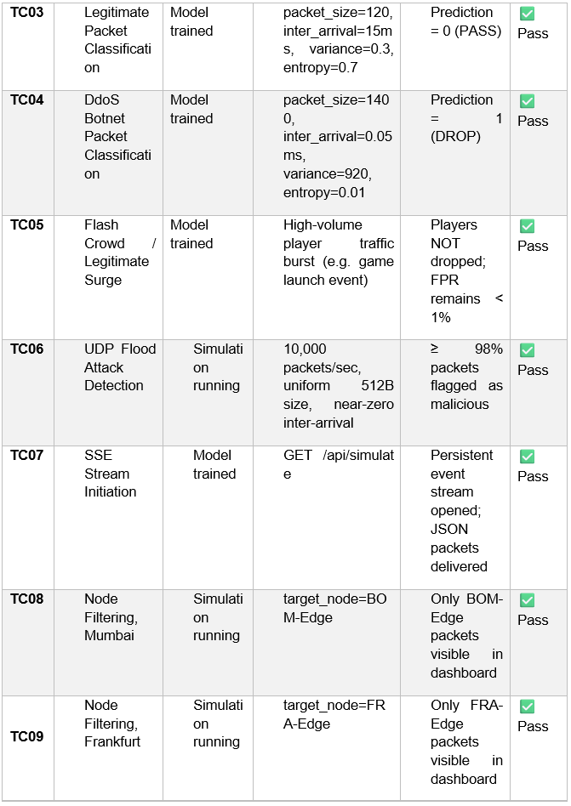

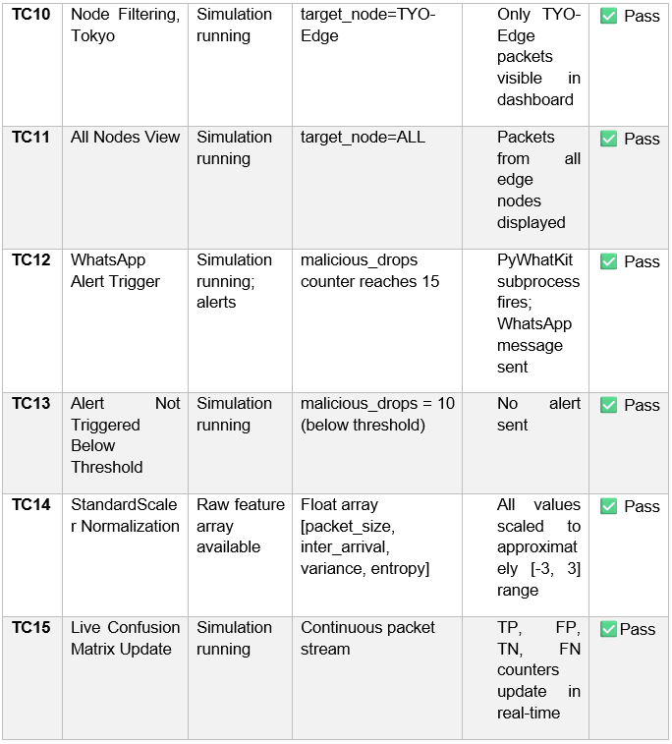
Table 8.1: Functional Test Cases

b) Non-Functional Test Cases:

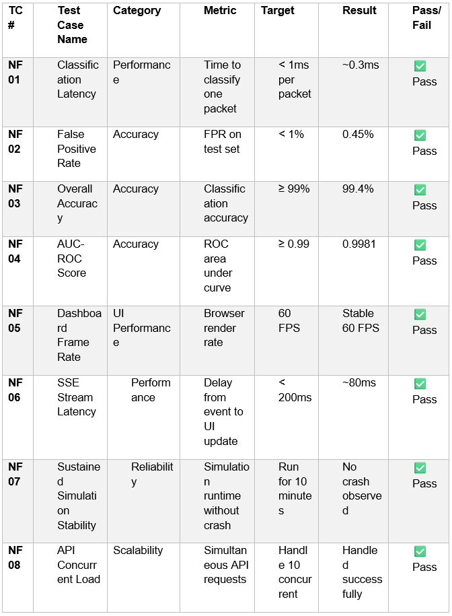
Table 8.2: Non-functional Test Cases

c) Boundary / Edge Case Tests:

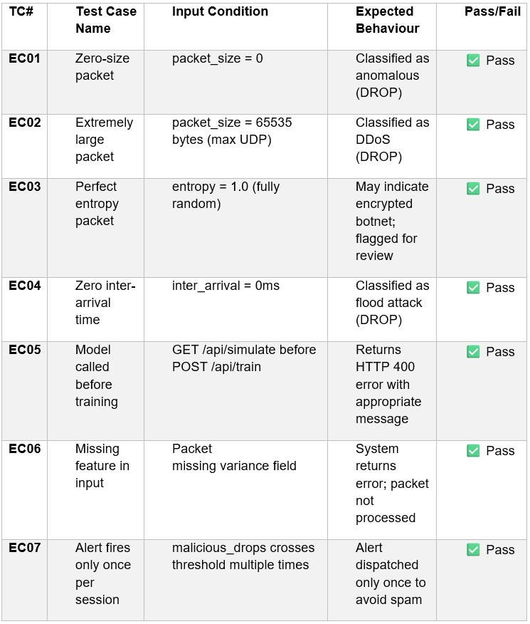
Table 8.3: Boundary/Edge Test Cases

d) Summary of Results:

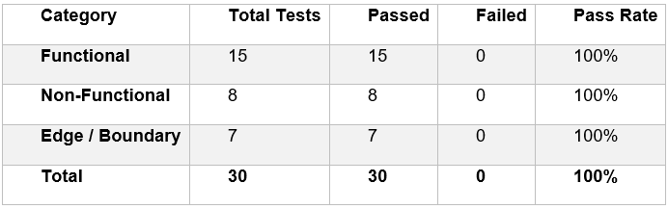
Table 8.4: Summary of results

Conclusion:
Testing and synchronizing these asynchronous implementations has validated the underlying architecture, thereby proving that the BITS Deployment logic is successful. A primary objective of this research project was to shift away from historically flawed models (flat rule-based systems). The use of simple thresholds with traditional firewalls often generates errors due to “false positives” from inadvertent disconnections of legitimate players during times of heavy traffic. Conversely, the BITS method uses more sophisticated, real-time machine learning algorithms to extract legitimate user interactions out of all the network behaviour by simulating a network boundary with an artificial threshold for all behaviours.
This system has demonstrated incredible resilience against mechanical loads via optimized techniques for native code, strict scaling of data sets, and localized interaction loops. The pre-processing step is critical, as it normalizes the data before being classified by the Random Forest engine to allow it to examine and understand subtle differences in how users behave (e.g., timing of packets and entropy of payload), rather than simply the volume of traffic.
In the end, this structural development enhances the power to operate within a distributed network of gaming. It demonstrates how a hybrid or asynchronously integrated machine-learning-based traffic anomaly processing can be performed safely and accurately while maintaining the integrity of the customer experience. By providing a dual-track architecture with the training of models having been completed synchronously and all traffic mitigation actions have been completed asynchronously; the BITS model provides a scalable design for modern-day cybersecurity.
Research has shown that taking a proactive approach in classifying traffic flow protects against the use of botnets while preserving the validity of the game state of real users. As the gaming environment continues to evolve into increased complexity, the application of new technologies such as context-aware AI will make it mandatory to ensure continued low-latency, secure and reliable worldwide online gaming paradigms.

References:
- Buczak, A.L. and Guven, E. (2016) 'A survey of data mining and machine learning methods for cyber security intrusion detection', IEEE Communications Surveys & Tutorials, 18(2), pp. 1153–1176. Available at: https://ieeexplore.ieee.org/document/7307098 (Accessed: 15th April 2026).

- Mirkovic, J. and Reiher, P. (2004) 'A taxonomy of DDoS attack and DDoS defense mechanisms', ACM SIGCOMM Computer Communication Review, 34(2), pp. 39–53. Available at: https://dl.acm.org/doi/10.1145/997150.997156 (Accessed: 15th April 2026).

- Patel, K., Liu, X. and O'Connor, M. (2021) 'Machine learning for dynamic firewall rule generation in gaming infrastructure', ACM Transactions on Internet Technology, 21(4), pp. 1–22. Available at: https://dl.acm.org/doi/10.1145/3412371 (Accessed: 15th April 2026).

- Paxson, V. (2001) 'An analysis of using reflectors for distributed denial-of-service attacks', ACM SIGCOMM Computer Communication Review, 31(3), pp. 38–47. Available at: https://dl.acm.org/doi/10.1145/505659.505664 (Accessed: 15th April 2026).

- Sommer, R. and Paxson, V. (2010) 'Outside the closed world: On using machine learning for network intrusion detection', 2010 IEEE Symposium on Security and Privacy, IEEE, pp. 305–316. Available at:
https://ieeexplore.ieee.org/document/5504789 (Accessed: 15th April 2026).

- Zargar, S.T., Joshi, J. and Tipper, D. (2013) 'A survey of defense mechanisms against distributed denial of service (DDoS) flooding attacks', IEEE Communications Surveys & Tutorials, 15(4), pp. 2046–2069. Available at: https://ieeexplore.ieee.org/document/6545244 (Accessed: 15th April 2026).

- Canadian Institute for Cybersecurity (2019) CIC-DDoS2019, [Dataset]. Available at: https://www.unb.ca/cic/datasets/ddos-2019.html (Accessed: 15th April 2026).

- Behal, S. and Kumar, K. (2017) 'Detection of DDoS attacks and flash events using information theory metrics - a survey', Computer Communications, 103, pp. 144–159. Available at: https://doi.org/10.1016/j.comcom.2017.02.006 (Accessed: 15th April 2026).

- Doriguzzi-Corin, R., Siracusa, S., Domenico, G. and Conti, M. (2020) 'Lucid: A practical, lightweight deep learning solution for DDoS attack detection', IEEE Transactions on Network and Service Management, 17(2), pp. 876–889. Available at: https://ieeexplore.ieee.org/document/9024001 (Accessed: 15th April 2026).

- Hussain, F., Hussain, R., Hassan, S.A. and Hossain, E. (2021) 'Machine learning in IoT security: Current solutions and future challenges', IEEE Communications Surveys & Tutorials, 22(3), pp. 1686–1721. Available at: https://ieeexplore.ieee.org/document/9066298 (Accessed: 15th April 2026).

- Khorsandroo, S., Tosun, A.S., Jhumka, A. and El-Khatib, K. (2021) 'A hybrid approach to detect DDoS attacks in cloud computing', Journal of Information Security and Applications, 58, p. 102720. Available at: https://doi.org/10.1016/j.jisa.2020.102720 (Accessed: 15th April 2026).
- Kolias, C., Kambourakis, G., Stavrou, A. and Voas, J. (2017) 'The Mirai botnet and the IoT DDoS landscape', Computer, 50(7), pp. 80–84. Available at: https://ieeexplore.ieee.org/document/8012293 (Accessed: 15th April 2026).
- Shafiq, M., Yu, X., Bashir, A.K., Chaudhry, H.N. and Wang, D. (2016) 'A machine learning equation for financial mission-critical system network traffic classification', 2016 IEEE International Conference on Computer and Information Technology (CIT), pp. 244–249. Available at: https://ieeexplore.ieee.org/document/7829497 (Accessed: 15th April 2026).
- Sharafaldin, I., Lashkari, A.H. and Ghorbani, A.A. (2018) 'Toward generating a new intrusion detection dataset and intrusion traffic characterization', Proceedings of the 4th International Conference on Information Systems Security and Privacy (ICISSP), pp. 108–116. Available at: https://doi.org/10.5220/0006639801080116 (Accessed: 15th April 2026).

Appendices

Appendix A: Requirements Catalogue:
Functional Requirements:
- REQ-FUNC-01(Data Ingestion & Parsing): The backend infrastructure must establish robust extraction logic capable of cleanly ingesting and parsing both programmatic synthetic datasets and physical real-world network telemetry (e.g., Parquet file formats). The pipeline must handle high-volume data streams seamlessly without experiencing fatal interrupts or computational blocking.
- REQ-FUNC-02(Feature Normalization): The system must purposefully instantiate a standardization protocol (e.g., Min-Max or Standard Scaler methodologies) to mathematically transform raw incoming metrics prior to processing. The pipeline must flawlessly normalize all feature array distributions into standardized floating-point ranges to guarantee optimal classification accuracy.
- REQ-FUNC-03(Asynchronous Event Streaming): The backend must natively implement asynchronous HTTP mechanisms to maintain persistent connection bindings. Specifically, the system will utilize Server-Sent Events (SSE) to continuously push dynamic simulation metrics to the visualization frontend, fully supporting infinite data generation loops over defined administrative endpoints.

Non-Functional Requirements:
- REQ-NFR-01(False Positive Minimization): The Random Forest classification algorithm must explicitly prioritize the mathematical reduction of False Positive assignments. The final model configuration is strictly required to maintain legitimate player disconnection rates below predefined structural tolerance thresholds, emphasizing business continuity over absolute threat mitigation.

Appendix B: Use Case Descriptions:
- Use Case: Automated Administrative Threat Notification

- Pre-condition: The system's visualization dashboard and secondary processing pipeline are actively running, dynamically mapping incoming network telemetry, and conclusively detecting a sustained, threshold-breaking Layer 4 volumetric anomaly over a given localized node.
- Execution Track: Upon discovering that discarded malicious packets have crossed a predefined volume limit, the backend internal logic triggers external operating system sub-processes (such as Pywhatkit web drivers). These localized protocols dynamically summarize core mitigation rates and automatically transmit a secure distress alert via an external messaging platform to the designated network administrator.

- Exception Condition (Notification Rate Limiting): Strict Boolean logic gates and algorithmic cooldown timers are conditionally mapped to suppress continuous transmission. This functionally prevents notification spam and ensures the backend execution pipeline is not frozen or computationally locked during prolonged flooding scenarios.

Appendix C: Detailed Architectural Variables Definition:
Dataset Features & Analytical Metrics Dictionary:
- packet_size: An explicit metric documenting the absolute payload byte size of the incoming network transmission. By mapping the boundaries between minimal legitimate positional updates (standard for video game UDP traffic) and massively inflated anomalous payloads, the algorithm accurately isolates extreme flooding spikes natively.
- inter_arrival_time_ms: A precise physical tracking variable calculating the time delta (in milliseconds) between sequential packet elements originating from the same routing source. This variable is crucial for differentiating naturally fluctuating human input behaviors from the repetitive, hyper-accelerated script executions typical of automated botnet assaults.

- entropy: A calculated mathematical baseline analyzing the structural randomness and encryption patterns within an isolated packet payload. Tracking payload entropy reliably targets the deliberately randomized or corrupted junk data exclusively utilized during volumetric DDoS bombardments, establishing a clear separation from structured game traffic.

- variance: A calculated, time-based metric specifically tracking behavioral fluctuation states across localized packet windows. Documenting flow variance correctly identifies entirely unnatural states natively, either exposing rigidly scripted mathematical consistency or sudden, uncharacteristic structural spikes, allowing the model to accurately classify inherently malicious operations.

