GT Automotives

BRD

October 7th , 2025

PROJECT OVERVIEW
GT Automotives is implementing a Vehicle Management System on Salesforce Automotive Cloud to streamline and unify its core business operations across Sales, Delivery, and Service. The solution will enable the company to efficiently manage the full sales lifecycle from lead to opportunity to close-won, capture and store delivery documentation within Salesforce, and maintain a comprehensive Customer 360 and Asset 360 view for enhanced customer engagement and vehicle tracking.
The system will also support end-to-end service processes, cover both scheduled maintenance and unscheduled repairs, while leveraging Cases and Work Orders to manage service operations effectively. By integrating these processes into a single platform, GT Automotives will ensure improved customer experience, operational transparency, and data-driven decision-making.

The key objectives of this implementation are to:
- Streamline Sales Processes – Manage leads, opportunities, and deals seamlessly from initiation through close-won within Salesforce.
- Digitize Delivery Operations – Enable the upload and management of delivery documents directly in Salesforce to ensure secure and centralized record-keeping.
- Enable Customer 360 & Vehicle 360 – Provide a single, comprehensive view of each customer and vehicle to strengthen customer relationships and track vehicle history.
- Enhance Service Management – Support both scheduled and unscheduled service processes by using Cases to track and capture customer interactions, and Work Orders to manage vehicle repairs, monitor parts consumption, and coordinate technician activities, ensuring accurate tracking, proper technician coordination, and timely resolution.
- Improve Customer Experience – Ensure consistent communication, timely updates, and transparency across sales, delivery, and service touchpoints.
- Enable Better Insights – Provide dashboards and reports for leadership and operations teams to monitor performance, service quality, and customer satisfaction.

CURRENT PROCESS
The end-to-end customer journey is structured into three core processes: Sales, Delivery, and Service. Each process represents a distinct stage in managing the customer lifecycle, from lead acquisition and vehicle purchase to handover and after-sales support.

SALES PROCESS
- Lead is captured from any source.
- Lead is auto-assigned to a Sales Advisor (round-robin).
- Sales Advisor contacts lead within 24 hours; SLA breach if delayed.
- Conversation notes are logged in Salesforce.
- Quotation may be requested by the lead.
- Sales Advisor drafts quotation and submits to Sales Manager.
- Sales Manager reviews and returns quotation for lead sharing.
- Quotation is stored in Salesforce as a document.
- Test drive is scheduled if requested.
- Lead pays deposit to reserve vehicle.
- Deposit receipt is recorded in Salesforce.
- Order is created in Salesforce.
- Vehicle is linked to the order.
- Vehicle is prepared for delivery.
- Responsibility is handed over to Delivery team.

DELIVERY PROCESS
- Delivery Advisor conducts Pre-Delivery Inspection (PDI).
- Delivery-related information is captured.
- Paperwork is prepared (registration, insurance, number plates, etc.).
- Delivery date is scheduled and confirmed with the customer.
- Vehicle is delivered on the confirmed date.

SERVICE PROCESS
The service process is divided into scheduled and unscheduled process
A. Scheduled Process
This stream covers scheduled maintenance services triggered by mileage or cadence-based reminders.
- Service Advisor schedules appointment based on cadence (e.g., mileage).
- Customer brings vehicle in.
- Vehicle inspection is performed and findings recorded.
- If no issues found, vehicle is returned after recording inspection details.
- If issues found, Service Advisor creates a Case.
- Technician diagnoses the issue.
- Technician informs Service Advisor and Service Manager.
- Parts ordered via Parts Advisor after customer approval.
- Service Advisor explains issue, repair cost, and warranty coverage to customer.
- Service Advisor prepares and shares quotation with customer.
- Upon approval, technician begins repair.
- Technician completes repair, updates the Service Advisor, and hands the vehicle back.
- Service Advisor updates the Work Order, processes payment, and returns the vehicle to the customer.
B. Unscheduled Process
This stream covers unscheduled vehicle repairs, including breakdowns and customer-reported issues.
- Customer calls Service Advisor to report repair or breakdown.
- Service Advisor and customer schedule vehicle drop-off.
- Service Advisor inspects vehicle and creates Case.
- Technician diagnoses the issue.
- Technician informs Service Advisor and Service Manager.
- Parts ordered via Parts Advisor after customer approval.
- Service Advisor explains issue, repair cost, and warranty coverage to customer.
- Service Advisor prepares and shares quotation with customer.
- Upon approval, technician begins repair.
- Technician completes repair, updates the Service Advisor, and hands the vehicle back.
- Service Advisor updates the Work Order, processes payment, and returns the vehicle to the customer.

PROCESS ALIGNMENT WITH CURRENT FLOW
The future-state process to be implemented in Salesforce must replicate the existing business workflows followed by the client. Every step, decision point, and role-based responsibility from the current process has been mapped and documented in this BRD. The Salesforce solution will mirror these flows without altering the sequence or ownership of activities, ensuring that users experience a systemized version of their current operational practices.

IDENTIFIED PAIN POINTS

Pain Point | Key Issues
Data Entry into Excel | Manual entry causes errors, duplication, data loss; not scalable for large volumes.
Data Inconsistency | Separate spreadsheets with varying formats lead to inconsistent data and unreliable reporting.
Difficulty in Tracking | Manual tracking is time-consuming, error-prone, and lacks visibility into case progress.
Risk of Data Loss | Spreadsheets may be deleted, overwritten, or corrupted; no backup/version control.
Time-Consuming Processes | Excessive manual effort in entry, validation, and coordination reduces productivity.
Compliance & Audit Challenges | Hard to maintain accurate logs for audits, compliance, and warranty verification.
Customer Experience Impact | Errors and delays affect service quality, causing miscommunication and repeated info requests.

FUNCTIONAL REQUIREMENTS

User Roles and Responsibilities
Role | Responsibility
General Manager | Oversees all processes with read-only access; views reports and dashboards.
Sales Manager | Oversees the sales process; approves/ rejects cancellation requests; monitors performance via reports and dashboards.
Service Manager | Oversees service operations; approves service requests; access reports/dashboards.
Marketing Manager | Oversees marketing processes; monitors campaigns and performance via dashboards.
Finance Manager | Handles all financial activities, including refunds and approvals.
Sales Advisor | Manages leads and opportunities through delivery.
Delivery Advisor | Manages all vehicle delivery-related activities.
Marketing Coordinator | Supports marketing activities and campaign execution.
Service Advisor | Manages customer service interactions, cases & work order creation, and scheduling.
Technician | Diagnoses and repairs vehicles as per service requirements.
Parts Advisor | Manages parts inventory, availability, and ordering for service/repairs.

Role Hierarchy Diagram

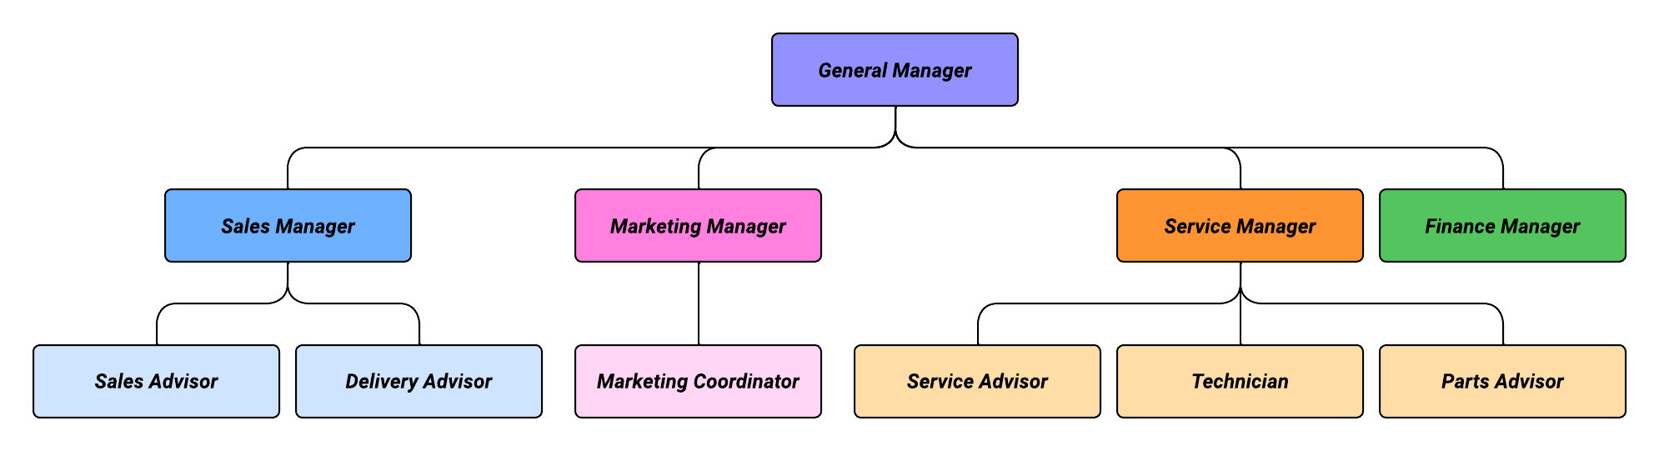

Sales Process

Lead Management
The lead management process within Salesforce for GT Automotive begins with the creation and capture of leads from multiple sources. The following channels have been identified:
Lead Source | How is it captured in Salesforce?
Walk-in | Leads manually created in Salesforce by the Sales Advisor when potential customers visit the dealership.
Referral | Leads manually recorded in Salesforce by the Sales Advisor, similar to walk-ins.
Website | Webform captures basic details (First Name, Last Name, Email ID, Comments) and automatically creates the lead via Web-to-Lead.
Campaign | Prospects receive a QR code linking to the website form; submission follows the same Web-to-Lead process as website leads.
Social Media | Data captured via social media activities is consolidated in Excel and uploaded into Salesforce using the Data Import Wizard.

Within the sales pipeline, each lead progresses through defined statuses, with key fields tracked at each stage:
Status | Description | Key Fields
New | A newly created lead that has not yet been contacted. | Lead Source, Lead Owner, Phone
Contacted | GT Automotive has initiated communication by calling the lead. | Contacted Date
Engaged | Two-way communication is established; the lead has responded. | Test Drive Scheduled (Y/N), Test Drive Date, Quotation Sent (Y/N), Upload Quotation

Upon completion of the engagement phase, the lead is converted into opportunity, which is covered in the subsequent section of this BRD.
To support the lead management process, the following features are enabled on the Lead object:
- Notes functionality to capture additional information.
- Chatter for collaboration and updates.
- Reminders and task creation to ensure timely follow-up.

Test Drive Scheduling
- During the Engaged stage of a lead, the Sales Advisor will schedule a test drive for the customer.
- The following details will be captured on the Lead object:
  - Customer's vehicle preference: color, model, and trim
  - Appointment date and time for the test drive

Unresponsive Lead Management
Leads that do not respond to follow-up calls will be managed systematically to ensure timely closure and revisit.
Process:
- Call within 24 hours – If there is no response, proceed to step 2.
- Call again after 3 days – If no response, proceed to step 3.
- Call again after another 3 days – If no response, proceed to step 4.
- Call again after 7 days – If no response, close the Lead by selecting the reason for the lead closure under the “Reasons for Lead Closure” picklist value.

Additional Notes / Fields:
- Add a field on the Lead object called “Revisit Lead in 3 Months” (checkbox).
- This checkbox can be selected when closing the Lead to flag it for follow-up but it is not mandatory.

Lead to Opportunity Conversion
A lead is converted to an opportunity once the customer commits to purchasing a vehicle by paying the required deposit. Conversion can occur under two scenarios:
- Reservation Fee Paid = Yes → The customer has paid the required deposit for the vehicle.
- Reservation Fee Paid = No (Trusted Customer) → Trusted customers are permitted to proceed directly to opportunity creation without paying a deposit. In this case, the Reservation Comment field must capture the reason for bypassing the deposit.
Conversion Trigger
- Field: Deposit Paid? (Values: Yes / No)
- This field is mandatory for conversion.
Conversion Outcome
During conversion, the following records are created and/or linked:
- Account – Created if it does not already exist; otherwise, linked to an existing record.
- Contact – Created if it does not already exist; otherwise, linked to an existing record.
- Opportunity – Always created as part of conversion.
The original Lead record is closed once conversion is complete.

Opportunity Management
Opportunities at GT Automotives track the sales process from order confirmation to delivery. Each stage captures key fields required to monitor progress and ensure smooth operations. Sales Advisors are responsible for updating the opportunity at each stage to ensure accurate tracking and timely progression through the sales cycle.
Within the sales pipeline, each opportunity progresses through defined stages, with key fields tracked at each stage:
Stage | Description / Purpose | Key Fields
Order Confirmed | Opportunity is confirmed by the customer. Vehicle details and expected delivery are recorded which triggers a task for the delivery team to prepare vehicle for delivery. | VIN Number, Engine Number, Trim, Color, Expected Delivery Date
Payment in Progress | The payment process is underway; invoices and payment details are tracked. | Payment Method, Invoice Sent? Upload Invoice, Total Amount, Receipt Number
Ready for Delivery | Vehicle is prepared for delivery to the customer. Documents and insurance are verified. | Actual Delivery Date, Handover Form, Warranty Document, Registration Form, Insurance Confirmed?
Closed Won – Delivered | Opportunity successfully completed; vehicle delivered to the customer.
Closed Lost – Cancelled | Opportunity was not completed; order cancelled.

Vehicle Cancellation

Vehicle cancellations can occur either at the Lead stage (before conversion) or at specific Opportunity stages after deposit payment. The process ensures proper tracking, approvals, and refunds while maintaining accurate Salesforce records.

1. Cancellation Process on Lead
- If the customer decides not to proceed during the Engaged stage or before lead conversion, the lead is simply closed.
- No “Cancel” button is required at the lead stage.
- Deposit Policy:
  - Customers may pay a reservation fee to secure their vehicle and priority in allocation.
  - The deposit is fully refundable until vehicle registration begins & this is done offline outside Salesforce.
Note: The entire lead cancellation process is carried out outside Salesforce. The only action performed within Salesforce is the manual closure of the Lead by the Sales Advisor.

2. Cancellation Process on Opportunity
Step | Action | Details / Notes
1 | Customer requests cancellation | Customer informs Sales Advisor/GT Auto of their intent to cancel. Only possible before vehicle registration.
2 | Log cancellation in Salesforce | The Sales Advisor records the request under the Opportunity record by clicking on the “Cancel Reservation” button.
3 | Internal Review | When button is clicked, a pop-up opens up with the following fields:  - Cancellation - Sales Advisor updates the value to “Pending Cancellation”  - Reason for cancellation  - Reservation Fee Amount
4 | Manager Approval | Salesforce automatically routes a notification/task to the Sales Manager. Manager reviews details and confirms eligibility. Status updated to: Approves for Refund.

Note: Cancel Reservation button is available on Opportunity stages: Order Confirmed and Payment in Progress.

Refund Process
- Once the sales manager approves, the Finance team is notified.
- The finance team will process the refund (bank transfer/cheque).
- Refund confirmation is uploaded/attached to the Salesforce record.
- Sales Advisor updates the record status to “Cancelled – Refunded.”
- Customer receives an email confirming cancellation and refund (outside Salesforce).
- Opportunity is marked as Closed Lost with “Cancelled Reservation” as the Reason for Loss.

DELIVERY PROCESS
1. Pre-Delivery
- The Delivery Advisor enters the vehicle registration number once registration is completed in Opportunity record.
2. Delivery Day
- Delivery Advisor uploads signed handover, registration, and warranty documents into the Opportunity record.
3. Post-Delivery
- Delivery Advisor enters the actual delivery date in the Opportunity record.
- This triggers:
  - Creation of a sub-task for the Service team.
  - Automated thank-you email with customer survey within 24 hours.

SERVICE PROCESS
There are two types of service processes:
- Scheduled Service – This occurs when the vehicle is brought in for maintenance based on predefined milestones. The Service Advisor proactively contacts the customer to schedule the service in line with the vehicle’s maintenance schedule.
- Unscheduled Service – This occurs when repair is needed due to unforeseen issues, such as accidents or breakdowns. In this case, the customer initiates contact with the Service Advisor to request assistance.

Scheduled Service — Step by step
Introduction Call: Within 5 business days of vehicle delivery, the Service Advisor contacts the customer to introduce themselves and explain the service cadence the vehicle will follow and sets a reminder to follow up to schedule the first maintenance appointment.
Step 1: After this initial call, the Service Advisor follows the maintenance schedule milestones and sets reminders to contact the customer at each milestone
Step 2: The Service Advisor validates customer information (Email ID, VIN, or Registration Number) and creates a Case by entering the required details.
Following are the fields entered in Case:
- Types of Service
- Type of Cases
- Concern (text field)
- Cause (text field)
- Correction (text field)
- Current Mileage (km) (text field)
- Requested Completion date
- Is the car off-road
Step 3: A notification is sent to the Service Manager to review the vehicle service.
Step 4: The Service Manager consults the technician to determine the scope of work required.
Step 5: The Service Manager records notes on the Case and instructs the Service Advisor to create a Work Order.
Step 6: The Service Advisor receives a notification via email & within salesforce, reviews the Manager’s notes, updates the notes fields and then closes the Case, and opens a Work Order.
Step 7: The Service Advisor books a customer appointment through their calendar for vehicle drop-off.
- The calendar has the following details: Customer’s Name, Technician’s Name, Duration of the work.
- If the appointment isn't soon, the Service Advisor sends the customer a reminder 24 hours before the vehicle drops off.
Step 8: Customer delivers the vehicle to the service center.
Step 9: The Service Advisor inspects the vehicle, completes the intake checklist, and uploads it to the Work Order.
Step 10: The Service Advisor communicates to the technician offline that the vehicle is available for service.
Step 11: The technician inspects the vehicle, assesses the repairs needed, and determines whether parts will be required
At this stage, a decision is made on whether parts are required. The subsequent processes for both scenarios are outlined side by side in the below table
Parts Not Needed | Parts Needed
Step 12: Service Advisor adds Work Order line items for required work based on conversation with Technician. | Step 12: Service Advisor contacts Parts Advisor for availability of parts. Work Order is placed on hold until part or technician is available.
Step 13: Service Advisor prepares a quotation in Salesforce. | Step 13: Service Advisor adds Work Order line items for required work based on conversation with Technician.
Step 14: Quotation is sent to the customer for approval. | Step 14: Service Advisor prepares quotation in Salesforce.
Step 15: Once approved, Service Advisor notifies technician to begin work. | Step 15: Quotation is sent to customer for approval.
Step 16: Technician completes the work and hands vehicle to Service Advisor. | Step 16: Once approved, Service Advisor notifies technician to begin work.
Step 17: Service Advisor schedules appointment for customer pickup. | Step 17: Technician completes the work and hands vehicle to Service Advisor.
Step 18: Service Advisor prepares vehicle outtake list. | Step 18: Service Advisor schedules appointment for customer pickup.
Step 19: Invoice is generated and uploaded to Salesforce; customer pays before or at pickup. | Step 19: Service Advisor prepares vehicle outtake list.
Step 20: Customer collects vehicle from Service Advisor. | Step 20: Invoice is generated and uploaded to Salesforce; customer pays before or at pickup.
Step 21: Service Advisor adds the vehicle outtake list to the Work Order and updates the reference number in the receipt field as proof of payment in Salesforce. | Step 21: Customer collects vehicle from Service Advisor.
 | Step 22: Service Advisor adds the vehicle outtake list to the Work Order in Salesforce.
Note: An asset can only have one active work order at any given time.

Unscheduled Service — Step by Step
Step 1: Customer contacts the Service Advisor to request vehicle repair.
Step 2: Service Advisor validates customer information (Email ID, VIN, or Registration Number) and creates a Case by entering the required details.
Case Fields:
- Type of Case
- Complaint (text field)
- Cause (text field)
- Correction (text field)
- Current Mileage (km) (text field)
- Requested Completion Date
- Is the car off-road?
Step 3: Service Advisor attempts to resolve the customer’s concern over the call by triaging the issue.
Step 4:
- If resolved on call → Case is closed with relevant notes captured detailing the reason or issue encountered.
- If not resolved → Case remains open.
Step 5: Notification is sent to the Service Manager to review the case and customer complaint.
Step 6: Service Manager consults the technician to determine the scope of work required.
Step 7: Service Manager records notes on the Case and instructs the Service Advisor to create a Work Order.
Step 8: The Service Advisor receives a notification via email & within salesforce, reviews the Manager’s notes, updates the notes fields and then closes the Case. Also, if the manager mentions to open a Work Order they go ahead and open one.
Step 9: Service Advisor books a customer appointment through the calendar for vehicle drop-off.
- Calendar details: Customer Name, Technician Name, Duration of work.
- If the appointment is not soon, a reminder is sent to the customer 24 hours before drop-off.
Step 10: Customer delivers the vehicle to the service center.
Step 11: Service Advisor inspects the vehicle, completes the intake checklist, and uploads it to the Work Order.
Step 12: Service Advisor communicates to the technician offline that the vehicle is available for service.
Step 13: Technician inspects the vehicle to identify the root cause of the issue and determines whether any parts are needed.
At this stage, a decision is made on whether parts are required. The subsequent processes for both scenarios are outlined side by side in the below table

Parts Not Needed | Parts Needed
Step 14: Service Advisor adds Work Order line items for required work based on conversation with Technician. | Step 14: Service Advisor contacts Parts Advisor for availability of parts. Work Order is placed on hold until part or technician is available.
Step 15: Service Advisor prepares quotation in Salesforce. | Step 15: Service Advisor adds Work Order line items for required work based on conversation with Technician.
Step 16: Quotation is sent to customer for approval. | Step 16: Service Advisor prepares quotation in Salesforce.
Step 17: Once approved, Service Advisor notifies technician to begin work. | Step 17: Quotation is sent to customer for approval.
Step 18: Technician completes the work and hands vehicle to Service Advisor. | Step 18: Once approved, Service Advisor notifies technicians to begin work.
Step 19: Service Advisor schedules appointment for customer pickup. | Step 19: Technician completes the work and hands vehicle to Service Advisor.
Step 20: Service Advisor prepares a vehicle outtake list. | Step 20: Service Advisor schedules appointment for customer pickup.
Step 21: Invoice is generated and uploaded to Salesforce; customer pays before or at pickup. | Step 21: Service Advisor prepares vehicle outtake list
Step 22: Customer collects vehicle from Service Advisor. | Step 22: Invoice is generated and uploaded to Salesforce; customer pays before or at pickup.
Step 23: Service Advisor adds the vehicle outtake list to the Work Order and updates the reference number in the receipt field as proof of payment in Salesforce. | Step 23: Customer collects vehicle from Service Advisor.
 | Step 24: Service Advisor adds the vehicle outtake list to the Work Order in Salesforce.
Note: An asset can only have one active work order at any given time.

INVENTORY MANAGEMENT
Inventory Management tracks vehicle inventory for cars and trucks. The system uses three objects: Product, Vehicle Definition, and Vehicle. Product represents the vehicle category, e.g., BYD cars or Foton trucks, and includes fields like Name, Vehicle Type (Car/Truck), and Total Stock (calculated from child Vehicle records). Vehicle Definition is a child of Product and stores detailed specifications, including Model, Engine, Transmission, Fuel Type, Features, and Stock Availability (picklist: In Stock / Out of Stock). A vehicle is a child of Vehicle Definition and represents individual vehicles, capturing Trim, Model Year, Color, VIN, Status (Available / Sold / Booked), Registration Number, and Location.
The system will manage Parts, Products, and Price books in Salesforce to ensure accurate inventory tracking, pricing, and sales operations. Parts will be maintained with details like Part Number, Description, Serial Number, Quantity, and Costs. Products will be created with appropriate record types and linked to relevant parts where applicable. Price books will store selling prices for products and parts, including VAT calculations, and updates will reflect across related Work Order Line Items to ensure accurate quotations and invoices. This configuration ensures visibility, traceability, and efficient management of inventory and pricing processes.
The system must track stock in real-time, maintain detailed specifications, allow reservation or booking of vehicles, and generate reports by Product, Vehicle Definition, and Status. Only authorized users can update vehicle records or change statuses. Stock Availability at the Vehicle Definition level must reflect the actual count of Vehicles. Booked vehicles cannot be reassigned unless released. Inventory details of vehicles & parts will be migrated into Salesforce via Data Import Wizard for smaller volumes or Data Loader for bulk data, depending on the number of records.

REPORTS & DASHBOARDS
The Salesforce solution statuses will provide real-time visibility into sales, delivery, and service processes through configurable reports and dashboards. These will enable leadership and operational teams to make data-driven decisions, track performance, and identify areas for improvement.

List of Reports
Sales Advisor
Reports visibility – Sales Advisor, Sales Manager
Report Name | Purpose | Report Type | Filters | Fields
Leads by Status | Track lead progress through different stages to monitor conversion pipeline. | Leads (Standard Object) | Status = All (with ability to drill down by individual statuses)  Date Created = Last 12 months (or configurable) | Lead ID, Lead Name, Lead Source, Status (New, Contacted, Engaged, Converted, Cancelled), Owner, Created Date
Opportunities by Stage | Provide visibility into deal pipeline and revenue potential by stage. | Opportunities (Standard Object) | Stage = All (with grouping by Stage)  Close Date = Current Quarter (default) | Opportunity ID, Opportunity Name, Stage (Qualification, Quotation Sent, Test Drive, Closed Won, Lost), Amount, Owner, Close Date
Reservation Fee Status (Collected vs. Pending) | Monitor collected vs. pending reservation fees to track customer commitment. | Opportunities / Payments | Reservation Fee Status = All  Payment Date = Last 12 months (or configurable) | Opportunity ID, Customer Name, Vehicle Model, Reservation Fee Amount, Reservation Fee Status, Payment Date
Test Drive Scheduled vs. Completed | Track customer engagement and follow-through on test drives. | Test Drives / Activities | Scheduled Date = Last 12 months (or configurable)  Status = All | Test Drive ID, Customer Name, Vehicle Model, Sales Advisor, Scheduled Date, Status (Scheduled, Completed, Cancelled)
Quotations Sent vs. Pending | Ensure timely quotation submission and follow-up with customers. | Quotations | Quotation Status = All  Created Date = Last 12 months (or configurable) | Quotation ID, Customer Name, Vehicle Model, Quotation Amount, Quotation Status (Sent, Pending), Created Date, Sales Advisor
Missed SLA Report – leads not contacted within 24 hours (highlighted in red) | Help sales advisors plan daily/weekly customer interactions and follow-ups. | Activities (Standard Object) | Activity Type = Call  Scheduled Date = Next 24 hours | Activity ID, Related Lead/Opportunity, Customer Name, Activity Type, Scheduled Date, Owner, Status

Delivery Advisor
Reports visibility – Delivery Advisor, Sales Manager
Report Name | Purpose | Report Type | Filters | Fields
Vehicles Assigned per Opportunity | Track vehicles assigned to customer opportunities. | Opportunities / Vehicles | Assigned Date = Last 12 months (or configurable) | Opportunity ID, Vehicle ID, VIN, Model, Customer Name, Assigned Date
Reservation Fee Status (Paid / Refunded / Applied) | Monitor reservation fee lifecycle across payment stages. | Payments | Fee Status = All  Date = Last 12 months (or configurable) | Payment ID, Opportunity ID, Customer Name, Vehicle Model, Fee Status (Paid, Refunded, Applied), Amount, Date
Orders Ready for Delivery (pre-delivery completed, pending delivery date) | Monitor orders that are ready for delivery but pending final scheduling. | Orders | Delivery Status = Ready  Pending Delivery Date = Next 30 days | Order ID, Customer Name, Vehicle Model, Delivery Status, Pre-delivery Completion Flag, Pending Delivery Date
Final Payment Status (Collected vs. Pending) | Track final payments collected vs. pending. | Payments | Status = All  Date = Last 12 months (or configurable) | Payment ID, Customer Name, Vehicle Model, Final Payment Amount, Status (Collected, Pending), Date
Delivery Dates & Delays – actual vs. scheduled | Track delays in deliveries compared to scheduled dates. | Deliveries | Status != Closed  Created Date = Last 12 months (or configurable) | Delivery ID, Order ID, Customer Name, Vehicle Model, Scheduled Date, Actual Date, Delay (Days)
Upcoming Deliveries – vehicles scheduled for delivery within the next 7 days | Provide visibility into upcoming deliveries within the next 7 days. | Deliveries | Scheduled Delivery Date = Next 7 days | Delivery ID, Vehicle Model, Customer Name, Scheduled Delivery Date, Delivery Status

Service Advisor
Reports visibility – Service Advisor
Report Name | Purpose | Report Type | Filters | Fields
Open Service Cases by Status (New, Scheduled, In Progress) | Service cases and their current status. | Service Cases | Status != Closed  Created Date = Last 12 months (or configurable) | Case ID, Customer Name, Vehicle Model, Status, Advisor, Created Date  Purpose: Monitor workload and case resolution by advisor.
Appointments Scheduled vs. Completed | Track customer service appointments and completion rate. | Appointments | Date = Last 12 months (or configurable)  Status = All | Appointment ID, Customer Name, Vehicle Model, Date, Status (Scheduled, Completed, Cancelled)
Average Response Time per Service Case | Measure service response efficiency. | Service Cases | Created Date = Last 12 months (or configurable) | Case ID, Customer Name, Created Date, First Response Date, Response Time (Hours)
Average Repair/Service Completion Time | Measure repair/service turnaround time. | Service Cases | Start Date = Last 12 months (or configurable) | Case ID, Customer Name, Vehicle Model, Start Date, Completion Date, Duration (Hours/Days)
SLA Violations / Escalations | Track SLA breaches and escalated cases for service accountability. | Service Cases | SLA Breach Flag = True  Created Date = Last 12 months (or configurable) | Case ID, Customer Name, Vehicle Model, SLA Breach Flag, Escalation Status, Owner, Created Date

Sales Manager
Reports visibility – Sales Manager

Report Name | Purpose | Report Type | Filters | Fields
Open / Closed Service Cases by Advisor | Monitor workload and case resolution by advisor. | Service Cases | Created Date = Last 12 months (or configurable) | Case ID, Customer Name, Vehicle Model, Status, Advisor, Created Date  Purpose: Monitor workload and case resolution by advisor.
SLA Compliance & Violations | Track SLA compliance across service cases. | Service Cases | Created Date = Last 12 months (or configurable) | Case ID, Customer Name, SLA Breach Flag, Response Time, Completion Time, Advisor
Average Diagnosis & Repair Time | Evaluate average time taken for diagnosis and repairs. | Service Cases | Start Date = Last 12 months (or configurable) | Case ID, Vehicle Model, Start Date, Completion Date, Duration (Hours/Days)
Parts Usage & Stock Requests | Monitor parts usage and demand for inventory management. | Parts Inventory / Requests | Request Date = Last 12 months (or configurable) | Part ID, Request ID, Vehicle Model, Quantity Requested, Quantity Used, Stock Status
Customer Feedback / Satisfaction Reports | Track customer satisfaction and service quality. | Surveys / Cases | Date = Last 12 months (or configurable) | Survey ID, Case ID, Customer Name, Rating, Feedback Comments, Date

Marketing Manager/ Marketing Coordinator
Reports visibility – Marketing Manager, Marketing Coordinator
Report Name | Purpose | Report Type | Filters | Fields
Total Leads by Source (Website, Social Media, Events, Referrals) | Track leads generated from various channels. | Leads | Created Date = Last 12 months (or configurable) | Lead ID, Lead Source, Owner, Status, Created Date
Lead Conversion Rate by Campaign / Source | Evaluate lead conversion success by campaign or source. | Leads | Created Date = Last 12 months (or configurable) | Lead ID, Campaign, Source, Conversion %, Owner
Customer Demographics & Segmentation | Analyze customer base demographics and segmentation. | Leads / Contacts | Created Date = Last 12 months (or configurable) | Customer ID, Name, Age, Gender, Location, Segment, Vehicle Interest
Vehicle Interest Trends (by Model / Category) | Identify popular vehicle trends and customer preferences. | Leads / Opportunities | Date = Last 12 months (or configurable) | Lead/Opportunity ID, Vehicle Model, Interest Level, Date

General Manager
Reports visibility – General Manager
Report Name | Purpose | Report Type | Filters | Fields
Total Sales by Month / Quarter / Year | Monitor sales trends across time periods. | Opportunities | Close Date = Last 12 months (or configurable) | Opportunity ID, Customer Name, Vehicle Model, Amount, Close Date
Total Leads & Conversion Rates | Measure overall lead generation and conversion success. | Leads | Created Date = Last 12 months (or configurable) | Lead ID, Lead Source, Status, Conversion %, Created Date
Revenue by Vehicle Model / Category | Track revenue by specific vehicle models and categories. | Opportunities | Close Date = Last 12 months (or configurable) | Opportunity ID, Vehicle Model, Category, Amount, Close Date
Reservation Fee and Final Payment Summary | Monitor financial collections for both reservation and final payments. | Payments | Date = Last 12 months (or configurable) | Payment ID, Customer Name, Vehicle Model, Fee Type (Reservation/Final), Amount, Date, Status
Service Performance Metrics (SLA compliance, turnaround time) | Track consolidated service KPIs. | Service Cases | Created Date = Last 12 months (or configurable) | Case ID, SLA Compliance %, Avg Turnaround Time, Escalations, Customer Rating

List of Dashboards
Sales Advisor
Report Name | Purpose | Report Type | Filters
My Pipeline Overview – funnel chart showing opportunities by stage & value | Provides a personal view of your opportunities by stage and value to help prioritize deals. | Opportunities by Stage Report | Stage = All, Close Date = Last 12 months (or configurable)
Leads & Conversions – breakdown by source, owner, and conversion rate | Track lead sources, owner performance, and conversion rates to optimize lead management. | Leads by Source & Conversion Rate Report | Created Date = Last 12 months (or configurable)
Daily/Weekly Follow-Ups – tasks (calls, emails, test drives) | Helps sales reps stay on top of scheduled customer calls, emails, and test drives. | Upcoming Calls Report | Scheduled Date = Next 7 days, Activity Type = Call / Email / Test Drive
SLA Compliance Snapshot – missed vs. upcoming calls marked in color | Shows missed and upcoming SLA activities for quick corrective actions. | Missed SLA Report | Created Date = Last 30 days

Delivery Advisor
Report Name | Purpose | Report Type | Filters
Delivery Pipeline – by stage (Assigned, Ready, Pending Payment, Delivered) | Provides visibility into the delivery status of vehicles across stages from assignment to delivery. | Delivery Dates & Delays Report | Scheduled Date = Last 12 months
Overdue Payments / Pending Final Payment | Tracks pending financial collections to manage overdue payments efficiently. | Final Payment Status Report | Status = Pending, Date = Last 12 months
Upcoming Deliveries Calendar View | Displays scheduled deliveries for the next week for planning and coordination. | Upcoming Deliveries Report | Scheduled Delivery Date = Next 7 days
Vehicle Assignment Status (VIN, Model, Customer, Delivery Stage) | Monitors which vehicles have been assigned to opportunities to ensure timely delivery planning. | Vehicles Assigned per Opportunity Report | Assigned Date = Last 12 months

Service Advisor
Report Name | Purpose | Report Type | Filters
Daily Service Schedule Overview – list of upcoming appointments | Tracks all scheduled appointments and their completion status for service efficiency. | Appointments Scheduled vs. Completed Report | Date = Last 12 months, Status = All
SLA Compliance Dashboard – overdue vs. on-time cases | Provides a detailed view of SLA breaches and escalated service cases. | SLA Violations / Escalations Report | SLA Breach Flag = True, Created Date = Last 12 months
High-Priority Vehicles – warranty/recall cases pending | Highlights vehicles with pending or critical service cases requiring attention. | Open / Closed Service Cases by Advisor Report | Status != Closed, Created Date = Last 12 months
Advisor Workload & Case Distribution | Tracks workload per advisor and helps allocate cases effectively. | Open / Closed Service Cases by Advisor Report | Created Date = Last 12 months

Sales Manager
Report Name | Purpose | Report Type | Filters
Team Pipeline Overview – opportunities by stage, value, and advisor | Provides an overview of the team’s pipeline by stage, value, and advisor for managerial insights. | Opportunities by Stage & Owner Report | Stage = All, Close Date = Last 12 months
Sales Performance Dashboard – revenue, units, conversion rate | Measuring team performance against sales targets with visual KPIs. | Sales Performance vs. Target Report | Close Date = Last 12 months
Top Performing Advisors | Ranks advisors based on sales performance to highlight top performers. | Sales Performance vs. Target Report | Close Date = Last 12 months
Forecast vs. Actual Revenue | Compare forecasted revenue against actuals for pipeline accuracy. | Opportunities by Stage Report | Close Date = Last 12 months

Service Manager
Report Name | Purpose | Report Type | Filters
Service Operations Dashboard – active cases, SLA breaches | Tracks key service KPIs including SLA compliance, turnaround time, and customer ratings. | Service Performance Metrics Report | Created Date = Last 12 months
Advisor Performance Dashboard | Monitors response and service completion times to evaluate advisor efficiency. | Average Response Time per Service Case Report / Average Repair/Service Completion Time Report | Created Date = Last 12 months
Daily Appointments & Vehicle Status | Combines daily service schedules with vehicle assignment tracking for operational oversight. | Appointments Scheduled vs. Completed Report / Vehicles Assigned per Opportunity Report | Date = Last 12 months
Pending Warranty & Recall Cases | Monitors all pending warranty and recall cases for proactive resolution. | High-Priority Vehicles Report / Open Service Cases by Status Report | Status != Closed

Marketing Manager & Marketing Coordinator
Report Name | Purpose | Report Type | Filters
Lead Generation Overview | Shows the total leads generated across channels for marketing effectiveness. | Total Leads by Source Report | Created Date = Last 12 months
Customer Segmentation Insights | Provides insights into customer demographics and segmentation for targeted campaigns. | Customer Demographics & Segmentation Report | Created Date = Last 12 months
Conversion Funnel | conversion funnel to evaluate how many leads have been converted to Opportunities

General Manager
Report Name | Purpose | Report Type | Filters
Executive Overview – consolidated KPIs for Sales, Delivery, and Service | Provides consolidated KPIs across Sales, Delivery, and Service for executive decision-making | Consolidated KPIs from Sales, Delivery, Service Reports | Last 12 months (configurable)
Revenue & Pipeline Summary | Summarizes opportunity pipeline and total sales revenue for trend analysis. | Opportunities by Stage & Amount / Total Sales by Month / Quarter / Year Report | Close Date = Last 12 months
Lead Generation & Conversion Trends | Tracks trends in lead generation and conversion to optimize marketing and sales strategies. | Total Leads & Conversion Rates Report / Leads by Source & Conversion Rate Report | Created Date = Last 12 months
Delivery & Service SLA Compliance | Combines delivery and service metrics to ensure SLA adherence and timely execution. | SLA Compliance & Violations Report / Delivery Dates & Delays Report | Last 12 months

SERVICE LEVEL AGREEMENT (SLA)
SLAs define expected timelines for key sales and service activities, triggering alerts and tasks to ensure timely responses and consistent customer experience.
Here are the SLA’s defined for each process:
1. Lead Management SLAs
Process | SLA / Timing | Implementation in Salesforce
Initial Contact | Call within 24 hours of lead creation | Use task creation and workflow to assign follow-up task to Sales Advisor
Follow-up Calls | 2nd call after 3 days, 3rd call after 3 more days, final call after 7 days | Salesforce tasks and reminders; escalation rules for unresponsive leads
Lead Closure / Revisit | Close lead after 4 call attempts; optionally mark “Revisit Lead in 3 Months” | Checkbox and automated tasks to revisit the lead

2. Opportunity Management SLAs
Process | SLA / Timing | Implementation in Salesforce
Delivery Advisor – PDI & other paperwork Initiation | Immediately after purchase confirmation | Use task creation/notification for the Delivery Advisor

3. Service Process SLAs
Step | SLA / Timing | Implementation
Initial customer call post-purchase | Within 5 business days | Task creation with due date for Service Advisor
Appointment Reminder | 24 hours before scheduled drop-off | Calendar reminder / email alert
Case Review by Manager | Immediately after Case is created | Workflow to notify Service Manager
Vehicle Handover | Same day as pickup appointment | Calendar event & task assignment

EMAILS & NOTIFICATION
Trigger / Event | Action | Recipient / Owner | Type | Notes / Requirement
New lead created (social media, walk-in, referral, campaign) | Notify assigned Sales Advisor | Sales Advisor | Notification | Lead assigned via round-robin; advisor receives system alert.
When opportunity status is updated to “Pending Cancellation” | Notify/Email Sales Manager | Sales Manager | Notification/Email
When opportunity status is updated to “Approved for Refund” | Notify and Email Finance Manager | Finance Manager | Email and Notification
Notify customer after Refund has been processed | Email to customer | Customer | Email
Delivery team to keep the vehicle ready | Notify Delivery team | Delivery team | Notification | From sales advisor to delivery advisor to keep vehicle ready a notification is pushed
After actual date is entered on Opportunity, notify the service queue about a new vehicle purchase | Notify Service team | Service team | Notification
Case open notification | Notification and Email to Service Manager | Service Manager | Notification and Email | Trigger an email and notification to service manager that the case is open
Notification to service advisor after Service Manager adds the comments on the case | Notification and Email to Service Advisor | Service Advisor | Notification and Email
Thank you and feedback survey email to customer | Email to Customer | Customer | Email | Trigger an email to take feedback about sales/ service or vehicle

SYSTEM SPECIFICATION

Core Objects and Their Definition
Object Name | Object Description
Lead | Captures information about a potential customer interested in vehicles or services
Opportunity | Tracks the sales process from vehicle reservation to final delivery
Account | Represents a customer organization or individual buyer in the system
Contact | Stores personal details of individuals linked to Accounts or Opportunities
Case | Logs customer service requests, issues, or repair needs for vehicles
Work Order | Represents a scheduled service or repair activity for a customer’s vehicle
Work Order Line Item | Details the individual parts or labor tasks associated with a Work Order
Warranty | Records warranty coverage details for vehicles, parts, or services
Claim | Tracks a customer or dealer request for warranty or service cost reimbursement
Products | Catalog of vehicles, parts, and services offered by the dealership
Pricebook | Maintains the selling prices of Products for quoting and invoicing
Vehicle Definition | Defines the standard specifications of a vehicle model, trim, and features
Vehicle | Represents an actual vehicle instance with VIN and ownership details
Parts | Stores details of spare parts, consumables, and accessories used in service or sales
Assets | Represents customer-owned vehicles or products with service and ownership history

Note:
The identification of High Priority Fields and Additional Fields has been carried out in the subsequent sections to ensure that critical information required by users is displayed prominently on the different objects. This approach allows users to quickly view and capture the most essential details first, while still retaining access to the remaining fields further down in the layout. This is how the below content (Account, Case, and Work Order) has been configured.

Lead Object
Record Type: Standard Lead (No custom record types required)
“Reason for Lead Closure” picklist field values
- No Response – Multiple contact attempts, no reply
- Unable to Reach – Invalid or inactive contact details
- Not Interested – Customer not pursuing at this time
- Unqualified – Does not meet budget, need, or timing
- Revisit – Potential future interest, follow-up reminder set

Field Name | Field Type | Required? | Values / Notes | Additional Notes / Features
First Name | Text | N | -- | --
Last Name | Text | Y | -- | --
Salutation | Picklist/Text? | N | -- | --
Title | Text | N | -- | --
Company | Text | N | -- | --
Phone | Phone | Y | -- | --
Email | Email | Y | -- | --
Lead Source | Picklist | N | Walk-in, Referral, Social Media, Campaign, Website | --
Lead Status | Picklist | N | New, Contacted, Engaged | --
Financing Qualified | Checkbox | N | -- | --
Contacted Date | Date | N | -- | --
Address | Address | N | Can be separated into Street, City, State, Postal Code, Country if needed | --
Lead Owner | Lookup (User) | N | -- | --
Test Drive Scheduled | Checkbox | N | -- | Test Drive tab between Details and Related in Lead record page
Test Drive Scheduled Date | Date | N | -- | --
Quotation Sent | Checkbox | N | -- | --
Quotation Upload | File / Attachment | N | -- | --
Reservation fee paid | Picklist | Y | Yes, No | --
Revisit Lead in 3 Months | Checkbox | N | -- | --
Reservation Comments | Text | N | -- | --
Reason for Lead Closure | Picklist | N | No Response  Unable to Reach  Not Interested  Unqualified  Revisit

Notes:
- Duplicate Lead Check: The system will check for duplicate leads based on email and phone using Salesforce Duplicate Rules. Users will be alerted if a potential duplicate exists.
- Test Drive tab: Create a separate tab in the Lead record page to show Test Drive details.
- Features like Notes, Chatter, Reminders, Tasks need to be enabled.

Opportunity Object
Access & Record Type:
- No users, roles, or profiles require the ability to create new Opportunities.
- “New” button is not required in the list view.
- No record type is needed.
Field Name | Field Type | Required? | Values | Validation
VIN Number | Text | N | -- | 17 characters exact
Engine Number | Text | N | -- | 17 characters exact
Registration Number | Text | N | -- | 3 letters + 1 to 4 numbers e.g. FAB1234, DPL1,PAV2
Vehicle Model | Picklist | N | List of available models | --
Vehicle Exterior Color | Picklist | N | List of available colors | --
Vehicle Interior Color | Picklist | N | List of available colors | --
Expected Delivery Date | Date | N | -- | --
Reservation Fee Payment Method | Picklist | N | Cheque, Cash, Bank Financing | --
Final Amount Payment Method | Picklist | N | Cheque, Cash, Bank Financing | --
Invoice Sent | Checkbox | N | True/False | --
Invoice Number | Text | N | -- | --
Invoice Date | Date | N | -- | --
Upload Invoice | File / Attachment | N | -- | --
Reservation Fee Amount | Text / Currency | N | -- | Numeric values only
Final Amount | Text / Currency | N | -- | Numeric values only
Receipt Number | Text | N | -- | --
Actual Delivery Date | Date | N | -- | --
Upload Handover Form | File / Attachment | N | -- | --
Upload Warranty Document | File / Attachment | N | -- | --
Upload Registration Document | File / Attachment | N | -- | --
Insurance Confirmed | Checkbox | N | True/False | --
Year | Picklist | N | List of manufacturing years | --
Registration Date | Date | N | -- | --
Delivery Completed | Checkbox | N | True/False | --
Upload Receipt | File / Attachment | N | -- | --
PDI Complete | Checkbox | N | True/False | --
Accessories on Hand | Text | N | -- | --
Close Date | Date | N | -- | Default = 3 months from Lead creation
Account Name | Lookup (Account) | N | Must reference existing Account | --
Stage | Picklist | N | List of opportunity stages | --
Cancellation | Picklist | N | 1. Pending Cancellation  2. Approves for Refund  3. Cancellation Saved  4. Cancelled – Refunded
Refund Amount | Text/ Currency | N
Upload Refund Receipt | File/ Attachment | N
Reason for Cancellation | Text | N
Reason for Loss | Text | N

Notes:
- Features like Notes, Chatter, Reminders, Tasks need to be enabled.

Account Object
- Access Control: Only Sales Advisors and Sales Managers will have the ability to create new Accounts.
- Visibility: All other roles will have read-only visibility into Account records but will not have account creation privileges.
- Record Types: Two record types will be enabled under the Account object:
  - Person Account
  - Business Account

High Priority Fields for Account Creation & Display on Top Section of Page Layout
A set of fields has been identified as priority for the Account object. These fields must be positioned at the top of the “Create New Account” page and displayed in the top section of the Account page layout to ensure efficient data entry and quick visibility of critical account information.

Account Fields (Grouped by Section)
1. General Information
Field Name | Description | Field Type | Values | Mandatory?
Account Name | Name of the company or individual account | Text | – | Y
Account Type | Type of account classification | Picklist | Corporate, Individual, Fleet, Government | N
Parent Account | Link to parent account (if part of a group) | Lookup (Account) | – | N
Account Category | Additional classification for reporting | Picklist | Retail, Fleet, Corporate, Government | N
Assigned Account Owner | Salesforce user responsible for the account | Lookup (User) | – | N

2. Contact Information
Field Name | Description | Field Type | Values | Mandatory?
Website | Official website of the account | URL | – | N
Phone | Primary contact number | Phone | – | N
Email | Primary email address | Email | – | N
Address | Billing and shipping address details | Address | – | N
Primary Contact | Main contact person details | Text / Phone / Email | – | N
Secondary Contact(s) | Other key contacts (finance, service, etc.) | Text Area | – | N
Decision Maker / Approver | Person responsible for purchase approvals | Text | – | N

3. Business & Compliance Information
Field Name | Description | Field Type | Values | Mandatory?
Tax ID | Unique tax identification number (if applicable) | Text | – | N
VAT | VAT registration number (if applicable) | Text | – | N
Business Registration Number | Legal registration number (if applicable) | Text | – | N
Fleet Size | Number of vehicles owned by company | Number | – | N

4. Vehicle & Brand Information
Field Name | Description | Field Type | Values | Mandatory?
Preferred Brand(s) | Customer’s preferred automobile brands | Multi-picklist | BMW, BYD, Foton | N
Current Vehicles Owned | Vehicle details (make, model, year, VIN) | Text Area (Long) | – | N
Primary Use | Main purpose of vehicle usage | Picklist | Personal, Fleet, Taxi, Government, Logistics | N
Additional Fields for “Create New Account” page (with Screenshots)
Screenshots of the “Create New Account” page are included below to capture the remaining fields that must also be part of the page layout. These fields may or may not overlap with the high-priority fields listed above.
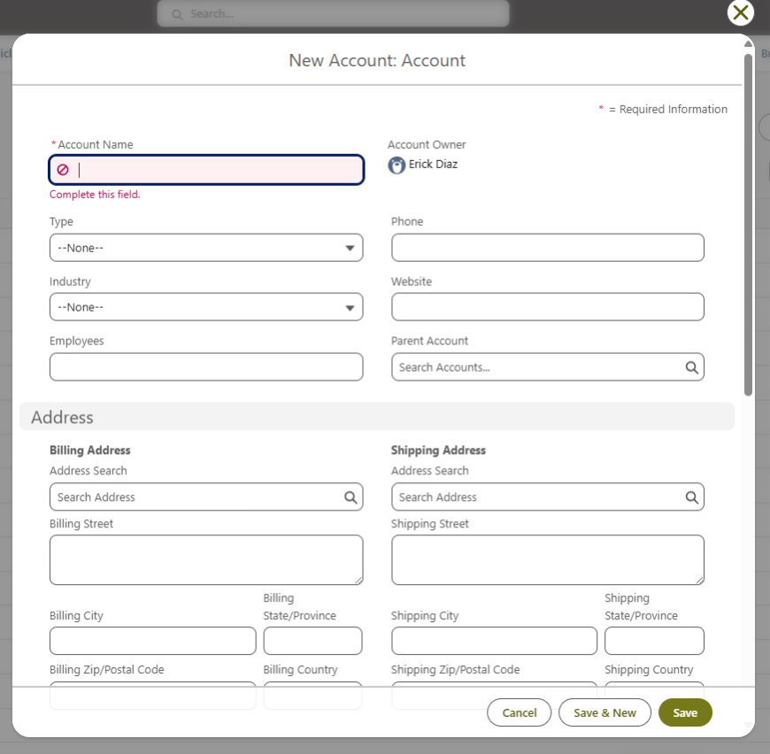
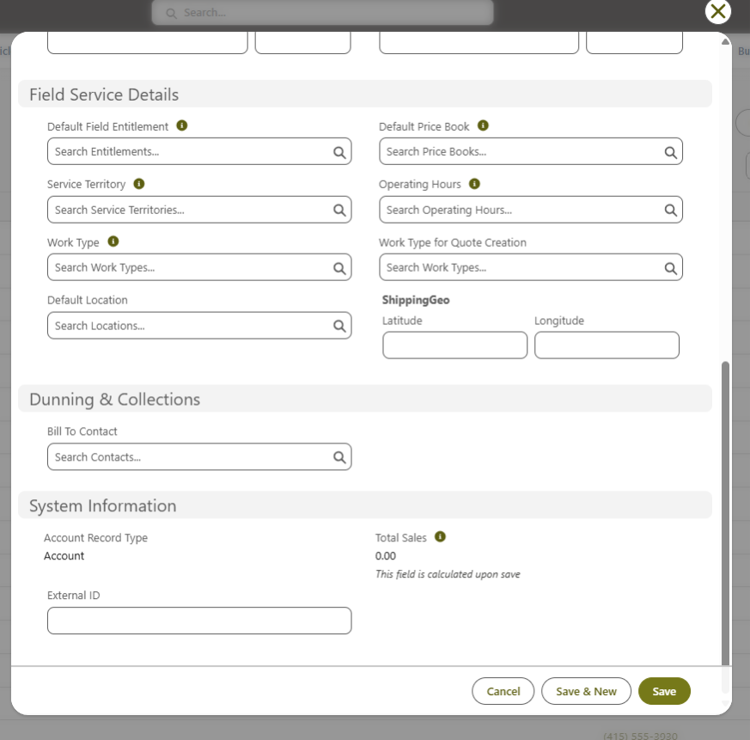
Additional Fields for page layout (with Screenshots)
Screenshots of the Account page layout are included below to capture the remaining fields that must also be part of the page layout. These fields may or may not overlap with the high-priority fields listed above.
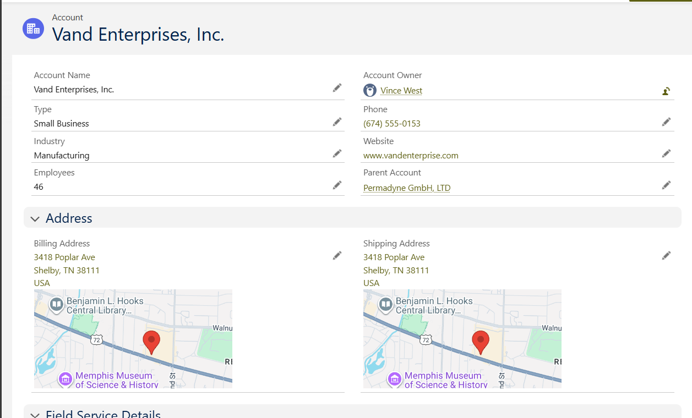
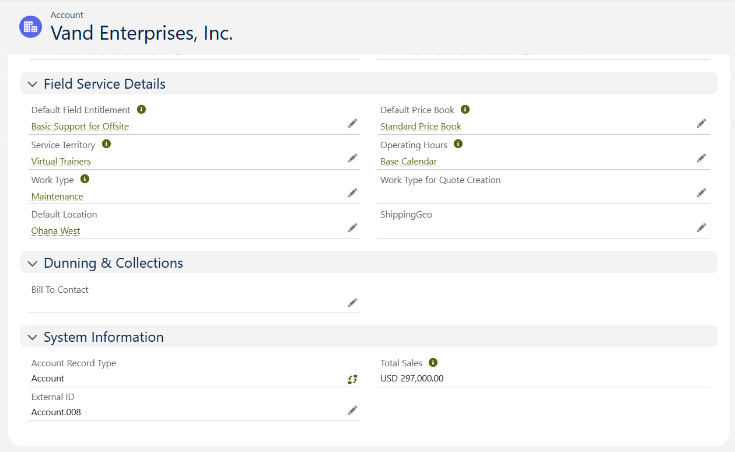
Notes:
- Features like Notes, Chatter, Reminders, Tasks need to be enabled.

Contact Object
Record Type: Contact only has standard record type
Fields to be displayed on “Create New Contact” page
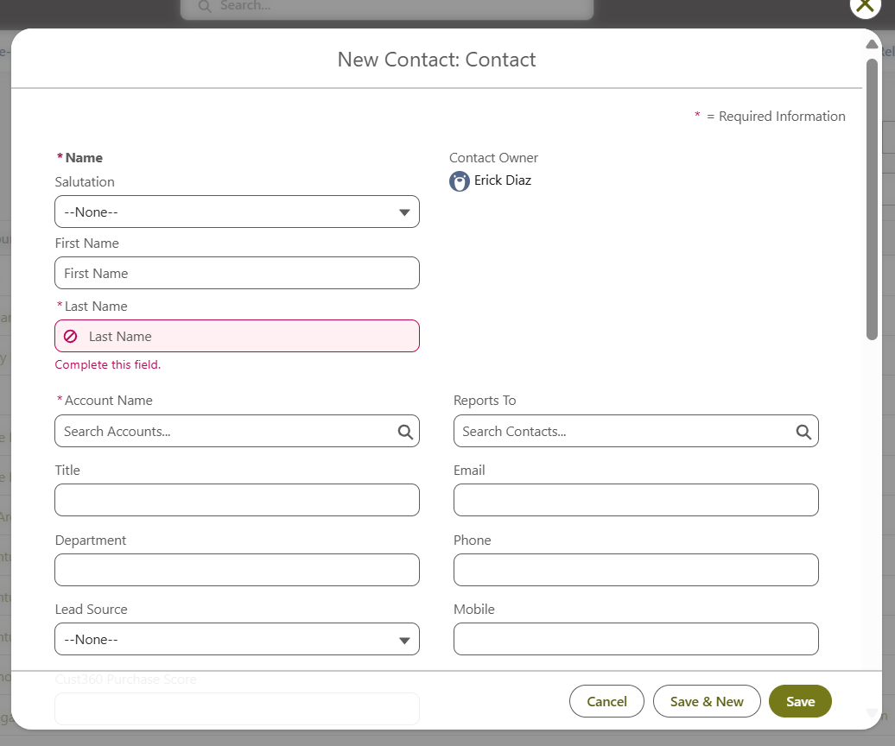
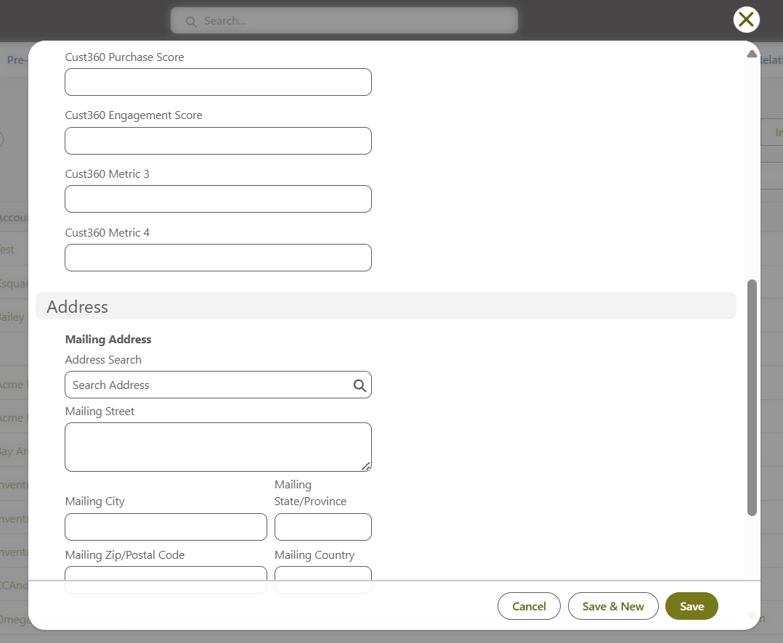
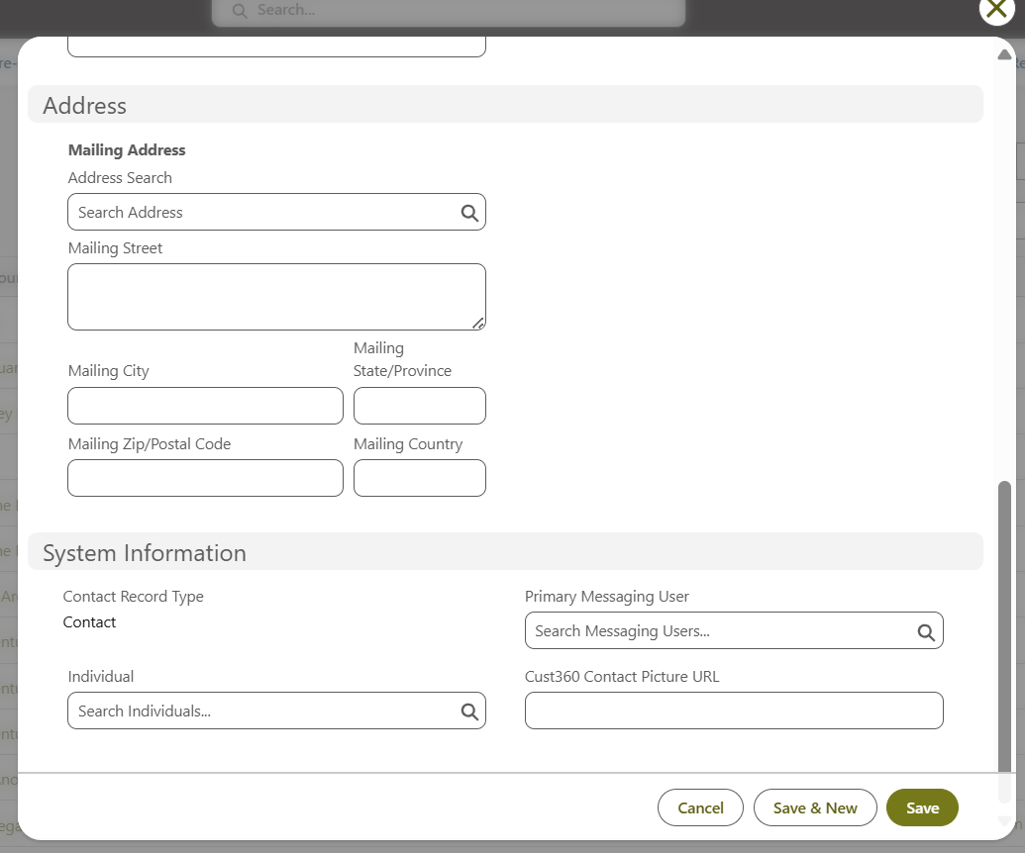
Fields to be displayed on Contact Record page
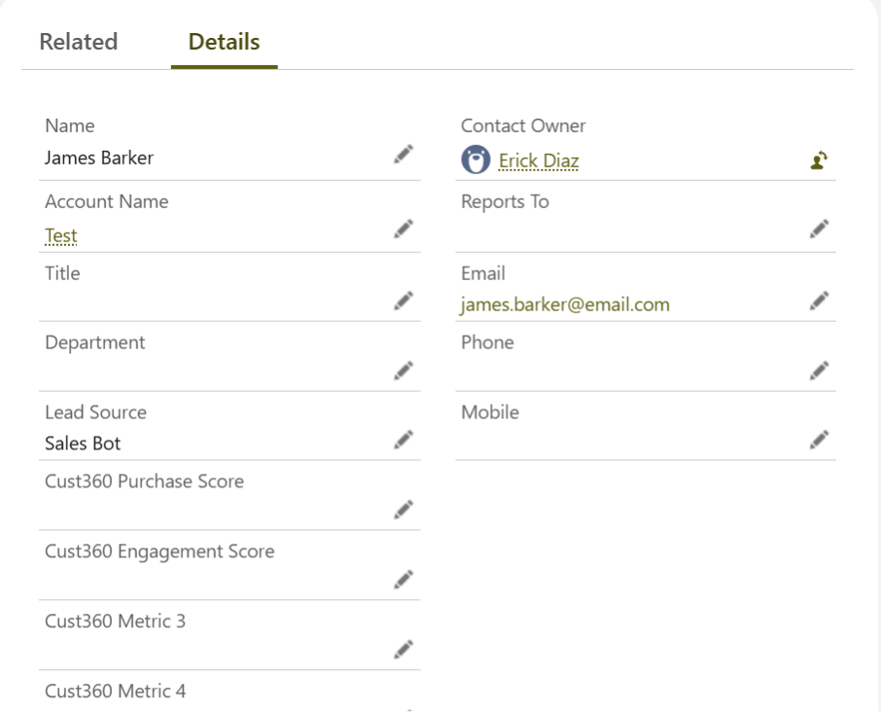
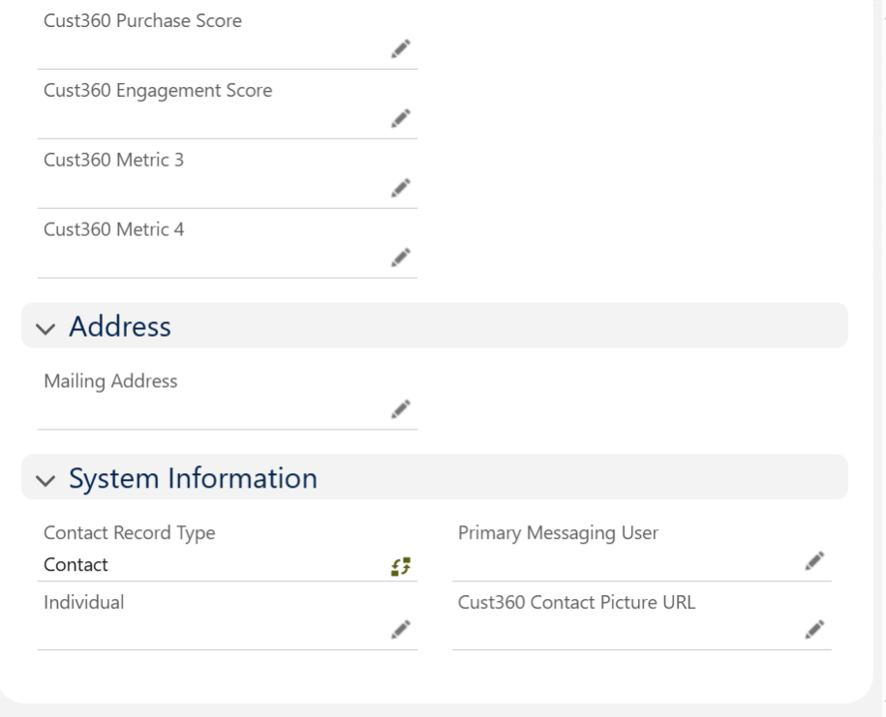
Notes:
- Features like Notes, Chatter, Reminders, Tasks need to be enabled.

Case Object (Service Requests)
Record Type:
The following are the record types
Record Type | Fields to be Displayed | Field Type / Values
Repair or Maintenance | Types of Services | Picklist → Values: Scheduled Maintenance, Unscheduled Maintenance
 | Concern | Text
 | Cause | Text
 | Correction | Text
 | Current Mileage (km) | Text / Number
 | Requested Completion Date | Date
 | Is the Car Off-Road | Yes / No
 | Notes | Text
Feedback | Description of Issue / Feedback | Text
 | New Information | Text
 | Reason for Change | Picklist → Values: Relocated, Correction, Other
 | Comments | Only visible if Other is selected in the Reason for Change
 | Status | Picklist → Values: Open, Closed, Pending  → Add reason in Notes field if Pending
 | Notes | Text
Profile Update / Information Change | Description of Issue / Feedback | Text
 | New Information | Text
 | Reason for Change | Picklist → Values: Relocated, Correction, Other
 | Status | Picklist → Values: Open, Closed, Pending  → Add reason in Notes field if Pending
 | Comments | Only visibile if Other is selected in the Reason for Change
 | Notes | Text
Escalation | Description of Issue / Feedback | Text
 | New Information | Text
 | Reason for Change | Picklist → Values: Relocated, Correction, Other
 | Comments | Only visibile if Other is selected in the Reason for Change
 | Status | Picklist → Values: Open, Closed, Pending  → Add reason in Notes field if Pending
 | Notes | Text

Case Auto-Population from Asset
When a Case is created directly from an Asset record during either a Scheduled Service or an Unscheduled Service, certain key details should automatically populate to ensure consistency and reduce manual effort. This also helps maintain a clear link between the customer, the vehicle/asset, and the service history.
The following fields should be auto populated:
- Asset Number
- Contact Name
- Account Name
- Email ID
- VIN Number
- Registration Number

Case Status
- New – Request is logged but not yet reviewed.
- Pending Review – Sales Manager review & feedback is pending after discussion with Technician.
- Closed – Case is closed after Work Order is open.
Note: Under each status, the key fields or guidance for success do not need to be displayed.

High Priority Fields for Case Creation & Display on Top Section of Page Layout
A set of fields has been identified as priority for the Case object. These fields must be positioned at the top of the “Create New Case” page along with the above fields and displayed in the top section of the Case page layout to ensure efficient data entry and quick visibility of critical case information.
S No. | Field Name | Data Type | Details / Usage | Mandatory (Y/N)
1 | Case Type | Picklist | Values: Scheduled Maintenance, Unscheduled Maintenance | N
2 | Service Sub-Type | Dependent Picklist | Visible only if “Unscheduled Maintenance”; Values: Warranty, Mechanical, Electrical, Collision | N
3 | Service Details | Text Area (Long) | Free text for specifics (e.g., oil change, filter replacement, inspection) | N
4 | Service Reference # | Auto-Number / Formula | Auto-generated unique identifier for tracking | N
5 | Concern | Text Area (Long) | Customer-reported issue in their own words | N
6 | Cause | Text Area (Long) | Technician’s diagnosis after inspection | N
7 | Correction | Text Area (Long) | Action taken to resolve the issue | N
8 | Current Mileage (km) | Number | Capture vehicle mileage in kilometers | N
9 | Requested Completion Date | Date | Customer’s expected completion timeline | N
10 | Is the Car Off-Road? | Checkbox (Yes/No) | Indicates if the car is immobile | N
11 | Case Status | Picklist | Value – New, Pending Review, Closed | N

Additional Fields for “Create New Case” page (with Screenshots)
Screenshots of the “Create New Case” page are included below to capture the remaining fields that must also be part of the page layout. These fields may or may not overlap with the high-priority fields listed above.
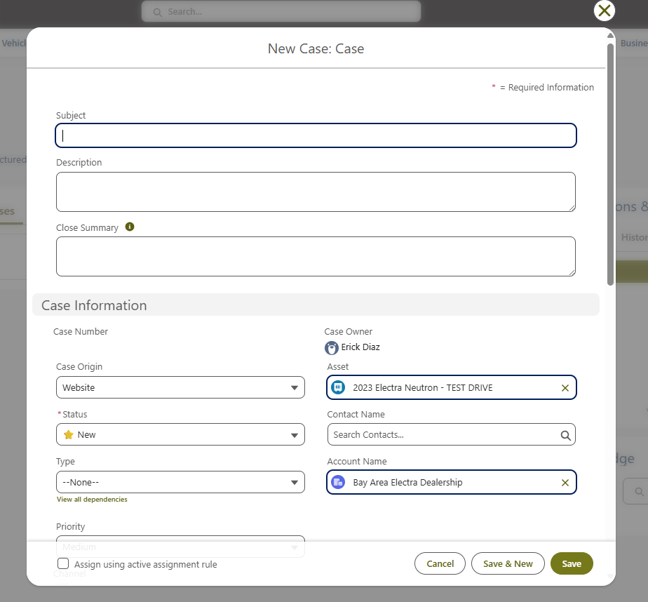
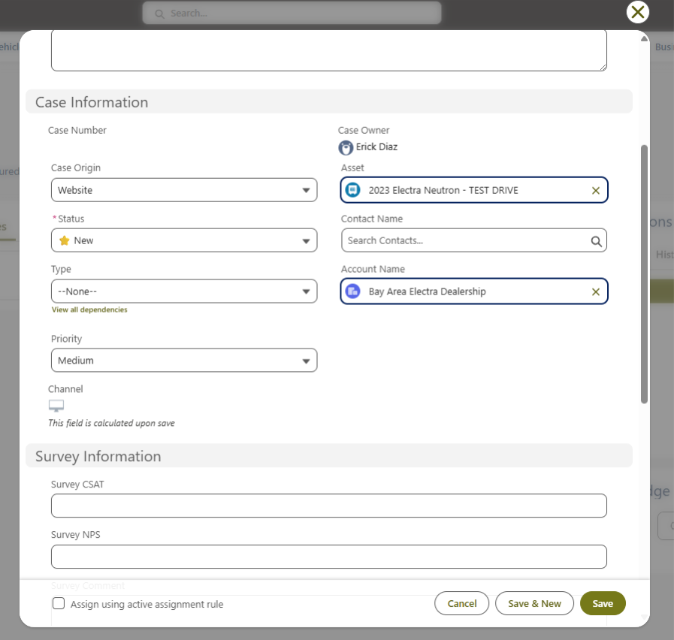
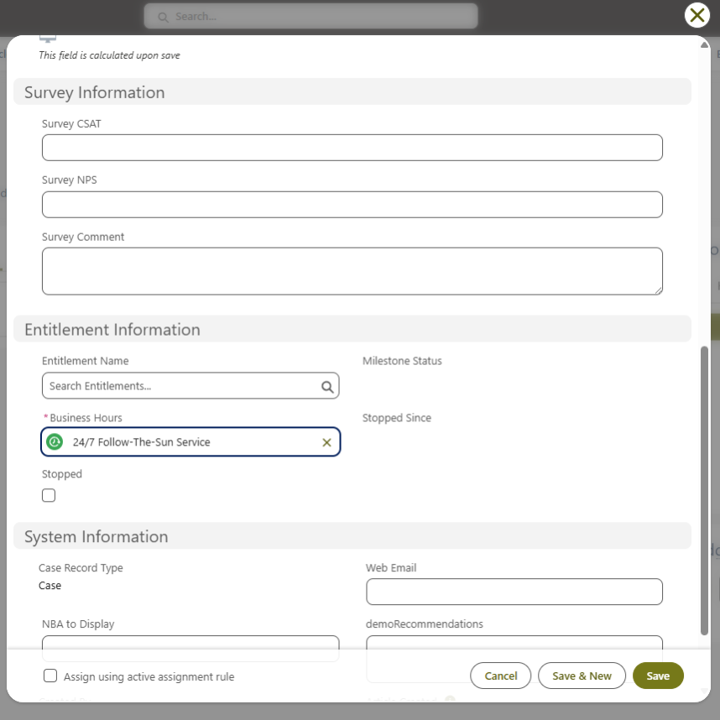
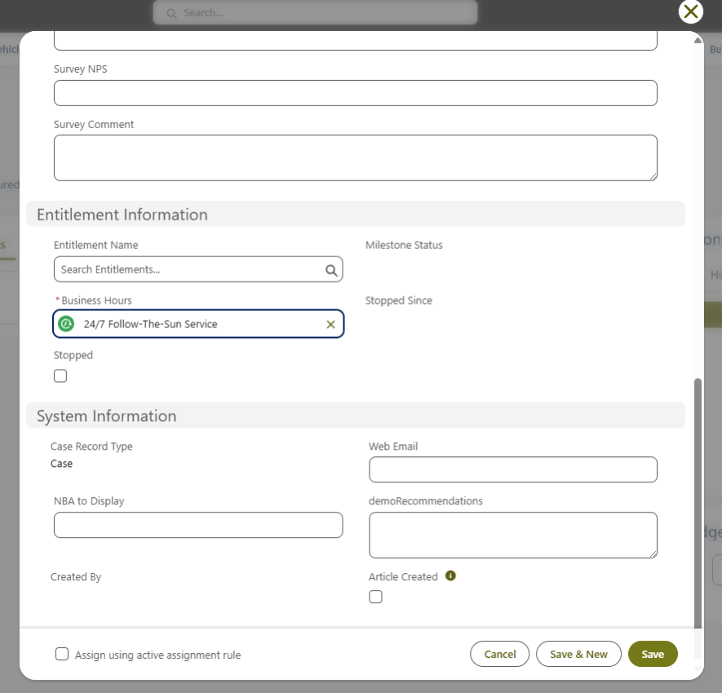

Additional Fields for page layout (with Screenshots)
Screenshots of the Case page layout are included below to capture the remaining fields that must also be part of the page layout. These fields may or may not overlap with the high-priority fields listed above.
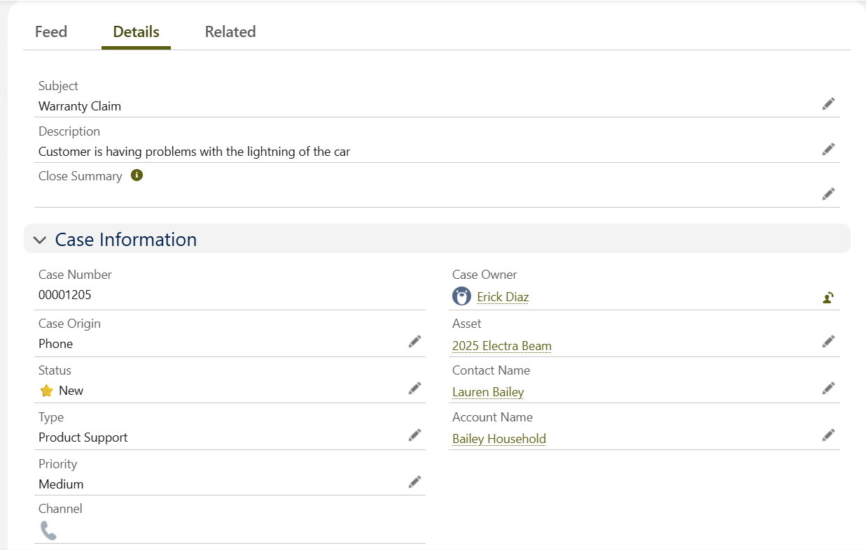
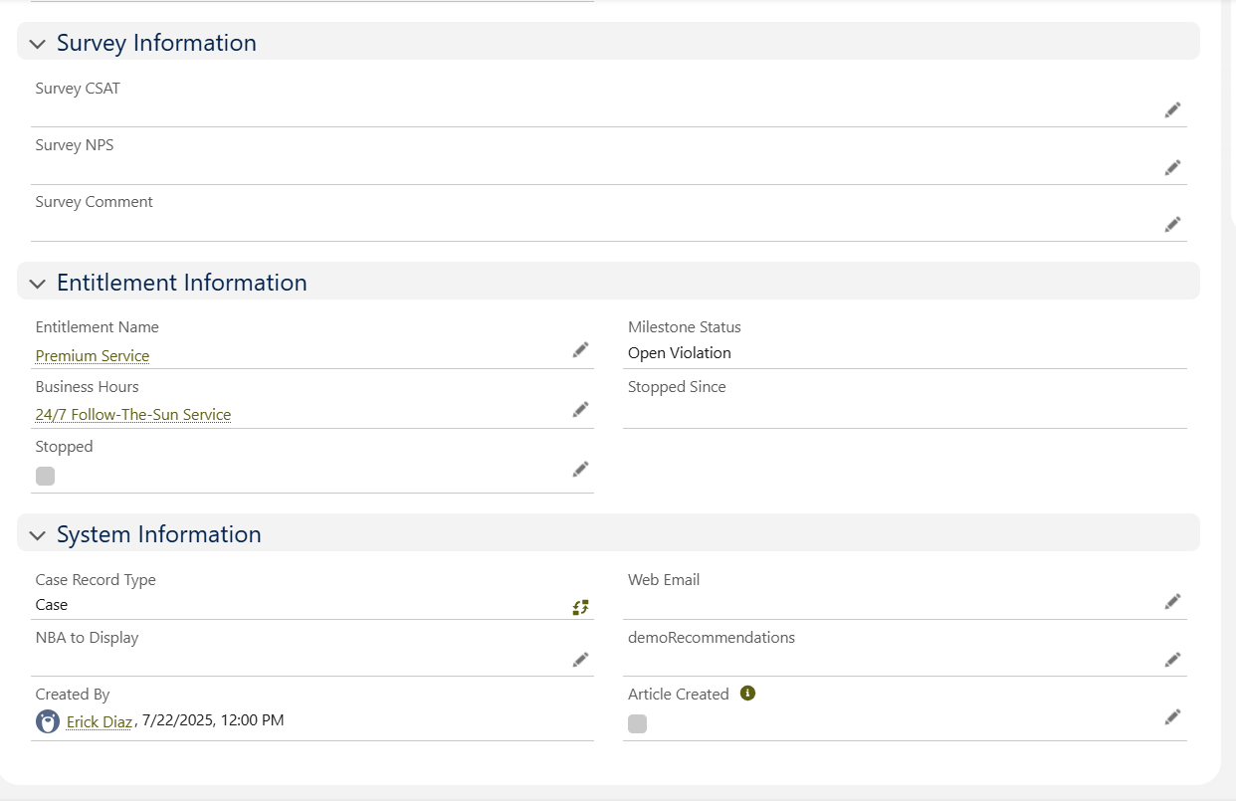
- Features like Notes, Chatter, Reminders, and Tasks need to be enabled.

Work Order Object
Record Type: Case only has standard record type

Work Order Types
Work orders in the system can be categorized based on their purpose and complexity:
- PDI Work Order – Prepares the vehicle for delivery using a simple checklist; triggered by vehicle intake.
- Repair Work Order – Fixes issues or performs maintenance; can involve parts, labor, and billing; triggered by customer complaints, warranty, or service schedule.

Work Order Status
The following table outlines the identified work order statuses along with their key activities and fields to be tracked at each stage of the service process.
Status | Description / Key Activity | Key Fields to Capture
New | Vehicle intake checklist; initial creation of work order | - Concern (customer’s description of issue)  - Cause (diagnosis by technician)  - Correction (what was done to fix it)  - Labor Hours Estimated  - Labor Hours Actual
Pending Manager's Review | Work order awaiting approval or verification | - Concern (customer’s description of issue)  - Cause (diagnosis by technician)  - Correction (what was done to fix it)  - Labor Hours Estimated  - Labor Hours Actual
In Progress | Service work started | - Concern (customer’s description of issue)  - Cause (diagnosis by technician)  - Correction (what was done to fix it)  - Labor Hours Estimated  - Labor Hours Actual
On Hold | Work temporarily paused | - Part Number  - Part Description  - Quantity Ordered  - Quantity Used  - Cost (per part)  - Total Parts Cost
Completed | Service completed; vehicle ready for delivery
Invoice | Prepare and collect payment; complete vehicle delivery checklist | - Deposit Received (Yes/No + Amount)  - Warranty Coverage (Yes/No, policy number)  - Estimated Repair Cost  - Final Invoice Amount
Closed | Fully resolved; work order and case officially closed

Pay Type
A non-mandatory picklist field with the following values:
- Warranty – Covered under manufacturer’s warranty.
- Customer Pay – Paid by the customer.
- Rectify – Internal correction for previous work or issue.
- Goodwill – Work approved by management at no cost to the customer.

High Priority Fields for Work Order Creation & Display on Top Section of Page Layout
A set of fields has been identified as priority for the Work Order object. These fields must be positioned at the top of the “Create New Work Order” page along with the above fields and displayed in the top section of the Work Order page layout to ensure efficient data entry and quick visibility of critical case information.
Section | Field Name | Values (Picklist / Options) | Mandatory Field (Y/N)
Work Order Details | Work Order Number | Auto generated | N
 | Date / Time Created | - | N
 | Service Advisor Assigned | - | N
 | Technician Assigned | - | N
 | Repair Order Type | Warranty, Customer Pay, Recall, Internal, Insurance Claim | N
 | Priority | High, Medium, Low | N
 | Status | New/Open, Pending Manager Review, In Progress, On Hold, Completed, Invoice, Closed | N
 | Pay Type | Warranty, Customer Pay, Rectify, Goodwill
 | Concern | - | N
 | Cause | - | N
 | On Hold Reason | Parts not available  Technician not available | N
 | Correction | - | N
 | Labor Hours Estimated | - | N
 | Labor Hours Actual | - | N
Parts Details | Parts Required | Yes, No | N
 | Part Number | - | N
 | Part Description | - | N
 | Quantity Ordered | - | N
 | Quantity Used | - | N
 | Cost (per part) | - | N
 | Total Parts Cost | - | N
Invoice Details | Deposit Received | Yes, No | N
 | Warranty Coverage | Yes, No | N
 | Estimated Repair Cost | - | N
 | Final Invoice Amount | - | N
 | Receipt Number
 | Warranty Reference Number
 | Claim Reference Number

Additional Fields for “Create New Work Order” page (with Screenshots)
Screenshots of the “Create New Work Order” page are included below to capture the remaining fields that must also be part of the page layout. These fields may or may not overlap with the high-priority fields listed above.
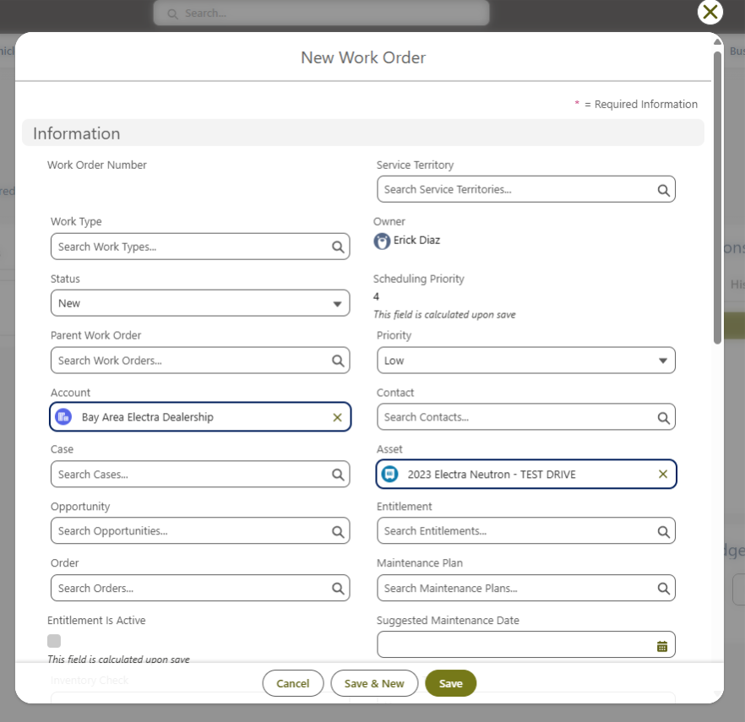
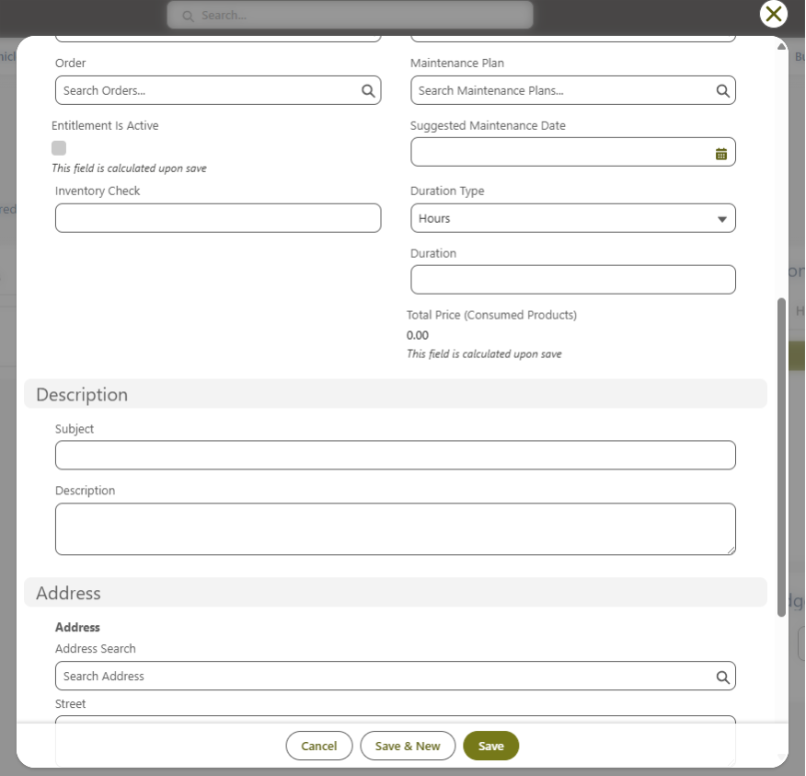
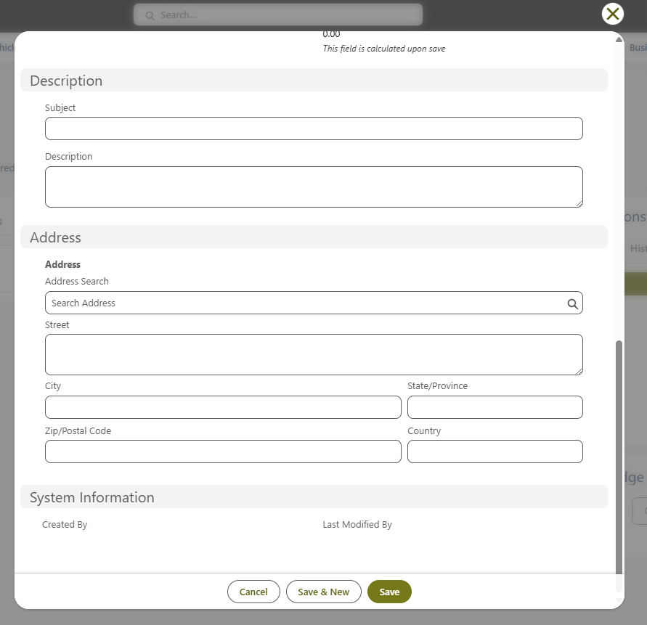

Additional Fields for page layout (with Screenshots)
Screenshots of the Work Order page layout are included below to capture the remaining fields that must also be part of the page layout. These fields may or may not overlap with the high-priority fields listed above.
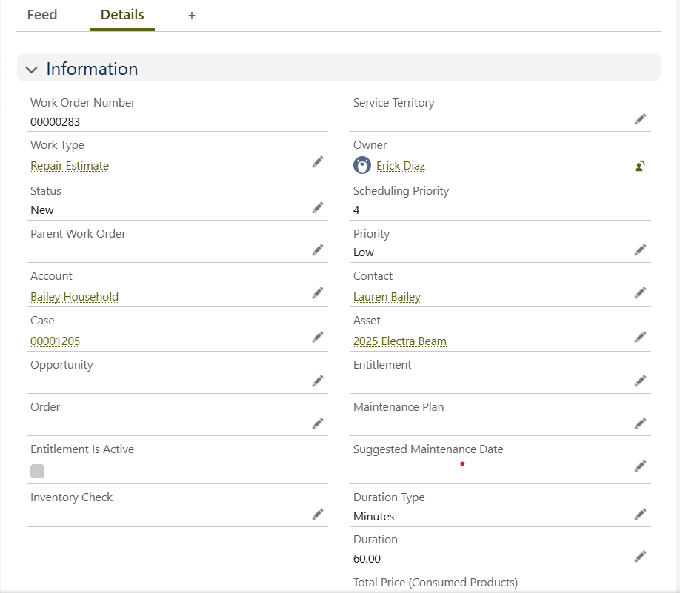
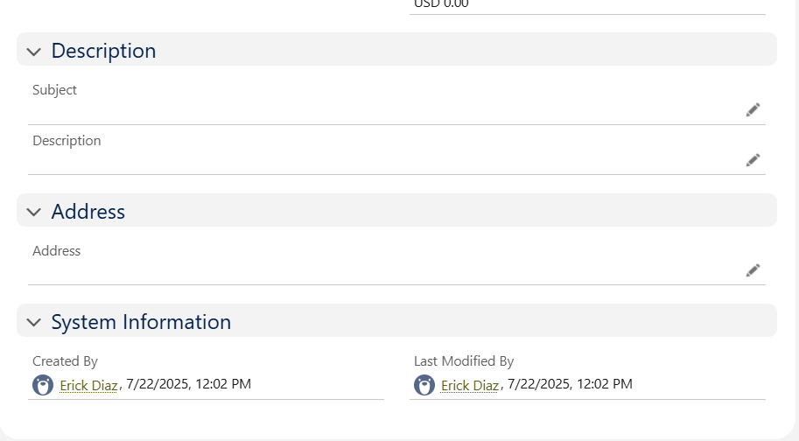

Quotation & Invoice Generation
Overview:
The system will enable users to generate Quotation and Invoice documents directly from Salesforce. Both documents will display identical information, with the only difference being the document heading — “Quotation” or “Invoice.”
Functional Details:
- Buttons:
  - Two action buttons shall be available on the relevant record page:
    - Generate Quotation
    - Generate Invoice
- Document Details:
  - Both Quotation and Invoice will display:
    - Customer details (Name, Contact, Account, Email, Phone)
    - Vehicle/Asset details like Vehicle Model, VIN Number, Registration Number
    - Work Order details
    - List of Work Order Line Items
- Calculation Logic:
  - Subtotal: The sum of all Work Order Line-Item Amounts.
  - Total VAT: The sum of the VAT field on each Work Order Line Item.
  - Total Amount: The sum of Subtotal + Total VAT.
- Document Output:
  - The system shall generate a formatted PDF for download or email.
  - The heading at the top of the document shall dynamically change based on the button clicked:
    - “Quotation” if Generate Quotation is clicked.
    - “Invoice” if Generate Invoice is clicked.

Note:
- Features like Notes, Chatter, Reminders, Tasks need to be enabled.
- Work Order should be added to the related list of Assets & Cases

Work Order Line Item Object
Work Order Line Item Status
The following are statuses
- New
- In progress
- Completed
- Closed
Fields to be displayed while creating a new Work Oder line Item & on the page layout
- Part No
- Part Name/ Description
- Item Serial Number
- Quantity
- Unit Cost
- Total Cost
- Availability Status (Field from part object) -

Additional fields to be displayed while creating a new Work Order Line Item
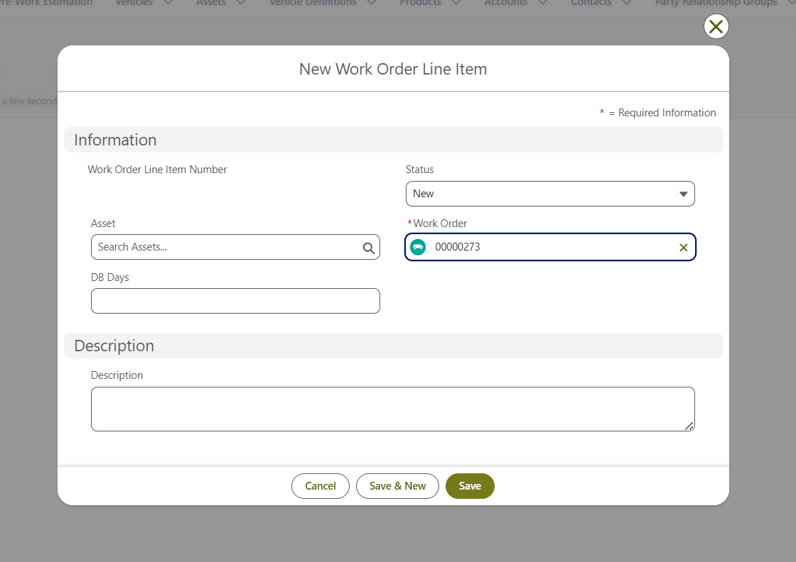
Additional fields to be displayed on Work Order Line Item layout
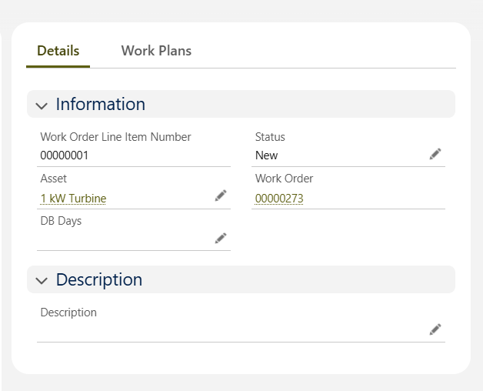

Labour Work Order Line Item
When recording labor against a Work Order Line Item, the following considerations apply:
- Description: Details of the work performed can be entered.
- Asset / Part Details: Not required for labor WOLIs.
- Unit Cost: Represents the per-hour labor charge.
- Quantity: Represents the number of labor hours.
- Total Cost: Calculated as Unit Cost × Quantity to reflect the total labor charge.

Note:
- Features like Notes, Chatter, Reminders, Tasks need to be enabled.

Claim Object
The system shall provide the following page layout for the creation of a new Claim
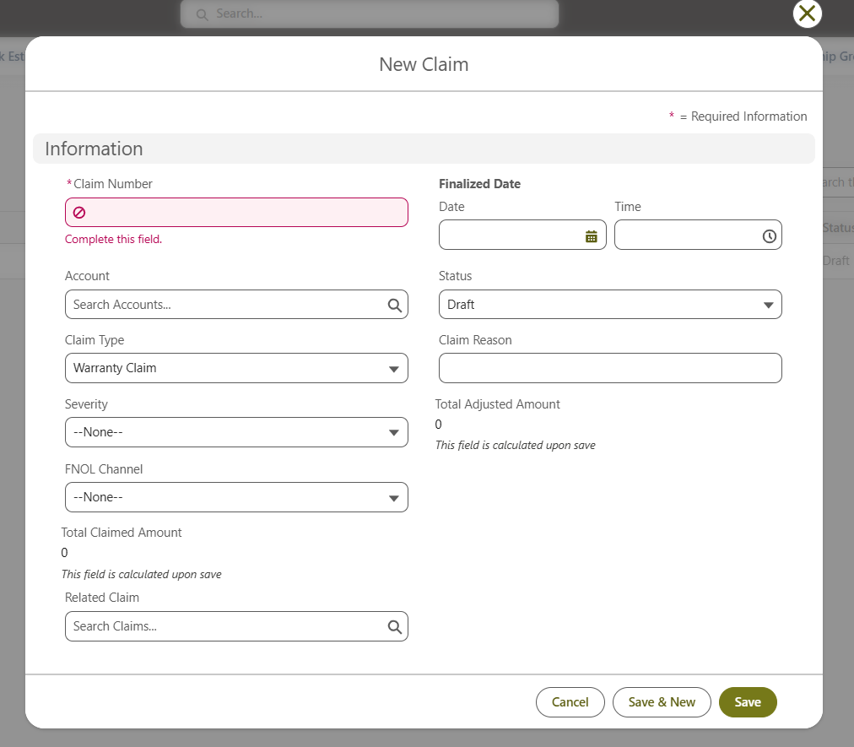
The following fields shall be available under each section of the Claim record page layout.
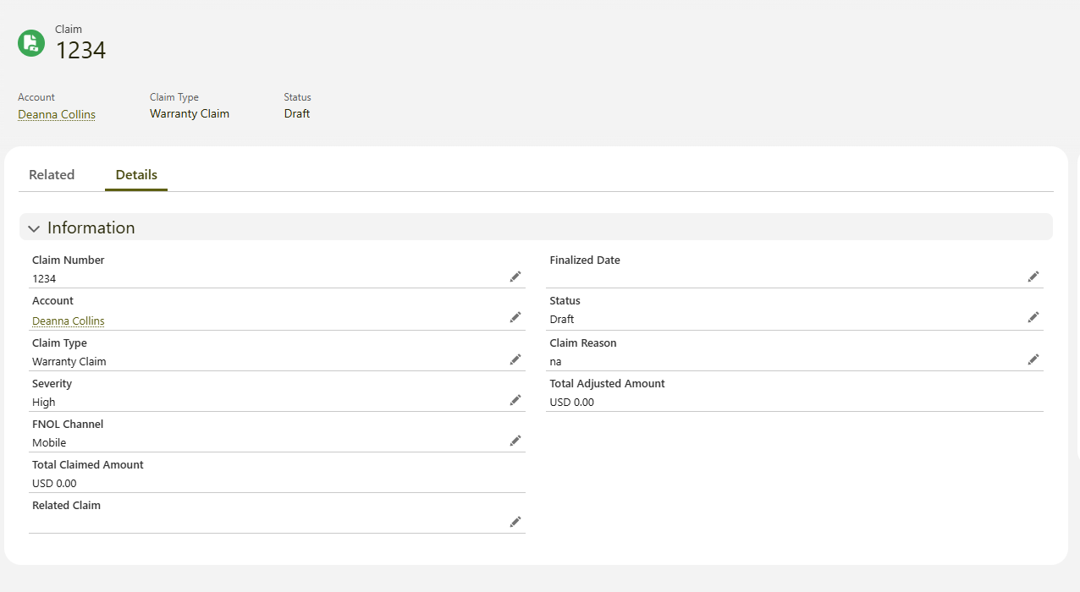
Note:
- Features like Notes, Chatter, Reminders, Tasks need to be enabled.

Product Object
- Record Types: Two record types will be enabled under the Account object:
  - Vehicle
  - Vehicle Part

The system shall provide the following page layout for the creation of a new Product if the Record Type is Vehicle
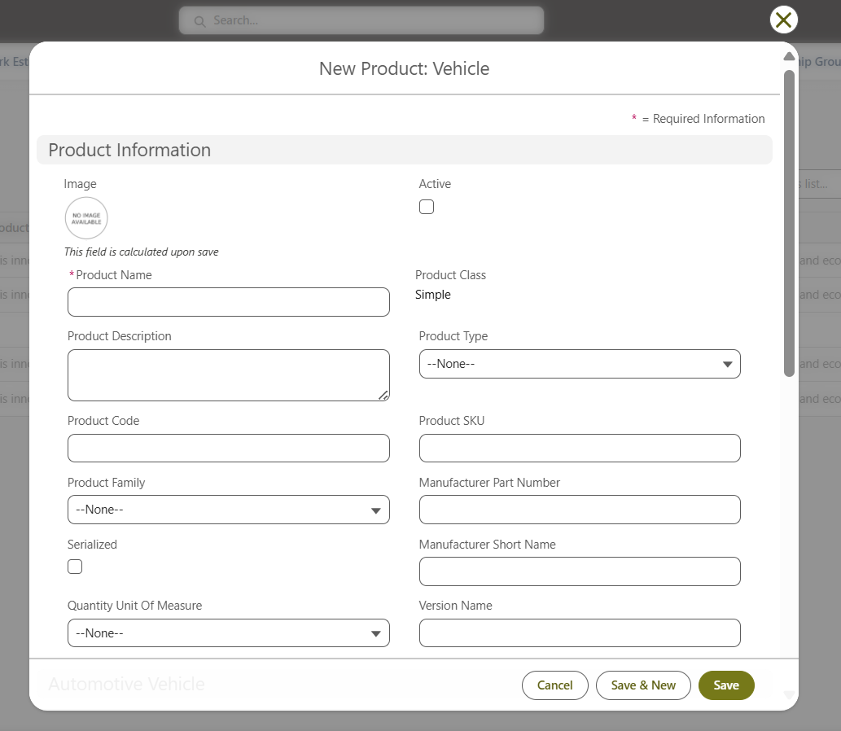
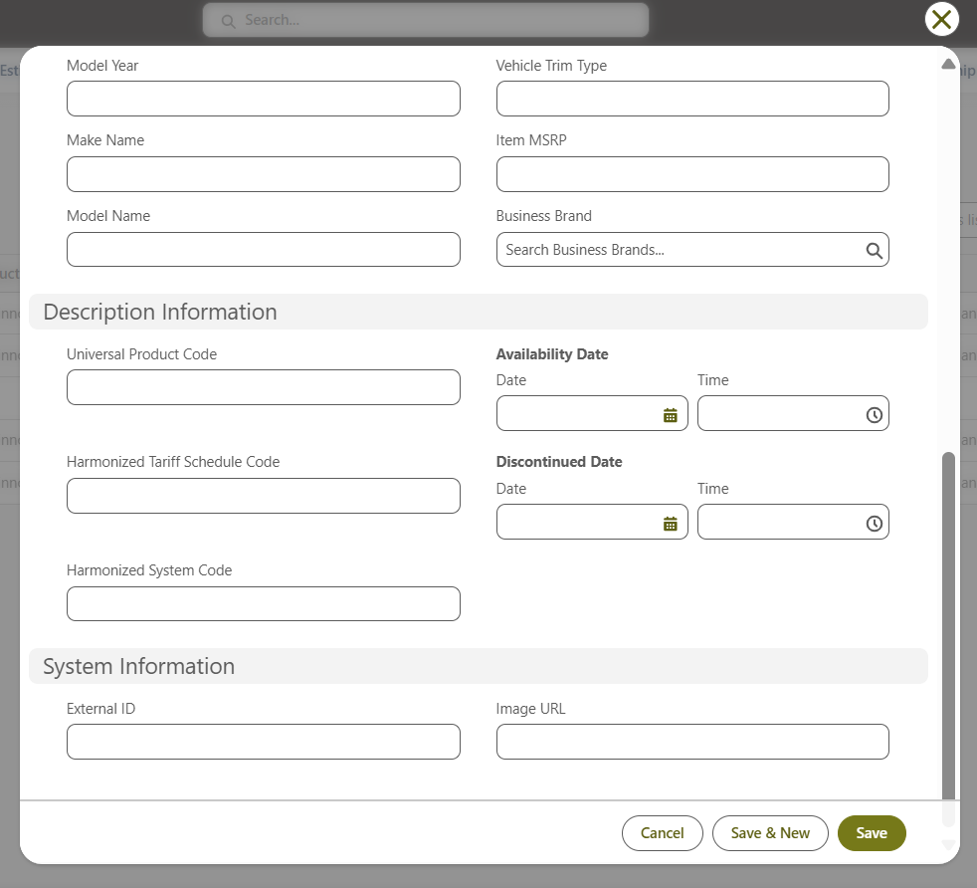
The system shall provide the following page layout for the creation of a new Product record when the Record Type is set to Vehicle Part. In addition to the screenshots provided, the fields listed below shall be included for Vehicle Parts.
Field Name | Description | Field Type | Mandatory (Y/N)
Part No | Unique identifier assigned to the vehicle part | Text | N
Part Name / Description | Name and descriptive details of the part | Text | N
Item Serial Number | Manufacturers or system-generated serial number | Text | N
Selling Price | Price at which the part is sold to the customer | Currency | N
Local Handling Fees / Brokerage | Additional local charges applicable to the part | Currency | N

The following fields shall be available under each section of the Product record page layout for Vehicle Record Type.
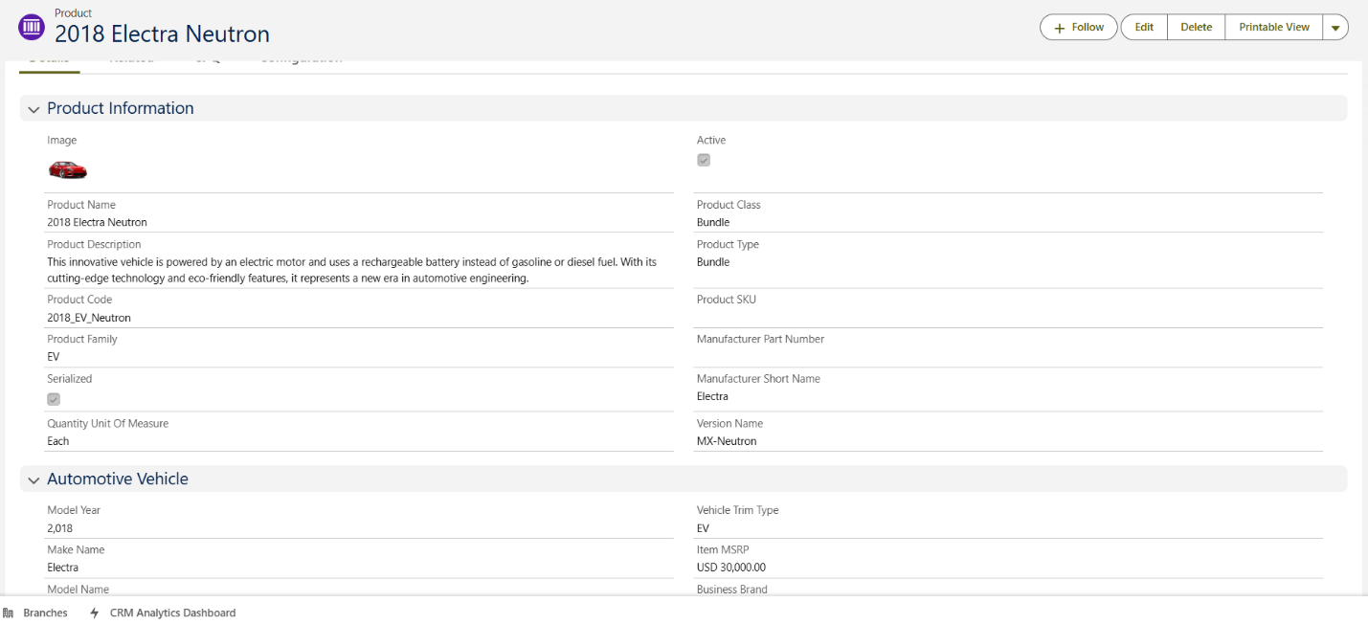
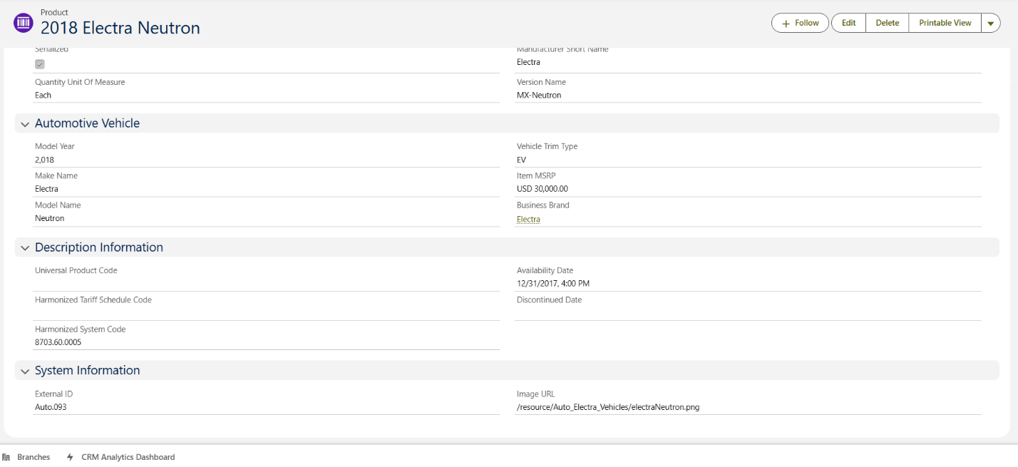
The fields on the Product record page layout for the Vehicle Part record type shall include all standard Product fields, along with the following additional fields:
- Part No
- Part Name / Description
- Item Serial Number
- Selling Price
- Local Handling Fees / Brokerage.

Part Object
Part Status
Below are part availability statues which are identified
- In Stock – Available now in the warehouse/showroom.
- Low Stock – Limited quantity left (e.g., under a set threshold).
- Out of Stock – Currently unavailable, no confirmed delivery date.
- On Order – Ordered from supplier but not yet shipped.
- In Transit – Shipped but not yet cleared or received in Guyana.
- Expected [Date] – Confirmed ETA for arrival (can tie to an "Expected Date" field).
- Reserved/Allocated – Stock exists but already committed to a customer order or service job.
- Discontinued – No longer supplied by BYD/supplier.

Part Type
The following are the part types which are identified
- Spare Parts
- Consumables
- Accessories

The following are the fields to be displayed on the Create New Part page & Part page layout
Category | Field Name | Description / Purpose | Salesforce Field Type | Mandatory? (Y/N)
Basic Details | Part No | Unique identifier for the part | Text (Unique) | N
 | Part Name / Description | Name/description of the part | Text Area | N
 | Item Serial Number | Serial/unique tracking number | Text (Unique) | N
 | Remarks | Notes or comments about the part | Text Area (Long) | N
 | ROQ (Reorder Quantity) | Threshold to trigger reorder | Number | N
 | Date Ordered | The date parts were ordered on | Date | N
 | ETA Date | The date parts are expected to arrive on | Date | N
Inventory Tracking | Date Received | Date part was received | Date | N
 | Quantity (QTY) | Number of parts in stock | Number | N
Procurement Details | Mode of Purchase | Purchase channel/method | Picklist | N
 | Shipping Mode | Mode of shipping (air/sea) | Picklist | N
 | Air Freight | Cost via air freight | Currency (USD/GYD) | N
 | Ocean Freight | Cost via sea freight | Currency (USD/GYD) | N
Costing (USD) | Unit Cost (USD) | Cost per unit in USD | Currency (USD) | N
 | Total (USD) | Total value in USD | Currency (USD) | N
 | FOB (USD) | Free on-Board cost in USD | Currency (USD) | N
 | CIF (USD) | Cost, Insurance & Freight in USD | Currency (USD) | N
Costing (GYD) | Unit Cost (GYD) | Cost per unit in GYD | Currency (GYD) | N
 | Total (GYD) | Total value in GYD | Currency (GYD) | N
 | FOB (GYD) | Free on-Board cost in GYD | Currency (GYD) | N
 | Import Duty (GYD) | Duty cost in GYD | Currency (GYD) | N
 | VAT (GYD) | VAT in GYD | Currency (GYD) | N
 | Local Handling Fees / Brokerage (GYD) | Handling or broker fees | Currency (GYD) | N
 | LAN/Cost (GYD) | Landed cost in GYD | Currency (GYD) | N
 | Unit Cost (GYD) (duplicate/verify) | Verify with LAN/Cost field | Currency (GYD) | N
Finance / Taxation | Exc Rate (Exchange Rate) | Rate used for conversion USD → GYD | Number (16,6) | N
 | Import Duty % | Duty percentage | Percent (16,2) | N
 | VAT % | VAT percentage | Percent (16,2) | N

Note:
- Features like Notes, Chatter, Reminders, Tasks need to be enabled.

Price book Object
Fields to be added on create new price book page
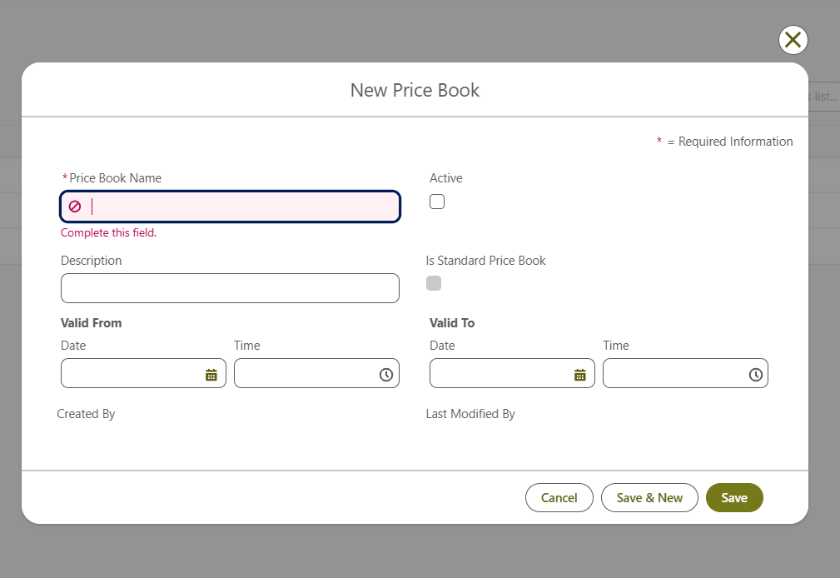
Fields to be added on Price book page layout
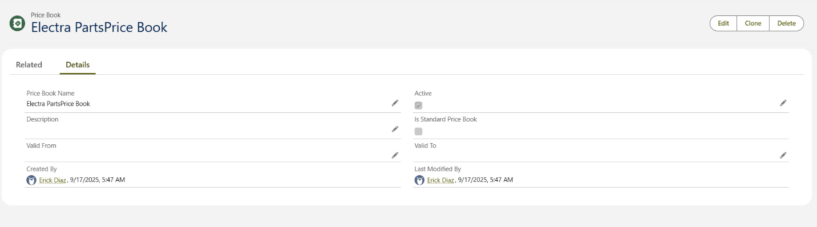
Additional fields to be added
Category | Field Name | Description / Purpose | Salesforce Field Type | Mandatory? (Y/ N)
Sales / Pricing | Margin | Mark-up margin | Percent (16,2) | N
 | Selling Price | Selling price in GYD | Currency (GYD) | N

Note:
- Features like Notes, Chatter, Reminders, Tasks need to be enabled.

Test Drive Scheduling on Leads
On the Lead record page, a separate tab titled “Schedule Test Drive” will be available.
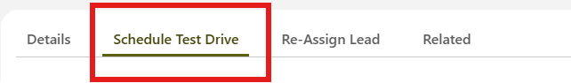
This tab will display the screens and fields required for scheduling a test drive.
Screen 1: To select vehicle which includes vehicle model, vehicle interior color and vehicle exterior color details.
Screen 2: Select Time Slot which included a calendar with date and time & also the details of the resource who would be responsible for helping with the test drive
Screen 3: Review Appointment details
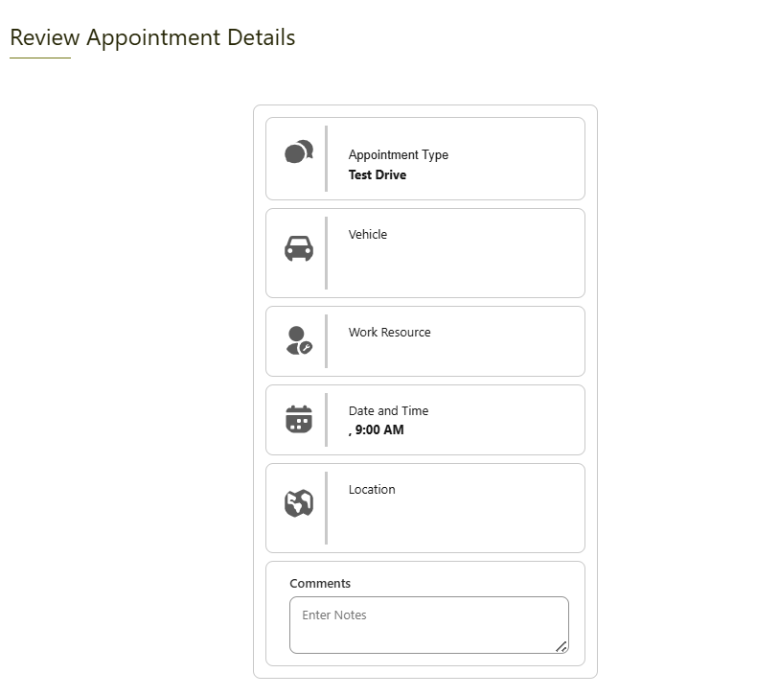
Screen 4: Appointment Booking Confirmed
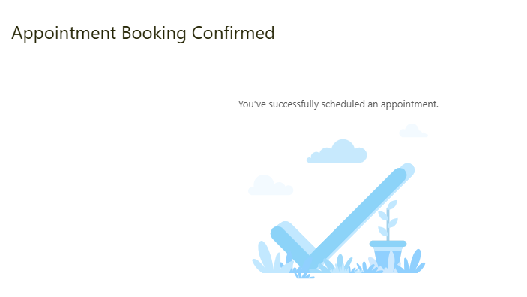

Task & Notification Configuration
Overview
A Task in Salesforce is an action item or reminder assigned to a user.
Sales Advisors can create tasks for themselves or have them automatically created (e.g., as part of a lead follow-up process).

1. Task Type
A custom picklist field called Task Type will be added on the Task object with the following values:
Sales Tasks
- Call customer - 1st Call
- Call customer - 2nd Call (3 days later)
- Call customer - 3rd Call (3 days later)
- Call customer - 4th Call (7 days later)
- Send Quotation
- Follow up on Payment
- Schedule Test Drive
Delivery Tasks
- Request Vehicle IDs
- Confirm Delivery Date & Time
Service Tasks
- Book Service Appointment – Schedule customer visit for maintenance or repair.
- Confirm Appointment – Call or message customer to confirm date and time.
- Update Customer on Repair Status – Notify if parts are delayed or work is extended.
- Notify Customer for Pickup – Inform customer when vehicle is ready for collection.
- Follow up after service

2. Key Standard Fields
These fields will appear on the Task layout by default:
Field Name | Description
Subject | Short title describing the task (e.g., “Call customer - 1st Call”).
Due Date | Deadline for the task.
Assigned To | User responsible for completing the task.
Related To | Lookup field to associate the task with a record (Lead, Account, Opportunity, or Case).
Status | Indicates progress — e.g., Not Started, In Progress, Completed.
Priority | Low, Normal, or High (used to highlight urgent follow-ups).
Comments / Description | Optional notes or call details for context.

3. Recommended Additional Fields
Field Name | Field Type | Purpose / Description
Reminder Set | Checkbox (Standard) | Enables reminder notification.
Reminder Date/Time | DateTime (Standard) | Specifies when the user should receive a reminder.

Unique Customer Identification
The system must ensure that each customer can be uniquely identified in Salesforce to prevent duplicates and ensure accurate record linkage. The following fields will serve as unique identifiers:
- VIN Number (Opportunity Object) – Must be exactly 17 characters; used to identify the vehicle linked to the opportunity.
- Registration Number (Opportunity Object / Vehicle Object) – Must follow the pattern: 3 uppercase letters followed by 1 to 4 digits (e.g., FAB1234, DPL1, PAV2); used to uniquely identify the vehicle.
- Email ID - Unique to each customer
Note: When searching for a customer in Salesforce, all GT Automotives users with system access should be able to find records using the last 9 digits of the VIN, the Registration Number, or the Email ID.
Validation Rules:
- VIN Number and Engine Number fields must enforce 17-character validation.
- Registration Number must enforce pattern validation to allow exactly 3 letters followed by 1–4 digits.

Approval

Client:: | GT Automotive | Supplier: | Ksquare Solutions Inc.
Name: | Sheri | Name: | Aditya Buddharaju
Position: |  | Position: | VP Delivery
Sign: |  | Sign:
Date: | 10/7/25 | Date: | 10/7/25
b

