Hexaware 2025 on-campus hiring

- Smallest element of an array.
Test case 2:
Input: 6
[4,1,2,9,0,7]
Output: 0

Test case 1:
Input: 5
[1,2,3,4,5]
Output: 1

- Middle element of an array after removing negative values
Test case 2:
Input: 5
[-5,10,-3,20,30]
Output: 20

Test case 1:
Input: 6
[3,-1,7,-4,9,2]
Output: 7

- Wheatstone bridge
Formula for wheat stone bridge is given by:
R1/R2 = R3/R4
Given values of three resistors, R1, R2, R3 find the value of the missing one, R4.

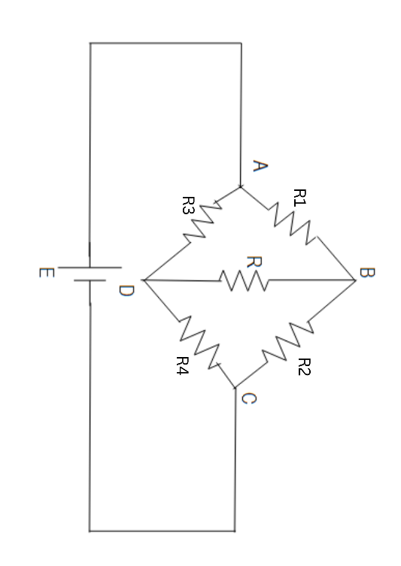
Testcase 2:
Input: 6, 3, 2
Output: 1

Testcase 1:
Input: 5, 10, 3
Output: 6

