|  |  |  |
| --- | --- | --- |
|  | **PORTFOLIO PROJECT** |  |

# Submitted by

# UDAYAKUMAR D

# 1P24MC056

In partial fulfillment of the requirements for the award of the Degree of

#### MASTER OF COMPUTER APPLICATIONS

From Bharathiar University, Coimbatore.

Under the Internal Supervision of

## Dr S.Ranjithakumari, MCA., M.Phil.,PhD.

Assistant Professor, Dept. of MCA, RVSCAS



## SCHOOL OF COMPUTER STUDIES MASTER OF COMPUTER APPLICATIONS

**RVS COLLEGE OF ARTS AND SCIENCE (AUTONOMOUS)**

## Sulur, Coimbatore – 641 402.

**Nov 2024**

# RVS COLLEGE OF ARTS AND SCIENCE (AUTONOMOUS)

## Sulur, Coimbatore – 641 402. School of Computer Studies

**Department of Computer Applications (MCA)**



#### Nov 2024.

**Register Number: 1P24MC056**

Certified *bonafide* original record of work done by **UDAYAKUMAR D**

## Internal Supervisor Director

Submitted for the project Evaluation and *Viva voce* held on**………………….**

**Internal Examiner External Examiner**

# CONTENT INDEX

|  |  |
| --- | --- |
| **Chapter** | **Page No.** |
| **Chapter 1**: Video Introduction  1.1. YouTube Video | 1 |
| **Chapter 2:** Website Bio Score   * 1. About me   2. Contact Information | 2 |
| **Chapter 3**: Pages & Navigation   * 1. Landing Page      1. Responsive Query   2. Project Page   3. Navigation bar   4. Skill Page   5. Qualification Page | 17 |
| **Chapter 4**: Style Score  4.1 Style links | 46 |

|  |  |
| --- | --- |
| **Chapter 5**: Website include the following Information   * 1. Project link to the GitHub   2. Project Description | 49 |
| **Chapter 6**: Bootstrap  6.1 Uses of Bootstrap | 51 |
| **Chapter 7**: Project README  Title description  How to run the project  Future improvement in the Project | 54 |
| **Chapter 8**: File structure  8.1 GitHub file Structure | 57 |

**Chapter-1**

## Video Information

**1.1 YouTube video introduction**

# C:\Users\vino\Pictures\Screenshots\Screenshot (286).png

# Description:

In this page, you can see the self-introduction of mine. By clicking the play button it will redirect to the YouTube page, so that you can know me more.

## Source Code:

### HTML:

# <iframe width="560"

# height="315" src="https://www.youtube.com/embed/m6hme9YDmuQ?si=csaXD5Hsv38E52sJ" title="YouTube video player" frameborder="0"

# allow="accelerometer; autoplay; clipboard-write; encrypted-media; gyroscope; picture-in-picture; web-share" referrerpolicy="strict-origin-when-cross-origin" allowfullscreen>

# </iframe>

# Chapter-2:

## Website Bio Score

## 2.1 About Me:

## C:\Users\Own\Pictures\Screenshots\Screenshot (232).png

## Description:

In this page, there is an image of mine, paragraph about me and also an option called View My Resume .So,That if any user want to see the resume they can directly download from here.

## Source Code:

### HTML:

### <section id="about">

### <div class="container">

### <h2>ABOUT ME</h2>

### <p>I'm <span>Udayakumar</span>, currently pursuing my Master of Computer Applications (MCA), building on my strong foundation in computer science gained

### from my Bachelor of Computer Applications (BCA). My academic journey has equipped me with a solid understanding of programming, software development, and IT systems.

### During my BCA, I developed proficiency in various programming languages, including Java, Python, and web technologies. Now, through my MCA, I am honing my skills in advanced Full stack development, data structures, algorithms.</h5>

### </p>

### <div class="about1"><img src="./images/newprofile2.jpg" ><br><br>

### <a href="./images/RESUME.jpg" class="btn btn-primary">RESUME</a>

### </div>

### </div>

### </section>

### CSS:

### /*=============== ABOUT ===============*/

### #about

### {

### color: white;

### text-align: center;

### background-color: #444;

### }

### #about img

### {

### border-radius: 50%;

### height: 300px;

### width: 300px;

### object-fit: cover;

### }

### #about .container

### {

### width: 95%;

### margin: 0 auto;

### padding: 20px;

### }

## 2.2 Contact Page :

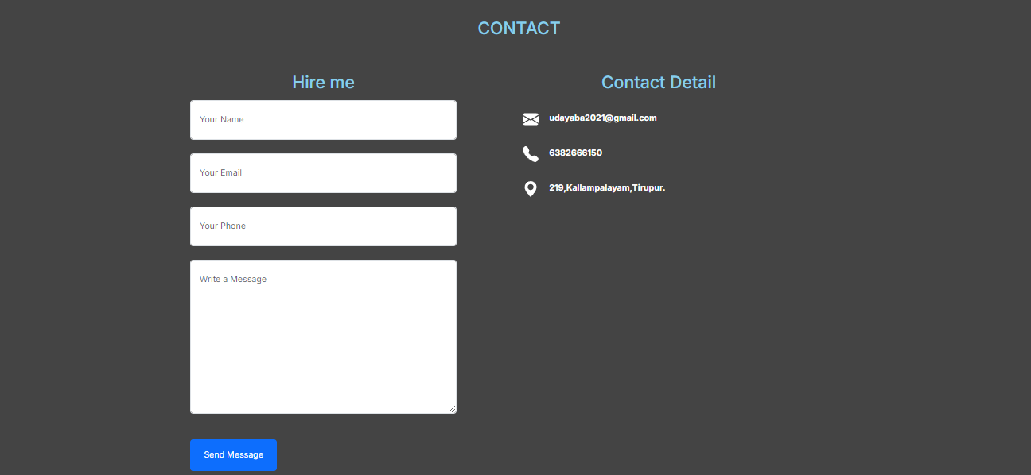

**Description:**

The above displayed figure is a contact page in the website. If the user wants to contact me, they can fill the form with their valid details. Here I imported library called Email-js to send messages.

## Source Code:

### HTML:

### <section id="contact">

### <div class="container">

### <div class="row">

### <div class="col-md-12 mb-5">

### <div class="section-heading text-center">

### <h2>CONTACT</h2>

### </div>

### </div>

### 

### <div class="col-md-5 mb-4 mb-md-0">

### <h2>Hire me</h2>

### <form action="" class="site-form" name="submit-to-google-sheet" >

### <div class="form-group">

### <input type="text" name="NAME" class="form-control px-3 py-4" placeholder="Your Name" >

### </div><br>

### <div class="form-group">

### <input type="email" name="E-MAIL" class="form-control px-3 py-4 "

### placeholder="Your Email">

### </div><br>

### <div class="form-group">

### <input type="text" name="MOBILE_NUMBER" class="form-control px-3 py-4"

### placeholder="Your Phone">

### </div><br>

### <div class="form-group mb-5">

### <textarea name="MESSAGE" class="form-control px-3 py-4"cols="30" rows="10" placeholder="Write a Message"></textarea>

### </div>

### <div class="form-group">

### <input type="submit" class="btn btn-primary px-4 py-3" value="Send Message">

### </div>

### </form>

### </div>

### <div class="col-md-7 mb-4">

### <h2>Contact Detail</h2>

### <p>

### <svg xmlns="http://www.w3.org/2000/svg" width="30" height="30" fill="currentColor" class="bi bi-envelope-fill" viewBox="0 0 16 16">

### <path d="M.05 3.555A2 2 0 0 1 2 2h12a2 2 0 0 1 1.95 1.555L8 8.414zM0 4.697v7.104l5.803-3.558zM6.761 8.83l-6.57 4.027A2 2 0 0 0 2 14h12a2 2 0 0 0 1.808-1.144l-6.57-4.027L8 9.586zm3.436-.586L16 11.801V4.697z"/>

### </svg>

### <b>[udayaba2021@gmail.com</b](mailto:udayaba2021@gmail.com%3c/b)>

### </p>

### <p>

### <svg xmlns="http://www.w3.org/2000/svg" width="30" height="30" fill="currentColor" class="bi bi-telephone-fill" viewBox="0 0 16 16">

### <path fill-rule="evenodd" d="M1.885.511a1.745 1.745 0 0 1 2.61.163L6.29 2.98c.329.423.445.974.315 1.494l-.547 2.19a.68.68 0 0 0 .178.643l2.457 2.457a.68.68 0 0 0 .644.178l2.189-.547a1.75 1.75 0 0 1 1.494.315l2.306 1.794c.829.645.905 1.87.163 2.611l-1.034 1.034c-.74.74-1.846 1.065-2.877.702a18.6 18.6 0 0 1-7.01-4.42 18.6 18.6 0 0 1-4.42-7.009c-.362-1.03-.037-2.137.703-2.877z"/>

### </svg>

### <b>6382666150</b>

### </p>

### <p><svg xmlns="http://www.w3.org/2000/svg" width="30" height="30" fill="currentColor"

### class="bi bi-geo-alt-fill" viewBox="0 0 16 16">

### <path d="M8 16s6-5.686 6-10A6 6 0 0 0 2 6c0 4.314 6 10 6 10m0-7a3 3 0 1 1 0-6 3 3 0 0 1 0 6"/>

### </svg>

### <b>219,Kallampalayam,Tirupur.</b>

### </p>

### </div>

### </div>

### </div>

### </section>

### CSS :

/*=============== CONTACT ===============*/

#contact

{

background-color: #444;

}

#contact p

{

color: white;

padding-top: 20px;

padding-left: 100px;

}

#contact b

{

padding-left: 20px;

}

.

# Chapter-3:

## Pages & Navigation

* 1. **Landing Page:**



Figure 3.1.1

## Description:

The above Figure 3.1.1 are the screenshot of Homepage in a desktop view. And this is a home screen of the portfolio which shows the landing page and navigation bar. Here I also attached Youtube,Github and Linkedin. which shown as Figure 3.1.1.

## Source Code :

### HTML

### <section id="home">

### <header class="header">

### <div class="container">

### <h1 class="name"> <span>U</span>DAYA<span>K</span>UMAR</h1>

### <h2 class="title">WEB DEVEVELOPER</h2>

### <img src="./images/udaya1.jpg">

### <div class="row justify-content-center" id="icon">

### <div class="col-4">

### <a href="https://www.youtube.com/embed/m6hme9YDmuQ?si=XV97GUX-IOKbtF84" class="icon-link">

### <p>

### <svg xmlns="http://www.w3.org/2000/svg" width="50" height="50" fill="currentColor" class="bi bi-youtube" viewBox="0 0 16 16" style="color: white;">

### <path d="M8.051 1.999h.089c.822.003 4.987.033 6.11.335a2.01 2.01 0 0 1 1.415 1.42c.101.38.172.883.22 1.402l.01.104.022.26.008.104c.065.914.073 1.77.074 1.957v.075c-.001.194-.01 1.108-.082 2.06l-.008.105-.009.104c-.05.572-.124 1.14-.235 1.558a2.01 2.01 0 0 1-1.415 1.42c-1.16.312-5.569.334-6.18.335h-.142c-.309 0-1.587-.006-2.927-.052l-.17-.006-.087-.004-.171-.007-.171-.007c-1.11-.049-2.167-.128-2.654-.26a2.01 2.01 0 0 1-1.415-1.419c-.111-.417-.185-.986-.235-1.558L.09 9.82l-.008-.104A31 31 0 0 1 0 7.68v-.123c.002-.215.01-.958.064-1.778l.007-.103.003-.052.008-.104.022-.26.01-.104c.048-.519.119-1.023.22-1.402a2.01 2.01 0 0 1 1.415-1.42c.487-.13 1.544-.21 2.654-.26l.17-.007.172-.006.086-.003.171-.007A100 100 0 0 1 7.858 2zM6.4 5.209v4.818l4.157-2.408z"/>

### </svg>

### </p>

### </a>

### </div>

### <div class="col-4">

### <a href="https://github.com/Udaya1011" class="icon-link">

### <p><svg xmlns="http://www.w3.org/2000/svg" width="50" height="50" fill="currentColor" class="bi bi-github" viewBox="0 0 16 16" style="color: white;">

### <path d="M8 0C3.58 0 0 3.58 0 8c0 3.54 2.29 6.53 5.47 7.59.4.07.55-.17.55-.38 0-.19-.01-.82-.01-1.49-2.01.37-2.53-.49-2.69-.94-.09-.23-.48-.94-.82-1.13-.28-.15-.68-.52-.01-.53.63-.01 1.08.58 1.23.82.72 1.21 1.87.87 2.33.66.07-.52.28-.87.51-1.07-1.78-.2-3.64-.89-3.64-3.95 0-.87.31-1.59.82-2.15-.08-.2-.36-1.02.08-2.12 0 0 .67-.21 2.2.82.64-.18 1.32-.27 2-.27s1.36.09 2 .27c1.53-1.04 2.2-.82 2.2-.82.44 1.1.16 1.92.08 2.12.51.56.82 1.27.82 2.15 0 3.07-1.87 3.75-3.65 3.95.29.25.54.73.54 1.48 0 1.07-.01 1.93-.01 2.2 0 .21.15.46.55.38A8.01 8.01 0 0 0 16 8c0-4.42-3.58-8-8-8"/>

### </svg>

### </p>

### </a>

### </div>

### <div class="col-4">

### <a href="https://www.linkedin.com/in/udayakumar-d-8471b430b" class="icon-link">

### <p>

### <svg xmlns="http://www.w3.org/2000/svg" width="50" height="50" fill="currentColor" class="bi bi-linkedin" viewBox="0 0 16 16" style="color: white;">

### <path d="M0 1.146C0 .513.526 0 1.175 0h13.65C15.474 0 16 .513 16 1.146v13.708c0 .633-.526 1.146-1.175 1.146H1.175C.526 16 0 15.487 0 14.854zm4.943 12.248V6.169H2.542v7.225zm-1.2-8.212c.837 0 1.358-.554 1.358-1.248-.015-.709-.52-1.248-1.342-1.248S2.4 3.226 2.4 3.934c0 .694.521 1.248 1.327 1.248zm4.908 8.212V9.359c0-.216.016-.432.08-.586.173-.431.568-.878 1.232-.878.869 0 1.216.662 1.216 1.634v3.865h2.401V9.25c0-2.22-1.184-3.252-2.764-3.252-1.274 0-1.845.7-2.165 1.193v.025h-.016l.016-.025V6.169h-2.4c.03.678 0 7.225 0 7.225z"/>

### </svg>

### </p>

### </a>

### </div>

### </div>

### </div>

### </header>

### </section>

### CSS:

/*=============== HOME ===============*/

#home

{

font-family: 'Poppins',sans-serif;

margin: 0;

padding: 0;

background-color: black;

}

#home img

{

border-radius: 50%;

width: 300px;

height: 300px;

object-fit: cover;

}

#icon{

padding-top: 20px;

}

#home .container

{

width: 95%;

margin: 0 auto;

padding-top: 30px;

}

span

{

color: skyblue;

font-size: 100%;

}

### **(Mobile view sample for one background image)**

### C:\Users\Own\Pictures\Screenshots\Screenshot (235).png

Figure 3.1.2

## Description:

The above Figure 3.1.2 are the screenshot of Homepage in a Mobile view. And this is a home screen of the portfolio which shows the landing page and navigation bar ,which shown as Figure 3.1.2.

## 3.1 Project Page

## C:\Users\Own\Pictures\Screenshots\Screenshot (236).png

## C:\Users\Own\Pictures\Screenshots\Screenshot (237).pngC:\Users\Own\Pictures\Screenshots\Screenshot (240).png

**Source Code**

### HTML:

<!-- ==================== PROJECTS ==================== -->

<section id="project" style="background-color: black;">

<h2 class="text-center mb-4">PROJECTS</h2>

<!-------------PROJECT 1-------------->

<div class="row">

<div class="col-md-4 mb-4 " sty>

<div class="card">

<img src="./images/ball ani.webp" height="250" class="card-img-top" alt="Project 1">

<div class="card-body">

<h5 class="card-title ">Moving Ball</h5>

<a href="https://udaya1011.github.io/moving-balls/" class="btn btn-primary">View Project</a>

<a href="https://github.com/Udaya1011/moving-balls" class="btn btn-primary">View Repository</a>

</div>

</div>

</div>

<!-------------PROJECT 2-------------->

<div class="col-md-4 mb-4">

<div class="card">

<img src="./images/three ani.gif" height="250" width="50" class="card-img-top" alt="Project 2">

<div class="card-body">

<h5 class="card-title">Three Ball Moving</h5>

<a href="https://udaya1011.github.io/THREE-BALL-MOVING/" class="btn btn-primary">View Project</a>

<a href="https://github.com/Udaya1011/THREE-BALL-MOVING" class="btn btn-primary">View Repository</a>

</div>

</div>

</div>

<!-------------PROJECT 3-------------->

<div class="col-md-4 mb-4">

<div class="card">

<img src="./images/pacani.gif" class="card-img-top" height="250" alt="Project 3">

<div class="card-body">

<h5 class="card-title">PacMan Animation</h5>

<a href="https://udaya1011.github.io/PACMAN-ANIMATION/" class="btn btn-primary">View Project</a>

<a href="https://github.com/Udaya1011/PACMAN-ANIMATION" class="btn btn-primary">View Repository</a>

</div>

</div>

</div>

<!-------------PROJECT 4-------------->

<div class="col-md-4 mb-4">

<div class="card">

<img src="./images/boston.gif" class="card-img-top" height="250" alt="Project 4">

<div class="card-body">

<h5 class="card-title">Boston Data</h5>

<a href="https://udaya1011.github.io/BOSTON-DATA/" class="btn btn-primary">View Project</a>

<a href="https://github.com/Udaya1011/BOSTON-DATA" class="btn btn-primary">View Repository</a>

</div>

</div>

</div>

<!-------------PROJECT 5-------------->

<div class="col-md-4 mb-4">

<div class="card">

<img src="./images/word.gif" class="card-img-top" height="250" alt="Project 5">

<div class="card-body">

<h5 class="card-title">Word Count</h5>

<a href="https://udaya1011.github.io/WORD-COUNT/" class="btn btn-primary">View Project</a>

<a href="https://github.com/Udaya1011/WORD-COUNT" class="btn btn-primary">View Repository</a>

</div>

</div>

</div>

<!-------------PROJECT 6-------------->

<div class="col-md-4 mb-4">

<div class="card">

<img src="./images/pacman ani.gif" class="card-img-top" height="250" alt="Project 6">

<div class="card-body">

<h5 class="card-title">Random PacMan Animation</h5>

<a href="https://udaya1011.github.io/RANDOM-PACMAN/" class="btn btn-primary">View Project</a>

<a href="https://github.com/Udaya1011/RANDOM-PACMAN" class="btn btn-primary">View Repository</a>

</div>

</div>

</div>

<!-------------PROJECT 7-------------->

<div class="col-md-4 mb-4">

<div class="card">

<img src="./images/eye ani.gif" height="250" class="card-img-top" alt="Project 7">

<div class="card-body">

<h5 class="card-title">Eye Ball Movement</h5>

<a href="https://udaya1011.github.io/EYE-BALL-MOVEMENT/" class="btn btn-primary">View Project</a>

<a href="https://github.com/Udaya1011/EYE-BALL-MOVEMENT" class="btn btn-primary">View Repository</a>

</div>

</div>

</div>

<!-------------PROJECT 8-------------->

<div class="col-md-4 mb-4">

<div class="card">

<img src="./images/mapani.gif" height="250" class="card-img-top" alt="Project 8">

<div class="card-body">

<h5 class="card-title">Roadmap</h5>

<a href="https://udaya1011.github.io/ROADMAP/" class="btn btn-primary">View Project</a>

<a href="https://github.com/Udaya1011/ROADMAP" class="btn btn-primary">View Repository</a>

</div>

</div>

</div>

<!-------------PROJECT 9-------------->

<div class="col-md-4 mb-4">

<div class="card">

<img src="./images/hanoi.gif" height="250" class="card-img-top" alt="Project 9">

<div class="card-body">

<h5 class="card-title">Roadmap</h5>

<a href="https://udaya1011.github.io/HANOI-TOWER/" class="btn btn-primary">View Project</a>

<a href="https://github.com/Udaya1011/HANOI-TOWER" class="btn btn-primary">View Repository</a>

</div>

</div>

</div>

</div>

</section>

## Navigation Bar

### Desktop View:

### C:\Users\Own\Pictures\Screenshots\Screenshot (242).png

Figure-3.3.1

## Description:

The Figure-3.3.1 are the samples of navigation bar in desktop View.This was a user-friendly method only, so the user can easily use the features.

## Source Code

### HTML:

<!--==================== HEADER ====================-->

<header>

<nav class="navbar navbar-expand-lg navbar-dark bg-dark fixed-top">

<div class="container-fluid">

<a class="navbar-brand" href="#home"><span>UDAYA</span></a>

<button class="navbar-toggler" type="button" data-bs-toggle="collapse" data-bs-target="#navbarNav"

aria-controls="navbarNav" aria-expanded="false" aria-label="Toggle navigation">

<span class="navbar-toggler-icon"></span>

</button>

<div class="collapse navbar-collapse" id="navbarNav">

<ul class="navbar-nav ms-auto">

<li class="nav-item">

<a class="nav-link" href="#home">Home</a>

</li>

<li class="nav-item">

<a class="nav-link" href="#education1">Qualifications</a>

</li>

<li class="nav-item">

<a class="nav-link" href="#certificates">certificates</a>

</li>

<li class="nav-item">

<a class="nav-link" href="#skills1">Skills</a>

</li>

<li class="nav-item">

<a class="nav-link" href="#project">Projects</a>

</li>

<li class="nav-item">

<a class="nav-link" href="#about">About</a>

</li>

<li class="nav-item">

<a class="nav-link" href="#contact">Contact</a>

</li>

</ul>

</div>

</div>

</nav>

</header>

# Mobile View

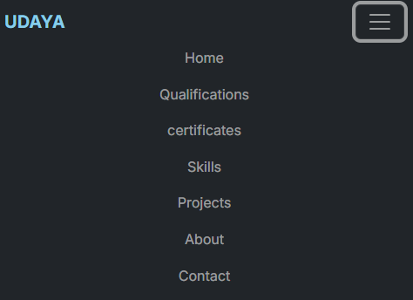

Figure -3.3.1 (mobile view)

## Description:

The figure-3.3.1 are the samples of navigation bar in mobile view. This was a user-friendly method only, so the user can easily use the feature

## Features:

There are many styles are added. Whenever the user move lists to the navigation bar it will hover with some effect. And also the navigation bar will be stable in the same position, even we switch to any other pages.

## 3.4 Skills:

## C:\Users\Own\Pictures\Screenshots\Screenshot (244).png

## Description:

The above figures are skills page,It contains a three container Programming Language , Web Development and DataBase .

## Source Code:

### HTML:

<!--==================== Skills ====================-->

### <section id="skills1" style="background-color: #444;">

### <div class="container">

### <h2>SKILLS</h2>

### <br>

### <div class="skills">

### <h3 id="skill" class="text-center" >Programming Language</h3>

### <h3 class="text-left">Basic Java Programming</h3>

### <div class="progress">

### <div class="progress-bar" role="progressbar" style="width: 90%; background-color:burlywood;"

### aria-valuenow="90" aria-valuemin="0" aria-valuemax="100">90%</div>

### </div>

### <br>

### <h3 class="text-left">Python</h3>

### <div class="progress">

### <div class="progress-bar" role="progressbar" style="width: 80%; background-color: orange;" aria-valuenow="80" aria-valuemin="0" aria-valuemax="100">80%</div>

### </div>

### </div>

### <br>

### <div class="skills">

### <h3 class="text-center" >Web Development</h3>

### <h3 id="skill" class="text-left">HTML & CSS</h3>

### <div class="progress">

### <div class="progress-bar" role="progressbar" style="width: 90%; background-color:burlywood;" aria-valuenow="90" aria-valuemin="0" aria-valuemax="100">90%</div>

### </div>

### 

### <br>

### <h3 class="text-left">JAVASCRIPT</h3>

### <div class="progress">

### <div class="progress-bar" role="progressbar" style="width: 75%; background-color: violet;" aria-valuenow="75" aria-valuemin="0" aria-valuemax="100">75%</div>

### </div>

### </div>

### <br>

### <div class="skills">

### <h3 id="skill" class="text-center">DataBase</h3>

### <h3 class="text-left">RDBMS [Relational DataBase Management System]</h3>

### <div class="progress">

### <div class="progress-bar" role="progressbar" style="width: 90%; background-color:burlywood;" aria-valuenow="90" aria-valuemin="0" aria-valuemax="100">90%</div>

### </div>

### </div>

### </div>

### </section>

### CSS:

/*=============== Skills ===============*/

.skills1 {

margin-bottom: 15px;

}

#skill{

color: skyblue;

}

.skills-section {

background-color: #fff;

padding: 50px;

margin: 20px auto;

max-width: 1200px;

box-shadow: 0 4px 8px rgba(0, 0, 0, 0.1);

}

.skills {

background-color: black;

padding: 20px;

border-radius: 8px;

width: 60%;

box-shadow: 0 2px 4px rgba(0, 0, 0, 0.1);

}

.skills h3{

margin-bottom: 10px;

color: white;

}

# Chapter-4 Style Score

## Styles

**Source Code:**

### CSS:

/*=============== REUSABLE CSS CLASSES ===============*/

*{

padding: 0;

margin:0;

box-sizing: border-box;

list-style: none;

scroll-behavior: smooth;

text-decoration: none;

}

body

{

line-height: 1.6;

margin: 0;

padding: 0;

background-color:black;

padding: 20px;

font-family: 'Inter', sans-serif;

scroll-behavior: smooth;

}

span{

color: skyblue;

font-size: 100%;

}

.container

{

width: 95%;

margin: 0 auto;

padding: 40px;

}

section

{

margin: 20px 0;

padding: 20px;

background-color: #fff;

border-radius: 8px;

}

section h2

{

margin-bottom: 15px;

color: skyblue;

text-align: center;

}

Nav

{

padding: 10px 0;

text-align: center;

}

ul

{

list-style: none;

padding: 0;

margin: 0;

display: flex;

max-width: 100%;

justify-content: center;

}

ul li

{

margin:0 20px;

}

a

{

color: white;

text-decoration: none;

font-weight: bold;

}

a:hover {

text-decoration: none;

}

.education1-section

{

padding: 0;

margin: 20px auto;

background-color: #444;

}

.education

{

background-color:black;

color: white;

padding: 20px;

border-radius: 8px;

width: 60%;

box-shadow: 0 5px 10px rgba(0, 0, 0, 0.1);

}

.education h3

{

font-size: 20px;

margin-bottom: 10px;

color: skyblue;

}

.education p

{

margin-bottom: 5px;

font-size: 16px;

}

## Style Links

<!--=============== CSS ===============-->

<link rel="stylesheet" href="main.css">

# Chapter 5:

## Website include the following Information

**5.1 Project links to GitHub:**

## Project-1

Title: **MOVING BALL**

Link: https://udaya1011.github.io/moving-balls/

## Project Description:

This HTML page displays a continuous bouncing red ball animation within a rectangular area controlled by JavaScript using the setInterval function with a 500- millisecond interval.

## Project-2

Title:  **THREE BALL BOUNCING**

Link: https://udaya1011.github.io/THREE-BALL-MOVING/

## Project Description:

Elevate the animation by enabling user input for modifying the ball's movement, incorporating elementslike keyboard and mouse controls, as well as introducing obstacles or targets to enhance interactivity.

#### PROJECT-3

Title: **PAC-MAN**

Link: https://udaya1011.github.io/PACMAN-ANIMATION/

## Project Description:

This HTML page features a Pac-Man animation moving horizontally within a container, controlled by JavaScript for direction, mouth animation, and boundary reversal, with a continuous animation loop triggered by setInterval every 100 milliseconds.

## PROJECT-4

Title: **BOSTON DATA**

Link: https://udaya1011.github.io/BOSTON-DATA/

## Project Description:

This JavaScript program retrieves and displays information about the top five earning employeesin Boston, providing key details for each employee.

## PROJECT-5

Title: **WORD COUNT**

Link: https://udaya1011.github.io/WORD-COUNT/

## Project Description:

This HTML document displays the top 5 most frequently occurring words from a providedparagraph after removing punctuation and converting all text to lowercase.

**PROJECT-6**

Title: **PACKMAN GAME**

Link: https://udaya1011.github.io/RANDOM-PACMAN/

* + - **Project Description:**

The HTML document creates a basic Pac-Man game with randomly generated Pac-Man characters that bounce off the container's boundaries and change mouth states while moving.

**PROJECT-7**

Title: **MOVING EYES**

Link: https://udaya1011.github.io/EYE-BALL-MOVEMENT/

* + - **Project Description:**

This HTML document creates a simple interactive face with moving eyes that follow the user's mouse cursor. The face consists of a red background with two eyes, and the eyes' black pupils follow the mouse movement.

**PROJECT-8**

Title: **MAP**

Link: https://udaya1011.github.io/ROADMAP/

* + - **Project Description:**

This HTML document displays a map using Mapbox and a button to animate a

marker's movement along predefined bus stops between Gandhipuram and Sulur.

**PROJECT-9**

Title: **HANOI TOWER**

Link: https://udaya1011.github.io/HANOI-TOWER/

* + - **Project Description:**

This HTML document displays a Hanoi tower to set an number for box and click move

button to start the puzzle for an Hanoi Tower.

.

# Chapter-6:

## Bootstrap

**6.1 Uses of Bootstrap:**

## Source Code

<!-- Bootstrap CSS (required for Bootstrap) -->

<link href="https://cdn.jsdelivr.net/npm/bootstrap@5.3.3/dist/css/bootstrap.min.css"

rel="stylesheet" integrity="sha384-QWTKZyjpPEjISv5WaRU9OFeRpok6YctnYmDr5pNlyT2bRjXh0JMhjY6hW+ALEwIH" crossorigin="anonymous">

## Description:

I have used bootstrap in this website as a embeded in html. Which was a built in CSS file, so we can use it to reduce our time and also it carries a (N) number of designs. So, I had linked them to the code in HTML.

# 

# Chapter 7:

## Project README

## C:\Users\Own\Pictures\Screenshots\Screenshot (245).png

## C:\Users\Own\Pictures\Screenshots\Screenshot (246).pngC:\Users\Own\Pictures\Screenshots\Screenshot (247).png

## C:\Users\Own\Pictures\Screenshots\Screenshot (248).pngC:\Users\Own\Pictures\Screenshots\Screenshot (249).png

## C:\Users\Own\Pictures\Screenshots\Screenshot (250).pngC:\Users\Own\Pictures\Screenshots\Screenshot (251).png

## C:\Users\Own\Pictures\Screenshots\Screenshot (252).png C:\Users\Own\Pictures\Screenshots\Screenshot (253).png

**Description:**

The above figures are the screenshot of project README files (Description, steps to run,

future enhancement) in a desktop view.

# Chapter 8

## File Structure

**8.1 GitHub File Structure**

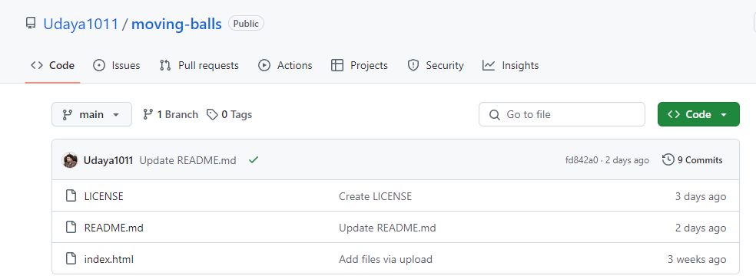

Figure 8.1.1

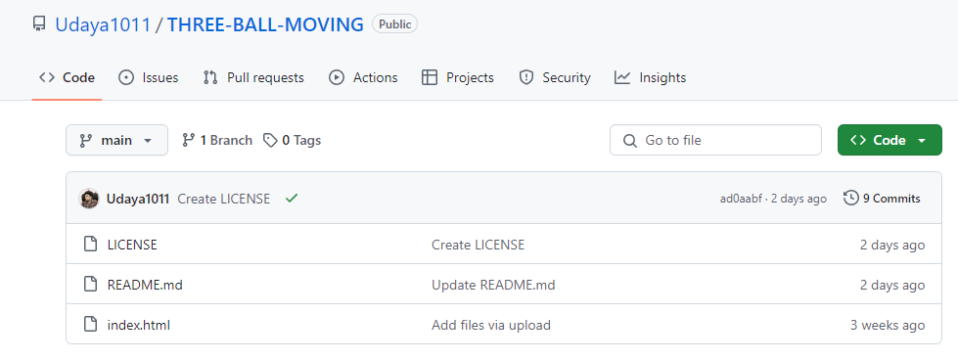

Figure 8.1.2

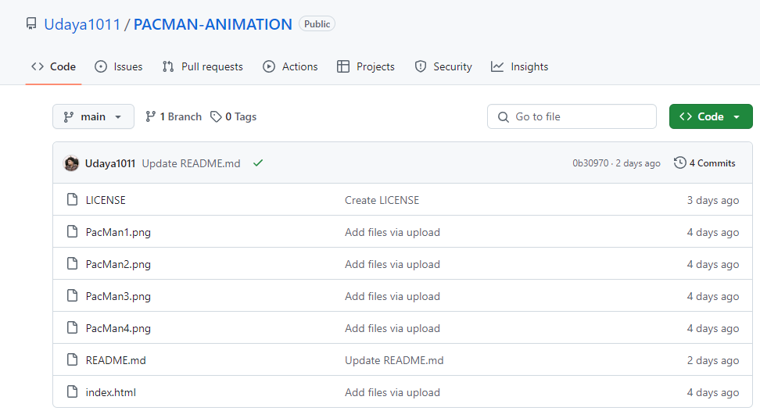

Figure 8.1.3

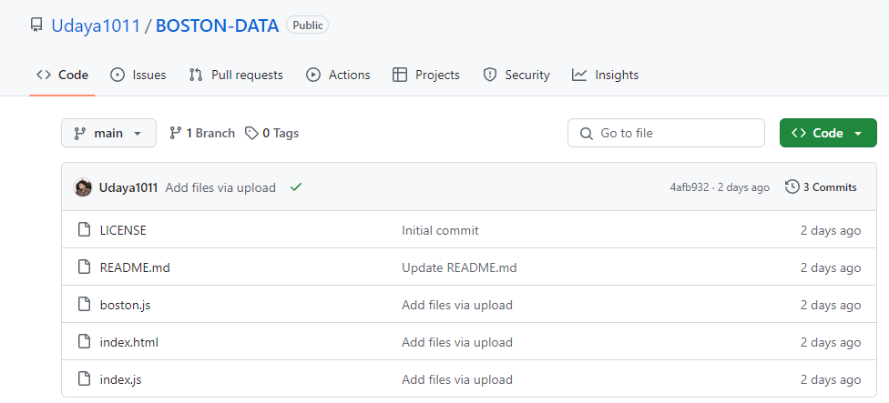

Figure 8.1.4

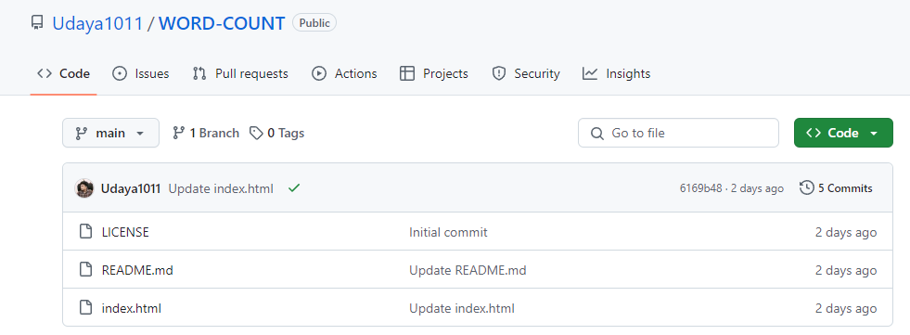

Figure 8.1.5

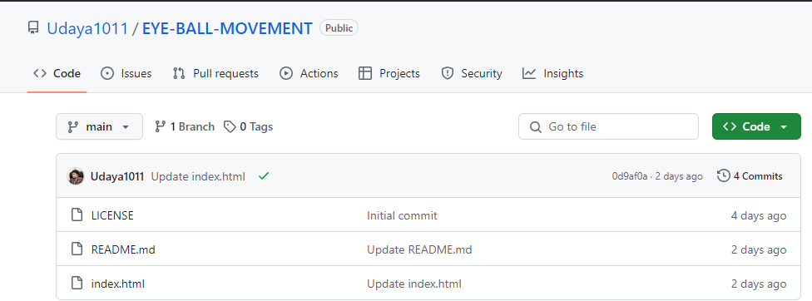

Figure 8.1.6

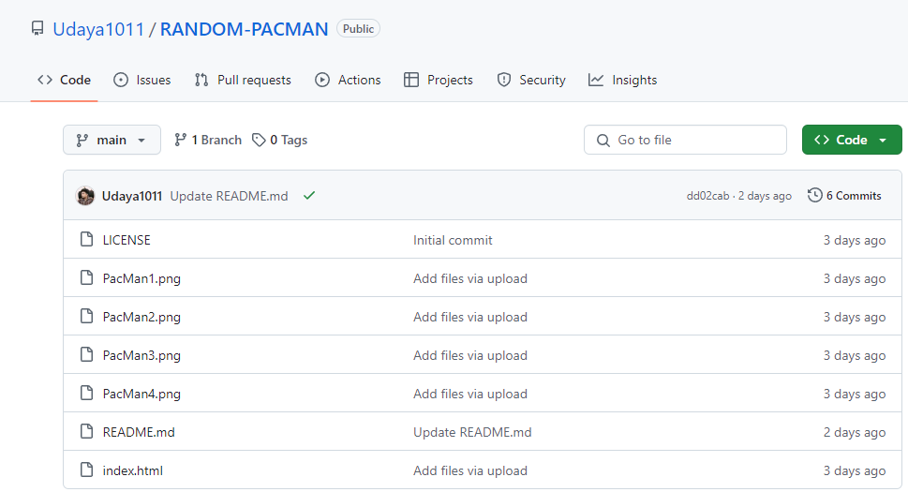

Figure 8.1.7

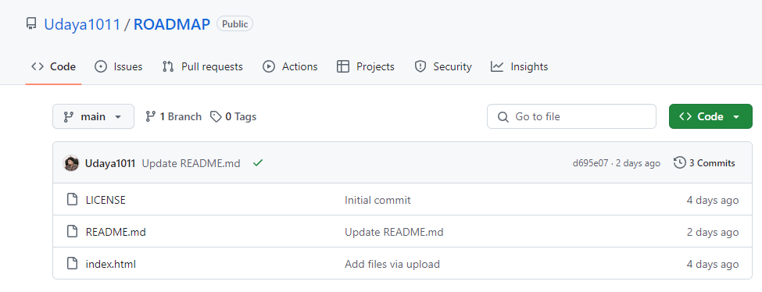

Figure 8.1.8

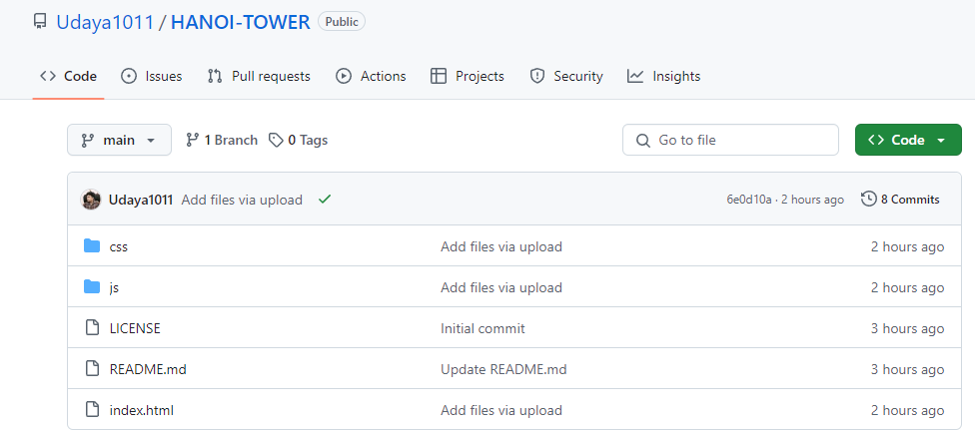

Figure 8.1.9

## Description:

This above Figures 8.1.1, 8.1.2, 8.1.3, 8.1.4, 8.1.5, 8.1.6, 8.1.7, 8.1.8 shows GitHub File Structure in desktop.