1. Run MapReduce Program and capture the application Id of the job.

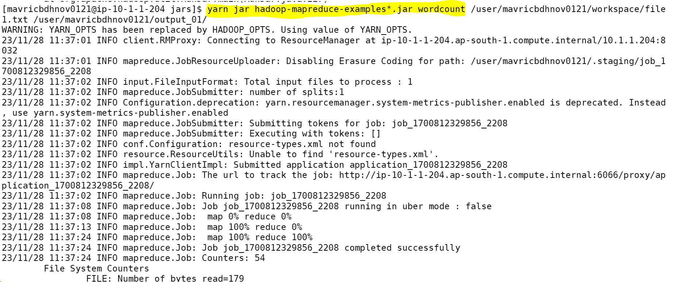

2.Re-run the MapReduce program and kill the application using the yarn command.

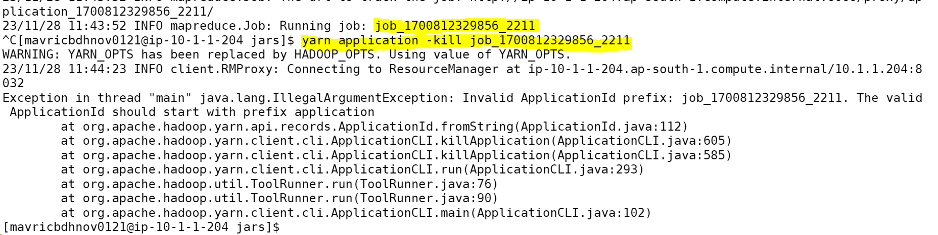

3.List all the applications which are RUNNING state

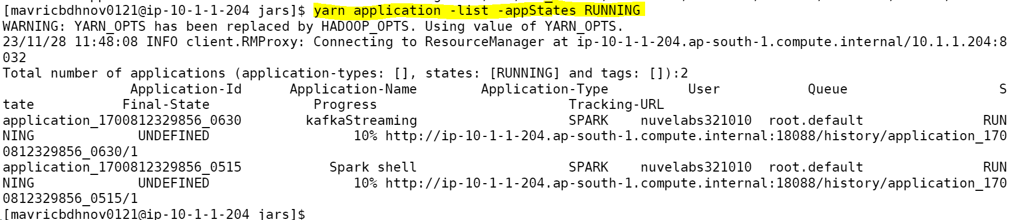

4.View the logs of any of the jobs which are already completed

